ZHANG Fan

EE511 Pro.4 USC ID:1417-68-5115

This is the updated version. Please ignore the another version I handed out. Thank you!!!

Q1: 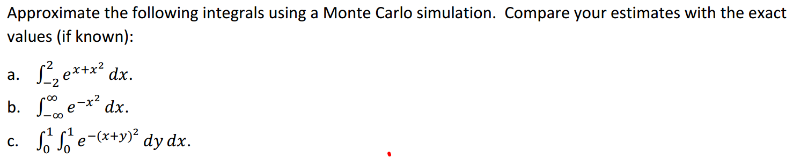

Code:

%Q1_ab

clear

N=10000;

bound(1:2)=[-inf,inf]

bound(3)=0

syms x

%y=exp(x+x^2);

y=exp(-x^2)

handout=vpa(int(y,bound(1),bound(2)))

fx=inline(y);

bound(4)=max(fx(bound(1):0.01:bound(2)));

B = bound;

R = rand(2, N);

%Set the random samplings to the correct intervals

R(1, :) = (B(2)-B(1))*R(1, :)+ B(1);

R(2, :) = R(2, :)*(B(4) - B(3)) + B(3);

area = (B(2)-B(1))*(B(4)-B(3));

s = fx(R(1,:))>=R(2,:);

total = sum(s);

avgF = total/N;

Approx = avgF*area

plot(R(1,:),fx(R(1,:)),'*')

hold on

plot(R(1,:),R(2,:),'b*')

**Results:**

**a.**

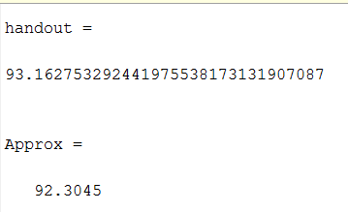

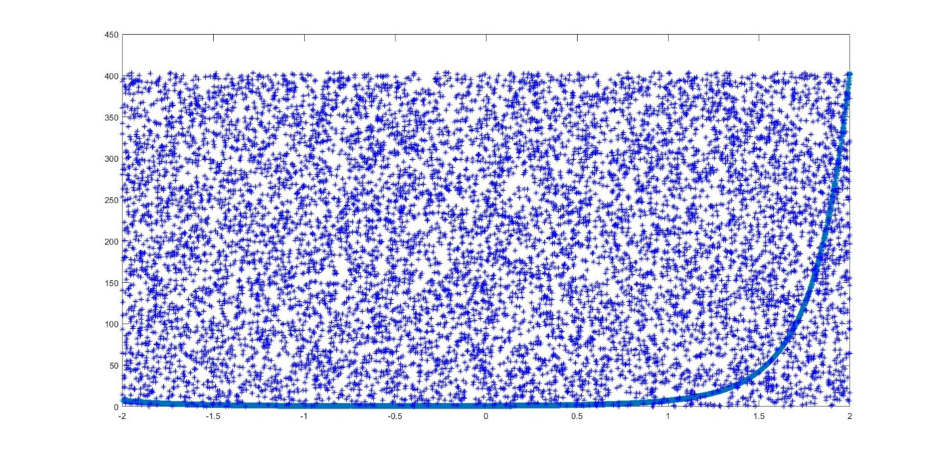

**b.**

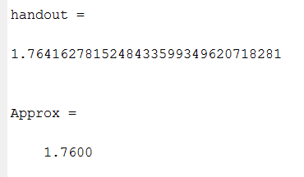

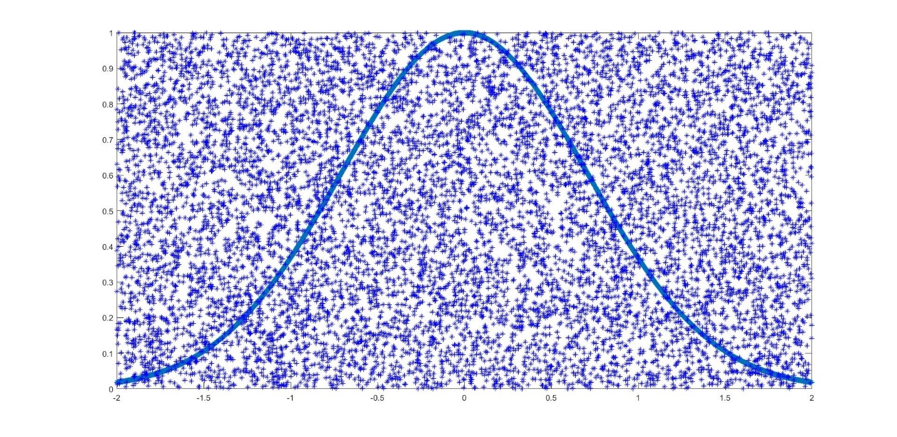

%code for Q1_c

clear

N=10000;

bound(1:4)=[0,1,0,1]

bound(5)=0

syms x y

%y=exp(x+x^2);

%y=exp(-x^2)

z=exp(-(x+y).^2);

%handout=vpa(int(y,bound(1),bound(2)))

%fx=inline(y);

fx=inline(z);

handout=vpa(int(int(z, x, 0, 1), y, 0, 1))

bound(6)=max(fx(bound(1):0.01:bound(2),bound(3):0.01:bound(4)));

B = bound;

R = rand(3, N);

%Set the random samplings to the correct intervals

R(1, :) = (B(2)-B(1))*R(1, :)+ B(1);

R(2, :) = R(2, :)*(B(4) - B(3)) + B(3);

R(3, :) = R(3, :)*(B(6) - B(5)) + B(5);

V = (B(2)-B(1))*(B(4)-B(3))*(B(6)-B(5));

s = fx(R(1,:),R(2,:))>=R(3,:);

total = sum(s);

avgF = total/N;

Approx = avgF*V

**Results for c:**

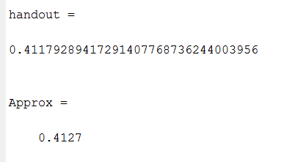

Q2

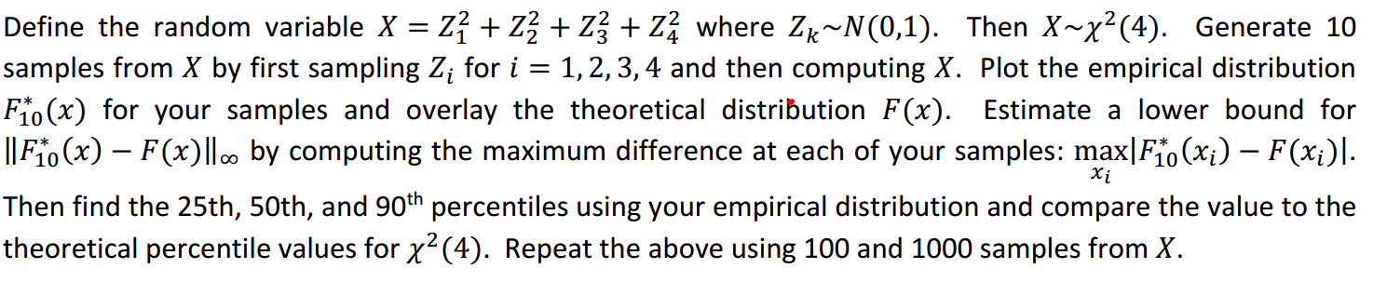

**Code:**

%Q2

clear

n=[10,100,1000];

for q=1:3

for i=1:n(q);

for j=1:4;

z(j)=randn;

end

X(i)=z(1).^2+z(2).^2+z(3).^2+z(4).^2;%randn: Normally distributed random numbers

end

X=sort(X);

subplot(1,3,q);

figure(1);

stairs(X,1/n(q):1/n(q):1,'b','linewidth',2);%X is the sample.

%The probablity of X1,X2,X3 may be 0.2, 0.5,0.3(pdf) or 0.2,0.7,1(cdf),

%in this case, it is cdf. The theory of cdf is:

%sort all of the samples,

%give each sample a number, 1, 2, 3, ...n in a accending order

%when the sequence(or the sample number) is standared, it become the cdf of the samples scpace.

hold on

grid on

x=0:0.2:15;

y=chi2cdf(x,4);

plot(x,y,'r--','linewidth',2);

hold off

legend('Empirical cdf','Theoretical cdf');

ylim([0 1.05]);

xlabel('x');

ylabel('F(x)');

title(['empirical distribution for ',num2str(n(q)) , ' sample number']);

sprintf('Sample number: %d, Theoretical 25th, 50th, 90th percentiles:%f,%f,%f',...

n(q),chi2inv(0.25,4),chi2inv(0.5,4),chi2inv(0.90,4))

sprintf('Smaple number: %d, Empirical 25th, 50th, 90th percentiles:%f,%f,%f',...

n(q),X(ceil(0.25*n(q))),X(ceil(0.5*n(q))),X(ceil(0.9*n(q))))

sprintf('sample number: %d difference of 25th, 50th, 90th percentiles between Empirical and theoretical confidence interval:\n%f,%f,%f',...

n(q),abs(chi2inv(0.25,4)-X(ceil(0.25*n(q)))),abs(X(ceil(0.5*n(q)))-chi2inv(0.5,4)),abs(X(ceil(0.9*n(q)))-chi2inv(0.90,4)))

end

**Results:**

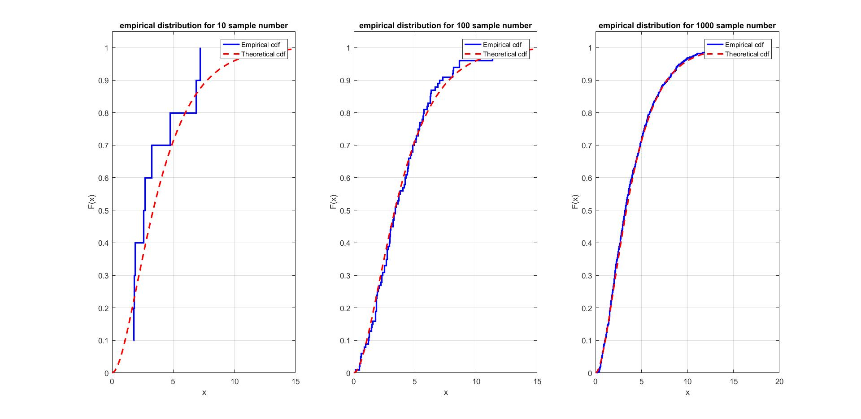

When the sample is 10:

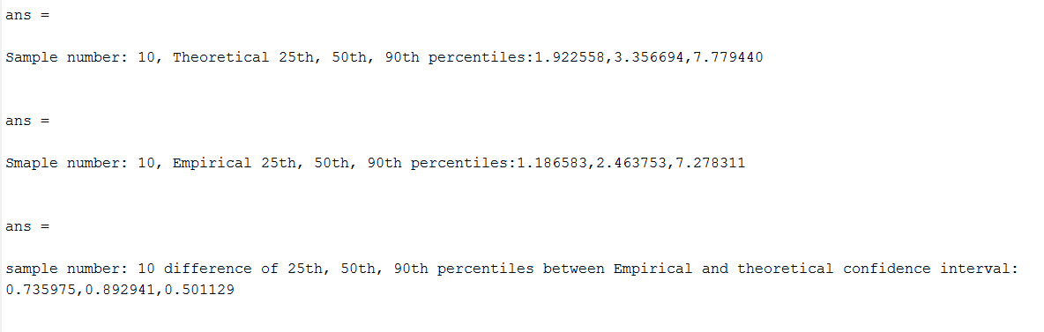

When the sample is 100:

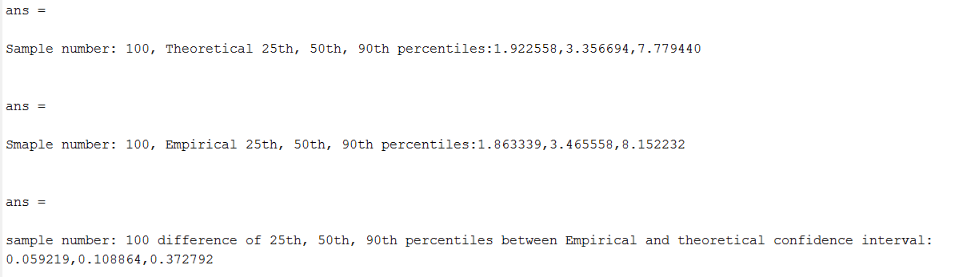

When the sample number is 1000:

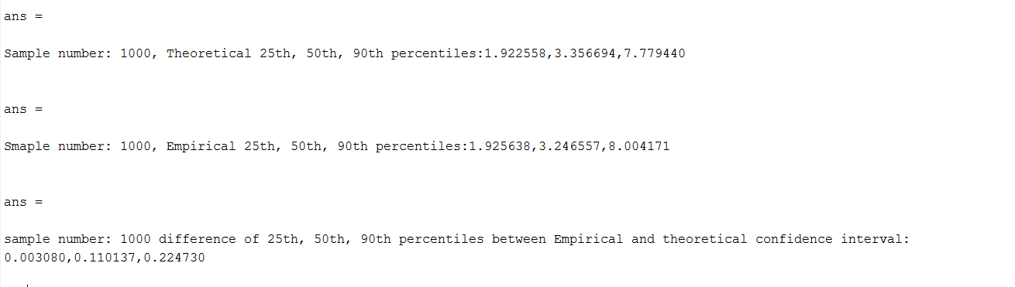

**Comment**:

the more sample number, the lower value which means the closer that the theretical results to the emprical results.

Q3:

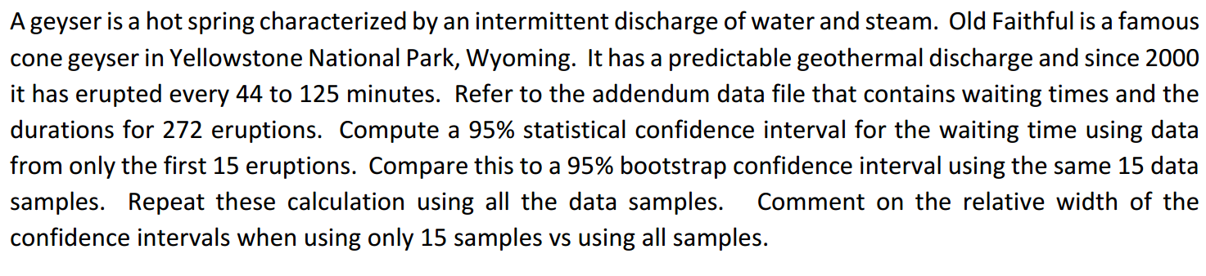

**Analysis:**

when 15 samples are used, t-distribution is used. Command “tinv” command in MATLAB can be used to determine ; similarly, when all the 272 samples are used, it is better to apply z-distribution. And MATLAB command “norminv”

After that, to obtain the confidence interval, we apply the equation   .

Finally, we apply bootstr method to get a new confidence interval and compare the statistical results with it.

**Code:**

y15=x(1:15,3)'

yall=x(:,3)'

StdAll=std(yall);

Std15=std(y15);

MeanAll=mean(yall);

Mean15=mean(y15);

%t - distrubition, sample number less than 30

t_afa = tinv(0.95,14)

Bound_15(1)=Mean15-Std15/sqrt(15)*t_afa;

Bound_15(2)=Mean15+Std15/sqrt(15)*t_afa;

%z distribution

z_afa = norminv([0.025 0.975],0,1)

BoundAll(1)=Mean15-z_afa(2)*StdAll/sqrt(272);

BoundAll(2)=Mean15+z_afa(2)*StdAll/sqrt(272);

stats = bootstrp(1000,@mean,yall);

SortAll=sort(stats);

BoundBootAll(1)=SortAll(25);

BoundBootAll(2)=SortAll(975);

stats = bootstrp(1000,@mean,y15);

Sort15=sort(stats);

BoundBoot15(1)=Sort15(25);

BoundBoot15(2)=Sort15(975);

BoundAll

Bound_15

BoundBootAll

BoundBoot15

Results：

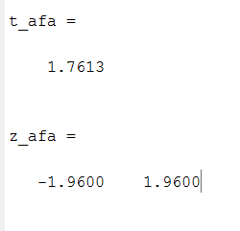

The condidence interval for the 15 samples is [69.3177,72.5490] and for all samples is [64.0547,77.8119]. And the bootstr method to get the confidence interval for all samples are [69.1360,72.4779] and for the 15 samples is [63.0667,78.000].

