GITHUB LINK: <https://github.com/FAST-shameer/PFLab5-25K0744-BCS1A/tree/main/PFLab-Assignment5-25K0744>

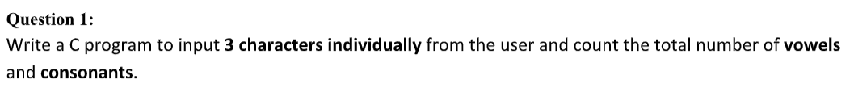

#include <stdio.h>

#include <ctype.h>

int main(){

char usrChar;

int vowelCount = 0;

int consonantCount = 0;

for (int i = 0; i < 3; i++){

scanf(" %c", &usrChar);

switch(tolower(usrChar)){

case 'a': case 'e': case 'i': case 'o': case 'u':

vowelCount ++;

break;

default:

consonantCount ++;

break;

}

}

printf("Vowels: %d\n", vowelCount);

printf("Consonants: %d\n", consonantCount);

return 0;

}

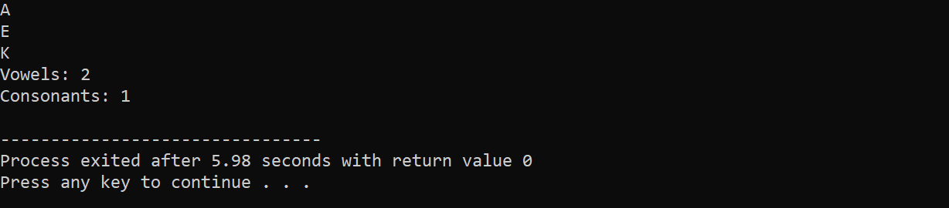

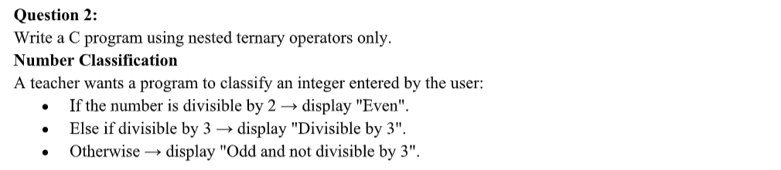

#include <stdio.h>

#include <ctype.h>

int main(){

int usrInput;

scanf("%d", &usrInput);

if (usrInput % 2 == 0){

printf("Even\n");

} else if (usrInput % 3 == 0){

printf("Divisible by 3\n");

} else {

printf("Odd and not divisible by 3\n");

}

return 0;

}

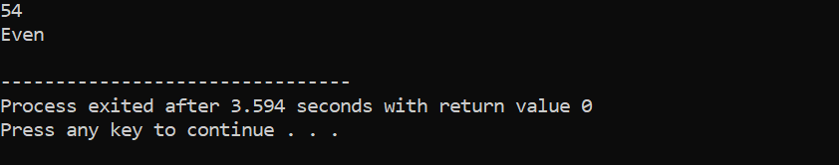

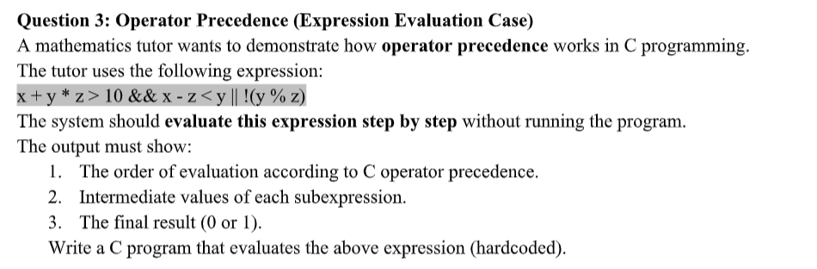

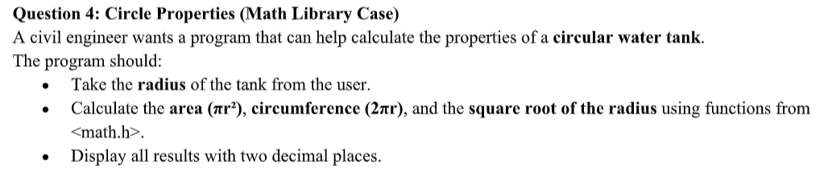

#include <stdio.h>

#include <math.h>

#define M_PI 3.14159265358979323846

int main(){

float radius, area, circumference, squareRoot;

scanf("%f", &radius);

area = M_PI * pow(radius, 2);

circumference = 2 * M_PI * radius;

squareRoot = sqrt(radius);

printf("Area of Circle: %.2f\n", area);

printf("Circumference: %.2f\n", circumference);

printf("Square Root of Radius: %.2f\n", squareRoot);

return 0;

}

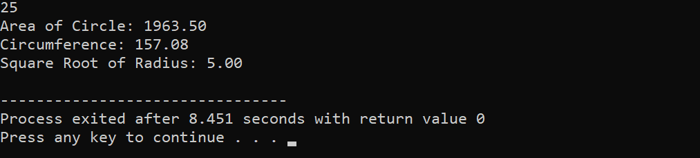

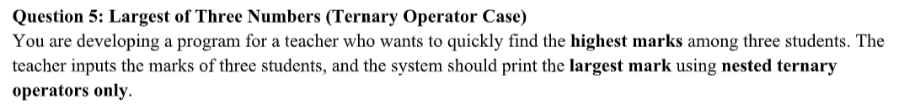

#include <stdio.h>

int main(){

int largest = 0;

int mark1, mark2, mark3;

printf("Enter the first marks: ");

scanf("%d", &mark1);

printf("Enter the second marks: ");

scanf("%d", &mark2);

printf("Enter the third marks: ");

scanf("%d", &mark3);

largest = mark1;

if (mark2 > largest){

largest = mark2;

}

if (mark3 > largest){

largest = mark3;

}

printf("Largest marks: %d\n", largest);

return 0;

}

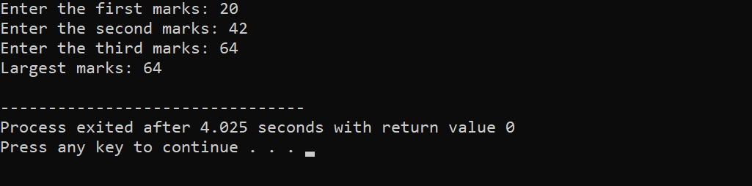

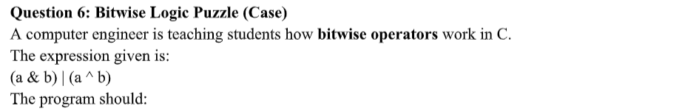

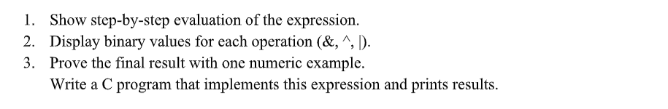

#include <stdio.h>

void print_binary(int n){

int bit;

for (int i = 31; i >= 0; i--){

bit = (n >> i) & 1;

printf("%d", bit);

}

}

int main(){

// expression: (a & b) | (a ^ b)

int a, b;

printf("Enter a: ");

scanf("%d", &a);

printf("Enter b: ");

scanf("%d", &b);

int and_operation = a & b;

int xor_operation = a ^ b;

int or_operation = and_operation | xor_operation;

printf("a in binary: ");

print_binary(a);

printf("\nb in binary: ");

print_binary(b);

printf("\na & b = %d. Binary: ", and_operation);

print_binary(and_operation);

printf("\na ^ b = %d. Binary: ", xor_operation);

print_binary(xor_operation);

printf("\n(a & b) | (a ^ b) = %d. Binary: ", and_operation | xor_operation);

print_binary(or_operation);

return 0;

}

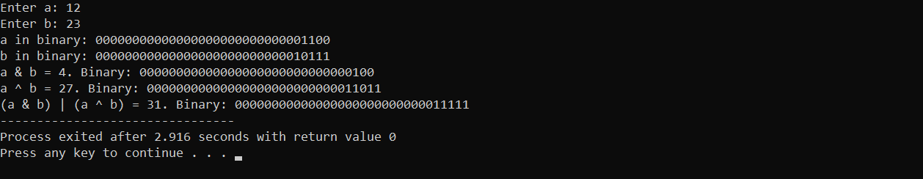

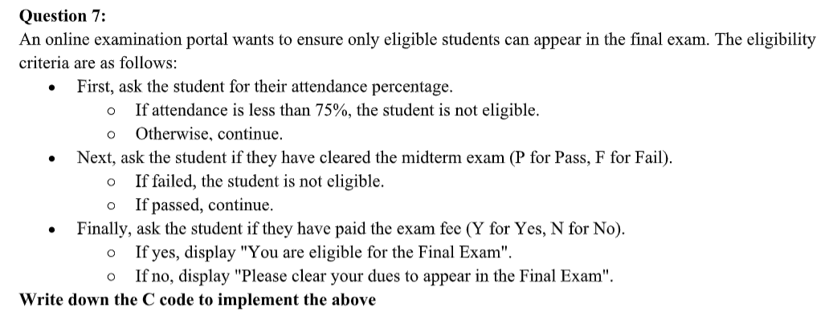

#include <stdio.h>

#include <ctype.h>

int main(){

float attendancePercentage;

char midtermResult;

char paidExamFee;

printf("Enter your attendance percentage: ");

scanf("%f", &attendancePercentage);

if (attendancePercentage < 75) {

printf("You are not eligible for the final exam because your percentage is less than 75\n");

} else {

printf("Did you pass your midterm (P/F)? ");

scanf(" %c", &midtermResult);

if (tolower(midtermResult) == 'f'){

printf("You are not eligible for the final exam because you failed your mid term exams\n");

} else if (tolower(midtermResult) == 'p'){

printf("Have you paid the exam fee (Y/N)? ");

scanf(" %c", &paidExamFee);

if (tolower(paidExamFee) == 'n'){

printf("You are not eligible for the final exam because you did not pay the exam fee\n");

} else if (tolower(paidExamFee) == 'y'){

printf("You are eligible for the final exam!");

} else{

printf("Enter a valid input!\n");

}

} else {

printf("Enter a valid input!\n");

}

}

return 0;

}

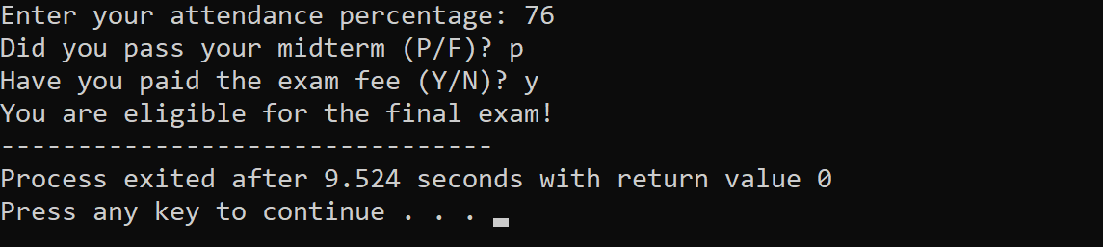

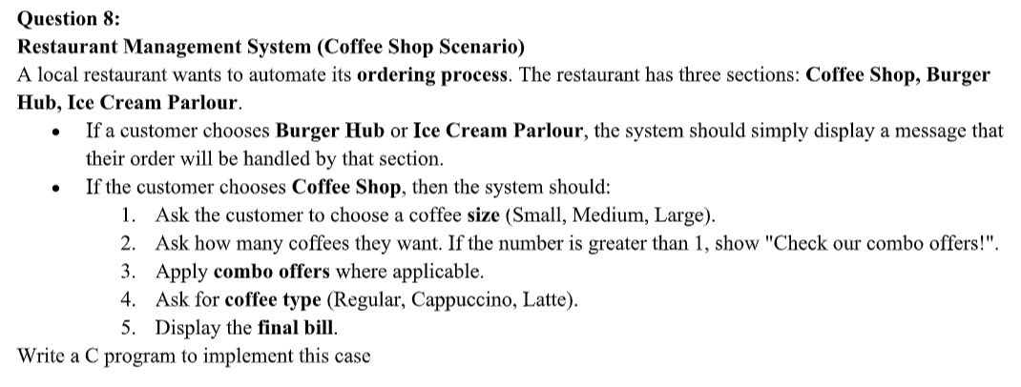

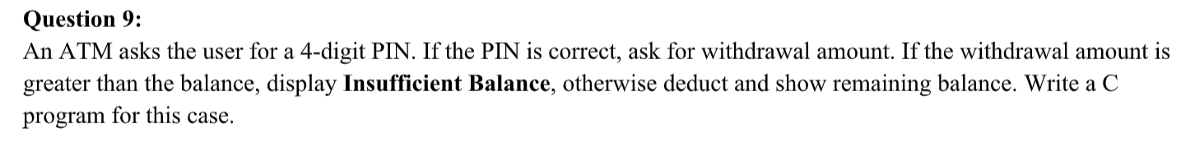

#include <stdio.h>

int main(){

const float accountBalance = 10000;

const int actualPIN = 1234;

int usrPIN, withdrawalAmount;

float finalBalance = 0;

printf("Enter PIN: ");

scanf("%d", &usrPIN);

if (usrPIN != actualPIN){

printf("Incorrect PIN!\n");

} else {

printf("Enter withdrawal Amount: ");

scanf("%d", &withdrawalAmount);

if (withdrawalAmount > accountBalance){

printf("Insufficient Balance\n");

} else {

printf("Withdrawal Successful!\n");

finalBalance = accountBalance - withdrawalAmount;

printf("Remaining Balance: %.2f\n", finalBalance);

}

}

return 0;

}

