Setup Flask application to run as a Linux service.
Step 1
Create the Flask app and i mentioned the sample code below.
#!/usr/bin/python
from flask import Flask, request
app = Flask(__name__)
@app.route('/', methods=['GET'])
def index():
return "Hai Manivannan this is ubuntu service with flask app"if __name__ == '__main__':
app.run(host="0.0.0.0", port=9006)
Step 2
We have to write the following service configuration in /etc/init/flask.conf:
sudo vi /etc/init/flask.conf
description "flask"
start on stopped rc RUNLEVEL=[2345]
respawn
exec python /home/manivannan/server.py

Step 3

Initialize the service using the command below:

sudo service flask start
If you receive any error, you may have to create an additional file: /lib/systemd/system/flask.service

sudo vi /lib/systemd/system/flask.service

Note: User=manivannan is the username. File content is shown below.

[Unit]
Description=Flask web server

[Install]
WantedBy=multi-user.target

[Service]
User=manivannan
PermissionsStartOnly=true
ExecStart=/home/manivannan/server.py
TimeoutSec=600
Restart=on-failure
RuntimeDirectoryMode=755
Step 4
Change the permission to server.py (Note: manivannan is username)
chown manivannan server.py
chmod +x server.py
Step 5
Run the service and check the status:
sudo service flask start
sudo service flask status
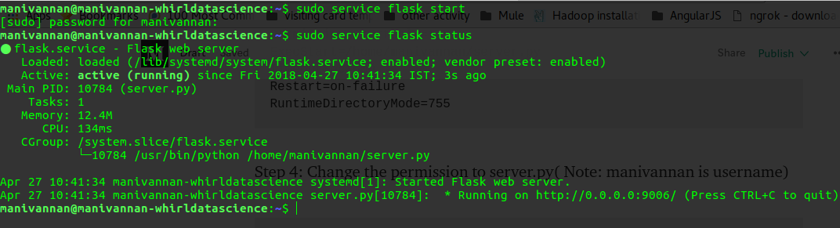
http://0.0.0.0:9006 is the service ip and port.

Final Step
Check the service running or not. Please hit the localhost:9006 on your browser.



source: https://medium.com/@manivannan_data/how-to-deploy-the-flask-app-as-ubuntu-service-399c0adf3606

