**In the Name of Allah**

**Candidate: Fatemeh Vakili Job Position: Senior Python Developer**

This report outlines the implementation of the RAG System with Vector Database and the rationale behind selecting each component for this project. The purpose of the issue is summarized below:

**Develop a Retrieve-and-Generate (RAG) system that leverages a vector database to store and retrieve information. The system should expose an API built with FastAPI to answer questions based on the embedded data.**

Note: The project requirements are a step-by-step process! The problem requirements are written in purple, with explanations following in black.

# **Requirements**

1. Vector Database Integration:

- Implement a vector database (excluding ChromaDb) to store information in a structured format that allows for efficient similarity search.

- Justify the choice of the database considering factors such as performance, scalability, and community support.

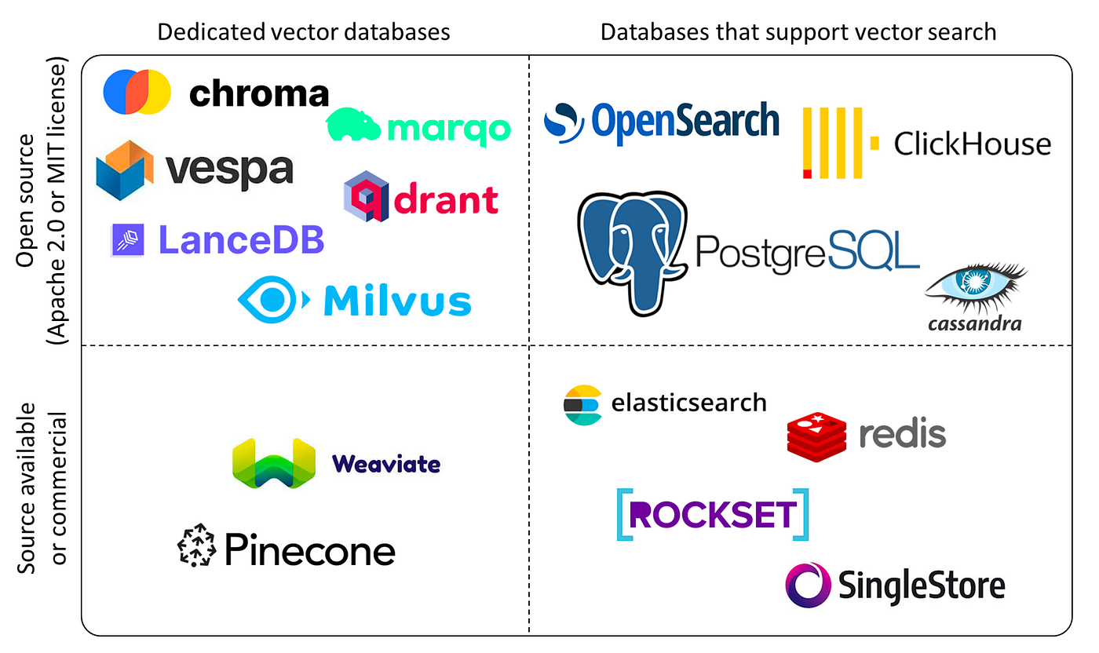

The