ONLINE COURSE ENROLLMENT
THIRD SEMESTER

MINI PROJECT REPORT
Submitted to the University of Kerala

In partial fulfilment of the requirements for the award of the
degree of
Master of Computer Applications

Submitted By

FATHIMA S (95524821031)


Department of Computer Applications

SREE NARAYANA INSTITUTE OF TECHNOLOGY

Vadakkevila, Kollam – 10 www.snit.ac.in
2025

SREE NARAYANA INSTITUTE OF TECHNOLOGY
Vadakkevila, Kollam – 10

Department of Computer Applications


“
onlin
e

course enrollment
”

done

by

FATH
IMA
S

(955248210
31
)

During the year 2025 in partial fulfilment of the requirements
for the award of Master of Computer Applications
by University of Kerala

Examiner Guide Head of Department

1. Rajitha P R Dr.Miriam Thomas

DECLARATION

I, Fathima S, declare that this project report entitled ‘ online course enrollment’ is the Bonafide work carried out under the supervision of Rajitha P R, Asst: Professor, Sree Narayana Institute of Technology, Kollam. To the best of my knowledge, the work reported here does not form part of any other project report or dissertation on which a degree or award was conferred on an earlier occasion to any other candidate. The content of this report is not being presented by any other student to this or any other University for the award of a degree.

Signature

Fathima S (Reg. No. 95524821018)

Countersigned

Head of Department,
Master of Computer Applications
Sree Narayana Institute of Technology, Kollam

ACKNOWLEDGEMENT

First and foremost, I thank the Almighty God who gave me the knowledge and strength to complete this project successfully. I express my deep sense of gratitude to The Principal Dr. T.Mahalekshmi and Dr.Miriam Thomas, Head, Department of Computer Applications for providing me with all the necessary facilities, which helped me a lot in the successful completion of this project. It is a great pleasure for me to acknowledge the assistance of my project guide Rajitha P R, Assistant Professor, Sree Narayana Institute of Technology, Kollam, for her valuable advice and kind support during this project.

Fathima S
(Reg.No. 95524821031)

TABLE OF CONTENTS

CHAPTER NO |  | TITLE | PAGE NO
 |  | ABSTRACT | i
 |  | LIST OF TABLES | ii
 |  | LIST OF FIGURES | iii
 |  | LIST OF ABBREVIATIONS | iv
1 |  | INTRODUCTION | 1
 | 1.1 | OVERVIEW OF THE PROJECT | 2
 | 1.2 | EXISTING SYSTEM | 2-3
 | 1.3 | PROPOSED SYSTEM OBJECTIVES & SCOPES | 3
 | 1.3.1 | Objectives of the Proposed System | 3
 | 1.3.2 | Scope of the Proposed System | 4
2 |  | REQUIREMENTS SPECIFICATION | 5
 | 2.1 | OVERALL DESCRIPTION | 5
 | 2.1.1 | Functional Requirements | 6
 | 2.2 | PRODUCT PERSPECTIVE | 6
 | 2.3 | PRODUCT FUNCTIONS | 7
 | 2.4 | User characteristics | 7
 | 2.5 | Operating environment and constraints | 8
 | 2.5.1 | Software specifications | 8
 | 2.5.2 | Hardware specifications | 8
 | 2.6 | Specific requirements | 9
 | 2.6.1 | User requirements | 9-10
 | 2.6.2 | Functional requirements | 10
 | 2.6.3 | Non functional requirements | 10
 | 2.6.4 | Security requirements | 11
3 |  | System design and test plan | 12
 | 3.1 | Dataflow diagram | 13
 | 3.1.1 | Level 0 DFD | 13-14
 | 3.1.2 | DFD level 1 | 14-16
 | 3.2 | Use case diagram | 16
 | 3.2.1 | Admin use case diagram | 17
 | 3.2.2 | Instructor use case diagram | 17-18
 | 3.2.3 | Student use case diagram | 18-19
 | 3.3 | Table design | 20
 | 3.3.1 | Students table | 20
 | 3.3.2 | Instructors table | 20-21
 | 3.3.3 | Admin table | 21
 | 3.3.4 | Courses table | 21-22
 | 3.3.5 | Enrollments table | 22
 | 3.3.6 | Reviews table | 22-23
 | 3.3.7 | Assignments table | 23-24
 | 3.3.8 | Submissions table | 24
 | 3.3.9 | Certificate_requests table | 24-25
 | 3.3.10 | Certificates table | 25
 | 3.3.11 | Course progress table | 26
 | 3.4 | Performance requirements | 27
 | 3.5 | Software quality attributes | 27-28
 | 3.6 | Detailed design | 28
 | 3.6.1 | User registration and login | 29
 | 3.6.2 | Course management | 29
 | 3.6.3 | Course enrollment | 30
 | 3.6.4 | Assignment submission and evaluation | 30
 | 3.6.5 | Logout and session management | 30
 | 3.7 | Sampling methods | 30-31
 | 3.7.1 | Random sampling | 31
 | 3.7.2 | Stratified sampling | 31
 | 3.7.3 | Cluster sampling | 31
 | 3.7.4 | Convinence sampling | 31-32
 | 3.7.5 | Systematic sampling | 32
 | 3.8 | Test cases | 33-35
4 |  | Implementation and results | 36
 | 4.1 | Implementation | 36
 | 4.1.1 | Backend development | 36
 | 4.1.2 | Frontend development | 36-37
 | 4.1.3 | Integration and testing | 37-38
 | 4.2 | Implementation results | 38
5 |  | Conclusion and future works | 39
 | 5.1 | Conclusion | 39
 | 5.2 | Future works | 40
 | 5.2.1 | Future implementation plan | 40-41
6 |  | references | 42-47
7 |  | Appendixes | 48-59
 |  | Appendix –A screenshots | 47-54
 |  | Appendix-B sample code | 55-59

ABSTRACT
The Online Course Enrollment System is a streamlined, user-centric web application designed to simplify digital learning by integrating essential functionalities for students, instructors, and administrators into a unified platform. Developed using PHP and MySQL, the system ensures efficient data handling, secure storage, and smooth retrieval of course-related information. Through an intuitive interface, students can browse courses, enroll, submit assignments, request certificates, and provide reviews, while the system manages data flow and communication seamlessly. The assignment module enables students to upload submissions, after which instructors can evaluate them, assign grades, and provide feedback. The certificate management feature further enhances the learning experience by allowing students to request course completion certificates, which instructors can approve, enabling instant access for download.
The system architecture follows a modular and scalable design, ensuring reliability, maintainability, and clear separation of roles. Administrators can manage users, monitor enrollments, approve instructors, and oversee course activities, while instructors can efficiently track enrolled students, respond to reviews, manage assignments, and approve certificates. Each module interacts securely with the backend database, while PHP handles validations, processing logic, and real-time data updates. Comprehensive test cases were executed across all modules, demonstrating consistent performance, accuracy, and user responsiveness.
This project aims to deliver a centralized learning management platform that eliminates the need for multiple separate tools, thereby improving accessibility, enhancing communication, and increasing productivity for all user roles. The system highlights the potential of integrating core academic functionalities into a single intelligent platform that adapts to institutional requirements and supports effective digital learning.
LIST OF TABLES
TABLE NO: | TITLE | PAGE NO:
3.1 | students | 20
3.2 | instructors | 20
3.3 | admin | 21
3.4 | courses | 21
3.5 | enrollments | 22
3.6 | reviews | 23
3.7 | assignments | 24
3.8 | submissions | 24
3.9 | certificate_requests | 25
3.10 | certificates | 25
3.11 | Courses_progress | 26

LIST OF FIGURES

FIGURE NO: | TITLE | PAGE NO:
3.1 | DFD Level 0 | 13-14
3.2 | DFD Level 1 | 14-16
3.3 | Admin Use Case Diagram | 17
3.4 | Instructors Use Case Diagram | 18
3.5 | Student Use Case Diagram | 18- 19
A.1 | Home Page | 48
A.2 | Students Register Page | 48
A.3 | Students Login Page | 49
A.4 | Student Dashboard | 49
A.5 | Course details Page  (Assignments,progress,certificate request) | 50
A.4 | Student Dashboard | 49
A.6 | Instructors Register Page | 50
A.7 | Instructors Login Page | 51
A.8 | Instructors Dashboard | 51
A.9 | Course creation Page | 52
A.10 | Assignment Creation | 52
A.11 | Submission | 53
A.12 | Admin login Page | 53
A.13 | Admin Dashboard | 53

LIST OF ABBREVIATIONS

List | Abbreviations | Meaning
1 | LMA | Learning Management Systems
2 | OCES | Online Course Enrollment System
3 | API | Application Programming  Interface
4 | JS | JavaScript
5 | CRUD | Create, Read, Update, Delete
6 | UX | User Experience
7 | UI | User Interface
8 | JSON | JavaScript Object Notation
9 | CSS | Cascading Style Sheets
10 | HTML | Hypertext Markup Language
11 | GUI | Graphical User Interface
12 | SQL | Structured Query Language
13 | DB | Database
14 | STU | Student
15 | INST | Instructor
16 | ADM | Admin

CHAPTER 1

1.INTRODUCTION
Developed using PHP for backend logic and MySQL for secure and structured data storage, the system provides an efficient and user-friendly interface that ensures quick access to academic resources. The platform is designed with three primary users—Admin, Instructor, and Student—each having dedicated modules and functionalities. Students can browse available courses, enroll in the subjects they wish to learn, view course materials, and submit assignments online. They can also request certificates upon completing a course and provide reviews to share feedback about the learning experience. Instructors are provided with tools to manage courses, evaluate assignment submissions, respond to reviews, and approve certificate requests. Admins play a supervisory role by managing all user accounts, monitoring enrollments, controlling course availability, and ensuring overall system integrity.
This system reduces reliance on manual paperwork, unnecessary communication gaps, and time-consuming administrative tasks. It provides a structured academic workflow that increases transparency, enhances communication, and improves the overall quality of online learning. With a clean, intuitive interface and secure user authentication, the Online Course Enrollment System brings a modern, efficient, and reliable solution to online education management.
In the digital era, online learning has become one of the most widely adopted methods of education, providing flexibility, accessibility, and convenience to learners across the world. However, many institutions still depend on multiple disconnected tools and manual processes to manage academic activities such as course registration, assignment submission, grading, and certificate distribution. This increases the workload for instructors and administrators while also reducing the overall learning experience for students. To address these challenges, the Online Course Enrollment System has been developed as a unified, web-based platform that integrates course enrollment, assignment management, and certificate processing into a single, streamlined system.

1.1 OVERVIEW OF THE PROJECT
The Online Course Enrollment System is a comprehensive, web-based application that manages the complete lifecycle of online learning—from course browsing to certificate generation. The system is designed to simplify academic operations by integrating all necessary components into a single digital platform. Students begin by registering in the system and accessing a personalized dashboard where they can explore various courses. Each course contains descriptions, instructor details, assignments, and learning materials. Once enrolled, students can track their progress, submit assignments with file uploads, and receive grades and feedback directly from instructors.
Instructors are equipped with an efficient management panel through which they can upload new courses, update course content, publish assignments, and grade student submissions. They can also view enrolled students, manage certificates requested by them, and respond to reviews given by learners. This not only improves communication but also helps instructors maintain transparency in evaluating student performance.
Admins act as system controllers who oversee student and instructor activities. They can add new instructors, approve or remove users, manage course categories, monitor enrollment reports, and ensure that all system operations run smoothly. The admin module ensures that the platform remains secure, updated, and wellorganized.
By combining these functionalities into one system, the project eliminates the need for scattered tools such as email for assignment submissions, messaging apps for feedback, and manual spreadsheets for enrollment tracking. The platform is scalable and can accommodate new features such as notifications, automated reminders, or analytics in the future, making it a strong foundation for modern learning environments.

1.2 EXISTING SYSTEM
The existing system for managing online course activities largely depends on disconnected tools and manual communication channels. Students often browse for course information on websites or social media platforms, enroll through registration forms or Google Forms, and submit assignments through email or WhatsApp. Instructors evaluate assignments manually, store student data in spreadsheets, and send feedback individually. Certificate generation is also a manual task, requiring instructors to create documents in Word or PDF format and send them to students individually.
This fragmentation leads to many challenges such as difficulty in tracking student progress, loss of assignment files, delayed communication, and lack of transparency in grading. Students may forget deadlines because there is no centralized system providing reminders or updates. Instructors spend a significant amount of time managing files and submissions, while admins struggle to maintain accurate records of users, courses, and certificates.
The absence of a unified platform negatively impacts productivity, data accuracy, and user satisfaction. As digital education becomes more widespread, the need for an organized, automated, and efficient online course management system becomes increasingly essential.

1.3 PROPOSED SYSTEM OBJECTIVES & SCOPE
1.3.1 Objectives of the Proposed System
The proposed Online Course Enrollment System aims to introduce a structured and automated approach to online learning management. The system is designed to provide a centralized platform where students, instructors, and admins can interact seamlessly. One of the main objectives is to simplify the enrollment process by allowing students to browse courses and register instantly through a user-friendly dashboard.
Another key objective is to streamline assignment handling by enabling students to submit assignments online and instructors to evaluate them directly within the system. This removes dependence on email or external file sharing platforms. Additionally, the system supports certificate request and approval of workflows, ensuring that students receive their completion certificates promptly and in a standardized format.
The platform also aims to enhance communication through a review and feedback module where students can share their learning experiences and instructors can respond professionally. With secure authentication, session handling, and database-driven architecture, the system ensures the confidentiality and accuracy of user data. Overall, the system seeks to reduce manual workload, improve academic transparency, and provide a smooth digital learning environment for all users.

1.3.2 Scope of the Proposed System
The scope of the Online Course Enrollment System extends across multiple academic activities, offering a complete solution for digital learning management. The system provides students with access to course materials, enrollment options, assignment uploads, certificate requests, and review functionalities. It supports instructors by providing tools to create and manage courses, grade assignments, monitor student performance, and handle certificate approvals.
For administrators, the system allows full management of students, instructors, courses, and all system-related data. Admins can oversee user activities, update system content, maintain academic records, and always ensure secure operations. The system supports robust database management, allowing data to be stored, retrieved, updated, and processed efficiently using MySQL.
The platform is built with scalability in mind, meaning additional features such as notifications, analytics dashboards, messaging systems, or AI-based recommendation modules can be added without disrupting existing functionality. With its clean design, organized modules, and flexible architecture, the system provides a strong technological foundation capable of supporting both small-scale and large-scale online learning environments.

CHAPTER 2

REQUIREMENTS SPECIFICATION
The Online Course Enrollment System is a web-based application developed using PHP and MySQL that provides a complete platform for managing courses, students, instructors, enrollments, and assignment submissions. The system streamlines the academic workflow by allowing students to browse available courses, view details, enroll, submit assignments, and access course-related information through an organized dashboard. Instructors can upload course content, view enrolled students, and manage assignments, while administrators oversee the entire platform, manage user accounts, monitor course data, and ensure smooth operation. The requirement specification defines all the functional and non-functional needs that guide the system’s development and implementation.

2.1 OVERALL DESCRIPTION
The Online Course Enrollment System is designed to replace manual academic tasks with an efficient, automated, and user-friendly digital solution. The system uses PHP to handle backend processing, authentication, and communication with the MySQL database. All system data—such as student information, instructor details, course lists, enrollments, assignment submissions, and reviews—is stored in the database for miniprojects_db.
Students can sign in to the system and browse the available courses uploaded by instructors. After selecting a course, students can enroll and gain access to course content, assignments, deadlines, and grades. The system ensures that students can submit assignments easily, view their submission status, and check instructor feedback. Instructors can manage course details, upload assignments, evaluate submissions, and update student grades. Administrators maintain overall system control by monitoring accounts, reviewing course quality, and ensuring data consistency.
The platform provides a structured and secure environment where every user type interacts with the system according to their defined roles. The interface is developed using HTML, CSS, and JavaScript, ensuring smooth navigation and ease of use on both desktop and mobile environments.

2.1.1 Functional Requirements
The system must allow users to register and log in securely depending on their role—student, instructor, or admin. Each user should access features according to their role permissions. Students must be able to view available courses, enroll in selected courses, and access course details. The system must allow students to view assignments, upload files, check grades, and resubmit if required. Instructors must be able to create and update course details, upload assignments, review student submissions, and assign grades. Administrators should manage user accounts, monitor course updates, and ensure that the system runs smoothly by managing data stored in the database.
The system must validate all user inputs, prevent unauthorized access, and ensure that session control is maintained. Duplicate course enrollments should not be allowed, and assignment submissions must be linked correctly to both course and student IDs. Each module should operate without conflict and maintain accurate database consistency.

2.2 PRODUCT PERSPECTIVE
The Online Course Enrollment System works as a centralized academic platform combining multiple modules within a single application. It is built using PHP for backend logic, which handles all server-side functions such as session management, enrollment processing, form input validation, and file uploads for assignments. The MySQL database acts as the core repository storing courses, student details, instructors, assignments, reviews, enrollments, and admin data.
The system’s architecture is structured so that each user role interacts logically with the system. Students and instructors operate using dedicated dashboards that retrieve information based on their assigned access level. Administrators, on the other hand, have oversight control and view system-wide statistics. The frontend interface uses HTML, CSS, and JavaScript to ensure responsiveness, clarity, and user friendliness. The system is designed to be scalable so additional modules—such as notifications, attendance tracking, or live classes— can be added.

2.3 PRODUCT FUNCTIONS
The system provides multiple key functions that support smooth academic workflows. User authentication ensures secure role-based access to Admin, Instructor, and Student dashboards. Students can browse all active courses, view course descriptions, and enroll instantly. After enrolling, students gain access to assignments, deadlines, grades, and instructor feedback. The assignment module enables file upload, resubmission, and status tracking.
Instructors can add new courses, update course content, upload assignments, download student submissions, and enter grades or feedback. Admins are responsible for managing student and instructor accounts, approving courses if needed, and monitoring the overall system to prevent inconsistencies. The database management functions ensure smooth storage, retrieval, and update operations for all modules including courses, users, enrollments, and reviews.

2.4 USER CHARACTERISTICS
There are three main types of users: Students, Instructors, and Administrators. Students are the primary users and should have basic computer knowledge to browse courses, view materials, and submit assignments. The interface is simple enough for students of all levels to understand without technical difficulty. Instructors require moderate familiarity with web applications to upload assignments, view student submissions, and grade work.Administrators require familiarity with data management and system operations to effectively maintain user accounts and monitor activity.The system is designed to be easy to use, ensuring that even individuals with minimal technical background can operate it without confusion.

2.5 OPERATING ENVIRONMENT & CONSTRAINTS
The Online Course Enrollment System runs in a web-based environment, requiring a server such as XAMPP, WAMP, or LAMP to execute PHP scripts and connect to the MySQL database. Stable internet or LAN access is necessary for multi-user environments.
2.5.1 Software Specifications
- Operating System: Windows 10/11, Linux
- Frontend: HTML, CSS, JavaScript
- Backend: PHP
- Database: MySQL (miniprojects_db)
- Browser: Chrome, Edge, Firefox, or any modern browser
- Server: XAMPP/WAMP/LAMP for local development
2.5.2 Hardware Specifications
To run the system smoothly, the minimum required hardware includes an Intel i3 processor, at least 4GB RAM (8GB recommended), and a minimum of 2GB storage for project and server files.

2.6 SPECIFIC REQUIREMENTS
The specific requirements of the Online Course Enrollment System define the precise functional and nonfunctional expectations necessary to develop a secure, reliable, and user-friendly academic platform. These requirements ensure that the system delivers smooth course management, accurate enrollment tracking, assignment submission, certificate generation, and review management. The specifications are organized to address the needs of all user types, including students, instructors, and administrators, and cover key aspects such as user authentication, course and enrollment management, assignment handling, certificate workflows, review and feedback, data security, and overall system performance.
2.6.1 User Requirements
Users of the Online Course Enrollment System expect a simple, secure, and efficient platform to manage their academic activities. Students must be able to register and log in easily, browse available courses, enroll in desired courses, and access course materials and assignments. They should be able to submit assignments online, check submission status, view grades, and request certificates upon course completion. Students also expect to write reviews for courses and view instructor replies. The system must provide clear dashboards displaying enrolled courses, pending assignments, submitted work, and certificates available for download.
Instructors require tools to manage courses, upload and update assignments, evaluate student submissions, and assign grades. They must also have the ability to approve or reject certificate requests and respond to student reviews. The interface should allow instructors to monitor enrolled students and manage course-related data efficiently.
Administrators are expected to manage students and instructors, add or remove users, oversee courses, monitor enrollments, and maintain system integrity. They should also be able to view all reviews, course activities, and certificate records, ensuring smooth operation and secure data handling.
The system must operate securely by protecting user data, maintaining proper session control, and preventing unauthorized access. Users require a responsive, fast, and error-free experience. Additionally, the platform should maintain consistent performance under multiple simultaneous users and provide a clean, intuitive interface for all modules.

2.6.2 Functional Requirements
The Online Course Enrollment System must validate all user inputs to ensure accurate data entry and prevent inconsistencies in the database. The system should securely store all student, instructor, and course-related information in the MySQL database. Role-based access must be implemented so that students, instructors, and administrators can only access their respective modules and functionalities. The system should manage course enrollments, assignment submissions, and certificate requests reliably, ensuring that each action is recorded correctly. Instructors must be able to review submissions, assign grades, and approve or reject certificates, while administrators must have oversight over all users, courses, enrollments, and reviews. The platform must provide proper error handling for invalid inputs, failed submissions, or any unauthorized access attempts, ensuring that all processes complete successfully without data loss or corruption.

2.6.3 Non-Functional Requirements
The system interface should be intuitive, well-structured, and easy to navigate for all types of users. Pages must load quickly, and the platform should remain responsive even when multiple users access it simultaneously. Data must be stored and retrieved efficiently from the database to maintain system performance. The application should ensure availability, stability, and accuracy at all times, and handle errors gracefully without disrupting the user experience. Additionally, the system should be scalable to accommodate future feature enhancements such as notifications, analytics, or additional modules.

2.6.4 Security Requirements
The Online Course Enrollment System must ensure that all sensitive information, such as user passwords, is securely encrypted in the database. User sessions must be protected to prevent unauthorized access or session hijacking. All inputs should be sanitized to prevent SQL injection or cross-site scripting attacks. The system should implement role-based access control to restrict users to authorized functionalities only. Furthermore, file uploads, assignment submissions, and certificate generation must be securely managed to prevent tampering or data breaches. Overall, the platform should maintain confidentiality, integrity, and availability of all academic and user-related data.

CHAPTER 3
SYSTEM DESIGN AND TEST PLAN

The system design of the Online Course Enrollment System focuses on building a structured and organized architecture that supports all essential modules, including Student Management, Instructor Management, Course Management, Enrollment Handling, Review Management, and Admin Monitoring. The system is developed using PHP for backend logic and MySQL as the primary database, ensuring secure data storage, efficient query handling, and smooth communication between all modules. The architecture follows a three-tier design, consisting of the User Interface Layer, Application Logic Layer, and Database Layer.
The User Interface Layer designed using HTML, CSS, Bootstrap, and JavaScript, provides clean, responsive, and user-friendly pages for students, instructors, and administrators. Students can browse available courses, enroll, view assignments, upload submissions, and check grades. Instructors can create courses, upload assignments, view submissions, and grade students. Admins oversee the complete system including student records, instructor profiles, course approval, and platform monitoring.
The Application Logic Layer (PHP) handles all functional operations: session management, authentication, enrollment validation, assignment handling, grade updates, review processing, and admin operations. This layer also manages communication among modules—ensuring, for example, that when an instructor uploads an assignment, it becomes available to the enrolled students, or when a student enrolls in a course, the database updates their enrollment status instantly.
The Database Layer (MySQL) stores all critical data in well-structured tables such as students, instructors, courses, enrollments, assignments, submissions, admins, and reviews. Each table is connected through foreign keys to maintain referential integrity. For example, the enrollments table links students to their courses, while the submissions table links assignment uploads with the correct student and course. Proper indexing and relational design ensure fast access and reliable performance as data grows.
Overall, the system design is modular, scalable, and secure, supporting future enhancements such as payment integration, live classes, notifications, or advanced analytics

3.1 DATA FLOW DIAGRAM (DFD)
The Data Flow Diagram (DFD) represents the movement of data within the Online Course Enrollment System and shows how different modules interact with users and the database. It provides both a high-level and detailed view of how information is processed from the moment a user enters the system until the system returns the required output. The DFD helps in understanding the system’s workflow, identifying major processes, and ensuring that the flow of data between components is logical, secure, and efficient. In this system, three types of users—Students, Instructors, and Admins—interact with different modules, and each interaction generates specific data flows. The system processes these inputs through internal modules and retrieves or stores information in the MySQL database before sending the appropriate output back to the user interface.

3.1.1 Level 0 DFD
The Level 0 Data Flow Diagram provides a high-level representation of how the Online Course Enrollment System as a whole functions. At this level, the user (student/instructor/admin) interacts with the system through inputs such as login information, course selections, assignment uploads, course creation, and review submissions. The system receives these inputs, processes them through the main application logic, and communicates with the MySQL database to store or retrieve data. The outputs—such as course details, enrollment status, assignment listings, grades, and reviews—are then displayed back to the user. Level 0 shows the system as a single overall process that exchanges data with the user and database, without showing internal modules.

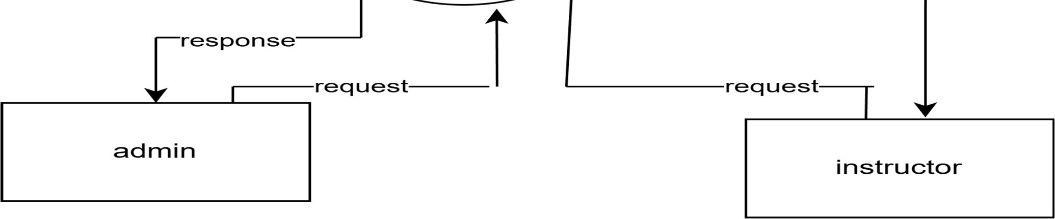
Figure 3.1: DFD Level 0

3.1.2 DFD Level 1
The DFD Level 1 of the Online Course Enrollment System breaks the main system into detailed sub-processes for each user type—Student, Instructor, and Admin. For Students, the Level 1 diagram shows processes such as registration, login, browsing courses, enrolling, viewing assignments, submitting work, and checking grades. Each of these processes interacts with relevant data stores like Students, Courses, Enrollments, Assignments, and Submissions.For Instructors and Admins, the Level 1 diagram shows how instructors manage courses, upload assignments, and evaluate submissions, while admins oversee user accounts, courses, and system reports. All these processes exchange data with the database tables to ensure proper flow of information across the system. This level of the DFD gives a clear view of how the entire system functions internally.

Figure 3.2: DFD Level 1

3.2 Use Case Diagram
The Use Case Diagram for the Online Course Enrollment System shows how different users—Admin,Instructor, and Student—interact with the platform. Students are able to register, log in, enroll in courses, view course details, submit assignments, check grades, and download certificates. Instructors can create and manage courses, upload assignments, view student submissions, grade assignments, and approve certificates. Admins manage the system by handling user accounts, monitoring course activity, and maintaining platform data for smooth operation. Each user type has specific actions linked to their role, ensuring secure and structured interaction within the system. The diagram clearly represents how users navigate through major functions such as enrollment, assignment submission, grading, and certification. It highlights the flow of operations within the system and helps visualize how all three actors work through the platform to complete their tasks.

3.2.1 Admin Use Case Diagram
The Admin is responsible for managing and supervising the overall Online Course Enrollment System. The Admin’s use cases include adding, updating, and deleting user accounts for both students and instructors. They also oversee course data by managing course information and ensuring that all modules function correctly. Additionally, the Admin monitors system activity, handles reports or issues submitted by users, and ensures that data remains secure and consistent. Through these actions, the Admin maintains platform stability and controls access permissions for all users.
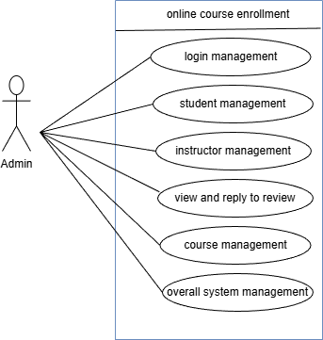
Figure 3.3: Admin use case Diagram
3.2.2 Instructor Use Case Diagram
The instructor interacts with the system primarily to manage teaching-related tasks. Their use cases include creating new courses, updating course details, uploading assignments, and viewing submissions from enrolled students. Instructors can also provide grades and feedback for each submission, helping guide student progress. They have the ability to approve certificate requests once a student completes all requirements. These use cases support instructors in delivering course content effectively and maintaining smooth academic workflow.

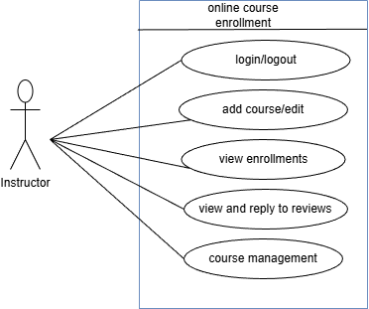
Figure 3.4: Instructors Use Case Diagram

3.2.3 Student Use Case Diagram
The Student is the main user of the system and has multiple learning-related interactions. The student can register an account, log in, enroll in available courses, and view course materials assigned by instructors. They can download assignments, submit their completed work, and later view .
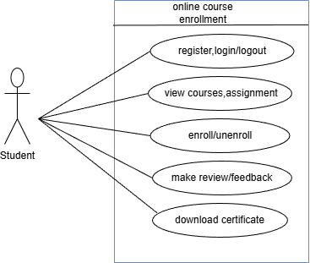
Figure 3.5: students use case diagram
3.3 TABLE DESIGN
3.3.1 Students Table
The students' table stores student registration and login information, including name, email, password, and account status. It helps manage authentication and track each student’s activities across courses.

Field | Data Type | Constraints | Description
id | Int (11) | Primary key,auto_increment,not null | Student id
name | Varchar (150) | Not null | Student name
email | Varchar (150) | Not null | Student email
password | Varchar (255) | Not null | Encrypted student password
created_at | timestamp | Default current_ timestamp | Registration time
status | Varchar (20) | DEFAULT 'active’ | Student account status
Table 3.1: student table
3.3.2 Instructors Table
The instructors table contains data for course instructors such as name, email, password, status, and created date. It is used to manage instructor login and link them to the courses they create.

Field | Data Type | Constraints | Description
id | Int (11) | Primary key,auto_increment,not null | Instructor id
name | Varchar (150) | Not null | Instructor name
email | Varchar (150) | Not null | Instructor email
password | Varchar (255) | Not null | Encrypted password
created_at | timestamp | Default current_timestamp | Account creation date
status | Varchar (20) | DEFAULT 'active’ | Instructor status
Table 3.2: instructors table
3.3.3 Admins Table
The admins table stores administrative user details including username, email, password, and created timestamp. It provides access control for managing system-wide operations and reviewing student feedback.

Field | Data Type | Constraints | Description
id | Int (11) | Primary key,auto_increment,not nul | Unique admin id
username | Varchar (100) | Null allowed | Admin username
email | Varchar (150) | Not null | Admin email address
password | Varchar (255) | Not null | Encrypted admin password
created_at | timestamp | Default current_timestamp | Account creation time
Table 3.3: admin table
3.3.4 Courses Table
The Courses table holds complete information about each course, such as instructor ID, title, description, duration, content, image, and status. It forms the core of the system, enabling enrollment, assignments, and progress tracking.

Field | Data Type | Constraints | Description
id | Int (11) | Primary key,auto_increment,not null | Course id
Instructor_id | Int (11) | Foreign key,not null | Instructor who created course
title | Varchar (200) | Not null | Course title
description | text | Null allowed | Course overview
duration | Varchar (100) | Not null | Course duration
content | text | Null allowed | Course content/lessons
image | Varchar (255) | Null allowed | Course image/thumbnail
created_at | timestamp | Default current_timestamp | Creation timestamp
status | Varchar (10) | DEFAULT 'active’ | Course availability
Table 3.4: courses table
3.3.5 Enrollments Table
The Enrollments table records which student is registered for which course. It includes student ID, course ID, and timestamp of enrollment, enabling course access and monitoring participation.

Field | Data Type | Constraints | Description
id | Int (11) | Primary key,auto_increment,not null | Enrollment id
Student_id | Int (11) | Foreign key,not null | Student enrolled
Course_id | Int (11) | Foriegn key,not null | Course enrolled into
Enrolled_at | timestamp | Default current_timestamp | Enrolled time/date
Table 3.5 :enrollments table

3.3.6 Reviews Table
The Reviews table stores student reviews about courses along with optional instructor and admin replies. It includes student ID, course ID, review text, reply, and create timestamp, supporting feedback and communication.

Field | Data type | Constraints | Description
id | Int (11) | Primary key,auto_increment,not null | Unique review id
Student_id | Int (11) | Foreign key,not null | Student who wrote the review
Course_id | Int (11) | Foreign key,not null | Course being reviewed
review | text | Not null | Review comment submitted by student
reply | text | Null allowed | Instructors reply to student review
Admin_reply | text | Null allowed | Admin's response if needed
Admin_id | Int (11) | Foreign key,null allowed | Admin who replied
Instructor_id | Int (11) | Foreign key,null allowed | Instructor who replied
created_at | timestamp | Default current_timestamp | Review submision time
Table 3.6 :reviews table
3.3.7 Assignments Table
The Assignments table holds assignment details uploaded by instructors, such as course ID, title, description, file path, and deadline. It allows students to receive and complete coursework for each course.

Field | Data type | Constraints | Description
id | Int (11) | Primary key,auto_increment,not null | Assignment id
course_id | Int (11) | Foreign key,not null | Course to which assignment belongs
title | Varchar (255) | Not null | Assignment title
description | text | Null allowed | Assignment details
file_path | Varchar (255) | Null allowed | File uploaded for assignment
deadline | date | Null allowed | Last submission date
Table 3.7: assignments table
3.3.8 Submissions Table
The Submissions table stores assignment submissions from students, including assignment ID, student ID, submitted file, timestamp, grade, and instructor feedback. It enables evaluation and grading.

Field | Data type | Constraints | Description
id | Int (1!) | Primary key,auto_increment,not null | Submission id
assignment_id | Int (11) | Foreign key,not null | Assignment that submitted
student_id | Int (11) | Foreign key,not null | Student submitting
file_path | Varchar (255) | Not null | Submitted file path
submitted_at | timestamp | Default current_timestamp | Submission time
grade | Varchar (100) | Null allowed | Marks/grade give
feedback | text | Null allowed | Instructor feedbacxk
Table 3.8: submissions table
3.3.9 Certificate Requests Table
The Certificate Requests table tracks student applications for course completion certificates. It stores student ID, course ID, status, requested date, instructor ID, and approval date for managing workflow.

Field | Data type | Constraints | Description
id | Int (11) | Primary key,auto_increment,not null | Request id
student_id | Int (11) | Foreign key,not null | Requesting student
course_id | Int (11) | Foreign key,not null | Course for certificate
status | Enum(“pending”,”approved”,”rejected”) | Default pending | Request status
Requested_at | timestamp | Default current_timestamp | Time of request
Instructor_id | Int (11) | Foreign key,null allowed | Instructor handling request
Approved_at | timestamp | Null allowed | Approval time
Table 3.9 :certificate_requests table
3.3.10 Certificates Table
The Certificates table stores final generated certificates for students after approval. It includes student ID, course ID, certificate file path, and generated timestamp for record keeping.

Field | Data type | Constraints | Description
id | Int (11) | Primary  key,auto_increment,not | Certificate id
 |  | null
student_id | Int (11) | Foreign key,not null | Student who recieved certificate
course_id | Int (11) | Foreign key,not null | Course completed
certificate_file | Varchar (255) | Not null | File path of generated certificate
generated_at | timestamp | Default current_timestamp | Certificate generation time
Table 3.10 :certificates table
3.3.11 Course Progress Table
The Course Progress table tracks how much of each course a student has completed. It includes student ID, course ID, progress percentage, and last updated timestamp to visually show learning progress.

Field | Data type | Constraints | Description
id | Int (11) | Primary key,auto_increment,not null | Progress id
student_id | Int (11) | Foreign key,not null | Student id
course_id | Int (11) | Foreign key,not null | Course id
progress | Int (11) | Default 0 | Course completion percentage
last_updated | timestamp | Default current_timestamp on update  current_timestamp | Last update date
Table3.11: course_progress table

3.4 PERFORMANCE REQUIREMENTS

The performance requirements of the Online Course Enrollment System define how efficiently and reliably the system should operate to meet user expectations. The system must provide fast response times so that actions such as user registration, login, course browsing, enrollment, assignment submission, and viewing results are processed and displayed within a few seconds.
The system should support multiple concurrent users, including students, instructors, and administrators, without performance degradation. Even during peak usage periods such as course enrollment deadlines or assignment submission times, the system must function smoothly.
Database operations such as retrieving course details, enrollment records, assignments, and submissions must be optimized to ensure real-time access to information. The system should maintain high availability with minimal downtime so that critical features like course enrollment, assignment submission, and result viewing are always accessible. Overall, the Online Course Enrollment System must be scalable, reliable, and capable of delivering consistent performance under varying workloads.

3.5 SOFTWARE QUALITY ATTRIBUTES

The Online Course Enrollment System is designed to achieve high software quality by focusing on key attributes such as reliability, usability, performance, scalability, maintainability, and security.
Reliability is ensured through accurate handling of user data, correct course enrollment processing, dependable assignment submission, and consistent result management. Usability is emphasized by providing a simple, intuitive, and responsive user interface that allows students, instructors, and administrators to navigate the system easily.
Performance is achieved through optimized database queries, efficient session handling, and quick system response times. Scalability allows the system to accommodate an increasing number of users, courses, and assignments as the institution grows. Maintainability is ensured through modular system design, clean code structure, and proper documentation, enabling easy updates and debugging.
Security is a critical attribute, ensuring protection of sensitive data such as user credentials, course records, and submission files through authentication mechanisms, session management, and controlled access. These quality attributes ensure that the Online Course Enrollment System is robust, secure, and user-friendly.

3.6 DETAILED DESIGN

The detailed design of the Online Course Enrollment System describes the internal structure and implementation of its modules, including user management, course management, enrollment handling, assignment submission, and administration. It defines the database schema, data flow between modules, and interaction between frontend and backend components to ensure secure and efficient system operation.

System Architecture

The system follows a three-tier architecture consisting of the presentation layer, application logic layer, and database layer. The presentation layer provides user interfaces for students, instructors, and administrators. The application layer handles business logic such as authentication, enrollment processing, and assignment management. The database layer stores user details, course information, enrollment records, assignments, and submissions securely.

3.6.1 User Registration and Login

Users can register as students or instructors and log in using valid credentials. The presentation layer collects user input and forwards it to the application layer for validation. The application layer verifies credentials against the database and establishes a secure session. Once authenticated, users gain access to features based on their roles.

3.6.2 Course Management

Administrators and instructors can add, update, or remove courses. Course details such as title, description, duration, and instructor information are stored in the database. Students can view available courses and enroll based on their preferences.

3.6.3 Course Enrollment

Students can enroll in available courses through the system. The application layer validates enrollment requests and updates enrollment records in the database. Enrolled courses are displayed on the student dashboard for easy access.

3.6.4 Assignment Submission and Evaluation

Instructors can create assignments for courses, and students can upload their submissions before the deadline. Submitted assignments are stored securely, and instructors can view, grade, and provide feedback through the system. Students can later view their grades and feedback.

3.6.5 Logout and Session Management

When users log out, the system securely terminates the session to prevent unauthorized access. Proper session handling ensures data security and maintains user privacy.

3.7 SAMPLING METHODS

The Online Course Enrollment System uses purposive sampling to collect feedback from users actively involved in online learning environments, such as students and instructors. This ensures meaningful evaluation of system usability and performance.

3.7.1 Random Sampling
Random sampling is used to collect unbiased feedback from users, ensuring that every user has an equal chance of selection. This helps evaluate system features such as course enrollment and assignment submission objectively.

3.7.2 Stratified Sampling

sampling divides users into groups such as students, in Stratified structors, and administrators to ensure balanced feedback from all user roles.

3.7.3 Cluster Sampling

Cluster sampling groups users based on departments or academic programs. Entire clusters are selected to test the system, ensuring diverse usage scenarios.

3.7.4 Convenience Sampling

Convenience sampling collects feedback from easily accessible users such as classmates or colleagues, allowing quick evaluation of usability and functionality.

3.7.5 Systematic Sampling
Systematic sampling selects users at fixed intervals, such as every fifth registered user, ensuring evenly distributed and unbiased data collection.

3.8 TEST CASES

3.8.1 Test Case for User
Category | Test Case | Description | Expected Result
User Registration | TC-01 | User enters valid details and registers successfully. | Accounts should be created and stored in the database.
User Registration | TC-02 | User enters mismatched passwords or empty fields. | Systems should show an error message and prevent submission.
Login | TC-03 | Login with correct email and password. | Users should be redirected to the Student Dashboard.
Login | TC-04 | Login with incorrect credentials. | System should show “Invalid email or password”.

Course Enrollment | TC-05 | Student selects a course and clicks Enroll. | Enrollment should be recorded in the Enrollments table.
Course Enrollment | TC-06 | Students try to enroll again in the same course. | Systems should prevent duplicate enrollment.
Assignment  Submission | TC-07 | Student uploads assignments before the deadline. | Submissions should appear in the Submissions table and status changes to “Submitted”.
Assignment  Submission | TC-08 | Students try to upload after the deadline. | System should block submission or show “Deadline passed”.
Certificate  Generation | TC-09 | Student completes courses and requests certificate. | Certificates should be generated and stored in the Certificates table.
Admin Login | TC-10 | Admin logs in with valid credentials. | Admin Dashboard should load with admin privileges.
Instructor Actions | TC-11 | The instructor uploads an assignment for a course. | Assignments should appear on the student assignment list.
Instructor Actions | TC-12 | The instructor grades a submitted assignment. | Grade and feedback should be updated in the Submissions table.

CHAPTER 4
IMPLEMENTATION AND RESULTS

4.1 IMPLEMENTATION
The implementation phase of the Online Course Enrollment System focuses on transforming the designed architecture into fully functional modules for Students, Instructors, and Admin. The system is developed using PHP for backend processing, MySQL for database management, and HTML, CSS, and JavaScript for the frontend interface. Each module—user authentication, course management, assignment submission, enrollment, and grading—is built individually and later integrated to ensure smooth data flow and a user-friendly experience across the platform.

4.1.1Backend Development
Backend is implemented using PHP to handle all core system operations, including login authentication, session handling, course creation, enrollment management, assignment uploads, submission validation, and grading. PHP scripts interact directly with the MySQL database to store and retrieve data accurately across modules such as Students, Instructors, Courses, Assignments, and Enrollments. Security features such as password hashing, input sanitization, and restricted access based on user roles (Admin, Instructor, Student) are implemented to protect system resources. Additionally, error-handling mechanisms ensure the system responds safely to invalid inputs, missing fields, or unauthorized access attempts.

4.1.2Frontend Development
The frontend is developed using HTML, CSS, and JavaScript to create a responsive and intuitive interface for users. Students can easily browse courses, check assignment deadlines, and submit work, while instructors can manage course content and evaluate student submissions. The Admin interface presents clear control options for managing users and course records. The layouts are organized to provide simple navigation, readable content areas, and interactive user controls. JavaScript is used for form validation, dynamic content updates, and improving user experience through alerts and instant feedback.

4.1.3 Integration and Testing
All modules—Student Portal, Instructor Panel, and Admin Dashboard—are integrated to work as a unified system. PHP backend scripts are connected with the MySQL tables to ensure that operations like login verification, enrollment updates, assignment submissions, and grading are synchronized. Integration ensures that when a student enrolls in a course, it reflects instantly in both the Enrollment table and the Instructor’s course view. Similarly, assignment uploads become available to students, and submissions become visible for grading.
After integration, multiple testing levels are performed:
- Functional Testing: Ensures core operations such as course enrollment, login, assignment upload, and grading work without errors.
- Interface Testing: Verifies that pages load correctly, buttons function properly, and forms display error messages when required.
- Database Testing: Confirms accurate CRUD operations in tables like students, courses, assignments, enrollments, and submissions.
- Performance Testing: Measures page load time, form submission speed, and stability of the system under multiple requests.
- Security Testing: Validates password hashing, session protection, restricted access, and prevention of SQL attacks.
- Compatibility Testing: Ensures consistent performance across different browsers, devices, and screen sizes.
Errors discovered during testing—such as invalid file formats, login failures, or missing fields—were fixed through iterative debugging. After corrections, regression testing ensured that new changes did not affect existing functionalities. This resulted in a stable, well-integrated system ready for deployment.

4.2 IMPLEMENTATION RESULTS
The system implementation yielded a fully operational Online Course Enrollment platform where all key modules function efficiently and accurately. Student features such as registration, login, course enrollment, assignment submission, and grade viewing performed seamlessly, confirming proper data flow between the interface, backend logic, and database. Instructor operations—including course creation, assignment uploads, submission review, and grading—worked consistently and reflected real-time updates in the system.
Admin functionalities like managing students, instructors, and courses also executed smoothly, ensuring complete control over the system's database records and activity logs.
Throughout testing, the system demonstrated fast response times, stable session handling, and secure access control. Input validation mechanisms minimized user errors, and encrypted passwords ensured safe authentication. The database handled all operations—including enrollment records, assignment submissions, and grade updates—without conflicts or data loss. Overall, the implementation results clearly show that the system is reliable, efficient, user-friendly, and fully capable of supporting real-world online course management operations.

CHAPTER 5
CONCLUSION AND FUTURE WORKS

5.1 CONCLUSION
- The developed Online Course Enrollment System successfully achieves its objective of delivering a secure, efficient, and user-friendly platform for managing academic activities among Students, Instructors, and Admin. The system provides an end-to-end solution covering essential functions such as user authentication, course management, enrollment handling, assignment submission, grading, and certificate generation.
- Through the integration of PHP, MySQL, HTML, CSS, and JavaScript, the system ensures smooth interaction between the frontend interface and backend logic, resulting in accurate data processing and consistent performance. Students can conveniently enroll in courses, view assignments, submit work, and track grades, while instructors can upload assignments, evaluate submissions, and manage their courses. The admin can efficiently handle user accounts, course records, and platform configuration.
- Extensive testing—including functional, database, interface, performance, and security testing—
confirmed the reliability, stability, and correctness of the system. All modules worked cohesively, and the system demonstrated responsive behavior and proper data handling under different scenarios. Overall, the Online Course Enrollment System provides a robust foundation for digital academic management and is ready for deployment in real educational environments.

5.2 FUTURE WORKS
- The system can be further improved by integrating advanced features and expanding functionalities to enhance usability, security, and efficiency. Future enhancements may include more automation, advanced analytics, better communication tools, and improved user engagement. Incorporating modern technologies will make the system more scalable and adaptable to larger institutions or online learning environments.
- Possible future improvements include strengthening security, simplifying instructor–student interactions, providing deeper reporting features, and enhancing accessibility across devices. Additionally, expanding the system to support real-time notifications, video-based learning, and automated certificate generation will significantly improve overall effectiveness.

5.2.1 Future Implementation Plan
- Integrate Learning Analytics:
Add dashboards for tracking student progress, assignment performance trends, and course completion statistics.
- Implement Real-Time Notifications:
Provide instant alerts for new assignments, deadlines, enrollment updates, grades, and announcements via email/SMS.
- Add Online Assessment Tools:
Introduce MCQ tests, quizzes, and auto-grading features for faster evaluation.
- Enable Cloud Storage Integration:
Store assignments, course materials, and submissions securely using cloud services for better scalability.
- Introduce Discussion Forums / Chat:
Create communication features to allow students to interact with instructors and classmates.
- Improve Security Measures:
Add features such as two-factor authentication, stronger password hashing, and secure file upload scanning.
- Enhance User Interface:
Redesign the UI for more modern, responsive, and mobile-friendly layouts to improve accessibility.
- Implement Certificate Automation:
Automatically generate and verify certificates once students complete course requirements.
- Add Instructor Performance Analytics:
Provide insights on student engagement, submission punctuality,
and grading.

REFERENCES

Journal Articles
Kumar, S., & Bhatia, P. (2022). Web-Based Academic Portals for Course Management and Online Enrollment Systems. International Journal of Computer Applications, 44(2), 101–110.
Rao, M., & Verma, A. (2021). Secure Authentication Mechanisms for PHP–MySQL Web Applications. Journal of Information Security and Digital Technologies, 19(3), 76–84.
Thomas, R., & Mathew, J. (2020). Online Assignment Submission and Evaluation Platforms Using Web Technologies. International Journal of Software Engineering Research, 12(4), 59–70.
Sharma, K., & Iqbal, S. (2023). E-Learning System Architecture and User Interaction Models. Journal of Educational Technology Systems, 31(1), 45–62.
Banerjee, A., & Nair, R. (2021). Database-Driven Web Applications for Student and Course Management. International Journal of Information Technology Innovations, 10(1), 134–148.

Textbooks
Sommerville, I. (2021). Software Engineering (11th Edition). Pearson.
Pressman, R. S., & Maxim, B. R. (2020). Software Engineering: A Practitioner’s Approach (9th Edition). McGraw-Hill Education.
Elmasri, R., & Navathe, S. B. (2016). Fundamentals of Database Systems (7th Edition). Pearson.
Tanenbaum, A. S., & Bos, H. (2015). Modern Operating Systems (4th Edition). Pearson.
Stallings, W. (2018). Computer Security: Principles and Practice (4th Edition). Pearson.

Web Sources
W3Schools. (2025). PHP Tutorial. Retrieved from https://www.w3schools.com/php/
W3Schools. (2025). MySQL Tutorial. Retrieved from https://www.w3schools.com/mysql/
Mozilla Developer Network (MDN). (2025). JavaScript Guide. Retrieved from https://developer.mozilla.org/en-US/docs/Web/JavaScript/Guide
Stack Overflow. (2025). PHP, MySQL, and Web Development Discussions. Retrieved from https://stackoverflow.com/
TutorialsPoint. (2025). HTML, CSS, JavaScript Tutorials. Retrieved from https://www.tutorialspoint.com/
GeeksforGeeks. (2025). Web Development with PHP & MySQL. Retrieved from https://www.geeksforgeeks.org/

Policy Documents
General Data Protection Regulation (GDPR). (2018). Regulation (EU) 2016/679 on data protection and privacy.
Retrieved from https://gdpr-info.eu/
Information Technology Act, India. (2000). The Information Technology Act, 2000. Ministry of Electronics &
Information Technology (MeitY). Retrieved from https://www.meity.gov.in/content/information-technology-act
National Institute of Standards and Technology (NIST). (2018). Framework for Improving Critical
Infrastructure Cybersecurity. Retrieved from https://www.nist.gov/cyberframework
Government Reports
Ministry of Electronics and Information Technology (MeitY), Government of India. (2023). Annual Report
2022–23. Retrieved from https://www.meity.gov.in
University Grants Commission (UGC), Government of India. (2022). Guidelines for Online and Open Distance
Learning (ODL) Systems. Retrieved from https://www.ugc.gov.in
All India Council for Technical Education (AICTE). (2021). Handbook for Implementation of Online Education and Digital Learning Systems. Retrieved from https://www.aicte-india.org
Department of Higher Education, Government of India. (2020). Digital Initiatives for E-Learning and Academic
Management. Retrieved from https://www.education.gov.in
Conference Proceedings
Thomas, J., & George, L. (2021). Web-Based Course Enrollment and Assignment Submission Framework Using PHP–MySQL.
Proceedings of the International Conference on Web Technologies and Information Systems (ICWTIS), 78–86.
Rao, P., & Menon, A. (2020). Secure User Authentication in Academic Portals Using PHP.
Proceedings of the International Conference on Cybersecurity and Web Engineering, 55–63.

Dissertations
Li, H. (2020). Design and Development of Online Learning and Assignment Management Platforms (PhD dissertation).
Massachusetts Institute of Technology, Cambridge, MA.
Kannan, R. (2022). A Study on Web-Based Educational Portals Using PHP and Relational Databases (Master’s thesis).
Indian Institute of Technology (IIT), Madras, India.

Industry Reports
Statista Research Department. (2022). Global E-Learning and Online Education Market Size and Forecast.
Retrieved from https://www.statista.com
Deloitte Insights. (2023). Technology Trends in Higher Education and Digital Platforms. Deloitte Development LLC.
McKinsey & Company. (2022). The Growth of Online Learning Systems and Digital Student Services. McKinsey Global Institute.

Online Articles
Brown, L. (2022). The Rise of Web-Based Learning Platforms for Universities and Colleges. TechCrunch. Retrieved from https://techcrunch.com
Singh, M. (2023). Why PHP–MySQL Is Still Popular for Academic Portal Development. GeeksforGeeks. Retrieved from https://www.geeksforgeeks.org
Davidson, R. (2022). How Digital Platforms Are Transforming Course Enrollment. EdTech Magazine.
Retrieved from https://edtechmagazine.com

Research Papers
Patel, S., & Mehta, P. (2021). Database-Driven Academic Portals for Student and Course Management. Journal of Advanced Computing Research, 18(2), 89–98.
Kumar, A., & Joseph, D. (2020). Automation of Enrollment and Assignment Systems in Higher Education. International Journal of Computer Science and Engineering, 14(4), 233–240.
Rani, S., & Das, P. (2022). Role of Web Technologies in Developing Online Course Management Systems. International Journal of Emerging Technologies in Learning, 17(3), 112–118.

White Papers
IBM Corporation. (2020). AI-Powered Digital Solutions for Scalable Web Platforms. IBM White Paper. Retrieved from the Ministry of Electronics and IT Portal.

Blogs
GeeksforGeeks. (2023). Building a Secure Student Management System Using PHP & MySQL. GeeksforGeeks. Retrieved from https://www.geeksforgeeks.org

Government Websites
Ministry of Electronics and Information Technology, India. (2023). Annual Report 2022–23: Digital Platforms, E-Governance Initiatives & Online User Systems. Government of India. Retrieved from https://www.meity.gov.in

Academic Papers
Banerjee, A., & Roy, S. (2021). Online Learning Platforms and Their Impact on Student Engagement: A WebBased System Approach. International Journal of Information Technology Innovations, 9(3), 142–150.

Theses / Dissertations
Li, H. (2020). Automated User Recommendation and Management Systems for Web Applications. PhD Dissertation, Massachusetts Institute of Technology.

Online Databases
IEEE Xplore Digital Library. (2025). Research on Web-Based Course Management Systems and PHPMySQL Technologies. Retrieved from https://ieeexplore.ieee.org

APPENDIXES

Appendix -A Screenshots



Figure A.1 Home Page


Figure A.2 student Register Page
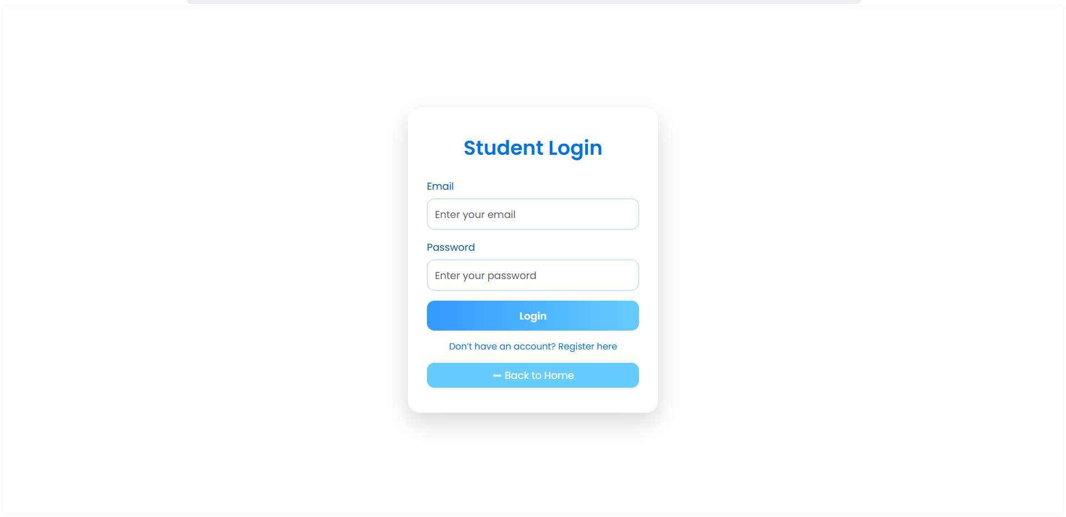
Figure A.3 students login page

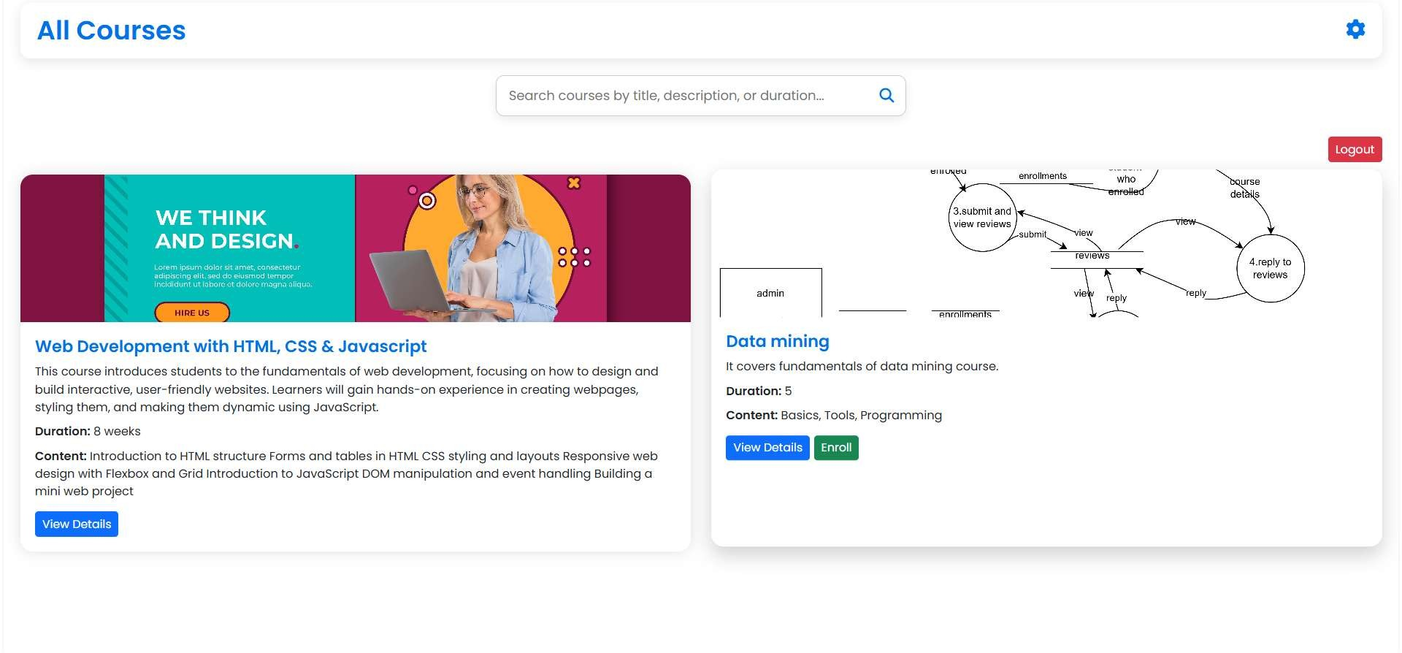

Figure A.4: Student dashboard

Figure A.5: Course details page

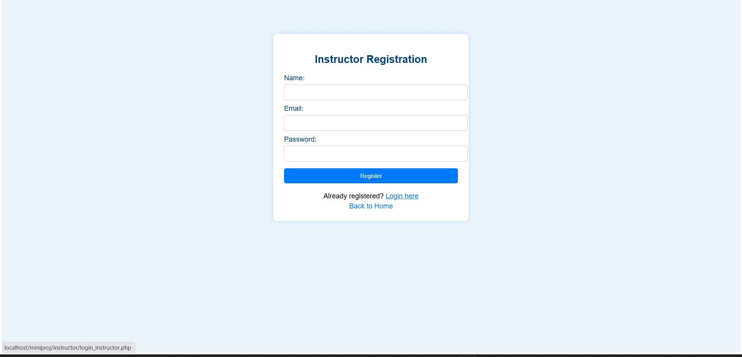
Figure A.6 instructor register page

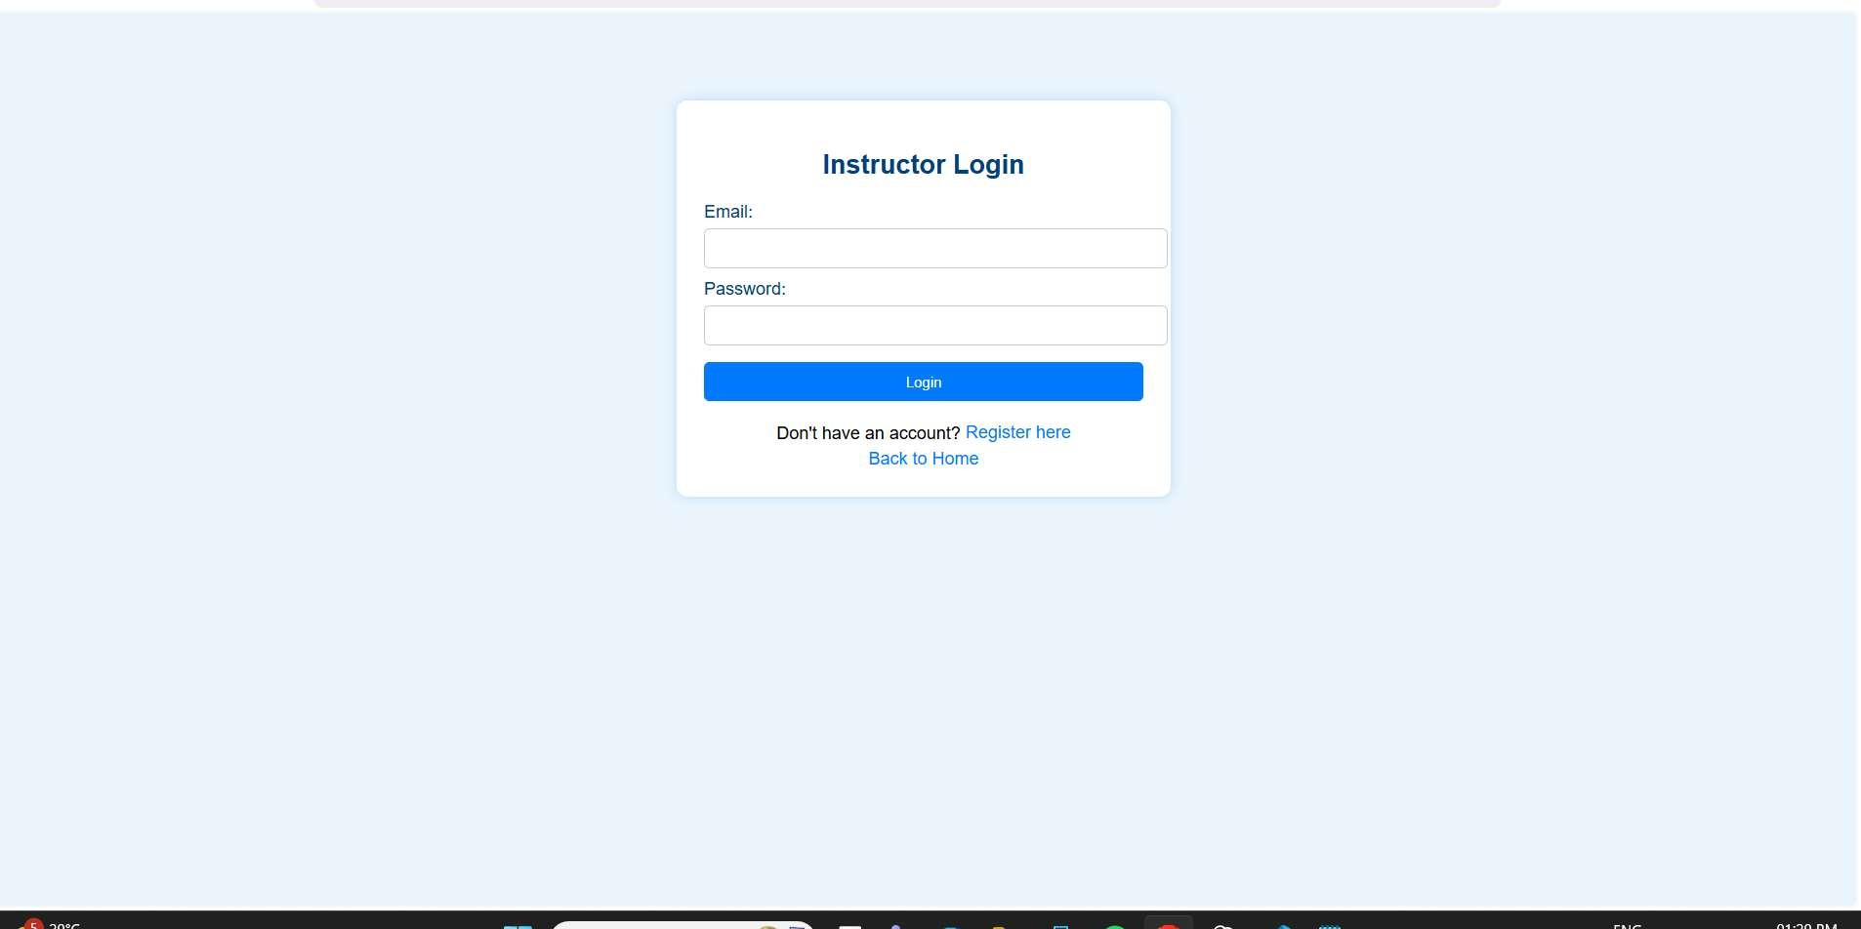

Figure A.7: instructor login page

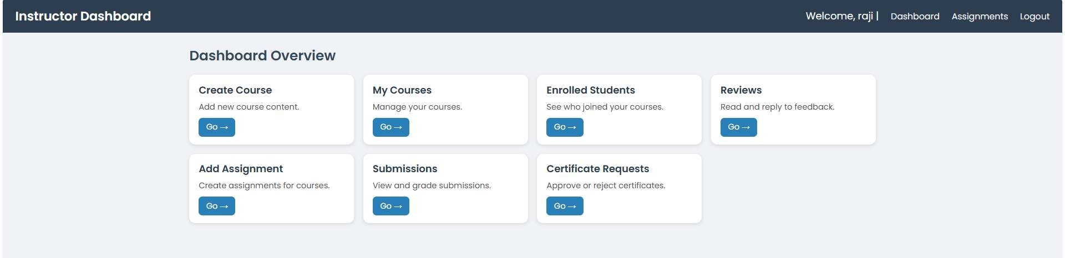
Figure A.8 instructor dashboard
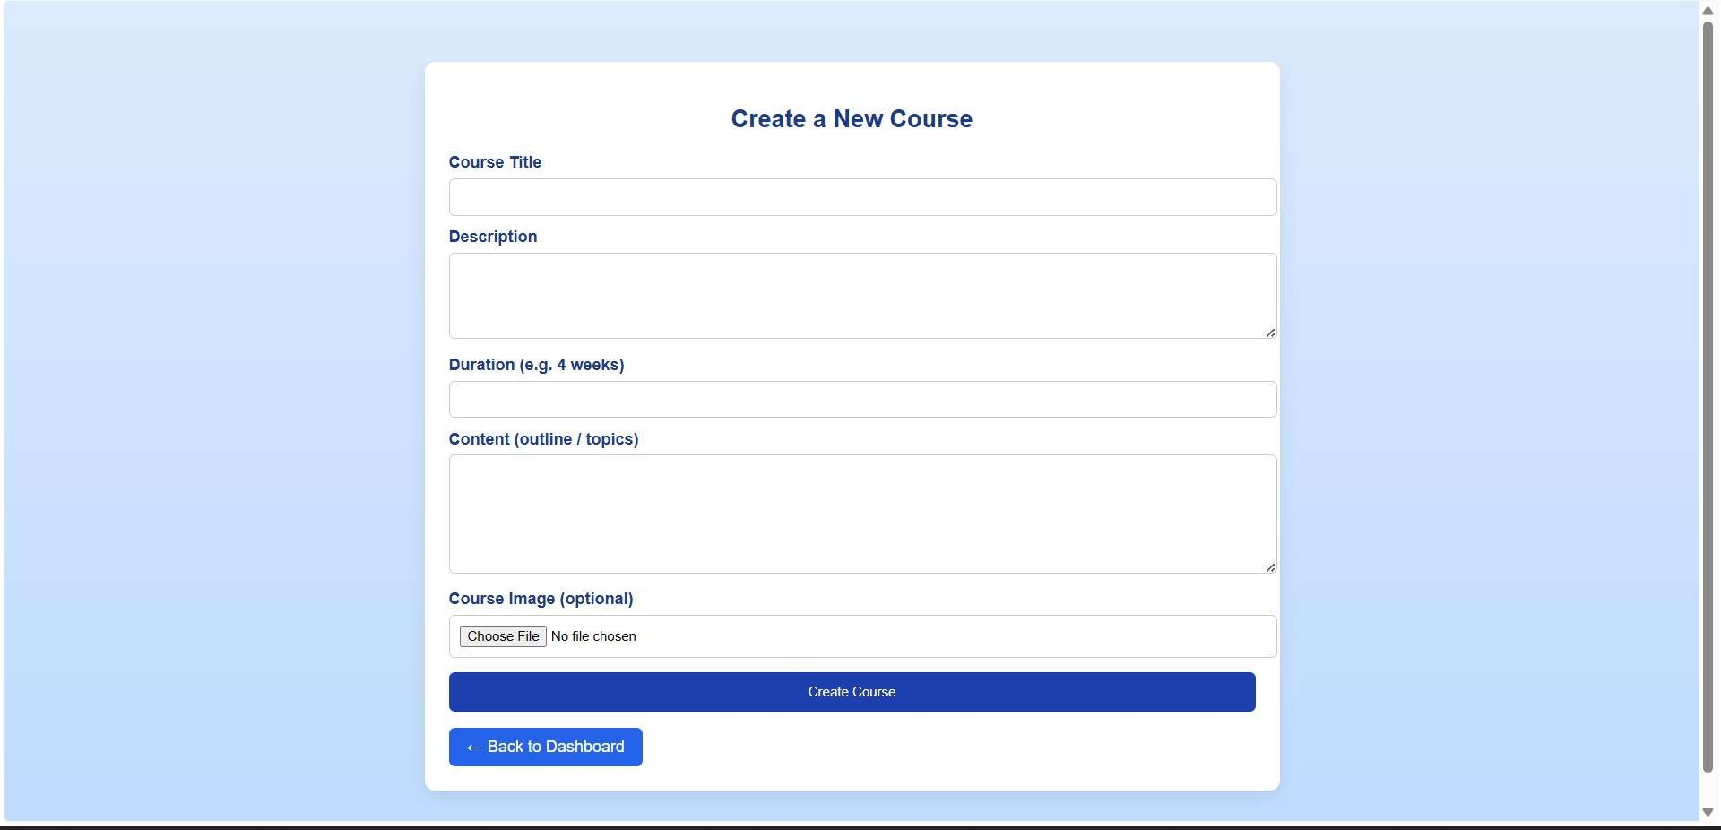
Figure A.9: course creation page

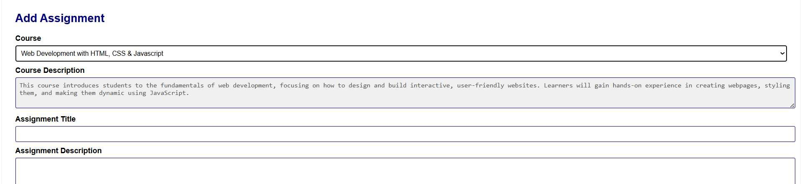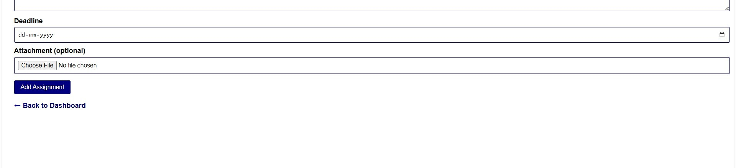
Figure A.10 assignment add

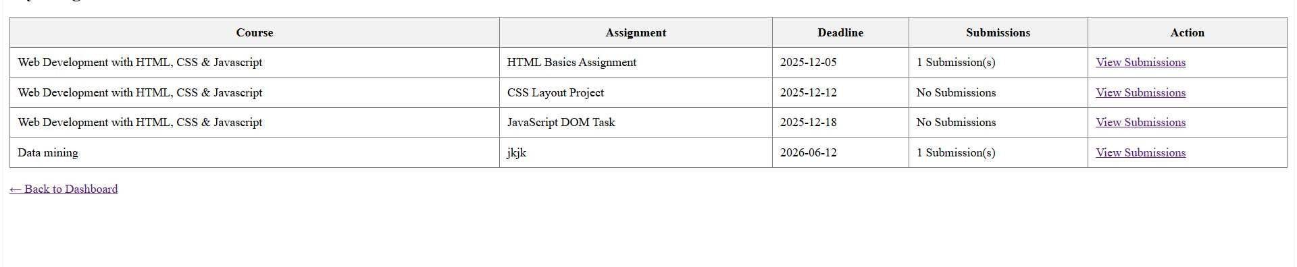
Figure A.11submissions

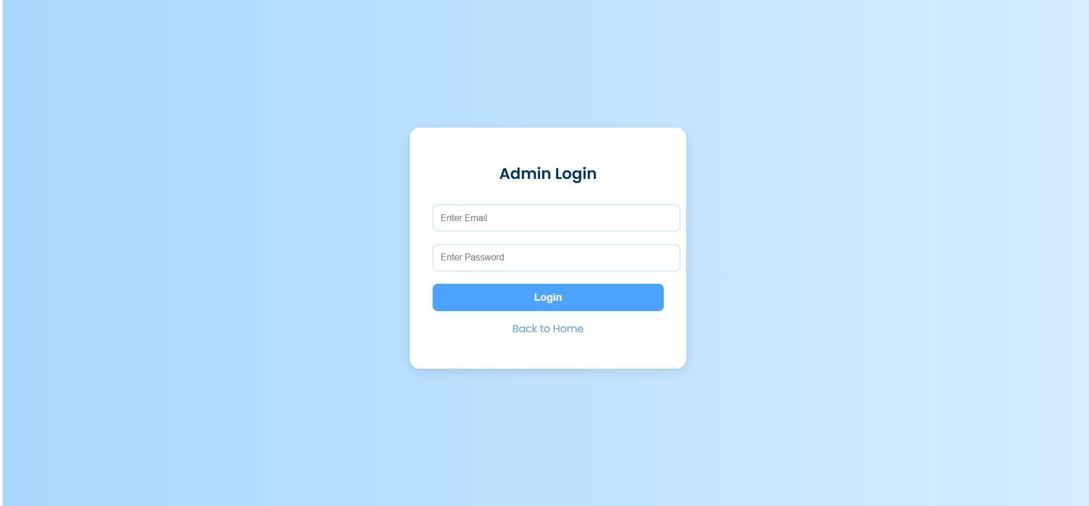
Figure A.12 Admin Login page

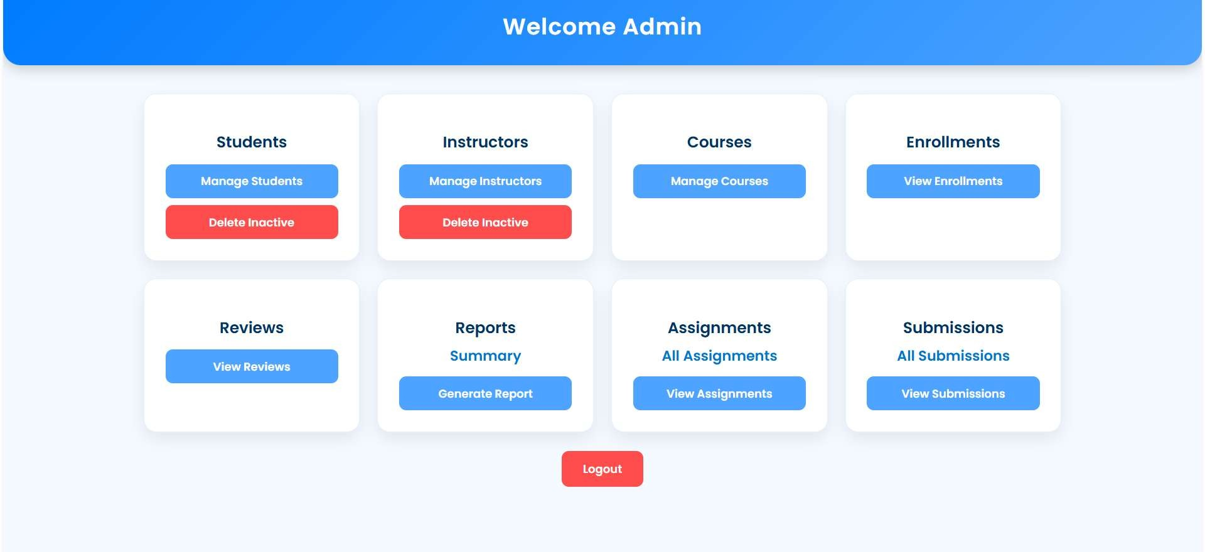

Figure A.13 Admin Dashboard

Appendix-B Sample Code
Register page:
Frontend:
<!DOCTYPE html>
<html lang="en">
<head>
<meta charset="UTF-8">
<title>Student Registration</title>
<link
href="https://cdn.jsdelivr.net/npm/bootstrap@5.3.3/dist/css/bootstrap.min.css" rel="stylesheet"> <style>
body { font-family: 'Poppins', sans-serif; background: lineargradient(...) }
.card { border-radius: 20px; background: rgba(255,255,255,0.85); ... } .card-header { background: linear-gradient(...); color: white; text-align:
center; ... }
.btn-primary { background: linear-gradient(...); }
.btn-secondary { ... }
</style>
</head>
<body>
<div class="card">
<div class="card-header">Student Registration</div>
<div class="card-body">
<form method="POST" action="">
<input type="text" name="name" placeholder="Enter your full name" required>
<input type="email" name="email" placeholder="Enter your email address" required>
<input type="password" name="password" placeholder="Create a strong password" required>
<button type="submit" name="register">Register</button>
<a href="login.student.php">Already Registered? Login</a>
</form>
</div>
</div>
</body>
</html>

Backend:
<?php include '../database.php';

if(isset($_POST['register'])) {
$name = mysqli_real_escape_string($conn, $_POST['name']);
$email = mysqli_real_escape_string($conn, $_POST['email']);
$password = md5($_POST['password']);

$check = "SELECT * FROM students WHERE email='$email'";
$result = mysqli_query($conn, $check);

if(mysqli_num_rows($result) > 0) { echo "Email already registered!";
} else {
$insert = "INSERT INTO students (name,email,password) VALUES
('$name','$email','$password')"; if(mysqli_query($conn,$insert)){ echo "Registration successful!";
} else {
echo "Error: ".mysqli_error($conn);
}
}
}
?>

Student dashboard

<?php
session_start();
include '../database.php';

if (!isset($_SESSION['student_id'])) {
header("Location: login_student.php"); exit;
}

$student_id = $_SESSION['student_id'];
?>

<!DOCTYPE html>
<html lang="en">
<head>
<meta charset="UTF-8">
<meta name="viewport" content="width=device-width, initial-scale=1.0"> <title>All Courses</title>

<!-- Bootstrap 5 -->
<link href="https://cdn.jsdelivr.net/npm/bootstrap@5.3.3/dist/css/bootstrap.min.css" rel="stylesheet">

<!-- Google Fonts -->
<link href="https://fonts.googleapis.com/css2?family=Poppins:wght@400;600&display=swap" rel="stylesheet">

<!-- Font Awesome -->
<link rel="stylesheet" href="https://cdnjs.cloudflare.com/ajax/libs/fontawesome/6.5.0/css/all.min.css">

<style> body {
font-family: 'Poppins', sans-serif; background: linear-gradient(rgba(255,255,255,0.9), rgba(255,255,255,0.9)), url('https://images.unsplash.com/photo-1523050854058-
8df90110c9f1?auto=format&fit=crop&w=2000&q=80')
no-repeat center center/cover; margin: 0;
padding: 20px;
}

.top-bar { display: flex; justify-content: space-between; align-items: center; padding: 15px 20px; background: #fff; border-radius: 12px;
box-shadow: 0 4px 15px rgba(0,0,0,0.1); margin-bottom: 20px;
}

.top-bar h2 { margin: 0; font-weight: 600;
color: #0073e6;
}

.settings-btn i { font-size: 24px; color: #0073e6; cursor: pointer;
}

.settings-btn i:hover {
color: #005bb5;
}

.card-grid { display: grid; grid-template-columns: repeat(auto-fit, minmax(280px, 1fr)); gap: 25px;
}

.course-card {
border-radius: 15px; overflow: hidden; box-shadow: 0 0 18px rgba(0,0,0,0.12);
transition: all 0.3s;
background: #fff;
}

.course-card:hover { transform: translateY(-6px);
box-shadow: 0 10px 25px rgba(0,0,0,0.18);
}

.course-card img { width: 100%; height: 180px; object-fit: cover;
}

.course-card-body {
padding: 18px;
}

.course-card h5 { font-weight: 600; margin-bottom: 8px;
color: #0073e6;
}

.course-card p { font-size: 0.9rem;
margin-bottom: 8px;
}

.course-card .btn { margin-right: 5px;
margin-top: 5px;
}

.logout-btn {
text-align: right;
margin-bottom: 15px;
}
</style>
</head>
<body>

<div class="top-bar">
<h2>All Courses</h2>
<div class="settings-btn">
<a href="edit_profile.php" title="Edit Profile"><i class="fa-solid fa-gear"></i></a> </div>
</div>

<div class="logout-btn">
<a href="logout_student.php" class="btn btn-danger btn-sm">Logout</a> </div>

<div class="card-grid" id="courseGrid">
<?php
// Fetch all courses from database
$sql = "SELECT * FROM courses ORDER BY created_at DESC";
$result = mysqli_query($conn, $sql);

if(mysqli_num_rows($result) > 0){ while($course = mysqli_fetch_assoc($result)){ echo '<div class="course-card">';
echo '<img src="' . ($course['image'] ?? 'https://via.placeholder.com/400x180') . '" alt="Course Image">';
echo '<div class="course-card-body">';
echo '<h5>' . htmlspecialchars($course['title']) . '</h5>'; echo '<p>' . htmlspecialchars($course['description']) . '</p>'; echo '<p><strong>Duration:</strong> ' . htmlspecialchars($course['duration']) . '</p>'; echo '</div></div>';
}
} else { echo '<p>No courses found.</p>';
}
?>
</div>

</body>
</html>

