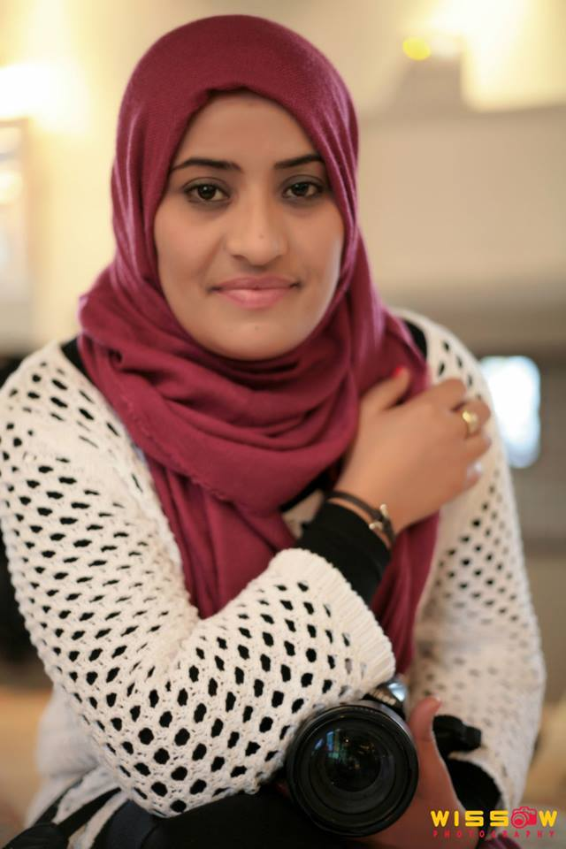

Dhibi Fatma Ezzahra

Information system Engineer

Adresse : le kram /Tunis
Tel : (216) 24873931/(216)92346368
E-mail : fatma.dhibi87@gmail.com
Git -hub : https://github.com/fatmad

Academic Path :

2015 : Engineer Degree : Information System
(Ecole Centrale Polytechnique)
2011 : Bachelor Degree : Information system
ISET
2010 : Higher Technician Diploma : Computer Science for Management
ISET
2007 : High School Diploma – Experimental Science

Professional trainings :

:

October 2017 : Full-time Full Stack JS Bootcamp (Go My Code)

August 2017 : IBM Watson training

February 2017 : Angular JS training (My way center)

March 2017 : symfony3 training (My way center)

November 2015: TOEIC (Test of English for International Communication)

March 2014 : JAVA EE5 development training (Spring, HibernateJSF)

January 2014 : CCNA certificate Exploration: Network Fundamentals and Concepts

Juin 2012: C.E.F.E certificate (Creating and developing projects)

Professional Experience and Internships

January 2018→Now: internship MSL

Technologies:JavaScript,JSON,React.JS/Redux,API,API-Messenger,Express, Node.JS, MongoDB Recast ai, Dialogflow ,Git, GitHub,ngrok,heroku, npm
- Chatbots developement and AI integration

October→December 2017: Full Stack JS training

Technologies: Html5, Css3, JavaScript, JQuery, Bootstarp, JSON, REACT.JS, Apache WEB Server, MYSQL, Python, A.W.S, Node.JS, Design Thinking, Git, GitHub

Go My Code (https://gomycode.tn/full-time)
August →October 2017: IBM Wotson training

- Creating 16 LABs « Watson Explorer Foundational Components v10 »

- .Use and Implementation of the cloud Watson Bluemix services « Building Cognitive Applications with IBM Watson Services ».7

- Creation of REDBOOKS LABs « IBM Watson Content Analytics • Content analytics miner

Technologies: IBM Watson Content Analytics, Watson Explorer Foundational Components v10, Blumiex, Node js

August 2015 →February 2017: Management assistant and commercial agent (Tunis):

- Technologies: Desktop tools , graphic design (Adobe illustrator, Adobe photoshop , Adobe Première)

January→Juin 2015: Internship at the UIB (Tunis): developing a banking mobile/web application – credits simulation
  - Technologies: JSF2, Spring3, Hibernate, Maven2, Eclipse, PostGresSQL9.3, Jdevelpoer, Tomcat, studio android, JUnit.

Juilly →September 2014 : Internship at the Dalion groupe (Tunis) : Developing a web application
Juin → Juilly 2013 : Internship at the Protect-PRO (sfax) : Developing a stock management application.

January →juin 2012 : web designer and developer at the Centre HAPPY TIME (sfax)

Skills :

Programming Languages: php, javascript, python

Database: MySQL, Oracle

web dev:HTML5,CSS3, JAVAScript,php 7

Plateform & Architecture: Angular JS, Node JS, Symphony3, ReactJS,CMS JOMLA ,CMS Prestashop ,SOA

More: Scrum /AGILE, UML, MVC, POO, Design Thinking, Machine learning

Desktop tools : Standard (MS office), Prezi

Tools : Phpstorm, Netbeans, Esay, CMS WodPress, prestashop, photoshop, Dreamwever,
PowerAMC, Phpstorm

Web and application services: Wamp, Easyphp, xamp, Aphace, Tomcat

Languages :

:

Arabic : native
English : fluent
French : fluent
Italian: beginner

My interests and other activities :

Social media club member
Microsoft polytech centrale club member
Freelance photography : Top- Création
Member : Association de Club Photographes Tunis ACPT
Member : Association Union des Jeunes Volantaires sans Frontiéres

