Breast Cancer App

Alex Teichen & Laura Cruz

Florida Atlantic University

Breast Cancer App

**Abstract**

Breast cancer is a major problem in the world today. It accounts for the largest percentage of cancer deaths in both men and women. It is important to leverage available technology in order to solve the breast cancer problem. The breast cancer application is one such tool that allows a user to enter their personal health information so that they can be alerted if they are likely to suffer from the disease. The application also helps to increase awareness about the disease.

**Background**

According to BreastCancer.org (2016), breast cancer is the most common cancer among women. Statistics indicate that about 12% of women will develop breast cancer in the United States (BreastCancer.org, 2016). Breast cancer accounts for 18% of all cancer deaths in both men and women. Many factors such as lifestyle and diet have been identified as possible contributors to the high prevalence of breast cancer in the world. As such, research has been carried out in order to improve diagnosis and treatment. This has resulted in more people being diagnosed and treated successfully. The life expectancy after discovery of breast cancer has improved significantly in the recent past.

However, in order for these measures to be effective, it is important to increase awareness of the disease to the public. In most cases of cancer, prognosis is best if it is discovered early. This is usually in stage 1 and stage 2 before the cancer has spread to other organs. Technology can be leveraged to increase awareness and also help users to communicate with relevant personnel to get more information. This need to leverage technology to increase awareness and create a link between the population and the medical practitioners has led to the development of the breast cancer application.

**Methods**

The application will allow people suffering from breast cancer to communicate with their doctors. This is particularly useful for people who have been successfully treated of breast cancer. Research shows that a person who has successfully been treated has a higher chance of relapsing and developing breast cancer again. The application will allow a user to enter their information in the system. This information will be stored in the user’s account and this information is accessible to their doctor. The doctor will be able to advise the patient regarding the disease. The doctor will be able to use the information to track the progress of the patient.

In case of anomalies in the information, the doctor can be able to predict the likelihood of a relapse and therefore the cancer will be discovered at the earliest stage possible, which makes it easier to treat. The application will be available in both desktop and mobile versions which will make it accessible. The application will have a team of doctors working in the background who will review the information of patients. They will be assisted in this task by algorithms which will be able to spot anomalies and therefore flag the records for further scrutiny and examination.

Results

The application has a home page that requests the user to input their password. This is very important as the application will handle very sensitive and personal information. This information has to be properly secured.

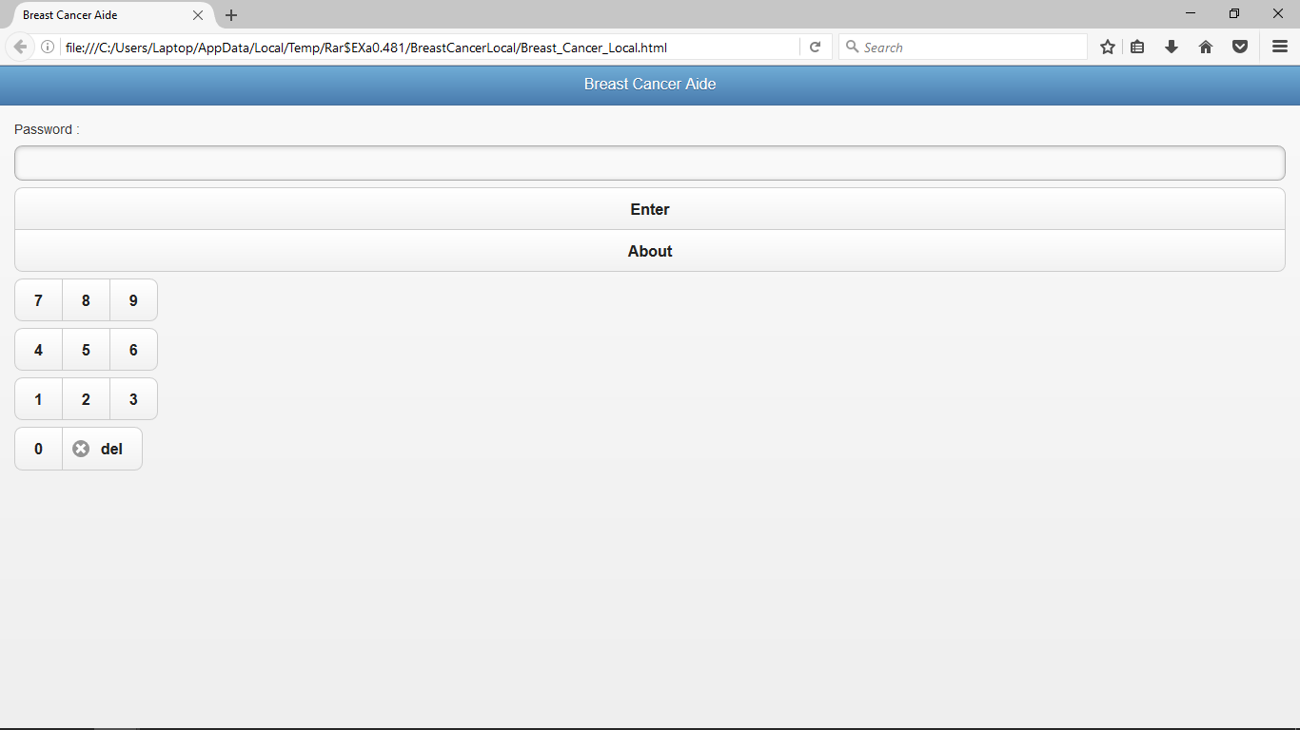

Figure 1: Application log in page

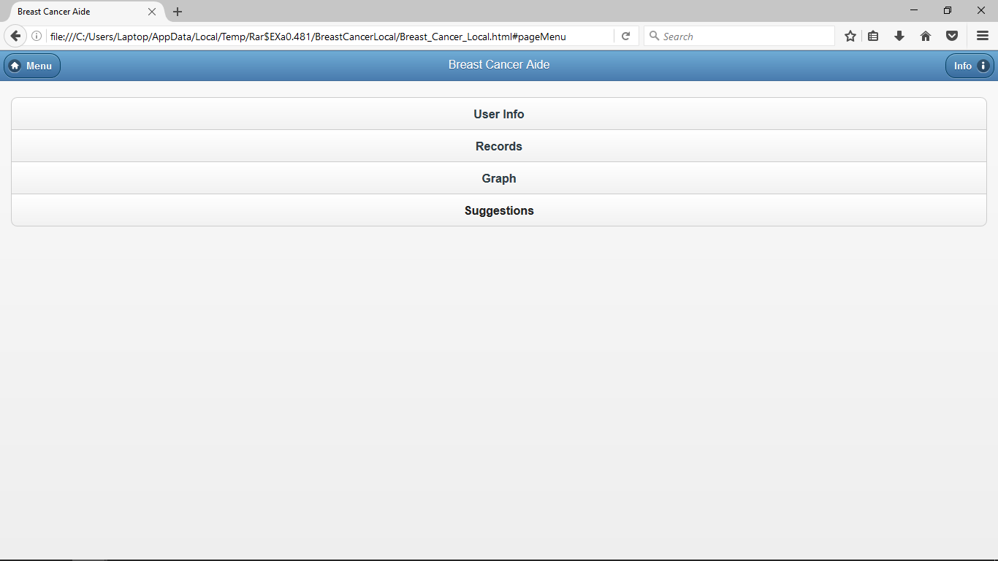

Figure 2: Application home page

After login in, the user is directed to the patient information page, which allows them to enter their personal details as well as their health details.

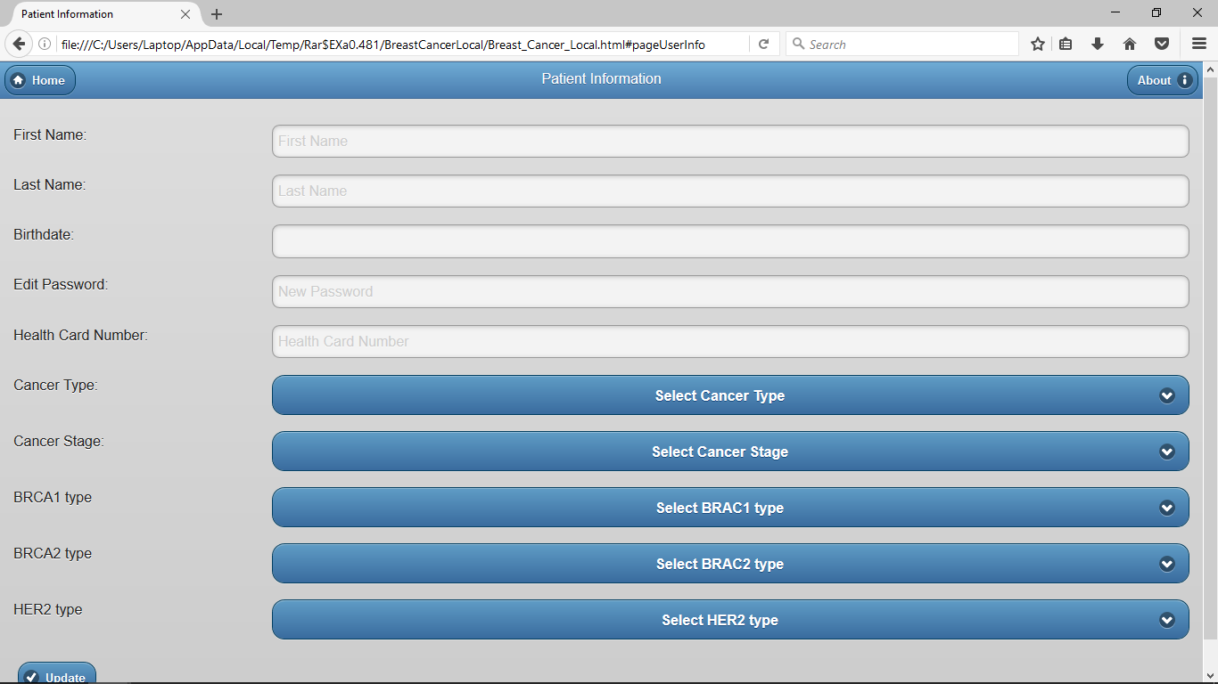

Figure 3: Patient information page

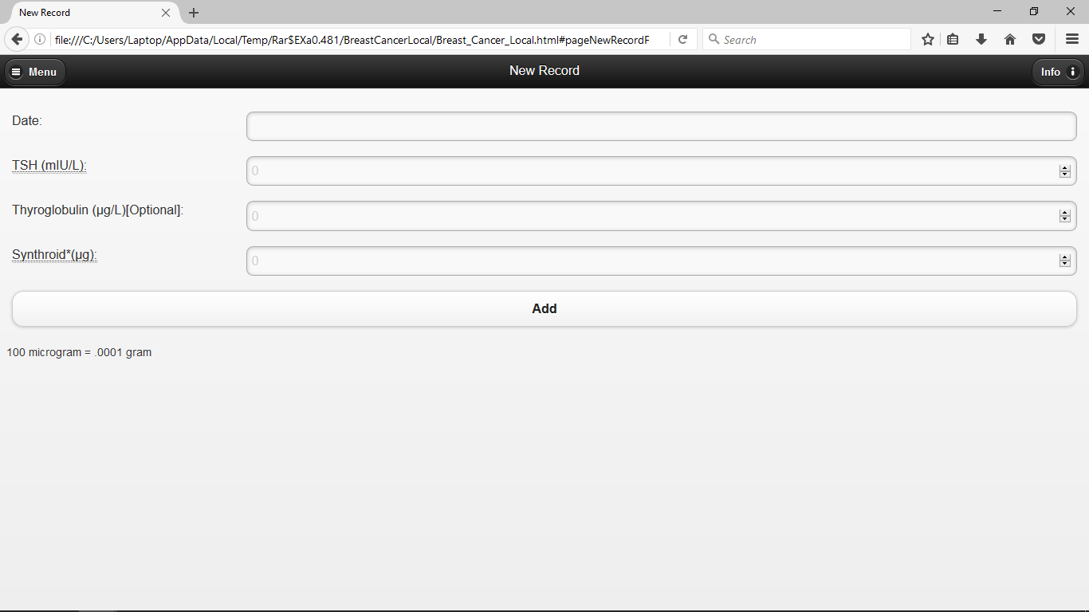

Figure 4: Record creation page

This information is saved and can be accessed in the records section. There is a graph section of the application that allows the user to get graphical representation of their history when using the app. These graphs are plotted using the input from the records.

Finally, there is a suggestion section of the app. This allows the app to make automatic suggestions to the user. This is also the section that allows the user of the app to communicate with a doctor on the other end of the application system. The application also has an information section that provides general information concerning breast cancer.

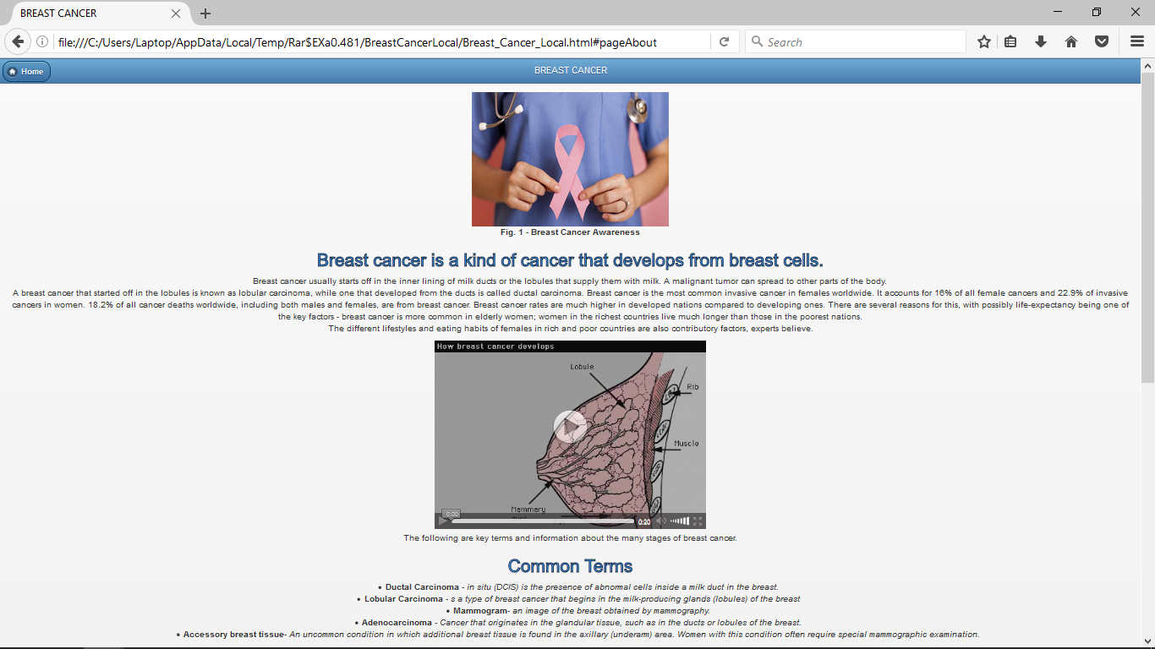

Figure 5: User information page

**Discussion**

The application has been developed for the reason of increasing awareness about breast cancer as well as providing the user of the application with a tool that allows them to keep track of their health and communicate with a medical professional in case of a problem. The application has been able to achieve both these requirements. The information section of the application provides general information about breast cancer that is important for anyone to know. This helps to create awareness about the disease in the general population. The tools contained in the application are also able to achieve their purpose. The application allows a user to enter their information which can then be accessed by a doctor who can give advice on what the patient needs to do. The application also creates a history of records which are important in tracking the progress of the patient.

**Conclusion**

The application’s design fulfills a particular purpose. It has been able to fulfill the requirement and also offer additional functionality. Leveraging technology to solve the world’s problems is a key driving force of business today and this is a great example of how simple technology can find use in a great cause.

Reference

BreastCancer.org (2016) U.S. *Breast Cancer Statistics*. Retrieved from http://www.breastcancer.org/symptoms/understand_bc/statistics