Report on Prostate Cancer Management App

By Ericky and Damoy

**Background:**

The Prostate Cancer Management App is about making it easy for medical patients which are in care for Prostate Cancer to manage their medical data. It is very useful because the patients can, from their smartphones, access the app, upload new data as requested by their doctor, and then view the data they uploaded or view the results which would be automatically generated by parameters created by the doctors.

In comparison to the current system where patients have to schedule consults, drive up to their doctor’s office, and let the doctor do the measurements, the patients could do whatever measurements is necessary with the right steps provided and then upload that data to the app. That way, the doctor can look at the specific patient if necessary or simply not do anything and let the automatically generated results take care of the patient.

**Results:**

In the two pictures below, it can be seen how the user is able to easily access any data upload that they have made and then see the results of what all of their data means to them.

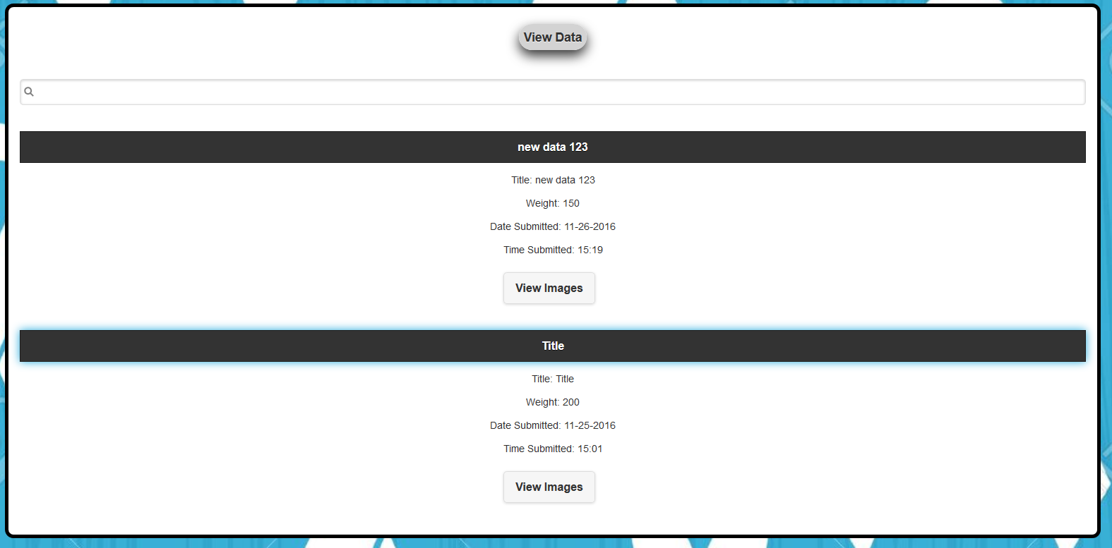

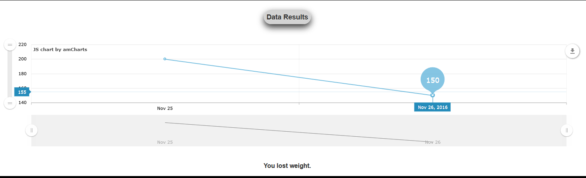

**Discussion:**

Throughout this project, we have achieved almost all the functionality that was desired. Because of time constraints, we have not fully implemented all the necessary data inputs that Prostate Cancer would require, we have not completely filled the website with information to guide the patient, and we have not fully programmed the data results to be very meaningful to the patient. Besides those three concepts that were not implemented, what was accomplished really demonstrates the idea of the project. However, it can still be improved for better performance and better UI. The technology used can also be improved to use node.js instead of PHP for example.

**Conclusion:**

The project went well overall and would have become a very useful app for Prostate Cancer medical patients if we had more time and resources to work with. Medical apps that helps the industry is a big topic and this can be an idea for a big addition to the industry.

**Reference:**

FAU Mobile Web. Prostate Cancer Management. Retrieved from,

<https://github.com/FAUMobileWeb/Prostate-Cancer-Management>

FAU Lamp. Prostate Cancer. Retrieved from,

<http://lamp.cse.fau.edu/~edossantos2014/prostate-cancer.html>