CHALLENGE PROJECT PLAN AND PROPOSAL
Faust Studio
Landing Page and Marketing Automation for the Faust Studio Vocal Autotune Tool
Project Name | Faust Studio
Team Name | Paris
Team Members | Finn, Valerie, Neda
Organization Name | Faust Studio (https://www.fauststudio.net/)

Contents
1. Project Details 3
1.1 Brief Background 3
1.2 Objective 3
1.3 Industry Focus 3
1.4 Value Proposition 4
2. Product Development Plan 4
2.1 Technology Stack 4
2.2 MVP Features (Phase 1) 5
2.3 Logistics and Communication Plan 5
2.4 Project Timeline and Milestones 6
2.5 Scalability Plan 8
3. Team Collaboration Log 8
3.1 Team Project Preference and Role Justification 8
3.2 Project Management Overview 9
3.3 Meeting Action Items, Role Changes, and Task Distribution 10
3.4 Challenges Encountered 10
3.5 Next Steps Based on Mentor Feedback 10
4. Risks and Challenges 11
4.1 Technical Risks 11
4.2 Market Risks 11
4.3 Regulatory Compliance 11
4.4 Mitigation Strategies 12
5. Concluding Remarks 12
Appendix A. AI Use Disclosure (Level 3 – AI Collaboration) 13
13
1. Project Details

1.1 Brief Background
Faust Studio is a recording studio in Prague, Czechia. A separate project team is building a web-based vocal autotuning tool for the studio. Our team does not build the tool. We focus on how the product is positioned, presented, and promoted to users, through a landing page and an AI agent or marketing automation.
The tool is free. The business case is to direct potential clients to it and then convert its users into paying customers by upselling Faust Studio’s music courses, studio time, and other products. The tool requires an email signup, and those emails are collected in a central location so we can contact users later to promote these products.
The problem. Free browser autotune is a commodity. At least five tools offer it with no signup, and every free tool ends at a download or funnels users to a plugin or subscription. No competitor we found leads users to a real recording studio with engineers and courses. This project tests whether a free tool can work as a lead source for a studio.

1.2 Objective
Our objective is to direct potential clients to the free autotune tool and convert its users into paying Faust Studio customers through upsells of music courses, studio time, and other Faust Studio products. We will deliver:
- a competitive review of similar tools;
- a landing page for the vocal autotuning tool;
- a marketing strategy for the product;
- an AI agent or automation that implements one of the strategy’s ideas;
- QA/UX testing, documentation, and recommendations for future development.
The AI/automation part will most likely act on the central list of signup emails, since that is the main channel for upselling. Which marketing idea it implements has not been chosen yet.

1.3 Industry Focus
Audio technology / digital product marketing (music production and recording services).
Our competitive review (11 browser tools and 3 desktop/mobile benchmarks, checked 6 October 2026) shows a clear market need:
- Professional pitch correction is expensive or complex: AutoTune Unlimited costs $30/month or $300/year, and Melodyne is desktop software.
- Platform tools (BandLab, Soundtrap, Soundation) require an account and learning a DAW before you hear any result.
- Free browser tools are anonymous utilities that leave the user with a WAV file and no next step.

1.4 Value Proposition
A free in-browser vocal tuner, backed by a Prague studio that has been recording since 1991, with a clear next step to Faust engineers, courses, and studio time. This positioning comes from our competitive review and has not yet been agreed with Faust Studio.
- No tool we checked offers a Czech interface, so a Czech + English tool from a Prague studio has open ground locally.
- This tool has a unique user pool, for the reasons mentioned in section 1.3
- A real studio behind the tool. Competitors funnel users to plugins, subscriptions, or anonymous referral networks. Faust can offer a named room and engineer at a published price.
- Local. Czech + English, in a market no competitor localizes for.
- Credibility. Active since 1991, with Czech and international artist references. Using artist names needs Faust Studio’s permission.
- Price ladder. Free tool → Studio session with an engineer

2. Product Development Plan

2.1 Technology Stack
Component | Choice
Development hosting | GitHub Pages (current platform, before release to a domain).
Production hosting | Likely Vercel.
Framework | If we go with a Vercel deployment, Next.JS is going to be the easiest and most flexible choice to program with.
Languages | JavaScript/TypeScript.
Signup and email collection | To be decided
AI agent / automation | This needs in-depth discussion with our representative from Faust, very unclear where we are going with this for now

2.2 MVP Features (Phase 1)
- Competitive review: drafted (11 browser tools + 3 desktop/mobile benchmarks, checked 6 October 2026).
- Landing page v1: headline and value proposition; a call to action linking to the tool; an honest description of the email signup; next-step upsell hooks, supported browsers and devices; responsive layout; Czech + English if agreed by Representative.
- Marketing strategy v1: target users, positioning, channels, and the email funnel from signup to upsell.
- Automation concept: To be discussed further with the Representative

2.3 Logistics and Communication Plan
 | Company (Faust Studio) | Team
Meeting frequency | Biweekly w/ Blanka, Thursday afternoons or mornings (tbd) | Weekly w/ Anna, Tuesdays 12:00pm
Communication channels | Whatsapp + Zoom/Google meets | - A shared GitHub repository, used by both the Berlin and Paris teams, for code and planning documents.  - Whatsapp

2.4 Project Timeline and Milestones
Weeks | Dates | Phase | Our planned activities
3–4 |  | Phase 1: finalizing the project setup (stakeholders, problem, team, research) | Briefing with Faust Studio and project description written; repo set up; competitive review started (drafted 6 Oct).
5–8 | now – 1 Nov | Phase 2: iterative development, getting feedback from the company | colour scheme, and design philosophy; settle email storage and the tool link with the tool team; design and build landing page v1 on GitHub Pages; draft the marketing strategy; pick the automation idea; get Faust Studio’s feedback on copy and design.
10–13 | 9 Nov – 6 Dec | Phase 3: rework based on feedback, prepare documentation | Demo the landing page MVP; present the marketing strategy and the automation concept.Rework from feedback; build the automation; QA/UX testing of the landing page and signup funnel; Czech localisation if agreed; move to the production domain/Vercel; write documentation.
14 | 7 Dec | Phase 4: final delivery, preparation for final presentation, handover of code and documentation to the company and IFSA | Final delivery; hand over code, documentation, and recommendations for future work
Timeline
Task | W3 | W4 | W5 | W6 | W7 | W8 | W9 | W10 | W11 | W12 | W13 | W14 | W15
Project setup, stakeholder research
Competitive review
Design decisions (domain, colours, style)
Landing page design + build (v1)
Marketing strategy
Automation: pick idea + design
Update presentation
Rework from feedback
Automation build
QA / UX testing
Documentation + recommendations
Final delivery + presentation

Milestones
ID | Week | Milestone
M1 | 5 (11 Oct) | Project plan and proposal submitted; competitive review complete.
M2 | 6 | Design decisions locked (colour scheme, design philosophy); email storage and tool link agreed.
M3 | 8 | Landing page MVP live on GitHub Pages and linking to the tool.
M4 | 9 | Update presentation; marketing strategy v1 presented.
M5 | 12 | Automation working end to end on a test list.
M6 | 13 | QA/UX testing complete; landing page on the production domain.
M7 | 15 | Final handover and presentation.

2.5 Scalability Plan
Extensions after handover: full Czech + English localization of the page and emails; course and upsell pages on fauststudio.net (the Courses page currently lists no course names, prices, or dates); a longer email sequence (welcome, recording tips, course offer, studio booking offer) segmented by tool usage; Czech and English SEO content; analytics and A/B testing across the funnel.
Potential issues: dependence on the tool team’s roadmap; GDPR consent and list hygiene as the list grows; integration with the client site, which runs on Wix; the domain choice (subdomain of fauststudio.net vs. a separate domain) affects SEO and tracking.
Maintenance: who at Faust Studio will maintain the site and automation after handover?

3. Team Collaboration Log

3.1 Team Project Preference and Role Justification
Team members
Name | Role | Background and expertise
Finn | SWE | Computer Science major. Extensive web and backend design experience. Fluent with website construction in Next.js + Vercel
Valerie | PM
Neda | Executor
Initial job descriptions
Role | Responsibilities
PM
SWE | Handles the website development and deployment, email collection, storage, and automation, and the agent integration.
Executor

3.2 Project Management Overview

Current organizational system is a main TODO in a shared GitHub repository with the other team (Berlin). We are in the process of setting up a Kanban board to handle team tasks. We are employing a scrum-esque workflow, with a Weekly instead of Daily standup. 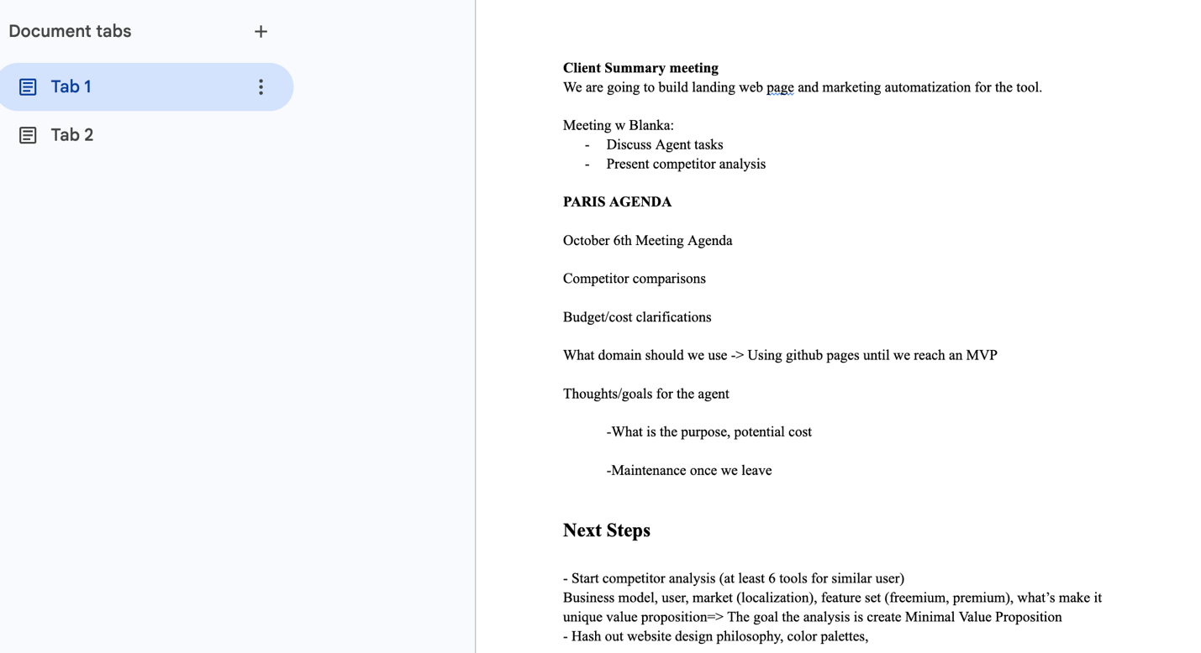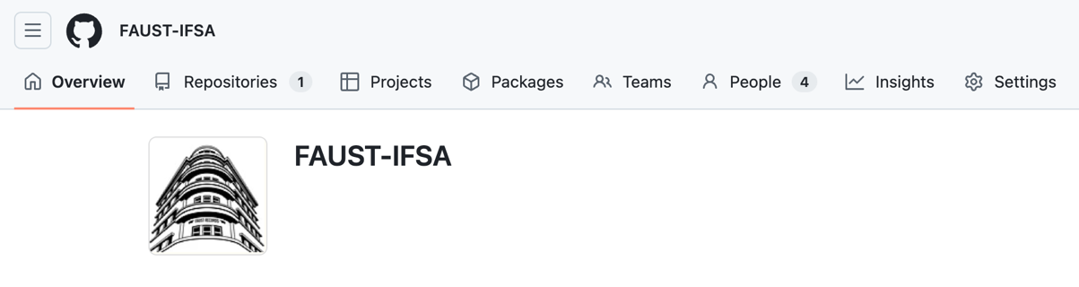

3.3 Meeting Action Items, Role Changes, and Task Distribution
Open action item
Coordinate weekly meeting time w/ Blanka
Choose a colour scheme
Decide on a design philosophy for the website
Decide where the collected signup emails are stored
Decide how the site links to the separately hosted tool

Task distribution will be handled mostly by the most applicable role, but with PM being the most heavily scheduled role the SWE (Finn) and the Executor (Neda) will pick up overflow tasks as necessary on top of their usual roles.

3.4 Challenges Encountered
- Dependence on a separate team for the tool: when the email is required, whether audio is processed locally or on a server, live correction, and the launch date are all outside our control.
- Two teams (Berlin and Paris) share one repository and need to coordinate.
- Unresolved decisions (email storage, tool link) block the automation and signup work.
- All development must occur locally or on a Github page, so there is an overhead of migration work to a real domain on top of the task of developing the site in the first place

Our completed Team Diagnostic Worksheet is attached as Appendix B.

3.5 Next Steps Based on Mentor Feedback
Task
Submit this proposal; agree open decisions with Faust Studio and the tool team.
Schedule meeting times w/ Blanka
Build the landing page on GitHub Pages instead of the final domain
Consult w/ Blanka for the AI automation specifics

4. Risks and Challenges

4.1 Technical Risks
- The tool’s features, timeline, and URL are owned by another team; the landing page could promise things the tool does not end up shipping
- Email storage and the link to the tool are undecided, which blocks the automation.
- Hosting moves from GitHub Pages to Vercel, and the framework is not confirmed.
- If the automation uses an LLM to write marketing content, it may produce wrong prices or features, or an off-brand tone.
- Data availability: before the tool launches, the email list will be small or empty, so the automation is hard to test and measure.

4.2 Market Risks
- Free browser autotune is a commodity; “free online autotune” alone will not stand out.
- Requiring an email before first use puts the tool behind no-signup competitors and may lower adoption.
- Upsell destinations are not ready: the Courses page lists no course details, and the rates page shows two prices for the 3-hour Green package (2,100 and 1,950 CZK).
- The jump from a free tool to a ~€90 session is large, so conversion may be low without steps in between (e.g. a course or tips content).

4.3 Regulatory Compliance
These points come from our competitive review; confirmation from our Representative is still needed.
- GDPR and Czech commercial email rules: consent for marketing emails must be separate from the signup needed to use the tool. We need consent text, a privacy policy owner, a double opt-in decision, and unsubscribe handling.
- “Auto-Tune” is an Antares trademark; we will use “autotune effect”, “pitch correction”, or “vocal tuner” with care.
- Artist names from Faust Studio’s references page need the client’s permission before use in marketing.
- Ethics: disclose AI-generated marketing content where appropriate and avoid misleading claims.

4.4 Mitigation Strategies
Risk | Mitigation
Tool dependency | Agree a feature list and launch date with the tool team; the landing page only claims confirmed features; use a placeholder link until the tool URL is ready.
Open decisions | List them in the TODO backlog with an owner and deadline; escalate to Faust Studio at the next meeting.
LLM-generated content | Human review before anything is sent; give the AI fixed facts (prices, products) instead of letting it generate them.
Small email list | Test with a seeded test list; define metrics in advance so results can be measured after launch.
Commodity market | Lead with the studio and the next step, not just “free autotune”; recommend that the tool team ask for the email at download rather than before first use.
Upsell readiness | Ask Faust Studio for course details and one confirmed price before launch.
Regulatory | Separate marketing-consent checkbox; double opt-in; privacy policy reviewed by a mentor or professor; neutral naming; written permission for artist names.

5. Concluding Remarks
Faust Studio is getting a free browser-based vocal autotune tool, built by a partner team. Our job is to make that tool an entry point into the studio: a landing page that positions it as “free autotune from a real Prague studio”, a marketing strategy, and an AI agent or automation that turns signups into course and studio customers. The competitive review shows that free tuners are common but none lead to a real studio, which is Faust’s opening. The main risks are our dependence on the tool team, open decisions about email storage and the tool link, and GDPR-compliant consent; the plan above addresses each before the Week 9 update.

Appendix: AI Use Disclosure (Level 3 – AI Collaboration)
Parts of this document were drafted with Claude from our project files (PROJ-DESC.md, MARKET-RESEARCH.md, README.md, TODO.md, and CLAUDE.md). This includes the Gantt chart in Figure 1. All outputs were then read over by all team members and corrected where necessary.
Original prompts
Prompt 1 (first draft):
“Based on the information in @PROJ-DESC.md, I want you to fill out the @"Project Plan & Proposal Structure and Rubric-FA26.docx" document (make a copy of it and edit the copy, not the original document). For all the sections where the project description markdown file is directly applicable, use the information from it. Do not paraphrase, use my direct language the way I wrote it in the file. For any sections where you can make some slight inference or assumptions from the project description, do that but mark it as such. If there are any sections where you have no basis of info from @PROJ-DESC.md or any other file in the repo, mark it and leave it for me to fill in later.”
Prompt 2 (formatting):
“Take the drafted information in @"Project Plan & Proposal - Faust Studio (Draft).docx", and create the formatted version of the doc following the formatting guidelines alongside the info in the draft. Format the title page, table of contents, etc. Maintain color coded text for confidence level, anything that is high-confidence put as blue in the final doc, and whatever is low-confidence put the section description in yellow and I’ll fill it myself.”

