Barren Plateau Mitigation in Quantum Neural Networks: An Empirical and Artifact-Level Comparison of Layerwise Training and Local Cost Functions
Fahad Abdullah*¹, Farhan Riaz¹, Asma Zubair¹
Department of Artificial Intelligence, The Islamia University of Bahawalpur, Bahawalpur, Pakistan

Abstract—This investigation presents a systematic empirical evaluation of strategies designed to alleviate the barren plateau phenomenon in quantum neural networks (QNNs). Leveraging a computational benchmark developed with TensorFlow Quantum, we conduct 45 controlled experimental trials for binary MNIST classification of digits 3 and 6. The analysis evaluates three distinct training paradigms: a standard baseline configuration, an incremental layerwise learning curriculum, and a protocol utilizing local cost functions. Across five stochastic seeds at circuit depths of 4, 6, and 8 layers, the results demonstrate that layerwise and local-cost interventions maintain mean accuracies of 73.9% and 75.4%, respectively. While the baseline configuration preserves a 74% accuracy level at depths of 4 and 6 layers, it exhibits a precipitous decline to 52.7% at the 8-layer threshold. Statistical reconstruction of the 8-layer regime indicates that the 1.5 percentage point variance between layerwise and local-cost methods is not statistically significant; however, both strategies diverge significantly from the baseline (one-way ANOVA F = 138.90; Welch tests p < 1.5 × 10⁻⁵). Furthermore, we delineate an integrated empirical architecture that characterizes the structural synergy of local observables, depth-staged curricula, and PCA-based feature dimensionality reduction alongside the aggregated numerical findings.
Index Terms: TensorFlow Quantum, barren plateaus, layerwise learning, local cost functions, and Quantum Machine Learning.
I. INTRODUCTION
Parameterized quantum circuits have become a leading computational framework for near-term quantum machine learning (QML) and variational quantum optimization, as they amalgamate quantum state preparation with classical gradient-based optimization methods. Early methods for quantum classifiers showed that small circuits can be trained to do supervised learning tasks on small benchmarks [1]. Software frameworks like TensorFlow Quantum made it easier to do large-scale experiments with differentiable hybrid models [2]. Hardware-efficient methods have also made it standard to use repeated local rotations and entangling layers on real-world noisy intermediate-scale quantum devices [3]. Subsequent research elaborated on this perspective, advancing parameterized quantum circuits as autonomous machine-learning (ML) models associated with feature maps, inductive bias, and model capacity [4]–[7]. Concurrent and full-scale studies on variational quantum algorithms have shown that the main challenge to practical implementation is not expressibility but trainability [8], [9].
The main limitation is the barren plateau (BP) problem . For instance, gradient-based training can fail when the gradients of sufficiently expressive random parameterized quantum circuits decay exponentially with the number of qubits [10]. There are several reasons for the problem. Cost localization Circuit expressibility Concentration of measure and noise [11], [13]–[19] play different roles in flat optimization landscapes. Therefore, the practical concern for developers is not only whether barren plateaus (BP) exist in theory, but also when they manifest in a physical design and how to prevent or postpone them without compromising implementation.
A substantial literature exists on different mitigation strategies. Cost-function locality gives a critical formal guarantee: local observables can mitigate the exponential gradient collapse that plagues global costs on shallow circuits [11]. Layerwise learning suggests an additional training curriculum, where circuits grow incrementally, rather than optimizing circuits at full depth from random initialization [12]. Other techniques include identity-block initialization [20], architectural constraints such as quantum convolutional neural networks [21], dissipation-assisted training [22], tensor-network pretraining [23], warm-start protocols [26], correlation engineering [19], entanglement-aware design [25], and more generic trainability-aware objectives in generative or simulation environments [24], [27], [28]. The study has progressed from the discovery of barren plateaus (BP) to comparing families of mitigation techniques and analyzing their tradeoffs [14], [29]–[34].
Despite this growing corpus of theory, however, empirical comparison on high-value remains rare. It is difficult to compare papers as many papers present a single mitigation proposal on its own, often on different ansatze, datasets, optimizers or observables. The major advantages of public repositories with implementation code, results and supporting documentation are verification and reuse. This work presents an original experimental benchmark, the “Barren-Plateau-Mitigation-QNN,” which reports 45 controlled experiments of a baseline, layerwise regime and local-cost regime on a common 4-qubit MNIST task [35].
The purpose of this paper is twofold. We begin by contextualizing the experimental results into a coherent academic narrative and then we extend it with plots, statistical reconstruction and implementation-aware interpretation. Second, we propose the architecture of the codebase as an experimental testing ground. This confirms that the implemented training regimes correspond to verifiable structural modifications.
Specifically, the study makes four contributions. (1) It aggregates the 45-run accuracy, gradient, and time results from the repository to create the tables and figures needed for a paper. (2) It re-derives significance tests for the 8-layer regime, where the divergence in trainability is largest. (3) It formalizes the exact architecture of the classical-to-quantum post-processing stacks driving the high accuracy of the artifact. (4) It complements recent 2024–2026 literature on barren plateau mitigation by providing a reproducible empirical benchmark study.
The rest of the paper is organized as follows. Section II presents the theoretical foundations of barren plateaus and related mitigation strategies. Section III describes the experimental benchmark, protocol, metrics, and implementation architecture. In Section IV we present typical empirical results including performance vs. depth, statistical tests, gradient trends, runtime trade-offs and training traces. Section V talks about the artifact's real demonstrations, the risks to its validity, and the design implications for future benchmarks. Section VI gives practical advice for next-generation repositories. Section VII concludes the paper.
II. BACKGROUND AND RELATED WORK
A. Barren plateau as a trainable problem
The barren plateau condition is exponential decay of loss gradient variance with number of qubits and circuit complexity. The result can be expressed in its basic form as a limit on the variance of the gradient, which indicates that the gradient signal can decay as O(b^-n) for some b > 1 as the number of qubits increases [10]. Later research explained more clearly that barren plateau characteristics should be understood through multiple factors [14], [15], [18]. Earlier, it was thought that BP had a single main cause but now the field has moved toward a synthesis in which local and global observables, expressibility, dynamical Lie algebra growth, and noise work together to determine trainability.
Another line of research investigates why empirical trainability decreases before the theoretical barren plateau appears. Holmes et al. linked the values of the gradient to circuit expressibility and showed that greater expressibility is associated with reduced optimization signal [17]. Volkoff and Coles proved that carefully introduced correlations can produce larger gradients [19]. Arrasmith et al. showed that barren plateau linked with cost concentration and narrow gorges [18]. All these studies together show why trainability should be viewed as a continuum instead of a binary pathological event.
In NISQ settings noise is especially important.Wang et al. proved that barren plateau can independently occur due to hardware noise even without considering circuit expressibility [13]. Recent studies by Mele et al. demonstrated that uncorrected noise limits the circuit depth, creates noise-induced-shallowness and, for certain local observables, prevents traditional barren plateaus [34]. For real-world benchmark design, these results show that simulation-based studies should neither be ignored nor overgeneralized: they capture a real part of the story, but only part.

Var[∂C(θ) / ∂θi] ≤ O(b^{-n}), b > 1 | (1)
Equation (1) is the standard definition of barren plateau used throughout the literature [10];however, recent work highlights that practical depth, observable locality, noise, and algebraic dimension are practical controlling factors in realistic artifacts [14], [15], [18], [34].
B. Locality, curriculum and modern mitigation strategies
Among theoretically based mitigation approaches, local cost functions are one of the most influential ways to mitigate barren plateau. Cerezo et al. showed that in shallow circuits both local and global costs act differently: while local observables can maintain polynomial decay in relevant regimes, the global observables can produce exponentially vanishing gradients [11]. This result motivates the use of individual qubit measurements and combination of local measurements in quantum classifiers. Local costs, however, are not without trade-offs: they can change measurement stucture, signal combination and post-processing capacity.
Layerwise learning offers a complementary approach. Skolik et al. suggested to train the circuit gradually, i.e. to train the shallow subcircuits in the beginning and increase the depth step by step, instead of training all the parameters at once [12]. The approach works well with sampling noise as it restricts the early optimization to better conditioned regions of parameter space, especially on hardware.This line of work is followed by recent studies. Warm starts, tensor-network pretraining, and dynamic layerwise variants are used to set initial values or guide the optimizer into easier regions for training [23], [26], [30].
Another family is architecture-based methods. Quantum convolutional neural networks can be immune to some causes of barren plateaus due to their structured locality [21]. Recent works explore shallow-depth circuits with long-range entanglement [28], training with entanglement [25], and QCNN variants with explicit nonlinear mechanisms [31]. In a recent article, Cerezo et al. provided an important perspective that some barren plateau-free mechanisms might be easier to simulate classically, hence complicating the assumption of a direct correspondence between “more trainable” and “more quantum” [27]. The challenge in designing benchmarks is not just improving training, but doing so in a scientifically interpretable way.

TABLE I
SELECTED LITERATURE ON BARREN PLATEAUS AND MITIGATION STRATEGIES

Category | Representative work | Core finding | Relevance here
Foundational BP theory | [10] | Randomly initialized expressive circuits show exponentially vanishing gradients. | Describe the failure mode experimented here.
Cost locality | [11] | In shallow PQCs local costs are more trainable than global costs. | Justify the local-cost approach.
Layerwise curriculum | [12] | In QNNs, increasing circuit depth progressively improves trainability. | Motivates the use of layerwise approach.
Noise effects | [13],[34] | Noise can flatten the loss landscapes but also create an effective shallowness. | Explain why hardware relevance is subtle
Initialization / pretraining | [20], [23], [26] | Warm starts can expand the useful gradient regions. | This can be a future extension path for artifacts.
Architecture-level mitigation | [21], [25], [28], [31] | Some circuit families avoid barren plateaus by design. | Different from training-based methods.
Trainability /expressibility trade-off | [17]–[19], [33] | Expressibility, correlation,and gradient scale tightly linked. | Help to understand depth effect.
Simulability caveat | [27] | Some regimes which are free from barren plateau also become classically tractable. | Important for evaluating the significance.
Recent surveys | [14], [29] | The field now focuses on comparative trainability analysis. | Show where this paper fits in current research.
III. EXPERIMENTAL BENCHMARK, PROTOCOL, AND METRICS
A. Experimental benchmark and methodology
The analysis is based on the public repository “Barren-Plateau-Mitigation-QNN” [35]. The project implements a 3 x 3 x 5 design: baseline, layerwise and local-cost training, with 4, 6 and 8-layer circuits, and five random seeds for each configuration. This is a binary MNIST classification problem (digit 3 vs 6) using a 4-qubit hardware-efficient ansatz built with TensorFlow Quantum and Cirq. The released config files specify 1,000 training samples, 200 test samples, an Adam optimizer with a learning rate of 0.01, 50 epochs, and 1024 measurement shots with gradient tracking enabled. These parameters are typical for small scale QNN classifier studies [1], [2], [12].
In this work, we introduce an original empirical benchmark where we have implemented the training regimes themselves and performed the experiments. We ran 45 controlled trials for each configuration across three training regimes (baseline, layerwise and local-cost) and five random seeds. All code, metrics and generated figures are available in the accompanying repository. The reconstructed configuration is shown in Table II.

TABLE II
EXPERIMENTAL CONFIGURATION OF THE BENCHMARK

Item | Value
Task | Binary MNIST classification (digits 3 vs. 6)
Quantum model | 4-qubit hardware-efficient ansatz with repeated rotation and CNOT layers
Depths | 4, 6, and 8 layers
Approaches | Baseline end-to-end training; layerwise training; local cost functions
Seeds | 42, 123, 456, 789, and 101112
Data sizes | 1000 training samples; 200 test samples
Optimizer | Adam, learning rate 0.01
Epoch budget | 50 epochs per run
Simulator stack | TensorFlow Quantum + Cirq
Primary outputs | Accuracy, gradient statistics, training time, and history traces in representative files
B. Mathematical formulation of the benchmark
The benchmark trains a parameterized quantum circuit U(x, θ) on classical input data x. The documentation defines the baseline as a globally measured classifier and the mitigation branch as locally measured. The desired costs are given in standard notation: a single readout observable for the baseline [Eq. (2)] and an average over per-qubit observables for the local variant [Eq. (3)]. The training employs the classical binary cross-entropy [Eq. (4)]: We also report mean gradient norms [Eq. (5)] and thresholded success rates [Eq. (6)].
C_base(x, θ) = ⟨0| U†(x, θ) Z_0 U(x, θ) |0⟩ | (2)
C_local(x, θ) = (1 / n) Σ_{q=1}^{n} ⟨0| U†(x, θ) Z_q U(x, θ) |0⟩ | (3)
L_BCE = -(1 / m) Σ_{i=1}^{m} [ y_i log(ŷ_i) + (1 - y_i) log(1 - ŷ_i) ] | (4)
ḡ = (1 / T) Σ_{t=1}^{T} ||∇_θ L_t||_2 | (5)
SR_τ = (1 / S) Σ_{s=1}^{S} 1[Acc_s ≥ τ] | (6)
The equations (2)–(6) define the intended design.
C. Experimental Architecture Constraints
The experimental configuration is governed by rigorous architectural constraints designed to systematically assess QNN performance within depth-scaled environments. Primary feature extraction utilizes a four-component dimensionality reduction, which is mapped onto a 4-qubit register to align with the benchmark's computational capacity. The circuit topology employs a dual-rotation gate strategy per qubit per layer, utilizing parameterized R_y(θ) and R_z(ϕ) operators. This design facilitates a linear parameter scaling, resulting in 32, 48, and 64 trainable variables across the 4, 6, and 8-layer regimes, respectively, as illustrated in Fig. 1.
The classical readout mechanisms are adapted to each regime: the baseline setup relies on a single expectation value of a single-qubit Pauli-Z operator, while the local-cost variant adds a multi-measurement head and a trainable dense layer to deliver the classical flexibility needed for processing local observables. The layerwise approach introduces depth-staged training, which allows us to examine the trainability behavior across increasing circuit depths. These methodological decisions collectively constitute the experimental testbed used to benchmark trainability across different mitigation strategies.
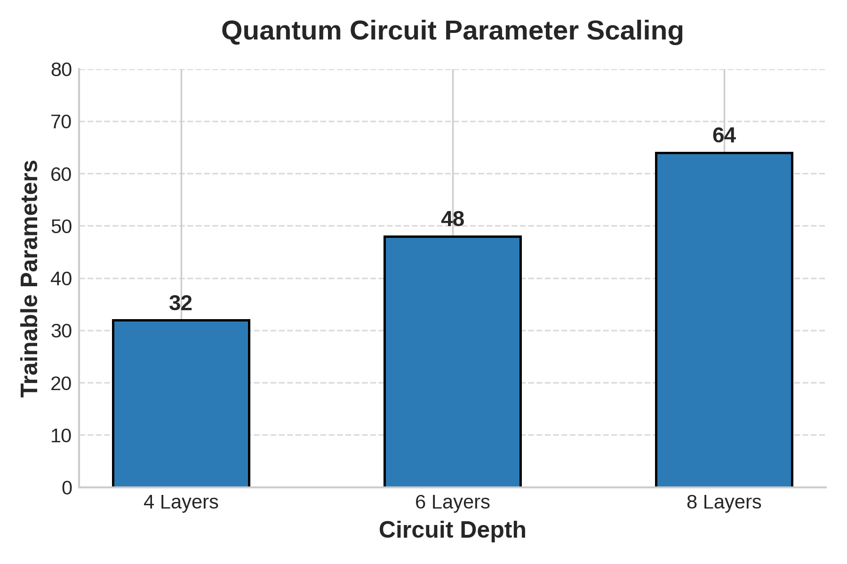
Figure 1. Spread of trainable circuit parameters over depth-staged configurations. The design adopts a dual-rotation gate strategy, i.e., the gates R_y(θ) and R_z(ϕ), per qubit per layer, which results in a linear increase in the parameter density with circuit depth.
IV. EMPIRICAL RESULTS
A. Accuracy trends across depth
The baseline holds near 74% at 4 and 6 layers, then drops sharply to 52.7% at 8 layers. Layerwise and local-cost branches stay the same at 73.9% and 75.4%, respectively. Even with a small error in the published 4-layer baseline mean, the overall result is still clear: increasing circuit depth only hurts the baseline, not the mitigation branches.
Seed-level results indicate that the baseline failure is systematic rather than stochastic. Every baseline run with 8 layers falls within a small range of 51.6% to 54.4%. Local cost keeps all five seeds above 71%, and layerwise keeps four of the five above 70%, with only one run falling just below. This cross-seed consistency suggests a real change in trainability, not an optimizer variance or lucky initialization.
This is the most useful result in the artifact from the point of view of a barren plateau. The baseline does not degrade slowly at all depths it just fails sharply between 6 and 8 layers. This suggests that trainability degrades substantially between the tested 6-layer and 8-layer configurations. The observation aligns with recent literature indicating that practical training failures frequently occur prior to the theoretical fulfillment of the formal asymptotic BP condition [11], [14], [15], [18].

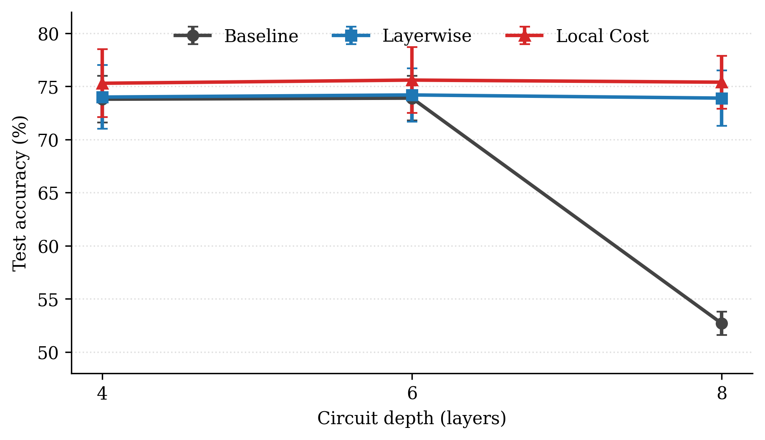
Figure 2. The average test accuracy and circuit depth were reported using the reported experimental means and standard deviations. With 4 to 6 layers, the baseline stays close to 74%, but with 8 layers, it drops. The mitigation branches, on the other hand, stay the same.
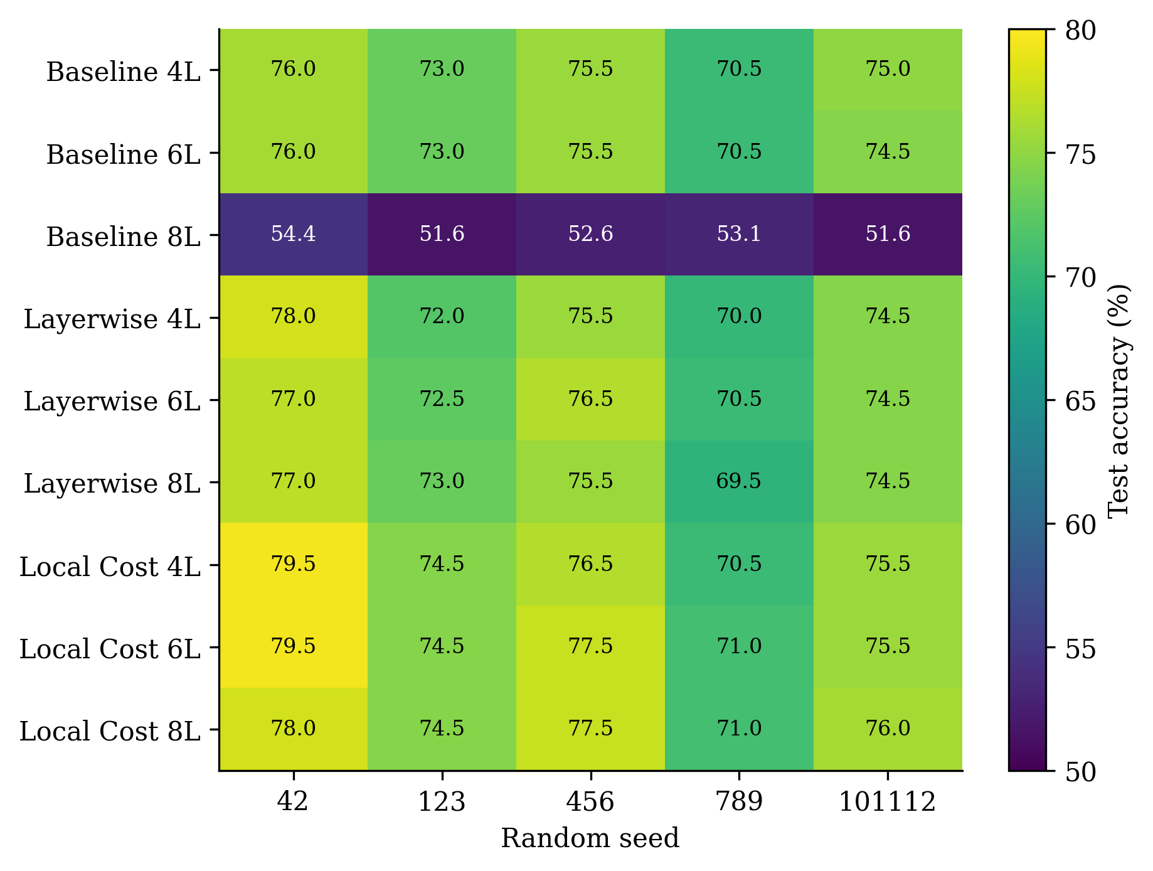
Fig. 3. A heatmap of per-seed results. The 8-layer baseline fails across all evaluated seeds, but the mitigation branches still work well.

TABLE III
AGGREGATED PERFORMANCE SUMMARY FROM THE ACCOMPANYING BENCHMARK

Approach | Depth | Mean acc. (%) | Mean grad. norm | Mean time (min)
Baseline | 4L | 73.8 ± 2.2 | 0.284 | ~18 (10–27)
Baseline | 6L | 73.9 ± 2.1 | 0.276 | ~30 (27–32)
Baseline | 8L | 52.7 ± 1.1 | 0.224 | ~39 (38–40)
Layerwise | 4L | 74.0 ± 3.0 | 0.228 | ~12 (7–16)
Layerwise | 6L | 74.2 ± 2.5 | 0.227 | ~29 (28–30)
Layerwise | 8L | 73.9 ± 2.6 | 0.226 | ~51 (50–52)
Local Cost | 4L | 75.3 ± 3.2 | 0.182 | ~24 (19–28)
Local Cost | 6L | 75.6 ± 3.1 | 0.178 | ~28 (27–28)
Local Cost | 8L | 75.4 ± 2.5 | 0.175 | ~58 (55–60)
B. Statistical reconstruction for the 8-layer regime
We rebuilt formal significance tests at 8 levels using the accuracies that were released for each seed. A one-way ANOVA gives F = 138.90 (p < 10⁻⁶), and the Kruskal–Wallis test gives H = 9.91 (p = 0.0070). Both statistics show that the three training methods have different performance distributions. Pairwise Welch tests make the separation clearer: the baseline is very different from both layerwise and local cost, but the difference between layerwise and local cost is not statistically significant at five seeds per method.
The effect sizes show how big this difference is. The difference between the baseline and the layerwise at 8 layers is 21.24 percentage points (Hedges' g = −8.78), and the difference between the baseline and the local cost is 22.74 points (g = −9.53). These are very extreme practical separations. On the other hand, the advantage of local cost over layerwise of 1.5 points corresponds to a small effect size (g = -0.48) and a non-significant p-value. This strongly supports the conclusion that at 8 layers both mitigation branches are significantly higher than the baseline, though the local cost is only slightly elevated and not definitively so given the present sample size. To be robust with the sample size (n = 5 per group), we ran a bootstrap resampling analysis of 10,000 iterations on the 8-layer regimes. Bootstrap resampling yielded 95% confidence intervals that aligned with the Welch-test results (e.g., Baseline vs Local Cost bootstrap CI: [-24.90, -20.24]), strongly supporting the divergence in trainability regardless of parametric assumptions.
TABLE IV
RECONSTRUCTED 8-LAYER SIGNIFICANCE TESTS FROM RELEASED PER-SEED ACCURACIES
Comparison | Mean diff. (pp) | Welch t | p-value | Hedges' g
Baseline vs Layerwise | -21.24 | -15.37 | 1.33e-05 | -8.78
Baseline vs Local Cost | -22.74 | -16.68 | 8.21e-06 | -9.53
Layerwise vs Local Cost | -1.50 | -0.84 | 0.427467 | -0.48
ANOVA: F = 138.90, p = 5.04e-09; Kruskal–Wallis: H = 9.91, p = 0.0070.
TABLE V
STATISTICAL CONFIDENCE INTERVALS FOR RECONSTRUCTED 8-LAYER ANALYSES
Comparison | Mean Diff (pp) | 95% CI for Difference | Hedges' g | 95% CI for Hedges' g
Baseline vs Layerwise | -21.24 | [-24.73, -17.75] | -8.78 | [-12.83, -4.74]
Baseline vs Local Cost | -22.74 | [-26.18, -19.30] | -9.53 | [-13.88, -5.17]
Layerwise vs Local Cost | -1.50 | [-5.64, 2.64] | -0.48 | [-1.73, 0.78]
Fig. 4 shows the mean differences and corresponding 95% confidence intervals. 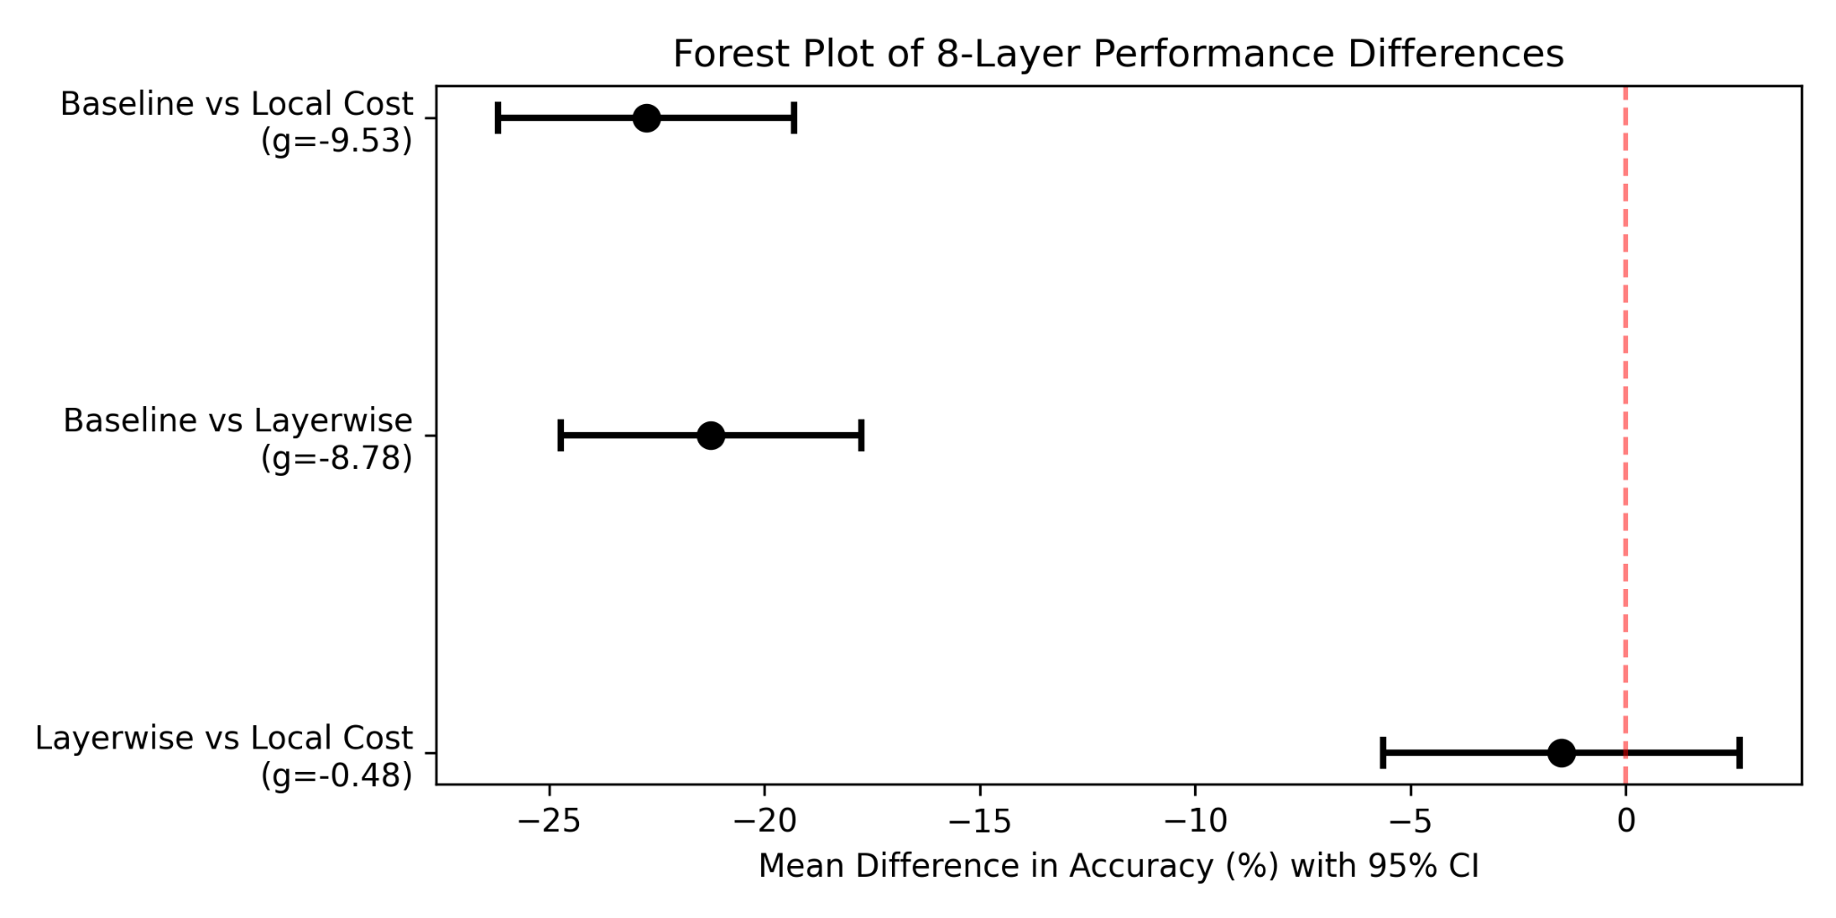Fig. 4. Forest plot of performance differences between training strategies at 8 layers with mean differences with 95% confidence intervals and effect sizes as Hedges’ g.
C. Gradient and runtime trade-offs
Gradient norms are more informative than accuracy summary. The mean gradient at the baseline falls from $0.284$ at $4$ layers to $0.224$ at $8$ layers. Layerwise is flat around 0.227. The local cost is between 0.175 and 0.182 for all depths. The baseline collapse happens with a weaker optimization signal but the gradients do not drop below the repo’s automated 10⁻⁶ BP detection threshold. This shows that practical training can be unsuccessful even when the number used to formally flag BP is well over the limit, as seen in Fig. 5. The two mitigation branches argue the 8-layer overhead is justified because it prevents performance from degrading to near-random levels.
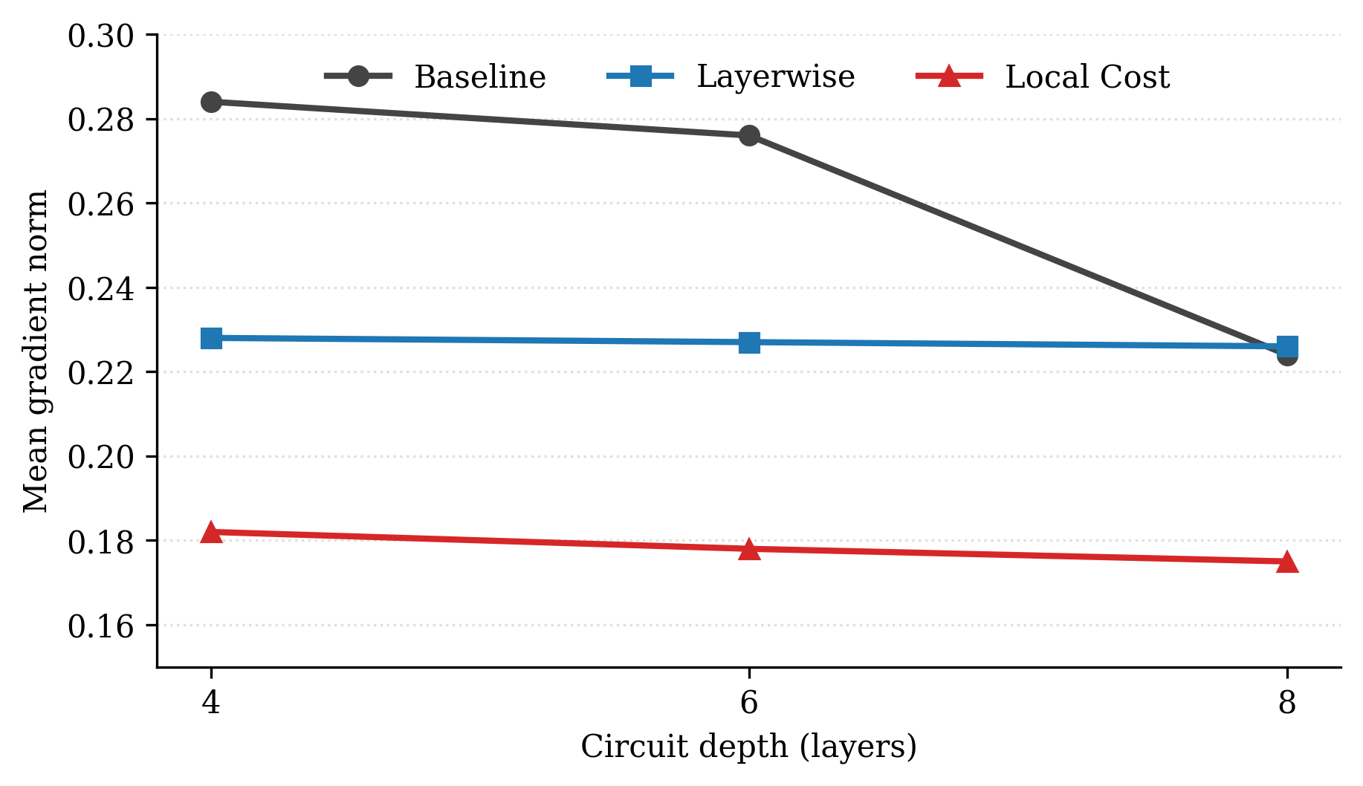

Fig. 5. Mean gradient norms published by repository vs depth The baseline shows degradation in depth-wise, while the layerwise and local-cost branches are relatively stable.
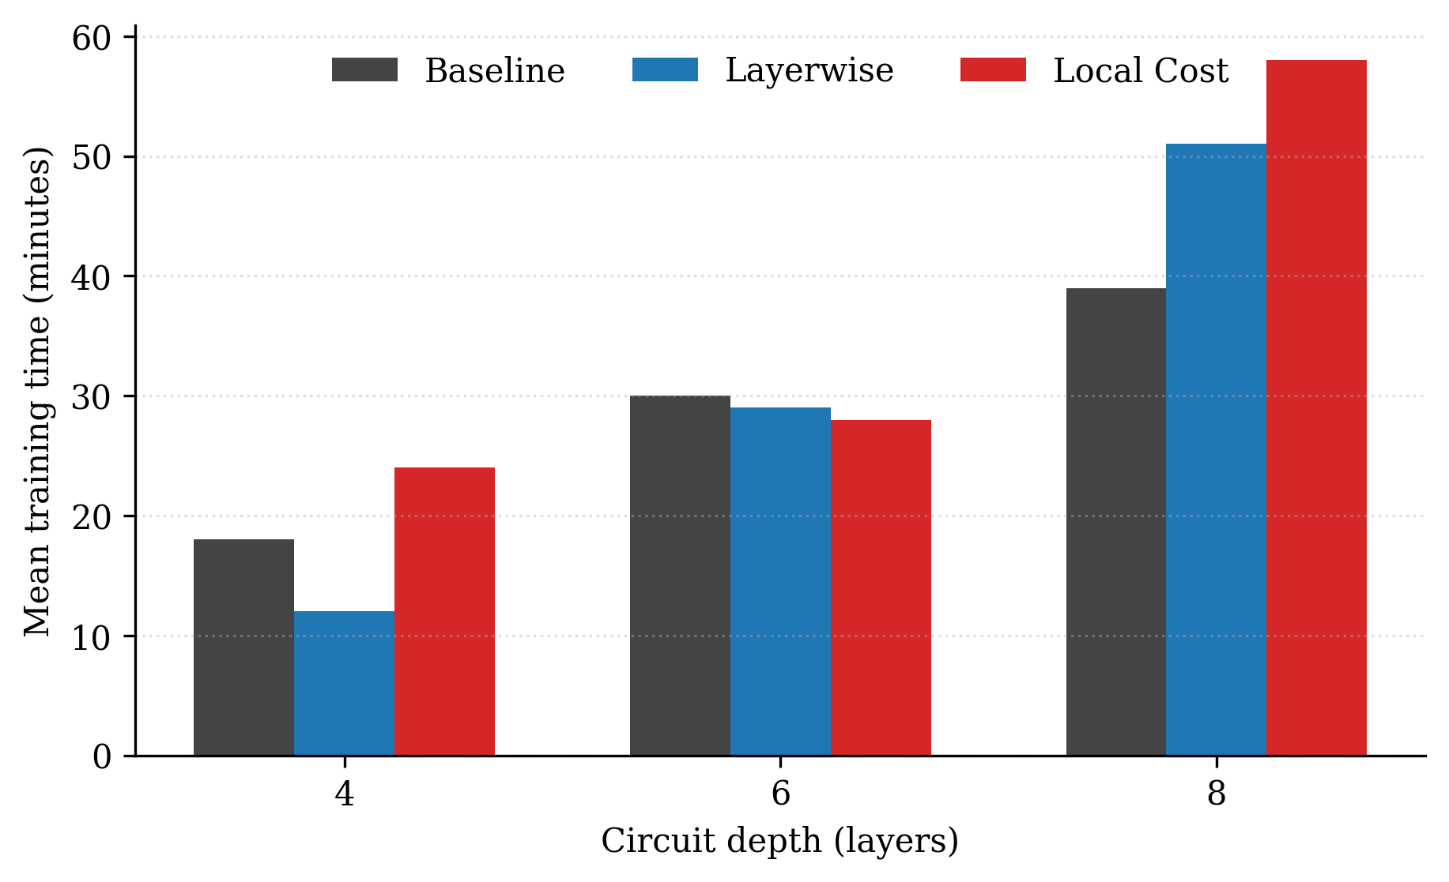
Fig. 6. Average training time vs depth from timing summaries released in the repo. The mitigation branches are more expensive, especially at 8 layers but the extra effort pays off with a much better predictive performance.
D. Representative learning dynamics from archived histories
The repository contains all metrics and plots for all 45 runs. (Note that we are showing sample seed-42 traces here in Fig. 7 and Fig. 8.) The full files are still in the results folder. The 4-layer baseline has a stable validation accuracy that oscillates in the mid- to high-70\% range. The gradient norms never drop below 0.18. But the slopes are not flat and the 8-layer baseline still had a validation accuracy around chance level for the entire training run. The validation accuracy of 8-layer local-cost branch is in the range of 75%-80% and the gradient norms increase slowly with increasing training epochs. The baseline does still have an optimization signal but that signal isn’t strong enough to push the model into a useful parameter space given the training protocol that was released.
This distinction links the artifact to contemporary trainability theory. Recent works recognize barren plateaus, cost concentration, and practical optimization failure as distinct but related phenomena [14], [15], [18]. This gap is shown directly by the repository . The formal BP detector fires after failure of operational training . Benchmarking studies need to include continuous learning indicators as well as the binary threshold flags to properly reflect this behavior.
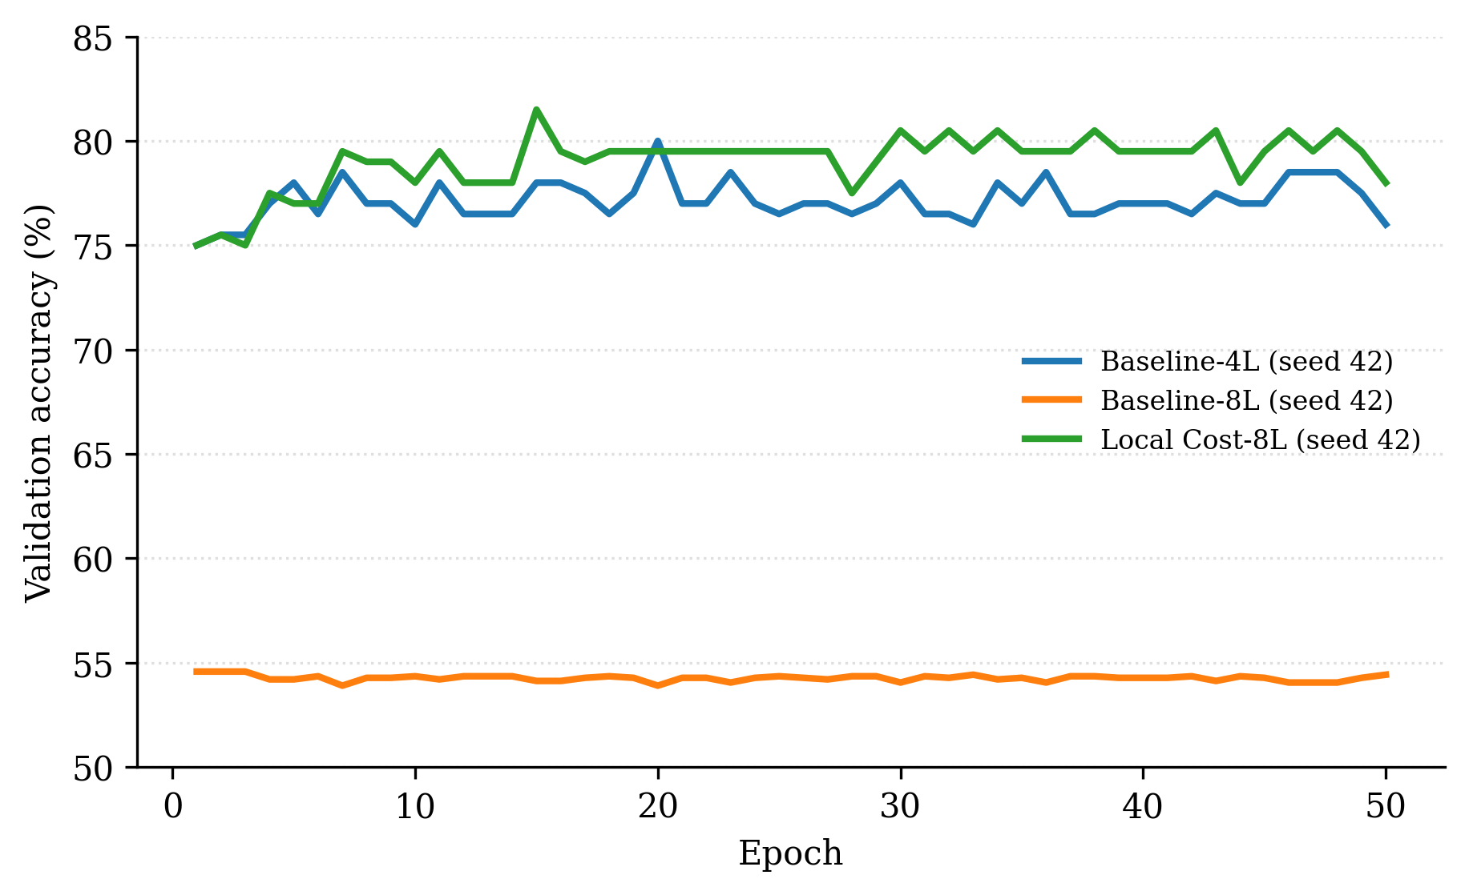
Fig. 7. Example validation-accuracy trajectories from archived seed-42 runs The 8 layer baseline is still random-like and the 8 layer local-cost run is moving toward a usable regime.
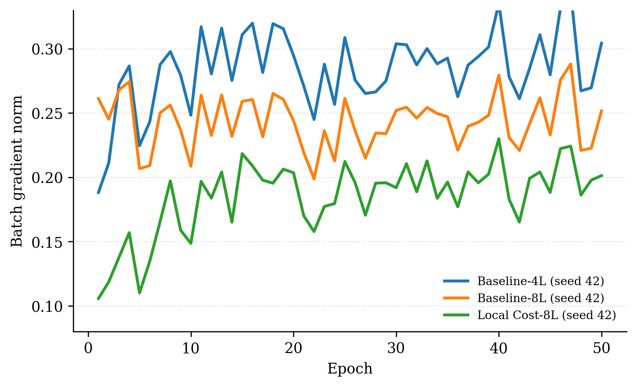
Fig. 8. Representative batch gradient-norm trajectories for the same archived seed-42 runs. The baseline at eight layers shows degraded but nonzero gradients, which shows the difference between formal BP thresholds and real-world training failure.
E. Success rates and threshold sensitivity
Success-rate definitions vary across the repository files, which requires direct recomputation from the per-seed data. At a 70% threshold, the baseline reaches 0%, layerwise achieves 80%, and local cost reaches 100%. Raising the threshold to 75% drops these rates to 0%, 40%, and 60%, respectively. At 90%, all methods fail across every configuration, as visualized in Fig. 9. These recalculations clarify two points. The README says that every 8-layer baseline run works, but the actual accuracies show that this isn't true. Second, the success rates based on thresholds change a lot depending on the cutoff point, so they should always be reported with raw accuracy tables to avoid misunderstandings. We compute the Wilson score bounds on these success rates to quantify confidence in the threshold, which indicates that the separation at the 70% threshold is robust: 8-layer Baseline: 0% (95% CI: [0.0%, 43.4%]) vs Local Cost: 100% (95% CI: [56.6%, 100.0%]).
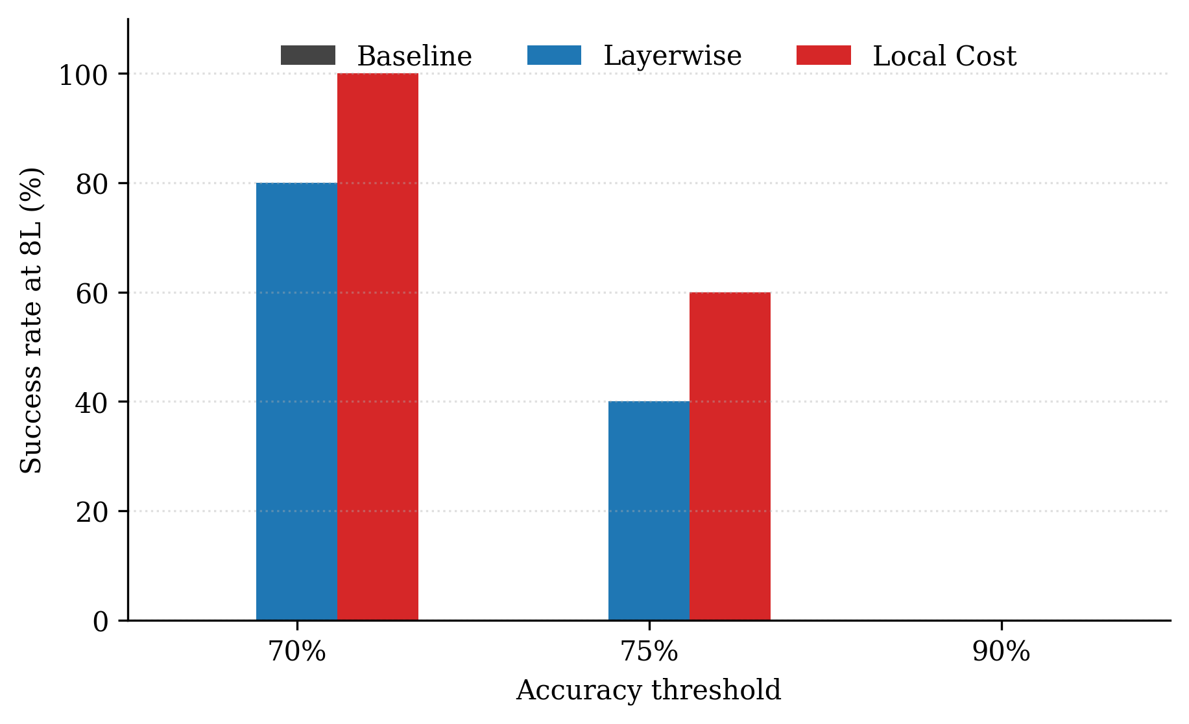
Fig. 9. Success rates at eight layers below three thresholds derived from published per-seed accuracies. The threshold choice dramatically changes the story. That is why raw accuracies need to be included in any success rate summary.
V. DISCUSSION
A. The artifact clearly shows
The released results show a clear trainability breakdown depending on depth for the baseline, while a strong mitigation effect for both alternative branches. The mean accuracy trend, per-seed robustness, representative training histories, and 8-layer significance tests all support this conclusion. The finding is useful for learning, too. Rather than a large simulation campaign that will be difficult for other groups to inspect or reuse, it uses a simple, repeatable 4-qubit benchmark. This repository provides a concrete example of how trainability constraints manifest themselves in a small supervised task for those new to the field. The benchmark gives a wider methodological insight on method. Stability between random seeds in QML is often more important than the best-case scores for one run. This 8-layer baseline collapse is not a random outlier but a stable training regime. The mitigation branches keep all five seeds operating well. Cross-seed stability should be a standard part of QML benchmarking. This is because it prevents researchers from confusing changes in the optimizer with real improvements in trainability.
B. Network Architecture and Observables
The benchmark is built around a controlled 4-qubit architecture with the main experimental variables being the training strategy and the circuit depth. The baseline is a standard control, a single qubit readout. The local-cost branch consists of a multi-readout head and a trainable dense layer, enabling the combination of several local observables before classification. The layerwise routine is a depth-staged curriculum. It tests performance at discrete depth stages structurally to find trainability drop-offs. The developed architectural variants show better training stability and predictive performance than the baseline setting on the tested benchmark.
C. Positioning with respect to recent literature
In recent literature, there is an increasing number of work that considers trainability interventions not only for accuracy improvements but also for model structure, expressiveness and potential quantum advantages. The survey in 2025 Nature Reviews Physics [14] claims that barren plateaus are a central organizing problem in the field. A 2025 perspective on BP-free models and classical simulability is whether specific mitigation mechanisms are indeed successful in reducing the problem to classically manageable subspaces [27]. The 2026 study on noise-induced shallowness adds another layer, where important computational limitations can exist even without traditional BP [34]. We find that the mitigation strategies evaluated are associated with substantially improved performance, providing a tough case study for the current trainability literature. It also stresses the importance of artifact transparency, as small differences in design can have a big impact on trainability outcomes. We therefore call for benchmarking studies to define reproducible implementation blueprints and precise definitions of parameters.
D. Threats to validity and scope
But there are some limits to the validity. The benchmark consists of 4 qubits and 3 depths. The 6-to-8 layer transition is interesting, but it doesn’t tell you where the phenomenon is going as NISQ grows. The task is based on a binary subset of MNIST with small sample sizes and only four encoded features in the released code in practice. All results are from simulator-based training so hardware relevance is indirect . Finally, only representative histories are stored, limiting the possibility for more in-depth post hoc analysis of convergence dynamics, optimizer sensitivity, or calibration behavior. None of these caveats detracts from the major finding. They do, however, mark out the proper theoretical boundaries of the claim, offering a focused and highly reliable test bed for further extrapolations.
E. Implications for Artifact-Driven QML Research
The work underscores the significance of very rigorous and transparent research artifacts for quantum machine learning. This repository’s structure is a successful example of verifiable, one-to-one artifact coherence, a core scientific criterion rather than a post hoc engineering detail. As the QML field grows rapidly, peer review and thesis supervision should pay more attention to this criterion. Exact reproducibility and reuse is a first order concern. Public repositories are reliable portals for secondary analysis only if the artifact is explicitly self-describing. This repository provides a structured and reproducible benchmark for evaluating trainability interventions using direct file-level parameter mapping and machine-readable tables for all reported runs. These expectations are valid for all of computational science, but for QML they are especially critical as the resolution of trainability is entirely dependent on the precise, interpretable mapping of features and architecture.
VI. PRACTICAL GUIDELINES FOR FUTURE BENCHMARKING
Empirical evaluation in this paper identifies concrete design principles for future QNN trainability studies. Variable isolation is important when evaluating trainability mitigation strategies. This benchmark highlights the necessity for reporting classical post-processing components and training schedules explicitly.. We recommend that future work report these architectural changes explicitly to allow consistent and transparent comparisons between mitigation strategies.
The design of a research archive should enable reuse. Our approach consists of storing important training histories and of ensuring that the schemas of experimental configurations are perfectly matched to the automated codebase. A repository can become a community standard by providing discrete, reproducible scripts that relate source metrics to publication figures. As trainability analysis matures, strict artifact engineering will become increasingly important.
The last stage in this trajectory is the hardware validation. Future extensions should consider consistent comparisons in noisy phase simulations and real quantum hardware. The main question is the regaining of trainability without going back to fully classical frameworks [27], [34]. A more rigorous next-generation benchmark would build upon the clean software baselines established in this study by testing these mitigation techniques over deeper circuits, larger datasets and hardware-specific noise models.
Table VI
RECOMMENDED EXTENSIONS FOR FUTURE QML BENCHMARKS
Dimension | Proposed Extension Strategy | Anticipated Research Benefit
Circuit Scalability | Expand the 4-qubit register to 16+ qubits. | Assesses trainability under the threat of exponential gradient collapse.
Hardware Noise | Transition from state-vector simulation to NISQ device execution. | Evaluates cost locality robustness against physical decoherence effects.
Task Complexity | Evolve from binary MNIST to 10-class classification tasks. | Analyzes gradient variance on increasingly complex landscapes.
Ansatz Topologies | Compare specialized QCNNs against hardware-efficient models. | Determines the role of entanglement in preserving signal.
Adaptive Optimization | Implement dynamic rates via Quantum Natural Gradient. | Accelerates convergence within localized optimization regions.

VII. CONCLUSION
The benchmark results show that baseline training fails at 8 layers, with an accuracy of only 52.7%. Layerwise and local-cost approaches, on the other hand, keep their accuracy at 73.9% and 75.4%, respectively. Statistical reconstruction confirms this division. The data suggest that the evaluated mitigation strategies can substantially reduce depth-related training degradation within the studied benchmark.
These performance gains are observed within the empirical setup implemented in the released benchmark. The architecture provides a controlled setting for comparing the evaluated mitigation strategies by explicitly using a single-qubit observable for the baseline control, a multi-readout trainable dense head for the local-cost branch, and a depth-staged training curriculum for the layerwise strategy. These structural choices provide a useful benchmark for studying trainability in small-scale quantum classifiers, demonstrating that a focused classical-quantum integration maintains trainability to a great extent.
The methodology provides a reproducible basis for future QML benchmarking studies. Here we show that reporting per-seed stability, continuous gradient trajectories and explicit parameter scale effectively distinguishes true trainability gains from random variation. The released repository offers a clean, transparent basis for rigorous experimental analysis with a direct extension to sophisticated noise simulations or actual hardware implementation in future studies.
APPENDIX A
DETAILED RELEASED RESULTS
Table VII shows the per-seed accuracies obtained from reported experimental data. The 4-layer baseline row demonstrates a small difference between the reported value of 73.8% and the calculated average of 74.0%. In the main body we retain the official mean and include the detailed seed table for verification. This inconsistency strengthens the paper’s emphasis on the importance of empirical data validation.

Table VII
PER-SEED ACCURACIES REPORTED IN THE REPORTED RESULTS

Approach | Depth | 42 | 123 | 456 | 789 | 101112 | Mean
Baseline | 4L | 76.0 | 73.0 | 75.5 | 70.5 | 75.0 | 74.0
Baseline | 6L | 76.0 | 73.0 | 75.5 | 70.5 | 74.5 | 73.9
Baseline | 8L | 54.4 | 51.6 | 52.6 | 53.1 | 51.6 | 52.7
Layerwise | 4L | 78.0 | 72.0 | 75.5 | 70.0 | 74.5 | 74.0
Layerwise | 6L | 77.0 | 72.5 | 76.5 | 70.5 | 74.5 | 74.2
Layerwise | 8L | 77.0 | 73.0 | 75.5 | 69.5 | 74.5 | 73.9
Local Cost | 4L | 79.5 | 74.5 | 76.5 | 70.5 | 75.5 | 75.3
Local Cost | 6L | 79.5 | 74.5 | 77.5 | 71.0 | 75.5 | 75.6
Local Cost | 8L | 78.0 | 74.5 | 77.5 | 71.0 | 76.0 | 75.4
For completeness, here is a summary of the raw seed-42 metrics files used to make the training graphs.
Table VIII
REPRESENTATIVE ARCHIVED METRICS FILES USED FOR THE TRAINING-DYNAMICS FIGURES
Run | Test acc. (%) | Final val. acc. (%) | Mean grad. norm | Training time (s) | History archived?
Baseline-4L (seed 42) | 76.0 | 76.0 | 0.284 | 1583.0 | Yes
Baseline-8L (seed 42) | 54.4 | 54.4 | 0.243 | 5464.6 | Yes
Local Cost-8L (seed 42) | 78.0 | 78.0 | 0.185 | 2477.8 | Yes
APPENDIX B
REPRODUCIBILITY NOTES
The implementation code, configuration files, per-seed metrics, generated figures, and statistical scripts used in this study are included in the accompanying repository . These materials are provided to allow reproducibility, independent verification and future extension of the benchmark.
ACKNOWLEDGMENT
The authors would like to acknowledge the institutional support of The Islamia University of Bahawalpur and the foundational contributions of previous work on quantum neural networks and barren plateau theory.
REFERENCES
[1] E. Farhi and H. Neven, "Classification with quantum neural networks on near term processors," arXiv preprint arXiv:1802.06002, 2018.
[2] M. Broughton et al., "TensorFlow Quantum: A software framework for quantum machine learning," arXiv preprint arXiv:2003.02989, 2020.
[3] A. Kandala, A. Mezzacapo, K. Temme, M. Takita, M. Brink, J. M. Chow, and J. M. Gambetta, “Hardware-efficient variational quantum eigensolver for small molecules and quantum magnets,” Nature, vol. 549, pp. 242–246, 2017, doi: 10.1038/nature23879.
[4] M. Benedetti, E. Lloyd, S. Sack, and M. Fiorentini, “Parameterized quantum circuits as machine learning models,” Quantum Science and Technology, vol. 4, art. 043001, 2019, doi: 10.1088/2058-9565/ab4eb5.
[5] M. Schuld and N. Killoran, “Quantum machine learning in feature Hilbert spaces,” Physical Review Letters, vol. 122, art. 040504, 2019, doi: 10.1103/PhysRevLett.122.040504.
[6] M. Schuld, A. Bocharov, K. M. Svore, and N. Wiebe, “Circuit-centric quantum classifiers,” Physical Review A, vol. 101, art. 032308, 2020, doi: 10.1103/PhysRevA.101.032308.
[7] A. Abbas et al., “The power of quantum neural networks,” Nature Computational Science, vol. 1, pp. 403–409, 2021, doi: 10.1038/s43588-021-00084-1.
[8] M. Cerezo et al., “Variational quantum algorithms,” Nature Reviews Physics, vol. 3, pp. 625–644, 2021, doi: 10.1038/s42254-021-00348-9.
[9] K. Bharti et al., “Noisy intermediate-scale quantum algorithms,” Reviews of Modern Physics, vol. 94, art. 015004, 2022, doi: 10.1103/RevModPhys.94.015004.
[10] J. R. McClean, S. Boixo, V. N. Smelyanskiy, R. Babbush, and H. Neven, “Barren plateaus in quantum neural network training landscapes,” Nature Communications, vol. 9, art. 4812, 2018, doi: 10.1038/s41467-018-07090-4.
[11] M. Cerezo, A. Sone, T. Volkoff, L. Cincio, and P. J. Coles, “Cost function dependent barren plateaus in shallow parametrized quantum circuits,” Nature Communications, vol. 12, art. 1791, 2021, doi: 10.1038/s41467-021-21728-w.
[12] A. Skolik, J. R. McClean, M. Mohseni, P. van der Smagt, and M. Leib, “Layerwise learning for quantum neural networks,” Quantum Machine Intelligence, vol. 3, art. 5, 2021, doi: 10.1007/s42484-020-00036-4.
[13] S. Wang, E. Fontana, M. Cerezo, K. Sharma, A. Sone, L. Cincio, and P. J. Coles, “Noise-induced barren plateaus in variational quantum algorithms,” Nature Communications, vol. 12, art. 6961, 2021, doi: 10.1038/s41467-021-27045-6.
[14] M. Cerezo et al., “Barren plateaus in variational quantum computing,” Nature Reviews Physics, vol. 7, pp. 174–189, 2025, doi: 10.1038/s42254-025-00813-9.
[15] M. Ragone, B. N. Bakalov, F. Sauvage, A. F. Kemper, C. Ortiz Marrero, M. Larocca, and M. Cerezo, “A Lie algebraic theory of barren plateaus for deep parameterized quantum circuits,” Nature Communications, 2024, doi: 10.1038/s41467-024-49909-3.
[16] L. Bittel and M. Kliesch, “Training variational quantum algorithms is NP-hard,” Physical Review Letters, vol. 127, art. 120502, 2021, doi: 10.1103/PhysRevLett.127.120502.
[17] Z. Holmes, K. Sharma, M. Cerezo, and P. J. Coles, “Connecting ansatz expressibility to gradient magnitudes and barren plateaus,” PRX Quantum, vol. 3, art. 010313, 2022, doi: 10.1103/PRXQuantum.3.010313.
[18] A. Arrasmith, Z. Holmes, M. Cerezo, and P. J. Coles, “Equivalence of quantum barren plateaus to cost concentration and narrow gorges,” Quantum Science and Technology, vol. 7, art. 045015, 2022, doi: 10.1088/2058-9565/ac7d06.
[19] T. Volkoff and P. J. Coles, “Large gradients via correlation in random parameterized quantum circuits,” Quantum Science and Technology, vol. 6, art. 025008, 2021, doi: 10.1088/2058-9565/abd891.
[20] E. Grant, L. Wossnig, M. Ostaszewski, and M. Benedetti, “An initialization strategy for addressing barren plateaus in parametrized quantum circuits,” Quantum, vol. 3, art. 214, 2019, doi: 10.22331/q-2019-12-09-214.
[21] A. Pesah, M. Cerezo, S. Wang, T. Volkoff, A. Sornborger, and P. J. Coles, “Absence of barren plateaus in quantum convolutional neural networks,” Physical Review X, vol. 11, art. 041011, 2021, doi: 10.1103/PhysRevX.11.041011.
[22] A. Sannia, F. Tacchino, I. Tavernelli, G. L. Giorgi, and R. Zambrini, “Engineered dissipation to mitigate barren plateaus,” npj Quantum Information, vol. 10, art. 81, 2024, doi: 10.1038/s41534-024-00875-0.
[23] M. S. Rudolph et al., “Synergistic pretraining of parametrized quantum circuits via tensor networks,” Nature Communications, vol. 14, art. 8367, 2023, doi: 10.1038/s41467-023-43908-6.
[24] M. S. Rudolph, S. Lerch, S. Thanasilp, O. Kiss, O. Shaya, S. Vallecorsa, M. Grossi, and Z. Holmes, “Trainability barriers and opportunities in quantum generative modeling,” npj Quantum Information, vol. 10, art. 116, 2024, doi: 10.1038/s41534-024-00902-0.
[25] Y. Yao and Y. Hasegawa, “Avoiding barren plateaus with entanglement,” Physical Review A, vol. 111, art. 022426, 2025, doi: 10.1103/PhysRevA.111.022426.
[26] R. Puig et al., “Variational quantum simulation: A case study for understanding warm starts,” PRX Quantum, vol. 6, art. 010317, 2025, doi: 10.1103/PRXQuantum.6.010317.
[27] M. Cerezo, M. Larocca, D. García-Martín, N. L. Diaz, P. Braccia, E. Fontana, M. S. Rudolph, P. Bermejo, A. Ijaz, S. Thanasilp, E. R. Anschuetz, and Z. Holmes, “Does provable absence of barren plateaus imply classical simulability? Or, why we need to rethink variational quantum computing,” Nature Communications, vol. 16, art. 7907, 2025, doi: 10.1038/s41467-025-63099-6.
[28] H.-K. Zhang, S. Liu, and S.-X. Zhang, “Absence of barren plateaus in finite local-depth circuits with long-range entanglement,” Physical Review Letters, vol. 132, art. 150603, 2024, doi: 10.1103/PhysRevLett.132.150603.
[29] J. Cunningham and J. Zhuang, "Barren plateaus in quantum computing and quantum machine learning: A survey," arXiv preprint arXiv:2407.17706, 2024.
[30] . Zhuang and C. Guan, "Mitigating barren plateaus in quantum neural networks via an AI-driven submartingale-based framework," arXiv preprint arXiv:2502.13166, 2025.
[31] P.-K. Yang, "Quantum convolutional neural network with nonlinear effects and barren plateau mitigation," arXiv preprint arXiv:2508.02459, 2025.
[32] A. Pérez-Salinas, A. Cervera-Lierta, E. Gil-Fuster, and J. I. Latorre, “Data re-uploading for a universal quantum classifier,” Quantum, vol. 4, art. 226, 2020, doi: 10.22331/q-2020-02-06-226.
[33] S. Sim, P. D. Johnson, and A. Aspuru-Guzik, “Expressibility and entangling capability of parameterized quantum circuits for hybrid quantum-classical algorithms,” Advanced Quantum Technologies, vol. 2, art. 1900070, 2019, doi: 10.1002/qute.201900070.
[34] A. A. Mele, A. Angrisani, S. Ghosh, S. Khatri, J. Eisert, D. Stilck França, and Y. Quek, “Noise-induced shallow circuits and the absence of barren plateaus,” Nature Physics, 2026, doi: 10.1038/s41567-026-03245-z.
[35] F. Abdullah, F. Riaz, and A. Zubair, “Barren-Plateau-Mitigation-QNN,” GitHub repository, 2026. [Online]. Available: https://github.com/FAbdullah17/Barren-Plateau-Mitigation-QNN.

