POLITECNICO DI MILANO
Computer Science and Engineering
Project of Software Engineering 2

Integration Test Plan
Document

Authors: Falci Angelo 875123
Lanzuise Valentina 807364
Lazzaretti Simone 875326

Reference Professor: Di Nitto Elisabetta

SUMMARY

1 Introduction
In this document we are going to realize an Integration Testing, which will show that all the components of our software interacts with each others and that their functionalities actually work. This integration testing includes interaction between all layers of the system, as a complete end-to-end of the functionality.

1.1 Revision History
Version 1.0

1.2 Purpose and Scope
This document represents the Integration Testing Plan Document for PowerEnJoy.
Integration testing is fundamental to ensure that every component that is in our system works well as all by itself but also with other components.
For this reason we write here in details every aspect of the integration test:
- A list of all components and their sub-components in the system that will have to be tested
- Description of the criteria that must be respected during the tests
- The approach that must be used and the logic behind it
- In which order the components and sub-components will be integrated and testing
- Expected output data for all integration test in front of determinate inputs
- The minimum performance demanded by the system requirements, listed in previous documents (specially in RASD)
- List of tools that will have to be used during the testing, together with a description of the operational environment in which the test will be executed

1.3 List of Definitions and Abbreviation
Here we write the main terms we will use in the project with their meaning.
• GUEST: identify the person not registered yet.
• REGISTERED USER: identify the person registered who can use the service.
• USER: identify the generic person who is using the service.
• SAFE AREA: identify the area where the user can leave a car to have a
• discount.
• POWER GRID: identify the power station that a safe area can have where the
• user can recharge the car to obtain a discount.
• SYSTEM: identify server and database that manage the web-application
service, and the software that manages the car.
• CAR: identify every single car provided by PowerEnJoy.
• POSITION: indicate the specific position about car, safe area and power grid
using latitude and longitude.
• ASSISTANCE: identify service who user can call if it has a problem with
the car.
• ASSISTANT: identify both the operator that manages the maintenance of the
cars and the telephone operator who helps clients.
• HOMEPAGE: indicate the page in which are addressed either guests and
registered users before signing up.
• USER HOME: identify the page in which users are addressed after log in where
they have access to the services.
• PERSONAL USER DEVICE: identify a generic device used by user with an
Internet connection.
• MSO: identify the “Money Saving Option” function.
• VoIP: is a acronym to identify Voice over Internet Protocol is a methodology and
group of technologies for the delivery of voice communications over Internet
Protocol (IP) networks, such as the Internet.
• Work Station: identify the computers in the office of PowerEnJoy with which the
assistants can communicate with the server.
• Model: identify the abstraction of the data of the DBMS.
• SA: “Safe Area” abbreviation.
• PG: “Power Grid” abbreviation.
• MVC: “Model View Controller” abbreviation.

1.4 List of Reference Documents
• The project description
• The RASD
• The DD
• Examples of project of the previous year

2 Integration Strategy

2.1 Entry Criteria
Before proceeding with the integration test, we have to introduce some entry criteria dictated by the progress of the process, in order to produce meaningful results.
First of all "Requirement Analysis and Specification Document" and "Design Document" must be written completely. This is necessary because we must know the all components that our system has and how they are connected each other.
Then, the components that we want to test must be at least partially completed. For this reason we can start integrating test when at least the following percentage for each components are completed:
- 100 % for the Model: database and all classes that interact with it must been completed because this is the most critic part and all other components depend from them
- 90% for User System: this is the components that connect our main stakeholders to the system (and all components that are included in the system). We integrate this before Car System because if nobody is connected to the system we can't test efficiently the Car System.
- 70% for Car System: this component include all the service that user can use through the car display. We let this component for last in order to test the system like in real case, in fact the user will interact first with user system (using the browser application) and the it will interact with car system (using the car display).
- 50% for User Client and Car Client: this components include the graphics that user will use to have access to the service.
The percentage written above shows the situation that we must reach before starting the integrating test. However when we integrate and test a single component, its percentage will have to be at lest 90% or we will waste time repeating the test again when the component is at an higher percentage of completeness.

2.2 Element to be Integrated
In the following paragraph we are going to provide a list of all the components
that need to be integrated together.
As described in the Design Document, the system is composed by five sub-systems: Model, User System, Car System, User Client and Assistant Client. We can view DBMS and Model like a unique subsystem because the DBMS doesn't offer functionalities but it just contain the data, while Model offers different functionalities to interact with the DBMS.
At first we are going to integrate those components that strongly depend one another and that provide the main functionalities of PowerEnJoy. We obviously will start from the Model because all other components need to interact with the data in DBMS in order to work.
Then we will integrate and test User System and Car System, these two components are included in the server and satisfy the requests that arrive from the User Client or Car Client.
We have to integrate and test different sub-components in order to test the entire User System: registration request, access request, modification info request, address request, booking request and renting request.
We have to do a similar work for the Car System: personal code request, safe area request, path request, MSO request, current charge request and parking request.
At the end we will integrate and test User Client and Car Client. They include the graphics that user will use to do the requests (like renting or booking) and they simply will sent the request to the server.

2.3 Integration Testing Strategy
The strategy used for testing will be a mix of the bottom-up strategy and the critical module first.
We are going to use a bottom-up strategy for the sub-systems we declared before, and in particular for the server side: this choice of the bottom-up takes consideration of the necessity to have in first place a full working server. We prefer bottom-up rather than top-down one, because we think that the last one is less functional, slow and dispersive, according to the fact that in order to test the whole system it must be already completed; by the other side, the choice of the bottom-up system have some negative aspect, like the fact that we could test every single component.
The first subsystem to implement is the Model one, because all other components in the system have to use this component to interact with the DBMS, as we are going to explain in the following paragraph.
Then, in order to have complete and functional integration, we thought to use the critical module first, in particular testing the different User System and Car System. This strategy allows us to concentrate our testing efforts on the riskiest components first.
According to the fact that User System and Car System interact each other but the last one depends on the implementation of the first and so also the fact that a malfunctioning of the first influence a lot the operating of the last, we choose to integrate User System and Car System in the respective order.

2.4 Sequence of Component/Function Integration

Software Integration Sequence
Above we already said that we will use the bottom-up approach, so in this chapter we describe in which order the sub-components are integrated in order to build the entire system.

Model
The first two components we integrate are “Database Management System” and “Model”. These must be the first components because all other components depend from them to modify the data of the system.
By “Model” we mean all classes that manage the queries on the DB; these classes will be used from the higher components in order to modify the data on the DB.
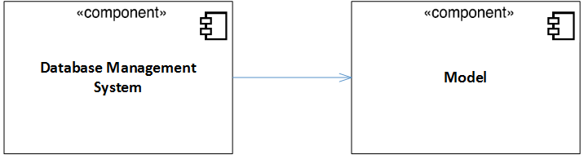

User System
Then we integrate all components that satisfy the requests that user will do in the browser.
We integrate this before the Car System because if user wants to interact with the Car System he/she needs a personal code, that user can achieve only after the registration, which is managed by “Registration Request”, a component that belongs to User System. So Car System depends in part from User System.
Now, user system includes different components, in the picture below we show the best order to integrate them:
- Personal Information Management: this component manages the personal information of the users. It includes four sub-components: one for the registration, one for logging in, one for modifying the personal information after the registration and the last one is for the personal code. This last sub-component is very simple to integrate and test (it just verifies that the personal code inserted is right) so we can add it later, during the Car System integration (also because we can test better this sub-component in the Car System).
The sub-components are inserted in the order shown in the picture because registration is independent, log in depends from registration (if nobody is registered, nobody can log in) and “Modify information manager” depends from registration and log in (if user wants to modify its personal information he/she has to sing up and log in)
- Map Management: this component handles all the requests dealing to the map. To includes five sub-component: for address research, for safe area research, for the path research and for the MSO option.
In this step we just integrate the address research because it is independent from the others, and moreover all other sub-components are used in the Car System so we can add them in the next step.
- User-Car Management: this component manages the booking and renting functionalities. It includes four sub-component: for renting, for booking, for parking function and for viewing charge.
Here we include the first two components, booking and renting that are more critic than other two.
We integrate booking sub-component before, but booking and renting depend each other so it is better integrate them together before testing (system for booking a car checks if the car isn't rented or booked, in the same way the system for renting a car checks if the car isn't rented or booked).
- Assistance Management: this is the last sub-component we integrate for user system. It is the less critical component in user system because it just manages the assistance request that user does. In details it puts in contact an user with a free assistant when user makes a request of assistance.
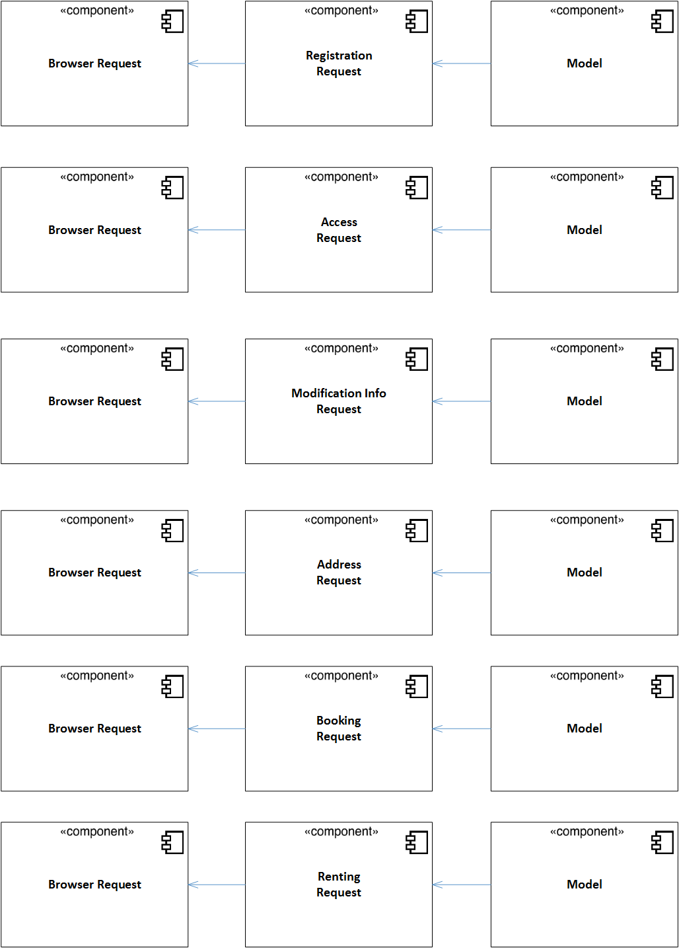
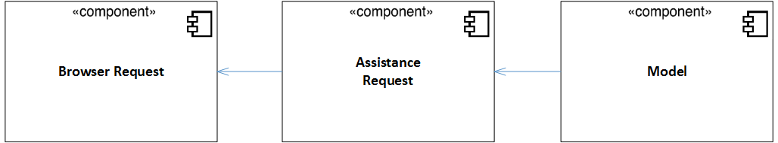

Car System
Now we have to integrate all components that satisfy the requests from the car display.
This component satisfies the requests that user does during the renting while he/she is in the car.
It includes different sub-components and we insert them in this order (shown in the following the picture):
- Personal Information Management: we start to insert the last sub-component we mentioned above because all components in Car System depend from it (in fact user must insert its right personal code to have access to the Car System).
- Map Management: for the second we insert the sub-components we didn't insert before (as we explained previously). We respect the order shown in the picture because, in order to build the path, it needs to know the position about safe area (so “Path Request” depends from “Safe Area Request) and in the “MSO request” component we use a combination of the two sub-component mentioned above (“Path Request” and “Safe Area Request”).
- User-Car Management: at the end we integrate and test the component for viewing charge and parking function. Their order is irrelevant because they are independent each other.

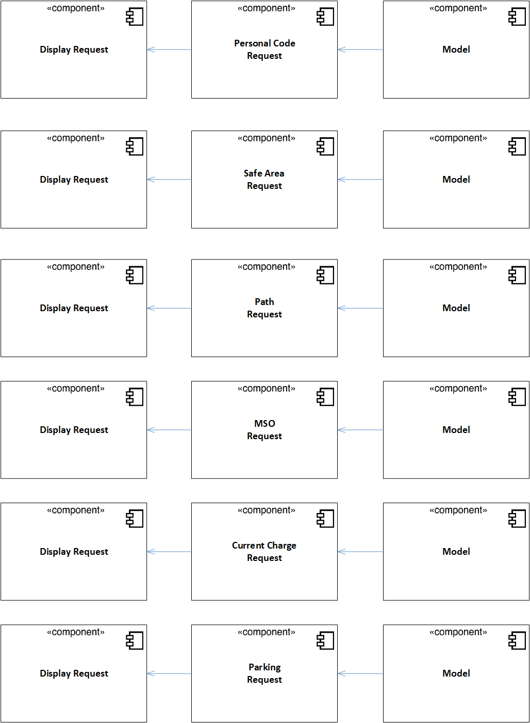

User Client
“User Browser Application” represents the web application that user can use in every device to have access to the services of PowerEnJoy.
This component interacts with User System.

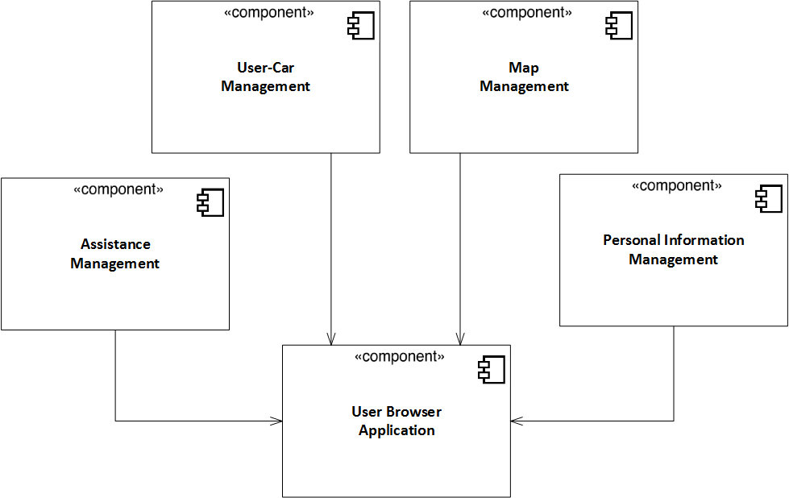
Car Client
“Car Display Application” represents the application that user can use in the car display to have access to the services in the cars of PowerEnJoy.
This component interacts with Car System.

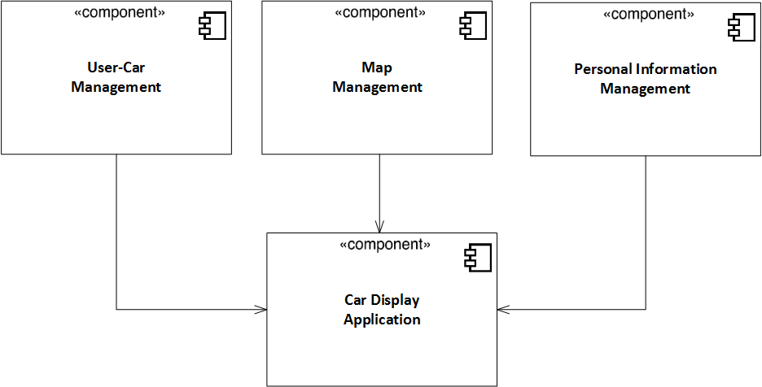

Subsystem Integration Sequence
In the graphics below we can see how all high-level components are connected each other in order to create the entire infrastructure.
We have described each high-level component and which sub-components it includes in the previous chapter, “Software Integration Sequence”.

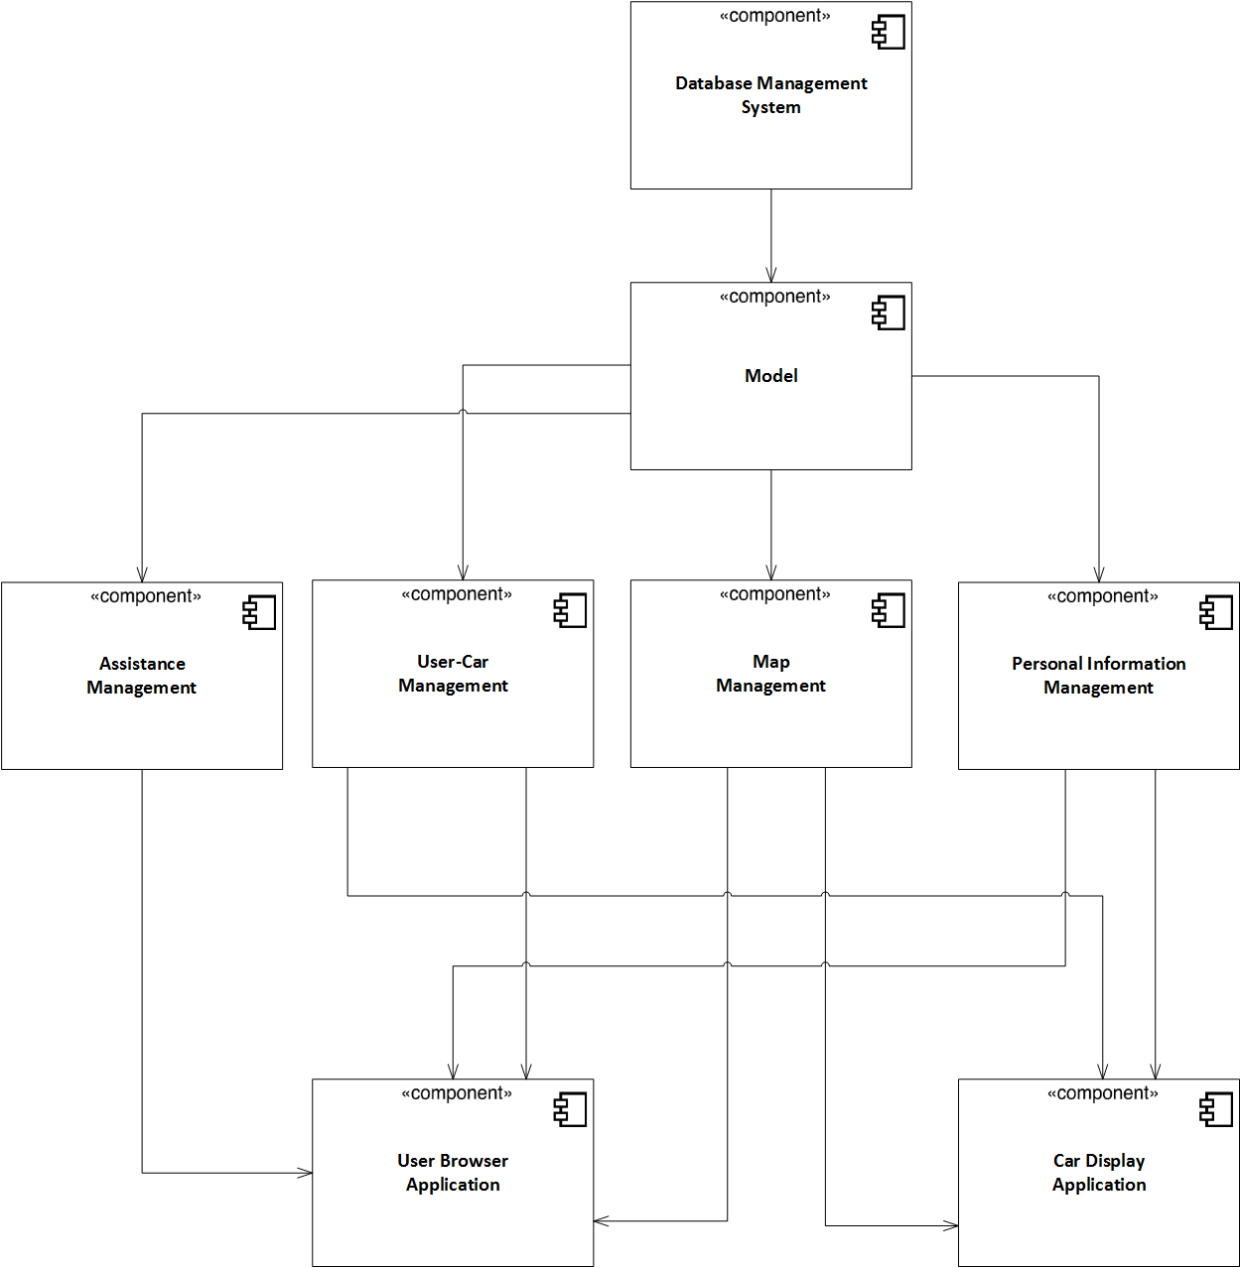

3 Individual Steps and Test Description

In this chapter we'll provide a detailed description of the tests to be per-
formed on each pair of components that have to be integrated.
The methods tested that are shown below are the most important and critical.
The structure is the following: the title is composed by the name of the sub-system checked and the components that interacts with the following functions. To be precised, the left component in the rounds is the caller, while the right component in the rounds is the called.
For each method we're going to provide a brief description of the input
values and the corresponding expected effects on the system. Where it's written "Nothing" under the "Input" column means that no argument has been passed in the function

Personal Information Management(Registration request → Model)

validate_newUserData(request)
Input | Effect
A null parameter | A NullArgumentException is thrown
A request with an invalid type of data | An InvalidArgumentException is thrown
A request with a driving-license ID, e-mail and/or identify card number already registered in the database | An InvalidArgumentArgumentException is thrown
Formally valid request | The request is ready to be sent to the database
Previous condition | Nothing

adding_Info(request)
Input | Effect
A null argument | A NullArgumentException is thrown
A formal valid request | Data are added to the database
Previous condition | validate_newUserData(request) ends successfully

Personal Information Management( Access Request → Model)

validate_log_in(combination)
Input | Effect
A null parameter | A NullArgumentException is thrown
A wrong combination of password and username | An InvalidArgumentException is thrown
A valid combination of password and username | The system returns the value to publish the userhome

Personal Information Management (Modification Information Request → Model)

modification_data(data, type)
Input | Effect
A null data | A NullArgumentException is thrown
The same data that is going to be substituted | An InvalidArgumentException is thrown
An invalid data | An InvalidArgumentException is thrown
A formal valid argument | The already existing data is updated with the new one

Personal Information Management (Personal Code Request → Model)

turn_onCar(code)
Input | Effect
A null code | A NullArgumentException is thrown
An invalid code | An InvalidArgumentException is thrown
A formal valid code | Confirm that the car can turn on

Map Management (Address Request → Model)

verify_address(address)
Input | Effect
A null address | A NullArgumentException is thrown
An invalid address | An InvalidArgumentException is thrown
A formal valid address | The system shifts the map view on the searched address

search_coordinates(address)
Input | Effect
A null address | A NullArgumentExceptionis thrown
A formal valid address | Returning the desired address

Map Management (Safe Area Request → Model)

getSA()
Input | Effect
Nothing | Return the list of safe areas to be published on a car display

getPG()
Input | Effect
Nothing | Return the list of safe areas with power grid station to be published on a car display

Map Management (Path Request → Model)

destination_address(address)
Input | Effect
A null argument | A NullArgumentException is thrown
An invalid address | An InvalidArgumentException is thrown
A formal valid address | Itinerary is shown to the user on the display

Map Management (MSO Request → Model)

sendingDestinationCoordinates(address)
Input | Effect
A null argument | A NullArgumentException is thrown
An invalid address | An InvalidArgumentException is thrown
A formal valid address | Send the coordinates for the search of the optimal safe area

getOptimalSA(address)
Input | Effect
A null argument | A NullArgumentException is thrown
An invalid address | An InvalidArgumentException is thrown
A formal valid address | The optimal safe area is returned

calculatingItinerary(startingPoint, optSA)
Input | Effect
Formal and valid arguments | The itinerary from the position of the car to the safe area is calculated
Previous condition | sendingDestinationCoordinates(address) ends successfully

User-Car Management (Booking Request → Model)

booking(request)
Input | Effect
A null request | A NullArgumentException is thrown
The car is not available for booking | An InvalidArgumentException is thrown
A formal valid request | Confirm notification sent to the user

delete_booking(request)
Input | Effect
An invalid request (empty booking list) | An InvalidArgumentException is thrown
A formal valid request | The selected booking is deleted

checking_availability(car)
Input | Effect
A null argument | A NullArgumentException is thrown
The field "status" of the argument is set to "locked" or "booked" | Return false
The field "status" of the argument is set to "free" | Return true

updateStatus(car)
Input | Effect
Null | A NullArgumentException is thrown
Formal valid argument and checking_availability(car) returns true | The field "status" is set to "booked"
Formal valid argument and checking_availability(car) returns false | The field "status" is set to "free”
Previous condition | checking_availability(car) ends successfully

User-Car Management (Renting Request → Model)

verify_existance(carPlate, carCode)
Input | Effect
A null data in the request | A NullArgumentException is thrown
An invalid data in the request | Return false
A formal valid request | Return true

verify_availability(carPlate)
Input | Effect
A null data in the request | A NullArgumentException is thrown
An invalid data in the request | Return false
The car matched with the argument is “locked” | Return false
The car matched with the argument is “free” | Return true

changing_status(carPlate)
Input | Effect
A null argument | A NullArgumentException is thrown
A formal valid argument | The car status is switched to "locked" and it's opened

stopping_charge(rentingID)
Input | Effect
A null argument | A NullArgumentException is thrown
A formal valid argument | The charge of the rent is stopped

formulating_bill(rentindID)
Input | Effect
A null argument | A NullArgumentException is thrown
A formal valid argument | The payment is committed and a notification is sent to the renter

Charge Management (Current Charge Request → Model)

getCharge(rentingID)
Input | Effect
A null argument | A NullArgumentException is thrown
A formal valid renting id | The charge data is returned from the server

Assistance Management (Assistance Request → Model)

askingHelp(request)
Input | Effect
A null argument | A NullArgumentException is thrown
A formal valid request | User's request is sent to all the assistance module in the server

inqueueAssistRequest(request)
Input | Effect
Nothing | Request is put in a waiting queue in order to wait to be resolved

dequeueAssistRequest(request)
Input | Effect
Nothing | Request is removed from the waiting queue because an assistant take it in charge

Personal Information Management (Browser Request → Registration Request)

send_request_to_RR(request)
Input | Effect
A null request | A NullArgumentException is thrown
A valid request | Request is forwarded to "Registration Request" component

Personal Information Management (Browser Request → Access Request)

send_request_to_AccR(request)
Input | Effect
A null request | A NullArgumentException is thrown
A valid request | Request is forwarded to "Access Request" component

Personal Information Management (Browser Request → Modification Info Request)

send_request_to_MIR(request)
Input | Effect
A null request | A NullArgumentException is thrown
A valid request | Request is forwarded to "Modification Info Request" component

Map Management (Browser Request → Address Request)

send_request_to_AddR(request)
Input | Effect
A null request | A NullArgumentException is thrown
A valid request | Request is forwarded to "Address Request" component

User Car Management (Browser Request → Renting Request)

send_request_to_RentingR(request)
Input | Effect
A null request | A NullArgumentException is thrown
A valid request | Request is forwarded to "Renting Request" component

User Car Management (Browser Request → Booking Request)

send_request_to_BR(request)
Input | Effect
A null request | A NullArgumentException is thrown
A valid request | Request is forwarded to "Booking Request" component

Personal Information Management (Display Request → Renting Request)

send_request_to_RentR(request)
Input | Effect
A null request | A NullArgumentException is thrown
A valid request | Request is forwarded to "Renting Request" component

Charge Management (Display Request → Current Charge Request)

send_request_to_CCR(request)
Input | Effect
A null request | A NullArgumentException is thrown
A valid request | Request is forwarded to "Current Charge Request" component

Map Management (Display Request → SA Request)

sending_to_SAR(request)
Input | Effect
A null request | A NullArgumentException is thrown
A valid request | Request is forwarded to "SA Request" component

Map Management (Display Request → MSO Request)

sending_to_MSOR(request)
Input | Effect
A null request | A NullArgumentException is thrown
A valid request | Request is forwarded to "MSO Request" component

User Client (User Browser Application → Personal Information Management)

sending_Request(request)
Input | Effect
A null request | A NullArgumentException is thrown
A valid request | The request is sent from the user client to the "Dispatcher Request" sub-component and forwarded to the "Browser Request" sub-component

publish_user_home()
Input | Effect
Nothing | The system shows the user home page to the user

publish_error_message()
Input | Effect
Nothing | The system shows an error message to the user

show_registration_complete()
Input | Effect
Nothing | The system says to the user with a message that the registration has been completed

User Client (User Browser Application → Map Management)

sending_Request(request)
Input | Effect
A null request | A NullArgumentException is thrown
A valid request | The request is sent from the user client to the "Dispatcher Request" sub-component and forwarded to the "Browser Request" sub-component

center_location(coordinates)
Input | Effect
Nothing | The system centers the position of the user on the coordinates received and published the result to the user

showing_car_information(carPlate)
Input | Effect
A null parameter | A NullArgumentException is thrown
CarPlate is not found in the model | An InvalidArgumentException is thrown
The parameter is valid | The system shows on the screen information of the car

User Client (User Browser Application → User-Car Management)

showing_renting_screen()
Input | Effect
Nothing | The system loads the screen where user inserts data to rent the car

sending_carplate&code(request)
Input | Effect
A null request | A NullArgumentException is thrown
A valid request | The request is sent from the user client to the "Dispatcher Request" sub-componentand forwarded to the "Browser Request" sub-component

Car Client (Car Display Application → User-Car Management)

activePF()
Input | Effect
Nothing | The engine of the auto activate the "Park Function" mode

checkPF(sensor)
Input | Effect
A null argument | A NullArgumentException is thrown
The sensor is turned off | Return false
The sensor is turned on | Return true

suspend_engine()
Input | Effect
Nothing | The engine is shut down, except for the charge service system and sensors

sending_request(request)
Input | Effect
A null request | A NullArgumentExcepion is thrown
A valid request | The request is sent from the user client to the "Dispatcher Request" sub-componentand and then forwarded to the "Display Request" sub-component

visualize_charge(charge)
Input | Effect
Nothing | The system shows on the display the current charge of the service

showing_proximity_SA(coordinates, distance)
Input | Effect
Distance is a null argument | A NullArgumentException is thrown
Distance is a valid argument and coordinates too | The system shows on the car display safe areas limited to a certain distance

showing_proximity_SA_wPG(coordinates, distance)
Input | Effect
Distance is a null parameter | A NullArgumentException is thrown
Distance is a valid argument and coordinates too | The system shows on the car display safe areas limited to a certain distance

showing_destination_screen()
Input | Effect
Nothing | The systems load the screen where user has to insert the destination address

showing_itinerary(setCoordinates)
Input | Effect
A null parameter | A NullArgumentException is thrown
A formal and valid argument | The system shows to the user the itinerary

4 Tools and Test Equipment Required
In order to test the various components of our project, we will use different automated testing tools. As we have written in the Design Document, our components are think in Java and Javascript, while Database is thought in MySQL. For the components that have a business logic running in Java, we are going to utilize these tools:
- JUnit framework: this tool is principally used to unit testing activity, but it is also useful to guarantee the exact execution of the components and that the produced results are correct. In particular, we are going to provide different kind of data to the methods of our main functionalities, in order to verify that wrong data raise an exception and it is managed in the right way, while inputs that are on the “domain border” and other topic data produced the results that we expected.
- Maven Integration Tests: this tool enables us to execute integration tests in order to verify that the components interact in the right way, so that the whole project actually works.

Instead, in order to test the components whose logic is executed in Javascript (client side), which can be difficult to test, we are going to use the following tools:
- Qunit: it permit to execute unit tests, so on the all script functions and object methods, using and verifying some assertions, and answering with true or false, depending if it is guaranteed the right execution of the unit.
- Mockjax : it is used to test in order to test and simulate the keyboard or mouse input of user.

5 Program Stubs and Test Data Required

As we have mentioned in the Integration Testing Strategy section of this
document, we are going to adopt a bottom-up approach for the component integration and testing.
Because of this choice, we need a number of drivers to actually perform the necessary method invocations on the components to be tested; this will be mainly accomplished in conjunction with the JUnit framework.
Here follows a list of all the drivers that will be developed as part of the integration testing phase, explained with their specific role:
- Model Driver this testing module will invoke the methods in the Model in order to verify that Model component interacts in the right way with the DBMS.
- Personal Information Management Driver this testing module will invoke the methods in all sub-components in the Personal Information Management in order to verify that they interact with the Model in the right way for satisfying the user requests.
- Map Management Driver this testing module will invoke the methods in all sub-components in the Map Management in order to verify that they interact with the Model in the right way for satisfying the user requests.
- User-Car Management Driver this testing module will invoke the methods in all sub-components in the User-Car Management in order to verify that they interact with the Model in the right way for satisfying the user requests.
- Assistance Management Driver this testing module will invoke the methods in all sub-components in the Assistance Management in order to verify that they interact with the Model in the right way for satisfying the user requests.
- User Browser Application Driver using Mockjax this testing module simulates the interaction between user and browser application in order to verify that all services offered for browser application are available and working.
- Car Display Application Driver this testing module simulates the interaction between user and the application in the car display in order to verify that all services offered for car application are available and working.

6 Effort Spent
- Falci Angelo
- Lanzuise Valentina
- Lazzaretti Simone

