b)

%{

#include<stdio.h>

%}

%%

[<][/]?[A-Za-z]+[0-9A-Za-z#.:="\t\\]*[>] { printf("%s \n",yytext);}

. {}

%%

int main()

{

yyin = fopen("file7h.txt","r");

yylex();

return 1;

}

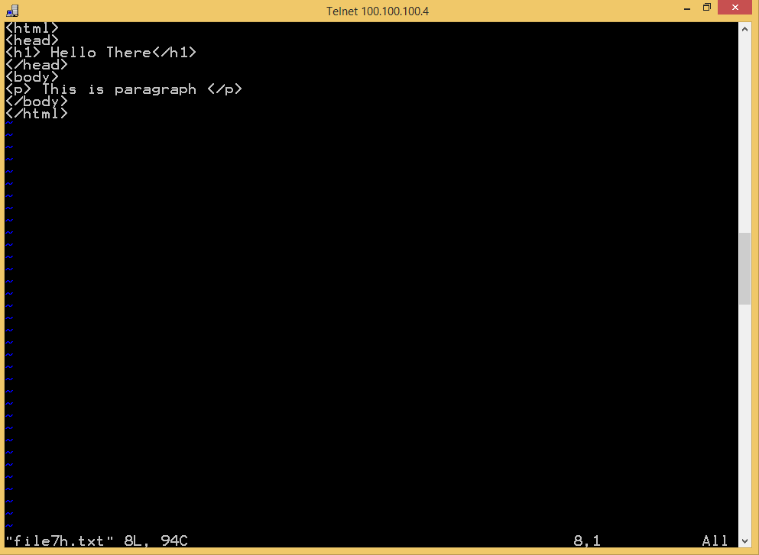

**OUTPUT:**

