Name - Milind Singh
Roll Number - S26BCAU0075

Question 1: Find out the sum of two digits and print their sum
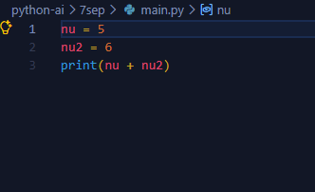
Answer 1:

Question 2: Find out the sum and average of three numbers and print their sum and average.
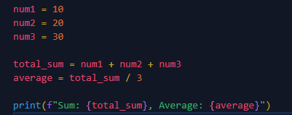
Answer 2:

