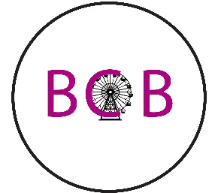Big city banquets

Online based banquet hall in the best big city there is, Seattle.

242 N. Waterfront Plaza Seattle, Washington 98003

# Who are we here at BCB?

Big City Banquets is the leading and largest online based banquet hall company in the U.S. with just over 600 bookings a year! BCB has been serving the Seattle area with a beautiful banquet hall to hold anything from business meetings to wedding receptions since 2008!

# How we got our start

There may be plenty of banquet halls in Seattle area, but what about a banquet hall that you can do almost ALL the planning online, now that is what Seattle needed. So we created Big City Banquets.

* We do 90% of event planning online
* We connect easier and quicker to our customers through the internet-based society that we live in today

# Why we do what we do

We wanted to create a new kind of banquet hall. A place where people who live out of state don’t have to come all the way to our location to plan their event. They can do it almost all online with the help of our amazing staff.

# Our target audience

Here at Big City Banquets we target anyone looking for a banquet hall to host their next event, with a little twist. We do almost ALL of our planning for your event online. Being that a lot of our customers are from out of state, it was very important to us that we were able to plan their whole event BEFORE they fly out for the real thing to eliminate any extra costs or troubles.