Workflow

How to code ping pong?

The idea of this workflow is to go along with the evolution of games, so we’re starting from the beginning till end step by step.
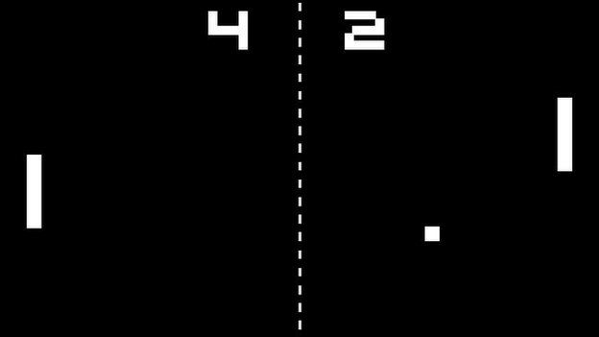
Just the dimensions of the image above it has a height of 351 and width of 624 and a black background

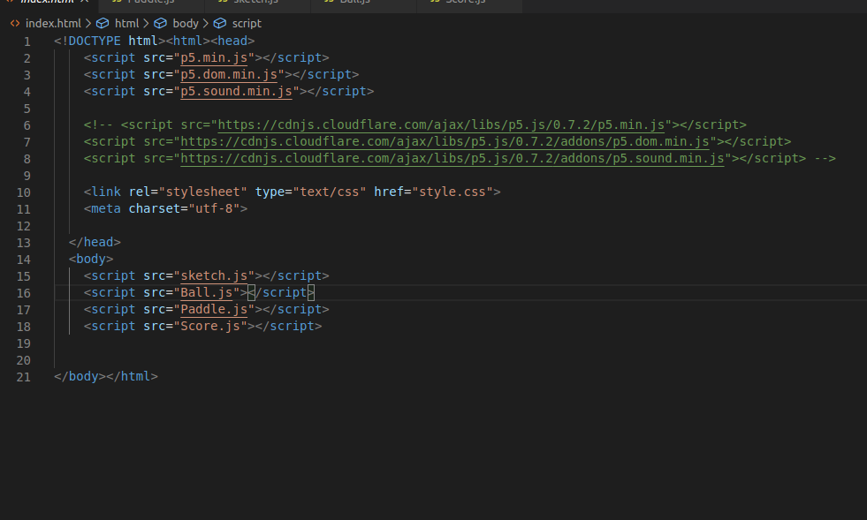
Then reference this file in the index.html, so we can access it in our js files and js files are with different names also in this project I have used the js library that you can see it in index.html file.

Paddle.js
So our paddle class only takes a number in its constructor, this number is going to represent the x position of the paddle. We only need to specify the x position because when creating the two paddles that’s the only thing between the two that is going to differ. If you’re unfamiliar with classes and constructors I recommend briefly glossing over this to get up to speed!
class Paddle {
constructor(x) {
this.x = x;
this.y = height / 2; // height is height of display window
this.height = 80;
this.width = 20;
}
display() {
fill(255);
rect(this.x, this.y, this.width, this.height);
}
}

Notice we’ve also created this function called display(), this is going to be called so that our paddles show on our canvas!

sketch.js
Let’s jump back to sketch.js and create our paddle object, in setup() and then call our display() on that paddle in the draw, this means that the display() function is called 60 times a second!
let playerPaddle;

function setup() {
createCanvas(624, 351);
playerPaddle = new Paddle(26);

}

function draw() {
background(0);
playerPaddle.display();
}

Let’s quickly add the other one! I’ve called it aiPaddle as we’re gonna add some very basic artificial intelligence to it!
let playerPaddle;
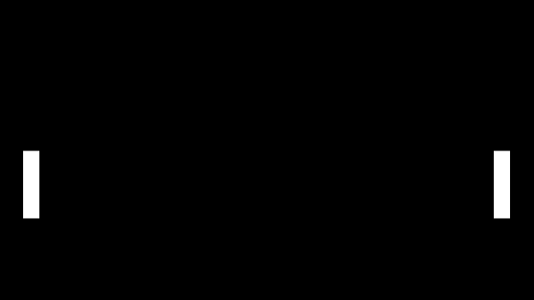
let aiPaddle;

function setup() {
createCanvas(624, 351);
playerPaddle = new Paddle(26);
aiPaddle = new Paddle(width - 48);
}

function draw() {
background(0);
playerPaddle.display();
aiPaddle.display();
}

Making the paddles move:
The paddles only need to go one of two directions, up or down. So let’s create a function in the paddle class called up() and down().
class Paddle {
constructor(x) {
this.x = x;
this.y = height / 2;
this.height = 80;
this.width = 20;
}
display() {
fill(255);
rect(this.x, this.y, 20, 80);
}
// add these little buggers
up() {
this.y -= 2;
}
down() {
this.y += 2;
}
}

Key presses:
Ideally, if we want to actually be able to play the game we’d like to control the paddle ourselves.
The first thing we need to do is add a couple flags to the Paddle class to track whether a paddle is currently moving up or moving down, these are going to be boolean values, isUp and isDown which will be either true or false.
class Paddle {
constructor(x) {
this.x = x;
this.y = height / 2;
this.height = 80;
this.width = 20;

this.isUp = false;
this.isDown = false;
}

Then we can use some p5.js built-in functions for keypresses! KeyPressed and keyReleased. So when we click the up arrow we set the isUp flag in the Paddle class to true and set the isDown flag to false, to stop it going down if it currently is. And then when we let go of the arrow (keyReleased) we set the flags to false. Note, this code is in sketch.js, just below the draw() function.
function keyPressed() {
if (keyCode == UP_ARROW) {
playerPaddle.isUp = true;
} else if (keyCode == DOWN_ARROW) {
playerPaddle.isDown = true;
}
}
function keyReleased() {
if (keyCode == UP_ARROW) {
playerPaddle.isUp = false;
} else if (keyCode == DOWN_ARROW) {
playerPaddle.isDown = false;
}
}

Then we actually need to call the up() and down() functions according to the flags, I’ve plonked this in the draw() function.

function draw() {
background(0);
playerPaddle.display();
aiPaddle.display();

// make the player move according to the flag
if (playerPaddle.isUp) {
playerPaddle.up();
} else if (playerPaddle.isDown) {
playerPaddle.down();
} }

Then if we run the program and click some buttons!

Keeping the paddles in the game:
So yeah, we need to stop the paddle from being able to move off the screen. How on earth do we do that? Well, let’s add some logic to the up() and down() functions.
up() {
if (this.y > 0) {
this.y -= 2;
}
}
down() {
if (this.y < height - this.height) {
this.y += 2;
}
}

The x and y location of the rectangle represents the top left corner point. So we take away the height of the paddle in order to constrain the whole paddle!
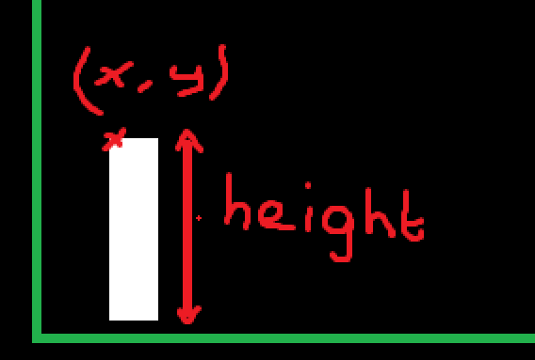

Adding the ball!
This part is going to be very similar to introduction p5.js blog as I added a ball which bounced off the walls! I dont want to repeat it again.
- Add a new file call it Ball.js
- Add the file in the index.html the same as what we did earlier
The ball is spawned in the center of the screen, and given a random direction from -3 to 3 this is defined by xSpeed and ySpeed, these values get added to the x and y each frame within the update function!
class Ball{
constructor() {
this.r = 10;
this.reset();
}
update() {
// if it hits the top or bottom change direction
if (this.y < this.r || this.y > height - this.r) {
this.ySpeed = -this.ySpeed;
}
// if it goes to the end of the sreen restart the game
if (this.x < this.r || this.x > width + this.r) {
this.reset();
}
this.x += this.xSpeed;
this.y += this.ySpeed;
}
reset() {
this.x = width/2;
this.y = height/2;

this.xSpeed = random(3, 4);
// determines if it's going left or right
let isLeft = random(1) > .5;
if (isLeft) {
this.xSpeed = -this.xSpeed;
}
this.ySpeed = random(-3, 3);
}
display() {
ellipse(this.x, this.y, this.r * 2, this.r * 2);
}
}

Now we just need to create the object in the sketch.js and call the ball objects update() and display() functions in sketches draw! (I’ve put some comments at the end of each line of code I’ve added to make it easier to see the changes)

let playerPaddle;
let aiPaddle;
let ball; // define the ball

function setup() {
createCanvas(624, 351);
playerPaddle = new Paddle(26);
aiPaddle = new Paddle(width - 48);
ball = new Ball(); // create the ball object
}

function draw() {
background(0);
playerPaddle.display();
aiPaddle.display();

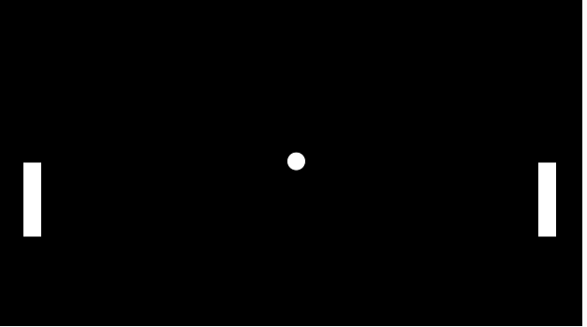
if (playerPaddle.isUp) {
playerPaddle.up();
} else if (playerPaddle.isDown) {
playerPaddle.down();
}
ball.update(); // call the update function within ball
ball.display(); // call the display function within ball
}

The first thing we need to do is pull this code out of the sketch.js file, as we want to make use of it with both players, so let’s plonk it into the paddle class.
if (playerPaddle.isUp) {
playerPaddle.up();
} else if (playerPaddle.isDown) {
playerPaddle.down();
}

So we have a new function now in the paddle class called update() this will be called in sketch.js.

update() {
if (this.isUp) {
this.up();
} else if (this.isDown) {
this.down();
}
}

THE AI!
If you were going to create some AI for the paddle what would you do? Well, here’s my thought process. If I’m the paddle, if the ball is above me, go up, if the ball is below me, go down. So that’s what I’ve coded.
Meet my beautiful function processAI(). It gets the middle of the paddle and determines whether the ball is above or below!
function draw() {
background(0);
playerPaddle.display();
aiPaddle.display();
playerPaddle.update(); // add this
aiPaddle.update(); // and this

processAI(); // andddd thiss
ball.update();
ball.display();
}
function processAI() {
let middleOfPaddle = aiPaddle.y + aiPaddle.height / 2;

if (middleOfPaddle > ball.y) {
aiPaddle.isUp = true;
aiPaddle.isDown = false;
} else {
aiPaddle.isDown = true;
aiPaddle.isUp = false;

}
}

Hitting the ball!
Now we actually need the ball to bounce off the paddle, so we can get a game going!
To do this we need to think about how the paddles differ, the main difference is that they are in different x locations, which means the same hit detection isn’t going to work for both.
We need 3 separate functions for this, that I’ve plonked into the ball class.hasHitPlayer() which checks to see whether the ball has hit the player using the player’s coordinates, as we pass in the player object! HasHitAi() is the same but with the different x location, then, isSameHeight() can be used by both hasHitPlayer() and hasHitAi().

hasHitPlayer(player) {
if (this.x - this.r <= player.x + player.width && this.x > player.x) {
if (this.isSameHeight(player)) {
this.xSpeed = -this.xSpeed;
}
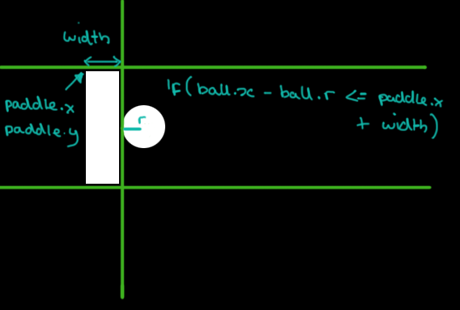
}
}

hasHitAi(ai) {
if (this.x + this.r >= ai.x && this.x <= ai.x + ai.width) {
if (this.isSameHeight(ai)) {
this.xSpeed = -this.xSpeed;
}
}
}
isSameHeight(player) {
return this.y >= player.y && this.y <= player.y + player.height
}

Halfway line!
Not really important, but why not, let’s add a halfway line. This is only 2 lines of code so relax!
In sketch.js
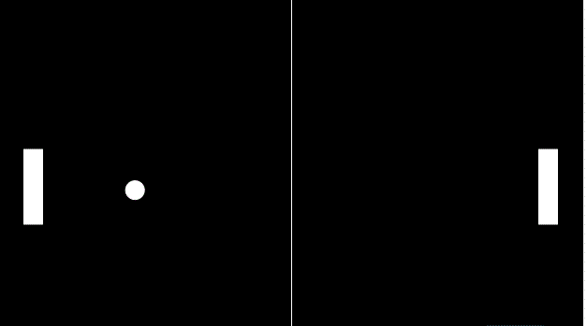
function draw() {
background(0);
playerPaddle.display();
aiPaddle.display();

playerPaddle.update();
aiPaddle.update();
processAI();

ball.update();
ball.display();

ball.hasHitPlayer(playerPaddle);
ball.hasHitAi(aiPaddle);

stroke(255); // gives a white stroke
line(width/2, 0, width/2, height); // draws a line between two points line(x,y,x1,y1)

}

Finally, let’s add some scores!
It’s not a game without a scoring system. Okay, so what we’re aiming for is something like this:
class Score {

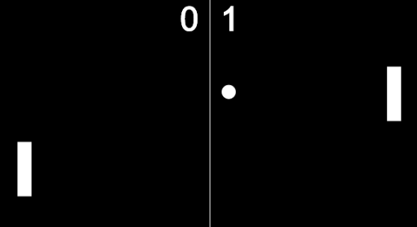
constructor(x) {
this.x = x;
this.score = 0;
}
display() {
textSize(50);
textAlign(CENTER);
text(this.score, this.x, 60);
}
increment() {
this.score++;
}
}

Woooooooooooooooo!! Let’s play !

