# Bivariate Distributions

[Link](http://stulp.gmw.rug.nl/ggplotworkshop/twodiscretevariables.html)

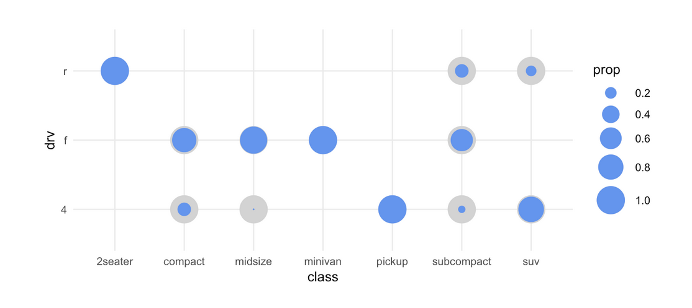

ggplot(mpg, aes(x=class, y=drv)) +

geom_count(aes(size=..prop..), colour="lightgrey") +

geom_count(aes(size=..prop.., group=class), colour="cornflowerblue") +

scale_size(range = c(0,10), breaks=seq(0,1,by=0.2)) +

coord_fixed() +

theme_minimal()

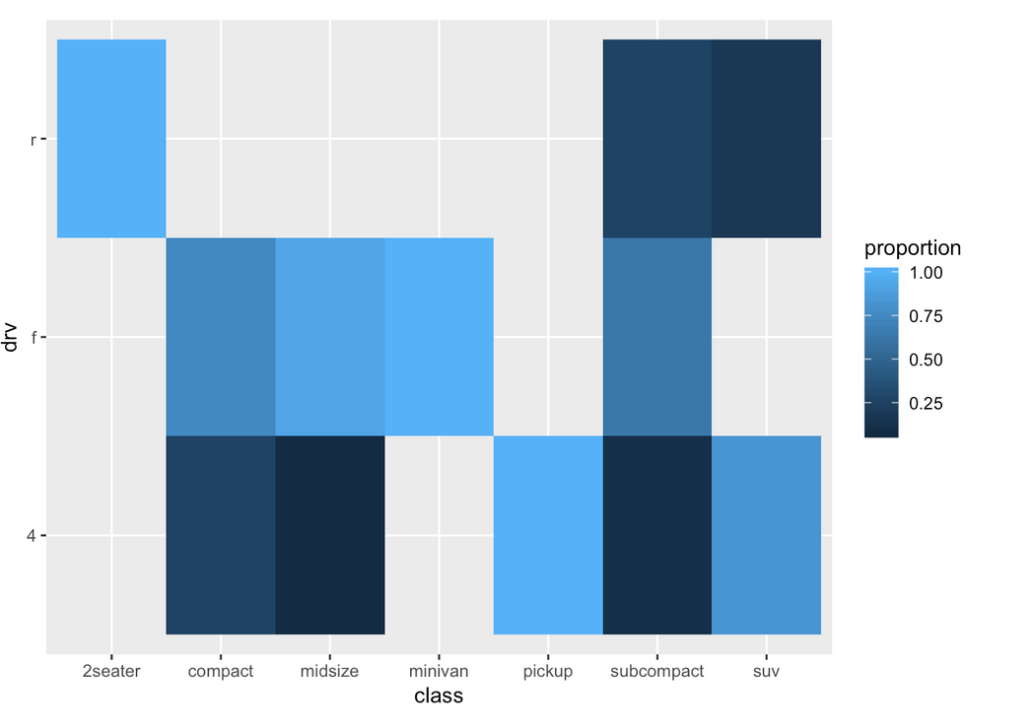

As 3D representation

# Conditional Distributions

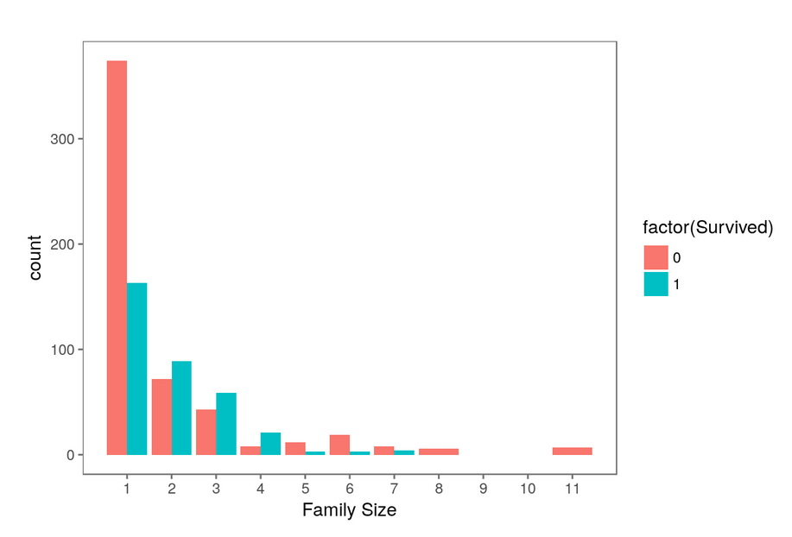

ggplot(full[1:891,], aes(x = Fsize, fill = factor(Survived))) +

geom_bar(stat='count', position='dodge') +

scale_x_continuous(breaks=c(1:11)) +

labs(x = 'Family Size') +

theme_few()

Organizing Rmd

[Link](https://www.kaggle.com/hiteshp/head-start-for-data-scientist)

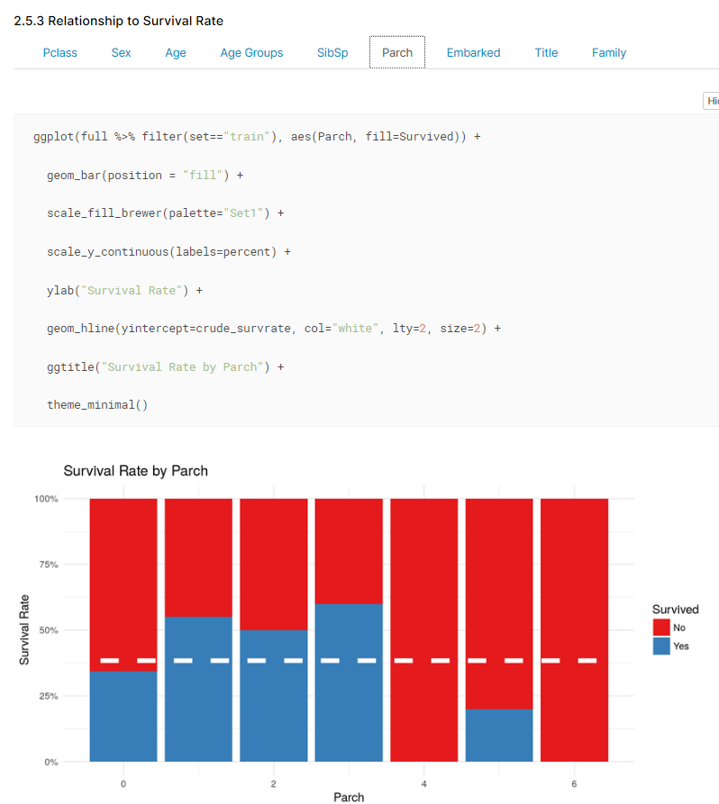

# Organizing in groups

[Link](https://stackoverflow.com/questions/10525957/how-to-draw-lines-outside-of-plot-area-in-ggplot2)

[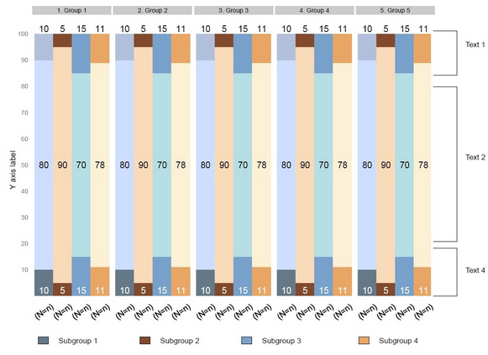](https://stackoverflow.com/questions/10525957/how-to-draw-lines-outside-of-plot-area-in-ggplot2)

