Assignment 0
MONK-2 longer boolean term → more complex tree → longer training
MONK-3 wrongly classified training data → more classification error

Assignment 1
Entropy for MONK-1: 1.0
Entropy for MONK-2: 0.957117428264771
Entropy for MONK-3: 0.9998061328047111

Assignment 2
Def. Entropy: Information gain if an event happens

In the case of a uniform distribution the entropy every occurrence of an event gives is the same. Examples: non-modified dies, coins, lottery.

In the case of a non-uniform distribution the entropy every occurrence of an event gives is different.
Examples:
A modified die with different probabilities of showing a number.
Asking a person if their mother language is english.

Entropy is the highest in uniform distributions and is lower the more the distribution is skewed to one event.

Assignment 3
MONK-1 attribute 1 has information gain of 0.07527255560831925
MONK-1 attribute 2 has information gain of 0.005838429962909286
MONK-1 attribute 3 has information gain of 0.00470756661729721
MONK-1 attribute 4 has information gain of 0.02631169650768228
MONK-1 attribute 5 has information gain of 0.28703074971578435
MONK-1 attribute 6 has information gain of 0.0007578557158638421
MONK-2 attribute 1 has information gain of 0.0037561773775118823
MONK-2 attribute 2 has information gain of 0.0024584986660830532
MONK-2 attribute 3 has information gain of 0.0010561477158920196
MONK-2 attribute 4 has information gain of 0.015664247292643818
MONK-2 attribute 5 has information gain of 0.01727717693791797
MONK-2 attribute 6 has information gain of 0.006247622236881467
MONK-3 attribute 1 has information gain of 0.007120868396071844
MONK-3 attribute 2 has information gain of 0.29373617350838865
MONK-3 attribute 3 has information gain of 0.0008311140445336207
MONK-3 attribute 4 has information gain of 0.002891817288654397
MONK-3 attribute 5 has information gain of 0.25591172461972755
MONK-3 attribute 6 has information gain of 0.007077026074097326

Trick is to find the attribute which maximizes the expected reduction of the entropy.
This is:
Attribute 5 for MONK-1
Attribute 5 for MONK-2
Attribute 2 for MONK-3

Assignment 4

How does the entropy of the subsets, S_k , look like when the information gain is maximized?
The entropy of the subsets should be as close to 0 as possible or in other terms the subsets should be distributed as non-uniformly as possible.

How can we motivate using the information gain as a heuristic for picking an attribute for splitting?
We want our tree to be as simple as possible (Occam’s razor), which has the side benefit of speedy training.
For that every question we ask should give us as much information about the category of the sample as possible.
If something rarely happens, but strongly correlates to one category it is a good indicator that something is part of that category.

Chapter 5
m1 a5=1 and attribute 1 has information gain of 0.0
m1 a5=1 and attribute 2 has information gain of 0.0
m1 a5=1 and attribute 3 has information gain of 0.0
m1 a5=1 and attribute 4 has information gain of 0.0
m1 a5=1 and attribute 5 has information gain of 0.0
m1 a5=1 and attribute 6 has information gain of 0.0
m1 a5=2 and attribute 1 has information gain of 0.040216841609413634
m1 a5=2 and attribute 2 has information gain of 0.015063475072186083
m1 a5=2 and attribute 3 has information gain of 0.03727262736015946
m1 a5=2 and attribute 4 has information gain of 0.04889220262952931
m1 a5=2 and attribute 5 has information gain of 0.0
m1 a5=2 and attribute 6 has information gain of 0.025807284723902146
m1 a5=3 and attribute 1 has information gain of 0.03305510013455182
m1 a5=3 and attribute 2 has information gain of 0.002197183539100922
m1 a5=3 and attribute 3 has information gain of 0.017982293842278896
m1 a5=3 and attribute 4 has information gain of 0.01912275517747053
m1 a5=3 and attribute 5 has information gain of 0.0
m1 a5=3 and attribute 6 has information gain of 0.04510853782483648
Attribute 4 and 6 should be used to split.

For attribute 4:
m1 a5=2 and a4=1 and attribute 1 has information gain of 0.060879074523283117
m1 a5=2 and a4=1 and attribute 2 has information gain of 0.016313165825732057
m1 a5=2 and a4=1 and attribute 3 has information gain of 0.05180039542238557
m1 a5=2 and a4=1 and attribute 4 has information gain of 0.0
m1 a5=2 and a4=1 and attribute 5 has information gain of 0.0
m1 a5=2 and a4=1 and attribute 6 has information gain of 0.05180039542238557
m1 a5=2 and a4=2 and attribute 1 has information gain of 0.19811742113040337
m1 a5=2 and a4=2 and attribute 2 has information gain of 0.5916727785823275
m1 a5=2 and a4=2 and attribute 3 has information gain of 0.12808527889139443
m1 a5=2 and a4=2 and attribute 4 has information gain of 0.0
m1 a5=2 and a4=2 and attribute 5 has information gain of 0.0
m1 a5=2 and a4=2 and attribute 6 has information gain of 0.19811742113040337
A 1 and A2 should be used

For attribute 6:
m1 a5=2 and a6=1 and attribute 1 has information gain of 0.03692795618414446
m1 a5=2 and a6=1 and attribute 2 has information gain of 0.10589695251027997
m1 a5=2 and a6=1 and attribute 3 has information gain of 0.0006611406448456814
m1 a5=2 and a6=1 and attribute 4 has information gain of 0.12824264908361171
m1 a5=2 and a6=1 and attribute 5 has information gain of 0.0
m1 a5=2 and a6=1 and attribute 6 has information gain of 0.0
m1 a5=2 and a6=2 and attribute 1 has information gain of 0.03488325362792244
m1 a5=2 and a6=2 and attribute 2 has information gain of 0.003585078590305768
m1 a5=2 and a6=2 and attribute 3 has information gain of 0.12369354800009502
m1 a5=2 and a6=2 and attribute 4 has information gain of 0.03488325362792244
m1 a5=2 and a6=2 and attribute 5 has information gain of 0.0
m1 a5=2 and a6=2 and attribute 6 has information gain of 0.0

A4 and A3 should be used
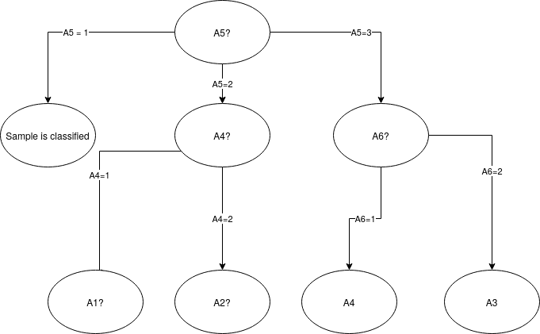

Majority classes:
m1 a5=1 True
m1 a5=2 False
m1 a5=3 False

Tree:
A5(+A4(---)A6(--)A1(--+))
A5(A3(-+)A3(+-)A3(--)A2(---))
A2(A5(+++-)A5(+++-)A4(---))
Assignment 5
MONK-1 Train: 1.0
MONK-1 Test: 0.8287037037037037
MONK-2 Train: 1.0
MONK-2 Test: 0.6921296296296297
MONK-3 Train: 1.0
MONK-3 Test: 0.9444444444444444

MONK-2 was the hardest to detect, which makes sense because it is the longest boolean term. I thought that the missclassified data would have more impact on performance.

Assignment 6
Models should not be overfitted (trained to recognize the training set) or underfitted (too general). To prevent this we use pruning.
Pruning selects a random node and removes it and checks if the result of the pruning is acceptable in terms of error rate or not.
So the trade-off is finding a good model that has some classification error (to allow generalization) not too that it is not a useful classifier anymore.

