Number of people descending from genesis Khan? About 0.5% of world population, 8% of asia

Where San nicholas from (original santa)? From Turkey (lycia)

Where does santa claus come from? From sinterklaas (dutch), then santa klaas, then santa claus. It became so because that shit happened in the US in Dutch families that immigrated there.

What is father Christmas? Pagan deity that used to simbolyze holiday happiness and partying (so a drunk)

Then they merged together

Santa is red because saint Nicholas has the characteristic red coat of Bishops which he was

The first ads in which Santa was used in were ginger ale, mineral water and zippy lighters. The first one was about selling carbonated water made by some sanfran

water company in 1915.

The reindeers were added in the 1860s because some guy made up a story for his children.

Who was the dauphin of France? The heir to throne of france

First mobile phone call? To rival company letting them know that they invented the phone

When first cigarette? 1758, used to be a byproduct of cigar/pipe tobacco production

Was old tobacco weaker or stronger than nowadays? It was much stronger, inhaling would cause allucinations, Indians used to use it in that way

When did people start inhaling cigarette smoke? In 1864, when burley tobacco was bred, people could inhale smoke, burley was lighter and less acidic than virginia

First match? 1826, but toxic (made with phosporus)

First non toxic match? 1896, that's when cigarettes started to become popular

When did collectible cards start? With James Duke cigarettes, in the 1890s, he put a card representing a famous landmark or person in each cigarette pack

What were micronite filters? Cigarettes filters made with asbestos, they were the filter of choice before cellulose acetate filters, the one we use nowadays

Who were the target demographic for malrboro at the very beginning (20s/30s)? Women

When ban on commercials about tobacco on TV? In the 60s, it was asked by the tobacco companies because it was mandated that for three tobacco ad there

had to be an anti-tobacco ad, that was reducing the smoking population in the US

What does pandemonium mean? All the demons (greek), all the spirits (Latin), also the city where the demons (Satan's followers) grouped up and discussed how to conduct a proxy war on God, after they have been sent to hell. In the book paradise lost (1650s) by John Milton

First electrical light? By humphrey David, In The early 1800s, it was basically an electrical arc in the air, it was superceded by the incandescent light

Meaning of Alexandrian? Boring, unoriginal writing, from the library of alexandria, because they mainly produced and stored commentaries of greek poems

Heberdashery meaning: emporio

Kiki Bubba photos

Which one is Kiki and which one bouba?

95 to 98 % of people associate Kiki to the spiky one and bouba to the round one.

Black and white dreams percentages in the years, black and white dreams epidemic, about 12% , almost all of them are more than 55 yo, they sleep 1/4 of the time in black and white

Ye old pub? Wikipedia article on thorn letter

Invention of microwave? James lovelock, who invented it to warm up frozen hamsters, also other people, he's not recognized to be the first one, but it seems that it was invented by several people in the same timespan.credited inventor Percy spencer.

Origin of bowling and amount of pins? First religious ceremony, who knocked down the pins cleansed himself of his sins. The pins used to be clubs that the brethrens brought with them everywhere, even to church, to protect themselves and their families, knocking them down was a sign that meant the cleansing of their sins.

Martin Luther was a big proponent of bowling and a fanatic of the sport. At first the number of pins was nine, but a law on the us made bowling illegal due to gambling problems, so tenpin bowling was invented to circumvent the problem. The only state that didn't declare it to be illegal was Texas, so in the aforementioned state ninepin bowling is still played to this day.

First rubber balloons? 1824, by Micheal Faraday, for experimentations with hydrogen, at the royal institution of great Britain

Most produced Volkswagen product? Volkswagen currywurst, it has a part number, 199 398 500 A, VW has reportedly sold more currywurst than cars, around 7 M per year. VW also makes ketchup, currywurst soup and utensils to eat said foods.

Who were the macaroni/ what does it mean to be "macaroni" in the late 18th century? People who exceed the boundaries of fashion, recognized by eating macaroni, the kind of pasta that they picked up in Italy, during their grand tour, and by wearing gigantic wigs, small hats and a large amount of makeup.

What does "nocumento" mean? Damage that stops the functioning and the efficiency of an object

What is nuclear pasta? Theoretical type of degenerate matter postulated to be within neutron star's crust

What was the original colour of the statue of liberty? Copper red, the outer shell is made out of copper, the green outside layer is copper oxide, which is green

Percentage of US GDP used to repair corrosion damages? 3%, or about 1400 $/

y, which is more than they pay for gas each year

What does it mean to be dense? Being dump, slow at comprehending facts, emotions and situations.

How many countries have common borders with France? Brazil and Suriname too

Who invented coursive and when? Niccolo de Niccolo in the 14th century

Stupidest sentence in the English language? Buffalo x 8

Where was Napoleon during the Waterloo battle? In the bathroom, he could not ride a horse because he had hemorrhoids

Where does cynic come from? From "cinos", dog in Greek

How much energy is a FOE? 10 to the 44th joules, about a supernova

What is an umpire? Referee in baseball

1 Canadian dollar coin nickname? Looney, from the loon (a duck)

2 Canadian dollars nickname? Toomey

Where is leaded gasoline still being used? In Algeria, Iraq, Yemen, north Korea and Afghanistan

Mob footbal wiki article

Where does pineapple come from/ what used to be called pineapple too? A pine

cone, they used to be called pineapples, the today's pineapples looked like the original pineapples, so they used to share a name

Where does Hawaii pizza come from? From the brand of pineapple used in the first pineapple pizza, it was called Hawaiian, the creator was Canadian

What is the Darwin award? Prize given to people who die or get infertile in a very dumb way

Last internationally recognised emperor in the world? The Japanese emperor, but Japan is not an empire anymore though

Has Tortuga ever existed? Yes, it's an island in Haiti. But the real tortuga, the pirate stronghold, was Port royal in

Jamaica. It was destroyed by an earthquake and then a tsunami, most of it is now under the sea, the one that was still out of the sea is now part of Kingstone, the capital of Jamaica

Longest reigning monarch? Louis the 14th, started at 14 years old, had a 72 year long reign

Head of state of Jamaica? Queen Elizabeth

Head of state of Australia? Queen Elizabeth

How old was Queen Elizabeth when she started talking to prince Philip? She was 13, he was 18

Why are five starts so common and used in the us flag? Because they are very easy to saw

Losing in Russian? Проиграть, agains the game

Winning in Russian? Выиграть, out of the game literally

Why are t-shirts called like this? Because they look like a T

D'jeet jet? Did you eat yet in Pittsburghese

What does "yinz" mean in Pittsburghese? You, but only plural

Buggy in Pittsburghese? Market kart

What does Philadelphia mean? City of brotherly love

What does Eritrea mean? From "eritros",

red, from the red sea

Second coming of Christ in the Rastafarian religion? Was emperor Selassie of Ethiopia

How many pennies in one shilling in LSD system? 12

How many shillings in one pound in LSD system? 20

Pronunciation of "close"? If it is a verb it is pronounced like a "з", if an adjective is a "с"

When was Chernobyl eventually completely shut down? 15th of February of 2000

How much is a guinea in LSD system? 1 pound and 1 shelling, not a real coin

Why is the pound (currency) called like this? From the Roman times, back then it was worth the same as a pound of silver

Fastest growing sport in the period 1994-1997? Roller skating, percentage wise

The propeller in a plane is slightly oriented to the right (if one propeller plane) to counteract some kind of a movement caused by the fact that there is only one propeller

The north pole is really the magnetic south pole

Where does second come from? From the Latins, where a second was called "pars minuta seconda" and a minute was called "pars minuta prima", so minute means small, the seconda part of second stuck,

for minute just the "minuta" part stuck

Alcoholics used to eat a bit of butter to coat the interior of the stomach to lower the absorption of alcohol

The king of hearts is mustacheless

1 ruble in 1992 had the same shape and diameter of a Swiss franc, so Russians used to go to Switzerland and buy tons of foods from the vending machines, they used to ship trucks full of snacks from Switzerland to Russian, they made a gigantic profit, 32 rouble in 1992 was about 1 Swiss franc

Name of people living in Manhattan? Manhattanite

Canada has vertical banknotes

What does it mean "to sandbag"? To bluff

Where do coffee plants come from? They come from Africa, specifically Ethiopia.

What is a thesaurus? a book that lists words in groups of synonyms and related concepts.

When does war WWI really end? June 28, 1919, they're the Paris peace treaty is signed a on the 11th hour of the 11th day of the 11th math in armistice is signed

What does "schtum" mean? Silent, non communicative, it's an adjective or a verb

Queen Elizabeth and prince Philip were second cousins

Remediate pronunciation? Remìdiate ad a verb, remédiate as ad adjective

What is a shortlist? A list of people or companies suitable for a prize or a job, from which the eventual recipient of said job or prize will be chosen

Who/what is the recipient of a prize? The person who receives said prize

What kind of absent does Scar have in the lion king English version? He has an english accent, whereas everybody else has an american accent.

Disney princess with highest kill count?

Mulan (around 2000 Huns)

What is a deuteragonist? A person second in importance in a plot only to the protagonist

Continents in which there is no city called "Rome"? Only Antarctica

Country with the most amount of heavy metal bands per capita? Finland

Name first derivative of acceleration? Jerk in us English, jolt in UK English and strappo in Italian

Hypodermic needles are sterilised during manufacture and supplied in sealed packs. It would be more expensive to specifically source unsterilised needles, just for use by executioners. However, **prison doctors do**

**still swab the condemned man's arm with alcohol, prior to inserting the needle**.

Nomi Di Qui, Quo e Qua in inglese? Huey, Dewey and Louie

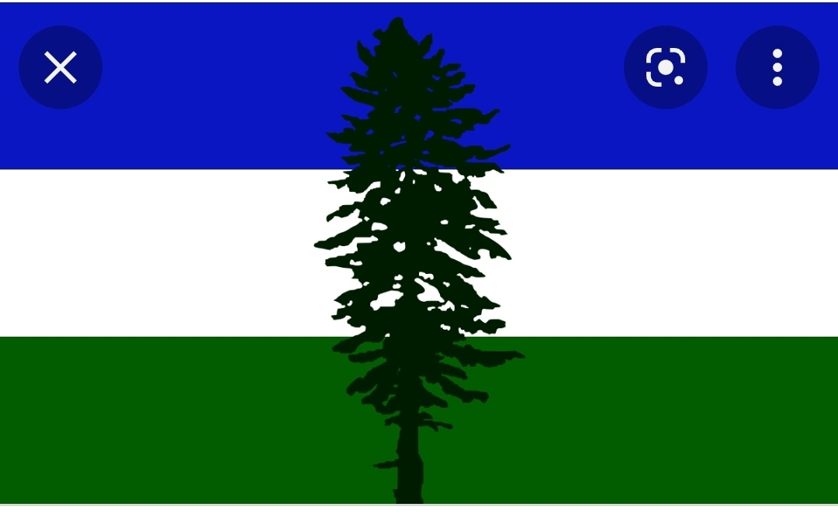

Whose flag is this? It the flag of Cascadia, a would be nation that would be situated in parts of the states of Oregon, Washington and the Canadian province of British Columbia.

What is the opposite of synonym? Antonym ("Antònimo")

Where does chess come from? India

Are there fishes with lungs? Yes, they are called lung fishes, they live in africa, when lakes dry up they hybernate in cocoons, they are fished with shovels when hybernated.

How do bees communicate? Bees communicate via dance movement, it was proven by a mechanical bee which communicated successfully with real bees.

What is the definition of vodka? Just alcohol distilled to about 95% (from any fermented beverage) and then diluted with water. The dilution is not necessary for the beverage to be called vodka.

Difference between ale and beer in the old

days? Ale is made with hops, beer is made with gruit (a non specific mix of natural bittery erbs and spices). Ale is thought to be invented because there was a tax imposed on gruit in the Netherlands. The closest relative of hops is marijuana. Nowadays the difference is that Ale is brewed with hop (like almost every beer) but with a specific yeast (Saccharomyces cerevisiae) that prefers to work at room temperature.

What is logger's beer? Beer brewed at a low temperature (low teens) and that use Saccharomyces pastorianus. It was invented by German monks when they stored fermenting beer in cold alpine caves.

What part of fungus do we eat? We eat their reproductive appendage (the so-

called mushrooms) so, to put it in an easy way, we eat their penis/ vagina (the sciency way to call them is fruiting bodies).

What is a Chicago sunroof? When to defecate in your enemies' car

Best temperature/weather for marathon? From 8 to 13 degrees, max is about 18, it must be cloudy too

What is panko? Bread dough cooked via electricy, they let electricity flow into the bread and that cooks the bread from the inside out, that results in fairly crispy kind of bread that is easy to recognise. It is said to be developed by Japanese soldiers during WWII buy cooking brand dough with tank batteries.

Where does the insult "cretin" come from? From the disease "cretinism", a goiter syndrome in which mothers were iodine deficient and their children turned out to be mentally impaired. It comes from the word "crétin" meaning Christian, from the common expression of "povero Cristo".

Why do we have iodine rich salt? To avoid goiter (gozzo), an enlargement of the thyroid due to iodine deficiency.

Birds are therapods, so dinosaurs.

Why is turkey the bird named just like turkey the country? Because Turkish traders 16th century used to import a ton of exotic stuff from everywhere, so much that everything exotic was called "Turkish", the name turkeycock formed and it was applied to guinea fowl, the to the proper

turkey we know today. In Turkish the bird is known as "Hindi", in Dutch its name originates from the name of the city of calcon, in malesian it is called literally a Dutch chicken.