***1.修改服务器启动参数***

***添加服务器启动参数***

***-agentlib:jdwp=transport=dt_socket,server=y,suspend=n,address=5505***

***2.idea配置***

***进入Run->Edit Configurations->Add->Remote***

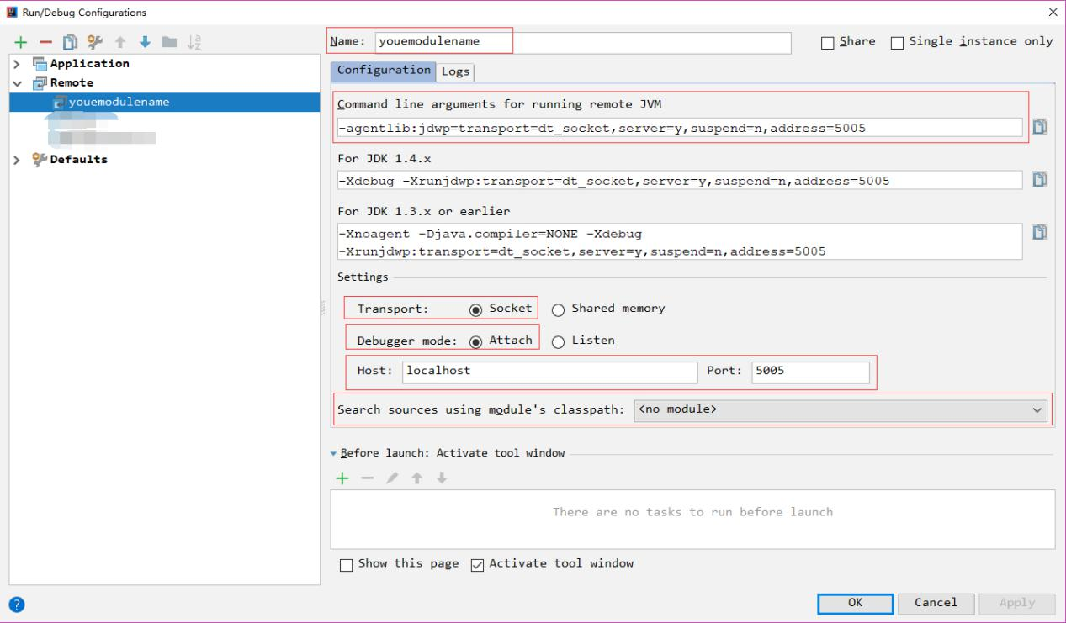

***配置远程jvm参数***

***配置ip port***

***测试连接***

***断点调试***

***——IDEA remote by FCBArry <https://github.com/FCBArry>***