Prepared for:
Federal Communications Commission
CMS Alliance to Modernize Healthcare
Federally Funded Research and Development Center
Contract No. HHSM-5000-2012-000081
Task Order No. FCC15D0002
ACE Direct Platform Release Documentation
Draft
Version 1.1
February 17, 2017
The views, opinions, and/or findings contained in this report are those of The MITRE Corporation and should not be construed as official government position, policy, or decision unless so designated by other documentation.
Approved for Public Release; Distribution Unlimited. Case Number 16-4058.
© 2017, The MITRE Corporation. All Rights Reserved.

Record of Changes
Version | Date | Author / Owner | Description of Change
1.0 | November 4, 2016 | CAMH | Version 1.0 for release to Sponsor
1.1 | February 17, 2017 | CAMH | Version 1.1 for release to Sponsor

About the CMS Alliance to Modernize Healthcare
The Centers for Medicare & Medicaid Services (CMS) sponsors the CMS Alliance to Modernize Healthcare (CAMH), the first Federally Funded Research and Development Center (FFRDC) dedicated to strengthening our nation’s healthcare system.
The CAMH FFRDC enables CMS, the Department of Health and Human Services (HHS), and other government entities to access unbiased research, advice, guidance, and analysis to solve complex business, policy, technology, and operational challenges in health mission areas. The FFRDC objectively analyzes long-term health system problems, addresses complex technical questions, and generates creative and cost-effective solutions in strategic areas such as quality of care, new payment models, and business transformation.
Formally established under Federal Acquisition Regulation (FAR) Part 35.017, FFRDCs meet special, long-term research and development needs integral to the mission of the sponsoring agency—work that existing in-house or commercial contractor resources cannot fulfill as effectively. FFRDCs operate in the public interest, free from conflicts of interest, and are managed and/or administered by not-for-profit organizations, universities, or industrial firms as separate operating units.
The CAMH FFRDC applies a combination of large-scale enterprise systems engineering and specialized health subject matter expertise to achieve the strategic objectives of CMS, HHS, and other government organizations charged with health-related missions. As a trusted, not-for-profit adviser, the CAMH FFRDC has access, beyond what is allowed in normal contractual relationships, to government and supplier data, including sensitive and proprietary data, and to employees and government facilities and equipment that support health missions.
CMS conducted a competitive acquisition in 2012 and awarded the CAMH FFRDC contract to The MITRE Corporation (MITRE). MITRE operates the CAMH FFRDC in partnership with CMS and HHS, and maintains a collaborative alliance of partners from nonprofits, academia, and industry. This alliance provides specialized expertise, health capabilities, and innovative solutions to transform delivery of the nation’s healthcare services. Government organizations and other entities have ready access to this network of partners, including RAND Health, the Brookings Institution, and other leading healthcare organizations. This includes select qualified small and disadvantaged business.
The FFRDC is open to all CMS and HHS Operating Divisions and Staff Divisions. In addition, government entities outside of CMS and HHS can use the FFRDC with permission of CMS, CAMH’s primary sponsor.

Executive Summary
The Federal Communication Commission (FCC) Telecommunications Relay Service (TRS) Center of Expertise (COE) Project promotes the Commission’s goal to foster innovations that advance functionally equivalent telecommunications. Toward that end, the project ensures that the Telecommunications Relay Service employs improved technology for persons who are deaf, hard of hearing, deaf-blind, and/or have speech disabilities. The FCC has embraced a research-based approach to achieve this goal by engaging the Centers for Medicare & Medicaid Services (CMS) Alliance to Modernize Healthcare (CAMH) Federally Funded Research and Development Center (FFRDC), operated by The MITRE Corporation (MITRE), to conduct independent engineering assessments that promote and demonstrate TRS’s functional equivalence.
CAMH is independently assessing voice telephone services, video access services, and Internet Protocol (IP)-based captioning technology; improvements to TRS efficiency; solutions for direct communication between people with communication disabilities and other telephone users; and the effectiveness, efficiency, and consumer response to current and future approaches for delivering TRS.
At the FCC’s request, CAMH developed a Direct Video Calling (DVC) Auto-Routing Proof of Concept (POC) in support of the FCC’s Accessible Communications for Everyone (ACE) program. This DVC auto-routing platform enables direct calling from deaf and hard-of-hearing individuals to an American Sign Language (ASL)-trained agent within the organization’s call center. The agent handles the call using a video-capable phone with real-time video connection. To demonstrate the capabilities of DVC, the FCC and CAMH have further advanced the original auto-routing POC into a call center platform for two to twenty customer service representatives. This new DVC platform is called ACE Direct.
Implementing the Direct Video Calling platform provides a number of benefits:
- Improved Communications – Direct video calling improves privacy and decreases misrepresentation, which improves efficiency, effectiveness, and productivity.
- Career Opportunities – Employing native ASL users to handle customer service video calls expands hiring opportunities. President Obama’s Executive Order 13548 (July 2010) directed federal agencies to increase employment opportunities for people with disabilities.
- Simple Implementation – The technology to implement a direct video calling system is readily obtainable, affordable, and easy to set up.
- Secure Communications – With proper configuration, agencies can use high-speed broadband and their own internal networks without compromising security or contending with barriers created by firewalls.
- Maintain ADA Compliance – Direct Video Calling ensures compliance with the Americans with Disabilities Act mandates.
- Cost Savings – Replacing three-way interpreted calls with two-way direct communication saves money by minimizing the need for repeat calls due to miscommunication and/or misunderstanding.
As part of this effort, CAMH developed and documented requirements and features, including user stories and associated use cases. CAMH also configured, tested, and integrated provider endpoint video devices with the ACE Direct platform. Detailed configuration and source code files are available for download and reproduction to improve solutions to support the community. The public can for download or clone these files at https://github.com/FCC/ACEDirect.

Table of Contents
1. Introduction 1
1.1 Background 1
1.2 Purpose and Scope 2
2. Overview of Direct Video Calling and ACE Direct 3
2.1 DVC Is an Alternative to Traditional Relay Calls 3
2.2 Open-Source Development to Promote Community Involvement 3
2.3 Conceptual System Overview 3
2.4 Highlighted User Stories 6
2.5 CSR Desktop User Guide 7
2.5.1 Logging into ACE Direct 7
2.5.2 CSR Desktop Layout 8
2.5.3 Side Panels 9
2.5.4 Video and Real-Time Text Communications 12
2.5.5 CSR Desktop Portal Header 14
2.5.6 VRS and Ticket Information 15
2.6 Consumer Portal 16
2.6.1 Consumer Complaint Form User Guide 16
2.6.2 Submitting a Complaint 17
2.6.3 Contacting the CSR 18
2.6.4 Complaint Ticket 18
2.6.5 Video Chat 19
2.6.6 Real-Time Text Chat 19
2.7 Management Portal 20
2.7.1 Management Dashboard 20
2.7.2 Call Detail Record Dashboard 22
3. Installation and Configuration 25
3.1 SSL Certificate 25
3.2 Asterisk Installation and Configuration Script 25
3.2.1 Manual Asterisk Server Installation 26
3.2.2 How It Works 27
3.2.3 Secure Calling 30
3.2.4 Sample Configurations 30
3.3 Node.js 31
3.3.1 Installing 32
3.3.2 Starting 33
3.3.3 Status 33
3.3.4 Restart 33
3.4 Management Portal 33
3.4.1 Installation 33
3.4.2 Configuration 34
3.4.3 Run 34
3.4.4 Log Files 34
3.4.5 Management Dashboard 35
3.4.6 Call Detail Record Dashboard 39
3.5 CSR / Agent Database (Provider) 43
3.5.1 MySQL Database Server Configuration 43
3.5.2 CSR / Agent RESTful Service Installation 46
3.6 VRS User Database (Provider) 46
3.6.1 MySQL Database Server Configuration 46
3.6.2 Video Relay Service RESTful Service Installation 48
3.7 STUN 48
3.8 iTRS ENUM Database 49
3.9 VyOS Router for Secure Socket Layer Tunnel 50
3.10 COTS CRM 51
3.11 Enterprise Service Bus 52
3.11.1 Background 52
3.11.2 Installation Overview 53
3.11.3 Testing the Broker Application 58
Acronyms 60

List of Figures
Figure 1. Notional Diagram for ACE Direct Platform 4
Figure 2. CSR Desktop Login Screenshot 8
Figure 3. Screenshot of CSR Desktop 9
Figure 4. Screenshots of the CSR Ready, Away, and In-Call Status 10
Figure 5. CSR Agent Status Screenshot 10
Figure 6. CSR Mailbox Screenshot 11
Figure 7. CSR Settings Screenshot 12
Figure 8. User Chat Box Screenshot 13
Figure 9. Script Box 13
Figure 10. Screenshot of Call Duration and Assistance Button 14
Figure 11. Screenshot of CSR Profile 14
Figure 12. Screenshot of VRS Information 15
Figure 13. Screenshot of Ticket Information 16
Figure 14. Screenshot of Consumer Portal 17
Figure 15. Screenshot of VRS Number Entry 17
Figure 16. Screenshot of Consumer VRS Information 18
Figure 17. Screenshot of Complaint Ticket 18
Figure 18. Screenshot of Video Chat Window 19
Figure 19. Screenshot of Real-Time Text Chat 19
Figure 20. Screenshot of Management Dashboard 20
Figure 21. Screenshot of Resource Status 22
Figure 22. Screenshot of Call Detail Record 22
Figure 24. pm2 list Command 33
Figure 25. VyOS Router for SSL Tunnel 50

List of Tables
Table 1. ACE Direct Components 5
Table 2. ACE Direct Highlighted User Stories 7
Table 3. Call Detail Record Column Definition 23
Table 4. Asterisk Endpoint Extensions 27
Table 5. AMI Actions and Descriptions 35
Table 6. Asterisk AMI Event 37

Introduction
The Federal Communications Commission (FCC) Telecommunications Relay Service (TRS) Center of Expertise (COE) Project promotes the Commission’s goal to foster innovations that advance functionally equivalent telecommunications. Toward that end, the project ensures that the Telecommunications Relay Service employs improved technology for persons who are deaf, hard-of-hearing, deaf-blind, and/or have speech disabilities.

Background
The FCC has embraced a research-based approach to achieve this goal by engaging the CMS Alliance to Modernize Healthcare (CAMH) Federally Funded Research and Development Center (FFRDC), operated by The MITRE Corporation (MITRE), to conduct independent engineering assessments that promote and demonstrate TRS’s functional equivalence. As part of the Accessible Communications for Everyone (ACE) program, CAMH independently assesses voice telephone services, video access services, and Internet Protocol (IP)-based captioning technology; improvements to TRS efficiency; solutions for direct communication between people with communication disabilities and other telephone users; and the effectiveness, efficiency, and consumer response to current and future approaches for delivering TRS.
In continuing pursuit of the Commission’s goal to advance functionally equivalent telecommunications, CAMH developed ACE Direct, an open source call center platform that supports Direct Video Calling (DVC) for two to twenty customer service representatives (CSR). Implementing ACE Direct in a corporate production environment requires customization to ensure adherence to corporate practices and policies related to security, system configurations, cloud services, and availability.
The FCC encourages government agencies and private businesses to make DVC part of their call center strategy because it offers significant gains for functionally equivalent telecommunications, including:
- Improved Communications – Direct video calling improves privacy and decreases misrepresentation, which enhances efficiency, effectiveness, and productivity.
- Career Opportunities – Employing native American Sign Language (ASL) users to handle customer service video calls expands hiring opportunities. President Obama’s Executive Order 13548 (July 2010) directed federal agencies to increase employment opportunities for people with disabilities.
- Simple Implementation – The technology to implement a direct video calling system is readily obtainable, affordable, and easy to set up.
- Secure Communications – With proper configuration, agencies can use high-speed broadband and their own internal networks without compromising security or contending with barriers created by firewalls.
- Maintain ADA Compliance – Direct Video Calling ensures compliance with the Americans with Disabilities Act (ADA) mandates.
- Cost Savings – Replacing three-way interpreted calls with two-way direct communication saves money by minimizing the need for repeat calls due to miscommunication and/or misunderstanding.
CAMH developed and documented ACE Direct requirements and features, including user stories and associated use cases. CAMH also configured, tested, and integrated provider endpoint video devices using the ACE Direct platform.

Purpose and Scope
This document presents an overview of the ACE Direct platform, including the ACE Direct architecture, user stories, and guidance for installation and configuration. This document describes how to integrate DVC within an agency’s current call center workflow to provide an independent, on-demand service.
In addition to this release documentation, detailed configuration and source code files are available to the public at https://github.com/FCC/ACEDirect for download and reproduction of the platform to support and promote future platform enhancements for the deaf, hard-of-hearing, deaf-blind, and speech-disabled community.

Overview of Direct Video Calling and ACE Direct
Deaf, hard-of-hearing, deaf-blind, or speech-disabled people use Telecommunications Relay Services to communicate with hearing people over the phone. Since the early 2000s, video relay service (VRS) calls have been the primary way that ASL users access telecommunications. VRS involves the use of third-party communication assistants (CA) as sign language interpreters to place telephone calls. The interpreter translates between ASL and spoken English for the non-signing party. People who communicate in ASL use VRS to place telephone calls to customer assistance divisions of government agencies and businesses in the United States every day, but there are other solutions.

DVC Is an Alternative to Traditional Relay Calls
The FCC’s sponsorship of the Accessible Communications for Everyone program includes creating a direct video calling platform. The ASL Consumer Support Line—the first of its kind in the federal government—allows ASL users to make video calls directly to an agent fluent in ASL. English is not the first language of many TRS deaf, hard-of-hearing, deaf-blind, and speech-disabled TRS users. One-to-one communication in ASL is most often preferred.
When comparing calls made to the FCC ASL Consumer Support Line with calls placed through VRS, the FCC found the average call length decreased 42 percent and incoming calls increased 533 percent. Most impressive is that the FCC achieved these results without adding more staff to handle the increased call volume.

Open-Source Development to Promote Community Involvement
ACE Direct is open source technology offering one option for implementing direct video calling. The proof of concept is based on open source as a development model. Open source promotes universal access via a free license to a product’s design/blueprint and universal redistribution of that design/blueprint, including subsequent improvements to it. The open source model employs a decentralized model of production. A main principle of open source software development is peer-production: products such as source code, “blueprints,” and documentation are available to the public at no cost.
The FCC encourages government agencies, educational institutions, and others seeking to enhance the lives of citizens who are deaf, hard of hearing, deaf-blind, and/or have speech disabilities to adopt and improve on the existing code base to provide additional features, improve the workflow, and introduce new technologies to the open source ACE Direct platform.

Conceptual System Overview
CAMH developed the open source-based ACE Direct platform for implementation in the Amazon Web Services (AWS) cloud environment. Figure 1 presents a notional view of the architecture of the ACE Direct components from a configuration and programming standpoint.
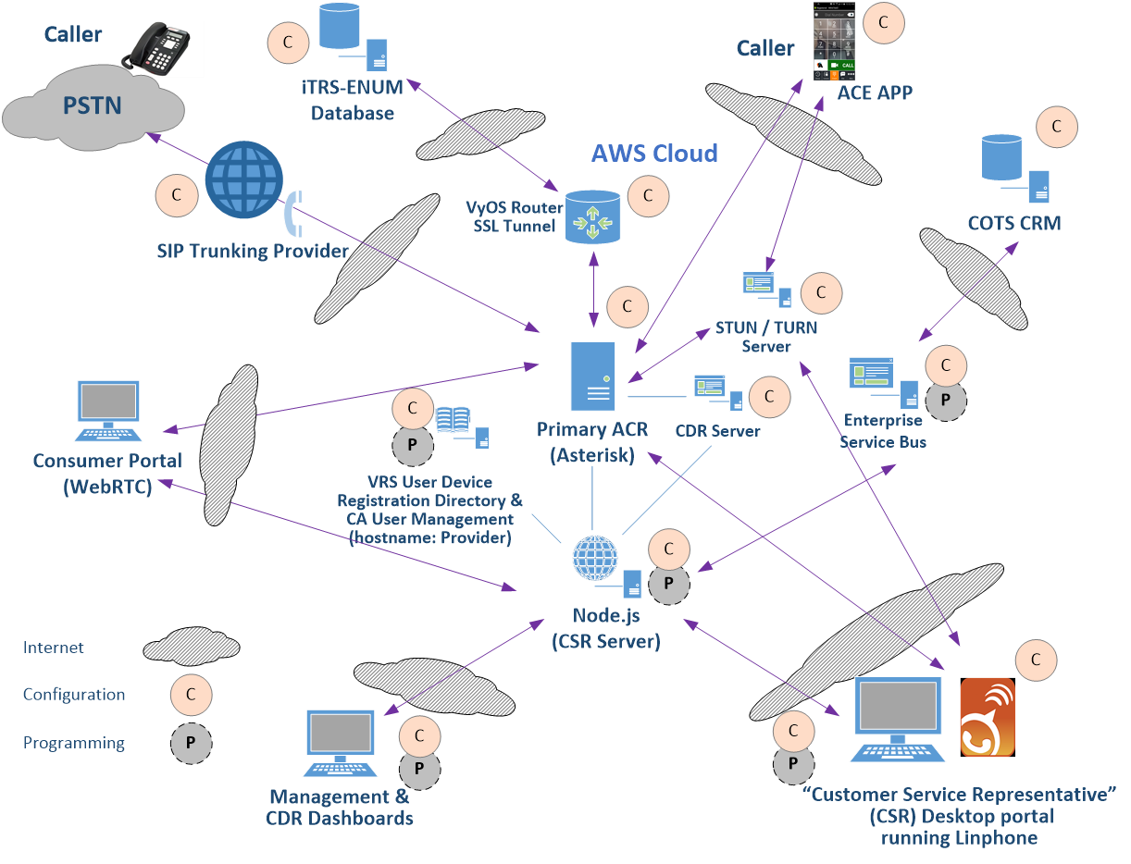
Figure 1. Notional Diagram for ACE Direct Platform
As Figure 1 shows, some ACE Direct components require only configurations (noted as “C”) and other components require both configuration and programming (noted as “P”). Table 1 presents an overview of these components. Section 3 provides detailed installation information and configurations.

Table 1. ACE Direct Components
Component | Description | Additional Details
Asterisk Open Source PBX (Private Branch Exchange) | Asterisk is an open source PBX that supports direct video communication vis both Public Switched Telephone Network (PSTN) and video calls. In the ACE Direct platform, a CSR uses a softphone (Linphone) registered to Asterisk to accept inbound calls (PSTN or video). | Subsection 3.2
Node.js | Node.js is an open source platform that can be used to develop applications and servers. For ACE Direct, the Node.js server contains several services running on ports to support the CSR desktop portal and other management-related portals, including the management dashboard and call detail record (CDR) dashboard. The Node.js server supports the Real-Time Text (RTT) between the CSR Desktop portal and the consumer portal. It also provides services for VRS lookup to verify that the phone number is a valid number in the VRS database. | Subsection 3.3
Consumer Portal | The Consumer Portal introduces the WebRTC technology to the ACE Direct platform. It combines form submission with real-time audio, video, and text communication to a CSR. CAMH elected to use a complaint process to demonstrate this technology. | Subsection 2.6
Management and Call Detail Record (CDR) Dashboards | The ACE Direct Management dashboard provides a number of Key Performance Indicators (KPI) the call center manager can monitor in real time. The CDR dashboard provides the view and export functions of the Asterisk CDRs stored in its MySQL database. | Subsection 2.7.2
VRS User Device Registration and CSR User Management (hostname: Provider) | The “Provider” server emulates the services for both the CSR user authentication and iTRS-URD (Internet Telecommunications Relay Service-User Registration Database) lookup from the Node.js to demonstrate the communications of the Node.js server in real-world scenarios. | Subsection 2.5.6
Customer Service Representative (CSR) Desktop | The CSR desktop provides a user interface to the CSR for login and conducting VRS services to the ACE Direct users. The CSR desktop is one of the two windows on the CSR’s workstation monitor. | Subsection 2.5
STUN Server | STUN (formerly Simple Traversal of UDP through NAT rfc3489) is reflexive and identifies if the endpoint is behind a Network Address Translation (NAT) or firewall and determines the public IP address. This helps STUN establish a peer-to-peer connection. | Subsection 3.6
iTRS-ENUM database | The iTRS database maps 10-digit U.S. telephone numbers to IP addresses using the industry-standard ENUM (E.164 Number to URI Mapping) protocol. VRS providers assign these 10-digit telephone numbers to their customers. | Subsection 3.7
VyOS (Vyatta Operating System) Router for Secure Socket Layer (SSL) Tunnel | To support the iTRS-ENUM database lookup, a VPN tunnel is established to Neustar from a VyOS router instance running in AWS. The router instance has a loopback interface with an Elastic IP (EIP) on it that is the encryption domain for the tunnel. | Subsection 3.8
Commercial Off-the-Shelf (COTS) Customer Relationship Management (CRM) | To demonstrate integration with a CRM service, ACE Direct connects to the Zendesk RESTful application programming interface (API) via the Enterprise Service Bus. ACE Direct sends Java Script Object Notation (JSON)-based messages to the RESTful Zendesk API to manage and query customer records. | Subsection 3.9
Enterprise Service Bus (ESB) | The enterprise service bus provides a generic method to update legacy database systems as well the diverse number of databases and unstructured data repositories on the market and in use today. ACE Direct ESB integrates with a COTS CRM service (e.g., Zendesk) as a ticketing system for the CSR to document service cases. | Subsection 3.10
SIP (Session Initiation Protocol) Softphones for CSR and ASL users | ACE Direct uses SIP video softphones, including ACE Access Point Platform (APP) and Linphone, as end-user devices that are registered to the Asterisk Server. | N/A

Highlighted User Stories
CAMH built ACE Direct to encompass the core functions of a traditional hearing-based call center. ACE Direct focuses on the responsibilities of CSRs and their managers. The FCC and CAMH partnered with federal agencies to derive typical requests for services and call center workflows. Table 2 presents a summary of ACE Direct user stories, which demonstrate these functions and capabilities.

Table 2. ACE Direct Highlighted User Stories
Story | Description
Direct Video Call with an ASL-fluent CSR | As an ASL user, I want to speak with another ASL user when I contact a call center.
CRM Integration | As a CSR, I can view, update, and enter new information regarding contact with the caller from the corporate CRM system.
Call Script Integration | As a CSR, I can view corporate call scripts based on the needs of the caller.
Call-handling capabilities | As an ACE Direct CSR, I can perform “Call on Hold” and “Call Transfer” as needed.
Consumer Portal | (A complaint process illustrates this story.) As a consumer, I wish to file a complaint through a web portal on my website. I will also have the option of conversing with the CSR through video and Real-Time Text. See Subsection 2.6 for details.
Video Mail | As a CSR, I can retrieve a video mail.
Management Dashboard | As the ACE Direct manager/operator, I can access near real-time information on the dashboard.
Call Detail Record | As the ACE Direct administrator, I can access the Call Detail Record through a web portal and export CDRs as needed for audit purpose. See Subsection 2.7.2 for details.
Web-based Application | As a CSR, I have the ability to work remotely from the main call center if necessary.
Multi-CSR Login with Status | As the ACE Direct CSR, I can log in using the CSR Desktop along with other CSRs and I can change my status between “Ready” and “Away.”

CSR Desktop User Guide
The ACE Direct CSR interfaces with three windows on the workstation monitor, including the CSR Desktop window, an inbound call softphone window (MicroSIP), and an outbound call softphone window (Linphone). This guide provides a walkthrough of the portal, highlighting each of the available functionalities.

Logging into ACE Direct
Upon navigating to the portal host URL, a login screen appears. To access the portal, agents must enter their username and password.
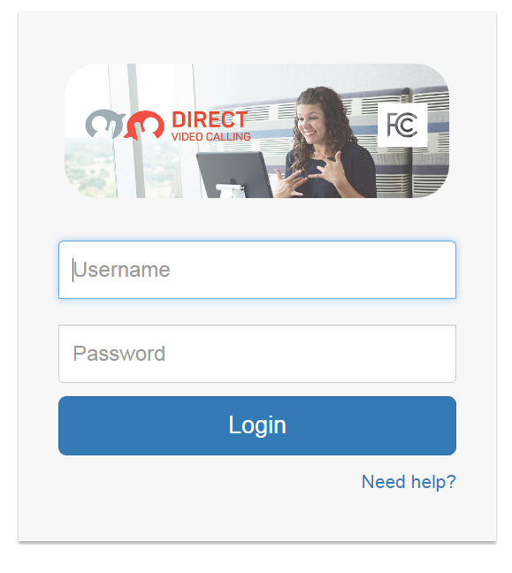
Figure 2. CSR Desktop Login Screenshot

CSR Desktop Layout
Figure 3 presents a screenshot of the CSR Desktop, which consists of the following elements:
- Side panels (left and right) to provide navigation, information, and settings to the CSR
- A user chat area for real-time text chats
- A header area that displays call duration information and an assistance button
- Profile information displaying the CSR’s name and picture and the ability to sign out of the system
- VRS caller information such as first name, last name, etc.
- Any prior CRM ticket information by the VRS caller
Figure 3. Screenshot of CSR Desktop

Side Panels
The ACE Direct CSR Desktop portal has two side panels that provide navigation, information, and settings to the CSR.

Left Side Panel (Main Navigation)
As shown in Figure 4, the left-side panel of the portal provides the CSR with both User Status and the Main Navigation. Here CSRs can select their status as “Ready” or “Away.” When a CSR first signs into the portal, the status defaults to “Away.” When the CSR is ready to receive calls, the CSR selects the “Ready” status. Once the CSR enters a call, the status changes to “In Call”. After the CSR leaves the call and clicks on the “Finished” button, the CSR’s status returns to the “Ready” state. The Agent status will also be reflected on the Management Dashboard.
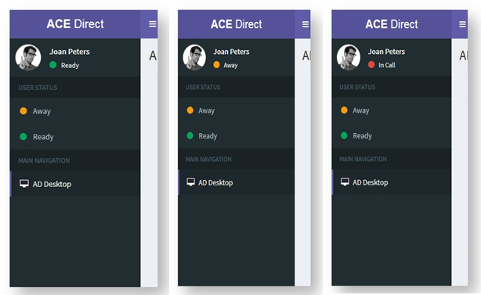
Figure 4. Screenshots of the CSR Ready, Away, and In-Call Status

Right-side Panel (Agent Status, Mailbox, and Settings)
The right-side panel as shown in Figure 5 is accessible by clicking on the gears icon in the top right corner of the portal. This section can be collapsed to give the CSR more space for the main content area. Upon opening the right-side panel, the CSR will be presented with three tabbed content areas (Agent Status, Mailbox, and Settings).
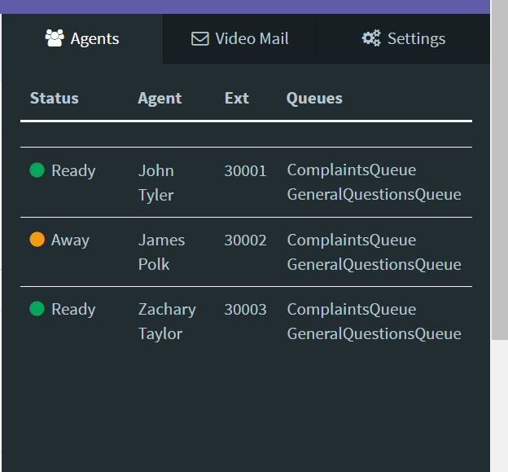
Figure 5. CSR Agent Status Screenshot

Agent Status
The agent status section provides the CSR with a list of CSR Agents logged into ACE Direct. The CSR can view information about each CSR Agent listed, such as their status, extension, and queues they belong to.

Mailbox
The Mailbox tab, as shown in Figure 6, displays a list of messages received while the CSR was not available to take the call. This list provides the CSR with the phone number, time and date of the call, and the length of the message.
Figure 6. CSR Mailbox Screenshot

Settings
Figure 7 shows the Settings. This section is currently empty and used primarily for testing. Ideally, this screen would be hidden from the primary user.
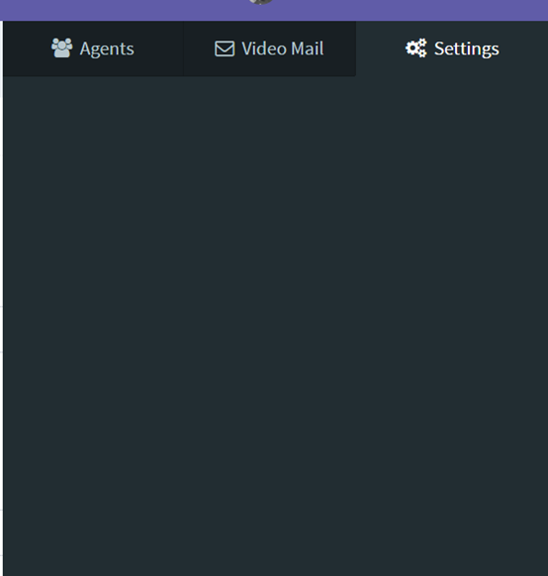
Figure 7. CSR Settings Screenshot

Video and Real-Time Text Communications
The ACE Direct platform supports multiple forms of communications with the CSR. Two of these methods are video and RTT. This subsection describes how each method operates in the platform.

Video Chat
Video Chat communications between the CSR and callers occur through a softphone (such as Linphone and Microsip). After the CSR first logs into ACE Direct, the CSR would then log into their softphone and register their extension in Asterisk.

RTT Chat
The User Chat box, as shown in Figure 8, provides the CSR a secondary method of communication with the caller. As the CSR types a message to the caller in the input field, the message will appear in real time to the user. The chat history will remain visible to the CSR until the CSR closes the ticket.
Figure 8. User Chat Box Screenshot

Scripts
The Scripts box, as shown in Figure 9, provides the CSR with two sub-tabbed areas where the CSR can select the appropriate script to apply to the conversation.
Figure 9. Script Box

CSR Desktop Portal Header
The CSR Desktop portal header provides the CSR with the call duration information, an assistance button, and profile information about the CSR along with the ability to sign out of the system.

Call Duration and Assistance Button
The Call Duration shows a running clock of the call length once the CSR accepts the incoming consumer call. As Figure 10 shows, the Assistance button allows the CSR to ask for help during a call. Once the Assistance button is clicked, the CSR’s name will change color and begin to flash on the Management Dashboard to indicate the CSR needs assistance.
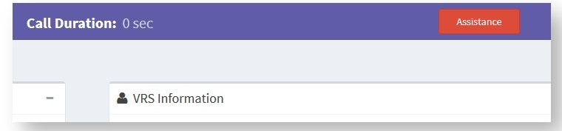
Figure 10. Screenshot of Call Duration and Assistance Button

CSR Profile
On log in, the CSR’s name and picture will appear in the top right corner of the CSR Desktop portal head as shown in Figure 11. The CSR clicks on the Sign out button to log out of the ACE Direct portal.
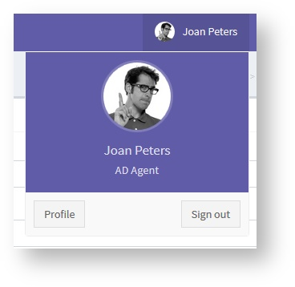
Figure 11. Screenshot of CSR Profile

VRS and Ticket Information

VRS Information
The VRS Information section displays the information about the caller that is currently on file. Figure 12 shows that, after the call has ended, the CSR must click on the Finished button in the VRS Information box to return to the queue and receive new calls.
Figure 12. Screenshot of VRS Information

Ticket Information
Figure 13 shows the Ticket Information section that provides the CSR with the ticket information submitted by the user.
Figure 13. Screenshot of Ticket Information

Consumer Portal
The web site design of the consumer portal gives consumers an option for submitting information without having to wait on the phone for a CSR. In this option, the consumer submits information through a web form. To illustrate this option, the web forms in Figures 14–19 are designed as a consumer complaint form.

Consumer Complaint Form User Guide
The Consumer Complaint User Guide provides a walkthrough of the consumer portal, as shown in Figure 14, highlighting each of the available functionalities.
Figure 14. Screenshot of Consumer Portal

Submitting a Complaint
Upon navigating to the portal host URL, the consumer will be prompted to enter their VRS number as shown in Figure 15.
Figure 15. Screenshot of VRS Number Entry

Contacting the CSR
Upon entering the Complaint Form page, the consumer will be presented their VRS information on file as shown in Figure 16.
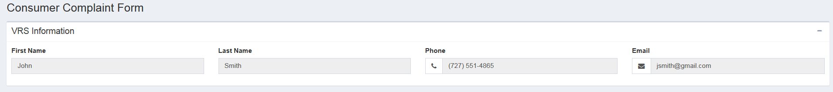
Figure 16. Screenshot of Consumer VRS Information

Complaint Ticket
In the complaint ticket box on the left side of the screen, as shown in Figure 17, the consumer enters a subject and description of the complaint to provide information to the agent. After writing a subject and description, the consumer clicks “Submit” to file the complaint. The complaint ticket is generated, which enables the “Call” button. This allows the consumer to communicate with an agent via video and chat.
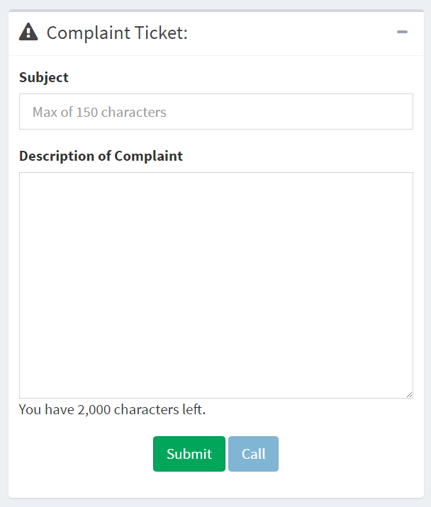
Figure 17. Screenshot of Complaint Ticket

Video Chat
After submitting and calling through the complaint ticket, the consumer will be connected with an agent. The primary form of communication is video. As shown in Figure 18, the agent’s video is displayed in the video box in the center of the screen.

Figure 18. Screenshot of Video Chat Window

Real-Time Text Chat
In Figure 19, the Agent Chat box on the right side of the screen provides the consumer a secondary method of communication with the agent. Notifications appear while the consumer is typing a message to the agent and vice versa. The messages will show up in real time, and the chat history will remain visible until the agent closes the ticket. A maximum of 500 characters per line are allowed during the chat.
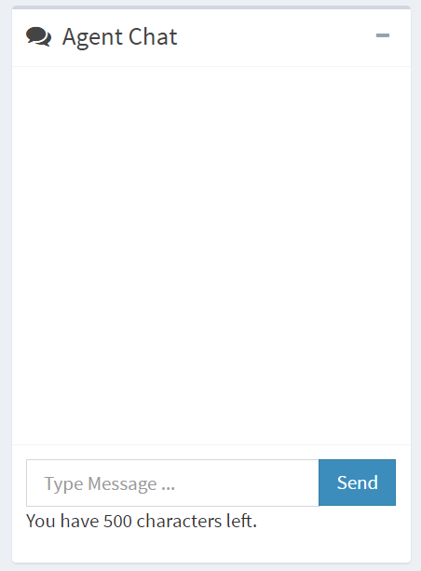
Figure 19. Screenshot of Real-Time Text Chat
When a CSR becomes available, the video chat will begin. After the call ends, the consumer is redirected to FCC.gov.

Management Portal
The Management Portal consists of two components, the Management and CDR dashboards. These dashboards present the manager with information about the operations of the call center and information about incoming calls.

Management Dashboard
The Management Dashboard, as shown in Figure 20, provides a number of KPIs the manager can monitor in real time. To access the Management Dashboard:
- Start a browser on a machine that can access the Management Portal server, Node.js.
- Enter the following URL “https://<hostname>:<port>/dashboard” where <hostname> is the host name of the Management Portal server, and the port is the port-dashboard parameter defined in config.json, e.g., “https://myhost.example.com:9081/dashboard”.
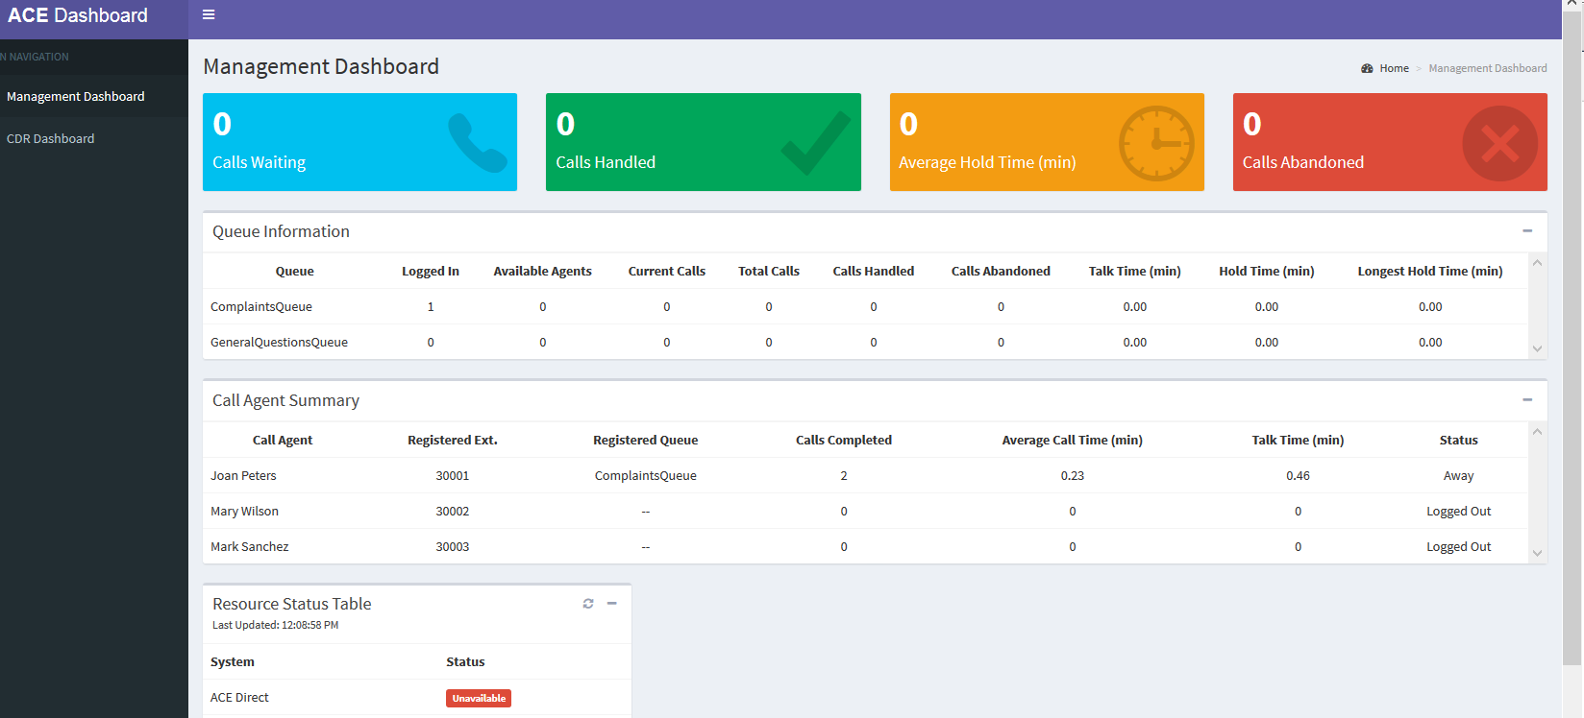
Figure 20. Screenshot of Management Dashboard
KPI Types
The ACE Direct Management Dashboard presents three types of KPIs:
- Summary Data
  - Calls Waiting – Number of calls waiting in the queue
  - Calls Handled – Number of calls completed
  - Average Hold Time (in min) – Average call holding time in the queue
  - Calls Abandoned – Number of calls not answered
- Queue-related KPIs – There are two queues in ACE Direct—ComplaintsQueue and GeneralQuestionQueue. The following KPIs are displayed per queue:
  - Logged In – Number of agents (CSR) currently logged into the system
  - Available Agents – Number of agents currently in a ready state
  - Current Calls – Number of calls currently in progress
  - Total Calls – Total number of calls made
  - Calls Handled – Total number of calls answered by an agent
  - Calls Abandoned – Total number of calls abandoned
  - Talk Time – Average talk time
  - Hold Time – Average hold time
  - Longest Hold Time – The longest hold
- Agent-related KPIs – The following KPIs are displayed per agent (CSR). The agent name, extension, and registered queues are displayed along with the KPI:
  - Agent name – Name of the agent
  - Registered extension – Extension assigned to the agent
  - Registered queues – Asterisk queues assigned to the agent. All queue names are displayed if an agent is assigned to more than one queue.
  - Calls Completed – Number of calls handled (answered and completed) by the agent
  - Average Call Time – Talk Time divided by number of calls
  - Talk Time – The cumulative time the agent has spent on calls
  - Agent status – Logged Off, Ready, Away, or In-Call
- Resource Status KPIs – Figure 21 shows the resource status KPIs:
  - Resources – A list of services required (ACE Direct, Zendesk, Asterisk, CDR, Agent Provider and VRS Lookup)
  - Status – The current status of each service (Running or Unavailable)
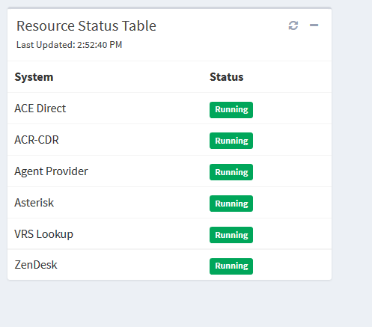
Figure 21. Screenshot of Resource Status

Call Detail Record Dashboard
Asterisk generates a CDR event when a call is completed. A CDR contains metadata that describes each call, such as call source, destination, and timestamp. The CDR dashboard provides a means of auditing call activity, tracking a call CSR’s activity, and creating a listing of both incoming and outgoing calls. The ACE Direct Call Detail Record Dashboard, as shown in Figure 22, provides a method to view and export the Asterisk CDRs stored in the MySQL database.
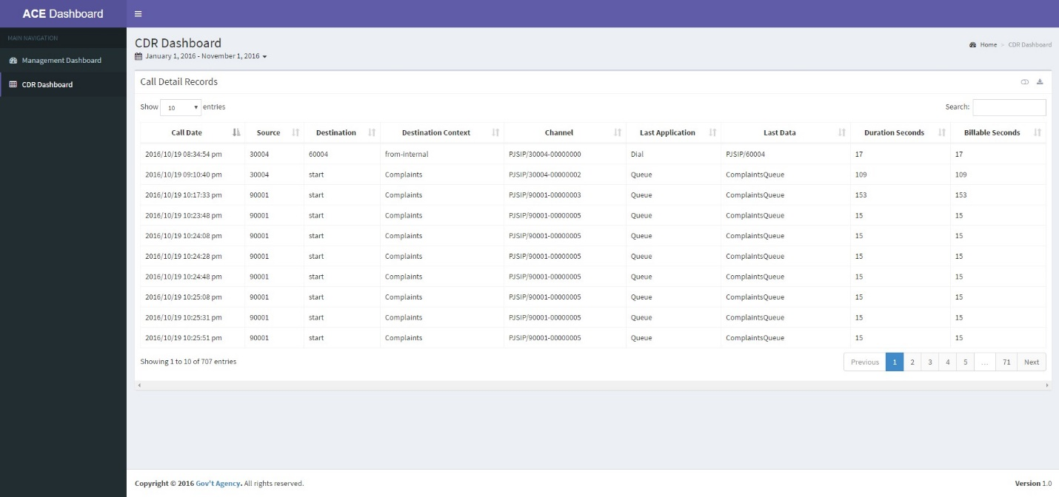
Figure 22. Screenshot of Call Detail Record
The CDR Dashboard allows the user to perform the following actions:
- Select Date Range – The user can select a date range for the report. Predefined values are Today, Yesterday, Last 7 days, Last 30 days, This Month, Last Month, All Time (January 1st 2016 to Today), and Custom Range. Default selection is “All Time.”
- Sort Column – The user can sort on any column by clicking the sort icon located next to each column name. To multi-sort columns, the user depresses the shift key when selecting columns.
- Show/Hide Columns – This action expands the table to include the following columns: Caller ID Text, Destination Channel, Disposition, AMA Flags, Account Code, User Field, Unique ID, Linked ID, Sequence, and Peer Account.
- Download CSV File – This action downloads the table as a Comma Separated Values (CSV) file. The CSV file contains only data within the date range.
- Search – The user can search the entire table. Search results are displayed in near real time.
Table 3 presents the column definitions in the CDR table.

Table 3. Call Detail Record Column Definition
Display Name | Database Column | Description
Call Date | calldate | The start datetime of the call. Default format: 2016-09-07T09:35:41Z dashboard formats the date to 2016/09/07 09:35:41 pm (adjusted for timezone).
Caller ID Text | clid | The full caller ID, including the name, of the calling party. This field is set automatically and is read-only.
Source | src | The calling party’s caller ID number. It is set automatically and is read-only.
Destination | dst | The destination extension for the call. This field is set automatically and is read-only.
Destination Context | dcontext | The destination context for the call. This field is set automatically and is read-only.
Channel | channel | The calling party’s channel. This field is set automatically and is read-only.
Destination Channel | dstchannel | The called party’s channel. This field is set automatically and is read-only.
Last Application | lastapp | The last dialplan application that was executed. This field is set automatically and is read-only.
Last Data | lastdata | The arguments passed to the lastapp. This field is set automatically and is read-only.
Duration Seconds | duration | The number of seconds between the start and end times for the call. This field is set automatically and is read-only.
Billable Seconds | billsec | The number of seconds between the answer and end times for the call. This field is set automatically and is read-only.
Disposition | disposition | An indication of what happened to the call. This may be NO ANSWER, FAILED, BUSY, ANSWERED, or UNKNOWN.
AMA Flags | amaflags | The Automatic Message Accounting (AMA) flag associated with this call. This may be one of the following: OMIT, BILLING, DOCUMENTATION, or Unknown.
Account Code | accountcode | An account ID. This field is user defined and is empty by default.
User Field | userfield | A general-purpose user field. This field is empty by default and can be set to a user-defined string.
Unique ID | uniqueid | The unique ID for the src channel. This field is set automatically and is read-only.
Linked ID | linkedid | A unique identifier that unites multiple CDR records.
Sequence | sequence | A numeric value that, combined with uniqueid and linkedid, can be used to uniquely identify a single CDR record.
Peer Account | peeraccount | The account code of the called party’s channel

Installation and Configuration
This section presents guidance for the installation and configuration of the ACE Direct components. To reproduce this version of the platform, download the configuration and source code files from the https://github.com/fcc/ACEDirect repository.

SSL Certificate
The applications within ACE Direct use a secure protocol (HTTPS) to provide security during web transmissions. To prevent major web browsers from potentially flagging the application as untrusted, it is recommended to acquire and implement a SSL certificate from a trusted certificate authority (CA), such as from LetsEncrypt (https://letsencrypt.org/). After obtaining a certificate, follow the instructions in the respective README files in the Node and Asterisk repositories to implement the SSL certificate.

Asterisk Installation and Configuration Script
An installation script has been developed to assist in the deployment and configuration of the Asterisk server. The Asterisk install script will install and configure Asterisk for ACE Direct on a CentOS 7 server. This script, which is available at https://github.com/fcc/ACEDirect in the Asterisk folder, can be utilized to quickly stand up an Asterisk instance. The script will perform the following tasks automatically:
- Update current packages and install required packages for Asterisk
- Install PJSIP
- Install Asterisk
- Retrieve and configure ACE Direct configuration files from the Git repository
- Start Asterisk
If you do not want to update the server’s packages, modify the script by commenting out or deleting the following line:
yum -y update
It is necessary to satisfy several prerequisites to the script before running it:
- A STUN server is available. (Although you may use Google’s free STUN server, it is recommended you set up a dedicated server because many users rely on Google’s STUN server, which may result in high latency.)
- The server must have a public IP address and a private IP address associated with it.
- A Dial-in number must be set up and configured in Twilio (or any other phone-number provisioning service) and point to the Asterisk server.
- A public/private key-pair must be created for (and located) on the server.

Manual Asterisk Server Installation
If you prefer to install Asterisk manually, the following procedures may be used. ACE Direct Asterisk Server is built with the following software versions:
- OS: CentOS 7.x
- Node.js 7.2.1
- Asterisk: 14.2.1
The Asterisk version 13.8.0 can be downloaded from http://downloads.asterisk.org/pub/telephony/asterisk/releases/ (scroll down to “asterisk-14.2.1-rc1.tar.gz ”).
Details of the Asterisk installation can be found at https://wiki.asterisk.org/wiki/display/AST/Installing+Asterisk+From+Source.
Download and install the required prerequisite software. This will vary by OS. The following listing is for CentOS:
Sudo yum -y install gcc gcc-c++ php-xml lynx bison gmime-devel psmisc tftp-server httpd make ncurses-devel libtermcap-devel sendmail sendmail-cf caching-nameserver sox newt-devel libxml2-devel libtiff-devel audiofile-devel gtk2-devel uuid-devel libtool libuuid-devel kernel-devel kernel-devel-$(uname -r) git subversion kernel-devel crontabs cronie cronie-anacron wget vim jansson-devel libsrtp-devel zip unzip
After starting your preferred server instance, update the OS base packages by running:
sudo yum update -y
Once you have downloaded asterisk*.*.tar.gz, unzip the file and change the directory to the newly created asterisk folder:
- cd ./asterisk*version/
- ./contrib/scripts/install_prereq – This will install the bundled version of pjproject, the SIP stack used in this version of ACE Direct.
- ./configure -–with-pjproject-bundled – The configure command will look at the libraries you installed earlier as the prerequisites and compile Asterisk accordingly. If you are missing options in the next step, you may be missing libraries. The packages required to enable the res_srtp resource module may need to be installed separately.
- make menuselect – This option loads a graphic interface from which you may select add-ons and resource modules for the Asterisk installation. The resource module res_srtp should be selected. If the option is not available, you may be lacking the srtp packages.
This option loads a graphical interface from which you may select add-ons and resource modules for the Asterisk installation. The resource module res_srtp should be selected. If the option is not available, you may be lacking the srtp packages. Ensure there is a successful completion of the “libstrp-devel” package installed by the above yum command. If you need to reinstall a package, you will have to rerun the “configure” script:
make && make install
A successful installation will display on the console window. Following a successful installation, it is recommended to create the sample configuration files. These sample configuration files will provide a template for configuring the Asterisk server. To make the sample configuration files, simply run the script by executing the following command:
make samples
The configuration files are automatically placed in the correct /etc/asterisk/* directory. Once the files have been created, make sure the Asterisk instance is running by entering the following command:
service asterisk status
If the server is not running, ‘service asterisk start’ may be used.
You may now restart the Asterisk service with the command:
service asterisk restart

How It Works
The Asterisk PBX system relies on the interconnected workings of three key files: pjpjsip.conf, extensions.conf, and http.conf. The pjpjsip.conf file contains the connection endpoints and parameters while the extensions file contains the syntax and programming for the extensions assigned to those endpoint connections. The http.conf file is the server configuration for Asterisk. This file defines the certificates Asterisk uses for secure communications.

Dial Plan
The dial plan is defined by the extensions.conf and pjpjsip.conf files under /etc/asterisk, which work together to establish the connection between devices and route the calls to those devices. An endpoint device is any device that places or receives the call. Table 4 shows an example of common endpoint devices and the associated extension along with the required codecs for the sample dial plan configuration in this guide.

Table 4. Asterisk Endpoint Extensions
Extension | Purpose | Device | Codec
6001 | ACE APP user 1 | softphone | h264/ulaw
6002 | ACE APP user 2 | softphone | h264/ulaw
6003 | ACE APP user 3 | softphone | h264/ulaw
6004 | ACE APP user 4 | softphone | h264/ulaw

As displayed in Table 4, the extension is the number assigned to the endpoint. The ability of that endpoint to connect to the Asterisk instance is configured in the pjpjsip.conf file. Its ability to dial to another endpoint is configured within the extensions.conf file. The device can be any phone capable of connecting to the Asterisk instance. This could be a softphone, a desktop phone, a Cisco video communication phone, or other such device. The codec refers to the preferred media codec, or in some cases, the only available codec, used by the endpoint. The codec is also configured in the pjpjsip.conf file.

Extensions.conf
The extensions.conf file is the configuration of your PBX. In this file, you will need to define how the endpoint extensions communicate with each other, or with the Asterisk server itself. The Asterisk server consists of many different applications working together to perform different functions. These functions can be called in the extensions.conf dial plan to route an endpoint device to a desired outcome. For example, a caller wants to dial their voicemail. In extensions.conf, that configuration must state that the caller’s phone number is to load the voicemail application, which would be done by the following syntax:
exten => _6XXX,1,Answer()
same => n,Voicemail(1234@ourpbx)
In this example, any extension matching the pattern _6XXX will be answered for immediate placement into the Voicemail application.
For specific phone numbers to route, as well as number schemes for unknown numbers, use the wildcard “X”. In the following example as shown in the context [from-internal] of the extensions.conf file, all extensions ended with 6xxx are configured. The “[from-internal]” label refers to the context in which those extensions reside. A context is an organizational container that can host a group of extensions and extension patterns that can route and dial to other extensions within the same context. As shown in this example, the file needs no other changes.
[from-internal]
exten => _50XX,1,Dial(PJSIP/${EXTEN})
same => n,DumpChan()
same => n,HangUp()

exten => _6XXX,1,Dial(PJSIP/${EXTEN})
same => n,DumpChan()
same => n,HangUp()

exten => _70XX,1,Dial(PJSIP/${EXTEN})
same => n,DumpChan()
same => n,HangUp()
Extension patterns use wildcards to encompass a greater range of possible matches to the same string. To dial to an extension in another context, that context must be specifically identified in the coding. The context defined must also be the same for the “Context” attribute of the endpoints defined in the pjpjsip.conf file (shown in subsection 3.2.4.1). For the Dial() function call, the extensions/numbers defined within the function call must be defined in pjpjsip.conf, as shown in subsection 3.4.2.1.

Pjpjsip.conf
The pjpjsip.conf file defines the endpoint connection parameters. Some key elements must be configured in this file. The extension itself must be identified, which serves as its SIP identity and subsequently the phone extension. In addition, the file must define the authentication method for this extension as well as the protocol Asterisk must use. The extensions configuration for network connectivity, the allowed codecs, and Asterisk-specific configuration settings must also be defined to make the endpoint a viable connection.
The pjpjsip.conf file tells the Asterisk PBX about the connection points from which your endpoint devices will acquire their information and connect. This means that this file is responsible for (1) the endpoint connection, (2) handling the contact that connects to that endpoint, (3) routing the call, and (4) passing information. The following is a list of critical attributes defined in a profile within pjsip.conf:
- Transport – The transport defined within the pjpjsip.conf file specifies the configuration for TCP, UDP, WS, or WSS connections. These transport settings require configuration as to the external IP, internal IP, and in the case of web sockets, certificate information to be used for secure communication.
- Endpoint –An endpoint to the pjpjsip.conf file is a profile that matches to an endpoint device. The endpoint can be defined in pjsip independently or as a template that numerous extensions can call. This template helps to keep a condensed file because otherwise this file can grow quite large. Endpoint templates are identified by (!) after the identifying name.
- Register – A registration is a type of authentication from an endpoint device. The device will send authentication information to Asterisk that will then “Register” the device to the PBX with the assigned endpoint profile. A registration is a temporary assignment of configuration options and network settings to identify the endpoint device and route calls.
- Contact – A contact is the network identifying information of a device that has registered and its corresponding extension. Viewing the contact information within the Asterisk console verifies that an endpoint device has authenticated and been assigned its configuration correctly.
Once the dial plan has been configured for the devices (e.g., ACE APP) to be registered with the Asterisk server, the profile for those devices can be configured in pjsip.conf under the “[h264_phone_test](!)” section. The “h264_phone_test” profile name can be changed according to the user’s preference.
Once the profile has been defined, extensions and numbers can be associated with the profile, which will be referred to back in the extensions.conf file to help route calls to their proper destination.

Secure Calling
This consumer portal makes use of a technology called WebRTC. Asterisk must use web sockets and, for most browsers, secure web sockets to successfully communicate with WebRTC. Previously, the Asterisk server certificates could be used with self-signed certificates; however, this is no longer the case and Asterisk must be used with a valid certificate authority.

Sample Configurations

Pjpjsip.conf
---------------------------------top of pjpjsip.conf file--------------------------------------------------
[transport-wss] ;name of transport configuration

type=transport ; type being configured is of type transport
protocol=wss ;protocol is web secure socket, can be tcp,udp,ws,wss
bind=0.0.0.0:443 ;bound ip/port
external_media_address=52.45.109.230 ;external ip of Asterisk
cert_file=/etc/asterisk/keys/star.pem ;certificate pem
priv_key_file=/etc/asterisk/keys/star.key ;certificate key
[endpoint-basic](!) ;Defines the name of the endpoint, the (!) designates it as a template
type=endpoint ;defines the type
transport=transport-wss ;defines the transport to be used
context=from-internal ;defines the context, must correspond to context in extensions.conf
disallow=all ;explicitly deny all media unless specified
allow=ulaw ;specify allow ulaw audio codec
allow=vp8 ;specify allow vp8 video
allow=h264 ;specify h264 video
allow=t140 ;specify allow t140 text protocol
force_rport=yes ;network configuration, reflexive port
direct_media=no ;network configuration, do not establish direct media link (NAT)
rewrite_contact=yes
media_address=52.45.109.230
rtp_symmetric=yes
ice_support=yes
message_context=internal-im ;context for internal messenger

[30001](endpoint-basic) ;Extension information, extension username is 30001
auth=auth30001 ;The auth profile to use
aors=30001 ;The aors profile to use

[auth30001](auth-userpass)
password=changeit! ;password to be changed
username=30001 ;username for authentication, typically extension number

[30001](aor-single-reg)
remove_existing=yes ; Remove pre-existing contact
max_contacts=1 ;Number of simultaneous contacts registered to an AOR
qualify_frequency=5 ;Interval in seconds of qualifying a registered contact
authenticate_qualify=yes ;Send authentication request on qualify if required
---------------end of pjpjsip.conf file-------------------------------------------------------------------

WebRTC Sample
The following is a sample WebRTC-enabled endpoint template in pjpjsip.conf:
[endpoint-webrtc](!)
type=endpoint
transport=transport-wss
context=from-internal
disallow=all
allow=vp8
allow=ulaw
allow=t140
media_encryption=dtls ; Determines whether res_pjsip will use and enforce
dtls_verify=fingerprint ; Verify that the provided peer certificate is valid (default:
dtls_fingerprint=SHA-1
dtmf_mode=auto
dtls_rekey=0 ; Interval at which to renegotiate the TLS session and rekey
dtls_cert_file=/etc/asterisk/keys/asterisk.pem
dtls_ca_file=/etc/asterisk/keys/ca.crt
dtls_setup=actpass
ice_support=yes ;This is specific to clients that support NAT traversal

Installation Script
The Asterisk installation script can be found in the Scripts folder at https://github.com/fcc/ACEDirect.

Node.js
The Node.js is a platform built on Chrome’s V8 JavaScript run-time engine, which was developed to build fast and scalable network applications. Node.js uses an event-driven, non-blocking I/O model that makes it lightweight and efficient, perfect for data-intensive real-time applications that run across distributed devices.
Node.js servers host the functionality of ACE Direct. More specifically, the servers host the Customer Service Representative, Consumer, Management, and Call Data Record portals. Node.js also provides CSR Data and Provider Data RESTful APIs to ACE Direct.
Examples of these RESTful services are VRS lookup and CSR verify functions. An Asterisk instance should already be up and running to support most of the Node.js instances.
Instructions for downloading and installing node.js can be found on the official Node.js website (https://nodejs.org/en/). For this version of ACE Direct, the Node.js server is built with the following software versions:
- Windows: CentOS 7.x
- Node.js: 7.2.1

Installing
Start with a fresh CentOS 7 installation. Then ensure that the bundled packages are up to date:
sudo yum -y update
Then, use wget to download and execute the nvm install script. Reload bashrc (you may need to restart your terminal for this to take effect) as fikkiws:
wget -qO- https://raw.githubusercontent.com/creationix/nvm/v0.32.1/install.sh | bash
source ~/.bashrc
Validate that nvm has been successfully installed, then install Node.js. The first command should print out the version of node installed, which should coincide with the URL used to download the npm install script. Afterwards, use npm to install PM2 and Bower:
nvm --version
nvm install node
npm install pm2 -g
npm install bower -g
Clone the Git appropriate repository to the instance:
git clone ssh://<repo_URL>.gitcd <repo>
If needed, generate a public/private key-pair for a non-root user and add the public key to your Git profile. You can use the following command to create a RSA key:
ssh-keygen -t rsa
Afterwards, move to the directory of the earlier cloned Git repo and check out the desired release/branch:
git checkout <release>
In all the folders (except the CSR Data and Provider Data portals), there are JSON configuration file templates that must be configured before running the applications. For example, the config.json_TEMPLATE file must be renamed to config.json and configured with the appropriate values. Under “asterisk”:“sip”, modify the “host” and “realm” properties to point to the DNS name of the associated Asterisk instance, and modify the “host-o” and “realm-o” properties to point to the elastic IP address of the Asterisk instance. Refer to the additional configuration instructions in the README.md files of each source code repository.

Starting
The root folder of each application contains a file with the extension “.js”. Run the following command to start the application:
pm2 start <.js_file>

Status
The pm2 list command in Figure 24 shows the running node server(s).:
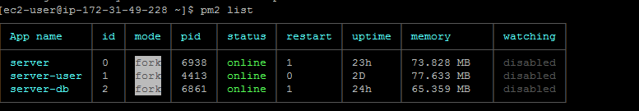
Figure 24. pm2 list Command

Restart
The UNIX command “pm2 restart <node server>” will restart a node server if the server has been updated. For example, “pm2 restart server-user” will restart the server-user node server. You can also use “pm2 restart all” to restart all node processes currently running, if necessary.

Management Portal
The ACE Direct Management Portal provides a number of Key Performance Indicators for real-time monitoring by the manager. This information may be used to improve user experience, increase user satisfaction, and overall call center performance.

Installation
The CAMH team developed a Node.js-based management dashboard to show system status. To install and launch the service, follow these instructions:
- Clone the managementportal repository
- Install Node.js
- cd managementportal
- npm install
  - Installs the required Node.js modules
- npm install -g bower
  - Installs the Bower package
- bower install
  - Installs the Bower managed packages
- node server-db.js
  - Starts the Management Portal server

Configuration
Update the following parameters in config.json if necessary:
- port-dashboard – This is the port number used by the dashboard; the default port is 8081.
- AsteriskAD/sip/host – Fully qualified domain name of the associated Asterisk server (e.g., mySIP.example.com).
- dashboard/queuesAD – Queue names configured for ACE Direct. Currently, ACE Direct has two queues—GeneralQuestionsQueue and ComplaintsQueue.
- Resource section – URL of the monitored resources (Zendesk, VRS lookup, Agent Provider, ACE Direct, CDR).
If necessary, update the following parameters in Asterisk queues.conf:
[StandardQueue](!)
autofill=no ; calls come from Asterisk serially
strategy=rrmemory
joinempty=yes
leavewhenempty=no
ringinuse=no
wrapuptime=25 ; When a member hangs up, how many seconds does queue wait before assigning another caller. Default is 0.
setqueuevar=yes
eventwhencalled=yes

Run
Follow the instructions in subsection 3.3.2 to start the Management Portal.

Log Files
Log files are located in managementportal/logs. The debug level is defined by the debugLevel field in the configuration file. The valid options are as follows: all, trace, debug, info, warn, error and fatal.

Management Dashboard

Web Server and Client Configuration
The management dashboard functionality relies on the Asterisk server to collect reports on call agents and queue status. The Management Dashboard (dashboard.js and dashboard.html) is hosted on the Node.js server (server-db.js). The following subsections describe the operational data flow.

Server Side
server-db.js – Communicates with the Asterisk Server through the Asterisk Management Interface (AMI) protocol. AMI events provide the Management Portal with data on queue and agent status.

Client Side
dashboard.html – Controls the UI for the CA Dashboard.
dashboard.js – Uses JavaScript data structures to store information to be displayed on the dashboard.html page.

Asterisk Management Interface
The AMI allows a client application to connect to an Asterisk instance and issue actions (requests) and receive events (responses). The Management Portal performs five unique AMI action calls to collect data on queue and agent status. Table 5 shows the AMI actions and descriptions.

Table 5. AMI Actions and Descriptions
AMI Action | Description | Syntax | Arguments | Triggered Events
Agents | Queries for information about all agents | Action: Agents  ActionID: <value> | - ActionID – ActionID for this transaction. Will be returned. | Agents  AgentsComplete
QueueReset | Resets the running statistics for a queue | Action: QueueReset  ActionID: <value>  Queue: <value> | - ActionID – ActionID for this transaction. Will be returned.  - Queue – The name of the queue on which to reset statistics.
Queues | Queries for queues information | Action: Queues |  | Queues
QueueStatus | Check the status of one or more queues | Action: QueueStatus  ActionID: <value>  Queue: <value>  Member: <value> | - ActionID – ActionID for this transaction. Will be returned.  - Queue – Limit the response to the status of the specified queue.  - Member – Limit the response to the status of the specified member. | QueueStatus  QueueStatusComplete
QueueSummary | Requests Asterisk to send a QueueSummary event | Action: QueueSummary  ActionID: <value>  Queue: <value> | - ActionID – ActionID for this transaction. Will be returned.  - Queue – Queue for which the summary is requested. | QueueSummary  QueueSummaryComplete

The dashboard server listens for the Asterisk AMI events shown in Table 6.

Table 6. Asterisk AMI Event
AMI Action | Description | Syntax | Fields
AgentsComplete | Generated when an agent has finishes servicing a member in the queue | Event: AgentComplete  Queue: <value>  Member: <value>  MemberName: <value>  HoldTime: <value>  [Variable:] <value>  TalkTime: <value>  Reason: <value>  Queue: <value>  Uniqueid: <value>  Channel: <value>  Member: <value>  MemberName: <value>  HoldTime: <value> | - Queue – The name of the queue.  - Member – The queue member's channel technology or location.  - MemberName – The name of the queue member.  - HoldTime – The time the channel was in the queue, expressed in seconds since 00:00, Jan 1, 1970 UTC.  - Variable – Optional channel variables from the ChannelCalling channel  - TalkTime – The time the agent talked with the member in the queue, expressed in seconds since 00:00, Jan 1, 1970 UTC.  - Reason  - caller  - agent  - transfer  - Queue  - Uniqueid  - Channel  - Member  - MemberName  - HoldTime
AgentLogin | Generated when an agent logs in | Event: AgentLogin  Agent: <value>  Channel: <value>  Uniqueid: <value> | - Agent – The name of the agent.  - Channel  - Uniqueid
AgentLogoff | Generated when an agent logs off | Event: AgentLogoff  Agent: <value>  Agent: <value>  Logintime: <value>  Uniqueid: <value> | - Agent – The name of the agent.  - Agent  - Logintime  - Uniqueid
FullyBooted | Generated when all Asterisk initialization procedures complete | Event: FullyBooted  Status: <value> | - Status
QueueMemberAdded | Generated when a new member is added to the queue | Event: QueueMemberAdded  Queue: <value>  Location: <value>  MemberName: <value>  StateInterface: <value>  Membership: <value>  Penalty: <value>  CallsTaken: <value>  LastCall: <value>  Status: <value>  Paused: <value>  Queue: <value>  Location: <value>  MemberName: <value>  StateInterface: <value>  Membership: <value>  Penalty: <value>  CallsTaken: <value>  LastCall: <value>  Status: <value>  Paused: <value> | - Queue – The name of the queue.  - Location – The queue member's channel technology or location.  - MemberName – The name of the queue member.  - StateInterface – Channel technology or location from which to read device state changes.  - Membership  - dynamic  - realtime  - static  - Penalty – The penalty associated with the queue member.  - CallsTaken – The number of calls this queue member has serviced.  - LastCall – The time this member last took call, expressed in seconds since 00:00, Jan 1, 1970 UTC.  - Status – The numeric device state status of the queue member.  - 0 - AST_DEVICE_UNKNOWN  - 1 - AST_DEVICE_NOT_INUSE  - 2 - AST_DEVICE_INUSE  - 3 - AST_DEVICE_BUSY  - 4 - AST_DEVICE_INVALID  - 5 - AST_DEVICE_UNAVAILABLE  - 6 - AST_DEVICE_RINGING  - 7 - AST_DEVICE_RINGINUSE  - 8 - AST_DEVICE_ONHOLD  - Paused  - 0  - 1  - Queue  - Location  - MemberName  - StateInterface  - Membership  - Penalty  - CallsTaken  - LastCall  - Status  - Paused
QueueMemberRemoved | Generated when a queue member is removed from the queue | Event: QueueMemberRemoved  Queue: <value>  Location: <value>  MemberName: <value>  Queue: <value>  Location: <value>  MemberName: <value> | - Queue – The name of the queue.  - Location – The queue member's channel technology or location.  - MemberName – The name of the queue member.  - Queue  - Location  - MemberName

Call Detail Record Dashboard
The Asterisk PBX system is capable of collecting and storing call data for each call that traverses the system. These data records, referred to as call detail records (CDR), are collected and stored for use by business intelligence (BI) tools, statistical analysis, and even compensation and reimbursement. The information collected is invaluable and can be retrieved and stored using various methods.
By default, the Asterisk server stores CDRs in a file called master.csv located in /var/log/cdr-csv. CDR records can be collected in real time, or near-real time, in various ways. The Asterisk server also allows different types of database connections. One method is to use Asterisk on an internal application for connecting to a database. Another is to configure an Open Database Connectivity (ODBC) connection for Asterisk. There is no restriction on the type of database used. For example, MySQL, MariaDB, and others are all viable options. CAMH elected to use a MySQL database server with Asterisk connecting through an ODBC.
To begin, install any additional packages for the MySQL server and the ODBC connector as follows:
sudo yum install unixODBC unixODBC-devel libtool-ltdl libtool-ltdl-devel mysql-connector-odbc
wget http://repo.mysql.com/mysql-community-release-el7-5.noarch.rpm
sudo rpm -ivh mysql-community-release-el7-5.noarch.rpm
sudo yum install mysql-server
sudo systemctl start mysqld
sudo yum update
Once the packages are installed, Asterisk must recognize these new packages. To do so, migrate to the Asterisk directory located in /usr/src/asterisk-14.2.1/. From this directory, run:
./configure
make menuselect
Once the graphic window is displayed, make sure that the res_odbc module is selected. Save and exit the graphic window. Run the following command:
make && make install
This will configure the Asterisk installation for use with the ODBC connection. Once the installation script successfully finishes, you can start the SQL server.
Once MySQL has been installed, run the basic hardening script for MySQL to remove anonymous connections, the test database, and establish the root password. To do this, run the following script and follow the prompts:
sudo /usr/bin/mysql_secure_installation
After installing MySQL and completing the initial configuration, log in to the MySQL using:
MySQL -u root -p
Once logged in, create the database and the table needed to store the CDRs. To do so, run the following commands:
CREATE DATABASE asterisk;USE asterisk;
CREATE TABLE `bit_cdr` ( `calldate` datetime NOT NULL default '0000-00-00 00:00:00', `clid` varchar(80) NOT NULL default '', `src` varchar(80) NOT NULL default '', `dst` varchar(80) NOT NULL default '', `dcontext` varchar(80) NOT NULL default '', `channel` varchar(80) NOT NULL default '', `dstchannel` varchar(80) NOT NULL default '', `lastapp` varchar(80) NOT NULL default '', `lastdata` varchar(80) NOT NULL default '', `duration` int(11) NOT NULL default '0', `billsec` int(11) NOT NULL default '0', `disposition` varchar(45) NOT NULL default '', `amaflags` int(11) NOT NULL default '0', `accountcode` varchar(20) NOT NULL default '', `userfield` varchar(255) NOT NULL default '', `uniqueid` VARCHAR(32) NOT NULL default '', `linkedid` VARCHAR(32) NOT NULL default '', `sequence` VARCHAR(32) NOT NULL default '', `peeraccount` VARCHAR(32) NOT NULL default '' );
ALTER TABLE `bit_cdr` ADD INDEX ( `calldate` );
ALTER TABLE `bit_cdr` ADD INDEX ( `dst` );
ALTER TABLE `bit_cdr` ADD INDEX ( `accountcode` );
To create a user account for remote connections, use the following syntax:
CREATE USER 'username'@'%' IDENTIFIED BY 'password';GRANT ALL PRIVILEGES ON *.* TO 'username'@'%' WITH GRANT OPTION;FLUSH PRIVILEGES;
Now that the database is up and running, connect to Asterisk by using the ODBC connector, as follows:
vi /etc/odbcinst.ini
[MySQL]
Description = ODBC for MySQL
Driver = /usr/lib/libmyodbc5.so
Setup = /usr/lib/libodbcmyS.so
Driver64 = /usr/lib64/libmyodbc5.so
Setup64 = /usr/lib64/libodbcmyS.so
FileUsage = 1

vi /etc/odbc.ini
[asterisk-connector]
Description = MySQL connection to 'asterisk' database
Driver = MySQL
Database = asterisk
Server = localhost
User = root
Password = password
Port = 3306
Socket = /var/lib/mysqld/mysqld.sock
To test your configuration, run the following command from the CLI:
echo "select 1" | isql -v asterisk-connector
You should see a message of Connected! returned.
| Connected! |
SQLRowCount returns 1 1 rows fetched
Now you will need to point Asterisk to your new database. To do so, modify the /etc/asterisk/res_odbc.conf file with the database name, username, password and port of the ODBC connection you have set up. The dsn variable will point to the dsn identified:
vi /etc/asterisk/res_odbc.conf
[asterisk]
enabled => yes
dsn => asterisk-connectorusername => username
password => password
pooling => no
limit => 99999
pre-connect => yes
Next, edit /etc/asterisk/cdr_odbc.conf to include the following:
vi /etc/asterisk/cdr_odbc.conf
[global]
dsn=asterisk
loguniqueid=yes
table=bit_cdr
Note: the dsn variable will point to the DSN identified in res_odbc.conf, NOT /etc/odbc.ini
Next, Edit /etc/ cdr_adaptive_odbc.conf to include the following:
vi /etc/asterisk/cdr_adaptive_odbc.conf
[asteriskcdr]
connection=asterisk
table=cdr
alias start=calldate
Next, ensure CDR writing is enabled in cdr_manager.conf:
vi /etc/asterisk/cdr_manager.conf
[general]
enabled = yes
Finally, restart Asterisk:
sudo service asterisk restart
The CDR reporting functionality relies on two Node.js servers: the management portal (server-db.js) and the acr-cdr (app.js). These servers provide the following capabilities:
- server-db.js –
  - Receives GET call for /cdrinfo.
  - Performs GET call to app.js /getallcdrrecs.
  - Acts as a middleman for the cdr.html page to the app.js node server. This node server can be bypassed by changing the cdr.html GET call from /cdrinfo to http://<app.js location>/getallcdrrecs if the CDR Dashboard needs to be separated from the Management Portal.
- app.js –
  - Receives GET call for /getallcdrrecs.
  - Performs query to the Asterisk CDR database table. Returns a JSON object of the data.

CSR / Agent Database (Provider)
The ACE Direct uses a database to store Customer Service Representative information and to verify agent identity when a CSR logs into the system.
To host the agent data, a MySQL database server is required.A RESTful API developed using Node.js provides access to the data for CSR verification. For this effort, CAMH built the Node.js server with the following software versions:
- Linux: CentOS 7.x
- Node.js: v7.2.1

MySQL Database Server Configuration
The CAMH team developed a MySQL database containing several tables to store the agent-related data. Create a database named agentdb_new and use the following MySQL script to create the tables that will store the agent-related data:
-- MySQL dump 10.13 Distrib 5.5.47, for debian-linux-gnu (x86_64)
--
-- Host: localhost Database: agentdb_new
-- ------------------------------------------------------
-- Server version 5.5.47-0ubuntu0.14.04.1

/*!40101 SET @OLD_CHARACTER_SET_CLIENT=@@CHARACTER_SET_CLIENT */;
/*!40101 SET @OLD_CHARACTER_SET_RESULTS=@@CHARACTER_SET_RESULTS */;
/*!40101 SET @OLD_COLLATION_CONNECTION=@@COLLATION_CONNECTION */;
/*!40101 SET NAMES utf8 */;
/*!40103 SET @OLD_TIME_ZONE=@@TIME_ZONE */;
/*!40103 SET TIME_ZONE='+00:00' */;
/*!40014 SET @OLD_UNIQUE_CHECKS=@@UNIQUE_CHECKS, UNIQUE_CHECKS=0 */;
/*!40014 SET @OLD_FOREIGN_KEY_CHECKS=@@FOREIGN_KEY_CHECKS, FOREIGN_KEY_CHECKS=0 */;
/*!40101 SET @OLD_SQL_MODE=@@SQL_MODE, SQL_MODE='NO_AUTO_VALUE_ON_ZERO' */;
/*!40111 SET @OLD_SQL_NOTES=@@SQL_NOTES, SQL_NOTES=0 */;

--
-- Table structure for table `agent_data`
--

DROP TABLE IF EXISTS `agent_data`;
/*!40101 SET @saved_cs_client = @@character_set_client */;
/*!40101 SET character_set_client = utf8 */;
CREATE TABLE `agent_data` (
`agent_id` int(10) NOT NULL AUTO_INCREMENT,
`username` varchar(10) NOT NULL,
`password` varchar(30) NOT NULL,
`first_name` varchar(20) NOT NULL,
`last_name` varchar(20) NOT NULL,
`role` varchar(50) NOT NULL,
`phone` varchar(12) NOT NULL,
`email` varchar(40) NOT NULL,
`organization` varchar(50) NOT NULL,
`is_approved` tinyint(1) NOT NULL,
`is_active` tinyint(1) NOT NULL,
`extension_id` int(10) DEFAULT NULL,
`queue_id` int(10) DEFAULT NULL,
`queue2_id` int(10) DEFAULT NULL,
PRIMARY KEY (`agent_id`),
UNIQUE KEY `username` (`username`),
UNIQUE KEY `email` (`email`)
) ENGINE=InnoDB AUTO_INCREMENT=26 DEFAULT CHARSET=utf8;
/*!40101 SET character_set_client = @saved_cs_client */;

--
-- Table structure for table `asterisk_extensions`
--

DROP TABLE IF EXISTS `asterisk_extensions`;
/*!40101 SET @saved_cs_client = @@character_set_client */;
/*!40101 SET character_set_client = utf8 */;
CREATE TABLE `asterisk_extensions` (
`id` int(10) NOT NULL AUTO_INCREMENT,
`extension` int(4) DEFAULT NULL,
`extension_secret` varchar(30) DEFAULT NULL,
PRIMARY KEY (`id`)
) ENGINE=InnoDB AUTO_INCREMENT=25 DEFAULT CHARSET=utf8;
/*!40101 SET character_set_client = @saved_cs_client */;

--
-- Table structure for table `asterisk_queues`
--

DROP TABLE IF EXISTS `asterisk_queues`;
/*!40101 SET @saved_cs_client = @@character_set_client */;
/*!40101 SET character_set_client = utf8 */;
CREATE TABLE `asterisk_queues` (
`id` int(10) NOT NULL AUTO_INCREMENT,
`queue_name` varchar(50) DEFAULT NULL,
PRIMARY KEY (`id`)
) ENGINE=InnoDB AUTO_INCREMENT=4 DEFAULT CHARSET=utf8;
/*!40101 SET character_set_client = @saved_cs_client */;

--
-- Table structure for table `outgoing_channels`
--

DROP TABLE IF EXISTS `outgoing_channels`;
/*!40101 SET @saved_cs_client = @@character_set_client */;
/*!40101 SET character_set_client = utf8 */;
CREATE TABLE `outgoing_channels` (
`id` int(11) NOT NULL AUTO_INCREMENT,
`channel` varchar(30) DEFAULT NULL,
PRIMARY KEY (`id`)
) ENGINE=InnoDB AUTO_INCREMENT=8 DEFAULT CHARSET=utf8;
/*!40101 SET character_set_client = @saved_cs_client */;

--
-- Table structure for table `scripts`
--

DROP TABLE IF EXISTS `scripts`;
/*!40101 SET @saved_cs_client = @@character_set_client */;
/*!40101 SET character_set_client = utf8 */;
CREATE TABLE `scripts` (
`id` int(10) NOT NULL AUTO_INCREMENT,
`queue_id` int(10) NOT NULL,
`text` varchar(10000) NOT NULL,
`date` date NOT NULL,
PRIMARY KEY (`id`)
) ENGINE=InnoDB AUTO_INCREMENT=3 DEFAULT CHARSET=utf8;
/*!40101 SET character_set_client = @saved_cs_client */;
/*!40103 SET TIME_ZONE=@OLD_TIME_ZONE */;

/*!40101 SET SQL_MODE=@OLD_SQL_MODE */;
/*!40014 SET FOREIGN_KEY_CHECKS=@OLD_FOREIGN_KEY_CHECKS */;
/*!40014 SET UNIQUE_CHECKS=@OLD_UNIQUE_CHECKS */;
/*!40101 SET CHARACTER_SET_CLIENT=@OLD_CHARACTER_SET_CLIENT */;
/*!40101 SET CHARACTER_SET_RESULTS=@OLD_CHARACTER_SET_RESULTS */;
/*!40101 SET COLLATION_CONNECTION=@OLD_COLLATION_CONNECTION */;
/*!40111 SET SQL_NOTES=@OLD_SQL_NOTES */;
Verify that the MySQL database is up, running, and accepting connections. A tool like MySQL Workbench can quickly verify that the configuration is correct. Populate the table with the simulated VRS data, again using a tool such as MySQL Workbench.

CSR / Agent RESTful Service Installation
The CAMH team developed a Node.js-based RESTful service to access the CSR database. To install and launch the service, follow these instructions:
- Clone the aserver repository.
- Download and install Node.js.
- Install the required Node.js modules:
  - cd userver
  - npm install
  - npm install apidoc -g
  - apidoc -I routes/ -o apidoc
    - This creates HTML documentation for this service.
- node.js app.js [ port – default is 8085 ]
  - Launches the RESTful service.
Once the service is running, the connection can be verified by using one of the following curl commands:
- curl –request GET http://hostname:80825
  - Verifies that the service is running.
- curl –request GET http://hostname:8085/agentverify/?username=<user>?password=<pass>
  - Displays the information for the CSR with the username and password.
- curl –request GET http://hostname:8085/getallagentrecs
  - Displays all CSR records in the database.

VRS User Database (Provider)
The Video Relay Service user database was developed to emulate a VRS user lookup in the iTRS-URD from the CSR desktop. This lookup verifies that the user-provided phone number is a registered VRS number. A MySQL database server is required. A RESTful API developed using Node.js provides access to the data for user verification. For this effort, CAMH built the Node.js server with the following software versions:
- Linux: CentOS 7.x
- Node.js: v7.2.1

MySQL Database Server Configuration
The CAMH team developed a MySQL database containing a single table to store the emulated VRS lookup data. Create a database named portaldb and use the following MySQL script to create the table (named user_data) that will store the VRS lookup data:
-- MySQL dump 10.13 Distrib 5.5.47, for debian-linux-gnu (x86_64)
-- Host: localhost Database: portaldb
-- Server version 5.5.47-0ubuntu0.14.04.1
/*!40101 SET @OLD_CHARACTER_SET_CLIENT=@@CHARACTER_SET_CLIENT */;
/*!40101 SET @OLD_CHARACTER_SET_RESULTS=@@CHARACTER_SET_RESULTS */;
/*!40101 SET @OLD_COLLATION_CONNECTION=@@COLLATION_CONNECTION */;
/*!40101 SET NAMES utf8 */;
/*!40103 SET @OLD_TIME_ZONE=@@TIME_ZONE */;
/*!40103 SET TIME_ZONE='+00:00' */;
/*!40014 SET @OLD_UNIQUE_CHECKS=@@UNIQUE_CHECKS, UNIQUE_CHECKS=0 */;
/*!40014 SET @OLD_FOREIGN_KEY_CHECKS=@@FOREIGN_KEY_CHECKS, FOREIGN_KEY_CHECKS=0
*/;
/*!40101 SET @OLD_SQL_MODE=@@SQL_MODE, SQL_MODE='NO_AUTO_VALUE_ON_ZERO' */;
/*!40111 SET @OLD_SQL_NOTES=@@SQL_NOTES, SQL_NOTES=0 */;
--
-- Table structure for table `user_data`
--
DROP TABLE IF EXISTS `user_data`;
/*!40101 SET @saved_cs_client = @@character_set_client */;
/*!40101 SET character_set_client = utf8 */;
CREATE TABLE `user_data` (
`vrs` bigint(20) NOT NULL AUTO_INCREMENT,
`username` varchar(255) NOT NULL,
`password` varchar(255) NOT NULL,
`first_name` varchar(255) NOT NULL,
`last_name` varchar(255) NOT NULL,
`address` varchar(255) NOT NULL,
`city` varchar(255) NOT NULL,
`state` varchar(255) NOT NULL,
`zip_code` varchar(255) NOT NULL,
`email` varchar(255) NOT NULL,
`isAdmin` tinyint(1) NOT NULL,
PRIMARY KEY (`vrs`),
UNIQUE KEY `username` (`username`),
UNIQUE KEY `email` (`email`)
) ENGINE=InnoDB AUTO_INCREMENT=7275514879 DEFAULT CHARSET=latin1;
/*!40101 SET character_set_client = @saved_cs_client */;
/*!40103 SET TIME_ZONE=@OLD_TIME_ZONE */;
/*!40101 SET SQL_MODE=@OLD_SQL_MODE */;
/*!40014 SET FOREIGN_KEY_CHECKS=@OLD_FOREIGN_KEY_CHECKS */;
/*!40014 SET UNIQUE_CHECKS=@OLD_UNIQUE_CHECKS */;
/*!40101 SET CHARACTER_SET_CLIENT=@OLD_CHARACTER_SET_CLIENT */;
/*!40101 SET CHARACTER_SET_RESULTS=@OLD_CHARACTER_SET_RESULTS */;
/*!40101 SET COLLATION_CONNECTION=@OLD_COLLATION_CONNECTION */;
/*!40111 SET SQL_NOTES=@OLD_SQL_NOTES */;
Verify that the MySQL database is up, running, and accepting connections. A tool like MySQL Workbench can quickly verify that the configuration is correct. Populate the table with the simulated VRS data, again using a tool such as MySQL Workbench.

Video Relay Service RESTful Service Installation
The CAMH team developed a Node.js-based RESTful service to access the VRS database. To install and launch the service, follow these instructions:
- Clone the userver repository.
- Download and install Node.js.
- Install the required Node.js modules:
  - cd userver
  - npm install
  - npm install apidoc -g
  - apidoc -I routes/ -o apidoc
    - This creates HTML documentation for this service.
- node.js app.js [ port – default is 8082 ]
  - Launches the RESTful service.
Once the service is running, the connection can be verified by using one of the following curl commands:
- curl –request GET http://hostname:8082
  - Verifies that the service is running.
- curl –request GET http://hostname:8082/vrsverify/?vrsnum=12345
  - Displays the information for VRS number 12345.
- curl –request GET http://hostname:8082/getallvrsrecs
  - Displays all VRS records in the database.

STUN
If a host is located behind a NAT, then in certain situations it can be impossible for that host to communicate directly with other hosts (peers). In these situations, the host must use the services of an intermediate node as a communication relay. This specification defines a protocol, called TURN (Traversal Using Relays around NAT), which allows the host to control the operation of the relay and to exchange packets with its peers using the relay. TURN differs from other relay control protocols because it allows a client to communicate with multiple peers using a single relay address. A TURN server, which is an implementation of the STUN protocol, uses a relay to provide an alternate method for NAT discovery and traversal (STUN). TURN is able to traverse symmetric NAT instances.
For this project, reTurn server (from reSIProcate) is used for STUN/TURN services. reTurn is a C++ implementation of STUN RFC5389 and TURN RFC5766. To install STUN services on an Ubuntu installation, start by installing the TURN server package:
sudo apt-get install resiprocate-turn-server
Edit the etc/reTurn/reTurnServer.config file, and modify the “AuthenticationRealm” property to point to the DNS of the server. Then restart the TURN service:
sudo service resiprocate-turn-server restart
Once the service is running, TURN will be listening on port 3478. In Asterisk, you can modify the “stunaddr” attribute in sip.conf to point to the DNS name of the server and port 3478.

iTRS ENUM Database
For phone numbers of deaf and hard-of-hearing users, iTRS is the authoritative database managed by Neustar. The lookup of the iTRS ENUM database performs DNS queries to determine a Uniform Resource Identifier (URI) for a 10-digit telephone number. There is a graphical user interface (GUI) as well as a programmatic interface.
To query the production iTRS database requires establishing an IPSec tunnel with Neustar. For the proof of concept, the CAMH team added the IP address 156.154.59.67 first in the DNS settings (/etc/resolv.conf) for the ENUM lookup to work. Note that with the default AWS instance settings, any changes made to the resolv.conf file will be overwritten on restart of the network service because new values are queries from DNS. This behavior must be disabled.
The following example snippet of code, which is part of an Asterisk Dial Plan, comes from an Extensions.conf file. Subsection 3.2.2.1 provides more information on the Asterisk Dial Plan.
exten => _9.[1-9]XXXXXXXXXX, 1, Set(sipuri=${ENUMLOOKUP(+${EXTEN:1},sip,,1,itrs.us)})
same => n,NoOp("Outbound Direct Video Call to: ${EXTEN:1}") ; just for informational purposes
same => s,n,SipAddHeader(P-Asserted-Identity: <sip:nnnnnnnnnn>) ;set the callerID number
same => n,NoOp("sipuri: ${sipuri:1}")
same => n,Dial(SIP/${sipuri:1},30)

VyOS Router for Secure Socket Layer Tunnel
To support the iTRS-ENUM database lookup, a Secure Socket Layer (SSL) VPN tunnel is established to Neustar from a VyOS router instance running in AWS (Figure 25). The router instance has a loopback interface with an Elastic IP on it that is the encryption domain for the tunnel. Neustar requires public IP addresses for the encryption domain and does not set aside a /30 network as is typical for an IPSec tunnel.
There is a NAT (actually a Port Address Translation) rule created on the VyOS router to allow traffic from the AWS instances to route out over the IPsec tunnel. A routing rule is added to the VPC to route traffic destined to the Neustar Encryption domain IP address to the router’s private IP address. Note: Source/destination checking must be disabled on the router instance’s elastic network interface.
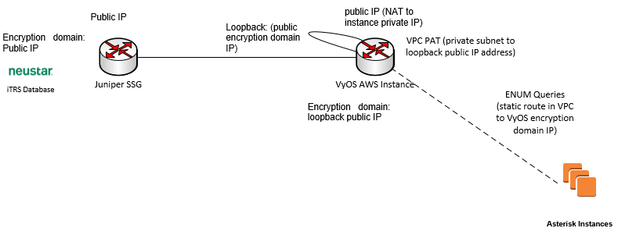
Figure 25. VyOS Router for SSL Tunnel
The VyOS router should be configured as follows.
set vpn ipsec esp-group trs compression disable
set vpn ipsec esp-group trs lifetime 28800
set vpn ipsec esp-group trs mode tunnel
set vpn ipsec esp-group trs pfs dh-group2
set vpn ipsec esp-group trs proposal 1 encryption aes128
set vpn ipsec esp-group trs proposal 1 hash sha1
set vpn ipsec ike-group trs lifetime 86400
set vpn ipsec ike-group trs proposal 1 dh-group 2
set vpn ipsec ike-group trs proposal 1 encryption aes128
set vpn ipsec ike-group trs proposal 1 hash sha1
set vpn ipsec ipsec-interfaces interface eth0
set vpn ipsec site-to-site peer “Neustar IP” authentication id “VyOS public IP”
set vpn ipsec site-to-site peer “Neustar IP” authentication mode pre-shared-secret
set vpn ipsec site-to-site peer “Neustar IP” authentication pre-shared-secret secret_code_goes_here
set vpn ipsec site-to-site peer “Neustar IP” connection-type initiate
set vpn ipsec site-to-site peer “Neustar IP” default-esp-group trs
set vpn ipsec site-to-site peer “Neustar IP” ike-group trs
set vpn ipsec site-to-site peer “Neustar IP” local-address “VyOS private address”
set vpn ipsec site-to-site peer “Neustar IP” tunnel 1 local prefix “your Encryption-Domain”/32
set vpn ipsec site-to-site peer “Neustar IP” tunnel 1 protocol
set vpn ipsec site-to-site peer “Neustar IP” tunnel 1 remote prefix “Neustar Encryption-Domain”/32
set vpn ipsec site-to-site peer “Neustar IP” tunnel 1 allow-public-networks enable
set interfaces dummy dum0 address “your Encryption-Domain”/32
set protocols static route “Neustar Encryption-Domain”/32 next-hop “your Encryption-Domain”
set nat source rule 100 outbound-interface dum0
set nat source rule 100 source address “your private subnet”
set nat source rule 100 translation address masquerade
set nat source rule 100 translation address “your Encryption-Domain”
In the AWS Cloud, a route must be created in the VPC route table to ensure that traffic to the iTRS database is routed to the VyOS instance, which in turn, then routes it out over the VPN tunnel. By default, instances drop packets when source and destination information do not match that of an instance. This behavior can be disabled from the AWS console by selecting an instance and going to network options.

COTS CRM
To demonstrate integration with a commercial Customer Relationship Management (CRM) service, ACE Direct connects to the Zendesk portal via the Enterprise Service Bus. ACE Direct sends JSON-based messages to the RESTful Zendesk API to manage and query customer records. Zendesk is a suite of web-based products that help companies provide better customer service. ACE Direct uses Zendesk to capture consumer complaints. When a consumer files a complaint, the ACE Direct software uses the Zendesk web service API to create and store a complaint ticket. This API also allows querying and updating of created tickets. When an ACE Direct CSR answers a call from a consumer, the application requests the ticket information from Zendesk and displays it on the ACE Direct CSR Desktop portal.

Enterprise Service Bus
The ESB provides a generic method to integrate with legacy database systems as well as the diverse number of databases and unstructured data repositories on the market and in use today. ACE Direct ESB integrates with a COTS CRM service (e.g., Zendesk) as a ticketing system for the CSR to document service cases.

Background
Apache ServiceMix 6.1.2 is used as the service broker. Apache ServiceMix is an enterprise-class, open source, distributed ESB based on the service-oriented architecture (SOA) model. It is a project of the Apache Software Foundation and was built on the semantics and APIs of the Java Business Integration (JBI) specification JSR 208. The software is distributed under the Apache License.
ACE Direct utilizes supported releases of ServiceMix 4 from Red Hat JBoss, called JBoss Fuse ESB. Fabric8 is a free Apache 2.0 Licensed upstream community for the JBoss Fuse product from Red Hat.
The current version of ServiceMix fully supports the OSGi framework. ServiceMix is lightweight and easily embeddable, and has integrated Spring Framework support. It can be run at the edge of the network (inside a client or server), as a standalone ESB provider, or as a service within another ESB. ServiceMix is compatible with Java SE or a Java Enterprise Edition (EE) application server. ServiceMix uses ActiveMQ to provide remoting, clustering, reliability, and distributed failover. The basic frameworks used by ServiceMix are Spring and XBean.
ServiceMix comprises the latest versions of Apache ActiveMQ, Apache Camel, Apache CXF, and Apache Karaf. Additional installation features include:
- BPM engine via Activiti
- JPA support via Apache OpenJPA
- XA transaction management via JTA via Apache Aries
The ServiceMix ESB provides:
- Federation, clustering, and container-provided failover
- Hot deployment and life-cycle management of business objects
- Vendor independence from vendor-licensed products
- Compliance with the JBI specification JSR 208
- Compliance with the OSGi 4.2 specification through Apache Felix
- Support for OSGi Enterprise through Apache Aries

Installation Overview
First install and get ServiceMix and its prerequisites running on the host machine.

ServiceMix System Requirements
To run Apache ServiceMix itself, you will need Java Runtime Environment (JRE) 1.8.x (Java 8), and about 100 MB of free disk space for the default assembly.
If you are developing your own integration applications and OSGi bundles, you will also need:
- Java Developer Kit (JDK) 1.8.x (Java 8)
- MySQL
- Apache Maven 3.0.4 or higher
The ACRDEMO broker application depends on MySQL for a database and Maven for building the application.

Installing the JDK
Issue the following commands to install the Java 8 JDK:
sudo apt-add-repository ppa:webupd8team/java
sudo apt-get update
sudo apt-get install oracle-java8-installer
Set the JAVA_HOME environment variable in the bash startup:
vi ~/.bashrc
Add the following lines to the end of the .bashrc script:
JAVA_HOME=/usr/lib/jvm/java-8-oracle/
export JAVA_HOME
PATH=$PATH:$JAVA_HOME/bin
export PATH

Installing Apache Maven
To install Apache Maven, issue the following command:
sudo apt-get install maven

Installing MySQL
You will be able to set the password for the root account. Note: There is a current issue with the ESB that requires also setting the privileges for anonymous local users; accordingly, do not disable access for anonymous users. To install MySQL, issue the following commands:
sudo apt-get update
sudo apt-get install mysql-server
sudo mysql_secure_installation
sudo mysql_install_db

Configuring MySQL
The ServiceMix broker application for the ACR demo connects to the MySQL database; therefore, first create and configure the demo database.
Login to the MySQL command-line tool using the root account with the password you set earlier:
mysql --user=root --password=somepassword
Create a database named “broker” for the ACR demo:
mysql> CREATE DATABASE broker;
mysql> USE broker;
Create the database user named “broker” for the ACR demo and set the password:
mysql> CREATE USER 'broker'@'localhost' IDENTIFIED BY 'somepassword';
Set the permissions for the database user “broker”. Note: This should be tuned to only grant the necessary privileges:
mysql> GRANT ALL PRIVILEGES ON broker.* TO 'broker'@'%' WITH GRANT OPTION;
Note: There is a current issue with the ESB that also requires setting the privileges for anonymous local users. Privileges must be set for anonymous users:
mysql> GRANT ALL PRIVILEGES ON broker.* TO ''@'localhost' WITH GRANT OPTION;
Create the “users” table:
mysql> CREATE TABLE `users` ( `user_id` bigint(20) NOT NULL, `user_name` varchar(50) DEFAULT NULL, `user_description` varchar(45) DEFAULT NULL, `user_phone` varchar(20) DEFAULT NULL, `user_address` varchar(50) DEFAULT NULL, `user_account` varchar(50) DEFAULT NULL, PRIMARY KEY (`user_id`));
Populate the “users” table with test records. Note: The user_id values need to correspond to IDs of Zendesk users:
mysql> INSERT INTO `users` VALUES (3770168798,'John Doe ','Some Details','555-555-1111',NULL,'121212'),(4060741111,'Jane Doe','No Description','222-111-1111','12341 Main Street','12345671'),(4758821111,'Tim','No Description','555-666-7777','','5656565');

Downloading and Building Broker Application
Set up SSH keys to access the git repository according to these instructions:
- Adding a new SSH key to your GitHub account
Create a folder for cloning the broker source code and navigate to that folder:
mkdir ~/code && cd ~/code
Clone the broker git repository from esb.git
Navigate to the broker code folder:
cd camel-rest-proxy-blueprint/
Modify the applications blueprint file for your environment.
Build the broker application with Maven:
mvn clean install

Downloading and Installing Apache ServiceMix
Apache ServiceMix 6.1.2 is available under the Apache License v2 and can be downloaded from http://servicemix.apache.org/downloads/servicemix-6.1.2.html.
Create and navigate to a folder where the downloaded zip file will be placed:
mkdir ~/dev-tools && cd ~/dev-tools
Download and uncompress the zip file. For example:
wget http://mirror.cc.columbia.edu/pub/software/apache/servicemix/servicemix-6/6.1.2/apache-servicemix-6.1.2.zip
unzip apache-servicemix-6.1.2.zip

Running and Configuring ServiceMix
In a command shell, navigate to the ServiceMix bin directory (e.g., ~/dev-tools/apache-servicemix-6.1.2):
cd ~/dev-tools/apache-servicemix-6.1.2/bin
Start ServiceMix:
./servicemix
Install the following features:
karaf@root>feature:install jdbc
karaf@root>feature:install pax-jdbc-mysql
karaf@root>feature:install camel-jsonpath
karaf@root>feature:install camel-jetty
karaf@root>feature:install camel-jdbc
You may need to download the pax-jdbc artifact from the Maven repository if the pax-jdbc-mysql install does not work:
karaf@root>feature:repo-add pax-jdbc 0.6.0
Create the JDBC connection to the MySQL database:
Note: Depending on your version of jdbc, you will need either the command “jdbc:ds-create” or “jdbc:create”. Type <tab> to print a list of available commands and find the one you need:
karaf@root>jdbc:ds-create -dn mysql -url jdbc:mysql://localhost:3306/demo?user=broker&password=somepassword mySqlDataSource
karaf@root>jdbc:create -d mysql -t MySQL -url jdbc:mysql://localhost:3306/broker -u broker -p somepassword mySqlDataSource
Check that the JDBC connection was created:
karaf@root>jdbc:datasources
Another way to check the database connection is to issue a query:
karaf@root>jdbc:query jdbc/mySqlDataSource "select * from users"
Install the broker application. The application will be installed as an OSGI bundle:
karaf@root>bundle:install -s mvn:org.apache.camel/camel-rest-proxy-blueprint/2.16.3
Check that the broker was installed. The bundle should be the last bundle in the list and its status should be ACTIVE:
karaf@root>bundle:list

Install and Start ServiceMix as a Service
Start the ServiceMix if is not already started. Issue the following commands:
karaf@root>feature:install wrapper
karaf@root>wrapper:install -s AUTO_START -n KARAF -d Karaf -D "Karaf Service"
A message similar to the following will be displayed:
Setup complete. You may wish to tweak the JVM properties in the wrapper configuration file before installing and starting the service:
/home/ubuntu/dev-tools/apache-servicemix-6.1.2/etc/KARAF-wrapper.conf
Ubuntu/Debian Linux system detected (SystemV):
To install the service:
$ ln -s /home/ubuntu/dev-tools/apache-servicemix-6.1.2/bin/KARAF-service /etc/init.d/
To start the service when the machine is rebooted:
$ update-rc.d KARAF-service defaults
To disable starting the service when the machine is rebooted:
$ update-rc.d -f KARAF-service remove
To start the service:
$ /etc/init.d/KARAF-service start
To stop the service:
$ /etc/init.d/KARAF-service stop
To uninstall the service:
$ rm /etc/init.d/KARAF-service
For systemd compliant Linux:
To install the service (and enable at system boot):
$ systemctl enable /home/ubuntu/dev-tools/apache-servicemix-6.1.2/bin/KARAF.service
To start the service:
$ systemctl start KARAF
To stop the service:
$ systemctl stop KARAF
To check the current service status:
$ systemctl status KARAF
To see service activity journal:
$ journalctl -u KARAF
To uninstall the service (and disable at system boot):
$ systemctl disable KARAF
Exit the ServiceMix/Karaf shell, by shutting down ServiceMix:
karaf@root>shutdown
Install the ServiceMix service:
sudo ln -s /home/ubuntu/dev-tools/apache-servicemix-6.1.2/bin/KARAF-service /etc/init.d/
Set the service to start when the machine is rebooted:
sudo update-rc.d KARAF-service defaults
Start the ServiceMix service:
sudo /etc/init.d/KARAF-service start
To log back into ServiceMix once the service is started, issue the following commands:
cd ~/dev-tools/apache-servicemix-6.1.2/bin
./client
To exit the ServiceMix shell without shutting down the service, type ^D (i.e., Ctrl-D). Note: If you type shutdown in ServiceMix shell, the entire service will be shut down.

Testing the Broker Application
At this point, all of the code for the Broker application is contained in the OSGI Blueprint file (i.e., blueprint.xml) that can be viewed in https://github.com/fcc/ACEDirect in the acrdemo-provider folder.
If the Broker application is running in ServiceMix running, you can check the application by using curl at the command line. For example:
$ curl -u wkchang@mitre.org/token:hLLUnPzJtpvMZ5WnntN3wCneKHkl20kP0Hhn5NrD http://localhost:9090/api/v2/users/me.json --insecure
You can check the status and statics of the main Broker route in the ServiceMix/Karaf shell:
karaf@root>camel:route-info rest-http-zendesk-mysql-demo
Here is example output from the camel:route-info command:
Camel Route rest-http-zendesk-mysql-demo
Camel Context: camel-1
State: Started
State: Started
Statistics
Exchanges Total: 2
Exchanges Completed: 2
Exchanges Failed: 0
Exchanges Inflight: 0
Min Processing Time: 240 ms
Max Processing Time: 494 ms
Mean Processing Time: 367 ms
Total Processing Time: 734 ms
Last Processing Time: 240 ms
Delta Processing Time: -254 ms
Start Statistics Date: 2016-07-19 14:43:44
Reset Statistics Date: 2016-07-19 14:43:44
First Exchange Date: 2016-07-19 15:12:15
Last Exchange Date: 2016-07-19 15:12:3

Acronyms
Term | Definition
ACE | Accessible Communications for Everyone
ACR | Auto Call Routing
ADA | Americans with Disabilities Act
ALI | Automatic Location Identification
AMA | Automatic Message Accounting
AMI | Asterisk Management Interface
API | Application Programming Interface
APP | Access Point Platform
ASL | American Sign Language
AWS | Amazon Web Services
CA | Certificate Authority, Communication Assistant
CAMH | CMS Alliance to Modernize Healthcare
CDR | Call Detail Record
CLI | Command Line Interface
COE | Center of Expertise
COTS | Commercial Off-the-Shelf
CRM | Customer Relationship Management
CSR | Customer Service Representative
CSV | Comma Separated Value
DNS | Domain Name System
DVC | Direct Video Calling
EIP | Elastic Internet Protocol
ENUM | E.164 Number to URI Mapping
ESB | Enterprise Service Bus
FCC | Federal Communications Commission
FFRDC | Federally Funded Research and Development Center
GUI | Graphical User Interface
HTTPS | HyperText Transport Protocol Secure
iTRS | Internet Telecommunications Relay Service
I/O | Input/Output
IP | Internet Protocol
IPSec | Internet Protocol Secure
Java EE | Java Enterprise Edition
JBI | Java Business Integration
JDBC | Java Database Connectivity
JDK | Java Developer Kit
JRE | Java Runtime Environment
JSON | JavaScript Object Notation
JSR | Java Specification Request?
KPI | Key Performance Indicator
NAT | Network Address Translation
ODBC | Open Database Connectivity
OS | Operating System
OSGi | OSGi Alliance (formerly Open Systems Group Initiative)
P2P | Point to Point
PAT | Port Address Translation
PBX | Private Branch Exchange
POC | Proof of Concept
PSTN | Public Switch Telephone Network
QoS | Quality of Service
REST | Representational State Transfer
RFC | Request for Comment
RTCP | RTP (Real-time Transport Protocol) Control Protocol
RTM | Requirements Traceability Matrix
RTT | Real-Time Text
RUE | Relay User Equipment
SIP | Session Initiation Protocol
SOA | Service-Oriented Architecture
SQL | Structured Query Language
SRTP | Secure Real-Time Transport Protocol
SSH | Secure Shell
SSL | Secure Socket Layer
STUN | Session Traversal Utilities for NAT
TCP | Transmission Control Protocol
TURN | Traversal Using Relay NAT
UDID | Unique Device Identifier
UDP | User Datagram Protocol
UI | User Interface
URD | User Registration Database
URI | Uniform Resource Identifier
URL | Universal Resource Locator
VRS | Video Relay Service
VyOS | Vyatta Operating System (open source)
WS | Web Socket
WSS | Web Secure Socket

https://www.fcc.gov/ace
Available at https://www.fcc.gov/document/fcc-adds-american-sign-language-consumer-support-line-videophone.

