Probing the Limits of Memory: Retention of a Learned Response Through Decapitation and Regeneration in Planaria

Francis Forde

School of Psychology, Victoria University of Wellington

Author Note

The authors have no conflicts of interest to disclose. This Thesis was supported by a Wellington Masters by Thesis Scholarship provided by Victoria University of Wellington.

Abstract

XX

*Keywords*: Memory, Learning, Planaria, Reinstatement, Cocaine, Methamphetamine, Behaviour

Table of Contents

Abstract 2

1. Introduction 3

1.1 Overview of Key Concepts in the Field of Learning and Memory 4

8. References 6

# 1. Introduction

A brain in isolation is just a clump of extravagant cells. A brain earns its keep by liaising with the body and the external world. It is among these brain-environment interactions that an organism can set and achieve goals and, ultimately, carve a pathway to survival. But brains operate in the dark. Their only insight into the on-goings of the world is through delicately placed sensory organs such as the eyes, nose and ears.

The sensory technology that each organism possesses, what philosophers call its sensorium, differs across species. Some build a picture of the world by capturing light using light sensitive proteins. Others live where no light can penetrate and so must form their worldview using other sensory modalities like echolocation. Notwithstanding these differences, neuroscientists and biologists seek to understand the suite of abilities each organism possesses, the neuronal and molecular mechanisms which underpin these, and the factors that determine when and why an organism deploys the behaviours in its arsenal. But we do not usually do this for the sake of the organism itself. Rather, we use non-human organisms with the hope of learning something about our own brains and bodies.

We now have a broad tool set for inspecting brains across different time spans and at different levels of analysis. From looking at activity within a single dendritic spine over microseconds to looking at connectivity between different brain structures over several minutes. We can even track changes in the size of spines on a single dendrite over time – impressive given the width of a spine is 100 times smaller than the thickness of a human hair (Bayramoglu et al., 2022; B.-Z. Li et al., 2023). At the network level, we are able to identify groups of neurons (ensembles) involved in encoding and storing memory, and can use precise tools to excite or inhibit those networks to alter an animals behaviour (Goshen, 2014).

Our experimental competency arose from many small steps. Before we had the capability for manipulating neurons to understand their role in memory, we had to attack things more abstractly. Our early exploration of how memory functions involved basic procedures like learning lists of nonsense syllables or simple motor tasks. This early research helped answer the question of whether memory is a unitary system or a suite of separate systems which can be dissociated. Out of this fell distinctions between episodic and semantic memory, as well as short- and long-term memory storage. Early theoretical progress provided the foundation upon which specialised tools and procedures could be developed to manipulate and characterise the biology of memory in its different forms.

## 1.1 Overview of Key Concepts in the Field of Learning and Memory

### 1.1.1 Categories of Memory

Memory is the embodiment of past experience which shapes our future behaviour. Learning, on the other hand, is the process of memory acquisition. That said, there may be as many different definitions of learning and memory as there are papers published on the topic. Barron et al. (2015) surveyed the various uses of the term “learning” across disciplines such as cognitive psychology, behavioural ecology, and machine learning and identified at least 50 definitions (albeit with a lot of overlap). Memory has been parceled into several distinct categories based on the content of the information held (see Figure 1 below). A major distinction was made between explicit and implicit memory (Schacter & Tulving, 1994; Squire, 1987). Explicit memories are those accessible to conscious awareness, like a memory of where you parked your car this morning. Implicit memories cannot be consciously accessed but still affect behaviour, an example being the small muscle movements needed to ride a bike. Explicit memory has been further subdivided into episodic and semantic memory (Tulving, 1972). Episodic refers to the rich experiential quality of personal memories, while semantic relates to things that you know but which lack an experiential component, such as facts about the world.

Figure 1

Categorisation of Memory

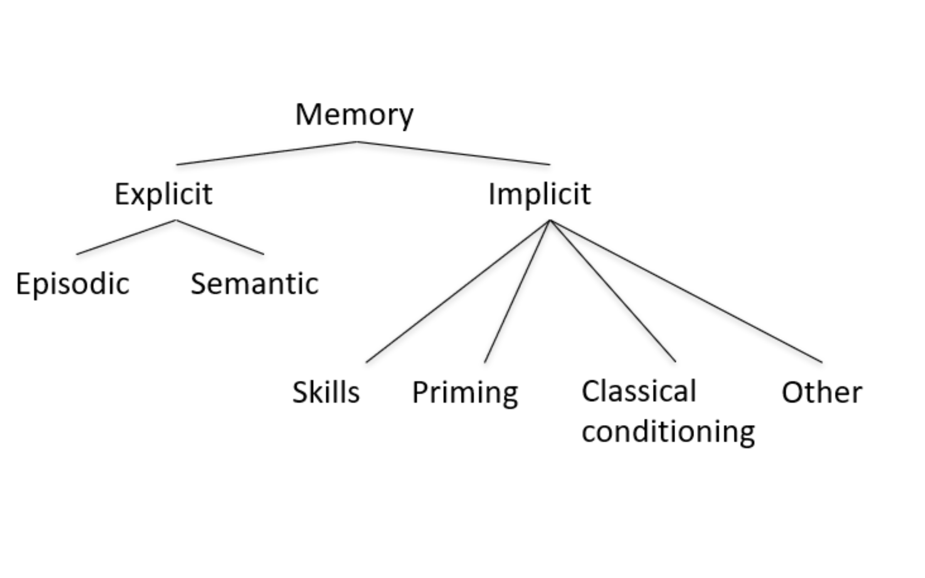

*Note*. Theoretical categorisation of memory based on the content and conscious accessibility of the information. The major explicit/implicit distinction was first put forward by Endel Tulving (1972). Figure adapted from Squire (1987).

### 1.1.2 Associative and Non-associative Learning

# 8. References

Abbott, S. M., & Wong, G. K. (2008). The Conditioning and Memory Retention of Planaria (Dugesia tigrina) for Directional Preferences. *Bios*, *79*(4), 160–170. <http://www.jstor.org/stable/25433841>