**Fall2023 - Assignment 1**

To be posted at 4pm Oct 8, 2023

Description:

It takes 9% of your course assessment.

Please submit on or before 6pm on Oct 12, 2023.

|  |  |  |  |  |  |
| --- | --- | --- | --- | --- | --- |
| **Question** | **True or False** | **Fill in the Blank** | **Multiple Select** | **Single Select** | **Total** |
| **Number** | ***Q1-5*** | ***Q6-7*** | ***Q8-11*** | ***Q12-16*** | **16** |
| **Mark** | ***2’*5*** | ***3’x 15 blanks*** | ***5’*4*** | ***3’*5*** | ***90’*** |

For Fill in the Blank: zero mark would be given to answers not following the correct format, as well as the ones contain typos/errors.

For Multiple Select: no partial gradings, i.e., partially correct answers are given zero mark.

If a submission is late for 24 hours or less, 30% will be deducted. If a submission is later for more than 24 hours, no credit will be given.

**True or False**

1. Attribute B is functionally dependent on A when attribute B determines attribute A. [TRUE/FALSE]
2. In the table: TABLE(A, B, C, D), A is fully functionally dependent on the composite key (B, D). [TRUE/FALSE]
3. As long as everything is planned and executed well step by step for the database development process, the resulted database system will be a perfect, ready-to-use system without the need of maintain and updates. [TRUE/FALSE]
4. As long as entity integrity and referential integrity of a table are met, the table ensures data integrity. [TRUE/FALSE]
5. Each column in a relational table represents a single entity instance within the entity set. [TRUE/FALSE]

**Fill in the Blank**

1. Please fill in the blanks below:

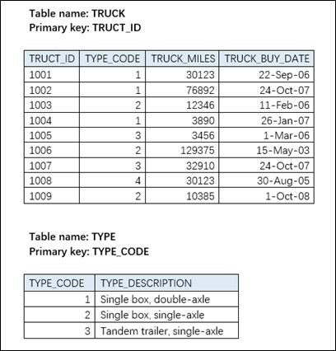

The foreign key of the TRUCK table is __TYPE_CODE_______.

TRUCK table exhibits _____ (entity/referential) integrity.

TRUCK table violates _____ (entity/referential) integrity.

TYPE table exhibits _____ (entity/referential) integrity.

The combination (TYPE_CODE, TRUCT_ID) is a _____________ (superkey/candidate key/primary key) of table TRUCK.

1. Please fill in the blanks below:

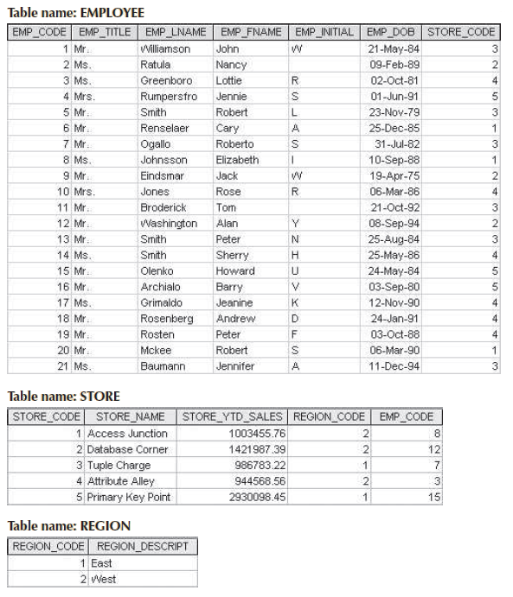

The data type of EMPLOYEE.EMP_TITLE is ___________ (numeric/character/date/logical).

The data type of EMPLOYEE.EMP_FNAME is ___________ (numeric/character/date/logical).

The data type of STORE.STORE_YTD_SALES is ___________ (numeric/character/date/logical).

Please note down the foreign key(s) of the table EMPLOYEE: ___STORE_CODE___________ (If a table does not have a foreign key, please write None; if multiple foreign keys, use comma “,” to separate them.)

Please note down the foreign key(s) of the table STORE: __REGION_CODE, EMP_CODE___ (If a table does not have a foreign key, please write None; if multiple foreign keys, use comma “,” to separate them.)

Please note down the foreign key(s) of the table REGION: _________________ (If a table does not have a foreign key, please write None; if multiple foreign keys, use comma “,” to separate them.)

The combination (EMP_CODE, EMP_LNAME) is a _____________ (superkey/candidate key/primary key) of table EMPLOYEE.

The combination (EMP_CODE, STORE_CODE) is a _____________ (superkey/candidate key/primary key) of table EMPLOYEE.

True or False: the null values in EMPLOYEE.EMP_INITIAL violate referential integrity. _____ (True/False)

True or False: the table STORE violates referential integrity. _____ (True/False)

**Multiple Select**

1. Which of the following are FALSE about superkeys? AC
2. A superkey must be a candidate key
3. A candidate key must be a superkey
4. A superkey must be a composite key
5. A primary key must be a candidate key
6. Which of the following statement are TRUE? BD
7. Attribute A and B are in the same table. If A determines B, then A is the superkey of the table.
8. In the table: TABLE(A, B), A is determined by B.
9. A table has four attributes, A, B, C and D. If C is fully functionally dependent on the combination of A and B, then the combination is the candidate key of the table.
10. A table has four attributes, A, B, C and D. If both C and D are fully functionally dependent on the combination of A and B, then the combination is the superkey of the table.
11. Which of the following statements are FALSE about the three relational tables: BD

* Department (DptID, DptName, DptDescription)
* Doctor (DocID, DocName, Gender, Title, DptID)
* ResidentPatient (PID, PName, BedNo, DocID, DateAdmitted)

1. DptID is the primary key of the Department table.
2. DptID is the primary key of the Doctor table.
3. DocID is the foreign key of the ResidentPatient table.
4. The foreign key, Doctor. DocID, references to ResidentPatient. DocID.
5. Which of the following are FALSE about integrity? BCD

A. When a primary key contains a null value, the table does not exhibit entity integrity.

B. When a primary key contains a null value, the table does not exhibit referential integrity.

C. When a foreign key contains a null value, the table does not exhibit entity integrity.

D. When a foreign key contains a null value, the table does not exhibit referential integrity.

**Single Select**

1. Which of the following is a correct relational schema for the table TRUCK shown in Question6. D
2. TRUCK (TRUCT_ID, TYPE_CODE, TRUCK_MILES, TRUCK_BUY_DATE)

Foreign key: TRUCK_ID references TRUCK.TRUCT_ID

1. TRUCK (TRUCT_ID, TYPE_CODE, TRUCK_MILES, TRUCK_BUY_DATE)

Foreign key: TRUCT_ID references TYPE.TRUCT_ID

1. TRUCK (TRUCT_ID, TYPE_CODE, TRUCK_MILES, TRUCK_BUY_DATE)

Foreign key: TYPE_ID references TYPE.TYPE_ID

1. TRUCK (TRUCT_ID, TYPE_CODE, TRUCK_MILES, TRUCK_BUY_DATE)

Foreign key: TYPE_CODE references TYPE.TYPE_CODE

1. A project can be done by at least one worker; a worker can work on zero or more projects. The above describes: F
2. Two mandatory many cardinalities
3. Two mandatory one cardinalities
4. Two optional many cardinalities
5. Two optional one cardinalities
6. One optional one, and one mandatory many cardinalities
7. One optional many, and one mandatory many cardinalities
8. One optional one, and one mandatory one cardinalities
9. One optional many, and one mandatory one cardinalities
10. Which of the following is the best ER diagram for the described scenario? C

***Scenario:*** A bakery needs a database for its own operation. Each baker should complete orders every day, and an order may have multiple types of products. The ordered products are described with the following attributes: type, size and price. For each completion on the order, baker’s completion time and working hours are stored. Each order’s initiation day, total amount, payment status, delivery status and the number of each contained product are recorded.

*\* Some attributes of Baker and those of Product are not listed here.*

A. 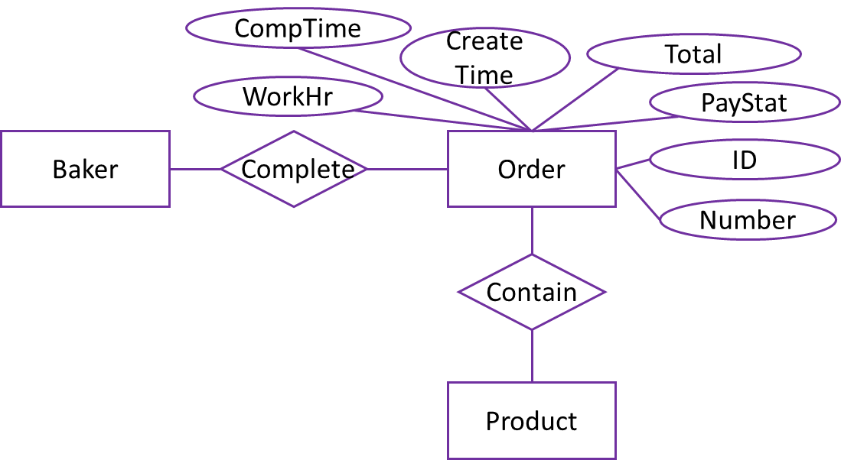 B. 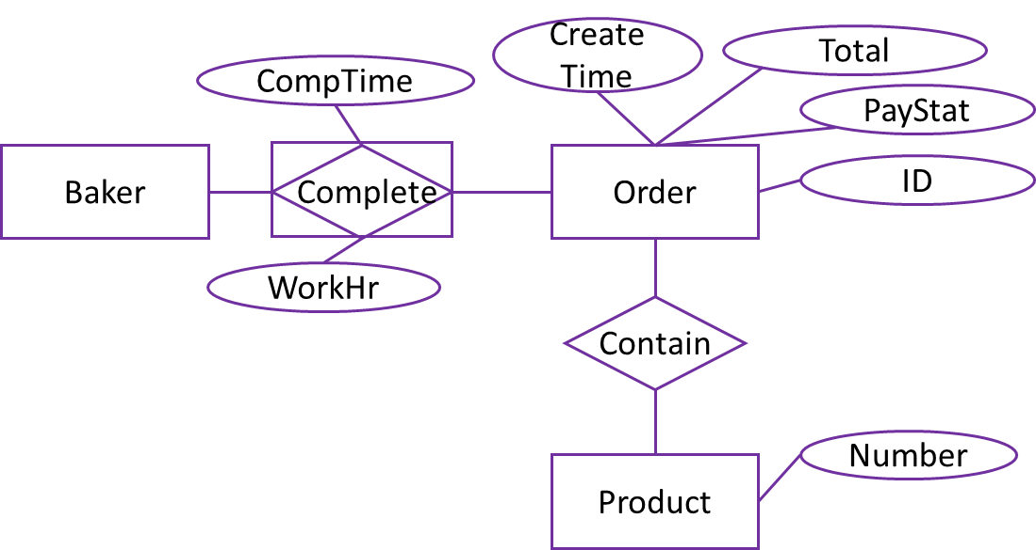

C. 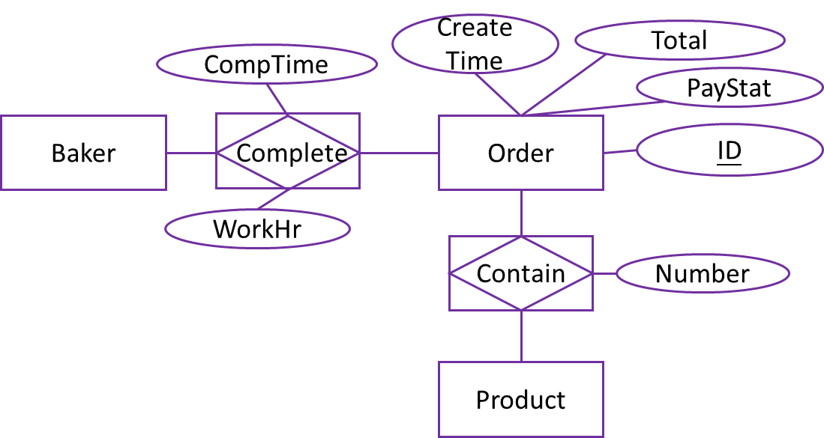 D. 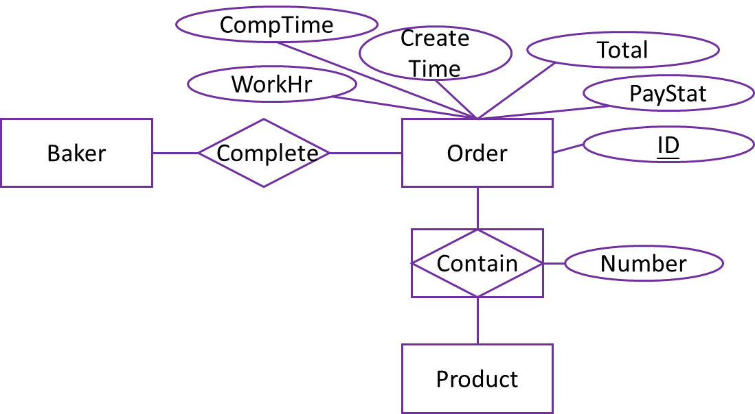

1. Which of the following is the best ER diagram for the described scenario? D

***Continue the bakery scenario:*** The orders are placed by customers. An order should be placed by only one customer, and a customer can place multiple orders.

*\* Attributes are not listed here.*

A. 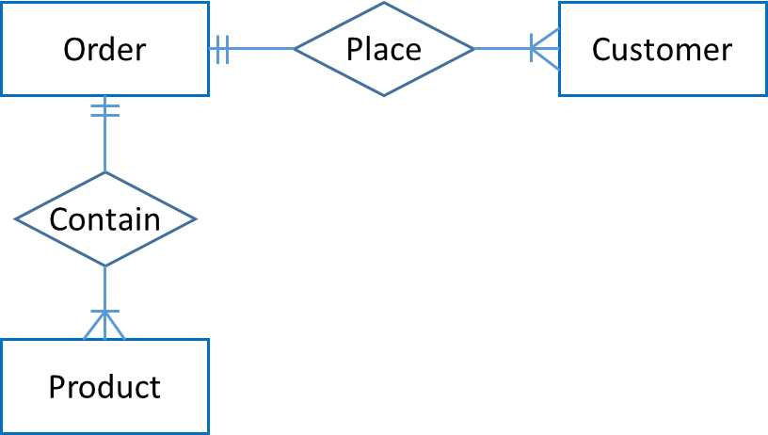 B. 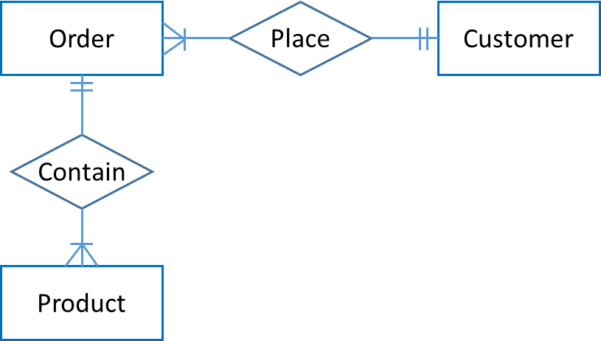

C. 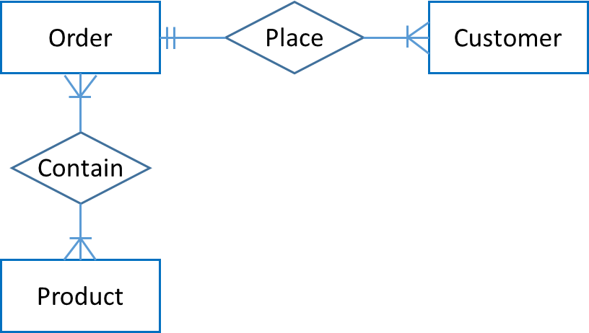 D. 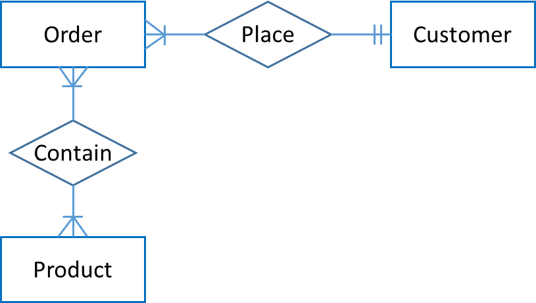

1. Which of the following is the best EER diagram for the described scenario? B

***Continue the bakery scenario:*** All the product types being sold in the bakery can be divided into two distinct categories, bread and cake. For each bread, the bread’s weight information is recorded. For each cake, the cake’s sweetness and style are recorded.

*\* Attributes are not listed here.*

A. 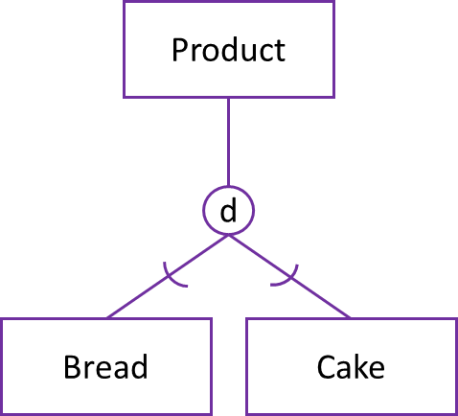 B. 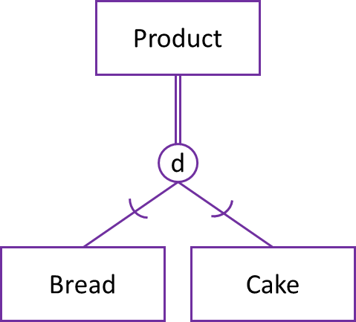

C. 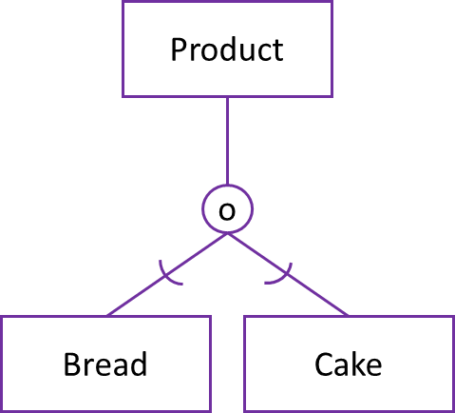 D. 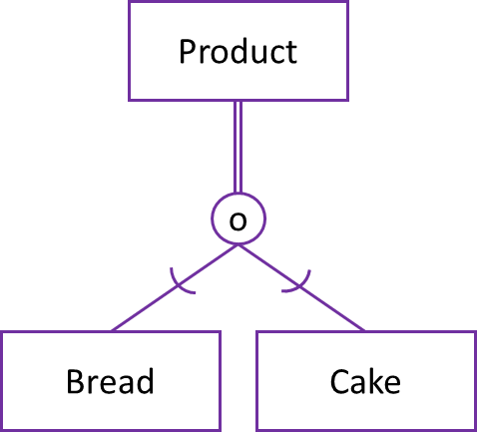

**Survey Question (0’)**

*If you have any suggestion on the teaching activities, please leave a comment here. Thank you.*