**Assignment 2 – Fall2023**

To be posted at 4pm November.3th

Description:

It takes 9% of your course assessment.

Please submit on or before 6pm on November.9th

|  |  |  |  |  |  |  |  |
| --- | --- | --- | --- | --- | --- | --- | --- |
| **Question** | **True / False** | **Fill in the Blank** | **Multiple Select** | **Single Select** | **Case Questions** | **SQL Commands** | **Total** |
| **Number** | **Q1-7** | **Q8** | **Q9** | **Q10-15** | **Q16-28** | **Q29-33** | **33** |
| **Mark** | ***1’ x 7*** | ***2’ x 4 blanks*** | ***3’ x 1*** | ***2’ x 6*** | ***2’ x 8 selects***  ***2’ x 7 blanks***  ***5’x 2 SQL*** | ***4’ x 5*** | **90** |

For Fill in the Blank: zero mark would be given to answers not following the correct format, as well as the ones contain typos/errors.

For Multiple Select: no partial gradings, i.e., partially correct answers are given zero mark.

Case Questions: can be both multiple-choice single-select questions and fill-in-the blank questions. You are invited to read the case descriptions presented carefully, try to understand it and then answer the questions.

**True or False**

1. A subtype should have at least one unique characteristic that doesn’t share with other subtypes. [TRUE/FALSE]
2. Redundancy in relations could cause anomalies. [TRUE/FALSE]
3. TRUNCATE command remove both data and the data structure in a table. [TRUE/FALSE]
4. Among logical operators “NOT”, “OR”, “AND”, AND has the lowest priority in operation [TRUE/FALSE]
5. Data Definition Language is used to insert or update records in SQL [TRUE/FALSE]
6. In SQL, ON UPDATE CASCADE is used to automatically delete related records in child tables when a record in the parent table is deleted. [TRUE/FALSE]
7. The REAL data type in SQL is used to store floating-point numbers with a higher precision than DOUBLE PRECISION. [TRUE/FALSE]

**Fill in the Blank**

1. Please read the table, and fill in the blanks with whole numbers below.

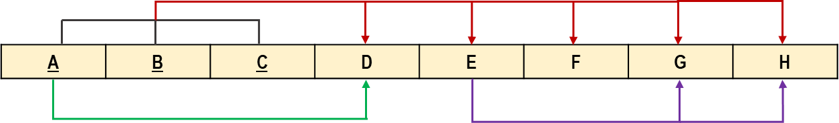

The number of primary key attributes in the table: \_\_\_3\_\_\_

The number of determinants of partial dependency relationships: \_\_1\_\_\_\_

The number of tables when convert the above table to its 2NF: \_\_\_2\_\_\_

The number of tables when convert the above table to its 3NF: \_\_\_3\_\_\_

**Multiple Select**

1. Which of the following is FALSE about subtype/supertypes? BC
2. Relationships at supertype level will be passed on to the subtypes in ER diagram.
3. The foreign keys on supertype tables need to be copied to subtype tables.
4. Relationship at subtype level will be passed on to the supertypes in ER diagram.
5. The primary keys on subtype tables are copied from supertype tables.

**Single Select**

1. You want to store a large amount of text, such as a product description, in an SQL column. Which data type should you use? B
2. VARCHAR
3. TEXT
4. CHAR
5. BLOB
6. What is the key difference between INT, BIGINT, and SMALLINT data types? D
7. INT stores larger values than BIGINT.
8. SMALLINT is used for decimals, while INT and BIGINT are for whole numbers.
9. INT is a 16-bit integer, BIGINT is a 32-bit integer, and SMALLINT is a 64-bit integer.
10. The key difference is the range and storage size, with SMALLINT < INT < BIGINT.
11. What is the key difference between CHAR and VARCHAR data types in terms of storage? C
12. CHAR is used for storing numeric values, while VARCHAR is used for character strings.
13. CHAR and VARCHAR are identical in their storage and use.
14. CHAR stores fixed-length strings, using a set amount of storage regardless of content length, while VARCHAR stores variable-length strings, using storage proportional to the content length.
15. CHAR is for single-byte character storage, and VARCHAR is for multi-byte character storage.
16. What is the purpose of the SQL statement ALTER TABLE? B
17. To retrieve data from a table
18. To modify the structure of an existing table
19. To delete records from a table
20. To join two or more tables
21. To retrieve employees from the "Employees" table who have a salary greater than $50,000 and work in the "Sales" department, what SQL statement should you use? A
22. SELECT \* FROM Employees WHERE salary > 50000 AND department = 'Sales';
23. SELECT \* FROM Employees WHERE salary > 50000 OR department = 'Sales';
24. SELECT \* FROM Employees WHERE salary > 50000 WHERE department = 'Sales';
25. SELECT \* FROM Employees WHERE salary > 50000, department = 'Sales';
26. You need to remove a column named "email" from an existing "Customers" table. Which SQL command is appropriate? B
27. DELETE COLUMN email FROM Customers
28. ALTER TABLE Customers DROP COLUMN email
29. TRUNCATE TABLE Customers
30. DROP TABLE Customers

**Case Questions**

***Case 1***

1. **The following diagram describes the entities in a university. Please translate the diagram into relational tables and answer the following two questions.**

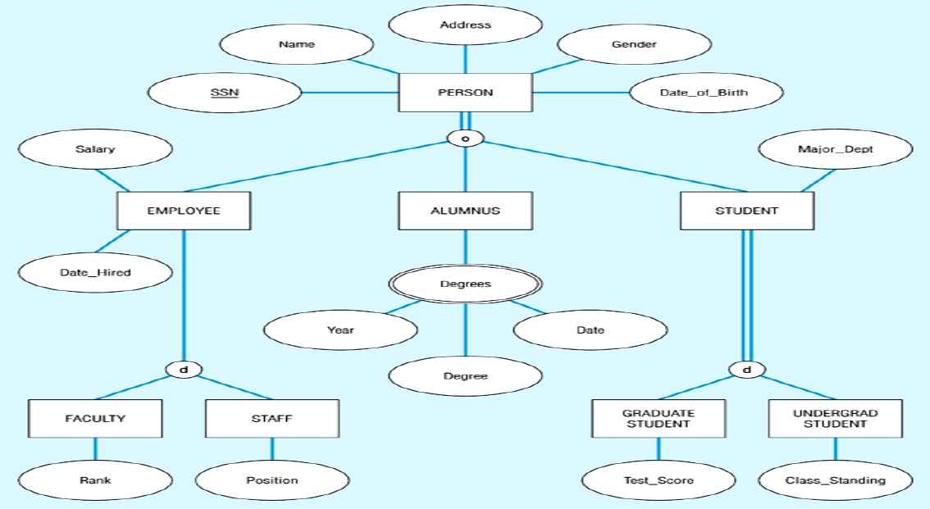

1. **How many tables are there in your logical design? F**
2. 4
3. 5
4. 6
5. 7
6. 8
7. 9
8. 10
9. **How many foreign keys are there across all the tables in your logical design? E**
10. 4
11. 5
12. 6
13. 7
14. 8
15. 9
16. 10

***Case 2***

Here list the functional dependency relationships in a table. Please answer the following three questions.

A -> F

B, C -> F

C -> E

B, C -> A

B, C, D -> A, E, F

1. What’s the primary key of the original table? D
2. C
3. B, C
4. A, C
5. B, C, D
6. A, B, C
7. If converted into its 2NF, how many tables are there in the result? B
8. 2
9. 3
10. 4
11. 5
12. If converted into its 3NF, how many tables are there in the result? C
13. 2
14. 3
15. 4
16. 5

***Case 3***

***Scenario***: A factory needs a database for its own operation. The factory hires many workers, and keeps the information about workers’ id, name, age, birthday, phone (multi-valued), and also the workers’ dependents information (name and phone). Each worker is assigned to one product line. Product lines are described with line number, type of product, and daily production information. Different machines are used for different product lines, so that one machine can be used in at least one to many product lines, and each product line can use at least one to many machines. Machine number, name, purchase date, and price are recorded.

1. Which of the following is a correct ER diagram for the described scenario? C

|  |  |
| --- | --- |
| A. | /private/var/folders/gv/4k65csb96b1gt9gdz15_54kh0000gn/T/com.kingsoft.wpsoffice.mac/photoedit2/20231029112821/temp.pngtemp |
| B. | /private/var/folders/gv/4k65csb96b1gt9gdz15_54kh0000gn/T/com.kingsoft.wpsoffice.mac/photoedit2/20231029112733/temp.pngtemp |
| C. | /private/var/folders/gv/4k65csb96b1gt9gdz15_54kh0000gn/T/com.kingsoft.wpsoffice.mac/photoedit2/20231029112632/temp.pngtemp |
| D. | /private/var/folders/gv/4k65csb96b1gt9gdz15_54kh0000gn/T/com.kingsoft.wpsoffice.mac/photoedit2/20231029112545/temp.pngtemp |

1. Please read the scenario description, and fill in the blanks with whole numbers.

* The number of strong entities in the scenario: \_\_3\_\_
* The number of weak entities in the scenario: \_\_1\_\_\_
* The number of resulted tables after translating into logical design: \_\_\_6\_\_\_\_

1. Please read the scenario description, and fill in the blanks.

* The primary key of ProductLine table: \_\_C\_\_ (A/B/C/…)
* The primary key of Dependent table: \_\_I\_\_\_ (A/B/C/…)
* The foreign key of Dependent table: \_\_B\_\_\_ (A/B/C/…)
* The foreign key of Machine table: \_\_\_A\_\_\_\_ (A/B/C/…)

|  |  |
| --- | --- |
| 1. None 2. Worker\_id 3. Line\_id 4. Machine\_id 5. D\_name | 1. (Worker\_id, Line\_id) 2. (Worker\_id, Machine\_id) 3. (Line\_id, Machine\_id) 4. (Worker\_id, D\_name) 5. (D\_name, Phone) |

***Scenario – cont’d***: The workers could be categorized into three groups, operators who operate routine work on the product lines, repairmen who maintain the product lines, and others to accommodate the workers that do not fall into the two groups. The database notes down each repairman’s certificate, each operator’s technical skills (multiple value), and other worker’s remarks. It’s known that a repairman could be an operator at the same time.

1. Then the described supertype/subtype relationship is of: A
2. Total participation and overlap rule
3. Total participation and disjoint rule
4. Partial participation and overlap rule
5. Partial participation and disjoint rule
6. Combining all the scenario descriptions for the case, the number of resulted tables after translating into logical design is: D
7. 8
8. 9
9. 10
10. 11
11. 12
12. 13

***Case 4***

You are managing a database for an e-commerce platform. You database contains two tables: a products table and a vendors table. The products table contains information about various products, while the vendors table lists the vendors who supply those products. The products table has a foreign key constraint on the vendor\_id column, which references the vendor\_id column in the vendors table:

product (product\_id, product\_name, vendor\_id, price)

vendors (vendor\_id, vendor\_name, vendor\_contact, vendor\_phone)

1. Write SQL to create the table structure, with appropriate key, foreign key, datatypes, constraints. And in a cascading update scenario, you want to change the vendor for a product in the products table. This change should automatically cascade to the vendors table, ensuring that the vendor's information is updated consistently in both tables.

CREATE TABLE vendors (

vendor\_id INT PRIMARY KEY,

vendor\_name VARCHAR(50),

vendor\_contact VARCHAR(50),

vendor\_phone VARCHAR(15)

);

CREATE TABLE products (

product\_id INT PRIMARY KEY,

product\_name VARCHAR(100),

vendor\_id INT,

price DECIMAL(10, 2),

FOREIGN KEY (vendor\_id) REFERENCES vendors(vendor\_id) ON UPDATE CASCADE

);

1. Now you need to delete records from the vendor, you also want the records in product table to automatically be deleted if the corresponding vendor is deleted. Write the SQL to alter this CASCADE. Hint: you need to first alter the table by dropping the constraint “vendor\_fk” then create the constrain “vendor\_fk” again with both update cascade and delete cascade.

ALTER TABLE products

DROP FOREIGN KEY `vendor\_fk`;

ALTER TABLE products

ADD CONSTRAINT `vendor\_fk`

FOREIGN KEY (vendor\_id)

REFERENCES vendors(vendor\_id)

ON DELETE CASCADE;

**SQL Commands**

With the Table “student” as illustrated below:

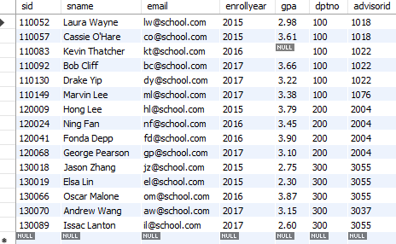

1. Write SQL command that list the sid, name and gpa of all students whose enroll year is after 2015 and gpa larger than 3.5.

SELECT sid, sname, gpa

FROM student

WHERE enrollyear > 2015 AND gpa > 3.5;

1. Write SQL command that calculate the maximum gpa of students grouped by department and enroll year, and list the department, enroll year and the calculated gpa.

SELECT dptno, enrollyear, MAX(gpa) AS max\_gpa

FROM student

GROUP BY dptno, enrollyear;

1. Write SQL command with subquery that calculate and list the average gpa of students whose advisor is “Nathan Katowsky”, rename the calculated average gpa as “Student GPA of Nathan Katowsky”. The advisorid is a foreign key with a reference to instructor(iid) where instructor contains instructor’s name in “name” column.

Instructor table:

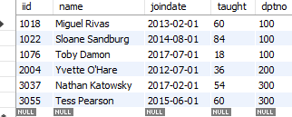

SELECT AVG(gpa) AS "Student GPA of Nathan Katowsky"

FROM student

WHERE advisorid IN (SELECT iid FROM instructor WHERE name = 'Nathan Katowsky');

1. Can the above command achieve the same output with JOIN instead of subquery? And write the command with JOIN.

SELECT AVG(student.gpa) AS "Student GPA of Nathan Katowsky"

FROM student

JOIN instructor ON student.advisorid = instructor.iid

WHERE instructor.name = 'Nathan Katowsky';

1. SQL query to display all instructors with their name, years since joining, number of students advised, and average GPA (rounded to 1 decimal place)

SELECT

i.iid AS Instructor\_ID,

i.name AS Instructor\_Name,

i.joindate AS Join\_Date,

YEAR(CURDATE()) - YEAR(i.joindate) AS Years\_Since\_Joining,

COUNT(s.sid) AS Number\_of\_Students\_Advised,

ROUND(AVG(s.gpa), 1) AS Average\_GPA

FROM instructor i

LEFT JOIN student s ON i.iid = s.advisorid

GROUP BY Instructor\_ID, Instructor\_Name, Join\_Date;

**Survey Question (0’)**

*If you have any suggestion on the teaching activities, please leave a comment here. Thank you.*