**Q1**

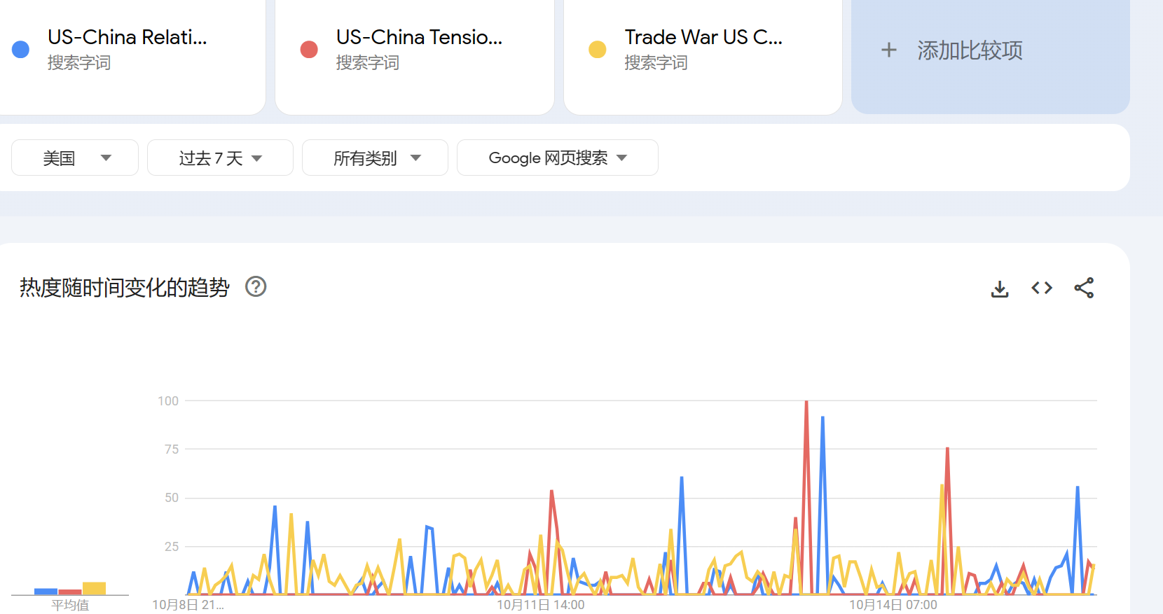

The key words are: US-China relationship, US-China tension, trade war US China.

As can be seen from the line chart, the increase in searches related to tense relations is almost always accompanied by an increase in searches for the US China trade war, while the search volume for relations at a macro level is almost intertwined with the other two indicators.

**Q2**

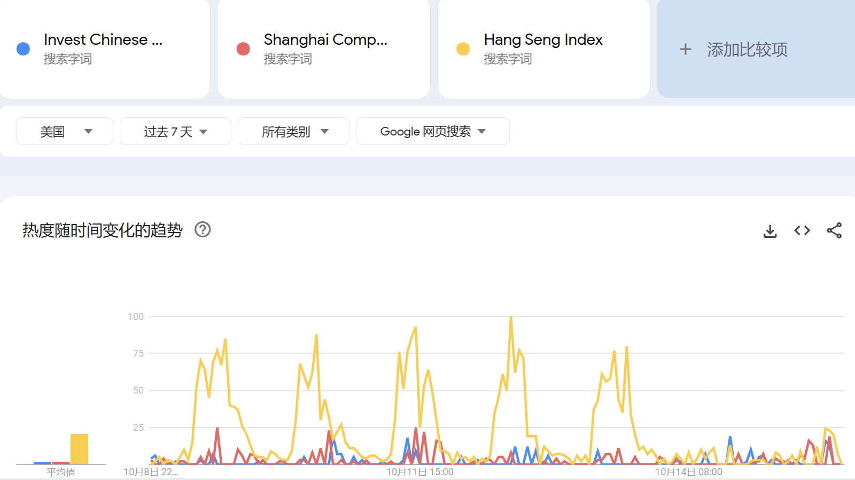

The key words are: invest Chinese market Shanghai Composite Index, Hang Seng Index.

When the search volume of invest Chinese market is large, it indicates that investors are more enthusiastic about the Chinese market. At this time, the two indexes almost increase as the search volume of invest Chinese market increases, and the same reason applies for the decrease.