**­­UNIVERSITY OF DAR ES SALAAM**



COLLAGE OF INFORMATION AND COMMUNICATION TECHNOLOGY

**Farm Connect group project**

Group members.

|  |  |
| --- | --- |
| Name | Reg. number |
| TAIRO, KELVIN BARTHOLOME | 2019 – 04 – 12422 |
| HUSSEIN, S KILONZO | 2019 – 04 – 04179 |
| LYAGANDA, MASANJA | 2019 – 04 – 05208 |
| HASHIM, B SANGA | 2019 – 04 - 11524 |
| MIALLA, MESHACK YONAS | 2019 – 04 - 07137 |

# Background/ Introduction

For the past years Tanzanians have been traditionally practicing agricultural activities, this has led to inefficiency in case of the time management, financial resources management, and also inefficient in utilization of the professionals we have in the country. As due to this farmer have not been able to get properly the professional services due to lack of effective means to connect them to these services, also talking about the market farmers has been dependent to some of the people who goes to them for the sake of buying their products and hence farmers were not linked directly to the market for them to be able to reach out the potential customers and also agricultural professionals were not able to practice effectively their profession.

# Problem statement

As it has been specified in the introduction part back on the days, there has been inefficient in resource utilization and these resources includes,

* Time resource

There has been a wastage of time for both the farmers while they are finding for market and buyers during surveying around different places finding for crops to buy.

* Financial resource

Due to lack of proper knowledge the farmers sometimes had made wrong decisions that led them to spend money for nothing

* Professionals

Also the professionals available in the country are not utilized properly as some of the people are not able to get them for help in different situations.

And also, farmers are not linked directly to the market to enable them sell their products at the maximum possible price making them with low profit compared to what they deserve.

# Proposed solution

We have proposed a Web application with the name “FARM CONNECT” meaning electronic farming this will have the following objectives;

* Main objective

The main purpose of this proposed solution is to provide a communicative link to the farmers, professionals and virtual market.

* Specific objectives

1. Enable farmers communicate with different professionals
2. Enable farmers display their products
3. Enable buyers to see what to buy and where to get their need
4. Link farmers from different places

# Significance of the project

1. At the completion of this project, there will be a system that will open doors to employment opportunities to the farmers and qualified agricultural professionals.
2. Have a catalogue that will show case the products that available with their respective quantity and location that they are for the buyers to place their order.

# Users and system requirement

## Users

* Farmers
* Professionals
* Customers
* Government

The government can be either on the customer side or professional.

## System Analysis And Design

|  |  |  |
| --- | --- | --- |
|  | Functional requirements | Non- Functional requirements |
| 1 | Registering farmers, Professionals, and Buyers | Stable and responsive requests |
| 2 | Enabling farmers, Professionals and buyers to Login | Accessible to any one who is connected to the internet |
| 3 | Enabling farmers to advertise their crops/ products and price |  |
| 4 | Buyers should be able to display their need and cost they are willing to pay |  |
| 5 | Directing users to respective pages |  |
| 6 | Latest posts should be displayed first |  |

# System Design

1. Interface Design

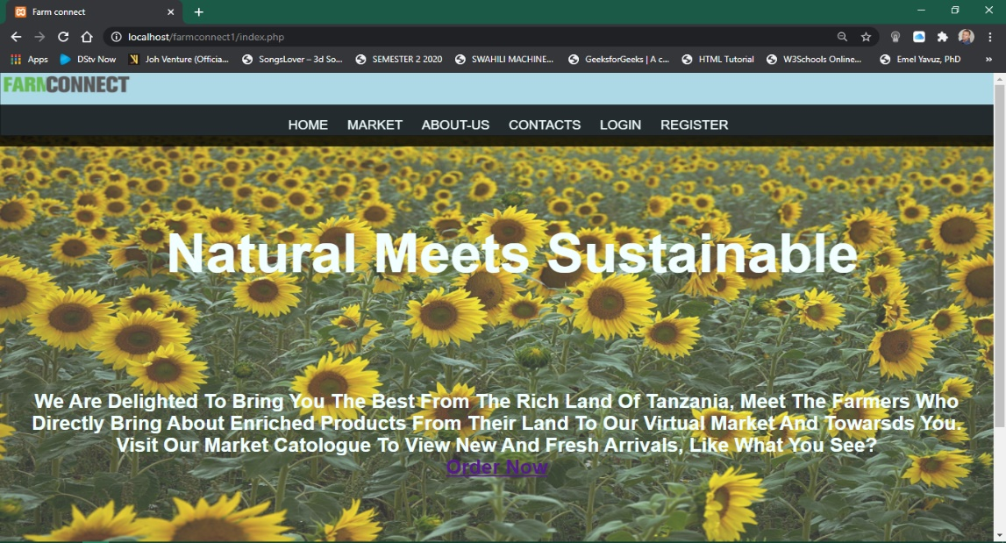

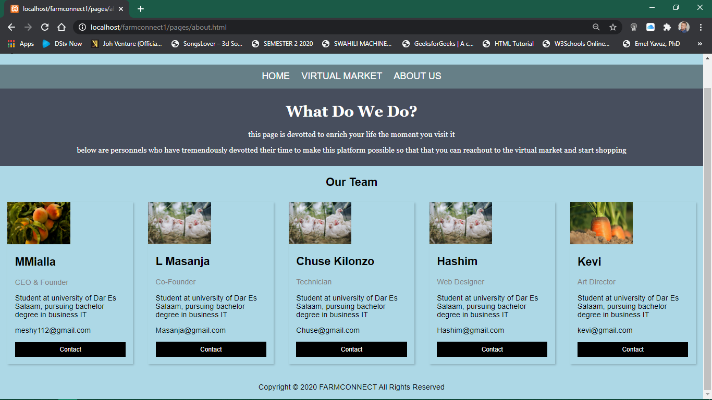

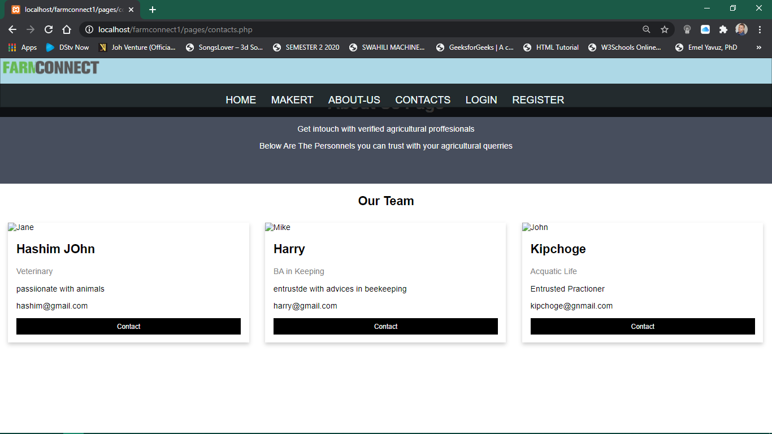

1. Database Design

Information we are interested to store at the data base are : - persons who have accessed our website and registered or ordered different products that are showcased at our virtual market, we also created the data base for these products that are displayed by farmers, then latter being ordered by the buyers.

Why we created these database tables?

1. these database tables that we created are used to store through posting of the user details that are fetched from the forms of registration, login as well as the products that are posted by the farmers.
2. We want to provide a basis for the verification and authenticity of our users.
3. Lastly we want to have the catalogue of products that are showcased by our farmers to buyers in our virtual market with reliable information such as where are they found, quantity available with the ability to pay an advance to secure the product.

Database Tables (Columns and data types): -

Users database table contains:-

1. User identification(user_id) with int
2. First and last name (first_name and last_name) with varchar
3. Email with varchar
4. Password with varchar
5. User_role with varchar
6. Work region with varchar
7. phone number with varchar

User_product database table: -

1. product name(product_name) with varchar
2. User identification(user_id) with int
3. quantity_available with int
4. region_available with varchar
5. product_image with varchar

reserver_products database table:-

1. order_id with int
2. reserved_product with varchar
3. quantity_reserved with int
4. total_cost with int
5. reserve_date with date data type
6. advance_payment with int

# System Implementation

System Feature and Functionalities Implementation: -

1. Registering farmers, Professionals, and Buyers

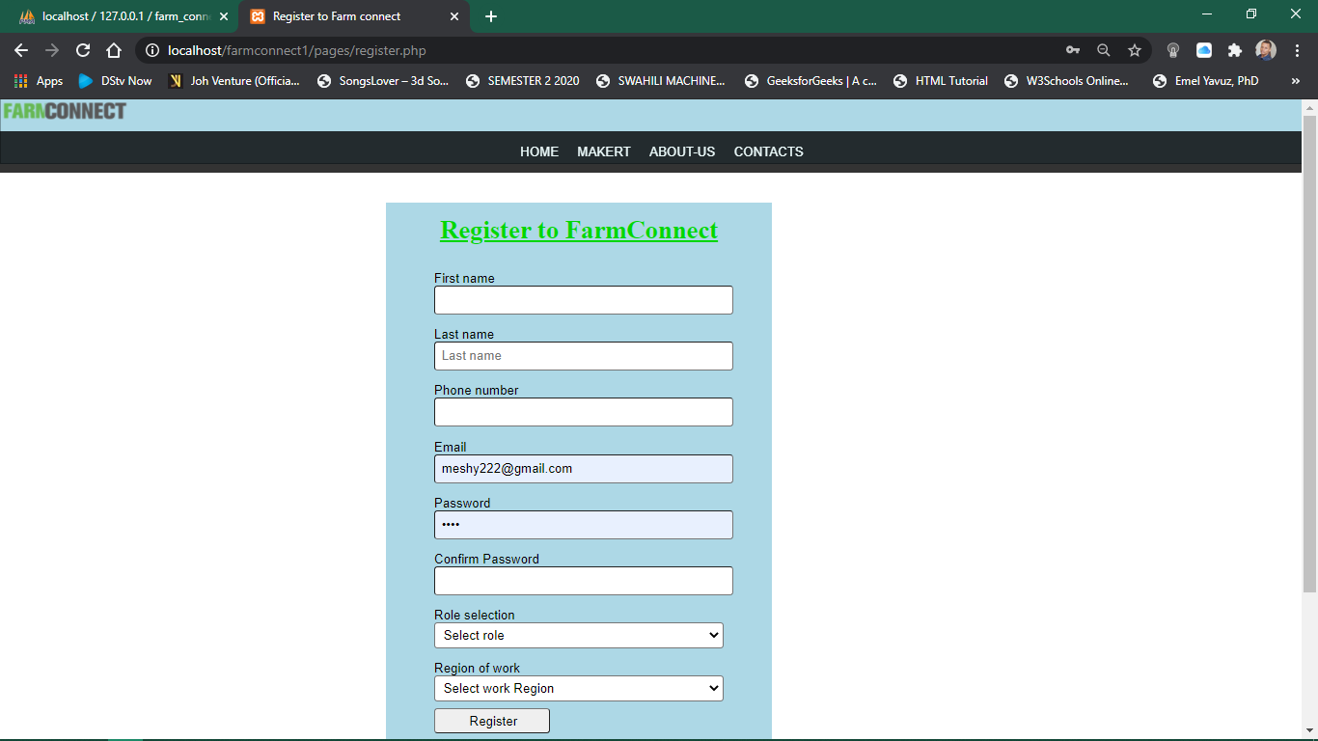

1. Enabling farmers, Professionals and buyers to Login

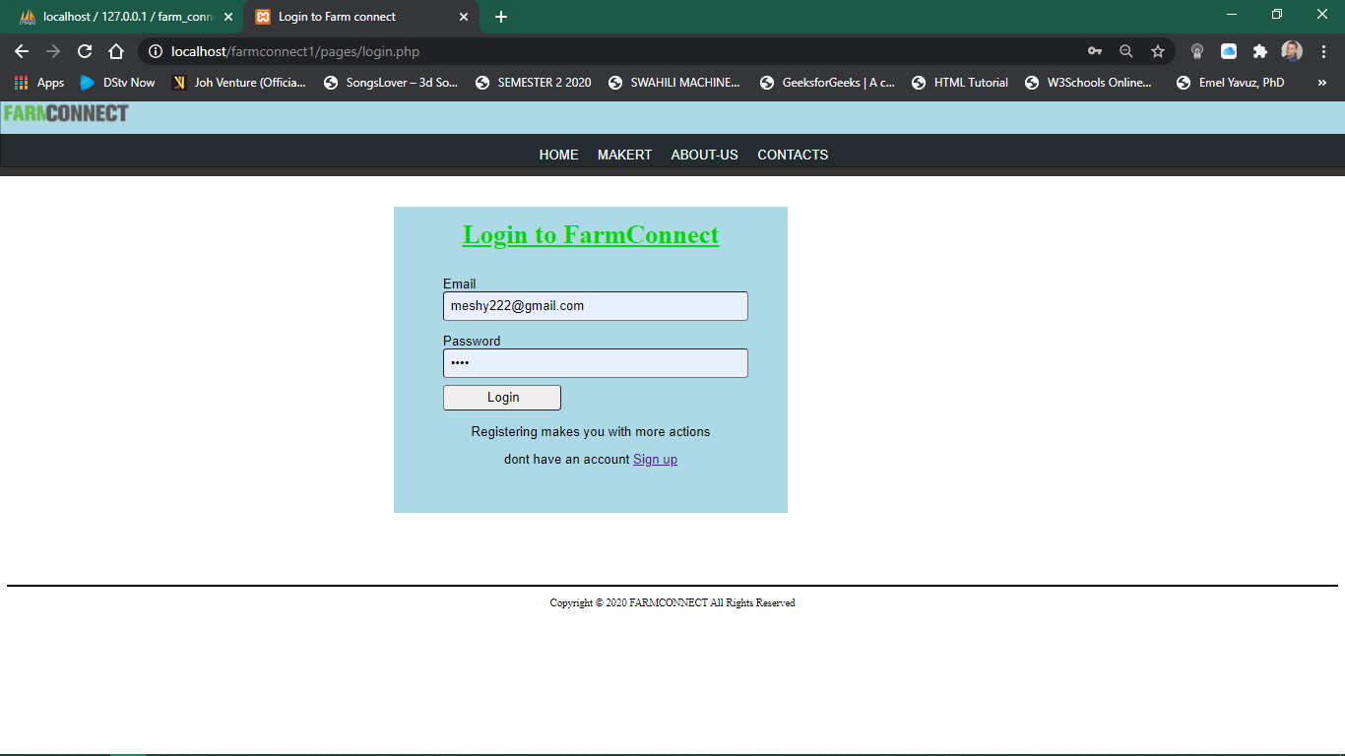

1. Enabling farmers to advertise their crops/ products and price

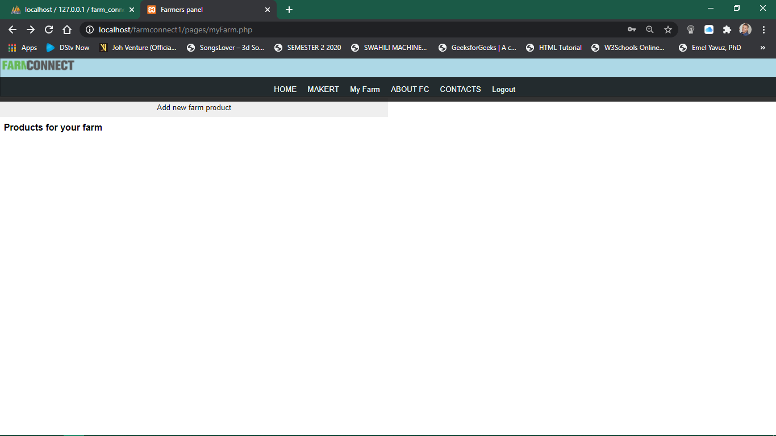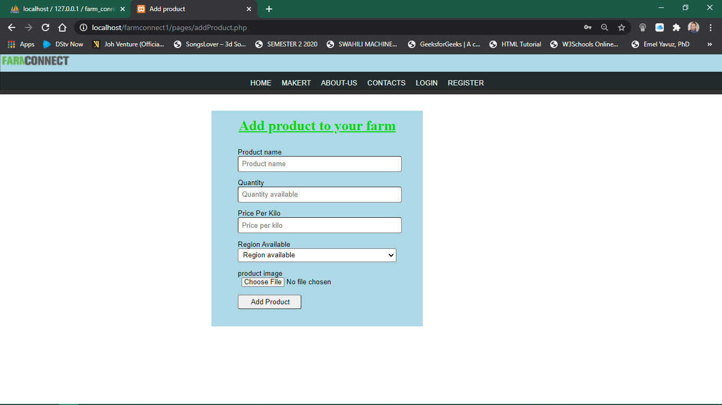

1. Buyers should be able to order and reserve

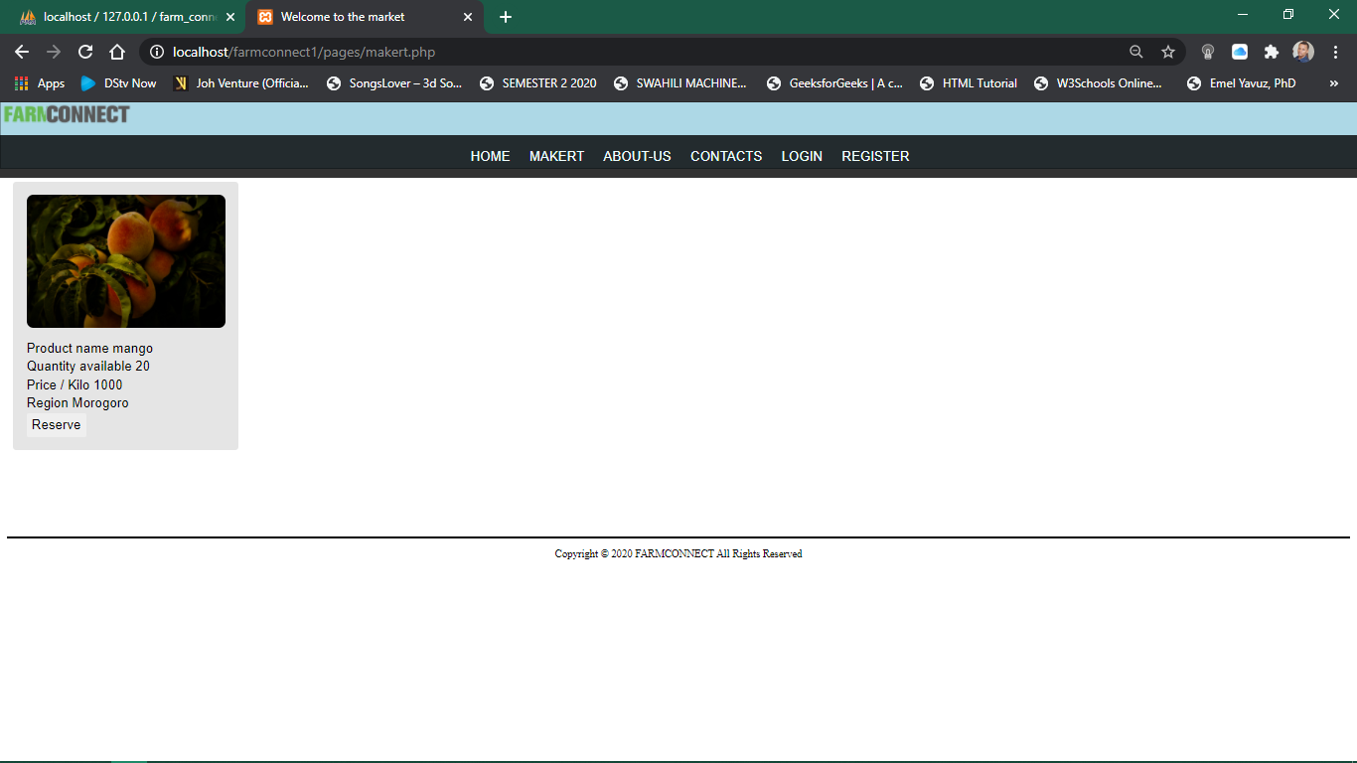

1. Directing users to respective pages( the answer to this is seen through the screenshots that have been filled at other parts 1-5 and 6) so for the matter of space I won’t showcase all the pages.
2. Latest posts should be displayed first

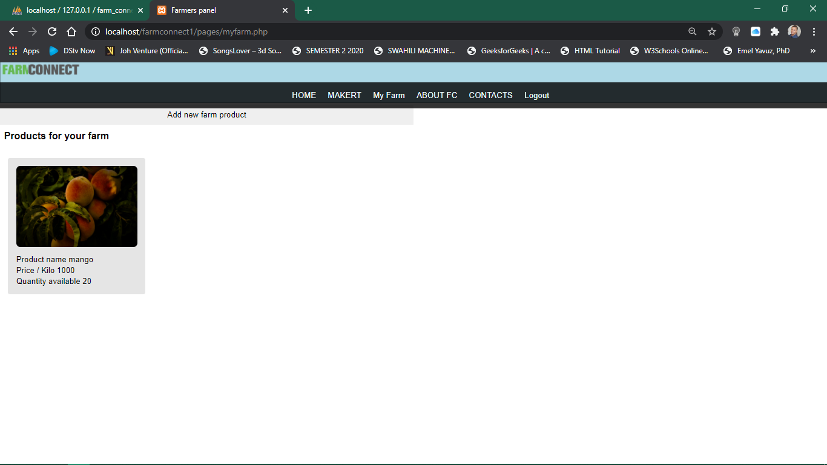

# Database Implementation (Schema design from MySQL or DBMS)

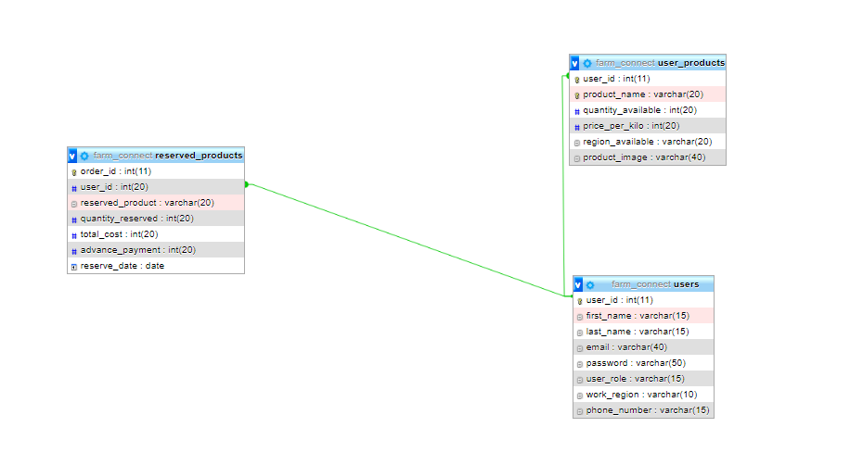

# System Testing and Validation

Test Plan

1. Test Scenarios

* The test scenario for our project was to see if we could have a platform that could showcase the farmers products.
* Having the ability to let users register and login successfully to our website.
* Letting users be able to see what our virtual market has and if they can order and make reservations on farm products of their likes.
* Have a catalogue for our staffs in case anybody finds problems while accessing our system.
* Have a catalogue for professionals so that if anybody finds problems on their agricultural schemes can access them instantly from our system

1. Testing results

* .the attempt to all the above is a success.

# Documentation

Tools and Technologies used: -

1. IDE – integrated development environment VScode and Sublime
2. Languages implemented are: -

* JavaScript
* HTML and CSS
* PHP
* SQL

1. Local webserver ie. Xampp with apache http server.

System Manual: -

The site provide the greatest exposure on our work staff catalogue and the place where you can do the ordering which is showcased from our virtual market subsection of our system, but to do all that we need you to register and login into our system.

1. To access it locally(for now) here is our addres <http://localhost/farmconnect1/index.php>
2. To register go to the navigation button right top as shown below
3. To see the market, go to the market navigation button as show below
4. To contact the professionals just click at the contacts navigation button
5. To contact our site administrators just click at the about us navigation button
6. As a farmer you will need to be an active user at this website so that you can add products and be notified of any reservation made.
7. If you want to register as a professional you need to contact our site administrators for verification of your profession.

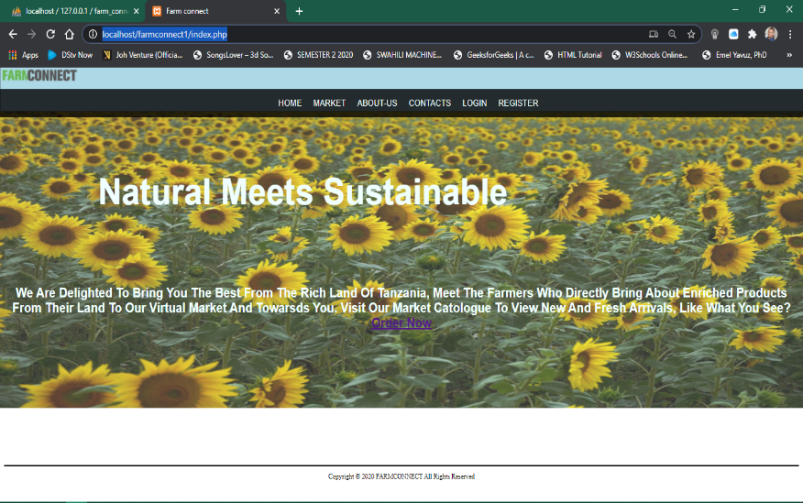

Conclusion & recommendations:-

Although the site is running locally and few of the system requirements are running well, but we would like to have a some other functionalities such as profession verification from other learning institutions databases for verification purposes. Besides that, it is step to greatness.

Our site is recommended for people who would like to buy farm products online, ones who have eligible qualities to become agricultural practitioners without forgetting entrepreneurs who are based on agricultural activities who seek to extend their marketing strategies.

References: -

* <https://github.com/FCONNECT/FARMCONNECT/tree/master/FarmConnect1>
* John.Wiley.and.Sons.PHP.and.MySQL.for.Dummies.Second.Edition
* W3schools.com