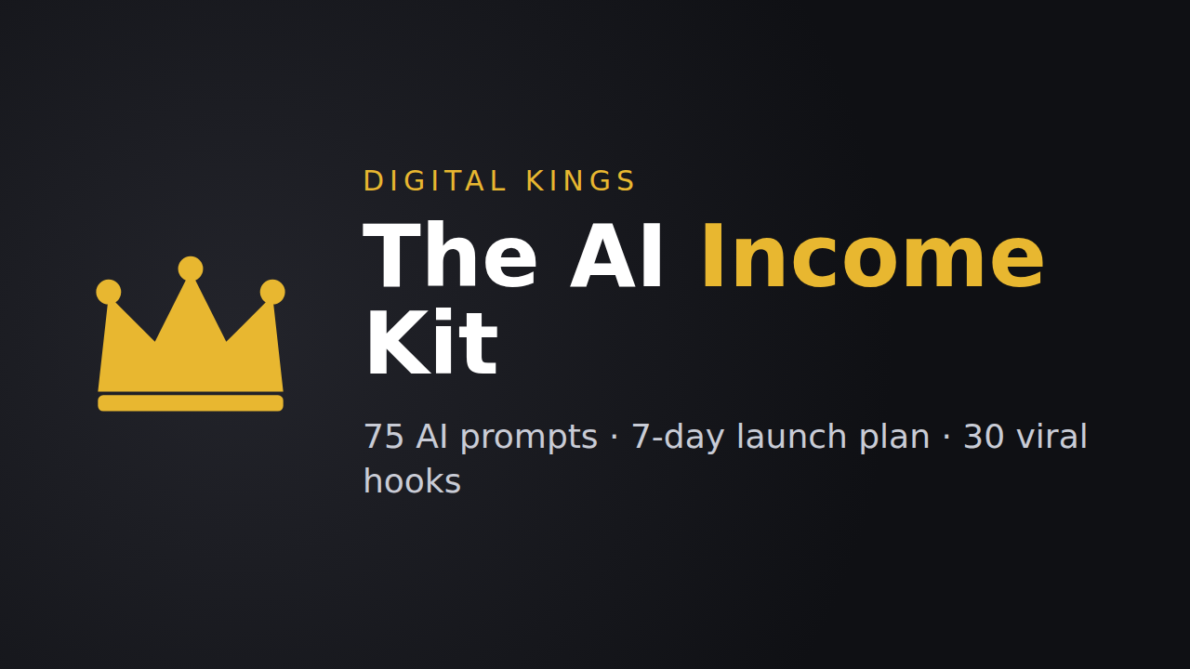

The AI Income Kit
75 Prompts to Create, Grow & Sell Online
Launch your first digital product in 7 days, with AI doing the heavy lifting.

Product description
Want to make money online but don’t know what to sell, what to post, or how to sell it without sounding pushy?
The AI Income Kit gives you 75 copy-paste prompts for ChatGPT, Claude or Gemini, organized into the exact steps to go from idea to first sale:
- Find your product: 10 prompts to find and validate an idea people will pay for
- Build it fast: 15 prompts to create an ebook, template pack or mini-course in 48 hours
- Content that sells: 20 prompts for Reels, carousels, Stories, captions and your bio
- Sell it: 15 prompts for your sales page, DMs, emails and launch week
- Grow & automate: 15 prompts for collabs, brand deals, analytics and automation
BONUSES INCLUDED
- 7-day launch plan with a day-by-day checklist
- 30 viral Reel hooks (fill-in-the-blank swipe file)
- Pricing cheat sheet for digital products
WHY BUY
- Instant PDF download
- Works with any AI assistant
- Beginner-friendly, no experience needed
Educational product; results depend on your effort. No income is guaranteed.

Listing details for Gumroad
Field | Paste this
Name | The AI Income Kit: 75 Prompts to Create, Grow & Sell Online
Price | $19
Launch discount | Code KING: $10 off (= $9), ends 7 days after launch
Summary / You’ll get | Instant PDF download · 75 AI prompts · 7-day launch plan · 30 viral hooks
File | AI-Income-Kit-Digital-Kings.pdf
Cover / Thumbnail | gumroad-cover.png (1280×720) / gumroad-thumbnail.png (600×600)
Tags | AI prompts, ChatGPT, side hustle, digital products, make money online
Seller | Digital Kings · @digitalking.io · virtualdmk@gmail.com

