**Pseudocode of Vending Machine**

7 drinks are Coke(RM 2.00), Mango Juice(RM 3.00), Pepsi (RM 2.00), Milo (RM 2.30), 100 Plus (RM 2.00), Iced Lemon Tea (RM 2.50), and Orange Juice (RM 2.50).

|  |
| --- |
| Start  Function MainMenu  DISPLAY “1: Coke – RM 2.00”  DISPLAY “2: Mango Juice – RM 3.00”  DISPLAY “3: Pepsi – RM 2.00”  DISPLAY “4: Milo – RM 2.30”  DISPLAY “5: 100 Plus – RM 2.00”  DISPLAY “6: Iced Lemon Tea – RM 2.50”  DISPLAY “7: Orange Juice – RM 2.50”  DISPLAY “Please Key in the Number for Drink.”  Input Number  If Number = 1  DISPLAY “Please Cash in RM 2.00”  Input Cash  If Cash= RM 2.00  give Coke  Else DISPLAY “Insufficient Cash”  Else if Number = 2  DISPLAY “Please Cash in RM 3.00”  Input Cash  If Cash = RM 3.00  give Mango Juice  Else DISPLAY “Insufficient Cash”  Else if Number = 3  DISPLAY “Please Cash in RM 2.00”  Input Cash  If Cash = RM 2.00  give Pepsi  Else DISPLAY “Insufficient Cash”  Else if Number = 4  DISPLAY “Please Cash in RM 2.30”  Input Cash  If Cash = RM 2.30  give Milo  Else DISPLAY “Insufficient Cash”  Else if Number = 5  DISPLAY “Please Cash in RM 2.00”  Input Cash  If Cash = RM 2.00  give 100 Plus  Else DISPLAY “Insufficient Cash”  Else if Number = 6  DISPLAY “Please Cash in RM 2.50”  Input Cash  If Cash = RM 2.50  give Iced Lemon Tea  Else DISPLAY “Insufficient Cash”  Else if Number = 7  DISPLAY “Please Cash in RM 2.50”  Input Cash  If Cash = RM 2.50  give Orange Juice  Else DISPLAY “Insufficient Cash”  Else  DISPLAY “Please Key in Valid Number.”  END if  DISPLAY “Thank You !”  END Function  call MainMenu  repeat MainMenu |
|  |

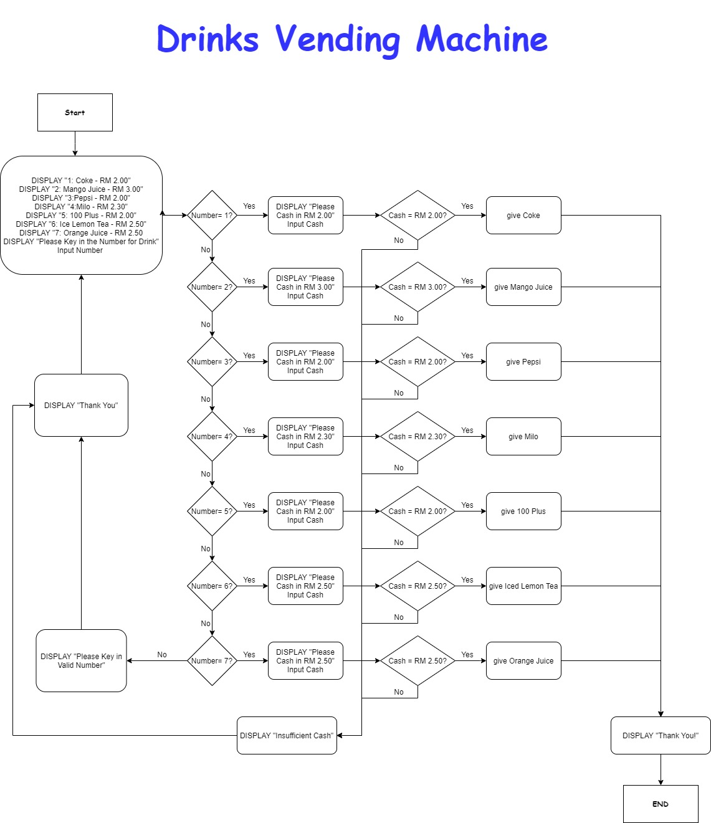**Flowchart Based on Pseudocode of Vending Machine Above**