Risk is uncertainty/variability of bad things might happen, while uncertainty is mix of danger and opportunity.

Risk management is actively select type and level of risk while risk taking is to take additional risk for additional gains

Identify (Name, Categorize, Understand) -> Analyze (Rank, Score, Measure, Quantify)

Manage (Avoid, Retain (acceptable), Mitigate (diversify), Transfer (hedge))

Assess (Effects, Repercussions)

EL: Known knows (EAD x LGD x PD), UL: unknow knows (banks need to allocate large amount of risk capital), Knightian uncertainty: known unknows, Unknown unknow

Identify risk appetite

* Amount/type of risks firm willing to accept, quantitative/qualitative, <> Risk Capacity which refers to the max risk firm can absorb
* Board work with management to set and must ensure consistency with biz strategy
* Need to consider potential conflict between debt and equity holders
* Board of directors set objectives, criteria, hedge profits, time horizon for risk factor

Mapping risks and make choices (frequency and severity, choose hedge instruments)

Operationalize risk appetite/ Implement (hedging plan like dynamic/static etc)

Hedging: ++ reduce cost of capital and enhance growth, indication of management doing good job, better control economic performance, cheap hedging tools like options than insurance -- distract from core business, requires extra effort, flawed hedge more risk, extra cost

Corporate governance

* roles and responsibilities of shareholders, directors, senior management
* core is to minimize and manage conflict of interests
* Board keeps independent from management, develops clear business strategy, cares all stakeholder’s interests, be careful of potential agency risks, approves major transactions, has independent risk and audit committee
* Sarbanes-Oxley Act2 (SOX)

Risk Governance

* define, implement, oversee RM, link risk appetite and appropriate business limits
* board risk committee identify, measure, monitor risks, set risk appetite
* audit risk committee in charge of accuracy and completeness of financial and regulatory disclosures, compliance, and need to be financially literate
* compensation committee remain independent, align stakeholders’ interest
* risk advisory director is a board member to provide advice on risk appetite, etc
* CRO establishes ERM approach, provide overall leadership, vision, direction of ERM, develop risk management policies, risk indicators, reports, communicate risk to stakeholders, allocate economic capital, develop risk management program, reports to CEO/CFO, dotted line reporting relationship

In complex systems, extremely rare events can happen over long time horizon even if the system remains structurally stable (can use extreme value theory)

Human agency/conflict of interests (biz line, risk managers, periodic independent oversight)

Credit risk

* Core risk exposure of banks, banks use ST liquid deposits to fund LT illiquid loads
* purchase insurance, netting counterparty exposures, MTM, require collateral, put option, reassignment of credit exposure to another party
* credit derivatives contribute to the process of credit price discovery, off-balance sheet instruments that transfer between two counterparties

Originate-to-distribute (OTD)

* transfer credit risk via ABS, etc
* Originators benefited from greater capital efficiency, enhanced funding opportunities, lower earnings volatility
* Investors benefited from wider investments that are diversified
* Borrowers benefited from larger pool of credit and products and lower rates

Risk Data

* sort, merge, breakdown of data: Internal (organized), external (collected/purchased)
* better anticipation of problem, easier identify solution, increase profits/efficiency
* governance, data/IT architecture, accuracy/integrity, completeness, timeliness, adaptability

Risk Reporting: accuracy, comprehensiveness, clarity and usefulness, frequency, distribution

Supervisors: review, remedial actions, home/host cooperation

ERM

* Prev. managed in silos, they cannot be segmented, may overhedge or underestimate
* ERM is comprehensive and integrated, gives enterprise-level view of risk
* helps firm define and adhere to enterprise risk appetite, focus oversight on most threatening risks, identify enterprise-scale risks at business level, manage risk concentration, enterprise risks, supports regulatory compliance, optimize hedge, strategic decision making, but consumes time and resources
* targets, structure, identification & metrics, ERM strategies, risk culture
* Scenario analysis

MPT assumes perfect market (no transaction cost, perfect information, perfect competition), normally distributed returns

U = E[R] – 0.5A: A > 0 🡪 risk-averse, A = 0 🡪 risk-neutral, A < 0 🡪 risk seeking

Minimum-variance frontier of risky assets (min. variance given certain return)

Global minimum-variance portfolio is the left most point on minimum variance frontier

Efficient frontier gives lowest risk for certain return, and offer highest return for given risk

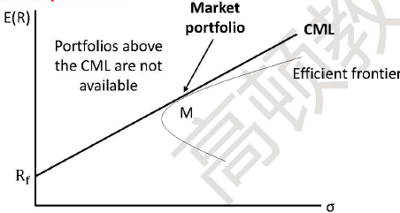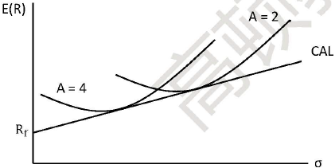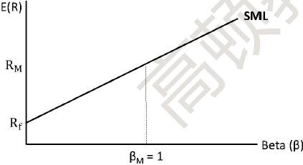

CML:

CAPM:

* investors make decisions solely in expected values and volatility of returns
* investors have same single holding period
* allocations made are infinitely divisible
* no transaction cost, tax, nor other frictions
* short sale is allowed unlimitedly
* all participants can borrow and lend at same risk-free rate
* all have same expectations
* individual decision will not change market prices
* all assets are tradable

TE: volatility of return difference between portfolio and benchmark

IR: residual return relative to benchmark divided by tracking error

APT asserts there are one or more systematic risk factors and only assumes no arbitrage, there are sufficient securities to diversify away unsystematic risk. Only systematic risks are awarded

While CAPM as a special case of APT, has only one risk factor (market risk), beta is exposure

, where is firm specific return

Interest rate risk: S&L industry – ride on yield curve, short term rate went up

Funding liquidity risk: Lehman Brothers, Continental Illinois, Northern Rock

Hedging strategies: Metallgesellschaft – stack and roll strategy exposes to basis risk (long ST)

Model risk: Niederhoffer (sell put), LTCM (underestimate tail risk with VaR), London Whale (poor risk culture breaches are ignored, and wrongly used VaR)

Rogue trading: Baring (unauthorized trading, short straddle, head of trading and back office)

Financial engineering: Bankers Trust (complex derivative for clients suffer reputational risk), Orange County (loss from complex FRN), Sachsen Landesbank (SPV become too large)

Reputational risk: Volkswagen (emission problem)

Corporate governance: Enron (management act in their own interest but not shareholders)

Cyber risk: Swift (hacked)

Housing bubble

* large capital inflows from abroad, especially from Asian countries
* the Fed adopted an expansionary interest rate policy
* banking system underwent an important transformation (OTD model)

Short-term wholesale debt market

* asset backed commercial paper and repurchase agreement

Structured investment vehicles (SIVs)

* banks moved assets to be securitized off their balance sheets to SIV (conduits)
* a limited-purpose, bankruptcy remote company used by banks to purchase assets, funded with ST CP

,

Poisson:

Chi-Square:

Student’s t:

F-distribution:

Sample mean is unbiased but sample variance is biased. This is because the sample variance depends on estimator of sample mean which consumes a degree of freedom and sample mean tends to resemble the sample of data a little too well

Best Unbiased Linear Estimator must be unbiased, consistent (, efficient (min. Variance among all linear unbiased estimators)

Spearman’s correlation =

Kendal’s correlation =

Linearity: linear relationship, additive errors, observable explanatory variable

Dummy Variable: binary values

OLS Assumptions: mean of error is zero, data are i.i.d., variance larger than zero, constant error variance, no outliers

(may go negative)

Problem with or Adjusted : doesn’t tell whether a variable is statistically significant, omitted variable bias, whether most appropriate set of regressors have been chosen

Model Fitness:

Regression diagnosis

* Omitted variable is the one has non-zero coefficient (correlated and determinant) but is not included in a model, it affects biasness and consistency
* Extraneous included variable is the one included but not needed (true coefficient is 0 in large sample), resulting in larger standard error and smaller adjusted R2
* Bias-Variance tradeoff as larger models have lower bias but larger variance (we should start with large model and remove statistically insignificant ones
* Heteroskedasticity: Var not constant, affects only efficiency, may use heterosk-robust covariance estimator in test or transform data or use weighted least squares
* Perfect collinearity like X and 2X, may lead to division by zero error
* Multicollinearity occurs when one explanatory variable can be largely explained by another variable, can use F-test or individual t-test, can ignore or consider remove
* Outliers can use Cook’s distance to check

Covariance Stationary: mean is constant, finite and constant variance and autocovariance

White Noise: mean zero, constant and finite variance, no autocorrelation or autocovariance

AR: , decay ACF and oscillating PACF, stationary if

MA: , Cut-off oscillating ACF and decay PACF, always stationary

ARMA: decay ACF, decay cut-off PACF

Joint test: Ljung Box and Box Pierce

Unit Root: , 1 is a root 🡪 unit root

* leads to spurious regression, no mean reversion, Dicky Fuller distribution
* Can take difference to solve

Exchanges: standard contracts, CCP (netting/offsetting, variation margin, daily settlement, default fund contribution), market size is smaller compared to OTC

OTC Market: each transaction as single transaction, may use collateral, SPV to keep credit risk legally separate, Derivative Product Companies as well-capitalized subsidiaries for AAA ratings

Accounting for gains and losses year-by-year due to hedge may increase earnings volatility

Basis Risk = Spot Price – Futures Price: the uncertainty associated with basis when close hedge

, ,

Stack and roll (滚动对冲)

Forward Price:

*,* with income/yield:

*,* with income/yield:

If the futures price is positively correlated with interest rate, futures price is larger than forward price.

FX forward quotes: points times 1/10000 then add to FX spot quote

* Transaction risk (交／收钱时的汇率风险)
* Translation risk (Asset/Liability management that affects reported earnings)
* Multi-currency hedge with basket options

Commodity Forwards:

Cost of Carry:

Return on the underlying asset and the return on the stock market is positively or negatively correlated 🡪 Positive correlation:

Swap cash flow, normally made in arrears, payment is made at the end of periods based on beginning-of-period LIBOR =

Use continuous compounding for fixed payments leg and semiannual compounding for floating leg. And notional needs to be included in the calculation for last payments.

Currency swap also needs to include notional in the final payment

Options with maturity less than 9 month needs to be paid in full price while the rest can be bought on margin (>=75%)

Warrants, CBs, Employee Stock Options

Deep-ITM American Call is best to exercise before an ex-dividend date

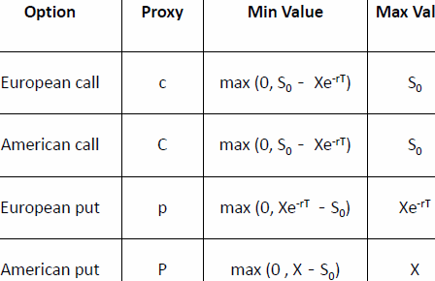

PC Parity: 🡪🡪

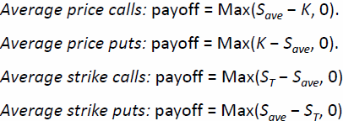 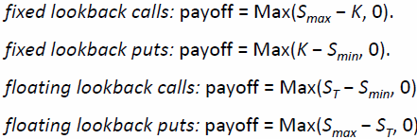

Binomial Trees: , in case of dividends:

BS Assumptions: European style, no dividends, allow short-selling, divisible assets, no arbitrage, no transaction cost, no taxes

In case of discrete dividends:

In case of continuous dividends:

Stock price after warrant exercise:

Value of warrant:

Call Delta: , with dividends:

Put Delta: , with dividends:

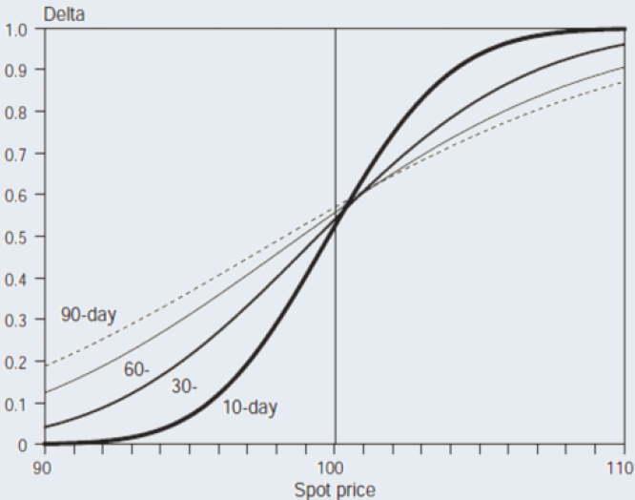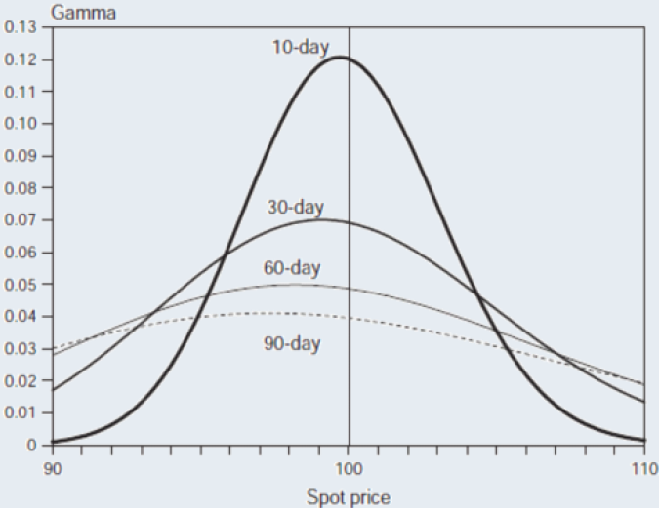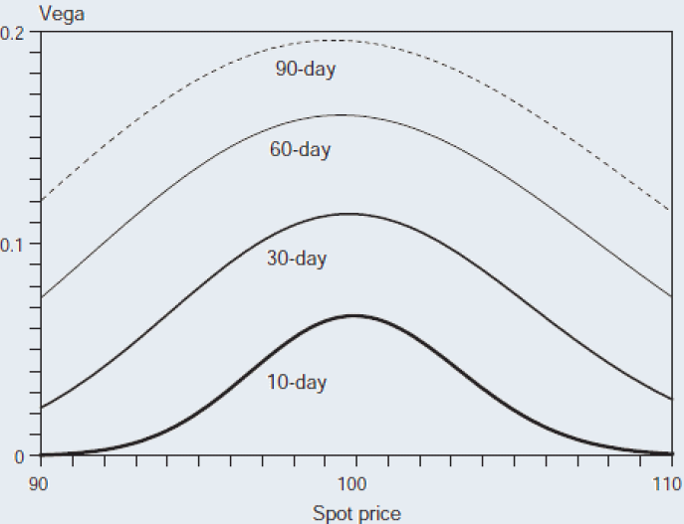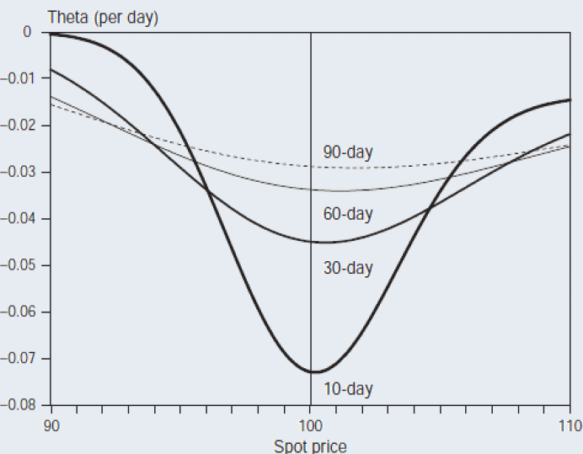

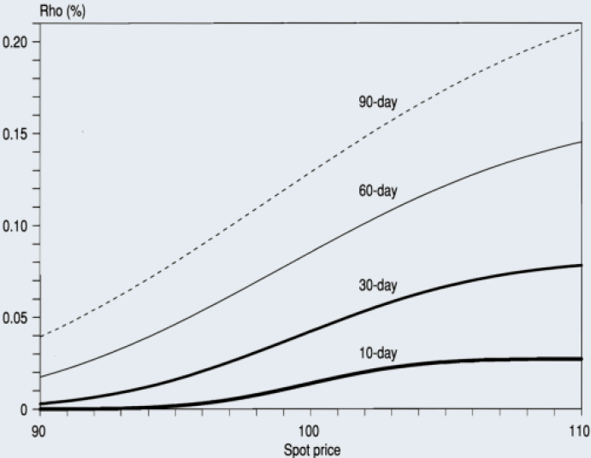

Longevity risk: live longer (life insurance) v.s. Mortality risk: life not long as expected (annuity)

Loss Ratio + Expense Ratio + Dividend – Investment Income = Operating Ratio

Defined benefit plan: pooled contribution, each determined by a formula

Defined contribution plan: employee choose the funds invested, plan is less risky to employer

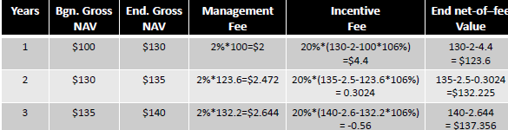

Commercial Paper (< 1Y) 🡪 Short-term notes (< 5Y) 🡪 Medium-term bonds (< 12Y)

Floating Rate Note coupon payment uses interest rate of previous three month LIBOR

Treasury Bills:

Treasury Bonds: (32nds quotation)

Day Count for Govies: Actual/Actual, for corporates: 30/360

Coupon Rate is normally quoted as annual, need to divide by 2 for semi

Annuity use BGN Mode ([2nd][PMT][2nd][ENTER])

Perpetuity

Spot rate normally show in annual, need to recompute to accommodate time

Continuous compounding forward rate:

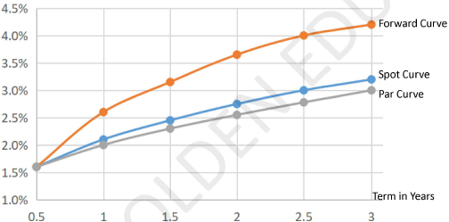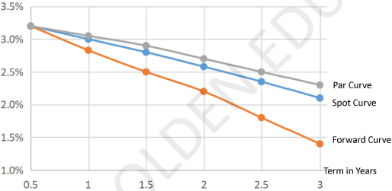

YTM: a single rate used to discount all cash flows

Compute dirty price: find full price at previous coupon date and grow risk free rate to current date, that is dirty price. Use the value subtract accrued interest to get clean price.

At coupon date, dirty price = clean price

Bond PnL: Carry Roll-Down (Price change + Cash Carry), Rate changes, Spread Changes, Financing Cost changes

,

,

,

,

Both Dur and Convexity of portfolio can use value-weighted scheme

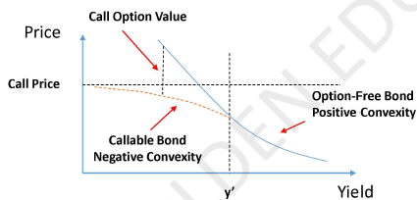 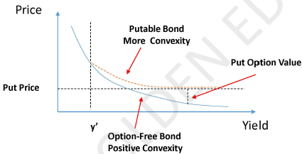

The security with more convexity outperforms in both bull and bear markets (long i/r vol)

Barbell portfolio outperform when there is a parallel shift in yield curve

DV01 = SUM(KeyRate01s)

, in case of PCA: 

Remember to use y/m for I/Y when use calculator

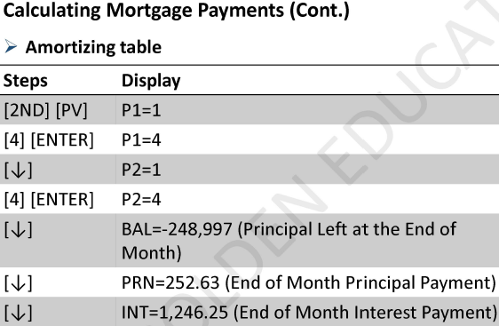

Credit Classifications: FICO (between 350-850, critical at 650, prime, subprime, and alternative)

Non-Agency MBS vs. Agency MBS: Ginne Mae, Fannie Mae, Freddie Mac

Mortgage Pass-Through Securities (MPS): all investor receives same return (prepayment risk)

Collateralized Mortgage Obligation (CMO): redistribute cash flow to sequential-pay tranches

Stripped MBS: Interest-only and Principle-only securities

* Specified pools (SP): agree to trade a certain amount of specified pool
* To-Be-Announced (TBA): a forward market and more liquid as pool not specified

Repo seller return the same pool, while dollar roll seller may return different pool

Repo transaction included interest to price while dollar roll does not

Prepayment Modelling

* Incentive function:
* Burnout effect: i/r decreases, increase of prepayment decreases as already refinanced
* Turnover: borrower sell houses (higher in summer and lower in early life of mortgage)
* Curtailment: when loans are old and balances are low
* Default: agency needs to pay remaining

Forward Rate Agreement

* Long position is borrower
* 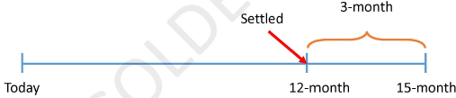

Price received for a bond = settlement price (quoted futures price) X Conversion Factor + AI

Cost of delivering a bond = Bond quoted price + AI – Futures quoted price X CF -AI

EuroDollar quotes: USD 100 – R, where R is the libor fixing for 90 day USD borrowings

A settlement at beginning of the three-month period and settled daily

Convexity Adjustment:

Libor-zero curve:



Coherent Risk Measures: Monotonicity, Homogeneity, Translation Invariance, Subadditivity

VaR 5% 1D: N\*5% th data point in ascending order

ES 5% 1D: Average of the tail excluding the 5% point

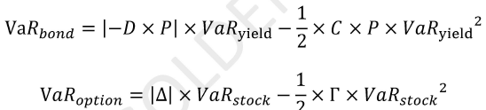

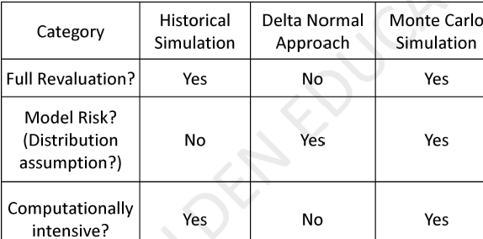

Vol Estimation:

* Slow changes of vol vs. regime switching
* Equally Weighted Standard Deviation (large time window vs. small time window)
* EWMA: 🡪
  + 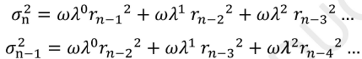
* GARCH: ,
  + EWMA is a special case of GARCH
  + is persistence level, the bigger the lower the variance revert to