User Manual

FDA – Website

FDA, Maharashtra

(fda-ITCell@gov.in)

14-07-2023

# Amendment Log

|  |  |  |  |  |
| --- | --- | --- | --- | --- |
| Version | Date | Change No | Brief Description | Sections Changed |
| 1.1 | 14 July 2023 | - | Draft | - |
|  |  |  |  |  |
|  |  |  |  |  |
|  |  |  |  |  |

# Approver Details

|  |  |  |  |  |
| --- | --- | --- | --- | --- |
| Sr.No. | Date | Approver Name | Document Version | Comments |
| 1 |  |  |  |  |
| 2 |  |  |  |  |
| 3 |  |  |  |  |
| 4 |  |  |  |  |

# Table of Content

Amendment Log 1

Approver Details 2

Table of Content 3

FDA Website – User Manual 4

Introduction 4

Access and User Roles 5

FDA Website Admin 5

Folder Structure & Managing Content 6

Step – 1: Login to cloud Server 6

Step – 2: Access Resources Folder 6

Step – 3 Open ‘lang’ Folder 6

Update PHP File – Examples 9

Edit ‘about.php’ 9

Edit ‘drugDuties.php’ 9

Edit ‘home.php” 9

# FDA Website – User Manual

## Introduction

User Manual for “Food and Drugs Administration, Maharashtra” (FDA) Website Admin for content management purpose. User Manual for the FDA Website Content Management system using a folder structure. This manual is designed to provide comprehensive instructions to FDA's admin users on effectively managing and organizing content within the FDA website. The FDA content management system empowers administrators to create folders, upload files, and perform various content management tasks to ensure a well-structured and easily accessible website.

By following the guidelines outlined in this manual, FDA admin users will be able to navigate the folder structure, create new folders, rename existing ones, move folders and files, upload files, rename files, and delete folders and files as necessary. Additionally, this manual will cover important information regarding security and access permissions to maintain the integrity and confidentiality of the FDA website content.

It is important to note that access to the FDA content management system is limited to authorize admin users only. These admin users possess the necessary permissions to manage the website effectively. Therefore, it is essential to follow the instructions outlined in this manual diligently and ensure adherence to FDA's policies and best practices for content management.

## Access and User Roles

#### FDA Website Admin

* Through the cloud authentication system, FDA admins will be granted exclusive access to the website's folder structure. This access ensures that only authorized personnel can make changes to the content, ensuring the integrity and security of the FDA website.
* FDA admin have the authority to add new files, update existing files, and delete files as necessary.

## Folder Structure & Managing Content

#### Step – 1: Login to cloud Server

1. Using cloud server credentials login to cloud server.
2. Cloud server access will be given to FDA admin only.

#### Step – 2: Access Resources Folder

Access the resource folder. Server path will be shared separately.

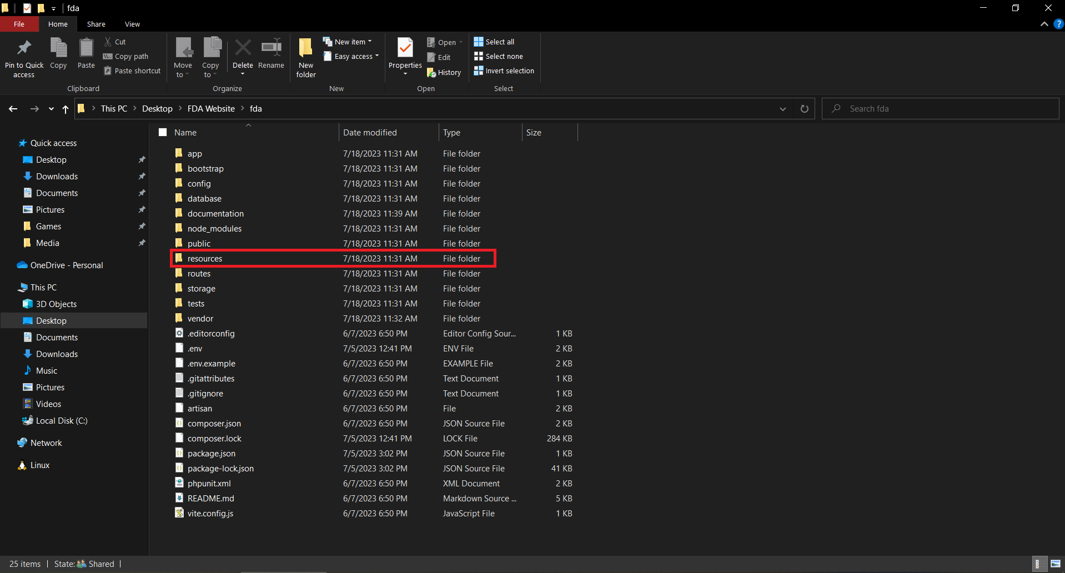

#### Step – 3 Open ‘lang’ Folder

Lang folder is used for saving website content in multiple languages. Currently FDA website supports English and Marathi languages.

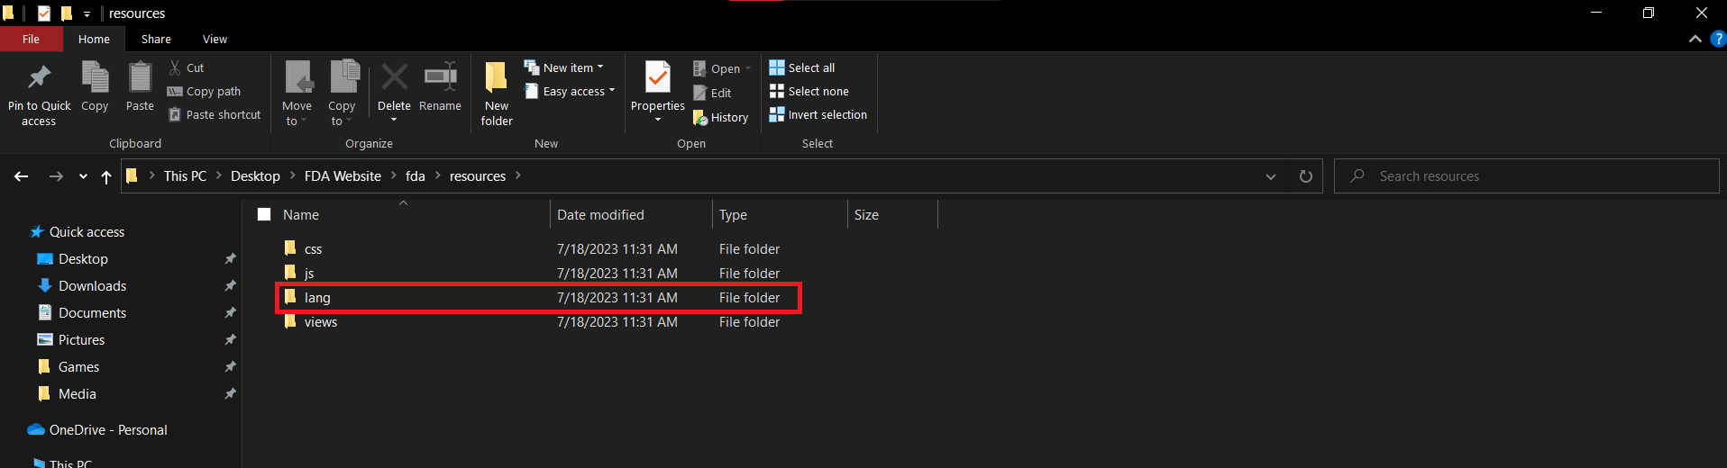

|  |  |  |
| --- | --- | --- |
| **Sr. No.** | **Language** | **Folder Name** |
| 1 | Marathi | mr |
| 2 | English | en |

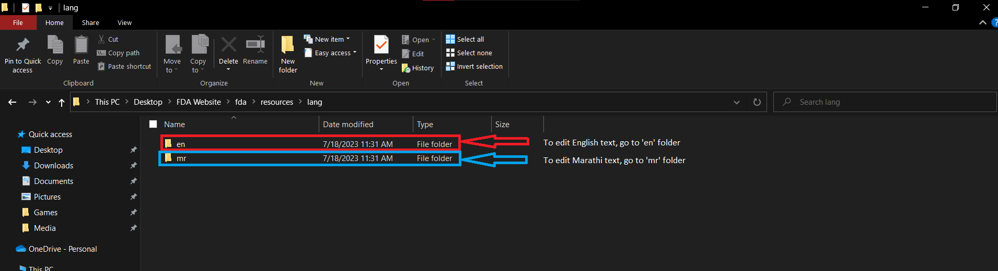

Update the PHP file content accordingly.

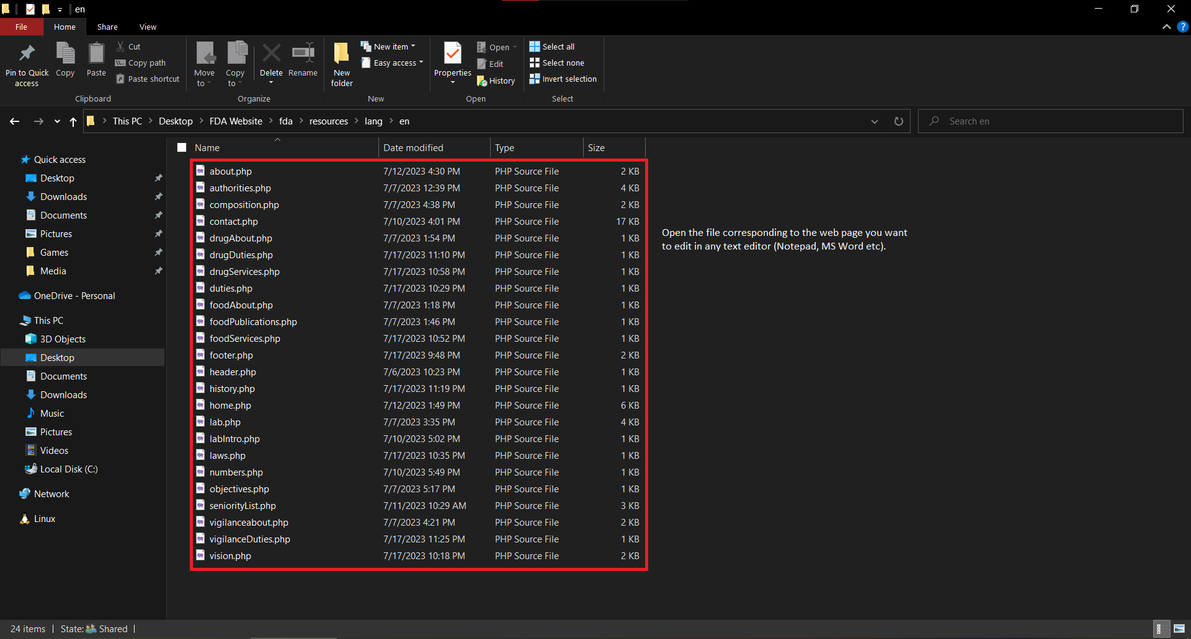

## Update PHP File – Examples

#### Edit ‘about.php’

This is the about page. It contains just the page title, and the about paragraph. To edit the title, just edit the text after **‘title’ =>** . Please make sure that the text is always within quotes (‘ ‘), otherwise the site will crash.

To edit the description, similarly just edit everything after **’description’ => ,** ensuring all the text is within quotes.

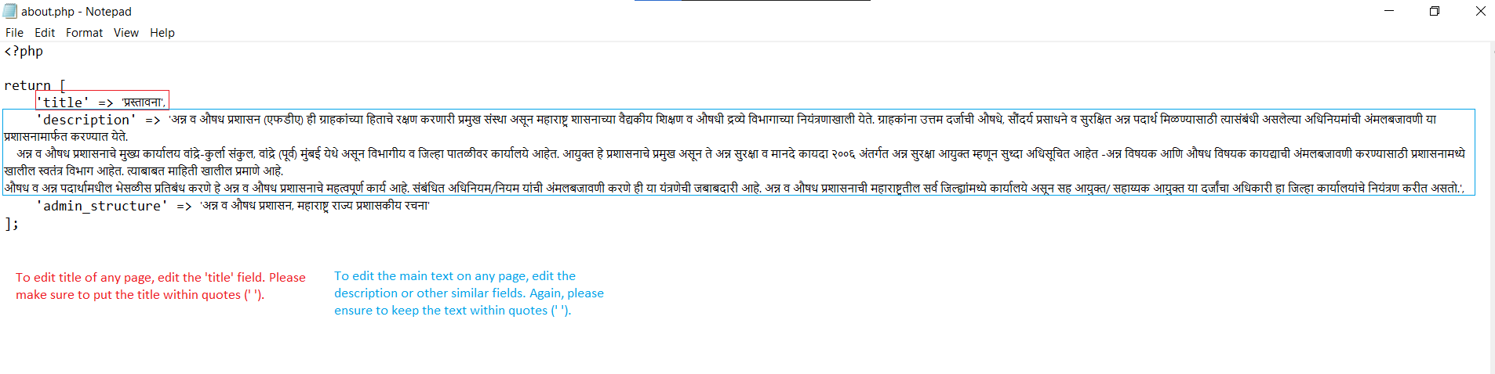

#### Edit ‘drugDuties.php’

This is the page that displays the duties of the drug department of the FDA.

To edit the title, just edit the text after ‘title’ => , the same way you did for the about page.

To edit the list of duties, edit the individual entries. Ensure that each point is enclosed within quotes (‘ ‘), and that each point is separated by a comma.

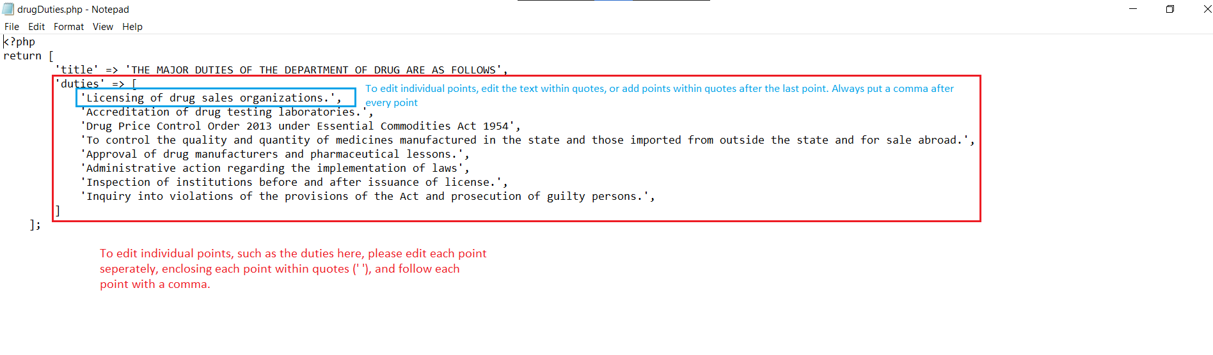

#### Edit ‘home.php”

This page contains all the required details to display the home page of the website.

To edit the pictures shown on the home page, change the pictures within ‘public/img/banner’ directory, and update the names within the ‘banner’ field.

To edit the list of Key Persons, change the name and post, then add the photo of the person to ‘public/img/key_person’ directory, then change the ‘photoName’ field in the file. Please ensure to do this for both the English and Marathi versions.

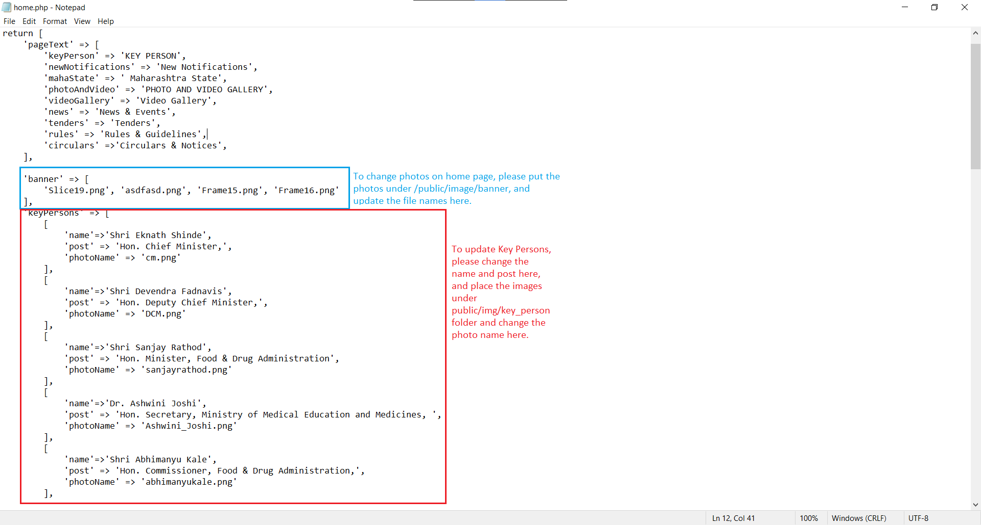

This is the sample format for news, tender, rules and circulars.

[

Give title for news/tender etc

'title' => '',

Give date. It should be in dd/mm/yyyy.

'date' => '',

Give only one, either link to website(for news, tenders and rules)

or name of file(only for circulars)

'link' => '',

'filename' => '',

],

Please put the files for the circulars in the ‘public/pdf file’ directory.

To update the charts, please put the updated charts in the ‘public/charts’ directory and update the names in the respective files.

There is currently no Admin dashboard to update the website directly. This guide will be updated once the dashboard is created.