Software Engineering Lab   
Implementation Report I - Build I  
EDUHELP

short line

DivyanshVerma(16CO110), Prince Abhinav(16CO134)  
March 17, 2018

# 1. Basic Information

any other tools and information on how to run your application>

Languages used :-

* Java for writing android programs and classed.
* XML for making and designing layout.
* NodeJs for implement server for forum.

APIs :-

* Google Sign-In API for sign-in feature.
* Firebase API for easy authentication and user g-mail profile information gathering.
* Socket.io Client Server API for FORUM implementation.

Libraries :-

* Glide libraries for easy and fast loading of images.
* Different Layout libraries for XML.
* Android-About-Page library for implementation of about page.
* Express.js for FORUM.

IDEs :-

* Android Studio IDE
* Sublime Text (Text Editor)

Others:-

* Android SDK and Android Virtual devices.

Application can be Downloaded from GITHUB repo. [SE-LAB-EDUHELP](https://github.com/failedcoder12/SE-LAB-EDUHELP). To run it you can directly install it in any android platform and run it. To run it in Windows or any other platform download android studio with virtual devices and run it there.

# 2. Functional Requirements (Implemented)

|  |  |  |
| --- | --- | --- |
| **FRID** | **NAME** | **Description** |
| FR1 | Download mobile application | User can download the mobile application from Github and can also see source code. The application will be free. |
| FR2 | User registration and Login | After downloading the app the user will be able to register through the mobile application. The user can register or login using any gmail account. All his/her data will be taken from that account |
| FR3 | User Log-out | Given the user is logged in, he/she will be able to log out of the mobile application. |
| FR4 | Chat system | After log-in is done, he/she can chat with other logged in users and user can ask any doubts. It is a kind of forum to ask and chat but it’s data will not get saved. |
| FR5 | Tutorials and Previous paper | A user have to enter the name of the examination or click on the examination in order to get the links of the papers as per required. User can download pdfs and they will get saved in internal or external memory of users mobile. |
| FR6 | Android Game | User will be able to play the game and score points by tapping on screen. |
| FR7 | Writing Notes | Important notes can be maintained in the notepad provided in the app. They will get saved in shared preferences of user’s mobile. |
| FR8 | PDF viewer | User can download pdf in external memory and open pdf within app without internet after saving it. |

# 3. Functional Requirements (Not Implemented)

|  |  |  |  |
| --- | --- | --- | --- |
| **FRID** | **NAME** | **Description** | **Why Not Implemented in this Build?** |
| FR1 | Reset Password | After the user has registered he or she will be able to reset his/her password by email. | For now we have used google sign-in in our application so it is not required to implement that. We will be working on allowing user to completely deleting account. |
| FR2 | Notes and tutorials | All the tutorials, books, notes and video links to help user to learn more and easily. | Due to time constraint we were not able to add find good resources. We can add other resources but they may not be helpful for user. So will try to give some time to acquire resources and try to insert them in our app. |
| FR3 | Notes Database | The important notes written to be saved in a online database to retrieve it’s data from any phone user logined. | We were trying to connect it to firebase to save all notes and data in the database but as we are new to firebase or any other online database i.e. why we failed to implement it. So in this built we have used Shared Preferences (Android offline database) to save notes in Phone Storage. |
| FR4 | Github Login Sign-up | Allow user to login using his/her github or facebook account. | We have implemented it for Google which is most used but we will try to implement it in future builds. |
| FR5 | Saving of chats in FORUM | Saving of all the messages and doubts in database such that any user can see it anyone time he logged in. | For this we need to learn MONGO-DB for that it was taking some time so at this build we have build an irc chat type forum |

# 4. Screenshots

## 4.1. FRID: Download Mobile Application



## 4.2. FRID: Registeration and Login

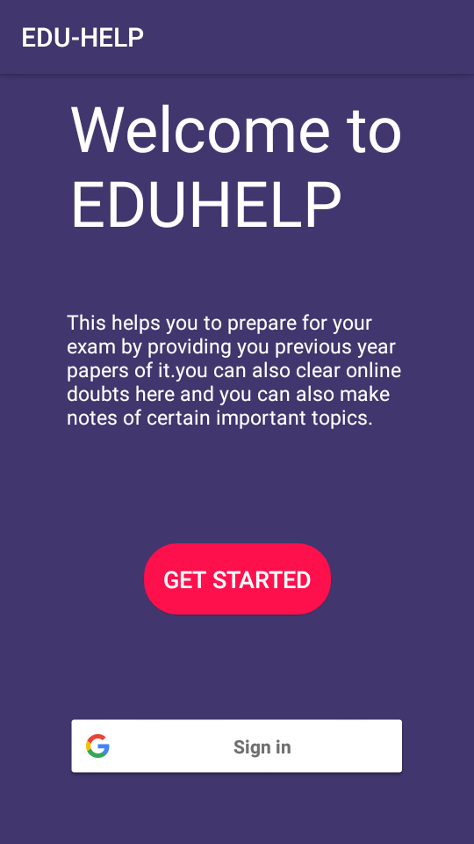

## 4.3. FRID: User Logout

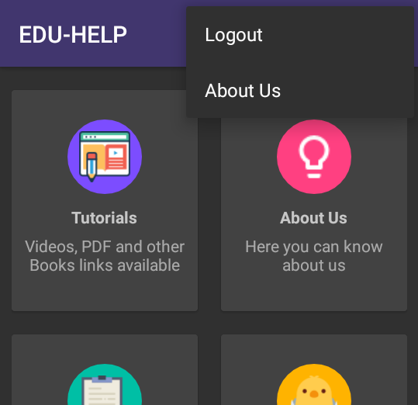

# 

## 4.4. FRID: Chat System

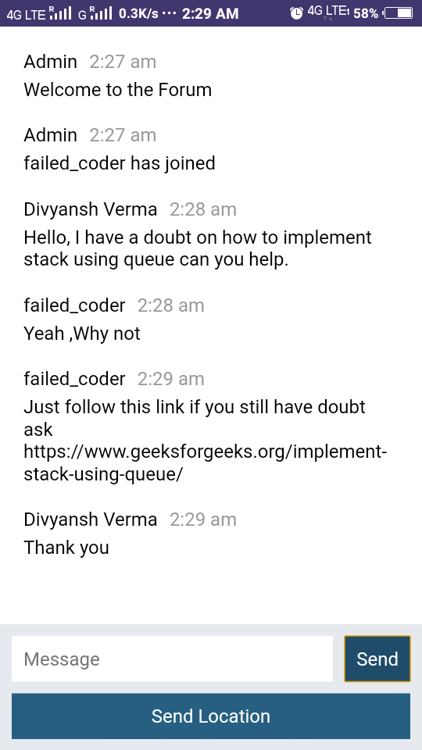

## 4.5. FRID: Tutorial and previous years papers

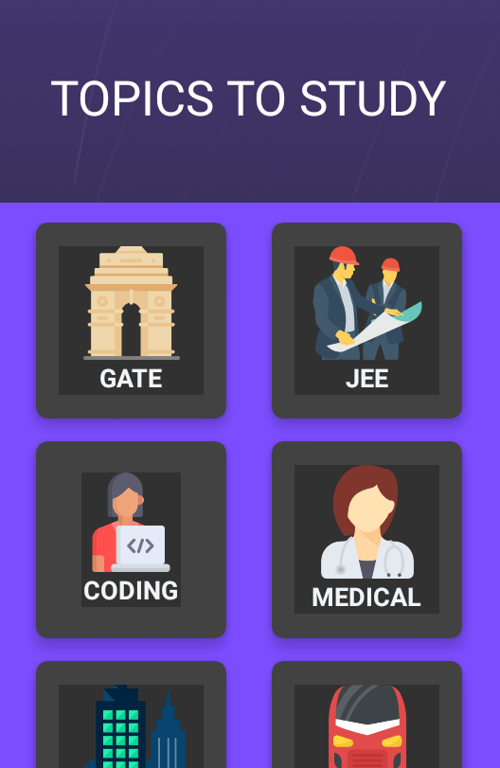

## 4.6. FRID: Android game

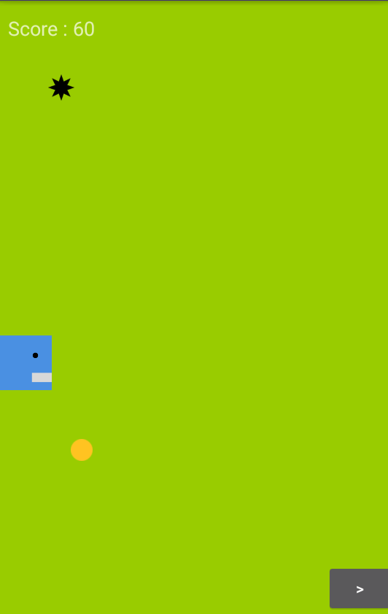

## 4.7. FRID: Writing Notes



## 

# 5. Plan for Next Build / Release

Functional or non-functional requirements that we will try to add :-

* Storage of all chat in a database such that anything which is missed can be read at other time.
* Github and facebook user login and registeration.
* User will be able to completely delete the account.
* Important notes to be saved using firebase such that they can be retrieved in other phones using user’s account.
* Different forum pages can be created for discussing different stuffs.
* More resources and study material to be added.

Information about revising your design and development strategies for providing a better solution :-

* We will remove unwanted stuffs like android game from our app to make the app to serve its purpose.
* We will try to make it more dependent on database and much more secure.
* We will continue to follow iterative model development.
* More user friendly design and we will try to develop the app in blocks instead of continuous development.

# 6. Summary

*<Summary of your report>*

short dash

# 7. Screenshots

