**Graduate Capstone Project: Group 7**

**Platform (Web Application) for Indie Game Developers**

Dmitriy Sizionov: 2054923

Guo Tang: 2056042

Jingchen Yang: 2085260

Fairleigh Dickinson University

24/VF CSCI 6806 V3 Computer Science Graduate Capstone Project

Dr. Sourav Mukherjee

September 20, 2024

List of Content:

1. Introduction……………………………………………………………………………….3
2. Related works……………………………………………………………………………..4
3. Approach………………………………………………………………………………….4
4. Deliverables……………………………………………………………………………….6
5. Evaluation…………………………………………………………………………………6
6. Risks………………………………………………………………………………………7
7. Conclusion………………………………………………………………………………...8
8. List of Sources…………………………………………………………………………….9

Appendix I: List of Figures…………………………………………………………………..10

1. Figure 1: Use Case Diagram……………………………………………………………..10
2. Figure 2: Class (Entity) Diagram………………………………………………………...11
3. Figure 3: Database Architecture………………………………………………………....12

1. Introduction

For the last decade video game industry has passed a long way from a nish-market with a few game studios to a multi-billion global market with global software companies. Game industry revenue might reach almost 307 billion by 2029 from 200 billion in 2022 (fortunebusinessinsights.com, 2024). Rapid growth is supported by the leaders in the industry for instance Microsoft, Nintendo, Sony, etc. but also small game studious. The video game industry is very competitive according to (MIT, 2022) with a low barrier to entering the market due to the simplification of game engines, availability of marketplaces, and possibility to communicate with players directly. However, the biggest challenge for small companies is establishing a community around the game in the early stage (Morris, 2020), since there is no common place for it. Game platforms are mostly focused on AAA titles from big companies since they are generating the biggest traffic of players to them. Small developers become lost and forgotten in the shadow from the big labels. Therefore, this project aims to solve this issue and provide a platform for small game developers to publish their works and build a community of fans around them.

Small indie game studious do not have a place where they can easily test and get feedback about the game from players in the pre-release stage. Since they have limited scale and budget, they need to start increasing their exposure early in the game development process to build a potential player base or to receive feedback and assistance from external sources. Currently, their options are mainly limited to setting up their own blogs or posting updates on personal social media platforms (Morris, 2020). Therefore, the platform, proposed in this project, aims to provide the possibilities for potential players to access the information about the indie projects they care about in one place and helping developers address issues encountered during development, so they are no longer isolated and unsupported.

The platform creation is a challenging project since the balance of interests between developers and players should persist. The aim is to make the platform easy to use for both players and developers in order to male it intuitive for browsing and interacting with. Therefore, the platform creation requires storing a content of developers and players, building packages for several interfaces, and integrate AI-generated analysis reports.

Despite the technical challenges, the project has significant benefits for users. Game studious will be able to upload test builds, publish promotional videos, trigger event notifications, distribute digital materials (such as character designs and soundtracks), get feedback about the game on the pre-released stage, and receive AI-generated analysis reports with a fan's community opinion.

2. Related Work

There are some well-known game distribution platforms like Steam, GOG and others. They place and promote indie games but these platforms focus more on promoting completed works. And also give ability to release there early-access products and facilitating community interaction. However, due to the large number of commercial AAA games on these platforms, the attention and support for indie games are often insufficient. In this situation, many game developers choose to use official social media accounts to promote their games like on Instagram/Discord. But in this case player targeting is a weak point since a social media platform are not specialized on this segment. Moreover, the biggest challenge to cooperate with players, game developers have to send direct personal invitations to the players to gather their feedback, analyze it, and incorporate changes after. While it requires a lot of resources from Game studio. In other hand, they might skipp this development part with public tests and releasing the game without it. This decreases the chance for a game to be successful at the end.

Therefore, the creation of a place where small games studious and players can meet each other and share their ideas, discuss some features, and interact with each other is required.

The players will familiarize themselves with the pre-released indie game info, interact with developers, and contribute to the work-in-process projects. Developers will be able to focus on games development, without spreading resources on gathering the players from various platforms. The platform will be able to provide a one-stop service for developers to upload game, test new features, and interact with potential players.

3. Approach

The initial project is a platform (web application) where game developers can share their games in the development stage for testing/feedback gathering.

This web application will primarily serve independent game developers or small indie game studios. The main focus is on facilitating the close communication with community on the early-stage game development.

Independent game developers will be able to create a homepage for their games. On this page, developers can post descriptions of the game, patch notes, playtest events, trailers, and more. Developers with needs can upload stage-specific game test builds for player testing, and quickly receive ratings and feedback from interested players about that stage's results, thus improving the final product more effectively.

Players would have a chance to familiarize themselves and test games before game release. They would be able to browse and track the development progress of games they are interested in, participate in testing, and directly contact developers through the platform to leave suggestions that help improve the game.

The platform will provide a summary for each game based on the player's feedback by gathering them and summarizing it via AI in a short article. That helps players to have a brief overview of the game. And also, it gives game developers a summary of feedback.

The project aims to adopt an architecture similar to MVC (Model View Controller) for building a platform. It's a software design pattern commonly used in web development by dividing the interface into 3 interconnected elements. According to Figure №1, it is planned to have 2 interfaces for Game Developers and Players. Additionally, it is planned to use one of the AI's API to process a Players input (ratings and comments) to generate data insights. To execute this architecture are developed a Class Diagram illustrated in Figure №2. Main actors will have their own entities with related methods. Furthermore, the project will include Database architecture represented in Figure № 3. The project contains intensive use of algorithms that might include some search algorithms like searching based on keywords and filtering search results on given fields like the game genre or developers, and others.

The project will be performed with the following Software stack:

The Framework will be implemented with Django Web Framework since is a free and open-source, Python-based web framework that runs on a web server. It fully supports the project MVC architecture concept. Additionally, it is tailored to use a relational database which is planned to use.

Front-End will include BootStrap to manage a web application to implement a website's HTML and CSS programming languages. To enhance a web application usability the front end will include React.js which uses JavaScrip language for styling websites.

The Back-End project will use Python as a major programming language with the support of SQL to communicate with Database. A Database will be implemented in MySQL to store the data as a relational database. Additionally, the project will include external APIs to interact with AI to process data.

4. Deliverables

The project includes the following diagrams: use case, class (entities), state, and sequence diagrams. The database architecture consists of tables and an access matrix to manage the data.

Major milestones are the Mid-term Demo version submission and Final project submission. Meantime, the deliverables include also other interim milestones. For the project execution, the team plan to distribut tasks and deliverables on the weekly team meetings.

|  |  |  |
| --- | --- | --- |
| **Date** | **Week** | **Task** |
| Sep 4 | Week 1 | Project idea generation |
| Sep 11 | Week 2 | Project concept developing |
| Sep 18 | Week 3 | Preparation of Documentation |
| Sep 25 | Week 4 | Establishment of environment, Framework, Database, and Development Tools |
| Oct 2 | Week 5 | Creation of main Entities, Methods, Database Tables |
| Oct 9 | Week 6 | Simple front-end concept preparation |
| Oct 16 | Week 7 | Demo version demonstration and Mid-term-report submission |
| Oct 23 | Week 9 | Development of non-essential features of the project |
| Oct 30 | Week 10 | Enhance front-end development |
| Nov 6 | Week 11 | Testing and debugging |
| Nov 13 | Week 12 | Testing and debugging |
| Nov 20 | Week 13 | Preparation of presentation and the final report |
| Nov 27 | Week 14 | Presentation and final report submission |

To communicate and maintain efficient project execution the project team plans to keep daily contact in established communication channels in messengers, GitHub, and other resources.

5. Evaluation

Evaluation of deliverable tasks is planned to be performed by conducting weekly team discussions and presentation of functionality. Additionally, it is planned to have 2 weeks of testing and debugging to achieve high-quality products at the end of the project. To achieve this the team plans to develop and perform auto-test for the web application in order to test functionality. Additionally, the team plans to conduct user testing gather feedback about usability and user product satisfaction. It is planned to assess the core web application functionalities for non-error conditions. And also the user interface should be simple and aesthetically pleasing, making it easy for new users to get started and for experienced users to navigate quickly.

As a benchmark for evaluation, the product has to follow those standards:

1. Game Browsing and Discovery Metrics:

* Game search results should be relevant, accurate, timely.
* Filters should be applied instantly, and sorting should correctly rank games by criteria such as popularity, release date, or rating.

2. Game Uploading for Developers Metrics:

* Games should be uploaded within a reasonable time frame
* Developers should be able to upload metadata (game title, description, screenshots, etc.) within 1 minute without errors.

6. Risks

The project major risks are the dis-synchronization within the team, the complexity of the software stack, and the size of the project. To mitigate those risks the team plan to implement the following measures:

* The team plans to develop documentation. In order to have a clear plan what is the scope of the project and how it is going to be delivered. This approach aims to provide clear project structure with the ability to nominate a specific task to each team member and set deadline for delivery.
* Risk of stack complexity is planned to be mitigated by team members experience in various topics. The team has experience in web development and database maintenance. All are familiar with Python programming language and have knowledge of front-end syntaxes. Also, the team has hands-on experience with SQL in Databases.
* The size of the project is also a risk for the project completion, but the mitigation measure is to outline the project scope in detail before the project kickoff. And to be flexible during the project to adjust and allocate team resources in required direction.

The team is going to have regular and close interaction during the full length of the project to be able to deliver the project on time and in accordance with high standards in the software industry.

7. Conclusion

The project aims to solve a real-world problem in the video game industry. In situation where game studious face a problem attracting players’ attention to their projects on the early stage of game development. Since it requires a lot of resources from developers that might be directed to the game creation activity. Current platform mainly neglects small indies studious due to the insufficient size of the community around their projects. Meantime, players have a difficulty to find new interesting projects with fresh view on games. And don’t have efficient channels for direct communication with game developers.

The project aims to develop a platform (web application) in accordance with industry standards and course deadline. That platform should be able to help developers to publish their game content and establish communication with the players community. It also should provide possibility for players to post their feedback about the games and interact with developers.

The Platform should work without technical errors, has a high usability for users and be intuitive in explanation.

8. List of Sources

MIT OpenCourseWare. (n.d.). *What’s possible for the gaming industry in the next dimension?* EY. <https://www.ey.com/en_us/insights/media-entertainment/what-s-possible-for-the-gaming-industry-in-the-next-dimension>

Morris, J. (2020, December 1). *How-to: Build an audience for your game as an indie developer on social media.* Medium. https://mister-morris-games.medium.com/how-to-build-an-audience-for-your-game-as-an-indie-developer-on-social-media-625721401886

*Video games market size, industry share, Forecast, 2032*. Video Games Market Size, Industry Share, Forecast, 2032. (n.d.). https://www.fortunebusinessinsights.com/video-game-market-102548#

Appendix I - List of Figures

Figure 1. Use Case Diagram

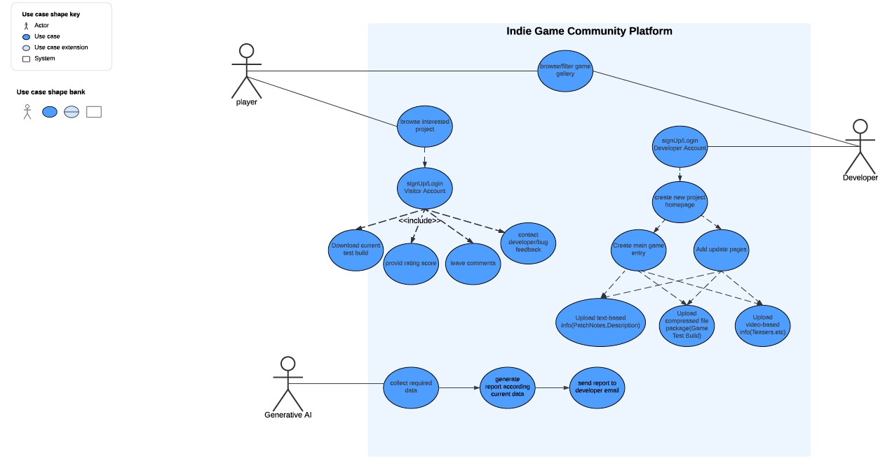

Figure 2. Class (Entity) diagram

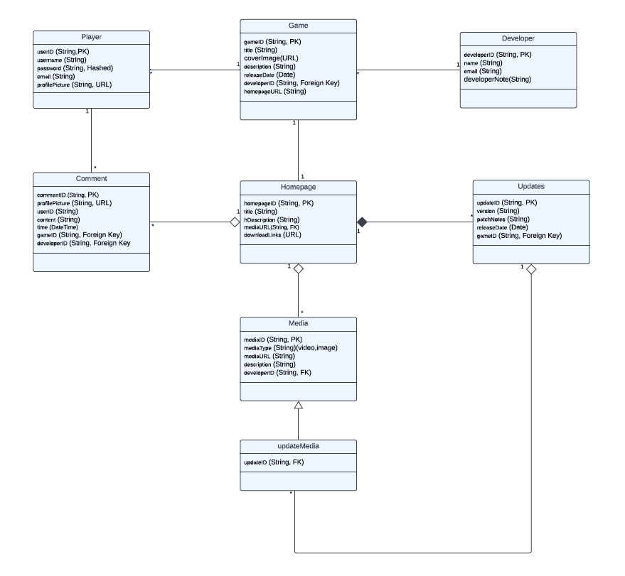

Figure 3. Database Architecture