RECOMMENDATION ITU-R S.1528
Satellite antenna radiation patterns for non-geostationary orbit satellite antennas operating in the fixed-satellite service below 30 GHz
(Question ITU-R 231/4)
(2001)
The ITU Radiocommunication Assembly,
considering
a) that the use of space station antennas with the best available radiation patterns will lead to the most efficient use of the radio-frequency spectrum;
b) that both elliptical and circular beam antennas are used on operational space stations;
c) that although improvements are being made in the design of space station antennas, further information is still required before a reference radiation pattern can be adopted for coordination purposes;
d) that the adoption of a design objective radiation pattern for space station antennas will encourage the fabrication and use of orbit-efficient antennas;
e) that it is only necessary to specify space-station antenna radiation characteristics in directions of potential interference for coordination purposes;
f) that for wide applicability the mathematical expressions should be as simple as possible consistent with effective predictions;
g) that nevertheless, the expressions should account for the characteristics of practical antenna systems and be adaptable to emerging technologies;
h) that measurement difficulties lead to inaccuracies in the modelling of spacecraft antennas at large off-axis angles;
j) that the size constraints of launch vehicles lead to limitations in the D/λ values of spacecraft antennas;
k) that a multiple beam antenna on the non-geostationary-satellite orbit (non-GSO) has to provide an earth coverage field-of-view (FOV) of up to ± 30° half-cone angle from a medium earth orbit (MEO) satellite, and up to ± 60° from a low earth orbit (LEO) satellite;
l) that most non-GSO fixed-satellite service (FSS) satellites are planned to use a large number of beams per satellite with either steerable or fixed beams;
m) that the peak gain of a multiple beam antenna decreases while the side-lobe level increases as a function of the off-axis beam pointing angle;
n) that the 1st and 2nd side lobes of a multiple beam antenna may be merged into the main beam when the beam is pointed toward or close to the edge of the Earth;
o) that for a practical antenna, spill-over from the main reflector, subreflector, or diffraction from the supporting structure may significantly affect the accuracy of our estimates in the near-in and far-out side lobe regions;
p) that actual radiation patterns of some kinds of multiple beam antennas may be significantly different from beam to beam,
recommends
1 that for multiple-beam non-GSO satellite antennas in the FSS having either circular or elliptical beams, the following radiation patterns should be used as a design objective or to perform interference analysis:
1.1 measured antenna patterns
Measured antenna patterns should be used in performing interference analysis whenever they are available.
When a measured pattern is not available, one or other of reference patterns given in the remaining sections may be used:
1.2 the reference pattern given by:
G(ψ) = Gm − 3 (ψ /ψb)α dBi for 0 < ψ ≤ aψb (1)
G(ψ) = Gm + LN + 20 log (z) dBi for aψb < ψ ≤ 0.5 bψb (2a)
G(ψ) = Gm + LN dBi for 0.5 bψb < ψ ≤ bψb (2b)
G(ψ) = X – 25 log (ψ) dBi for bψb < ψ ≤ Y (3)
G(ψ) = LF dBi for Y < ψ ≤ 90° (4a)
G(ψ) = LB dBi for 90° < ψ ≤ 180° (4b)
where:
X = Gm + LN + 25 log (bψb) and Y = bψb 100.04 (Gm + LN – LF )
ψb : one-half the 3 dB beamwidth in the plane of interest (3 dB below Gm) (degrees)
ψb : 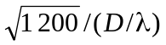 for minor axis (use actual values if known) (degrees)
ψb : (major axis / minor axis) for major axis (use actual values if known) (degrees)
G(ψ) : gain at the angle ψ from the main beam direction (dBi)
Gm : maximum gain in the main lobe (dBi)
LN : near-in-side-lobe level (dB) relative to the peak gain required by the system design
LF : 0 dBi far-out side-lobe level (dBi)
LB : back-lobe level (dBi)
z : (major axis/minor axis) for the radiated beam
LB = 15 + LN + 0.25 Gm + 5 log z dBi or 0 dBi, whichever is higher
D : diameter of the antenna (m)
λ : wavelength of the lowest band edge of interest (m).
The numeric values of a, b, and α for LN = –15 dB, –20 dB, –25 dB, and –30 dB side-lobe levels are given in Table 1. The values of a and α for LN = –30 dB require further study. Administrations are invited to provide data to enable the values of a and α for LN = –30 dB to be refined.
NOTE 1 – Patterns applicable to elliptical beams require experimental verification. The values of a and α in Table 1 are provisional.
TABLE 1

LN  (dB) | a | b | α
–15 | 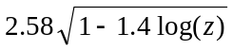 | 6.32 | 1.5
–20 | 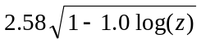 | 6.32 | 1.5
–25 | 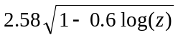 | 6.32 | 1.5
–30 | 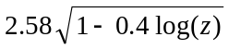 | 6.32 | 1.5
The radiation pattern in relative gain vs. ψ/ψb is shown in Fig. 1.
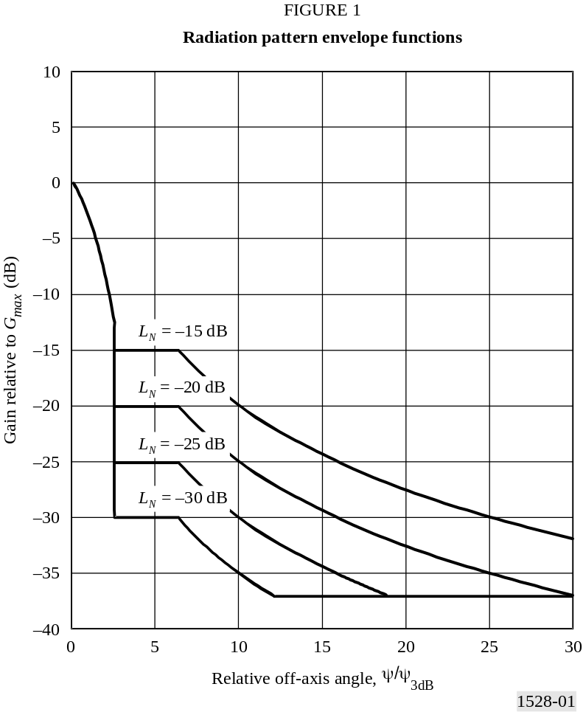

1.3 the reference pattern given by:

For D / λ < 35:
G(ψ) = Gm – 3 (ψ /ψb)2 dBi for ψb < ψ < Y
G(ψ) = Gm + Ls – 25 log (ψ /Y ) dBi for Y < ψ < Z
G(ψ) = LF dBi for Z < ψ < 180°
For MEO:
Ls = –12; Y = 2 ψb
G(ψ) = 20 log (D / λ) + 3.5 – 25 log (ψ /ψb) dBi for 2 ψb < ψ < Z
For LEO:
Ls = –6.75; Y = 1.5 ψb
G(ψ) = 20 log (D / λ) + 5.65 – 25 log (ψ /ψb) dBi for 1.5 ψb < ψ < Z
where:
ψ : off-axis angle (degrees)
G(ψ) : gain at the angle ψ from the main beam direction (dBi)
Gm : maximum gain in the main lobe (dBi)
ψb : one half the 3 dB beamwidth in the plane of interest at the largest off-axis angle
Ls : main beam and near-in side-lobe mask cross point (dB) below peak gain
LF : far-out side-lobe level (dBi), ~ 0 dBi for ideal patterns
Y = ψb (– Ls / 3)1/2
Z = Y × 100.04 (Gm + Ls – LF )
λ : wavelength at the lower band edge of interest (m)
D : diameter of antenna (m).
The reference pattern is shown in Fig. 2.
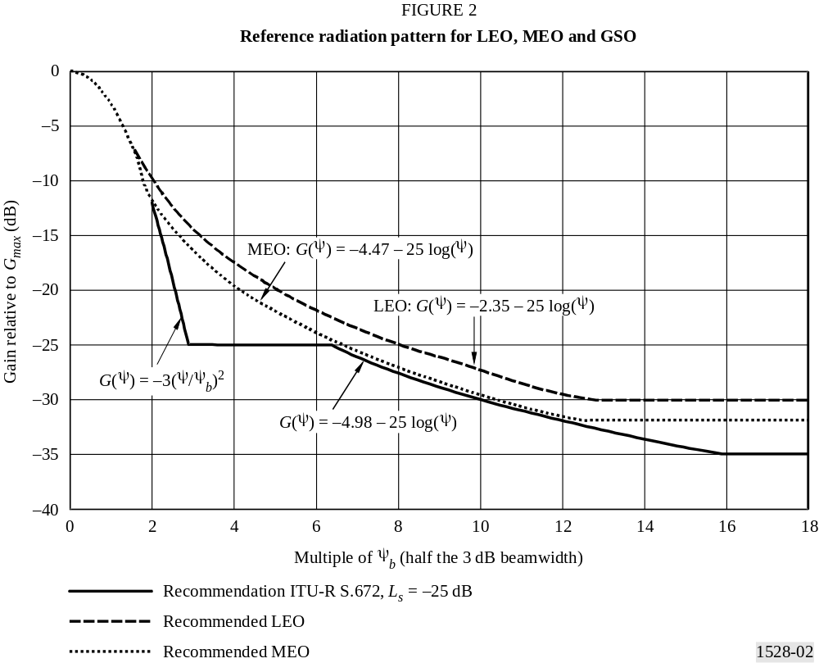
Recommended antenna patterns for non-GSO satellite multiple beam antennas operating in the FSS below 30 GHz are given in Annex 1;
1.4 the reference pattern given by an analytical function which models the side lobes of the non-GSO satellite.
In the study of frequency sharing between non-GSO systems, taking into account a non-GSO satellite antenna diagram as realistic as possible allows a more accurate analysis of the interference, while limiting the overestimation of it.
It is proposed to use a circular Taylor illumination function which gives the maximum flexibility to adapt the theoretical pattern to the real one. It takes into account the side-lobes effect of an antenna diagram.
To simplify the function, the peaks of the side lobes have been considered symmetrical which is a conservative assumption in the analysis of the interference.

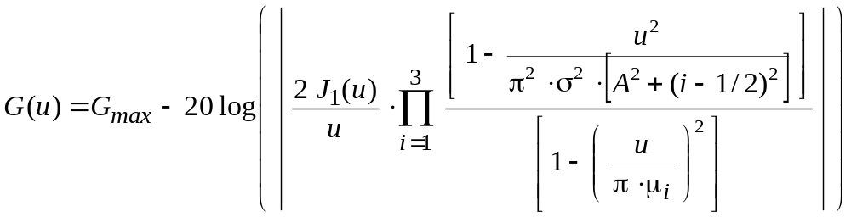

where:
G(u) : gain in the direction of the considered point (dB)
Gmax : maximum gain of the diagram (dB)
μ1, μ2, μ3 : three primary roots of the J1 Bessel function (rad).

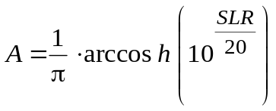

where SLR is the side-lobe ratio of the pattern (dB), the difference in gain between the maximum gain and the gain at the peak of the first side lobe.

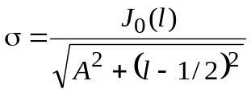

where l is the number of secondary lobes to consider in the pattern; J0( ) is the Bessel function.
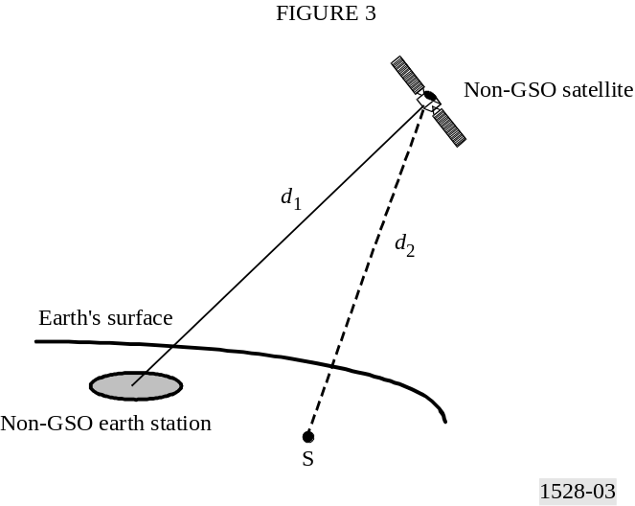
u is a function of both the antenna characteristics and the angle between the sub-satellite point (S is the sub-satellite point) and the illuminated beam as seen from the non-GSO satellite.
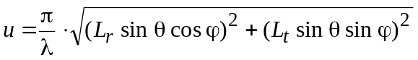
where:
(θ, ϕ) : coordinates of the test point with respect to the centre of the illuminated beam in the satellite reference (see Fig. 4)
Lr and Lt : radial and transverse sizes of the effective radiating area of the satellite transmit antenna (m).
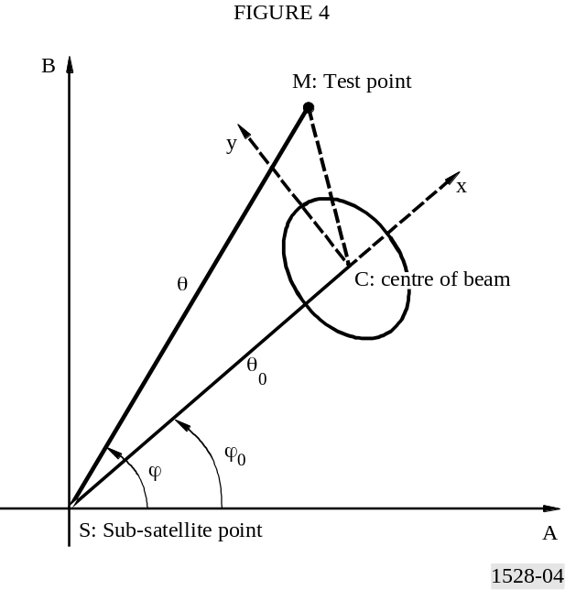
The parameters Lr and Lt are to be provided by the non-GSO system as input parameters.
An example of pattern obtained with this analytical function is given in Annex 2.
Further studies are needed to define the bounds of the antenna gain for the nulls that appear when using a Bessel type of function.
ANNEX 1
Examples for recommends 1.3

Example:
LM-MEO satellite antennas (USAMEO-1)
A typical non-steerable MEO satellite antenna has an earth FOV of > ± 22.5°
Lens diameter, D / λ : 22.6 wavelength at 18.8 GHz
Half power beamwidth, 2 ψb : 3.2° at 18.8 GHz, scanned 21° off-axis
Gain at 21° off-axis, Gm : 35 dBi

MEO reference radiation pattern
ψb = 1.6° Gm = 35
Ls = −12 Y = 2 ψb = 3.2°
LF = 3 Z = 20.0°
G(ψ) = Gm – 3 (ψ /ψb)2 dBi for ψb < ψ ≤ Y
= 35 – 3 (ψ /1.6)2 1.6° < ψ ≤ 3.2°
G(ψ) = Gm + Ls – 25 log (ψ /Y ) dBi for Y < ψ ≤ Z
= 23 – 25 log (ψ /3.2) 3.2° < ψ ≤ 20.0°
= 35.6 – 25 log (ψ)
G(ψ) = 3 dBi for 20.0° < ψ ≤ 180°

LEO reference radiation pattern
ψb = 1.6° Gm = 35
Ls = −6.75 Y = 1.5 ψb = 2.4°
LF = 5 Z = 20.4°
G(ψ) = Gm – 3 (ψ /ψb)2 dBi for ψb < ψ ≤ Y
= 35 – 3 (ψ /1.6)2
G(ψ) = Gm + Ls – 25 log (ψ /Y ) dBi for Y < ψ ≤ Z
= 28.25 – 25 log (ψ /2.4) 2.4° < ψ ≤ 20.4°
= 37.76 – 25 log (ψ)
G(ψ) = 5 dBi for 20.4° < ψ ≤ 180°
Using Recommendation ITU-R S.672
ψb = 1.6° Gm = 35
Ls = −25 Y = 2.887 ψb = 4.62°
LF = 0 Z = 25.4°
G(ψ) = Gm – 3 (ψ /ψb)2 dBi for ψb < ψ ≤ Y
= 35 – 3 (ψ /1.6)2 1.6° < ψ ≤ 4.62°
G(ψ) = Gm + Ls dBi for Y < ψ ≤ 6.32 ψb
= 10 4.62° < ψ ≤ 10.1°
G(ψ) = Gm + Ls + 20 – 25 log (ψ /ψb) dBi for 6.32 ψb < ψ ≤ Z
= 35.1 – 25 log ψ 10.1° < ψ ≤ 25.4°
G(ψ) = 0 dBi for 25.4° < ψ ≤ 180°

ANNEX 2
Examples for recommends 1.4
The antenna pattern presented is applicable to a non-GSO satellite system at an altitude of 1 469 km, generating beams on the ground covering a 350 km radius cell (see Fig. 5).
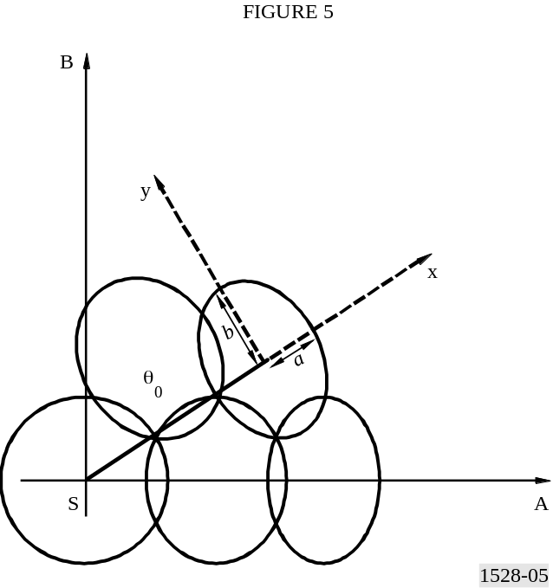
The study is performed at a frequency of 12 GHz.
The three primary roots of the J1 Bessel function are:
μ1 = 1.2
μ2 = 2.233
μ3 = 3.238
In each case, the SLR considered is 20 dB and the number of secondary lobes is four. These two parameters give A = 0.95277 and σ = 1.1692.
Lr and Lt are distances on the ground and depend on the beam roll-off (difference between the maximum gain and the gain at the edge of the illuminated beam). The calculation has been performed using roll-off of 7 dB, 5 dB and 3 dB.
The Lr and Lt input parameters to be used are given in Table 2.
TABLE 2*

Roll-off | 7 | 5 | 3
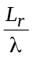 | 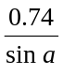 | 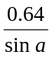 | 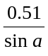
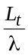 | 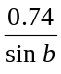 | 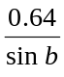 | 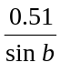
* The coefficients depend on the side-lobe ratio chosen in this particular case, as well as on the roll-off at the edge of coverage. The Lr and Lt obtained are in metres.
a: half-radial axis distance of the illuminated beam (degrees) (subtended at the satellite);
b: half-transverse axis distance of the illuminated beam (degrees) (subtended at the satellite).
For a pointing angle θ0 of 0°, relative to sub-satellite points (see Fig. 5) the results are plotted on the graph in Fig. 6.
