1. Установить Apache2. Прислать лог вводимых команд либо скриншот.

sudo apt update

sudo apt install apache2

1. Установить MySQL. Проверить работу, через консольного клиента, проверить команды select user from mysql.users; и select * from users;

sudo apt update

sudo apt install mysql-server mysql-client

mysql -V

mysql Ver 8.0.23-0ubuntu0.20.04.1 for Linux on x86_64 ((Ubuntu))

sudo mysql_secure_installation

sudo mysql

mysql> show databases;

+--------------------+

| Database |

+--------------------+

| information_schema |

| mysql |

| performance_schema |

| phpmyadmin |

| sys |

+--------------------+

5 rows in set (0.01 sec)

mysql> SELECT user,host FROM mysql.user;

+------------------+-----------+

| user | host |

+------------------+-----------+

| debian-sys-maint | localhost |

| mysql.infoschema | localhost |

| mysql.session | localhost |

| mysql.sys | localhost |

| phpmyadmin | localhost |

| root | localhost |

+------------------+-----------+

6 rows in set (0.01 sec)

mysql> exit

Bye

1. Установить php7.2 и phpmyadmin

sudo apt update

sudo apt install phpmyadmin php-mbstring php-zip php-gd php-json php-curl

sudo dpkg -l | grep php

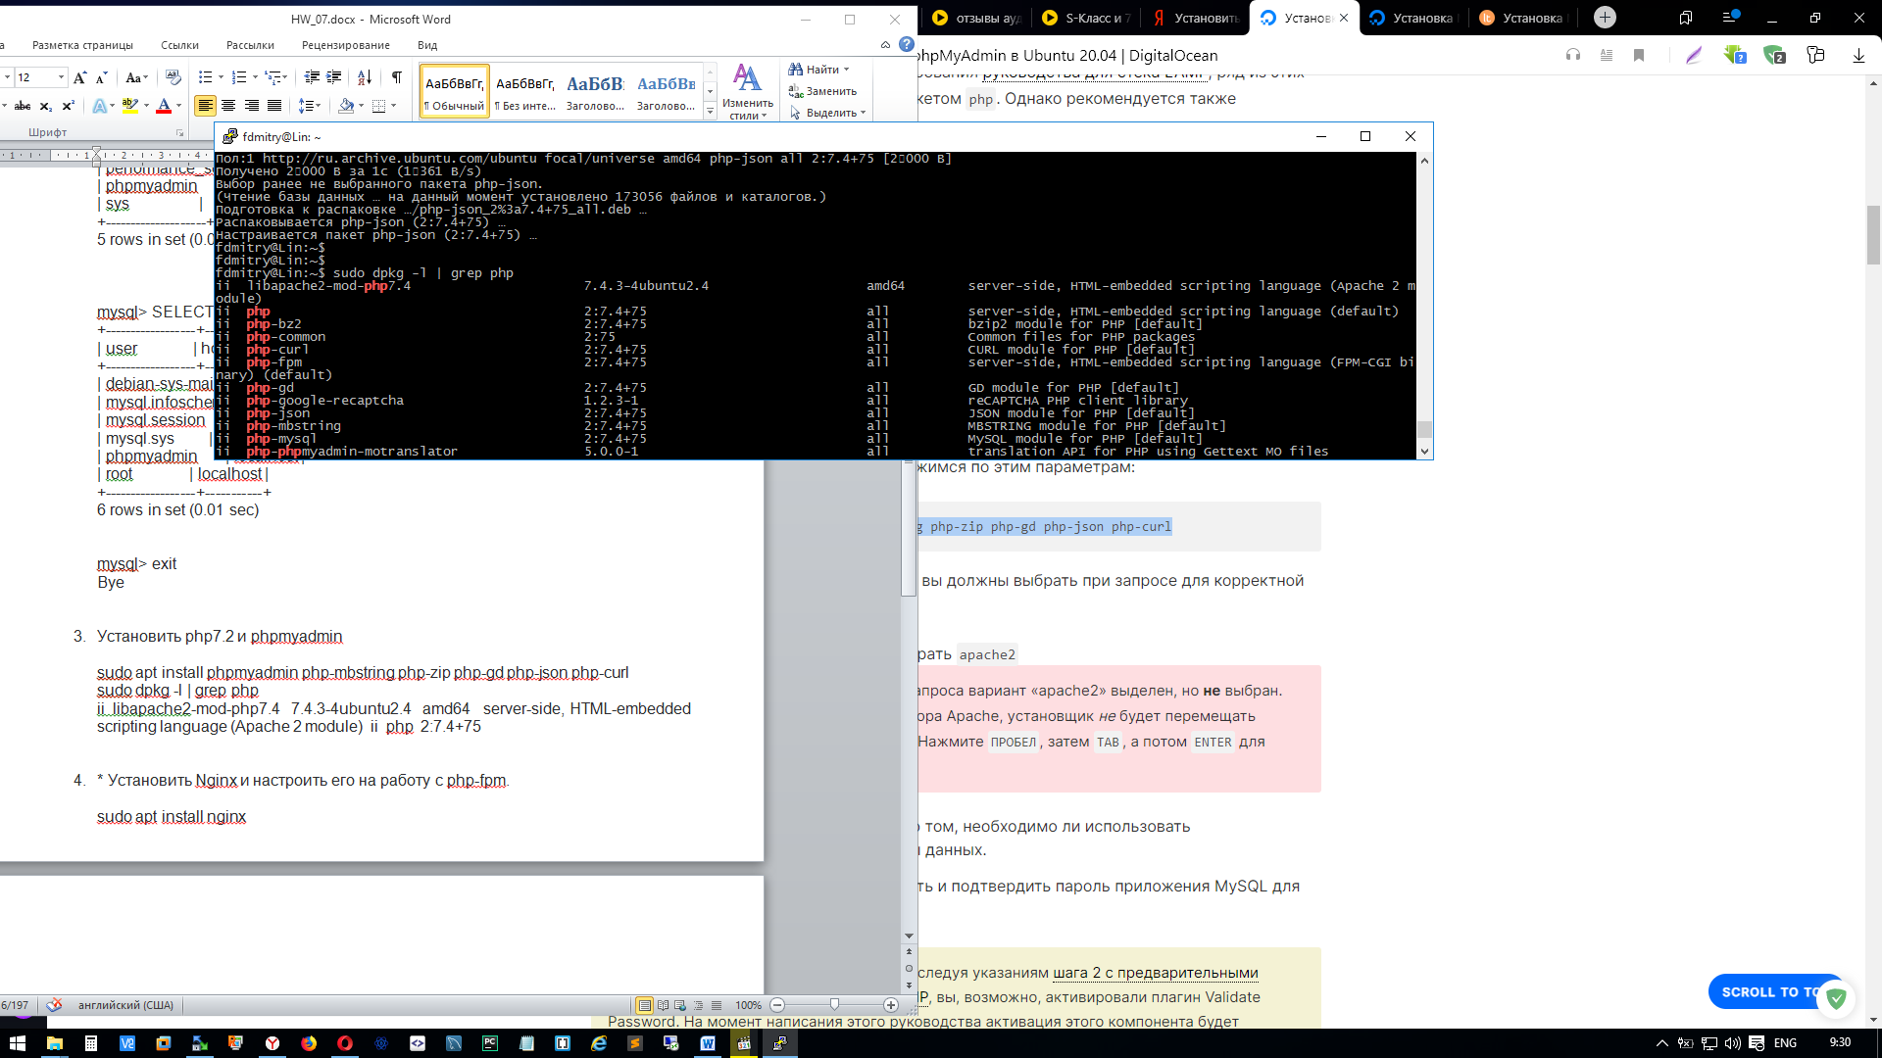

sudo phpenmod mcrypt

sudo phpenmod mbstring

sudo a2enconf phpmyadmin

sudo systemctl restart apache2

<http://192.168.0.187/phpmyadmin/>

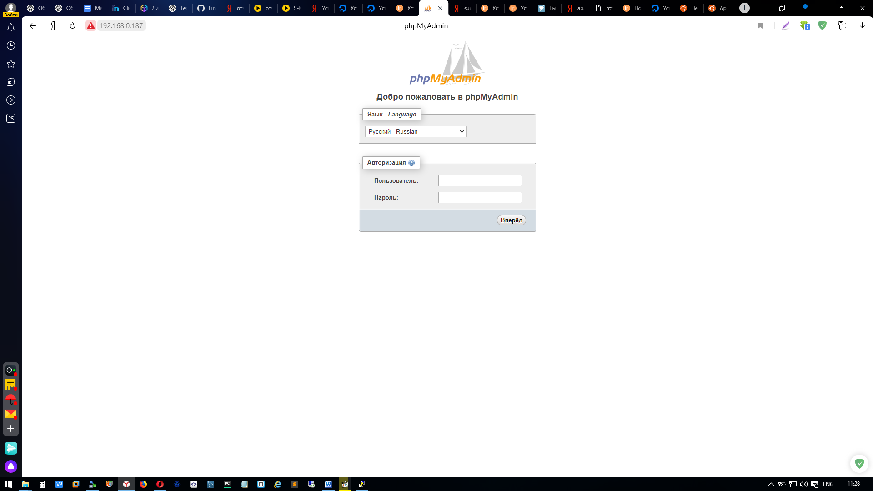

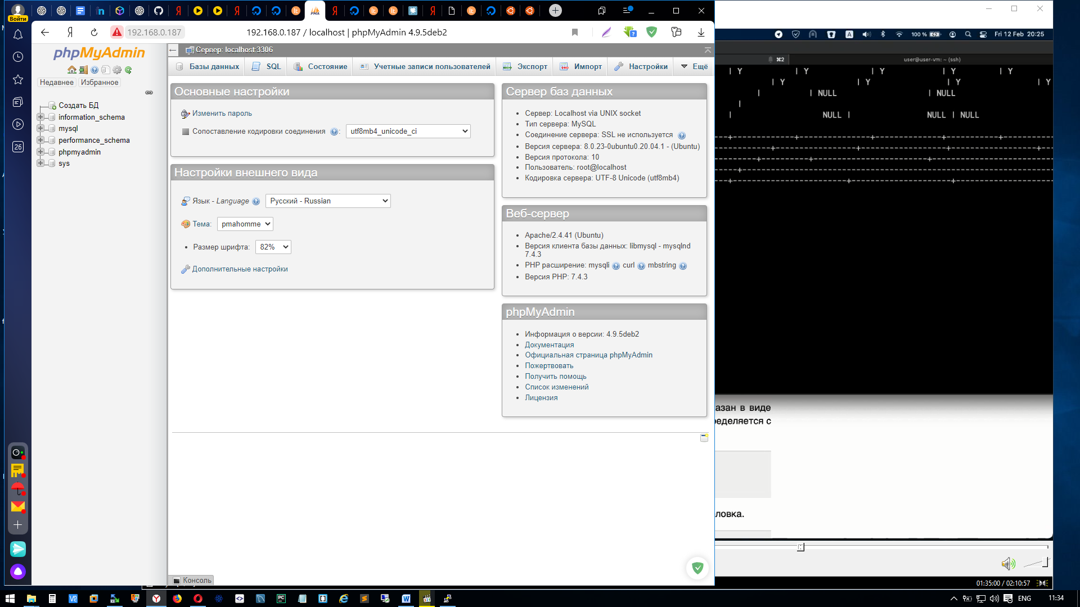

1. * Установить Nginx и настроить его на работу с php-fpm.

sudo apt install nginx

sudo apt install php-fpm php-mysql

sudo mkdir /var/www/fdmitry.tk

sudo chown -R $USER:$USER /var/www/fdmitry.tk

sudo nano /etc/nginx/sites-available/fdmitry.tk

server {

listen 80;

server_name fdmitry.tk www.fdmitry.tk;

root /var/www/fdmitry.tk;

index index.html index.htm index.php;

location / {

try_files $uri $uri/ =404;

}

location ~ \.php$ {

include snippets/fastcgi-php.conf;

fastcgi_pass unix:/var/run/php/php7.4-fpm.sock;

}

location ~ /\.ht {

deny all;

}

}

sudo ln -s /etc/nginx/sites-available/fdmitry.tk /etc/nginx/sites-enabled/

sudo nginx –t

sudo systemctl reload nginx