**The circularity gap of nations: A multiregional analysis of waste generation, recovery, and stock depletion in 2011**

Glenn A. Aguilar-Hernandez, Carlos Pablo Sigüenza-Sanchez, Franco Donati, Stefano Merciai, Jannick Schmidt, João F.D. Rodrigues, Arnold Tukker

***Supplementary Material***

Contents

1. Procedure 1

• Import data 1

• Use cgn_main.py, results.xls and analysis.xls 2

• Build Sankey diagram using cgn_sankey.py 2

2. Comparing material flow data from EXIOBASE v3.3.15 4

3. Literature 4

# Procedure

In this section we explain the procedure to import from EXIOBASE v3.3.15, use ***cgn_main.py***, obtain ***results.xls*** and ***analysis.xls***, and creating Sankey diagram for the circularity gap calculation.

## Import data

The dataset is stored as tab-delimited text file (txt.file) in the folder ***exio_mr_hiot_v3.3.15_2011***. In order to obtain EXIOBASE v3.3.15 txt.file, the following steps are implemented:

1. From ‘Data Download’ in EXIOBASE website (<http://www.exiobase.eu/>), download ‘EXIOBASE 3.3.15-HSUT-2011’
2. In ‘EXIOBASE 3.3.15-HSUT-2011’, open Excel file ‘MR_HSUT_2011_v3_3_15_extensions.xlsb’. This file contains spreadsheets with the accounts of: domestic material extraction (‘resource_act’ and ‘resource_FD’); waste supply (‘waste_sup_act’ and ‘waste_sup_FD’); emissions (‘Emiss_act’ and ‘Emiss_FD’); waste use (‘waste_use_act’); and in-use stock additions (‘stock_add_act’ and ‘stock_add_FD’). Notice that stock depletion account is located in ‘waste_sup_FD’ spreadsheed.
3. Copy each spreadsheet in a separate Excel file. Apply the following steps in each new Excel file:
   1. Delete rows with sector codes leaving only country abbreviation and activity name as headers (usually correspond to rows 3 and 4 of the array).
   2. Save files as tab delimited files (.txt)
   3. Re-name files as follow: ‘resource_act’ = RE_ACT.txt ; ‘resource_FD’ = RE_FD.txt; ‘waste_sup_act’ = WS_ACT.txt; ‘waste_sup_FD’ = WS_FD.txt; ‘Emiss_act’ = EM_ACT.txt; ‘Emiss_FD’ = EM_FD.txt; ‘waste_use_act’ = WU_ACT; ‘stock_add_act’ = SA_ACT ; ‘stock_add_FD’ = SA_FD.txt; and ‘SD’= SD.txt
4. For intermediate and final demand matrices:
   1. In ‘EXIOBASE 3.3.15-HSUT-2011’, open Excel file ‘Exiobase_MR_HSUT_2011_v3_3_15_by_prod_tech.xlsb’. This file contains spreadsheets with the accounts of: intermediate transaction matrix (in ‘HIOT’), and final demand matrix (in ‘FD’)
   2. Copy each spreadsheet in a separate Excel file. Apply the following steps in each new Excel file:
      1. Delete rows with sector codes leaving only country abbreviation and activity name as headers (usually correspond to rows 3 and 4 of the array).
      2. Save files as tab-delimited text file
      3. Re-name files as follow: ‘HIOT’ = HIOT.txt ; and ‘FD’ = FD.txt
5. For population and GDP per capita dataset:
   1. Download data from World Bank Statistics (2018) website (<https://data.worldbank.org/indicator/SP.POP.TOTL>)
   2. Copy dataset in Word Bank to EXIOBASE convertor ( in ***wb_to_exio_conv.xls***)
   3. In ‘coverted_data’ spreadsheed, copy and save array as tab-delimited text file (.txt)
   4. Re-name files as follow: population data = POP.txt ; and GDP data = GDP.txt
6. Save all files in folder as ***exio_mr_hiot_v3.3.15_2011***

## Use cgn_main.py, results.xls and analysis.xls

1. Run ***cgn_main.py*** using Python 3.6.0
2. ***results.xls*** is created by calling function ***save_res( )***
3. From ***results.xls***, copy arrays from ‘data_glo’, ‘data_cou’, ‘data_reg’ spreadsheets to ***analysis.xls***
4. Figures in ***analysis.xls*** are automatically updated

## Build Sankey diagram using cgn_sankey.py

Sankey diagram can be created by using Floweaver software (Lupton and Allwood 2017), as follows:

1. Import ‘data_glo’ in ***results.xls*** as a Pandas Dataframe in Python environment, preferably Jupyter Notebook.
2. Import ***cgn_sankey.py*** function (function contains only one variable as a Pandas Dataframe, called ‘df’)
3. Run ***cgn_sankey.py*** function using ‘data_glo’ as the ‘df’ variable
4. Function returns and saves Sankey diagram for the global material flows, as:

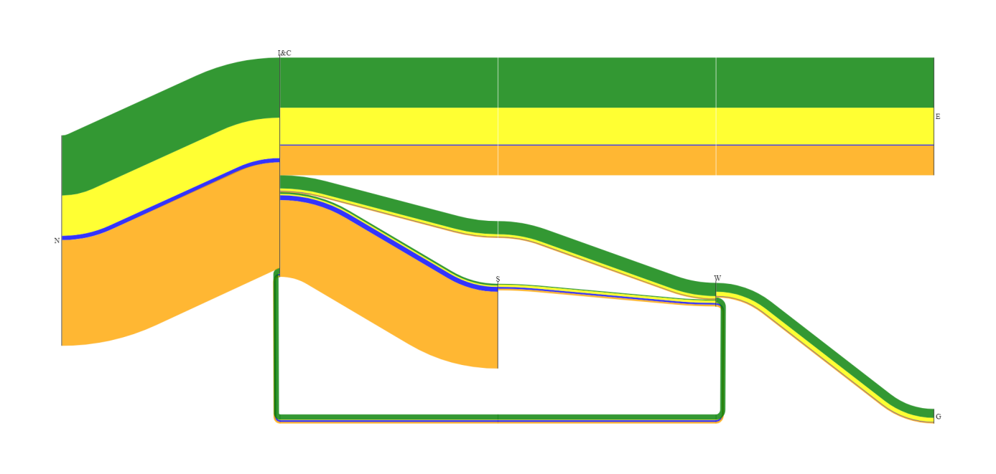

1. Additional features are developed by using Adobe Illustrator CC 2018 version[1]:

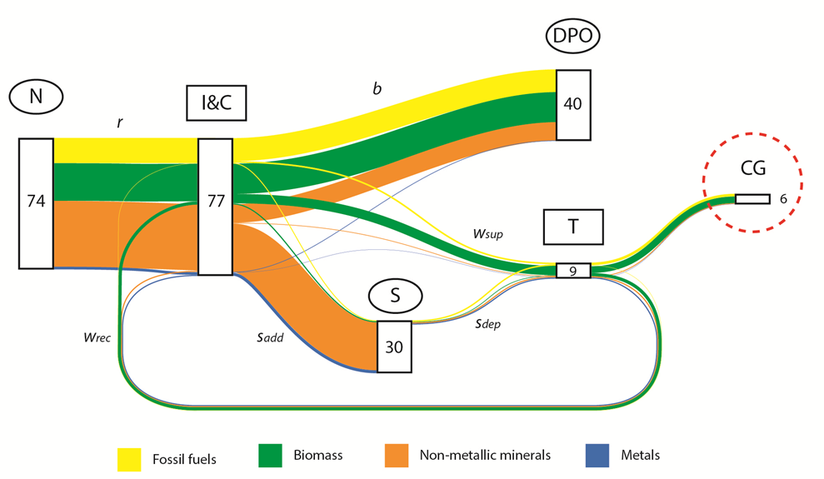

# Comparing material flow data from EXIOBASE v3.3.15

Table 1 shows a comparison between data from EXIOBASE v3.3.15 and other sources of material flow accounts. This allows to verify the reliability of material flow classification used in this study. Regarding the values of domestic resource used extraction, results show that data from EXIOBASE v3.3.15 extensions are similar to those presented in previous studies.

Table 1. Comparison between the values domestic material resource extraction of EXIOBASE v3.3.15 and different sources, per material category

|  |  |  |  |
| --- | --- | --- | --- |
| Source | EXIOBASE v3.3.15  (2018; 2018) | Global Material Flows Database UN-IRP (2018) | Haas et al. (2015) |
| Year reference | 2011 | 2011 | 2005 |
| Units | Gigatonnes | Gigatonnes | Gigatonnes |
| Domestic extraction category: | | | |
| * Fossil fuels | 14.1 | 14.0 | 12.0 |
| * Biomass | 21.0 | 21.2 | 19.7 |
| * Metals | 1.7* | 7.7** | 1.3* |
| * Non-metallic minerals | 36.9 | 37.4 | 28.9 |
| Total | 73.5 | 79.9 | 61.9 |

*Values expressed in terms of metal content

**Values expressed in terms of metal ores

In order to include the total amount of extracted ores for 2011, 'mining waste' in the EXIOBASE extensions (i.e. 6.4 Gt) should be added to the extraction of pure metals. This will result in 8.1 Gt of extracted metal ores for 2011.

# Literature

Haas W, Krausmann F, Wiedenhofer D, Heinz M (2015) How circular is the global economy?: An assessment of material flows, waste production, and recycling in the European union and the world in 2005. J Ind Ecol 19:765–777 . doi: 10.1111/jiec.12244

Lupton RC, Allwood JM (2017) Hybrid Sankey diagrams : Visual analysis of multidimensional data for understanding resource use. Resour Conserv Recycl 124:141–151 . doi: 10.1016/j.resconrec.2017.05.002

Merciai S, Schmidt J (2018) Methodology for the Construction of Global Multi-Regional Hybrid Supply and Use Tables for the EXIOBASE v3 Database. J Ind Ecol 0:1–16 . doi: 10.1111/jiec.12713

Stadler K, Wood R, Bulavskaya T, et al (2018) EXIOBASE 3. Developing a Time Series of Detailed Environmentally Extended Multi-Regional Input-Output Tables. J Ind Ecol 22:502–515 . doi: 10.1111/jiec.12715

World-Bank (2018) World Bank Open Data. https://data.worldbank.org/

(2018) The Material Flow Analysis Portal. http://www.materialflows.net/. Accessed 31 Oct 2018

1. Adobe Illustrator is a vector graphics software, therefore the measurements are consistent mathematically correct. For example, 1 point of thickness of the lines represent 1 Gt in the mass flows in the Sankey diagram