# **RESULTS**

IMPORTED IMPORTANT MODULES

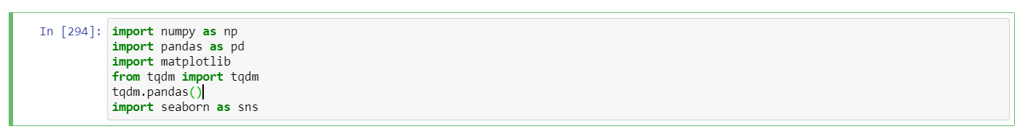

DATA IMPORTED SUCCESSFULLY THROUGH PANDAS

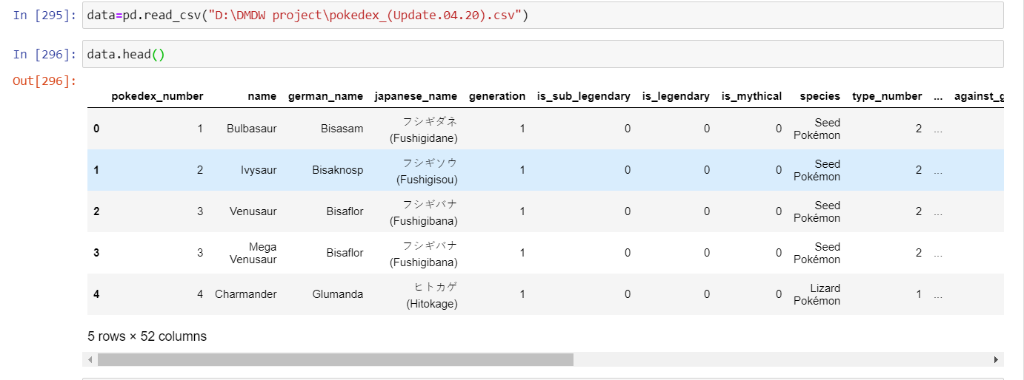

PREPROCESSING DATA

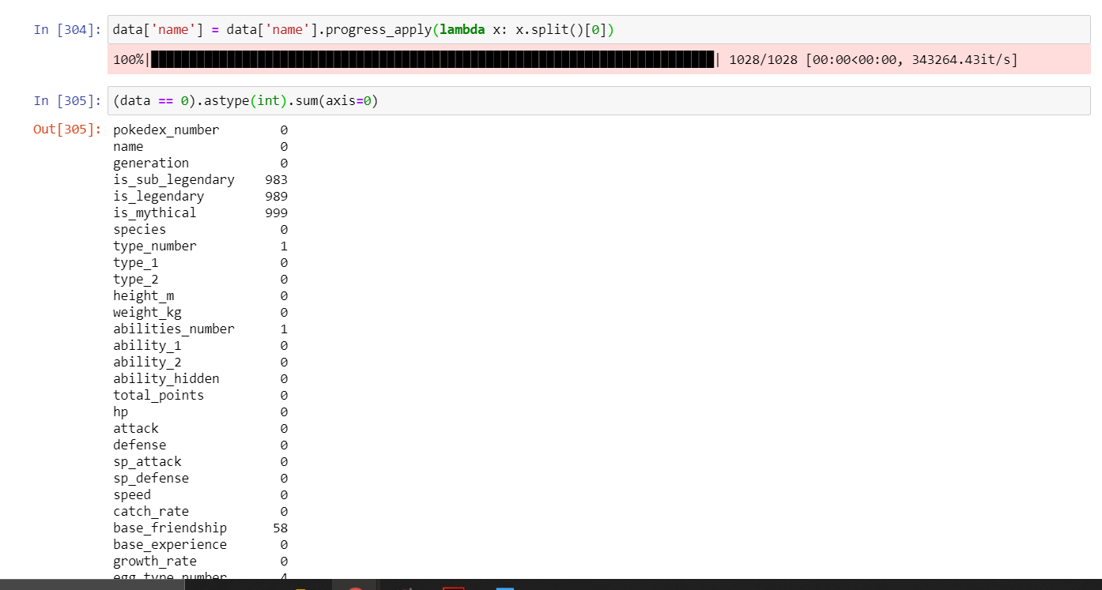

EXPORTED CLEANED DATA TO A NEW FILE FOR ANALYSIS

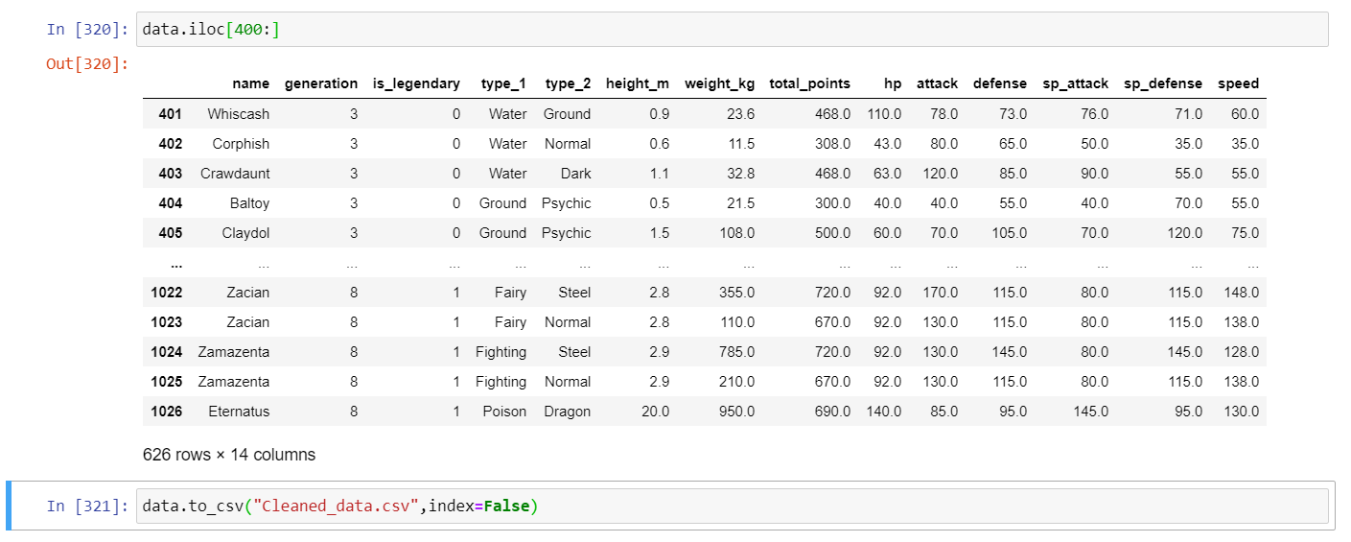

POKEMON STATS SUMMARY

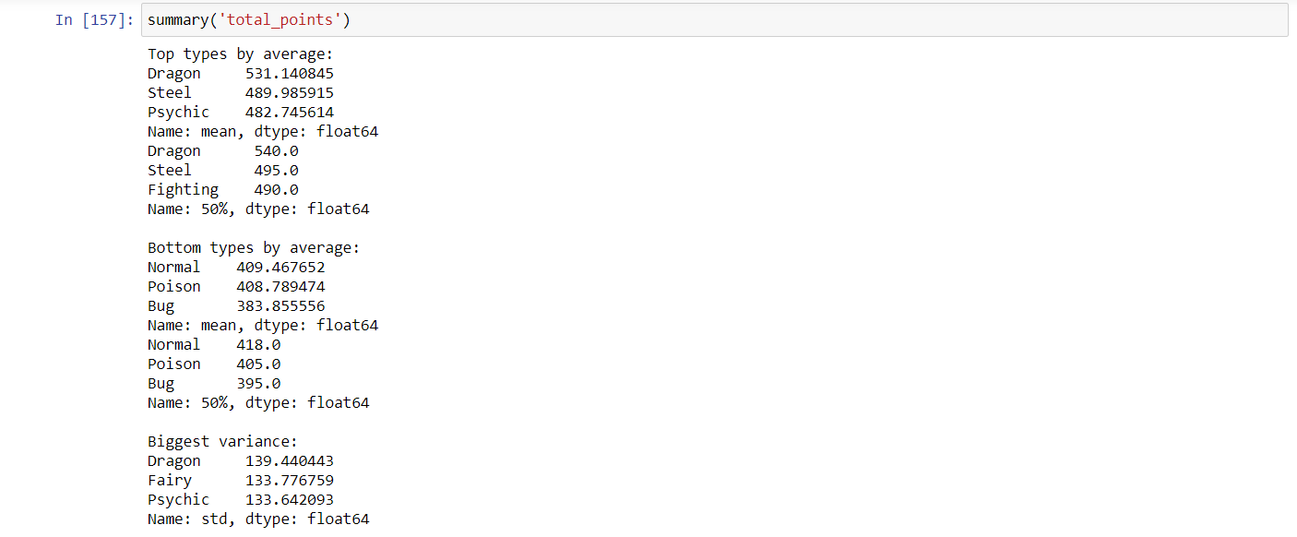

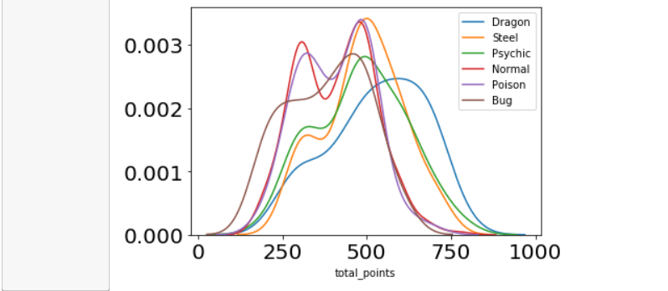

APRIORI ALGORITHM FOR FREQUENT ITEMSET RESULTS – TO FIND FREQUENT POKEMON TYPES

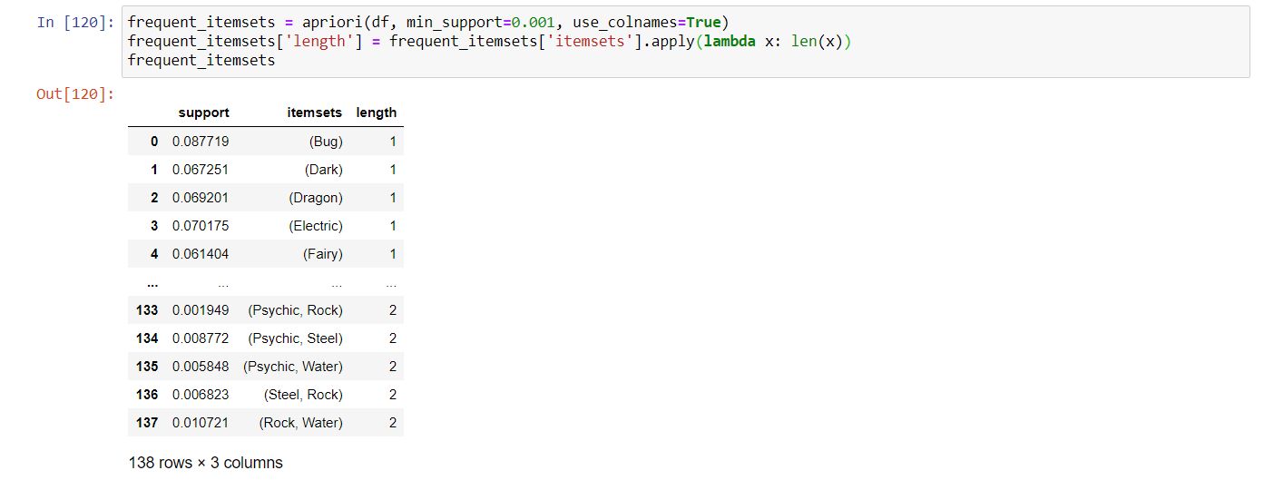

ASSOCIATION RULE MINING BY APRIORI ALGORITHM

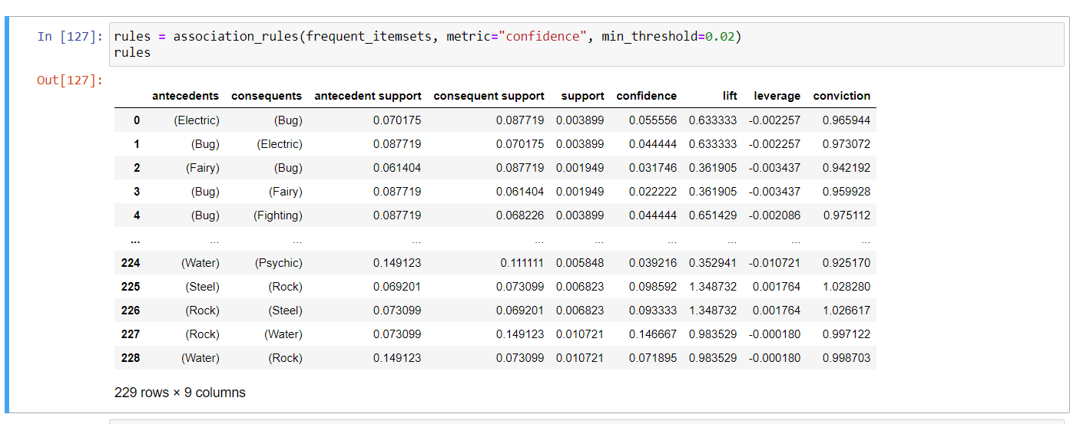

STRONG RULES FOR COMMON TYPE OF POKEMONS BY APRIORI ALGORITHM

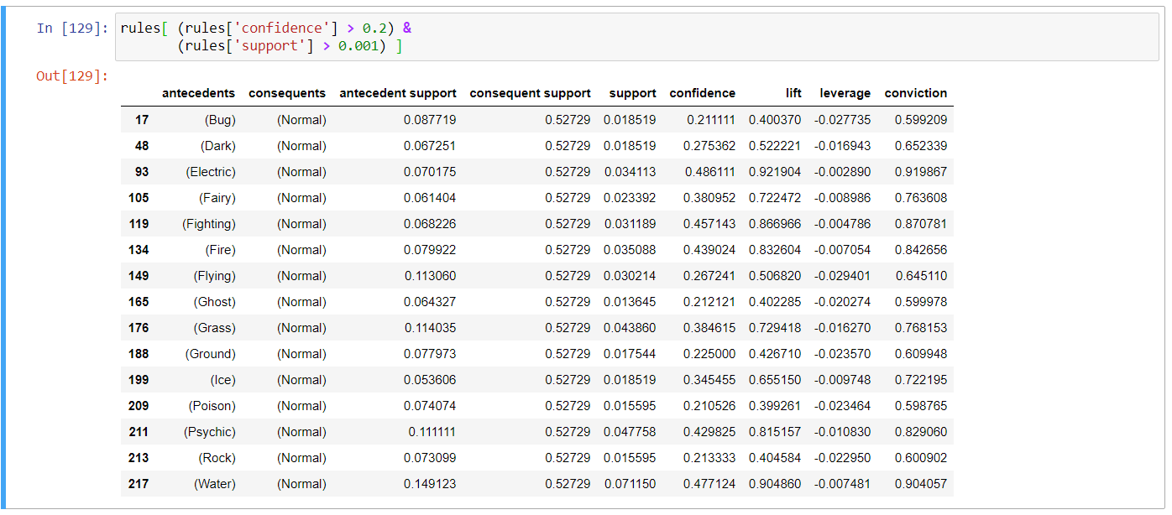

FPGROWTH ALGORITHM FOR FREQUENT ITEMSET RESULTS – TO FIND FREQUENT POKEMON TYPES

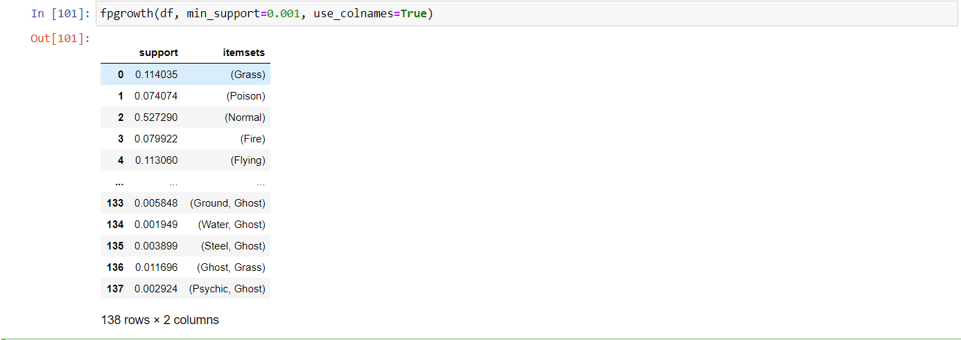

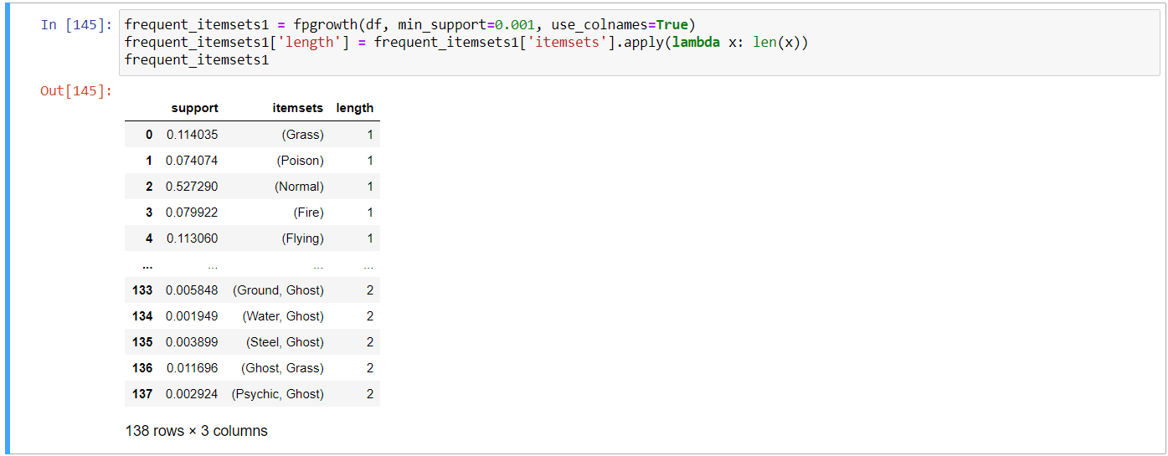

FPTREE

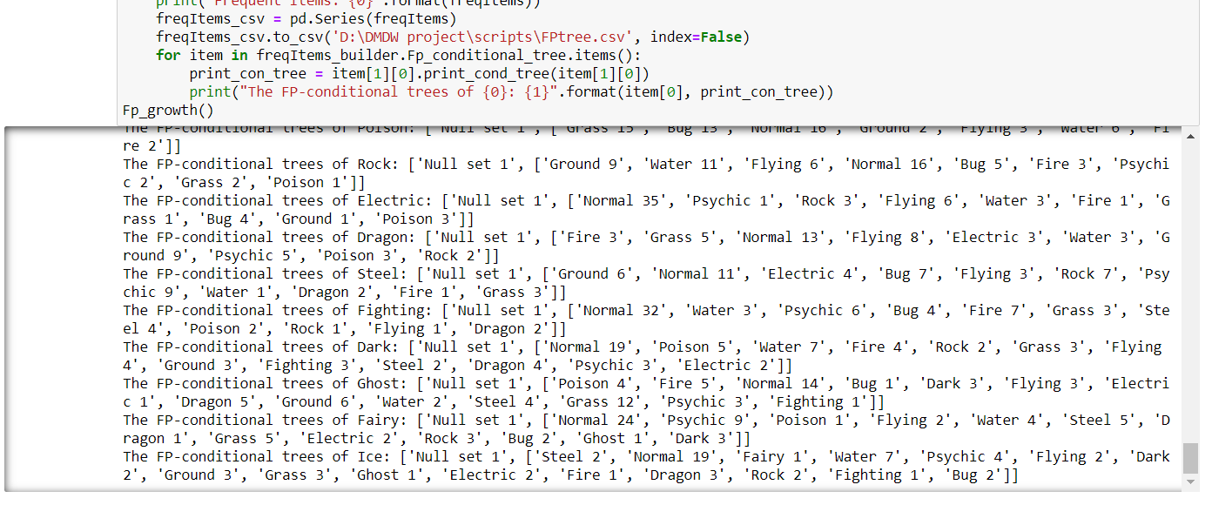

ASSOCIATION RULE MINING BY FPGROWTH

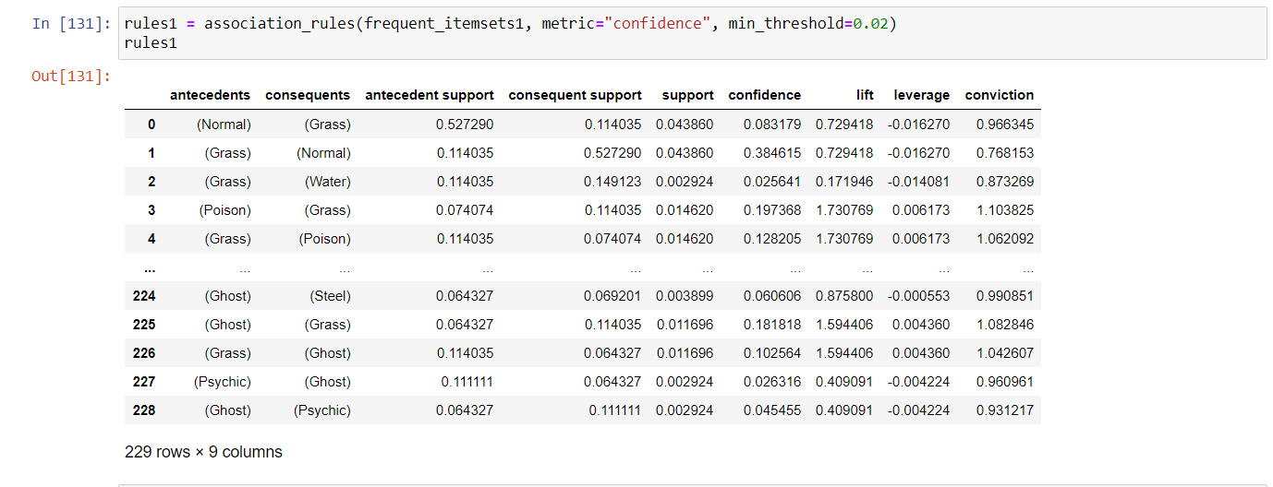

STRONG RULES FOR COMMON TYPE OF POKEMONS BY FPGROWTH ALGORTIHM

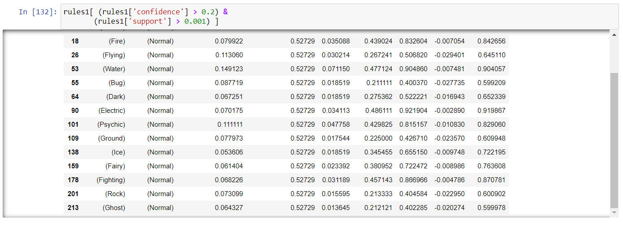

RESULTS FROM THE SWARMPLOT-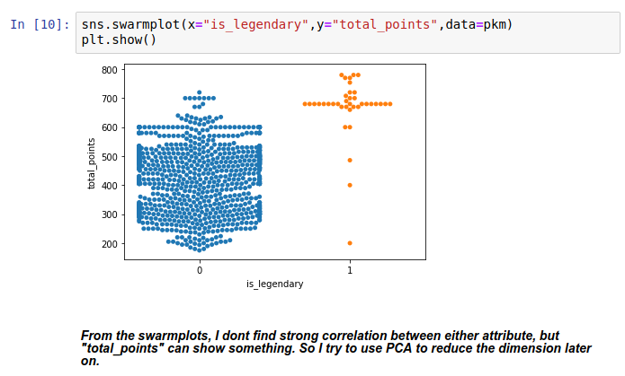

DECISION TREE USING ID3-

-CREATING NEW ATTRIBUTE ‘is_powerful’ – 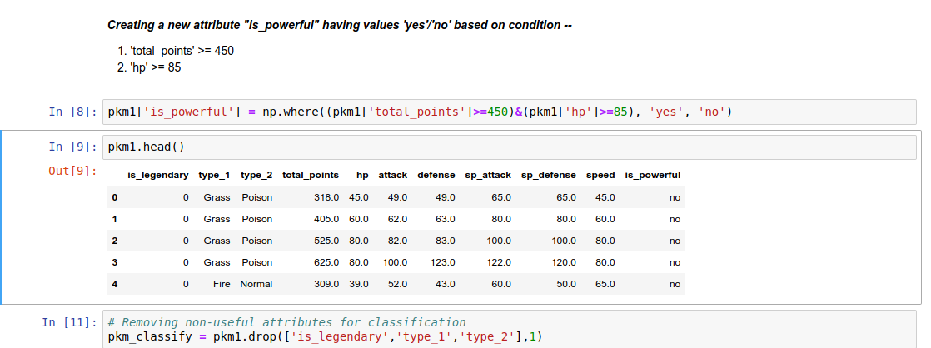

CALCULATING ENTROPY AND THEN INFO GAIN OF EACH ATTRIBUTE-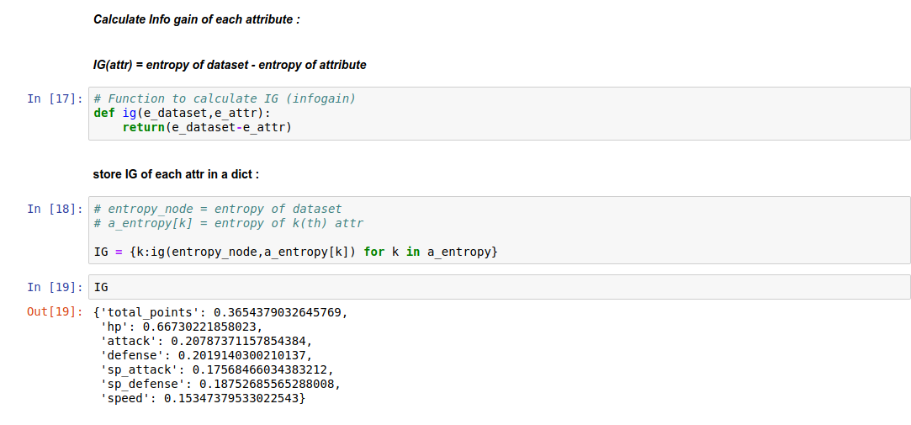

PRINTING THE DECISION TREE MADE USING ID3 ALGORITHM- 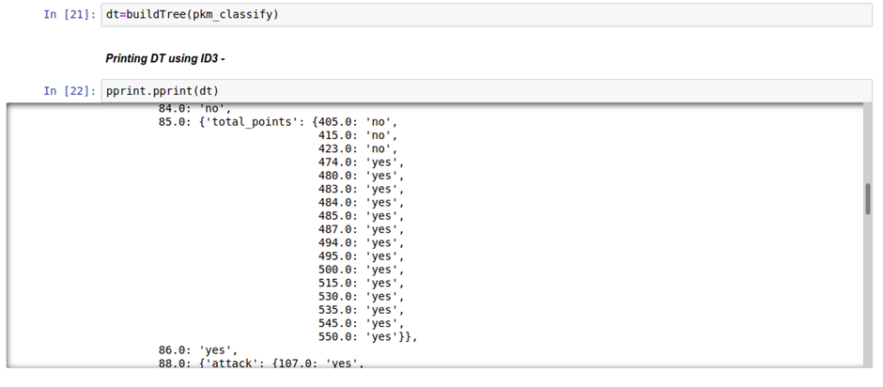

APPLYING PRINCIPAL COMPONENT ANALYSIS AND FINDING RATIO-

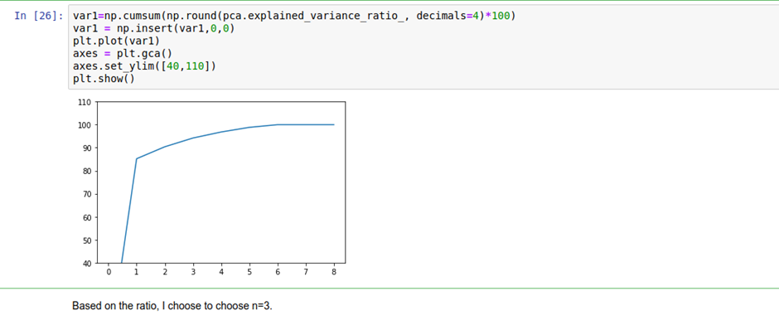

TRANSFORMING THE DATASET IN COMPONENT SCORE AND SPLITTING DATASET IN TRAIN AND TEST-

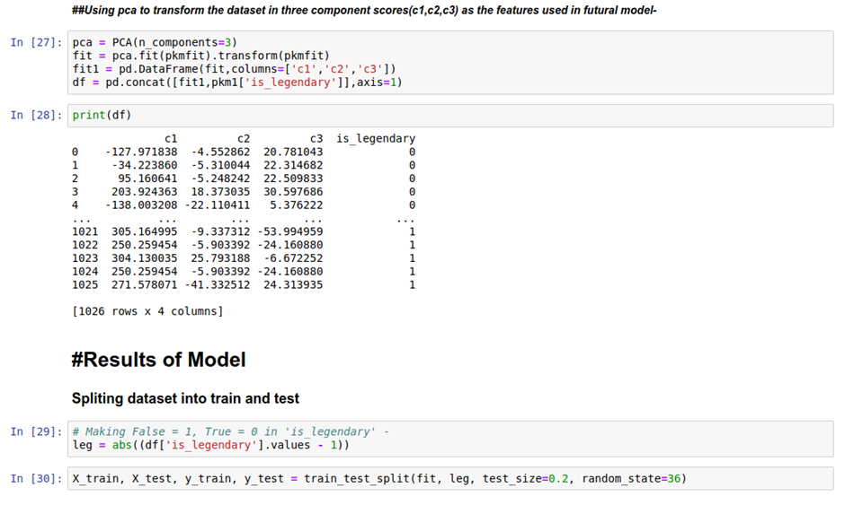

AFTER APPLYING DECISION TREE CLASSIFIER FINDING THE OPTIMAL NO. OF MAX DEPTH-

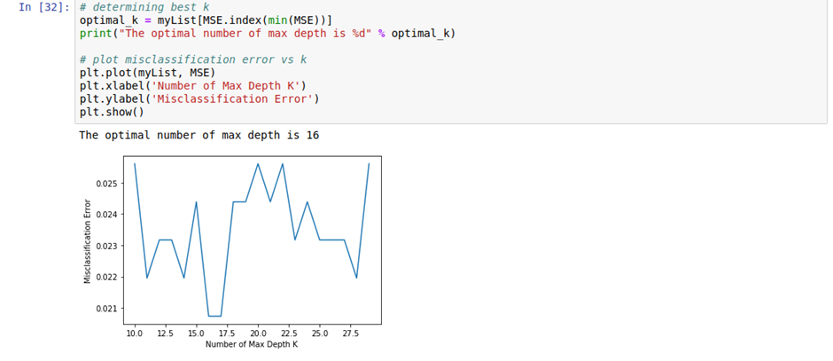

BOXPLOT OF DECISION TREE-

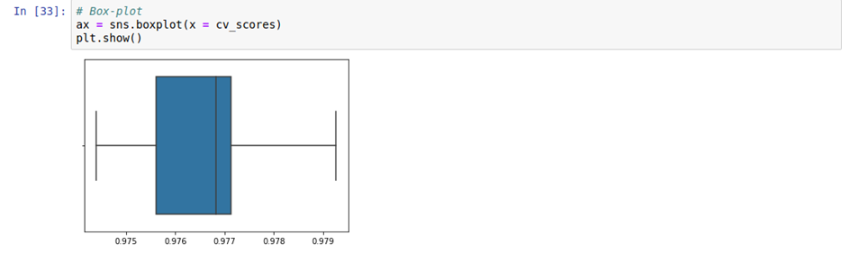

RESULTS OF DECISION TREE– CONFUSION MATRIX AND ACCURACY

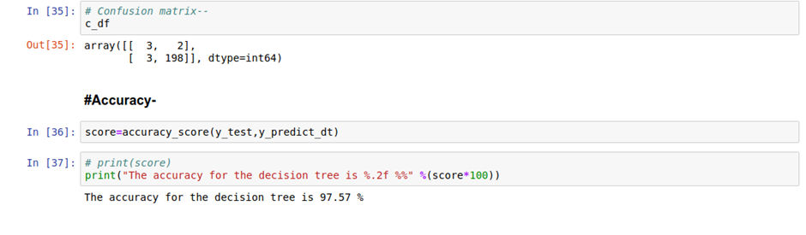

APPLYING ADABOOST AND FINDING OPTIMAL NO. OF N ESTIMATOR-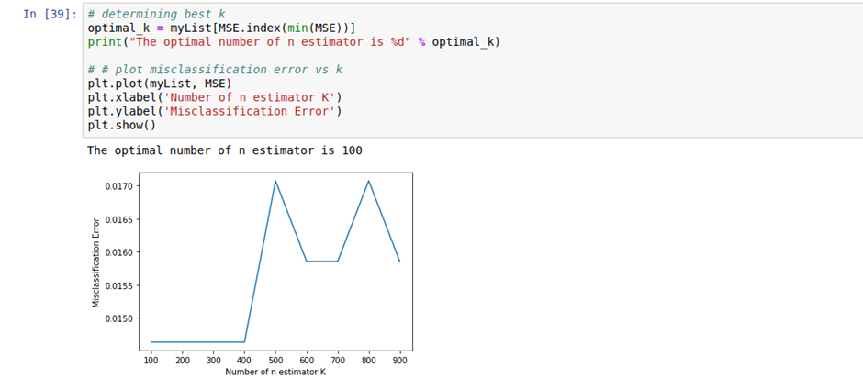

BOXPLOT FOR ADABOOST-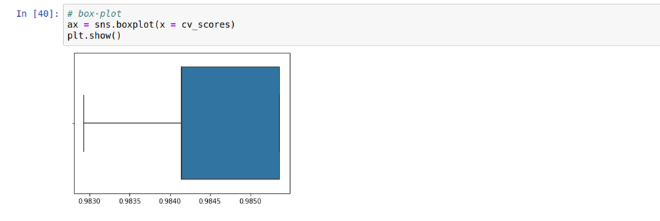

RESULTS OF ADABOOST– CONFUSION MATRIX AND ACCURACY-

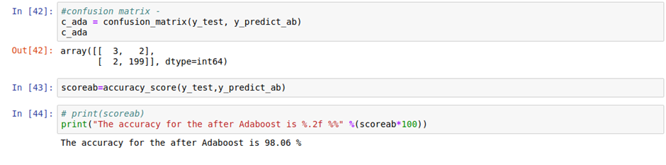

CONSTRUCTING THE DECISION TREE USING FEATURE-SET AND TARGET VARIBLE “is_legendary”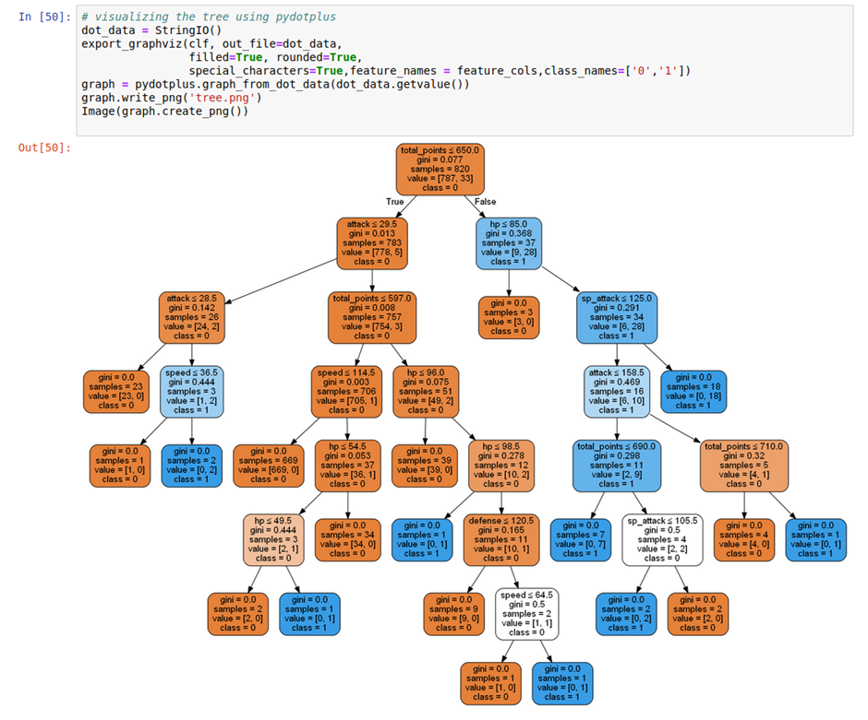

CLUSTERING WITH KMEANS AND PLOTTING FOR EACH FEATURE-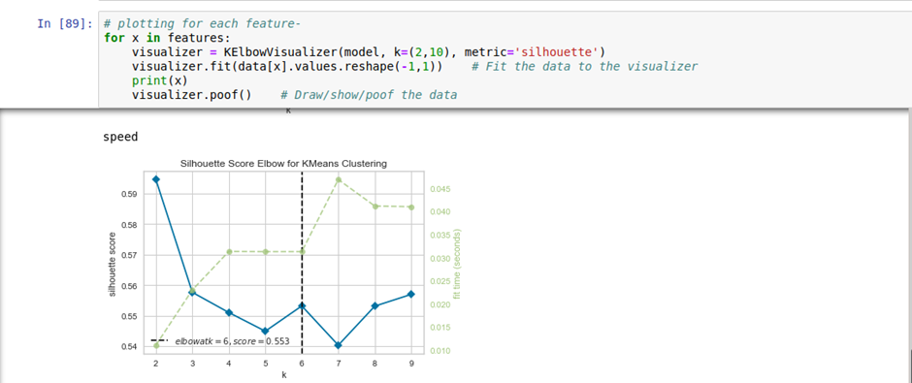

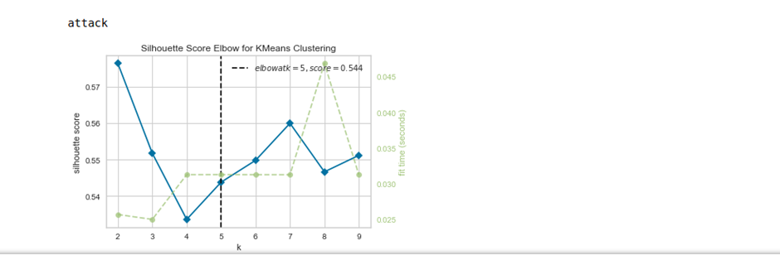

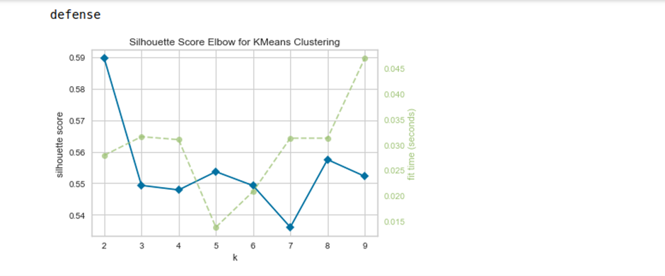

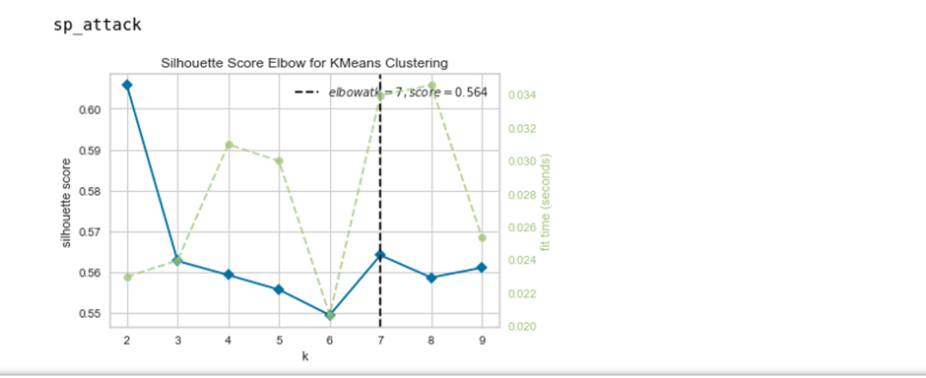

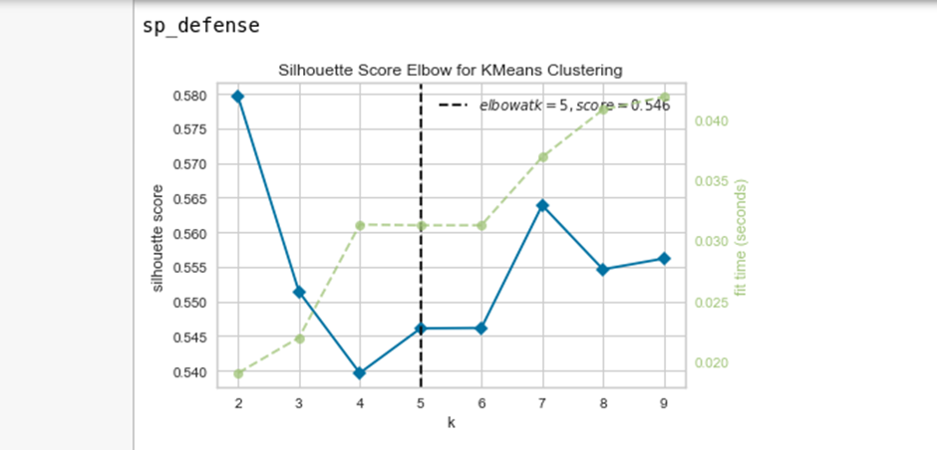

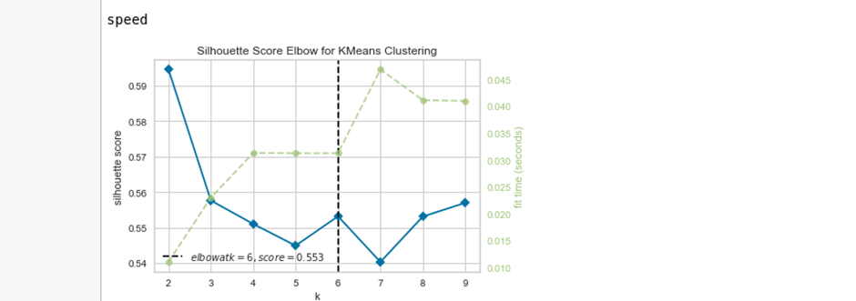

CLUSTERING BY BINNING AND PRODUCING LABELED BINS-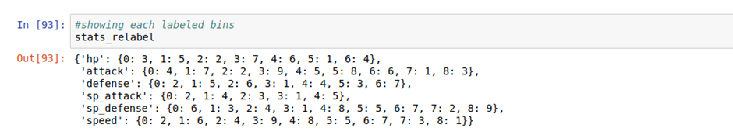

DETERMINING THE NUMBER OF LABELS IN EACH BIN FOR EACH FEATURE-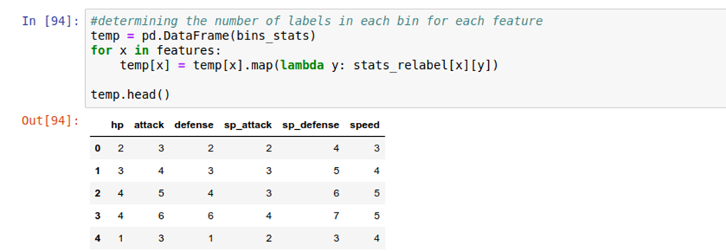

VISUALIZING THE CLUSTERS AND VARIATION-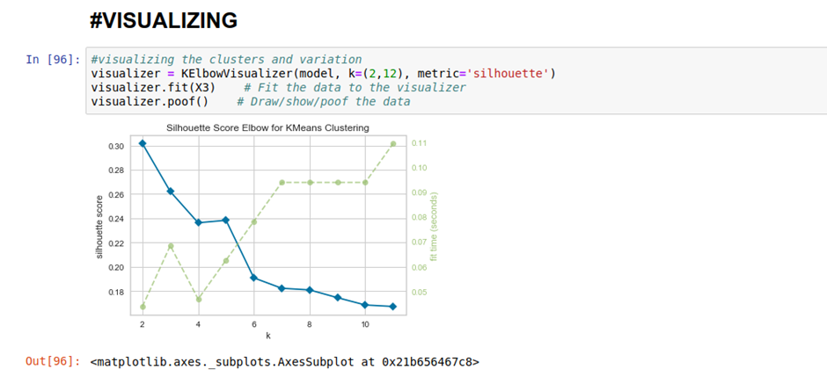

CLUSTERING THROUGH BINS AND PREDICTING THE COMMON VARIATIONS-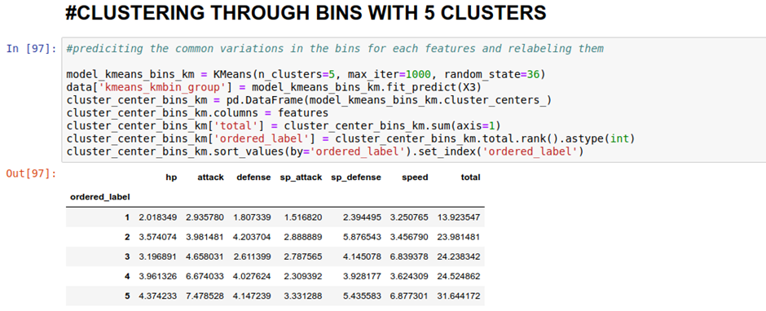

FINDING THE CLUSTER CENTERS AND APPLYING LABELS TO EACH CLUSTER CENTER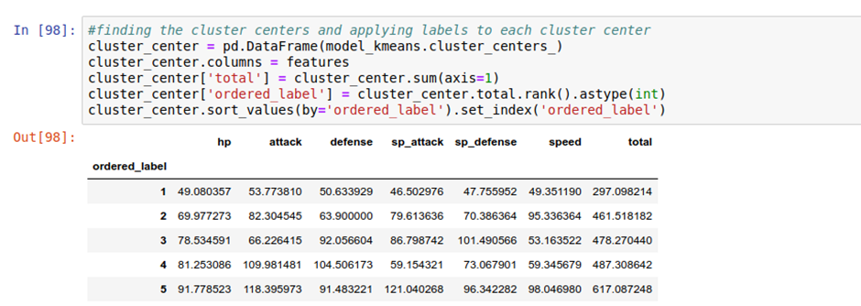

INFO SCORE AND RANDOM SCORE BETWEEN THE BINS-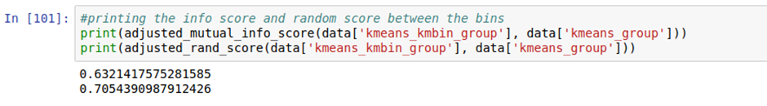

CONFUSION MATRIX-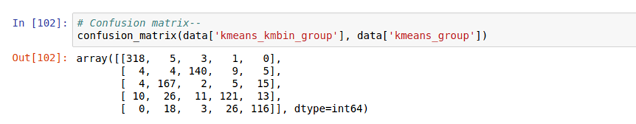

CLUSTERING EACH ATTRIBUTE WITH DIFFERENT BIN SIZE OF 3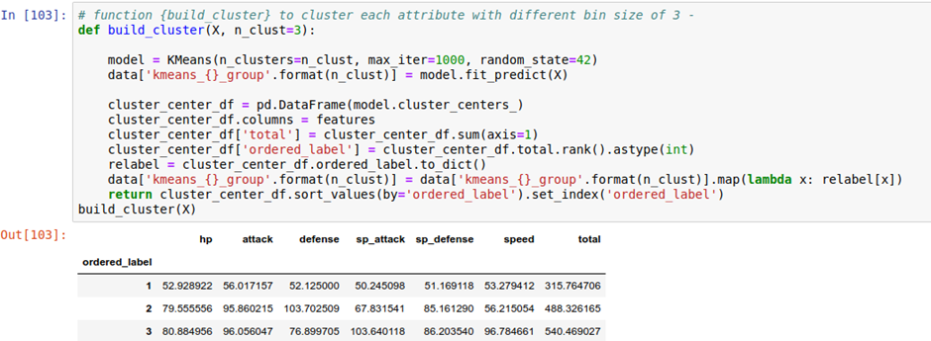

RESULTS OF CLUSTERED BINS-