Broadly Reconfigurable and Expandable Automation Device (BREAD) – Slice Datasheet: DC Motor Control Slice (SLC-DCMT)
By: Nicholas Whisman (ngwhisma@mtu.edu) – Revision 0, on 17. May 2021

Short Device Description
This slice is designed to control two DC motors. The main control is through a H-Bridge chip, and the system feedback is received via rotary encoder.

Quick Information
Device at a Glance
Short title | DC Motor Control Slice
Part # | SLC-DCMT
Repository Link | Link to OSF or other repository
Academic Paper DOI | DOI link to published paper
Device Cost | Monetary cost of the device
Assembly Difficulty | Difficult. Millable.
Application Area | Machinery Control, Robotics

Device Connections
J2 – Rotary Encoder Input
Pin # | Description | Rating
1 | Signal A | N/A
2 | Signal B | N/A
3 | +5V | N/A
4 | GND | N/A

J3 – Rotary Encoder Input
Pin # | Description | Rating
1 | Signal A | N/A
2 | Signal B | N/A
3 | +5V | N/A
4 | GND | N/A

J4 – Motor 1 Power Select
Pin # | Description | Rating
1 | Custom Power Pin | 55V
2 | +12V Standard | N/A
3 | Feed to H-Bridge / Motor | One of the above pins MUST be connected to this feed pin for the system to operate.

J5 – Motor 2 Power Select
Pin # | Description | Rating
1 | Custom Power Pin | 55V
2 | +12V Standard | N/A
3 | Feed to H-Bridge / Motor | One of the above pins MUST be connected to this feed pin for the system to operate.

J6 – Feed to Motor
Pin # | Description | Rating
1 | Motor + | Use current sense functionality to ensure safety for individual motors.
2 | Motor - | Use current sense functionality to ensure safety for individual motors.

J7 – Feed to Motor
Pin # | Description | Rating
1 | Motor + | Use current sense functionality to ensure safety for individual motors.
2 | Motor - | Use current sense functionality to ensure safety for individual motors.

J8 – Custom Power Input
Pin # | Description | Rating
1 | +V | Max of 55V
2 | GND | N/A

J9 – Custom Power Input
Pin # | Description | Rating
1 | +V | Max of 55V
2 | GND | N/A

Commands
Write Power (no significant returns)
Byte: Address | Bit: 1 | Float: | Float:
Write Speed (no significant returns)
Byte: Address | Bit: 0 | Float: 0 | Float: 0
Brake (no significant returns)
Byte: Address | Bit: 0 | Float: 0 | Float: 0
Write Direction (no significant returns)
Byte: Address | Bit: 0 | Float: 0 | Float: 0
Read Current (returns detected current through the motors)
Byte: Address | Bit: 0 | Float: 0 | Float: 0
Read Thermal Flag (returns current value of thermal flag)
Byte: Address | Bit: 0 | Float: 0 | Float: 0
Setup (no significant returns)
Byte: Address | Bit: 0 | Float: 0 | Float: 0

Schematic
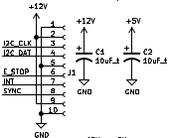Figure 1: BREAD Connection Point and Power Capacitors
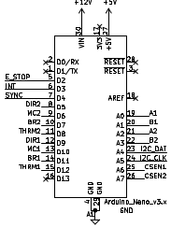Figure 2: Arduino Nano

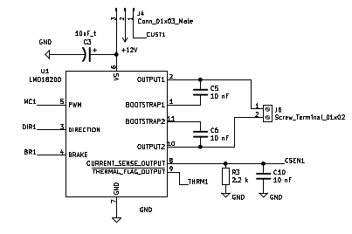Figure 3: One of two H-Bridge channels

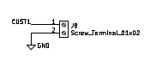Figure 4: One of two custom power inputs

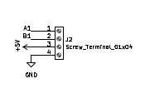Figure 5: One of two rotary encoder inputs

Bill of Materials
Designator | Description | Quantity | Cost / part | URL
C5-10 | 10 nF 1206 Packaging Ceramic Capacitor | 6 | 0.24 | https://www.digikey.com/en/products/detail/yageo/CC1206KRX7R9BB103/302908
C1-4 | 10 µF 1206 Packaging Ceramic Capacitor | 4 | 0.64 | https://www.digikey.com/short/2ffb0248
A1 | Arduino Nano | 1 | 22.00 | https://www.digikey.com/en/products/detail/arduino/A000005/2638989
R3-4 | 2.2k 1206 Packaging Resistor (±0.1%) | 2 | 0.62 | https://www.digikey.com/en/products/detail/yageo/RT1206BRD072K2L/1079707
J6-9 | 01x02 1/10” Pitch Terminal Blocks | 4 | 1.27 | https://www.digikey.com/short/72hnmwd5
J4-5 | 01x03 1/10” Pitch Terminal Blocks | 2 | 2.06 | https://www.digikey.com/short/70279tb0
J2-3 | 01x04 1/10” Pitch Terminal Blocks | 2 | 2.75 | https://www.digikey.com/short/bftjz0bt

Construction & Fabrication
List any tools that are required and short guide on the order which parts should be soldered / assembled. Be sure to note any specialized methods and point out components that may easily be soldered in the incorrect orientation. Additionally include at least one picture of the assembled board (include both sides if there are components on both sides).
[Image of the assembled Circuit Board]
Fig #. Subtitle should go here.

Configuration & Calibration
Include a list of default jumper and potentiometer positions:
Hardware Positions
- Turn P1 to be roughly 50%
- Turn P2 to be completely closed (turn clockwise until potentiometer clicks)
- Place a jumper to short out J3. Etc…
Detail any key parameters the end-user may want to adjust in the firmware, and if there are any special instructions before programming the Slice.
Tools Required For Calibration
- An oscilloscope with at least 15Mhz sampling
- A multimeter. Etc…
List all of the tools / instruments required for calibration. Provide a detailed & step by step guide on how to calibrate (or validate) each unique type of channel on the card. Include what variables in the firmware may need to be adjusted (and when). Attach a wiring diagram for each relevant calibration circuit.
[Image of the calibration circuit]
Fig #. Subtitle should go here.

Usage & Constraints
List the relevant constraints for each type of channel on the card. These parameters may be quantities like max current, max voltage, frequency, sampling frequency, etc.
List an example wiring diagram of the slice in use, as well as some suggested applications
[Image of the example usage wiring diagram]
Fig #. Subtitle should go here.

General Comments on Slice
This section is intended as a catch-all for any topics that are relevant to the Slice that don’t fit in any other category.

Revision Notes
- Rev 0 – Initial document release (DATE HERE)

