Broadly Reconfigurable and Expandable Automation Device (BREAD) – Slice Datasheet: Relay Slice (SLC-RLAY)
By: Nicholas Whisman (ngwhisma@mtu.edu) – Revision 0, on 17. May 2021

Short Device Description
This device controls 4 relay channels via the Arduino, and receives analog signals (optionally) as feedback.

Quick Information
Device at a Glance
Short title | Relay Slice
Part # | SLC-RLAY
Repository Link | Link to OSF or other repository
Academic Paper DOI | DOI link to published paper
Device Cost | Monetary cost of the device
Assembly Difficulty | Medium. Millable.
Application Area | Controls, Power Monitoring

Device Connections
J2 – Relay Output 1
Pin # | Description | Rating
1 | Normally closed switch of relay | 277 VAC, 30V DC, 3A
2 | Normally open switch of relay | 277 VAC, 30V DC, 10A AC, 5A DC
3 | Common pin | N/A

J2 – Relay Output 2
Pin # | Description | Rating
1 | Normally closed switch of relay | 277 VAC, 30V DC, 3A
2 | Normally open switch of relay | 277 VAC, 30V DC, 10A AC, 5A DC
3 | Common pin | N/A

J2 – Relay Output 3
Pin # | Description | Rating
1 | Normally closed switch of relay | 277 VAC, 30V DC, 3A
2 | Normally open switch of relay | 277 VAC, 30V DC, 10A AC, 5A DC
3 | Common pin | N/A

J2 – Relay Output 4
Pin # | Description | Rating
1 | Normally closed switch of relay | 277 VAC, 30V DC, 3A
2 | Normally open switch of relay | 277 VAC, 30V DC, 10A AC, 5A DC
3 | Common pin | N/A

Commands
Write Switch(es) (no significant returns)
Byte: Address | Bit: 1 | Float: Target Temp | Float: Ramp Rate (d/m)
Timed Write (no significant returns)
Byte: Address | Bit: 0 | Float: 0 | Float: 0
Analog Read (Returns selected voltages from analog feedback)

Schematic
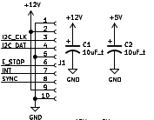Figure 1: BREAD Connection Port + Power Capacitors

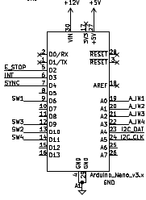Figure 2: Arduino Nano

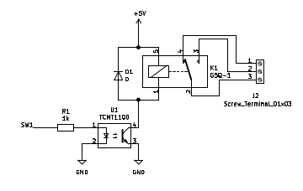Figure 3: One of Four Relay Channels
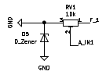Figure 4: One of Four Analog Input Paths
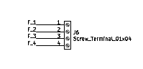Figure 5: Feedback Input Port

Bill of Materials
Designator | Description | Quantity | Cost / part | URL
U1-4 | Optocouplers | 4 | 0.51 | https://www.digikey.com/short/5fmc702d
RV1-4 | 10k Trimmer Potentiometer | 4 | 4.16 | https://www.digikey.com/short/ftm98v7t
R1-4 | 1k 1206 Packaging Resistor | 4 | 0.1 | https://www.digikey.com/short/d1dmzmbb
K1-4 | G5Q1 SPDT Relay | 4 | 1.52 | https://www.digikey.com/short/vj4jr0vq
J6 | 01x04 1/10” Pitch Terminal Block | 1 | 2.75 | https://www.digikey.com/short/rnm0hhhn
J2-5 | 01x03 1/10” Pitch Terminal Block | 4 | 2.06 | https://www.digikey.com/short/71d77cj2
D5-8 | 5.1V Zener Diode | 4 | 0.22 | https://www.digikey.com/short/tvbtwpmt
D1-4 | Standard THT Diode | 4 | 0.21 | https://www.digikey.com/short/tp4mrn5q
C1-2 | 10 µF 1206 Packaging Ceramic Capacitor | 4 | 0.64 | https://www.digikey.com/short/2ffb0248
A1 | Arduino Nano | 1 | 22.00 | https://www.digikey.com/en/products/detail/arduino/A000005/2638989
J1 | 01x10 Female Header Pins | 1 | 0.79 | https://www.digikey.com/short/23bfwwjh

Construction & Fabrication
List any tools that are required and short guide on the order which parts should be soldered / assembled. Be sure to note any specialized methods and point out components that may easily be soldered in the incorrect orientation. Additionally include at least one picture of the assembled board (include both sides if there are components on both sides).
[Image of the assembled Circuit Board]
Fig #. Subtitle should go here.

Configuration & Calibration
Include a list of default jumper and potentiometer positions:
Hardware Positions
- Turn P1 to be roughly 50%
- Turn P2 to be completely closed (turn clockwise until potentiometer clicks)
- Place a jumper to short out J3. Etc…
Detail any key parameters the end-user may want to adjust in the firmware, and if there are any special instructions before programming the Slice.
Tools Required For Calibration
- An oscilloscope with at least 15Mhz sampling
- A multimeter. Etc…
List all of the tools / instruments required for calibration. Provide a detailed & step by step guide on how to calibrate (or validate) each unique type of channel on the card. Include what variables in the firmware may need to be adjusted (and when). Attach a wiring diagram for each relevant calibration circuit.
[Image of the calibration circuit]
Fig #. Subtitle should go here.

Usage & Constraints
List the relevant constraints for each type of channel on the card. These parameters may be quantities like max current, max voltage, frequency, sampling frequency, etc.
List an example wiring diagram of the slice in use, as well as some suggested applications
[Image of the example usage wiring diagram]
Fig #. Subtitle should go here.

General Comments on Slice
This section is intended as a catch-all for any topics that are relevant to the Slice that don’t fit in any other category.

Revision Notes
- Rev 0 – Initial document release (DATE HERE)

