Broadly Reconfigurable and Expandable Automation Device (BREAD) – Slice Datasheet: Stepper Motor Control Slice (SLC-STEP)
By: Nicholas Whisman (ngwhisma@mtu.edu) – Revision 0, on 18. May 2021

Short Device Description
This device is designed to very finely control up to four stepper motors. The system has a feedback path in the form of 4 analog inputs. Finer control can be achieved by utilizing the microstep pin connections.

Quick Information
Device at a Glance
Short title | Stepper Motor Control Slice
Part # | SLC-STEP
Repository Link | Link to OSF or other repository
Academic Paper DOI | DOI link to published paper
Device Cost | Monetary cost of the device
Assembly Difficulty | Difficult, Millable
Application Area | Controls, Robotics

Device Connections
J2 – Analog Input Paths
Pin # | Description | Rating
1 | Analog Input 1 | 5V
2 | Analog Input 2 | 5V
3 | Analog Input 3 | 5V
4 | Analog Input 4 | 5V

J3 – Output to Stepper
Pin # | Description | Rating
1 | Motor 2, Signal 1B | ±2A
2 | Motor 2, Signal 1A | ±2A
3 | Motor 2, Signal 2A | ±2A
4 | Motor 2, Signal 2B | ±2A
5 | Motor 1, Signal 1B | ±2A
6 | Motor 1, Signal 1A | ±2A
7 | Motor 1, Signal 2A | ±2A
8 | Motor 1, Signal 2B | ±2A

J4 – Output to Stepper
Pin # | Description | Rating
1 | Motor 3, Signal 2B | ±2A
2 | Motor 3, Signal 2A | ±2A
3 | Motor 3, Signal 1A | ±2A
4 | Motor 3, Signal 1B | ±2A
5 | Motor 4, Signal 2B | ±2A
6 | Motor 4, Signal 2A | ±2A
7 | Motor 4, Signal 1A | ±2A
8 | Motor 4, Signal 1B | ±2A

Commands
Set Up (no significant returns)
Byte: Address | Bit: 1 | Float: Target Temp | Float: Ramp Rate (d/m)
Speed Select (no significant returns)
Byte: Address | Bit: 0 | Float: 0 | Float: 0
Step Select (no significant returns)
Analog Read (returns voltage on selected analog input line)

Schematic
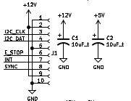Figure 1: BREAD Connection Port and Power Capacitors
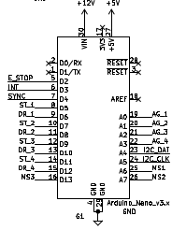Figure 2: Arduino Nano
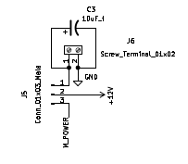Figure 3: Custom Power Select
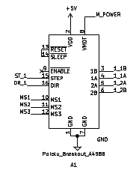Figure 4: One of four breakout stepper motor drivers
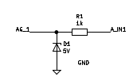Figure 5: One of four feedback voltage paths
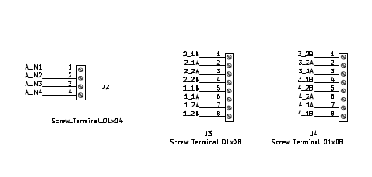Figure 6: Signal Input Ports

Bill of Materials
Designator | Description | Quantity | Cost / part | URL
J5 | 01x03 1/10” Pitch Male Connector Pins | 1 | 0.27 | https://www.digikey.com/short/jv0b95z0
C1-3 | 1206 Packaging 10 µF Capacitor | 3 | 0.64 | https://www.digikey.com/short/qfrbqfhd
J6 | 01x02 1/10” Pitch Terminal Block | 1 | 1.27 | https://www.digikey.com/short/0v8hf4h8
R1-4 | 1k 1206 Packaging Resistor | 4 | 0.10 | https://www.digikey.com/short/wp8502p7
J3-4 | 01x08 1/10” Pitch Terminal Block | 2 | 6.45 | https://www.digikey.com/short/mqn9fd88
J2 | 01x04 1/10” Pitch Terminal Block | 1 | 2.75 | https://www.digikey.com/short/tv7tzq1r
D1-4 | 5.1V Zener Diode | 4 | 0.22 | https://www.digikey.com/short/z0f0ztp2
A1-4 | Pololu A4988 Stepper Driver | 4 | 5.95 | https://www.pololu.com/category/156/a4988-stepper-motor-driver-carriers
G1 | Arduino Nano | 1 | 22.00 | https://www.digikey.com/en/products/detail/arduino/A000005/2638989
J1 | 01x10 Female Header Pins | 1 | 0.79 | https://www.digikey.com/short/23bfwwjh

Construction & Fabrication
List any tools that are required and short guide on the order which parts should be soldered / assembled. Be sure to note any specialized methods and point out components that may easily be soldered in the incorrect orientation. Additionally include at least one picture of the assembled board (include both sides if there are components on both sides).
[Image of the assembled Circuit Board]
Fig #. Subtitle should go here.

Configuration & Calibration
Include a list of default jumper and potentiometer positions:
Hardware Positions
- Turn P1 to be roughly 50%
- Turn P2 to be completely closed (turn clockwise until potentiometer clicks)
- Place a jumper to short out J3. Etc…
Detail any key parameters the end-user may want to adjust in the firmware, and if there are any special instructions before programming the Slice.
Tools Required For Calibration
- An oscilloscope with at least 15Mhz sampling
- A multimeter. Etc…
List all of the tools / instruments required for calibration. Provide a detailed & step by step guide on how to calibrate (or validate) each unique type of channel on the card. Include what variables in the firmware may need to be adjusted (and when). Attach a wiring diagram for each relevant calibration circuit.
[Image of the calibration circuit]
Fig #. Subtitle should go here.

Usage & Constraints
List the relevant constraints for each type of channel on the card. These parameters may be quantities like max current, max voltage, frequency, sampling frequency, etc.
List an example wiring diagram of the slice in use, as well as some suggested applications
[Image of the example usage wiring diagram]
Fig #. Subtitle should go here.

General Comments on Slice
This section is intended as a catch-all for any topics that are relevant to the Slice that don’t fit in any other category.

Revision Notes
- Rev 0 – Initial document release (DATE HERE)

