ST0501 FRONT-END WEB DEVELOPMENT
INDIVIDUAL CA2 REFLECTION JOURNAL

Student Name: __Choo Min Yu____________________ Admin Number: ___________________
Class: ___DCITP/FT/1A/11___________________________ Group 5 No:_________________________

Objective :
This Reflection Journal requires you to critically analyze your CA2 project decisions, technical issues, and your responsible use of AI tools. Tutors are looking for depth of thought and examples that demonstrate understanding of your work.
Instructions:
- Answer all 3 parts below
- Total word count : 900-1200 words
- Use examples from your CA2 or class activities where relevant
- Submitted individually via BrightSpace.
- Attach your AI prompt logs using the Academic Integrity Declaration link (available in BrightSpace) in Appendix, this will not be included in the wordcount.

Part 1: Reflection on Styling Frameworks & Interactivity
- What changes are made to the original plan? Why are the changes necessary? And what impact do they cause e.g on the website, user experience, performance etc?
- Analyze the trade-offs between using a front-end styling framework (e.g., Bootstrap/Tailwind) and writing custom CSS in your project. How did your choice affect the efficiency, design flexibility, or maintainability of your website?
- Evaluate one interactive feature (e.g., form validation, DOM update, dynamic menu) you implemented: How well does it improve user experience? If you had to enhance it further, what changes would you make and why?

Word Count Suggestion: 250-450 words. (Write your answer here)

- We added recipe instructions with checkboxes. Initially, we were not going to add the instructions on the website. But, after consulting with our teacher, we realised we needed more interactivity in our website, so we came up with ticking checkboxes. Once a user is done with a step, they can tick it. This also tells them where they stopped or may need to continue with the steps they skipped later, making it convenient for them and taking some mental load off the user such as remembering where they stopped or which steps they skipped
- Although tailwind is highly customisable, it is still limited to utility classes. While custom CSS has unlimited flexibility, you can implement any design pattern that you want. Tailwind is easy to update compared to custom CSS. Because of these reasons, we used tailwind for almost everything except for one part where we used custom CSS because we wanted a specific colour that tailwind does not have. We used it for <h2> and <h3> tags. Because of our decisions, our website is more maintainable (more readable compare to custom CSS) and efficient since we mostly used tailwind which uses utility classes

- We used dropdown menu for our navigation. This makes it easier for the user to navigate the website as related information such as the breakfast, lunch, dinner, dessert and snacks recipes are grouped together in “Recipes”. Thus, users are able to find the specific webpage that they want, making it convenient for the users. It also improves user experience as they are not being burdened with a hard time of navigating the website. If the dropdown menu were not there, users would have to go through almost every webpage to find the webpage that they need.

Part 2: Reflection on JavaScript & DOM Interactivity
- What changes are made to the original plan? Why are the changes necessary? And what impact do they cause e.g on the website, user experience, performance etc?
- Which JavaScript feature you added (e.g., image gallery, menu toggle, validation) made the biggest impact on your website’s user experience? Why?
- Think about the form your created in CA2 or practiced in class: What makes a form easy or hard for users to complete? What is one improvement you would suggest making a form more user-friendly, and why?

Word Count Suggestion: 250-450 words. (Write your answer here)

- Originally, the plan was to have an aside, but after adding it, it felt out of place and takes up too much space. So, we decided to remove it. By doing so, the website feels more natural and improved the visual. For example, the homepage looks more coherent. If the aside was still there, the appeal of the homepage would have been damaged as the aesthetic would be ruined.

- The JavaScript feature that made the biggest impact is the dropdown menus. It made navigating through the webpages much easier. When users want to go to a specific webpage they have in mind, they would not need to go through clicking all the buttons to get to that webpage. Instead, they can just use the dropdown menu to locate the webpage that they are looking for. Without the dropdown menu, users would have a tough time finding webpages that they need as they would need to go through almost every webpage to find the webpage they need, making it incredibly inconvenient for them.

- A form is easy for users to complete as all they have to do is fill in the blanks or press the option that they feel is correct. One improvement I would suggest making a form more user-friendly is to have more options so that they can choose instead of filling in the blanks. This would make it more convenient for users as they would not have to type and would just need to press. Thus, reducing the work of the user, making them more likely to do the form instead of skipping it altogether because it is too much work.

Part 3: Reflection on AI Usage and Evidence of Understanding

- Analyze your use of AI during this project: Which specific problem or task did AI help you with, and why did you choose to use AI for it?
- Choose one example where you used AI to help with coding for your website. Show the original AI-generated snippet and your modified version. Explain what you changed and why. How did your changes make the code better or fit your project needs?

Word Count Suggestion: 250-450 words. (Write your answer here)
- I used AI to help me figure out why the dropdown menu and why the like button was not working. I used AI as it provides tailored explanation and feedback to what I should do to fix it. Thus, making it easier for me to solve the issue. I also used it to improve my code. 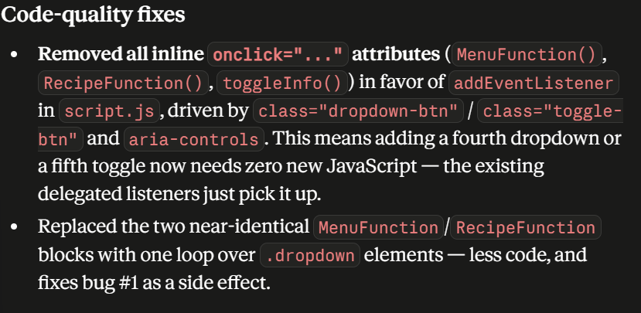

I used AI to add a heart button to the recipes.
Original AI-generated snippet:
<button type="button" class="like-btn ... text-stone-300 hover:text-red-400 transition"
data-recipe-id="scrambled-eggs" data-recipe-title="Scrambled Eggs"
data-recipe-page="breakfast.html#scrambled-eggs"
data-recipe-desc="Soft, fluffy scrambled eggs..." aria-pressed="false">♥</button>

Modified version(made the like button stay red when clicked):
HTML:
<button type="button" class="like-btn cursor-pointer text-3xl leading-none text-stone-300 hover:text-red-400 transition"
data-recipe-id="scrambled-eggs" data-recipe-title="Scrambled Eggs" data-recipe-page="./pages/breakfast.html#scrambled-eggs" data-recipe-image="../assets/images/scrambled eggs.jpg"
data-recipe-desc="Soft, fluffy scrambled eggs made with butter and a touch of seasoning."
aria-pressed="false" aria-label="Like Scrambled Eggs">♥</button>
Javascript:
function setLikedLook(button, liked) {
button.setAttribute('aria-pressed', liked ? 'true' : 'false');

if (liked) {
button.style.color = '#dc2626';
} else {
button.style.color = '#d6d3d1';
}
}
By making the like button stay red when clicked, it lets the users know which recipes they like. Thus, they would not need to memorise the recipes they like as they would already know it through the red heart.

Appendix (e.g AI outputs or evidences you would like to include, this will not be included in the wordcount)
Microsoft Copilot: Chat
Detailed Description of Scrambled Eggs(don’t need)
Microsoft Copilot: Your AI companion
https://claude.ai/share/913a0c0d-a9ac-437c-8954-5317fb9af0e6
Your first chat with Claude - Claude
JavaScript Form Validation

~~ The End ~~

