ST0501 FRONT-END WEB DEVELOPMENT
INDIVIDUAL CA2 REFLECTION JOURNAL

Student Name: Pyae Sanda Aung Admin Number: 2627599
Class: DCITP/FT/1A/11 Group No: 5

Objective :
This Reflection Journal requires you to critically analyze your CA2 project decisions, technical issues, and your responsible use of AI tools. Tutors are looking for depth of thought and examples that demonstrate understanding of your work.
Instructions:
- Answer all 3 parts below
- Total word count : 900-1200 words
- Use examples from your CA2 or class activities where relevant
- Submitted individually via BrightSpace.
- Attach your AI prompt logs using the Academic Integrity Declaration link (available in BrightSpace) in Appendix, this will not be included in the wordcount.

Part 1: Reflection on Styling Frameworks & Interactivity
- What changes are made to the original plan? Why are the changes necessary? And what impact do they cause e.g on the website, user experience, performance etc?
- Analyze the trade-offs between using a front-end styling framework (e.g., Bootstrap/Tailwind) and writing custom CSS in your project. How did your choice affect the efficiency, design flexibility, or maintainability of your website?
- Evaluate one interactive feature (e.g., form validation, DOM update, dynamic menu) you implemented: How well does it improve user experience? If you had to enhance it further, what changes would you make and why?

Word Count Suggestion: 250-450 words. (Write your answer here)
Originally, we were planning to have an Aside and a web page navigation section on the left of all the pages. However, we decided that there was nothing meaningful we could put inside of the Aside, and the web page navigation would not be necessary for the structure of the website we are building. We also made changes to the structure of the Contact, About and Mealplan pages, as the previous layouts were too derivative of the layouts of the recipe pages. Examples of these changes are the tips in the Mealplan page being arranged in a 2x2 grid, as opposed to being in 1 column, and the members in the About page being side-by-side, as opposing to being stacked on top of each other. As the UI/UX designer, I decided to stick to Tailwind CSS when it comes to styling the webpages. While custom CSS allows for more versatility and freedom, it is more time-consuming and more performance intensive. Tailwind, despite not having as much freedom, allows for designs to be made faster and more consistent across the whole website, while also keeping the performance impact as minimal as possible. One interactive feature we added is the dropdown menu for website navigation, for both website information and recipes. It consolidates multiple navigation buttons into one menu, which allows for an uncluttered header, allowing for easier navigation. It will also maintain a consistent design throughout every webpage so that the user knows exactly where to look and click to be brought to a page. Furthermore, both dropdown lists consolidate into one hamburger menu when scaled up enough. This is to account for the smaller screens that mobile users of the website have, so that the navigation will be more efficient and easier to read. One improvement I would make to it if I had to, is enhancing the design with custom text, dropdown animations and a more visually interesting header as a backdrop to it, to give the website a cleaner, more polished feel.

Part 2: Reflection on JavaScript & DOM Interactivity
- What changes are made to the original plan? Why are the changes necessary? And what impact do they cause e.g on the website, user experience, performance etc?
- Which JavaScript feature you added (e.g., image gallery, menu toggle, validation) made the biggest impact on your website’s user experience? Why?
- Think about the form your created in CA2 or practiced in class: What makes a form easy or hard for users to complete? What is one improvement you would suggest making a form more user-friendly, and why?

Word Count Suggestion: 250-450 words. (Write your answer here)
Originally, we were planning for the recipes to just display the ingredients in a regular list. Now, however, we added checkboxes as step-by-step instructions underneath each ingredient list so that the user can keep track of what part of the instructions they have completed. This allows the user to have an easier time remembering their next step in the recipe, while giving them an incentive to keep the website open. The JavaScript feature that made the biggest impact to the website would probably be the two dropdown menus / hamburger menu for navigating through every single web page. As said before, it allows for much easier and efficient navigation throughout the website and is easy to understand for users. Alongside that, the favouriting of recipes is also an impactful feature for its cross-webpage interactivity and the ability to pin the user’s favourite recipe to the homepage, saving the user the precious time of browsing through the menus. Forms are usually easy to complete when they ask the user to choose between set options, or when they set certain guidelines to how each field can be filled. Forms get harder when they ask the user to give longer, less straight-forward questions, or when they don’t have easy to understand wording for questions. One improvement I suggest for forms is to add as many preset options for question as possible, while only allowing long answers for questions that need them, like feedback or suggestions. Also allow for easy editing and example answers for questions.

Part 3: Reflection on AI Usage and Evidence of Understanding

- Analyze your use of AI during this project: Which specific problem or task did AI help you with, and why did you choose to use AI for it?
- Choose one example where you used AI to help with coding for your website. Show the original AI-generated snippet and your modified version. Explain what you changed and why. How did your changes make the code better or fit your project needs?

Word Count Suggestion: 250-450 words. (Write your answer here)
As the UI/UX designer of the website, most of my AI usage involved the clean-up of already written code by my team members, whether it be adding some whitespace, changing div tags to semantic tags, reformatting classes, etc. The most I did was generating code for a hamburger menu on the navigation, which appears when the screen size shrinks to a certain size. It consolidates the two dropdowns in the desktop view within itself. But even then, I was not satisfied with how it spanned across the entire view width, and I especially was not happy about the dropdowns not fitting the screen. So, I shrunk the width of the menu to a third of the view width and made sure the menu was right aligned, with no space in between the browser border and the hamburger dropdown, sitting just below the hamburger button so as not to obscure it. I also ended up reducing the font size and the padding of the list elements when the screen size is not desktop, so that all the elements fit within the height of the window. For example, the classes, top-full left-0 w-full in the nav section becomes top-4/5 right-0 w-1/3 rounded-lg. Alongside that, I used AI to generate a logo for the website, using ChatGPT, as every good website needs a recognisable and appealing logo to round out the design. I went through multiple iterations of logos until I landed on the one we currently have. Even then, I opened the logo image up in Krita to desaturate the text and make it appear white so that it would be more readable on the website.

Appendix (e.g AI outputs or evidences you would like to include, this will not be included in the wordcount)
Logo: https://chatgpt.com/share/6a70944d-8b90-83ec-aef8-012f16eef63e
Hamburger Menu: https://claude.ai/share/086fad7e-7340-4ea9-b2d1-ec942e3484d4
Whitespace and Semantics: https://claude.ai/share/e995adae-3457-47f2-b26f-57d28a14cbb6
Mobile-first Modification: https://claude.ai/share/f9a2b555-fe60-40f4-ae6f-af9f78b6760f
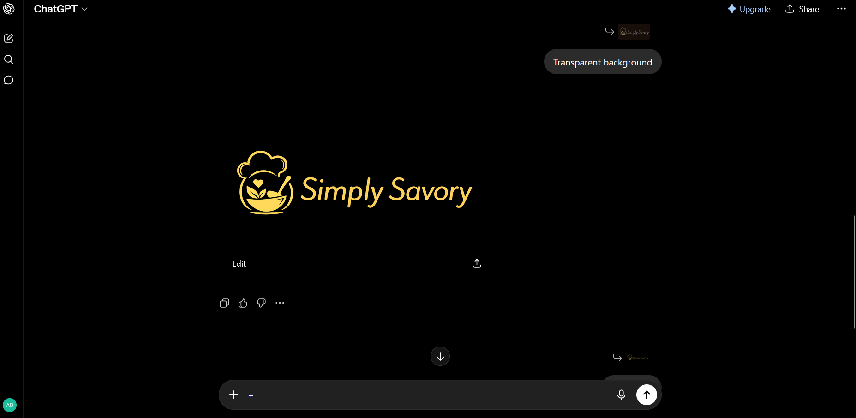
The logo we picked (before editing).
~~ The End ~~

