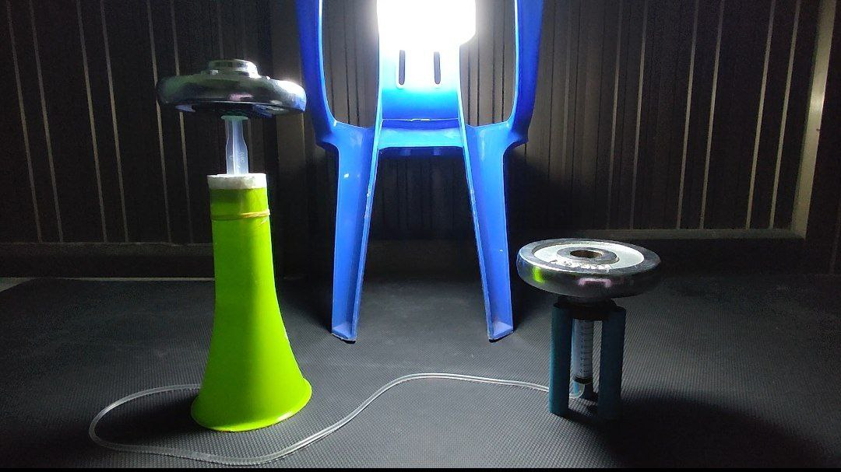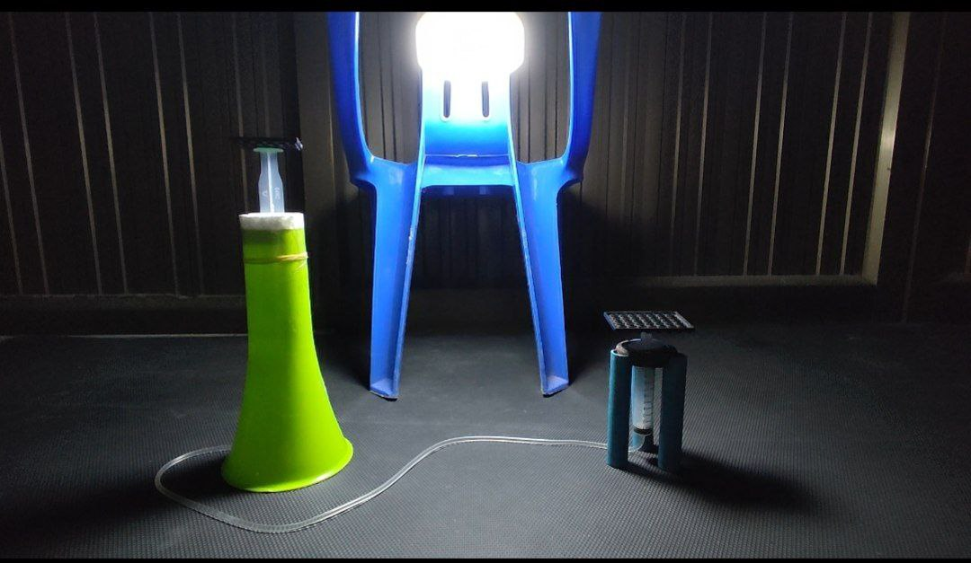

F1=1250 gram(+friction) F2=1450 gram

Friction=400gram

F1=1250gram F2=1450gram

Friction=400gram

F1 net=(1250-400)gram

=850gram

For Area

V1=10cm3 V2=10cm3

H1=5.7cm H2=3.5cm

V=A\*H V=A\*H

A=V/H A=V/H

A=10cm3/5.7cm A=10cm3/3.5cm

=1.8cm2 =2.9cm2

F1net/F2 = A1/A2

850/1450 = 1.8/2.9

0.586206897 = 0.620689655

0.6 = 0.6