

**MANAGEMENT AND**

**CONTENT DELIVERY**

**FOR SMART NETWORKS**

**Algorithms and Modelling**

**A.Y. 2015/2016**

**LABORATORY 1**

**PERFORMANCE OF SINGLE QUEUES**

**BARUSSO FEDERICO**

**CERUTTI MARCO**

**ORLANDO MATTEO**

The goal of this laboratory is to practice with queue simulators. Starting from the simulator of the M/M/1 queue, the objective is to get familiar with main elements of the simulator and then, by plotting the results, to evaluate the performance of the queue through simulations.

**M/M/1 queue simulation**

In this first step the simulation is run with a fixed service rate of $100 customers/s$ and varying the arrival rate from $10$ to $90 customers/s$. The simulation time is $1000s$. No changes in the code.

|  |  |  |  |  |  |  |
| --- | --- | --- | --- | --- | --- | --- |
| ρ | number of services | average delay | theoretical average delay | average number of users | theoretical number of user | probability server is idle |
| 0,1 | 10030 | 0,110250 | 0,111111 | 0,110692 | 0,111111 | 0,9 |
| 0,2 | 19960 | 0,123732 | 0,125000 | 0,247002 | 0,250000 | 0,8 |
| 0,3 | 30116 | 0,143576 | 0,142857 | 0,432393 | 0,428571 | 0,7 |
| 0,4 | 39879 | 0,165825 | 0,166667 | 0,661364 | 0,666667 | 0,6 |
| 0,5 | 50044 | 0,199336 | 0,200000 | 0,997698 | 1,000000 | 0,5 |
| 0,6 | 60119 | 0,248110 | 0,250000 | 1,491592 | 1,500000 | 0,4 |
| 0,7 | 70391 | 0,339329 | 0,333333 | 2,388774 | 2,333333 | 0,3 |
| 0,8 | 80139 | 0,474599 | 0,500000 | 3,803814 | 4,000000 | 0,2 |
| 0,9 | 90398 | 1,000719 | 1,000000 | 9,046151 | 9,000000 | 0,1 |

The following plots represent the comparison between the value of delay and number of users obtained with the simulation and the theoretical ones.

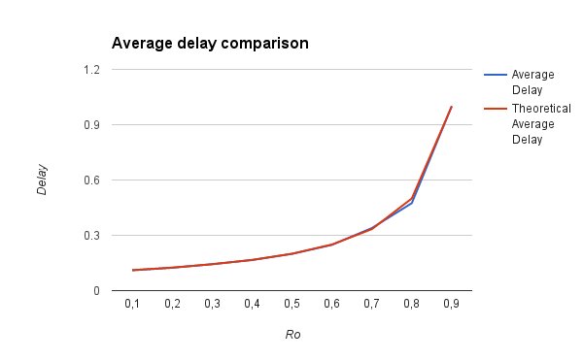

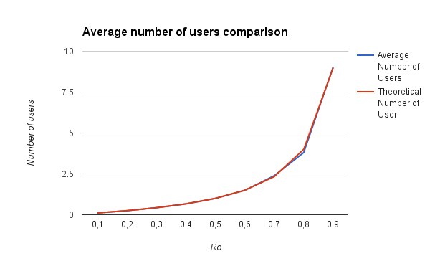

In this simple case the results are very similar to the theoretic ones. As predicted, the number of users in the system increases as the arrival rate increase and as a consequence also the average delay increases.

**M/M/1 queue simulation: different simulation duration**

In this other simulation, the simulation time is the first time $1000s$ and the second time $10000s$.

|  |  |  |  |  |  |  |  |
| --- | --- | --- | --- | --- | --- | --- | --- |
| ƛ | μ | Time | number of services | average delay | theoretical average delay | average number of users | theoretical number of user |
| 5 | 8 | 1000 | 4940 | 0,325827 | 0,333333 | 1,611180 | 1,666667 |
| 5 | 8 | 10000 | 49754 | 0,322042 | 0,333333 | 1,602284 | 1,666667 |

Multiplying by 10 the simulation time, also the number of services is more or less 10 times higher. The other measured values remain almost the same. In this case the simulation time doesn’t affect the simulation results.

**M/G/1 queue simulation**

In this simulation the exponential distributed service time typical of M/M/1 queues is substituted by one with a different distribution. The chosen one is the constant distribution, because makes calculations simpler and also because it models in a good way the behaviour of today's routers.

As before the service rate is fixed, while the ratio between the arrival rate and the service rate varies from $0,1$ to $0,95$. The $0,95$ value is included because there is more interest in analyzing a queue behavior in stress conditions, because are the worst work conditions. The simulation time is fixed to $1000s$.

|  |  |  |  |  |  |
| --- | --- | --- | --- | --- | --- |
| ρ | Number of Services | Average  Delay | Theoretical Average Delay | Average Number of Users | Theoretical Number of User |
| 0,1 | 10035 | 0,010555 | 0,010556 | 0,106025 | 0,105556 |
| 0,2 | 20128 | 0,011245 | 0,011250 | 0,226601 | 0,225000 |
| 0,3 | 30197 | 0,012146 | 0,012143 | 0,366877 | 0,364286 |
| 0,4 | 40310 | 0,013417 | 0,013333 | 0,540829 | 0,533333 |
| 0,5 | 50165 | 0,015054 | 0,015000 | 0,755207 | 0,750000 |
| 0,6 | 60312 | 0,017699 | 0,017500 | 1,067481 | 1,050000 |
| 0,7 | 70149 | 0,022011 | 0,021667 | 1,544012 | 1,516667 |
| 0,8 | 80160 | 0,030940 | 0,030000 | 2,481128 | 2,400000 |
| 0,9 | 90144 | 0,059234 | 0,055000 | 5,340560 | 4,950000 |
| 0,95 | 95168 | 0,115527 | 0,105000 | 10,99504 | 9,975000 |

The following plot represent the behavior of the average delay and of the average number of users in this M/G/1 simulation.

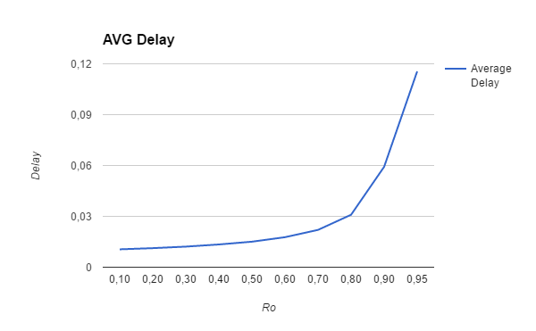

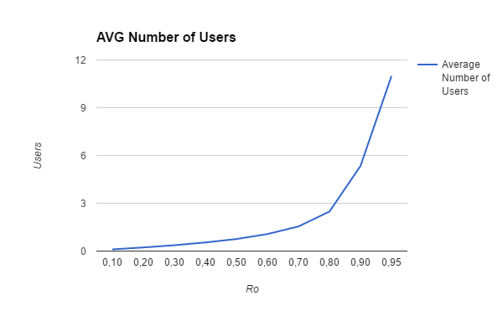

Having these data is possible to verify the **Pollaczek-Khintchin** formula:

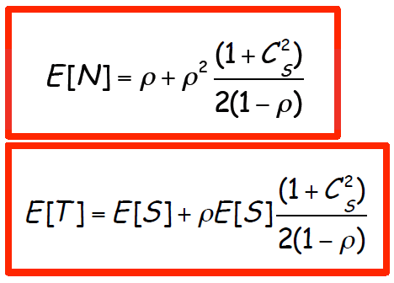

Where $E[N]$ is the average number of customers in the system, $ρ$ is the ratio between the arrival and the service rate, $C_{S}^{2}$ is defined as ${E\left[S^{2}\right]- E^{2}[S]}/{ E^{2}[S]}$ and is constant and equal to zero in this queue (M/D/1 type), and $E[T]$ is the average delay.

In this simulation the service time for the single customer is set to $E[s] =0.01$.

In the following table are shown the results obtained by the PK formula and the difference with the measured and the theoretical ones.

|  |  |  |  |  |  |
| --- | --- | --- | --- | --- | --- |
| E[N]_PK | E[N] | E[N] | E[T]_PK | E[T] | E[T] |
| PK-measured | PK-theoretical | PK-measured | PK-theoretical |
| 0.105556 | 0.000469 | 0.000000 | 0.010556 | 0.0000006 | 0.000000 |
| 0.225000 | 0.001601 | 0.000000 | 0.011250 | 0.0000050 | 0.000000 |
| 0.364286 | 0.002591 | 0.000000 | 0.012143 | 0.0000031 | 0.000000 |
| 0.533333 | 0.007496 | 0.000000 | 0.013333 | 0.0000837 | 0.000000 |
| 0.750000 | 0.005207 | 0.000000 | 0.015000 | 0.0000540 | 0.000000 |
| 1.050000 | 0.017481 | 0.000000 | 0.017500 | 0.0001990 | 0.000000 |
| 1.516667 | 0.027345 | 0.000000 | 0.021667 | 0.0003443 | 0.000000 |
| 2.400000 | 0.081128 | 0.000000 | 0.030000 | 0.0009400 | 0.000000 |
| 4.950000 | 0.390560 | 0.000000 | 0.055000 | 0.0042340 | 0.000000 |
| 9.975000 | 1.020040 | 0.000000 | 0.105000 | 0.0105270 | 0.000000 |

Is possible to see that the differences between the values obtained by the PK formula and the theoretical ones is always zero, as expected, so the PK formula is verified.

Besides is possible to see that the difference between the measured values and the ones obtained by the PK formula is always really little, so that is a proof of the goodness of the simulator.

**M/G/k/B queue simulation**

For the implementation of the M/G/k/B queue the original code has been modified inserting a limitation on the length of the queue and verifying each time a customer arrives, if the number of user in the queue don’t overcome its dimension. Then the *in_service Record\** variable was substituted with a vector of k elements.

All statistics are referred to the complete system with a limited queue and k servers.

In the following table are shown the statistics about the simulation. The system is one queue with dimension $k=300$ and $5$ servers with a constant service rate of $10 customers/s$. The simulation time is $1000$ unit.

|  |  |  |  |  |  |  |
| --- | --- | --- | --- | --- | --- | --- |
| λ | AVERAGE DELAY | AVERAGE # USERS | AVERAGE # BUSY SERVER | # USERS SERVED | # OF LOSSES | PROBABILITY OF USER DROP |
| 10 | 0.100060 | 1.004050 | 2.006776 | 10035 | 0 | 0.000000 |
| 20 | 0.101280 | 2.038361 | 2.968950 | 20128 | 0 | 0.000000 |
| 30 | 0.107001 | 3.231072 | 3.798397 | 30197 | 0 | 0.000000 |
| 40 | 0.131962 | 5.319178 | 4.486976 | 40307 | 0 | 0.000000 |
| 50 | 3.252983 | 162.461347 | 4.995722 | 49907 | 141 | 0.002811 |
| 60 | 5.705532 | 286.108935 | 4.999801 | 49995 | 10026 | 0.166233 |

Is possible to see that when λ is lower than $5*service_rate$, the system is ergodic and there are no losses. When λ reaches $50 customers/s$ the system begins to be unstable and most of the time all servers work. Customers begin to be lost. If λ grows again, the load overcomes 1 and the system is totally unstable so a very high number of customers are lost.

In the following plots are represented the average delay and the probability of user drop.

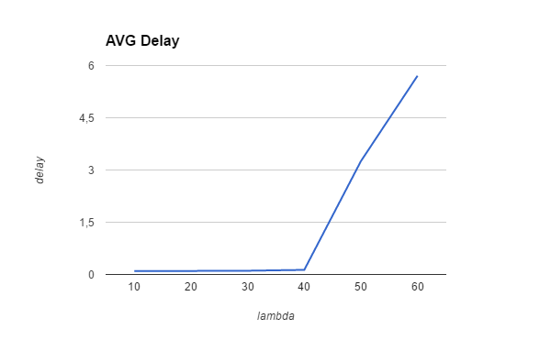

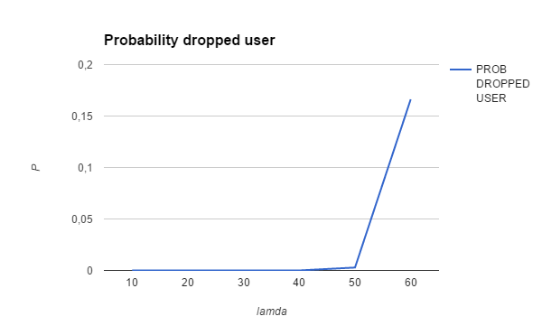

In the next table is shown how many customers are served in the simulation by each servers.

|  |  |  |  |  |  |
| --- | --- | --- | --- | --- | --- |
| Lambda | SERVER1 | SERVER2 | SERVER3 | SERVER4 | SERVER5 |
| 10 | 5033 | 2988 | 1415 | 476 | 123 |
| 20 | 6788 | 5491 | 3993 | 2541 | 1316 |
| 30 | 7969 | 7217 | 6264 | 5036 | 3712 |
| 40 | 8981 | 8671 | 8229 | 7633 | 6796 |
| 50 | 9993 | 9989 | 9984 | 9978 | 9968 |
| 60 | 10000 | 10000 | 10000 | 10000 | 10000 |
|  |  |  |  |  |  |

Since the service rate of each server is constant ($10 customer/s$) and the simulation time is $1000s$, it means that each server can serve a maximum number of $10000$ customers during the simulation. So when λ is equal to $60$, on average, $60000$ customers arrive, but 5 servers cannot serve all of them. In this special case $10000$ customers on average are lost.

From this table it is evident what is the customer-server assignment’s policy: when a customer arrives it is assigned to the first free server starting from SERVER1. In fact, is possible to see, checking also the average number of busy servers from the previous table, that when λ is low, so the load is low, the last servers do not work for a large amount of time. Only the firsts servers are a great number of customers to serve. Obviously this difference is much little increasing λ. Already when λ is equal to $40 customers/s$, most of the time all servers work. Indeed, when the load is critical, on average all servers are used.

To control that the system works well, $k$ is set to $1$, and very long queue is defined, so is possible compare the results with the previous M/G/1 queue.

|  |  |  |  |  |
| --- | --- | --- | --- | --- |
| ρ | AVERAGE DELAY M/G/1 | AVERAGE DELAY M/G/k/B | AVERAGE # USER M/G/1 | AVERAGE # USER M/G/k/b |
| 0,1 | 0,010555 | 0,0104624 | 0,106025 | 0,101213 |
| 0,2 | 0,011245 | 0,0111868 | 0,226601 | 0,223277 |
| 0,3 | 0,012146 | 0,0120171 | 0,366877 | 0,357461 |
| 0,4 | 0,013417 | 0,0134795 | 0,540829 | 0,541390 |
| 0,5 | 0,015054 | 0,0149647 | 0,755207 | 0,748136 |
| 0,6 | 0,017699 | 0,0174834 | 1,067481 | 1,050895 |
| 0,7 | 0,022011 | 0,0216782 | 1,544012 | 1,513503 |
| 0,8 | 0,03094 | 0,0309240 | 2,481128 | 2,475194 |
| 0,9 | 0,059234 | 0,0581227 | 5,34056 | 5,228947 |

The obtained results are very similar, depending also on the chosen seed.