|  |
| --- |
| Functional Specification Document  <ClothsOnline> |

**DOCUMENT VERSION <V1>**

**<13.09.2020>**

**AUTHORS**

|  |  |  |
| --- | --- | --- |
| **Name** | **Role** | **Department** |
| Thomas Bach-Nilsen | Business Analyst | Digital Development |

**DOCUMENT HISTORY**

|  |  |  |  |
| --- | --- | --- | --- |
| **Date** | **Version** | **Document Revision Description** | **Document Author** |
| 12.09.2020 | V1 | Draft Version | Thomas Bach-Nilsen |
|  |  |  |  |
|  |  |  |  |
|  |  |  |  |
|  |  |  |  |

**APPROVALS**

|  |  |  |  |
| --- | --- | --- | --- |
| **Approval Date** | **Approved Version** | **Approver Role** | **Approver** |
| 13.09.2020 | V1 | Development Team Leader |  |
|  |  |  |  |
|  |  |  |  |

**Table of Contents**

1. Introduction (give a brief description of the company) 6

1.2 Purpose of the document 6

1.3 Project Scope 7

1.4 Scope of the document 7

2.2 System Actors 9

2.3 Dependencies and Change Impacts 10

3. Functional Specifications 10

3.1 Develop an online site and mobile app 10

6. Reporting Requirements 12

7. Integration Requirements 12

8. References 15

# **Introduction**

# ClothesOnLine is a start-up online company which just launched. The company specializes in selling clothing, shoes and accessories online, worldwide. Your digital agency was approached to develop their online site and mobile app that they will advertise their merchandise on.

# **Purpose of the document**

# The purpose of this document is to document the business requirements and functional rules of the clothingonline mobile app and website. This document will include a basic mockup of the website and mobile app.

# All system requirements and restraints will be documented.

# **Risks and Assumptions**

|  |  |  |  |
| --- | --- | --- | --- |
| **Risk** | **Level** | **Impact** | **Responsible** |
| User logins will not be migrated to the new portal | High | Users will not be able to login in using their existing login details | Development Team |

# **System/ Solution Overview**

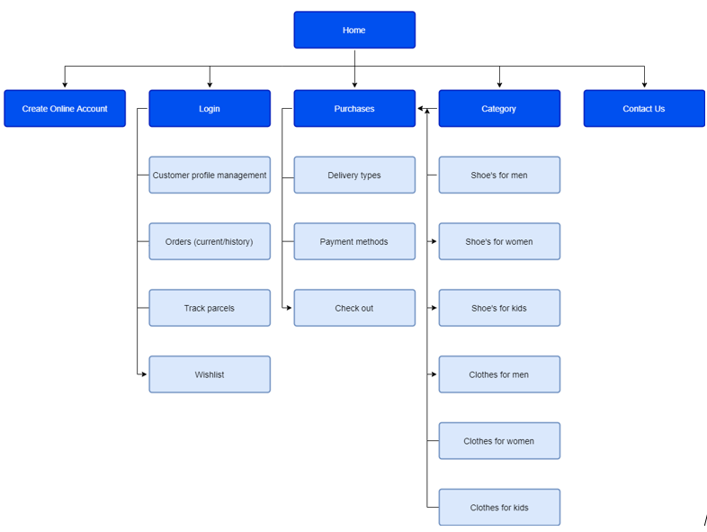

# **Functional Specifications**

### Develop an online site and mobile app

### Develop and integrate payment methods

### Use API to integrate third party like Vipps etc.

### Purpose/ Description

## Develop an online site and mobile app that for advertising merchandise on

1. ClothesOnLine

|  |  |
| --- | --- |
| **UC-1** | **Differentiate gender clothing and shoes, e.g. men, women, kids**  **and sizes of all clothing apparel.** |
| **Primary Actor(s)** | Customers |
| **Stakeholders and Interest** | CEOBusiness Owner |
| **Trigger** | Create a website |
| **Pre-conditions** | Website does not exist |
| **Post-conditions** | URL of website to exist |
| **Main Success Scenario** | Enter one of ClothesOnLine’s landing pages or enter the app.Search by filtering out the check boxes for clothes, shoes, gender. Choose color and sizeA confirmation for successful/ unsuccessful search is displayed.  * 1. Develop payment methods. |
| **Extensions** | If URL does not work, try google search for ClothesOnLine |
| **Priority** | High |
| **Special Requirements** | A domain name and host to exist |
| **Open Questions** | <Notes and questions> |

# **Mock-up**

# **Integration Requirements**

## There will be needed to save user information to use for the payment registration. It will be necessary to use card payment, Vipps or invoiced to have all options available for the users.

