Technical Website Requirements Specification

CLOTHESONLINE

Created by: **Thomas Bach-Nilsen**

Version 1.0 – **13.09.2020**

# Background

# ClothesOnLine is a start-up online company which just launched. The company specialises in selling clothing, shoes and accessories online, worldwide. Your digital agency was approached to develop their online site and mobile app that they will advertise their merchandise on.

# USE CASE

### **Develop an online site and mobile app**

### **Develop and integrate payment methods**

### **Use API to integrate third party like Vipps etc.**

### **Purpose/ Description**

## Develop an online site and mobile app that for advertising merchandise on

### **Use case**

|  |  |
| --- | --- |
| **UC-1** | **Differentiate gender clothing and shoes, e.g. men, women, kids**  **and sizes of all clothing apparel.** |
| **Primary Actor(s)** | Customers |
| **Stakeholders and Interest** | CEOBusiness Owner |
| **Trigger** | Create a website |
| **Pre-conditions** | Website does not exist |
| **Post-conditions** | URL of website to exist |
| **Main Success Scenario** | Enter one of ClothesOnLine’s landing pages or enter the app.Search by filtering out the check boxes for clothes, shoes, gender. Choose color and sizeA confirmation for successful/ unsuccessful search is displayed.  * 1. Develop payment methods. |
| **Extensions** | If URL does not work, try google search for ClothesOnLine |
| **Priority** | High |
| **Special Requirements** | A domain name and host to exist |
| **Open Questions** | <Notes and questions> |

# Mock-ups and process/diagrams flows

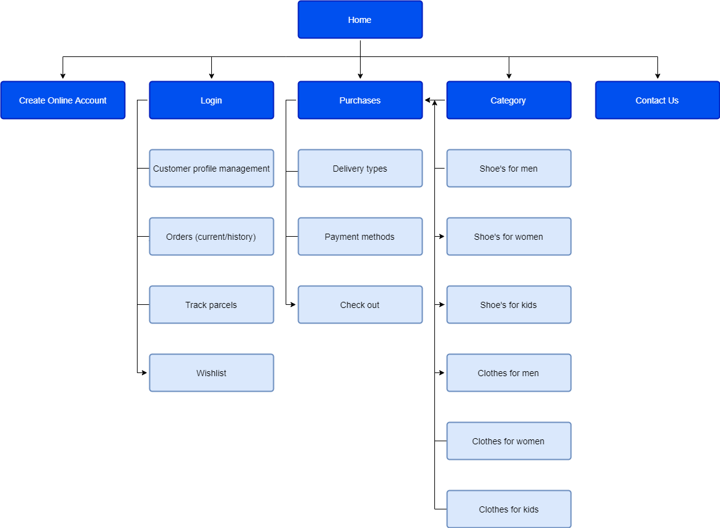

# Visitor Interaction

|  |  |  |
| --- | --- | --- |
| **Req** | **Description** | **Comments** |
| 1.1 | As a customer, I want to pay with card so what purchase is insured. |  |
| 1.2 | As a customer, I want to pay cash or card on delivery so that I am sure I get what I ordered. |  |
|  |  |  |

# Editing, Updates and Administration

|  |  |  |
| --- | --- | --- |
| **Req** | **Description** | **Comments** |
| 2.1 | Administrative rights |  |
| 2.2 | CMS Management |  |

# Sitemap and Navigation

|  |  |  |
| --- | --- | --- |
| **Req** | **Description** | **Comments** |
| 3.1 | Each of the policy for the payment methods must be approved. |  |
| 3.2 | Every landing page has a login button that leads the user to the login page |  |

# Content Management

|  |  |  |
| --- | --- | --- |
| **Req** | **Description** | **Comments** |
| 4.1 | wordpress |  |
|  |  |  |

# Tracking (website statistics)

|  |  |  |
| --- | --- | --- |
| **Req** | **Description** | **Comments** |
| 5.1 | https://statcounter.com/ |  |
| 5.2 | https://analytics.google.com |  |

# Search Engine Optimisation (SEO)

|  |  |  |
| --- | --- | --- |
| **Req** | **Description** | **Comments** |
| 6.1 | headlines, meta tags, and navigational elements |  |
| 6.2 | Google ad words |  |

# Accessibility

|  |  |  |
| --- | --- | --- |
| **Req** | **Description** | **Comments** |
| 8.1 | Encrypted log in page |  |
| 8.2 | Username and password |  |

# Styling and Design

|  |  |  |
| --- | --- | --- |
| **Req** | **Description** | **Comments** |
| 9.1 | H1, H2, H3: font-family: "Bree Serif" Fallback, serif; / color: #4a4a4a |  |
| 9.2 | Body: font-family: "Oswald",sans-serif; / color: #000 , background-color: #FFF |  |

# Security

|  |  |  |
| --- | --- | --- |
| **Req** | **Description** | **Comments** |
| 10.1 | Encrypted site |  |
| 10.2 | Source code stored on cloud |  |

# Hosting

|  |  |  |
| --- | --- | --- |
| **Req** | **Description** | **Comments** |
| 11.1 | icloud |  |
| 11.2 | Owned web provider |  |