 The University of Azad Jammu & Kashmir,Muzaffarabad
Department of Software Engineering

DIP Lab

Lab # 03

Task Title: Image Enhancement and Intensity Transformations

Submitted to: Fahad Nisar

Student Name: Feeza Kulsoom

Roll No: 2024-SE-03

Reg Number: 2024-UMDB-004738

Deliverable 0: Grayscale Image Validation & Numeric Safety
To prevent integer underflow and overflow bugs inherent to 8-bit unsigned representations (uint8 modulo arithmetic), all mathematical operations in this lab promote raw pixel arrays to higher precision numerical types (int32 or float64). Outputs are explicitly bounded to the valid display gamut [0, 255] using clipping before converting back to uint8.
1. Image Validation Results
• Image File: image.jpg
• Dimensions / Resolution: 678 × 452 (Width × Height), fulfilling the ≥ 300 × 300 rubric mandate.
• Array Shape: (452, 678)
• Data Type: uint8 (Single-channel 8-bit grayscale)
• Intensity Range: Min = 0, Max = 245

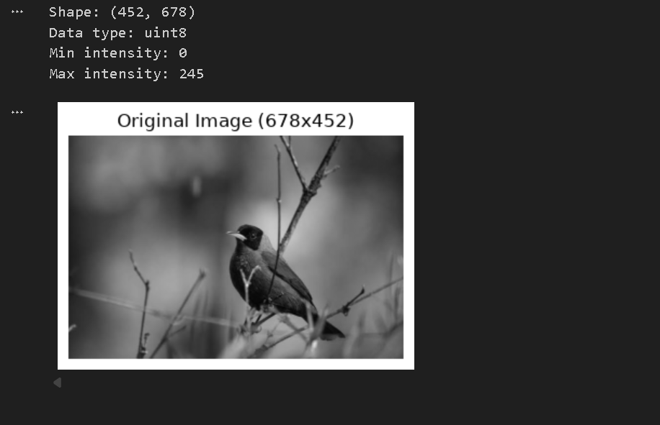

Deliverable 1: Brightness Adjustment
Brightness adjustment is an intensity translation applying an additive constant parameter β across the spatial domain: s = r + β.
1. Dry Run Calculations
Using test pixel array: [30, 80, 128, 180, 240] with offsets β = +40 and β = -40.
Pixel (r) | β = +40 (Raw) | β = +40 Clipped (uint8) | β = -40 (Raw) | β = -40 Clipped (uint8)
30 | 70 | 70 | -10 | 0 (Clipped)
80 | 120 | 120 | 40 | 40
128 | 168 | 168 | 88 | 88
180 | 220 | 220 | 140 | 140
240 | 280 | 255 (Saturated) | 200 | 200
Python Verification Output:
Dry Run 1 (+40): [70, 120, 168, 220, 255]
Dry Run 1 (-40): [0, 40, 88, 140, 200]
Verification Passed: Vectorized and nested-loop implementations are identical.
2. Lost Detail Analysis
• For β = +40: High-intensity highlights saturate. Any pixel r > 215 results in a raw value > 255, clamping to 255. Subtle variations in bright cloud/sky/feather textures are irreversibly destroyed as multiple gray levels collapse into pure white.
• For β = -40: Shadow details clip to black. Any pixel r < 40 results in a raw value < 0, clamping to 0. Dark textural features in deep plumage and background foliage collapse into pure black.

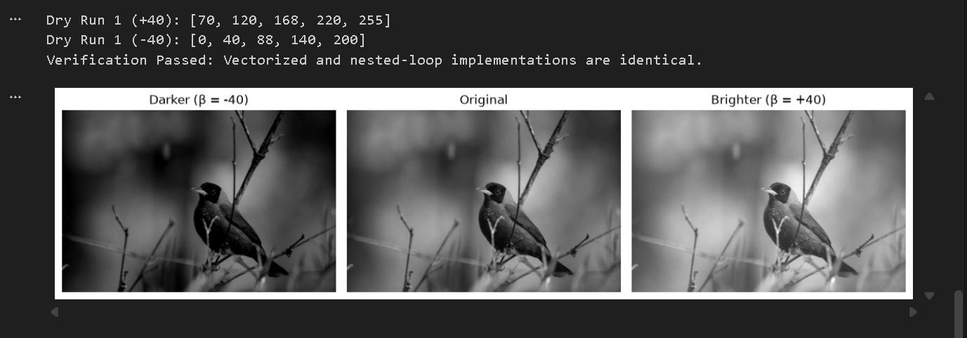

Deliverable 2: Linear Contrast from Zero
Linear contrast from zero applies multiplicative scaling: s = αr + β with α = 1.5 and β = 0. Values are clipped to [0, 255] and truncated.
1. Dry Run Calculations
Using test pixel array: [30, 80, 128, 180, 240] with α = 1.5.
Pixel (r) | Raw 1.5r | Clipped & Truncated (uint8) | Saturation Status
30 | 45.0 | 45 | Preserved
80 | 120.0 | 120 | Preserved
128 | 192.0 | 192 | Preserved
180 | 270.0 | 255 | Saturated (Blown out)
240 | 360.0 | 255 | Saturated (Blown out)
Python Verification Output:
Dry Run 2 Output: [45, 120, 192, 255, 255]
2. Contrast & Saturation Observations
Because scaling anchors at zero (r = 0), every nonzero pixel intensity increases (e.g., r = 128 shifts up to 192). Consequently, this transformation simultaneously boosts perceived brightness while expanding contrast. Pixels r ≥ 170 exceed 255, causing intense highlight blowout and flattening all upper tonal differentiation into pure white.

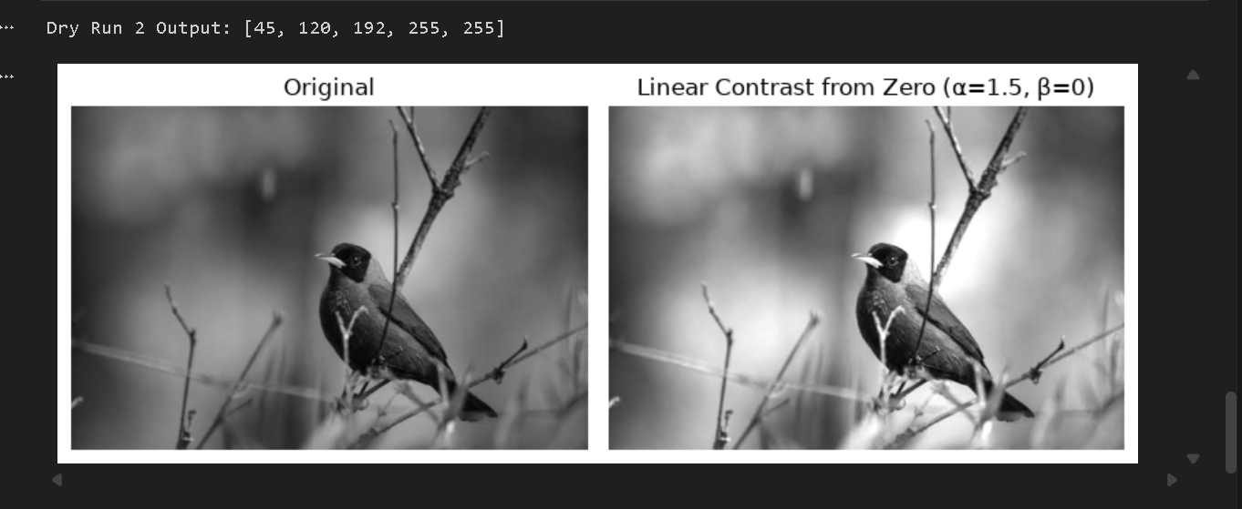

Deliverable 3: Contrast Centered at 128
Centered contrast scales intensities around the midtone anchor: s = (r - 128)α + 128. This symmetrically expands or compresses tones without shifting the global midtone exposure.
1. Dry Run Calculations
Using test pixel array: [30, 80, 128, 180, 240] for α = 1.5 (expansion) and α = 0.5 (compression).
Pixel (r) | α = 1.5 (Raw) | α = 1.5 Final (uint8) | α = 0.5 (Raw) | α = 0.5 Final (uint8)
30 | (30-128)*1.5 + 128 = -19.0 | 0 (Clipped) | (30-128)*0.5 + 128 = 79.0 | 79
80 | (80-128)*1.5 + 128 = 56.0 | 56 | (80-128)*0.5 + 128 = 104.0 | 104
128 | (128-128)*1.5 + 128 = 128.0 | 128 (Invariant) | (128-128)*0.5 + 128 = 128.0 | 128 (Invariant)
180 | (180-128)*1.5 + 128 = 206.0 | 206 | (180-128)*0.5 + 128 = 154.0 | 154
240 | (240-128)*1.5 + 128 = 296.0 | 255 (Clipped) | (240-128)*0.5 + 128 = 184.0 | 184
Python Verification Output:
Dry Run 3 (α=1.5): [0, 56, 128, 206, 255]
Dry Run 3 (α=0.5): [79, 104, 128, 154, 184]
2. Comparison with Contrast from Zero & Fixed Point Analysis
• Fixed Point at r = 128: When r = 128, (r - 128) = 0, leaving s = 128 regardless of α. The perceptual center remains completely invariant.
• Comparison: Unlike contrast from zero (which shifts the entire histogram upward and creates severe highlight saturation), centered contrast pushes darks lower and brights higher symmetrically for α = 1.5, and compresses the dynamic range inward around 128 for α = 0.5.

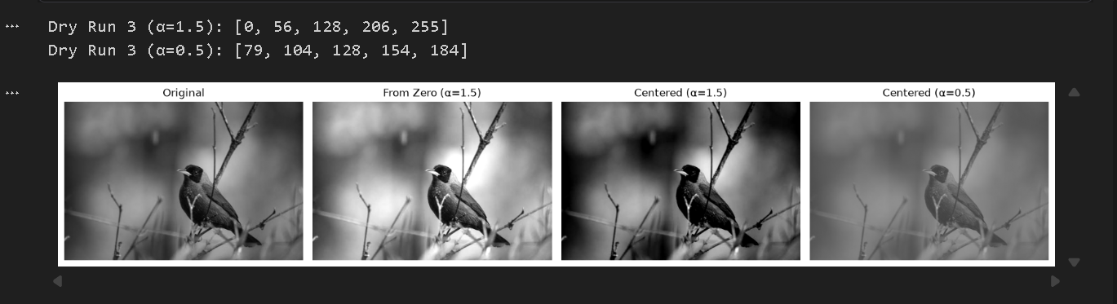

Deliverable 4: Image Negative
The negative transformation reverses the tonal scale: s = 255 - r.
1. Dry Run Calculations
Using test pixel array: [30, 80, 128, 180, 240].

Pixel (r) | Negative s = 255 - r | Re-inverted s' = 255 - s | Preservation Check
30 | 225 | 255 - 225 = 30 | Exact Match
80 | 175 | 255 - 175 = 80 | Exact Match
128 | 127 | 255 - 127 = 128 | Exact Match
180 | 75 | 255 - 75 = 180 | Exact Match
240 | 15 | 255 - 15 = 240 | Exact Match
Python Verification Output:
Dry Run 4 Negative: [225, 175, 127, 75, 15]
Dry Run 4 Inverted Back: [30, 80, 128, 180, 240]
2. Practical Inspection Utility
Negative transformations are extensively utilized in medical imaging (e.g., digital chest radiography and mammograms) and industrial flaw inspection. Human visual psychophysics detects faint, high-contrast white structures against dark surrounds much more reliably than discerning subtle gray differentials within dark, dense anatomical masses.

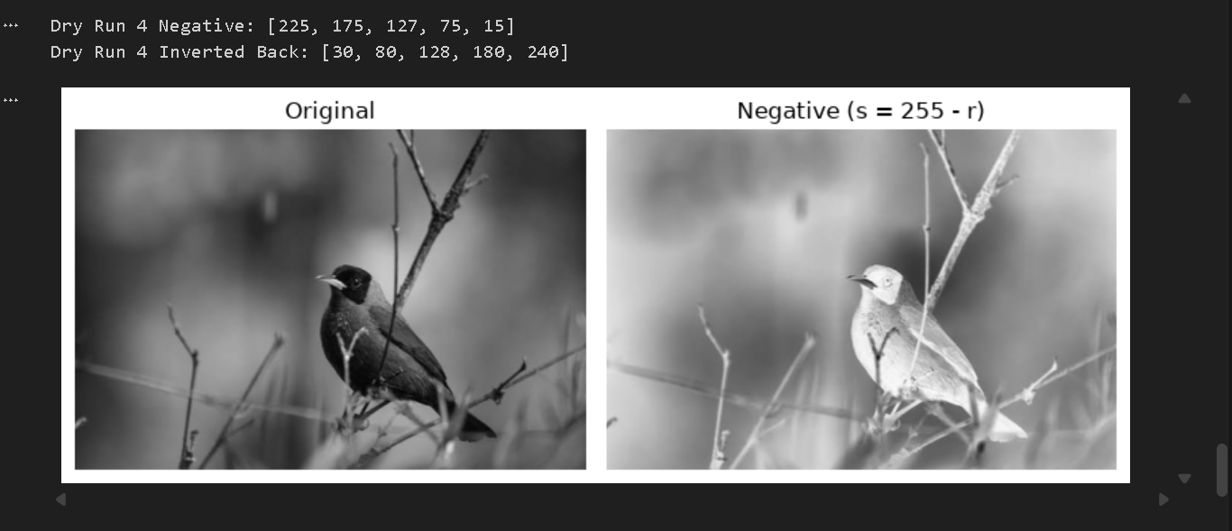

Deliverable 5: Gamma Correction (Power-Law)
Gamma correction implements power-law transformation: s = 255 * (r / 255)^γ. Arithmetic is maintained in double precision and truncated at the final uint8 assignment.
1. Dry Run Calculations
Using test pixel array: [0, 64, 128, 192, 255] for γ = 0.5 (expansion) and γ = 2.0 (compression).
Pixel (r) | Normalized (r/255) | γ = 0.5 (Raw Float) | γ = 0.5 Truncated | γ = 2.0 (Raw Float) | γ = 2.0 Truncated
0 | 0.000000 | 0.0000 | 0 | 0.0000 | 0
64 | 0.250980 | 127.7497 | 127 | 16.0627 | 16
128 | 0.501961 | 180.6654 | 180 | 64.2509 | 64
192 | 0.752941 | 221.2690 | 221 | 144.5647 | 144
255 | 1.000000 | 255.0000 | 255 | 255.0000 | 255
Python Verification Output:
Dry Run 5 (γ=0.5): [0, 127, 180, 221, 255]
Dry Run 5 (γ=2.0): [0, 16, 64, 144, 255]
2. Observations & Truncation vs. Rounding Analysis
• Behavior on Shadows & Extremes: For γ = 0.5, shadow regions are significantly expanded (e.g., r = 64 jumps to 127), revealing hidden underexposed details. For γ = 2.0, shadow intensities are compressed downward (e.g., r = 64 drops to 16). The extreme boundaries r = 0 and r = 255 remain perfectly fixed.
• Slide Discrepancy Note: Conventional lecture slide examples use mathematical rounding (round()), yielding 128 for 127.75 and 181 for 180.67. This lab strictly mandated floor truncation (int()), resulting in 127 and 180 respectively.

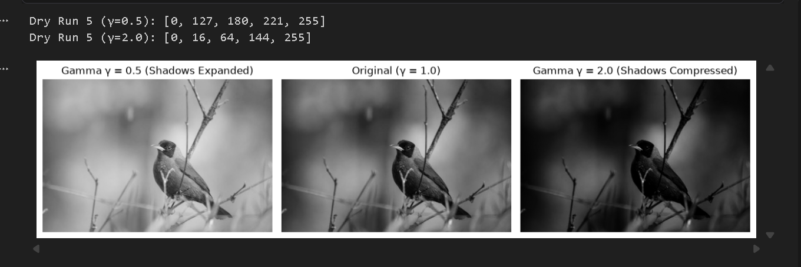

Deliverable 6: Grayscale Histogram
A grayscale intensity histogram plots the discrete frequency of occurrence of each intensity level across the image canvas.
1. Dry Run Calculations
Given 2×4 matrix A = [[0, 50, 50, 100], [100, 150, 200, 255]], total pixels N = 8.
Intensity Level (rk) | Count / Frequency (nk) | Probability pk = nk / N | Percentage
0 | 1 | 1 / 8 = 0.125 | 12.5%
50 | 2 | 2 / 8 = 0.250 | 25.0%
100 | 2 | 2 / 8 = 0.250 | 25.0%
150 | 1 | 1 / 8 = 0.125 | 12.5%
200 | 1 | 1 / 8 = 0.125 | 12.5%
255 | 1 | 1 / 8 = 0.125 | 12.5%
2. Spatial Invariance & Intensity Distribution Interpretation
• Spatial Invariance: A histogram computes purely zero-order statistical counts. Because spatial coordinate indices (x, y) are discarded during binning, any spatial scrambling or shuffling of image pixels produces the exact same histogram.
• Image Distribution Interpretation: The histogram of image.jpg exhibits a unimodal Gaussian-like profile centered strongly around midtones (bins 90–135, peaking near 110 at >4,000 counts) with a smooth tapering drop-off towards shadows and highlights. The absence of severe clustering at 0 or 255 confirms a well-exposed scene with balanced dynamic range and no harsh clipping.

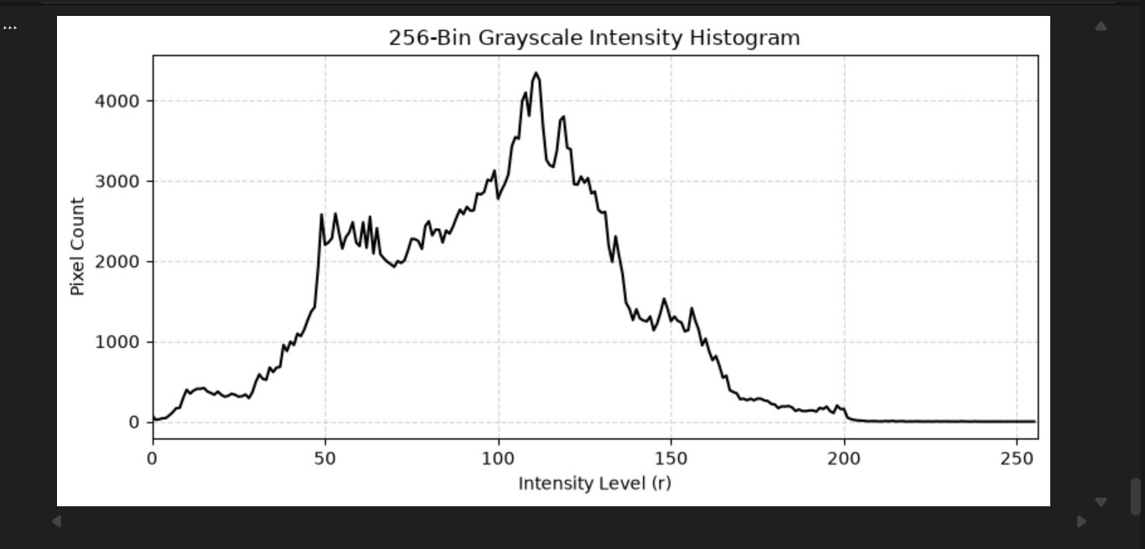

Deliverable 7: Global Histogram Equalization
Global Histogram Equalization flattens the cumulative distribution function (CDF), remapping intensity levels to maximize image dynamic range and global contrast.
1. Dry Run Calculations
Given pixel array: [50, 50, 100, 150], total pixels N = 4.
Frequencies: n(50)=2, n(100)=1, n(150)=1.
Cumulative counts: C(50)=2, C(100)=3, C(150)=4.
CDF: CDF(50)=2/4=0.50, CDF(100)=3/4=0.75, CDF(150)=4/4=1.00.
Lowest non-zero CDF: CDFmin = 0.50.
Intensity | CDF | Mapping 1: round(255 * CDF) | Mapping 2: round(255 * (CDF-CDFmin)/(1-CDFmin)) | OpenCV cv2.equalizeHist
50 | 0.50 | round(127.5) = 128 | round(255 * 0.0) = 0 | 0 (matches normalized)
100 | 0.75 | round(191.25) = 191 | round(255 * 0.5) = 128 | 128
150 | 1.00 | round(255.0) = 255 | round(255 * 1.0) = 255 | 255
Python Verification Output:
OpenCV Dry Run Output:
[0, 0, 128, 255]
Verification: The OpenCV result [0, 0, 128, 255] exactly matches Mapping 2 (which subtracts CDFmin).
2. Enhancement vs. Noise Amplification Discussion
Global equalization significantly enhances overall contrast by spreading densely packed midtone frequencies across the entire [0, 255] span. However, in smooth background regions (such as the blurred bokeh backdrop in our image), spreading sparsely populated bins causes drastic tonal quantization gaps and heavily amplifies high-frequency sensor noise, producing a harsh, unnatural appearance.

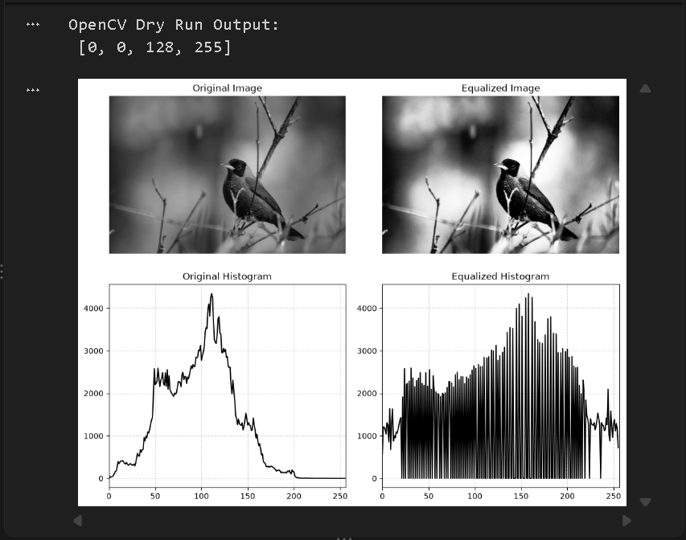

Deliverable 8: Contrast Limited Adaptive Histogram Equalization (CLAHE)
CLAHE prevents severe noise amplification by computing equalization within local contextual tiles and enforcing a strict contrast clipping ceiling.
1. Dry Run Calculations
Given 4-bin histogram: [6, 2, 0, 0] with an absolute bin cap = 4.
• Step 1 (Clipping): Bin 0 has count 6 (exceeding cap 4 by 2). Excess = 2. Clipped histogram = [4, 2, 0, 0].
• Step 2 (Redistribution): Excess (2) is distributed equally across all K = 4 bins: Δ = 2 / 4 = 0.5 per bin.
New Bin Counts = [4 + 0.5, 2 + 0.5, 0 + 0.5, 0 + 0.5] = [4.5, 2.5, 0.5, 0.5]. Total sum = 8.0.
• Step 3 (New CDF Calculation):
- CDF[0] = 4.5 / 8.0 = 0.5625
- CDF[1] = (4.5 + 2.5) / 8.0 = 7.0 / 8.0 = 0.8750
- CDF[2] = (7.0 + 0.5) / 8.0 = 7.5 / 8.0 = 0.9375
- CDF[3] = 8.0 / 8.0 = 1.0000
2. Tile Parameters & Bilinear Interpolation Rationale
• Tile Grid Size Clarification: In cv2.createCLAHE(clipLimit=2.0, tileGridSize=(8, 8)), the parameter (8, 8) partitions the entire image into an 8×8 grid of contextual tiles (64 total regions), not tiles measuring 8×8 pixels.
• Bilinear Interpolation Necessity: Applying adaptive histogram equalization independently within individual tiles creates sharp, unnatural step discontinuities along tile borders. CLAHE employs bilinear interpolation between neighboring tile mappings to eliminate tile boundaries and produce smooth, seamless tonal gradations.

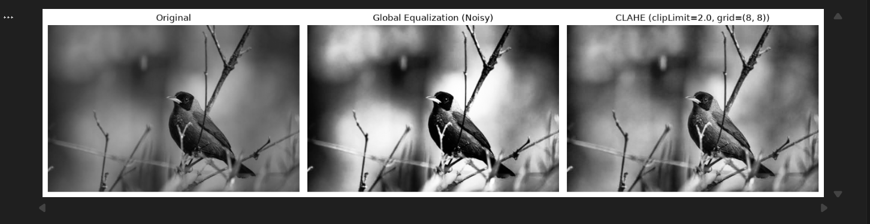

Deliverable 9: Fixed Binary Thresholding
Fixed thresholding segments an image into binary foreground and background using a static intensity cutoff T: s = 255 if r > T else 0.
1. Dry Run Calculations
Given pixel array: [0, 80, 127, 128, 180, 255] for thresholds T = 127 and T = 180.

Pixel (r) | T = 127 (Condition: r > 127) | T = 180 (Condition: r > 180)
0 | 0 | 0
80 | 0 | 0
127 | 0 | 0
128 | 255 | 0
180 | 255 | 0
255 | 255 | 255
Python Verification Output:
Dry Run 9 (T=127): [[0, 0, 0, 255, 255, 255]]
Dry Run 9 (T=180): [[0, 0, 0, 0, 0, 255]]
Unique pixel values in binary image: [0 255]
White-Pixel Count: At T = 127, white count = 3 (pixels 128, 180, 255). At T = 180, white count = 1 (pixel 255).

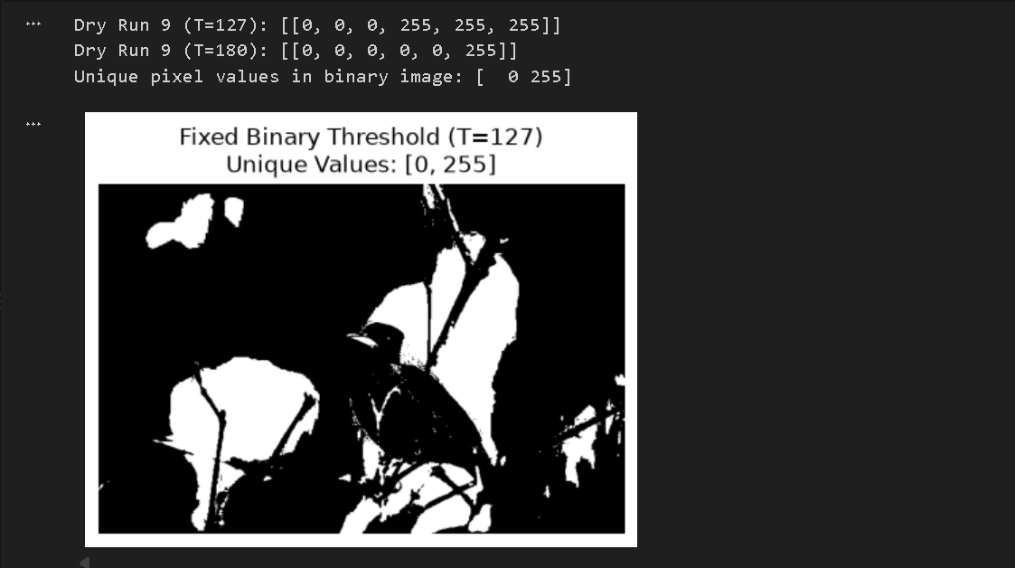

Deliverable 10: Otsu Thresholding
Otsu's algorithm exhaustively searches for an optimal global threshold T that maximizes the between-class variance σB²(T) = w0*w1*(μ0 - μ1)².
1. Dry Run Calculations
Given pixel array: [0, 1, 4, 5], total pixels N = 4. Splitting at C0: r ≤ T and C1: r > T.
T | C0 (r ≤ T) | C1 (r > T) | Weights (w0, w1) | Means (μ0, μ1) | (μ0 - μ1)² | Between-Class Variance σB²
0 | [0] | [1, 4, 5] | 0.25, 0.75 | 0.0, 3.333 | 11.111 | 0.1875 * 11.111 = 2.0833
1 | [0, 1] | [4, 5] | 0.50, 0.50 | 0.5, 4.500 | 16.000 | 0.2500 * 16.000 = 4.0000 (Max)
2 | [0, 1] | [4, 5] | 0.50, 0.50 | 0.5, 4.500 | 16.000 | 0.2500 * 16.000 = 4.0000 (Max)
3 | [0, 1] | [4, 5] | 0.50, 0.50 | 0.5, 4.500 | 16.000 | 0.2500 * 16.000 = 4.0000 (Max)
4 | [0, 1, 4] | [5] | 0.75, 0.25 | 1.667, 5.0 | 11.111 | 0.1875 * 11.111 = 2.0833
Python Verification Output:
Otsu Dry Run Threshold: 1.0
Otsu Dry Run Mask: [0, 0, 255, 255]
Computed Otsu Threshold on Image: 94.0
Tie-Breaking Rule: The maximum variance σB² = 4.0 is tied across T = 1, 2, and 3. The algorithm selects the lowest threshold among tied maxima (T* = 1.0).
2. Mask Comparison (Fixed vs. Otsu)
Fixed thresholding at T = 127 segments purely by an arbitrary midpoint, causing thinner background coverage and losing subtle subject details. Otsu dynamically computes the optimal statistical threshold based on the actual image histogram (T = 94.0), capturing significantly more foreground structure and producing a richer object contour.

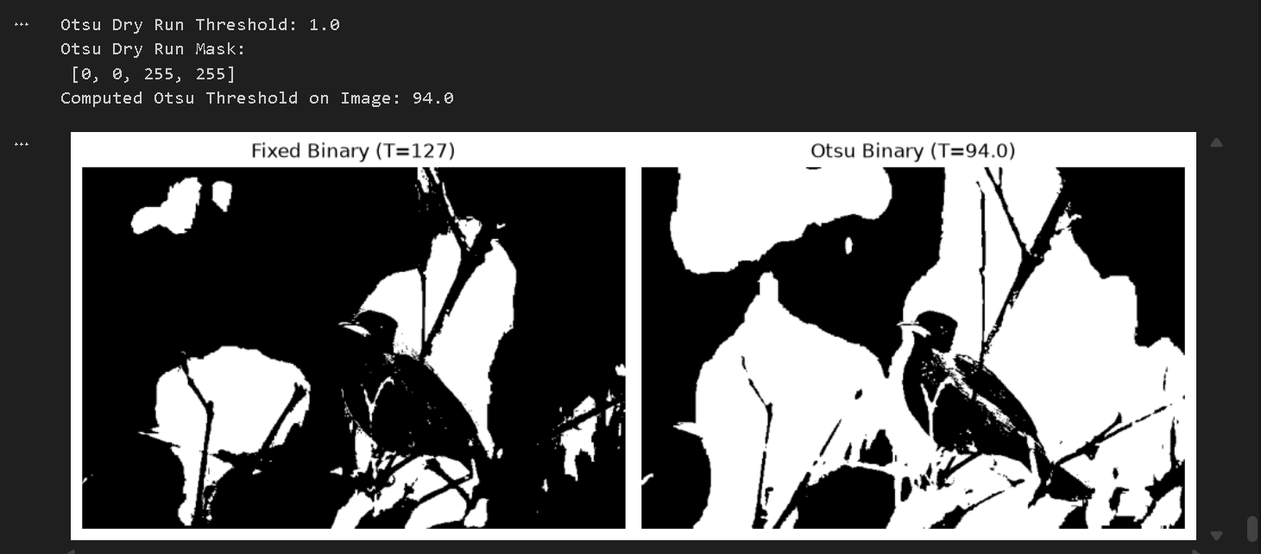

Deliverable 11: Adaptive Gaussian Thresholding
Adaptive thresholding computes an individual, dynamic threshold for every pixel based on the Gaussian-weighted mean of its surrounding local neighborhood.
1. Dry Run Calculations
Given 3×3 neighborhood and 3×3 Gaussian weight matrix (sum = 16):
Window = [[100, 100, 100], [100, 120, 140], [140, 140, 140]]
Weights = [[1, 2, 1], [2, 4, 2], [1, 2, 1]] / 16
Convolution Sum Calculation:
Sum = (100*1) + (100*2) + (100*1) + (100*2) + (120*4) + (140*2) + (140*1) + (140*2) + (140*1)
Sum = 100 + 200 + 100 + 200 + 480 + 280 + 140 + 280 + 140 = 1920
Weighted Mean μ = 1920 / 16 = 120.0
Local Threshold T = μ - C = 120.0 - 2 = 118.0
Classification Results:
• Center Pixel Classification (r = 120): Because 120 > 118.0, the condition evaluates to True -> Classifies as 255 (White).
• Classification when r = T (r = 118.0): OpenCV uses the strict inequality r > T. Therefore, when r = T, the condition evaluates to False -> Classifies as 0 (Black).
2. Global vs. Local Thresholding Analysis
Global thresholding techniques (Fixed T=127, Otsu T=94) establish a single global cutoff. In scenes with non-uniform illumination or uneven lighting gradients, one side of the image gets completely washed out while the other collapses into black. In contrast, Adaptive Gaussian Thresholding computes a dynamic threshold per neighborhood, effectively extracting fine edges, textures, and details regardless of global shading variations.

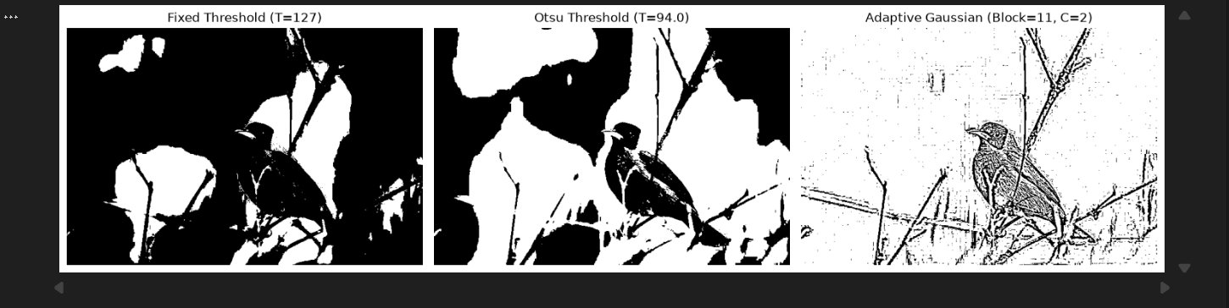

Comprehensive Rubric Explanations & Theory
1. Prevention of Numeric Overflow and Clipping Mechanism
Standard 8-bit image matrices utilize the uint8 data format, bounded strictly between 0 and 255. In uint8 arithmetic, values wrap around modulo 256. For example, 240 + 40 wraps to 24 (causing severe black blotches in bright highlights), and 20 - 40 wraps to 236 (turning dark shadows white). To prevent wraparound errors, operations must promote image arrays to wider representations (such as int32 or float64), clamp them explicitly using np.clip(val, 0, 255), and truncate back to uint8.
2. Brightness vs. Contrast Transformation
• Brightness (Additive Shift): Governed by s = r + β. It translates the entire intensity histogram uniformly left or right along the intensity axis without altering the distance or relative slope between individual bins.
• Contrast (Multiplicative Scaling): Governed by s = αr. It alters the spread and dispersion of histogram bins. When α > 1, the dynamic tonal separation between features is expanded; when α < 1, the histogram is compressed inward.
3. Gamma Correction Mathematical Convention
Gamma correction is defined by s = 255 * (r / 255)^γ. Normalizing to [0.0, 1.0] maps intensities along a continuous power-law curve. When γ < 1.0 (sub-linear), shadow and midtone intensities are pulled upward, expanding dark details without saturating bright highlights. When γ > 1.0 (super-linear), midtones are pulled downward, darkening underexposed areas. Crucially, the endpoints 0 and 255 remain invariant because 0^γ = 0 and 1^γ = 1 for all γ > 0.
4. Global vs. Local Enhancement and Thresholding Utility
• Global Operations (Global Histogram Equalization, Otsu Thresholding): Effective and computationally efficient when the illumination field is uniform and the intensity distribution is distinctly bimodal. However, they fail in scenes with spatial lighting gradients and unnecessarily amplify noise across flat regions.
• Local / Adaptive Operations (CLAHE, Adaptive Gaussian Thresholding): Crucial when illumination varies across the frame (e.g., vignetting or directional cast shadows). CLAHE prevents noise saturation by clipping local histogram peaks, while Adaptive Gaussian thresholding isolates fine boundaries and structural contours across varying background intensities.

