CISC7204 · DATA VISUALIZATION · PAIR PROJECT PROPOSAL
Breathing Unequal
Has New York City's air-quality improvement reached every neighbourhood? Fifteen years of PM2.5 across 59 community districts, 2009–2024
Student ID / name: MC662131 Fei Yue · Pair member: MC663216 Fei YuXin · Course: CISC7204 · Assignment 02, Revised Project Proposal · 21 October 2026

1. Title and guiding question
Between 2009 and 2024, did the 59 community districts of New York City converge in annual mean PM2.5 concentration, and is the remaining variation explained by traffic density and co-pollutants rather than by borough identity alone? The unit of analysis is the community district, the smallest geography at which the health department publishes annual air-quality estimates.
2. Background and motivation
New York City's air has become cleaner: nitrogen dioxide and fine particulate matter fell sharply after 2010 as heating oil switched to cleaner fuels, and the pandemic year produced the most abrupt drop in traffic in recent memory. A single citywide figure, however, cannot answer the question residents and policymakers ask — is the improvement reaching the blocks that carry the highest burden? Citywide averages are dominated by where people and emissions are concentrated, and they hide the difference between a district that halved its concentration and one that barely moved.
PM2.5 is the right indicator for this question: it is small enough to reach the alveoli, is linked to asthma and cardiovascular events, and is measured or modelled for every district every year. It is also spatially structured, responding to local traffic, building density and heating, so a district-level map carries real information. The city publishes enough adjacent material — traffic density, NO₂ and borough-level health outcomes — to test whether the residual pattern looks like a traffic pattern or an arbitrary geographic one.
3. Purpose
Outcomes — the project should turn encoding skills into an argument about who is still exposed:
- Produce a defensible answer a city agency could act on: which districts remain above the WHO guideline, and by how much.
- Build a reusable workflow — open-data API, tidy panel, weighted indicators, narrative — that transfers to other environmental or public-health datasets.
Skills — acquisition and analysis:
- Programmatic download from a government portal, recorded in a script so the analysis rebuilds from scratch.
- Reshaping a long indicator table into a district × year panel, joining population weights on a derived key, and applying weighting, correlation and simple regression.
- Designing a disciplined visual system: one palette, paired charts and finding-based captions.
Knowledge — content made concrete:
- PM2.5 and NO₂ as indicators, and the WHO 2021 guideline value of 5 µg/m³.
- The difference between concentration and population exposure, and the ecological fallacy that limits district-level inference about individuals.
4. Data
Both datasets are open government data on NYC Open Data (part of the data.gov network), downloaded on 21 October 2026 and stored in the project folder, so the notebook runs offline.
Dataset | What it contributes
Air Quality and Health Impacts  (NYC DOHMH, c3uy-2p5r) | Annual mean PM2.5 by community district, 2009–2024 (944 district-years); NO₂, ozone, benzene, formaldehyde and traffic density; borough-level modelled health impacts (asthma ED visits, hospitalisations, deaths).
Population by Community Districts  (NYC DCP, xi7c-iiu2) | Census population for the 59 districts (1970–2010), used to convert concentrations into population-weighted exposure.
Two limitations are stated up front. The district population series ends in 2010 because a later table is not published on the portal, so the weights are a stable proxy for the relative size of districts rather than a current count. The health-impact indicators are modelled estimates published only at borough level, giving five observations — enough for a descriptive cross-check, not for inference.
5. Analytical approach
Five steps, each producing one view: (1) a population-weighted citywide trend plotted over the 59 district trajectories; (2) a dumbbell chart pairing each district's 2009 and 2024 values, ordered by its 2024 concentration; (3) a comparison of absolute and relative dispersion — standard deviation against coefficient of variation — to test convergence; (4) scatters of district PM2.5 against traffic density (2019) and NO₂ (2024) with fitted lines and correlations; and (5) a population-weighted count of residents above the WHO guideline, followed by a borough-level asthma cross-check.
Design rules are fixed before the first chart: exactly six colours (#fdc0e1, #fecee6, #ffeef8, #c4dffc, #9ecafe, #71b0fd), one categorical assignment for boroughs, a pink-to-blue ramp for continuous values, black titles, no chartjunk, and a finding-based caption on every figure.
6. What the analysis shows
All numbers below are produced by the executed notebook, not typed by hand. The city improved substantially: the population-weighted mean fell from 10.90 to 6.54 µg/m³ (−40%), dipping to 6.27 in 2020, reaching a series low of 6.02 in 2022 and drifting back to about 6.7 by 2024.
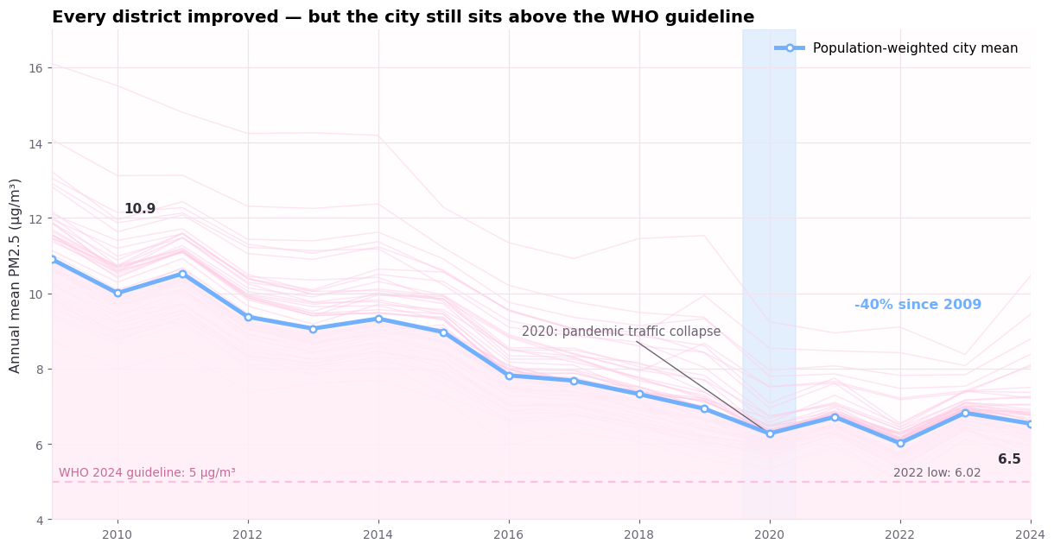
Figure 1. Population-weighted citywide PM2.5 with all 59 district trajectories behind it; the dashed line is the WHO 2024 guideline of 5 µg/m³.
Improvement is universal but unequal. Every district reduced its concentration, yet the ranking is sticky: Midtown (10.45 µg/m³), Greenwich Village/Soho (9.44) and Clinton/Chelsea (8.78) remain highest in 2024, while the Rockaways (5.26), Queens Village (5.43) and Bayside (5.48) are lowest. The largest proportional reductions — around 45% — occurred in the Bronx and the Upper East Side, districts that started high.
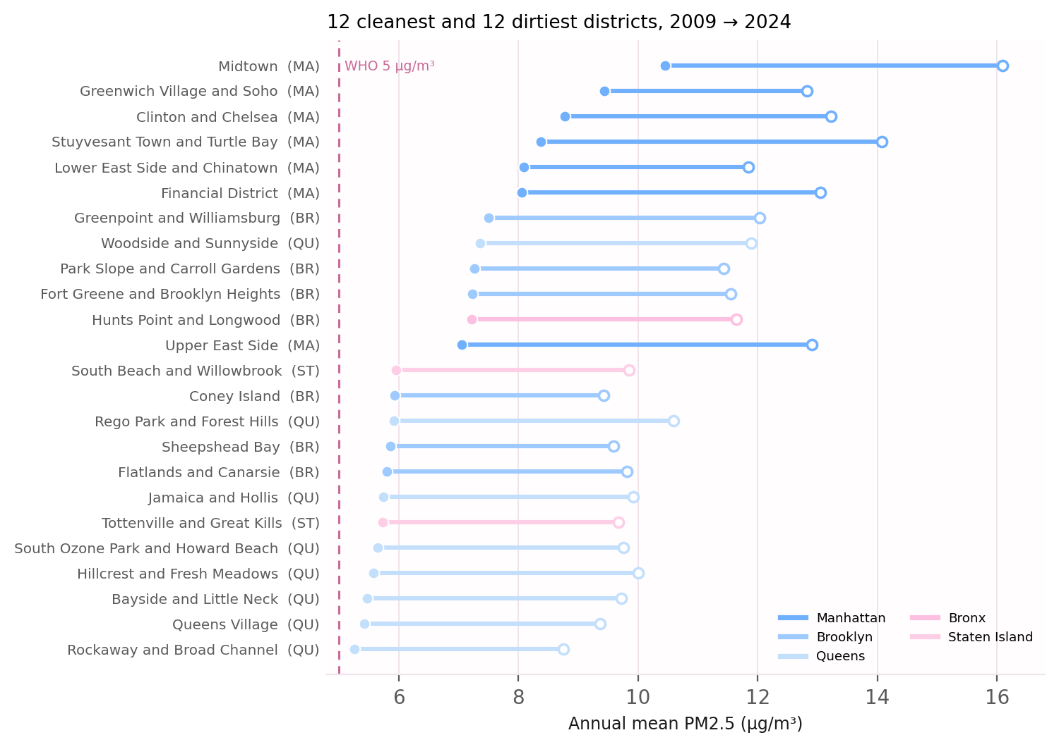
Figure 2. The 12 cleanest and 12 dirtiest districts: 2009 value (hollow) paired with 2024 value (solid), coloured by borough. The full 59-district version is in the notebook.
The gap narrowed in micrograms, not in proportion. Absolute dispersion fell (SD 1.25 → 0.94 µg/m³), but relative dispersion did not improve: the coefficient of variation was 11.3% in 2009 and 14.1% in 2024, and the dirtiest-to-cleanest ratio moved from 1.84× to 1.99×. Districts that started low improved proportionally faster.
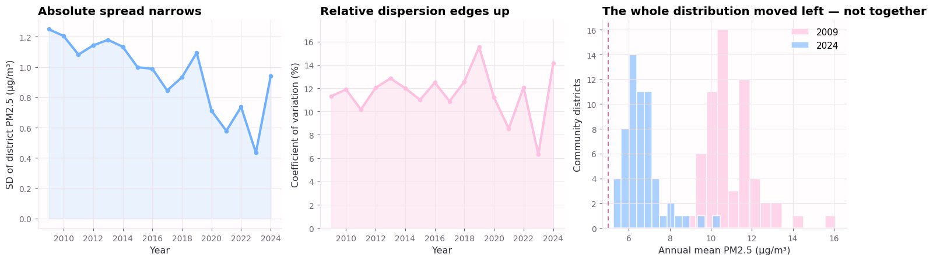
Figure 3. Absolute spread narrows while relative dispersion does not; the 2009 and 2024 distributions overlap but are not the same shape.
The residual pattern looks like traffic. District PM2.5 correlates with traffic density at r = 0.62 (2019) and with NO₂ at r = 0.90 (2024). The second is the stronger evidence: NO₂ is emitted almost entirely by combustion engines, so a near-perfect correlation between a gas and a particle points to a shared local source rather than to geography.
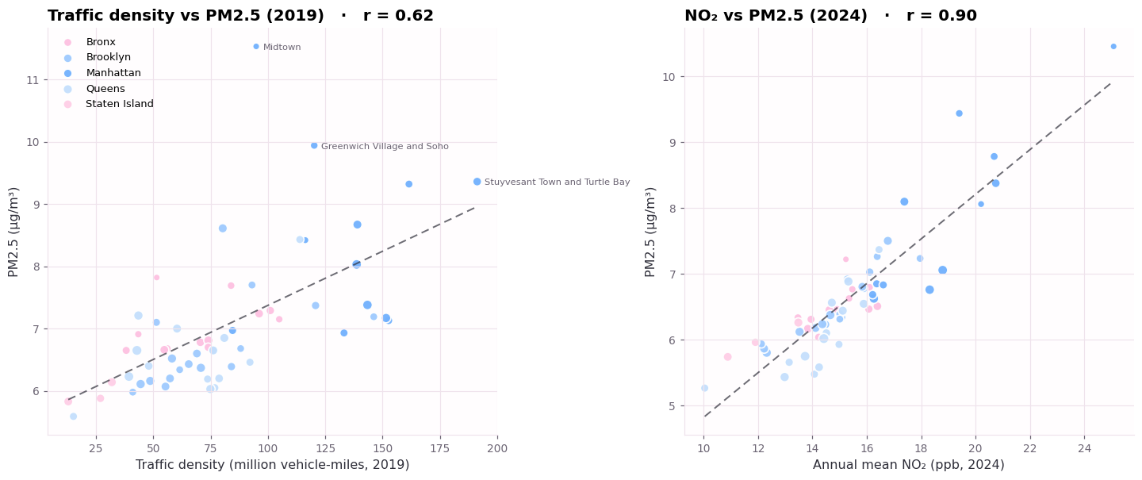
Figure 4. Traffic density (left) and NO₂ (right) against district PM2.5; bubble size is population and the dashed line is the least-squares fit.
The guideline is still out of reach for everyone. In 2024 all 59 districts exceeded 5 µg/m³ and the cleanest sits only 5% above it, so the exposure calculation returns a stark result: 100% of the population covered by the dataset lives in a district above the guideline, even as the citywide mean approaches it.
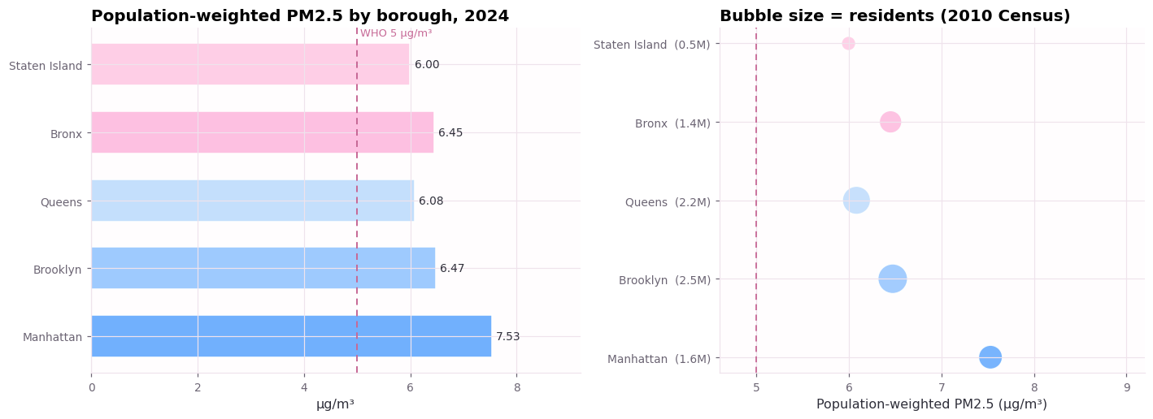
Figure 5. Population-weighted PM2.5 by borough (left) and population mass against exposure (right).
Air quality and health vulnerability are different maps. Borough-level asthma emergency-department rates for children are highest in the Bronx (108 per 100,000), which is not the borough with the highest PM2.5; the five-point correlation is only r = 0.56. This is not a test of association — it is a warning that pollution is one input among housing quality, poverty and access to care.
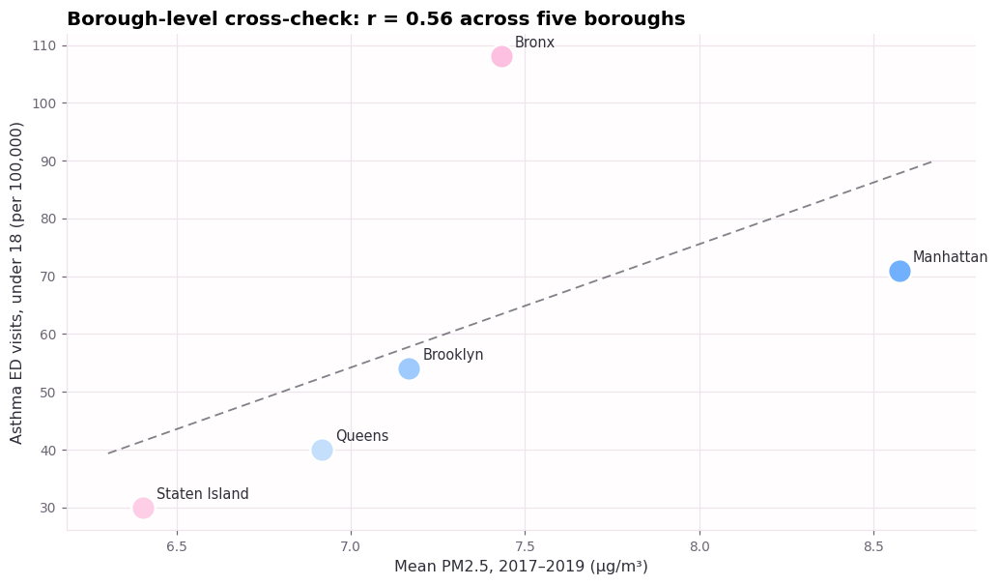
Figure 6. Borough-level cross-check: mean PM2.5 (2017–2019) against asthma emergency-department visits for children. Five points, descriptive only.
7. Deliverables, criteria and collaboration
Work is evenly split between Fei YuXin (MC663216) and Fei Yue(MC662131), with cross-review for all outputs.
Fei YuXin (MC663216) is responsible for project proposal revision, dataset retrieval and local caching, data cleaning, merging air-quality data with 2010 census population weights, constructing the district-year panel dataset, implementing population-weighted metrics, correlation and dispersion calculations, and writing the core reproducible notebook code. This member documents dataset limitations and verifies all computed numerical results.
Fei Yue(MC662131) takes charge of defining the unified visual style and colour palette, generating all six figures, composing finding-oriented figure captions, drafting the data dictionary, references, next-steps and figure inventory appendix, organising submission deliverables, performing palette accessibility checks, and conducting the second-reader review of code outputs, charts and text.
Both team members attend weekly sync meetings, jointly interpret analytical results, co-write conclusions, control project scope, and complete final proof-reading prior to submission.
8. Data dictionary
Variable | Definition and source
pm25 | Annual mean fine-particulate concentration (µg/m³) for a community district and year, 2009–2024. DOHMH modelled estimate, dataset c3uy-2p5r.
no2 | Annual mean nitrogen-dioxide concentration (ppb) for a district and year. Same dataset.
traffic | Traffic density in million vehicle-miles per district; only 2005, 2010 and 2019 are published. Same dataset.
pop2010 | Census population of the district in 2010, used as an exposure weight. Dataset xi7c-iiu2.
asthma_ed_u18 | Asthma emergency-department visits per 100,000 residents under 18, by borough, in five multi-year periods (2005–2007 to 2017–2019). Same dataset, borough rows.
Derived fields used in the notebook: borough, decoded from the first digit of the district code; district name, stripped of the '(CDn)' suffix; and the population-weighted mean, computed per year with pop2010 as the weight.
9. Next steps
- Add the US EPA's national PM2.5 monitor series as an independent measurement cross-check on the modelled city estimates.
- Join American Community Survey income and housing indicators by district to test whether the residual burden tracks deprivation rather than emissions alone.
- Fit a spatial lag model to separate local emissions from diffusion between neighbouring districts.
10. References
1. NYC DOHMH (2026). Air Quality and Health Impacts, NYC Open Data c3uy-2p5r. https://data.cityofnewyork.us/Environment/Air-Quality-and-Health-Impacts/c3uy-2p5r
2. NYC DCP (2026). New York City Population by Community Districts, NYC Open Data xi7c-iiu2. https://data.cityofnewyork.us/City-Government/New-York-City-Population-By-Community-Districts/xi7c-iiu2
3. World Health Organization (2021). WHO global air quality guidelines: particulate matter (PM2.5 and PM10), ozone, nitrogen dioxide, sulfur dioxide and carbon monoxide. Geneva: WHO.
Appendix. Figure inventory
Figure | What it shows and why it is there
1 | Citywide trend with all 59 district trajectories — establishes the improvement and the spread behind the average.
2 | Paired 2009/2024 district values — shows that improvement is universal but the ranking is sticky.
3 | Dispersion measures — tests convergence; absolute and relative spread disagree.
4 | Traffic density and NO₂ against PM2.5 — identifies the likely driver of the residual pattern.
5 | Population-weighted exposure by borough — converts concentration into people affected.
6 | Borough asthma cross-check — separates air quality from health vulnerability.

