ORDER MANAGEMENT DASHBOARD
OPERATIONAL PERFORMANCE REVIEW

STUDENT NAME | FELCIA SAIRAH SIJI
COURSE | MS IN DATA ANALYTICS
MODULE | DATA VISUALIZATION
INSTITUTION | TECHNOLOGICAL UNIVERSITY OF THE SHANNON (TUS), ATHLONE
DATE | 21-04-2025
DATASET | BRAZILIAN E COMMERCE DATASET BY OLIST

Declaration
I hereby certify that the material submitted in this report towards the award of MSc in Data Analytics is entirely my own work and has not been submitted for any academic assessment other than part fulfilment of the above-named award.

Signed: 
Date: 21/04/2025

2. Executive Summary:
The data visualization project focuses on improving the order fulfillment efficiency and the delivery performance using the Brazilian e-commerce Dataset by OList. The primary objective of the project is to identify delays, cancellations, and bottlenecks within the order processing. This analysis aims to improve overall business performance and customer satisfaction.
The analysis focuses on delivery performance as the core outcome variable, measured through various parameters such as delivery time, delivery delay, and on-time delivery rate. The factors that influence the order processing are analyzed, including order status, customer location, and temporal patterns in order placement. These variables play an important role in helping understand how operational and logistical elements impact fulfillment efficiency.
Data Preparation was performed in Tableau and involved integrating multiple datasets using relationships. The data types used in the dataset were standardized, mainly for date variables so that calculations will be accurate. Missing values such as delivery dates were handled by creating a new field called Delivery Status variable which classified orders as delivered or not delivered instead of deleting the records. To avoid distortion of key metrics, cancelled orders were identified and excluded from delivery performance calculations. For more deep analytical insights, derived variables such as delivery time and delivery delay were created.
Exploratory Data Analysis showed that the majority of orders are successfully delivered, which indicates an efficient order fulfillment process. However, there is also the presence of delivery delays and a small number of cancelled orders which indicate that operational improvements are needed in this area. Trends show that there are fluctuations in order volumes. Geographical analysis indicates that delivery performance varies across regions and logistical inefficiencies.
The findings from this analysis are important for managerial decision-making. The delays in delivery can have a negative impact on customer satisfaction that would increase cancellation rates, and lead to potential revenue loss. The company can take targeted actions such as improving processing times and enhancing regional operations by identifying bottlenecks in processing and shipping.
In short, this project aims to demonstrate how data-driven analysis support strategic decisions to improve delivery efficiency, so that cancelations can be reduced, strengthening customer experience, thereby helping the business maintain a competitive advantage in the e-commerce industry.
Overall, this project demonstrates how data-driven analysis can support strategic decisions aimed at improving delivery efficiency, reducing cancellations, and strengthening customer experience, thereby helping the business maintain a competitive advantage in the e-commerce industry.

Table of Contents:
- Declaration.........................................................................................................2
- Executive Summary...........................................................................................3
- Glossary of Terms..............................................................................................5
- Introduction........................................................................................................6
- Dataset Description............................................................................................7
- Methodology......................................................................................................8
- Data Visualization and Analysis........................................................................9
- Dashboard..........................................................................................................14
- Key findings.......................................................................................................15
- Recommendations..............................................................................................15
- Conclusion..........................................................................................................16
- Bibliography.......................................................................................................17
- Appendix A: Data Preparation and Calculated Fields…………………………18
- Appendix B: Data Dictionary……………………………………………….....20
- Appendix C: Additional Charts………………………………………………..21

3.Glossary of Terms:

Terms | Definition
Delivery Performance | The Delivery Performance shows how well we do our job of getting orders to customers. It is measured by things like whether deliveries on time how long they take and if there are any problems.
Delivery Delay | A Delivery Delay happens when an order takes longer to arrive than it should. It is the difference between when the order arrived and when it was supposed to arrive.
On-Time Delivery Rate | The On-Time Delivery Rate is the percentage of orders that arrive on or before the day they were supposed to.
Cancellation Rate | The Cancellation Rate is the percentage of orders that get cancelled before we can complete them.
Geographic Analysis | The Geographic Analysis is when we look at how our delivery process works in different areas.
Dashboard | The Dashboard is a tool that helps us see how well everything is working. It shows us a lot of information like charts and graphs all in one place.
Order Fulfillment Bottleneck | An Order Fulfillment Bottleneck is when there is a problem in our order fulfillment process that slows everything down.
Key Performance Indicator | A Key Performance Indicator is a way to measure how well something is working.

4.Introduction
The rapid growth of the e-commerce sector day by day has reshaped the global retail environment leading to an increase in customer expectations such as high delivery speed, service transparency, and reliability. Today, efficient order fulfillment and on-time delivery have become critical elements of customer satisfaction and organizational performance. Delivery Delays, cancellations within the order delivery process can have an adverse effect on customer trust and retention and hence the need to optimize logistics and operational workflows.
This study mainly focuses on the analysis of order processing performance using the data obtained from Brazilian e-commerce platform. This dataset contains all details of the order lifecycle including order placement, processing, shipment till order delivery, and also includes the customer and geographical data. These details enable a comprehensive evaluation of the order fulfillment process and facilitate the identification of inefficiencies within the system.
By assessing the key metrics such as delivery time, delivery delay, and on-time delivery rate, the analysis is primarily focused on delivery performance. These metrics provide a quantitative basis for evaluating the effectiveness and reliability of the fulfillment process. Additionally, the study aims to identify patterns and inconsistencies across different regions by examining temporal trends and geographic disparities in delivery performance.
Moreover, this project seeks to identify operational bottlenecks within the order processing by analyzing different order status distributions such as completed and cancelled orders. A part of analysis is finding out the factors contributing to delays and inefficiencies, which may happen due to seller-related processes or regional infrastructural constraints.
The insights from this analysis contribute to a deeper understanding of order fulfillment dynamics within e-commerce systems. By providing data-driven insights into performance gaps and inefficiencies, the analysis aims to inform strategic decision-making and support the development of targeted interventions to enhance delivery efficiency, reduce cancellations, and improve overall service quality.
Business Questions:
Three questions shaped the analysis:
What factors are causing delays and inefficiencies in order fulfillment and delivery?
Which states or regions have the highest delivery delays? Which regions need operational improvements?
What proportion of orders are delivered vs cancelled?

5.Dataset Description
The dataset used for the analysis is the Brazilian E-Commerce dataset provided by Olist taken from Kaggle. This dataset contains data related to orders that are placed on an e-commerce platform, including geographical details, order timestamps, delivery details, customer information, and order status.
The dataset contains multiple related tables such as orders, customer, order items, and sellers. To get an overall view of the order lifecycle, the tables were integrated. The tables integrated are the customer details, order details, and delivery details. The key variables used for the analysis includes order purchase date, states etc
The dataset contains details of both cancelled and delivered orders, enabling the complete analysis of order fulfillment lifecycle. Missing values in the dataset were identified and handled during data preparation.
Key Categorical Variables
The core categorical variables are used for grouping, filtering, and segmentation includes:
Order ID: A unique identifier assigned to each order. It is used to track individual transactions across different tables.
Customer ID: Identifies each customer in the dataset. It allows analysis of customer-level behavior.
Order Status: The current state of an order (e.g., delivered, cancelled, shipped)for distinguishing valid orders from cancelled ones.
Customer State / City: Represents the geographic location of the customer. This is used for regional analysis of delivery performance and identifying geographic disparities.
Order Purchase Timestamp: The date and time when the order was placed, used for time-series analysis and identifying trends over time.
Key Measures: Numerical & Time Variables
These variables are used for calculations and performance evaluation:
Order Delivered Customer Date: The actual date when the order was delivered to the customer. This is essential for calculating delivery performance metrics.
Order Estimated Delivery Date: The expected delivery date promised to the customer. This is used as a benchmark to measure delays.

6. Methodology
Data preparation and analysis were conducted using Tableau. Multiple datasets were integrated using relationships to maintain data integrity analysis. The analysis involved data preparation – to clean and transform the raw data to remove redundancy and maintain accuracy. This included removing duplicates, standardizing the date formats and validating key formats. Derived variables were created to support the analysis.
Several calculated fields were created to support the analysis:
- Delivery Time: Difference between order purchase date and actual delivery date. Measures the total time taken to deliver an order
- Delivery Delay: Difference between estimated and actual delivery dates. Measures how late or early a delivery was
- Clean Delivery Time: Delivery time calculated only for successfully delivered orders
- Delivery Status: Classification of orders as delivered or not delivered
- Valid Order: Indicator used to filter out cancelled orders. A binary indicator used to exclude cancelled orders from delivery performance calculations
Exploratory Data Analysis (EDA) was performed to understand the structure of the data, identify patterns, and validate assumptions before building the dashboard. After Data Preparation, a set of Key Performance Indicators (KPI's) was selected to measure operational efficiency and service quality. The KPI's for the order management dashboard includes total orders, delivered orders, on time delivered orders, cancelled orders and the average delivery time taken. Comparative analysis was carried out across different order statuses to evaluate how delivery performance varied between successfully fulfilled and cancelled orders.
6.1. Filters Used:
The dashboard contains various interactive filters to improve flexibility and to promote user driven exploration of order management performance. The primary filters used in the dashboard include Order Status, Customer State, Month of Order and a range-based filter for Average Delivery Days. These filters play an important role in the multidimensional analysis of order management.
The Order Status filter helps the user to analyze the data within specific categories such as delivered, cancelled, or all orders. This is useful even for comparing performance metrics across different outcomes such as identifying whether cancelled orders exhibit longer delivery times. By using the filters selectively, it is easy to identify patterns associated with failed transactions or how the order fulfillment performance differs. This helps identify whether delays or inefficiencies are associated with higher cancellation rates.
The Customer State filter gives a geographic dimension to the analysis. This helps management to focus on specific areas or states that are underperforming and prioritizing improvements where it is necessary. This is important for identifying areas with consistently high delivery delays and guiding resource allocation or logistics optimization strategies.
The Month of Order filter supports the analysis of temporal trends helping to identify seasonal fluctuations in order volumes and delivery performance. This allows management to anticipate peak demand periods and ensure adequate capacity planning to maintain service levels during high-volume intervals.
The Average Delivery Days filter provides the ability to focus on specific delivery time ranges, enabling the identification of both high-delay orders and best-performing cases. This supports root cause analysis of inefficiencies and highlights opportunities for process improvement.
Overall, these filters enhance the dashboard’s functionality by enabling targeted analysis and rapid identification of performance issues. This interactive capability supports proactive decision-making, helping to improve delivery efficiency, reduce delays, and strengthen overall operational performance.

7.Data Visualization and Analysis
This section presents the key insights derived from the dashboard, structured around the main analytical objective:
What factors are causing delays and inefficiencies in order fulfillment and delivery?
The analysis focuses on delivery performance, temporal trends, geographic variation, and order status distribution to identify operational bottlenecks and areas for improvement.
7.1 Order Volume Trend Over Time
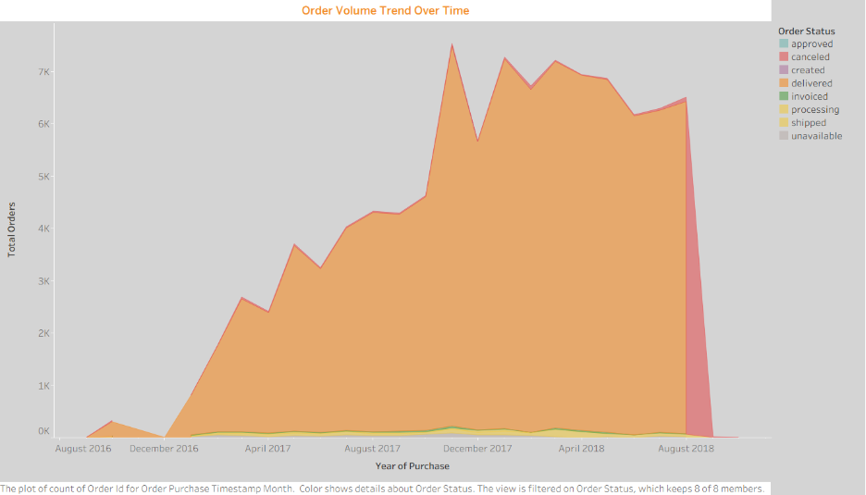
The Order Volume Trend Over Time chart shows the growth and distribution of orders across different order statuses such as approved, cancelled, delivered, processed, created from 2016 to 2018. Overall, there is a significant increase in total order volume over time. There is a sharp increase in the number of orders throughout 2017 and a peak rise in late 2017 to early 2018. This indicates rapid business expansion during this period.
Delivered orders dominate among all other order status and constitute most total transactions. Hence, reflecting a high fulfillment success rate.
Other order statuses, such as cancelled, shipped, and processing, represent only a small area of total number orders compared to the delivered status and remain almost stable over time. However, there is a noticeable increase in cancelled orders towards the end of August 2018, which may be due to operational disruptions or data incompleteness during that period. Overall, the chart shows strong growth in demand throughout the years. Moreover, this indicates that the platform maintains a high delivery completion rate despite increasing order volumes.
This growth points out to the increasing customer adoption and expansion of the e-commerce platform. However, rising order volumes can also place pressure on logistics and fulfillment systems. When demand increases rapidly, existing infrastructure may struggle to maintain efficiency, leading to delays.
The chart also highlights periods of increasing growth, which may be due to seasonal demand or any type of promotional activity. From an operational perspective, these peak periods are very critical as they always coincide with the higher delivery times.
7.2 Delivery Performance Analysis (Delivery Time Trend)
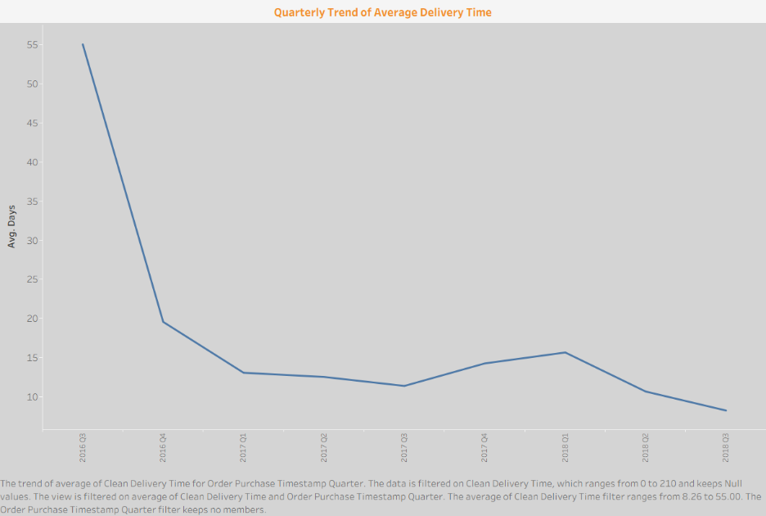
The line chart above shows how the average delivery time varies across each quarter from 2016 Q3 to 2018 Q3. The trend is strongly downwards which suggests that the delivery performance has increased significantly over time. Initially, the average delivery time was very high, but gradually the time reduced by 2016 Q3 and then stayed at a much low and stable level.
In 2016 Q3, the average delivery time was about 55 days, which is the highest on the above chart. But by the end of 2016 Q4, it decreased steeply to about 20 days showing improvement. After that, the values continued to decline and reached about 11 to 13 days which suggests that the delivery process became more consistent.
On close observation, it can be seen that there is an increase in the delivery time of about 14 to 16 days in 2017 Q4 and 2018 Q1, which may be due to seasonal demand or operational delays. But this rise is temporary as the delivery time falls back to 8 to 10 days. This shows that there is better fulfillment options and fast order processing by the end of the time period.
This chart shows a positive trend because low delivery time usually leads to better customer satisfaction, reliability and stronger service quality. The chart highlights that after an initially weak performance, the delivery system improved steadily and ended at its best level in the period shown.
7.3 Distribution of Delivery Time by Order Status
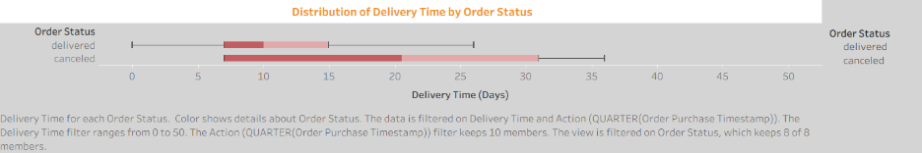
The above boxplot compares delivery time in days for order status mainly for delivered and cancelled orders. This chart not only shows the typical delivery time but also how much variation exists within both order status. In this analysis, this chart is very useful for understanding if the cancellations are due to the longer delivery times and if the delivered orders are completed efficiently.
The boxplot shows that the delivered orders have a lower delivery time compared to the cancelled orders. The middle part of the delivered category is focused on a shorter time range which indicates constant fulfillment, whereas canceled orders have a wider spread, suggesting that the delivery times vary more, sometimes may include delays or unstable processing patterns.
It can be seen that Canceled Orders have a higher upper range than delivered orders indicating that some orders were canceled because it was delayed too long. This reflects operational issues or stock problems within the platform. The overlap between two groups in the boxplot is not the main reason for cancellation, but it is a strong contributing factor.
In summary, the chart shows how fast and consistent the delivery is linked with successful order delivery. Reducing delivery days may help lower cancellation and improve customer experience.

7.4 Distribution of Delivery Time by Order Status
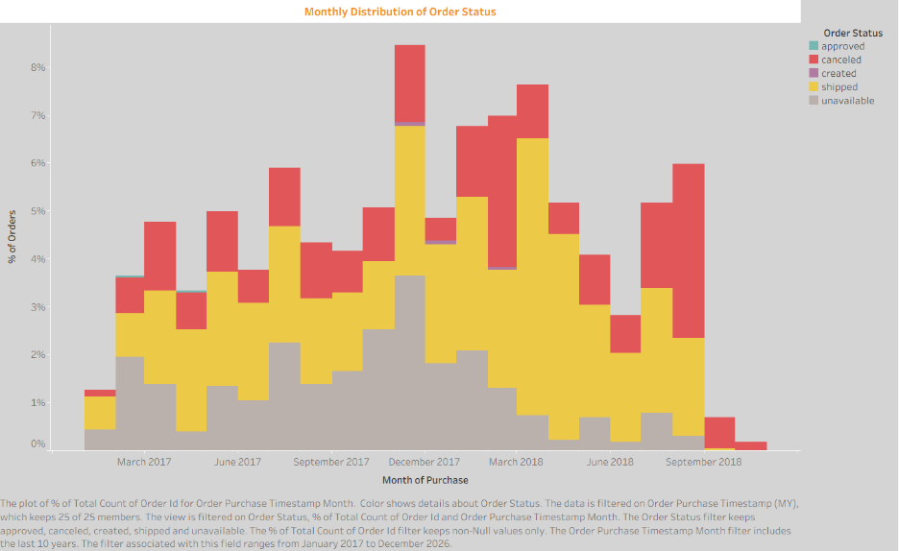
This chart presents the monthly distribution of order statuses across the observed period, with the data grouped by month of purchase. This chart shows an overview of how different order status such as shipped, cancelled, approved and unavailable varied over time. This chart is useful for identifying the changes in operational performance and also in understanding if there is a higher level of successful fulfillment in any month.
The most dominant and prominent category in the chart is the shipped category. This indicates that a large number of orders were successfully processed and dispatched. Order fulfillment remained relatively effective in most months. There is also a significant number of cancelled orders in the later months, which may be due to issues such as delayed processing, inventory shortages, or customer cancellations. There is also the presence of unavailable categories which indicates that some orders could not be completed due to product availability.
The stacked structure of the chart highlights that multiple order statuses contributed to the total monthly volume, rather than a single dominant outcome. Overall, this pattern suggests the need for stronger inventory planning, improved processing efficiency, and closer monitoring of periods with elevated cancellation activity. Such measures could help enhance the fulfillment of reliability and improve customer satisfaction.

7.5 Distribution of Delivery Time by Order Status
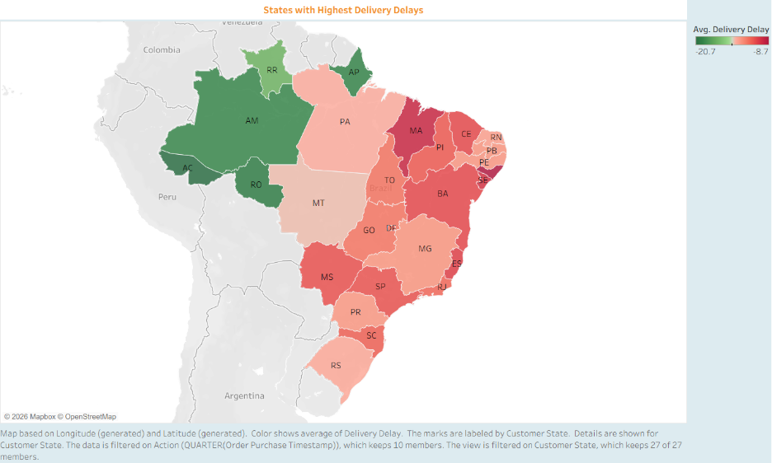
This map above shows the average delivery delay across different states in Brazil. The color scale represents the level of delay, with dark red shades indicate higher delays and green shades indicate lower delays. It helps in identifying the regions where delivery performance is weaker and where operational performance may need improvement.
The chart suggests a clear regional pattern in delivery delays. Several states in the northeastern and southeastern parts of Brazil show higher delay values, especially in states such as Bahia, Maranhão, Piauí, and Sergipe. These regions appear in stronger red tones indicating that deliveries in these areas generally take longer than in other states. Some northern states such as Acre, Amazonas, and Rondônia appear in green, suggesting comparatively lower average delays.
This pattern in the chart may reflect differences in infrastructure, transport availability, geographic distance, or operational efficiency across regions. States with higher delays may be more difficult to deliver due to longer transit routes, weaker logistics networks, or slower last-mile delivery processes. The chart therefore highlights specific locations where delivery operations may need to be improved.
Overall, the map shows that delivery performance is not uniform across the country. It suggests that improving logistics in high-delay states could help reduce delivery times, improve customer satisfaction, and create a more consistent service experience nationwide.

8.Dashboard:
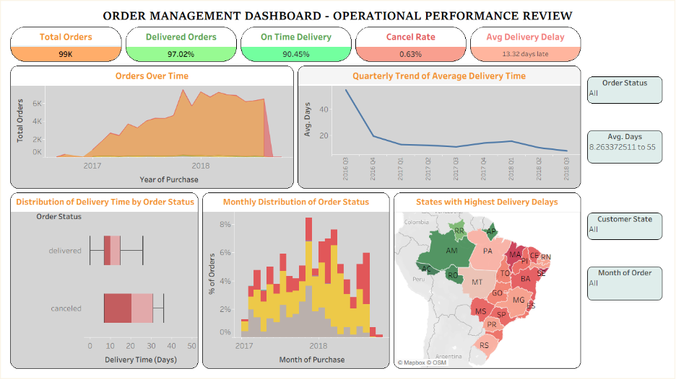
The Order Management Dashboard – Operational Performance Review consists of multiple analytical components integrated into a single interactive interface for managers to get comprehensive overview of order management performance. This dashboard is developed as a unified reporting tool, enabling quick assessment of operational efficiency, delivery reliability, and regional performance without requiring the examination of separate reports.
The dashboard is structured into various zones. The header in the dashboard represents the title. The title is followed by the key performance indicator (KPI) tiles. These indicators provide an immediate summary of system performance and dynamically get updated when necessary, filters are applied. These KPI tiles summarize the critical metrics in the analysis, such as total orders (99K), delivered orders (97.02%), on-time delivery rate (90.45%), cancellation rate (0.63%), and average delivery delay (13.32 days late). Beneath the KPIs, the main visualization area is divided into multiple sections: the top row contains an area chart illustrating order volume trends and a line chart showing quarterly changes in average delivery time, while the bottom row includes a box plot of delivery time by order status, a stacked bar chart of monthly order status distribution, and a geographic map highlighting states with the highest delivery delays.
The dashboard also contains interactive filters on the right-hand side, including controls for order status, average delivery days, customer state, and month of order. These filters are applied simultaneously across all visualizations. For example, selecting a specific state or order status will automatically update the time trends, delivery distributions, and geographic map showing the relevant subset of data. This interactivity allows users to drill down into specific operational segments without the need to recreate individual charts.
In short, the dashboard supports descriptive analysis of historical performance but also include diagnostic insights. By combining temporal trends and distributional analysis, it enables managers to identify inefficiencies—such as regions with high delivery delays or periods with increased cancellations—and supports data-driven decision-making to improve logistics and customer satisfaction.

9.Key findings:
- The number of orders increased gradually over time. The peak increase of orders was around 2017-2018, indicating the expansion of business activity.
- Average delivery time improved after 2016 – indicating process optimizations or operational enhancements were implemented but it was not a longer term since there are fluctuations later, showing instability when there is high demand.
- A large number of orders were delivered later than the estimated delivery dates, which can negatively affect the customer satisfaction and also pointing to the underlying issues with delays and stock issues
- Delivery performance varies across various regions. Some states experience higher delays that points to structural inefficiencies in the network.
- Among all the challenges, a majority of orders are successfully delivered suggesting that overall the platform is effective and functional but the cancellation of orders shows the gap in the order processing or customer experience.
With all these findings, even though the business is scaling successfully, the operational systems are not fully optimized for consistency and equitable performance across regions. This highlights the need for a more scalable solution.
The findings clearly answer the core question: Delays and inefficiencies in order fulfillment are primarily driven by high order volumes, regional logistical challenges, and inconsistencies in operational performance over time.
10.Recommendations:
- Identify states with consistently high delivery delays and prioritize them for operational improvement. This can be implemented by setting up warehouses or distribution hubs.
- Optimize delivery routes using route planning and tracking technologies by Tracking on-time delivery rate
- Increase the number of staffs, inventory stocks, and logistics capacity during high-demand periods by expanding logistics infrastructure ahead of demand
- Monitor and address the reasons for extreme delivery delays
- Reduce delays in order confirmation, packaging, and dispatch. This can be done by analyzing the reasons for cancellation, Reducing order-to-ship time and Improving order confirmation speed.
- Provide proactive updates to customers regarding order status and delivery timelines.
10.1 Ethical Issues:
Data visualization can cause ethical issues if the data is not handled or treated properly. One of the ethical concern with data visualization is the misintepretation of data. If the axes of the visuals are changed, scaling is not correct or if only selective data is shown, then the visual gives an unreal picture than reality. Bias of data is another main concern. Sometimes Bias may be introduced unintentionally such as wrong use of colors, labels or the type of chart. This can sometimes emphasize some trends while neglecting others.
Another main and important ethical issue in data visualization is the responsible use of data and the data privacy associated with it. Proper anonymization must be applied to avoid the risk of exposing confidential information. Poorly designed or complex visualizations may sometimes lead to misintepretation leading to incorrect decisions. It is very much essential to ensure accuracy, clarity and transparency in visualizations simultaneously protecting the privacy of the user.

11.Conclusion:
The analysis of the order management dataset shows that the business has strong growth and maintains a generally effective fulfillment system, as it has high delivery success rate. However, this growth also has possess operational pressures which resulted in inconsistent delivery performance, cancellation of orders, and regional delivery issues. While delivery time improvements have been made, the lack of consistency indicates that these improvements is not implemented across all regions. Moreover, delivery delays and cancellation of orders shows the upcoming inefficiencies in order processing.
In short, the findings suggest that the organization is in a transitional phase where its existing operational systems are not sufficient enough to support continued growth at the same level of efficiency. To remain competitive and promote customer satisfaction, the business must move beyond short-term fixes and adopt more scalable, data-driven, and region-specific strategies. By improving consistency, reducing delays, addressing geographic issues, and strengthening operational infrastructure, the company can build a more reliable order fulfillment system that supports long-term growth and delivers a better customer experience.

12.Bibliography:
- Kaggle. (n.d.). Brazilian E-Commerce Public Dataset by Olist.
- Tableau Software. (n.d.). Tableau Desktop.

Appendix A: Data Preparation and Calculated Fields
Calculated Fields:
Field Name | Calculation | Description
Delivery Time | DATEDIFF('day', [Order Purchase Timestamp], [Order Delivered Customer Date]) | Difference between order purchase date and actual delivery date.
Delivery Delay | DATEDIFF('day', [Order Estimated Delivery Date], [Order Delivered Customer Date]) | Difference between estimated and actual delivery dates.
Clean Delivery Time | IF [Order Status] = "delivered" THEN  DATEDIFF('day',[Order Purchase Timestamp],[Order Delivered Customer Date])  END | Delivery time calculated only for successfully delivered orders
Performance Category | IF [Delivery Delay] < -5 THEN "Very Fast"  ELSEIF [Delivery Delay] < 0 THEN "Fast"  ELSE "Delayed"  END | Classification of orders as fast or delayed
Valid Order | IF [Order Status] = "canceled" THEN "No"  ELSE "Yes"  END | Indicator used to filter out cancelled orders

Data Preparation:
- Cleaned the dataset by removing duplicates and handling missing or inconsistent date values.
- Converted all date fields (order, shipping, delivery) into proper date formats for accurate calculations.
- Created calculated fields such as delivery time and delivery delay to support analysis.
- Filtered the data to include only relevant records (e.g., delivered orders for delay analysis).

Appendix B: Data Dictionary
The table below defines all variables used in the analysis.

Column Name | Data Type | Definition
order_id | String (Categorical) | Unique identifier for each order
customer_id | String (Categorical) | Unique identifier for each customer
order_status | Categorical | Current status of the order (e.g., delivered, shipped, canceled)
order_purchase_timestamp | Date/Time | Timestamp when the order was placed
order_approved_at | Date/Time | Timestamp when the order was approved
order_delivered_carrier_date | Date/Time | Timestamp when the order was handed over to the carrier
order_delivered_customer_date | Date/Time | Timestamp when the order was delivered to the customer
order_estimated_delivery_date | Date/Time | Estimated delivery date provided to the customer

Appendix C: Additional Charts and Tableau Screenshots
Extra charts created throughout the analysis that aren't shown on the main dashboard are included in this appendix. You should add screenshots of every Tableau worksheet below.
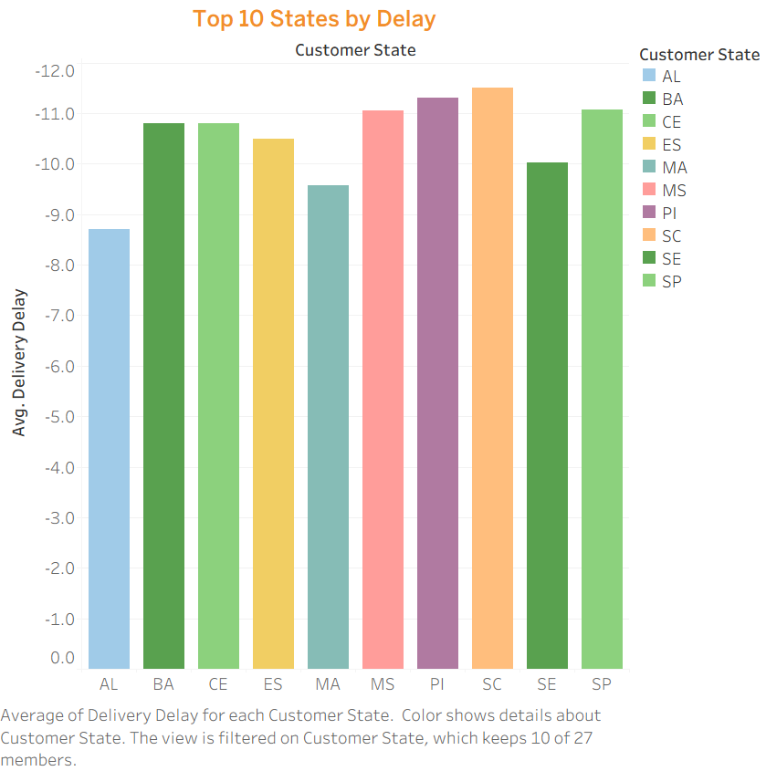
The chart shows that certain states consistently experience higher average delivery delays, highlighting regional inefficiencies in logistics performance.
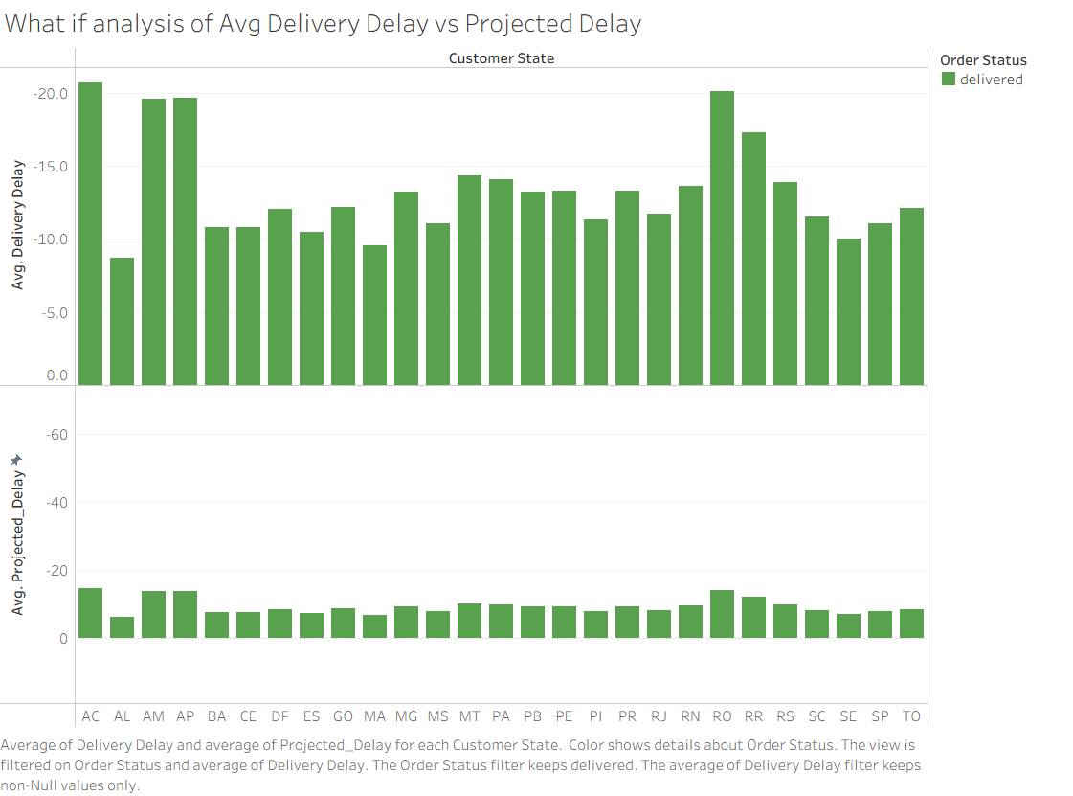
The chart compares actual and projected delays across states using the What if feature in Tableau revealing gaps between expected and real performance and indicating inconsistencies in delivery accuracy. A calculated parameter called Improvement Percentage is created to see the difference between Projected Delivery and the Delivery Delay.

