**Group 1: Daniel Dehnel, Jimmy Ho, Alex Modyil**

**Concept Location**

|  |  |  |
| --- | --- | --- |
| Step # | Description | Rationale |
| 1 | We searched for “Treatment Given” and related phrases in the entire solution using the intelliJ IDE search function. | Identify the screens or graphical elements that need to be changed. |
| 2 | We identified that the label is coming from treatementTab.scala.html. |  |
| 3 | We looked at the project structure of the above identified file and guessed that the given file is used somewhere under the Medical Menu, since the file was listed under medical. | Trace which UI elements or features the screen is related to. |
| 4 | We tried searching for some patients but we got a “That patient's encounter has been closed” message. | Find a patient with nonzero number of treatments to test. |
| 5 | We decided to submit a new patient with the assumption that it might help to enter the medical info. |  |
| 6 | We created a patient and searched the medical records using the new patient id and then we were able to get to the treatments tab and we verified the label is “Treatment Given”. |  |
| 7 | We looked for the value “treatment” under the tab_fields table. | To find what table and column to change in the database. |

**Time spent (in minutes):** 30

**Impact Analysis**

|  |  |  |
| --- | --- | --- |
| Step # | Description | Rationale |
| 1 | We considered the label change for “Treatment Given” as moderately low risk | It only involves changing a label on the UI, as well as a name of a column in the DB. So long as we're diligent and find all the references, there should not be any chance of bugs or unwanted side effects. |
| 2 | We started a case-sensitive search for the word “treatment” in the entire solution and came with results in following classes:   1. MedicalController.java 2. DatabaseSeeder.java 3. HistoryController.java 4. Edit.scala.html 5. PDFController.java 6. indexEncounter.scala.html 7. treatmentTab.scala.html | Find the impact of changing the label and DB column name by locating all references to it in the code. |
| 3 | We analyzed each of the files with tables tab_fields & tabs and eliminated MedicalController, DatabaseSeeder, HistoryController, and Edit.scala. | Unrelated to tabField name change. |

**Time spent (in minutes):** 30

We did not perform any pre-refactoring for this change request as it involved only 3 files.

# **Actualization**

|  |  |  |
| --- | --- | --- |
| Step # | Description | Rationale |
| 1 | We added a new SQL file (99.sql) to the default evolution to update the record in tab_fields. | Update table tab_fields with new column name. |
| 2 | We update the usage of the field name “treatment” in PDFController, indexEncounter.scala & treatmentTab.scala. | To ensure the tab field is read correctly. |
| 3 | We update the label for "Treatment Given" with "procedure_counseling" in treatmentTab.scala.html | Label change as specified in change request. |

**Time spent (in minutes):** 10

We did not perform any post factoring for this change request.

**Validation**

|  |  |  |
| --- | --- | --- |
| Step # | Description | Rationale |
| 1 | We restarted the application/webpage. |  |
| 2 | We searched for the user we created before and verified the label changed to “Procedure/counseling”. | Verify label change applied appropriately. |
| 3 | We entered some value for the label “Procedure/counseling”, saved the patient and verified the value was saved by viewing the treatment again. | Make sure the system can save to the new field name. |
| 4 | Clicked on patient’s history on the medical screen and viewed the encounter and verified the treatment field value. | Verify that the “treatment” field is reading the tab field appropriately on the Encounter screen. |
| 5. | Clicked Generate PDF on the encounter and verified the value again. | Also verify the PDF displays the correct value. |

**Time spent (in minutes):** 20

**Timing**

Summarize the time spent on each phase.

|  |  |
| --- | --- |
| Phase Name | Time (in minutes) |
| Concept location | 30 |
| Impact Analysis | 30 |
| Prefactoring | 0 |
| Actualization | 10 |
| Postfactoring | 0 |
| Verification | 20 |
| Total | 90 |

**Reverse engineering**

This change request impacts a few interactions especially when they request the tabservice to get the tab fields

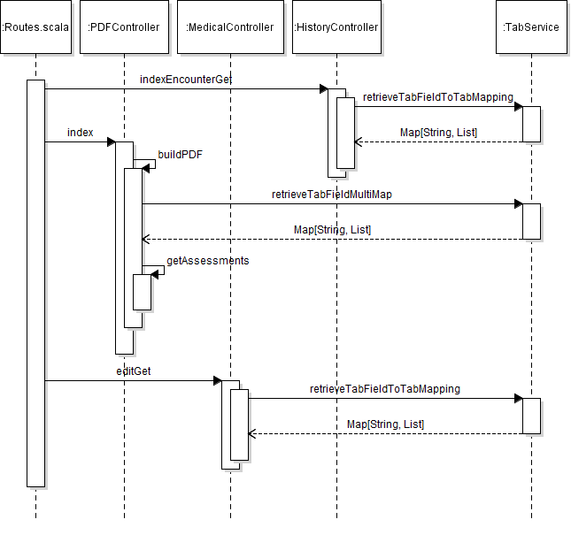

These were the important classes along with their members and methods. The class diagram has grown very large so has been split into 2 separate parts.

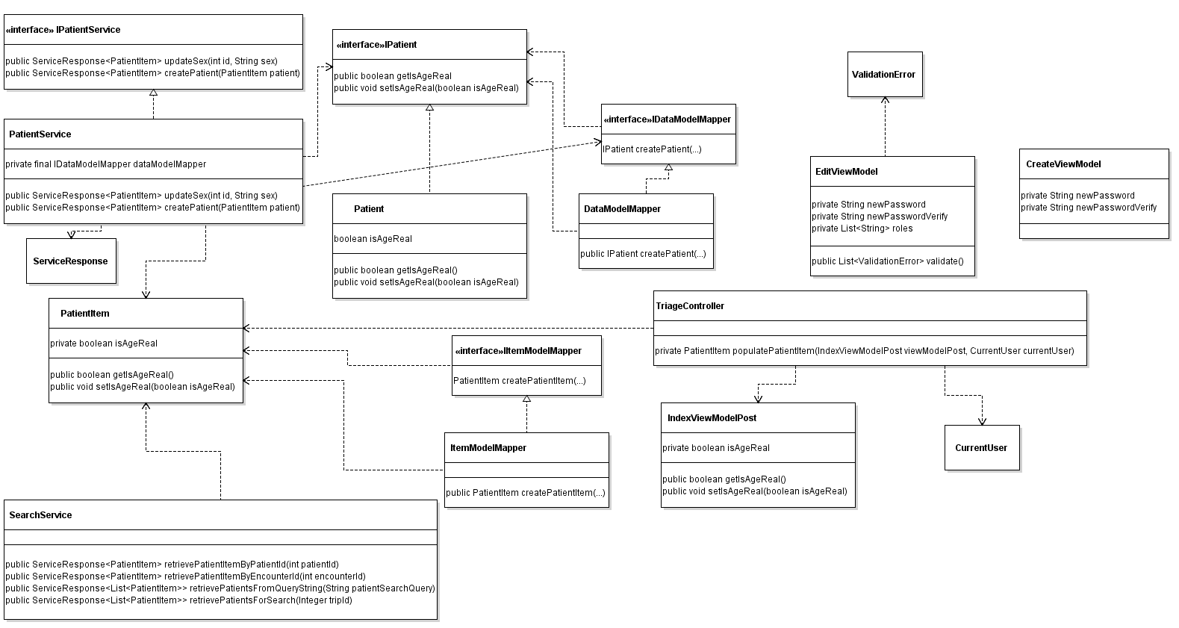

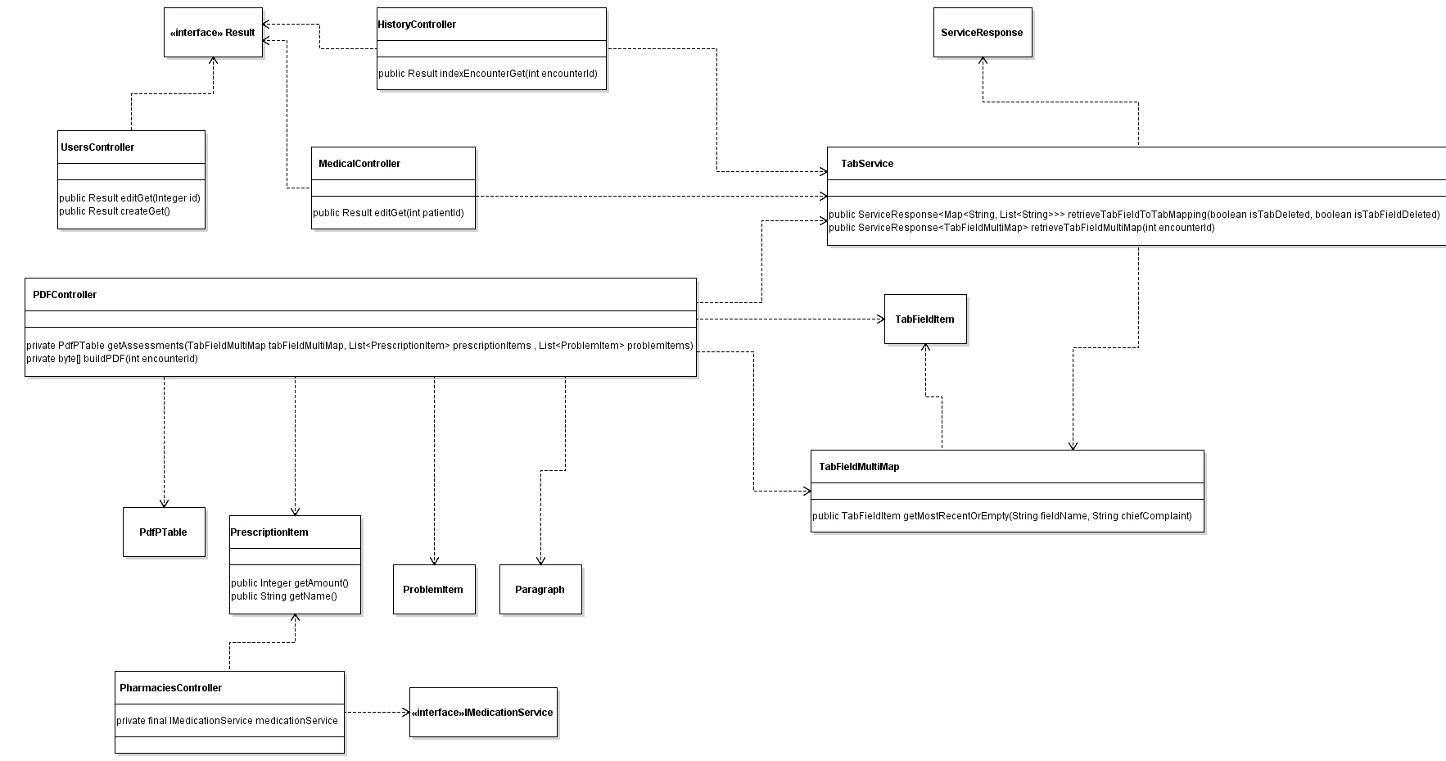

**Conclusions**

The change request had some degree of complexity around the field name change in table tab_fields. Doing impact analysis to trace the usage of the field name and analyzing whether it need to be changed took the most effort, followed by searching the screens impacted by the change. The label change in itself was very simple.

Alex did the coding for this change request; Alex, Jimmy and Daniel did the documentation.

Classes and methods changed:

* \femr\app\femr\ui\views\history\indexEncounter.scala.html
* \femr\app\femr\ui\views\partials\medical\tabls\treatmentTab.scala.html
* \femr\app\femr\ui\controller\PDFController.java
  + privatePdfPTable getAssessments (TabFieldMultiMap tabFieldMultiMap, List<PrescriptionItem> prescriptionItems , List<ProblemItem> problemItems)

Added SQL

* \conf\evolutions\default\99.sql