Library Management Database: SQL Implementation
Olufemi Keripe | CS 2203: Databases 1 | Unit 4 Programming Assignment
GitHub repository: https://github.com/FEMZYKENTLTD/library-management-sql

1. Database Schema Overview
This project implements a compact library database with Books, Members, and Loans relations. Books uses ISBN as its primary key and stores the required title, author, genre, and quantity attributes. Members uses MemberID as its primary key and additionally enforces unique email addresses. Loans uses LoanID as its primary key and stores MemberID and ISBN as foreign keys. Therefore, each loan references one valid member and one valid book without duplicating descriptive member or book data. The schema also prevents a negative quantity and prevents a ReturnDate earlier than LoanDate. The DELETE demonstration removes M003, a member with no loans, because the foreign-key rules intentionally preserve members with loan history.
The statements below use SQLite for validation. `CREATE TABLE` is DDL, while `INSERT`, `SELECT`, `UPDATE`, and `DELETE` are DML operations. The complete runnable source, repository README, database verification script, ER diagram, and the same execution evidence are available at the linked GitHub repository. SQL data types, keys, and constraints collectively define valid data and enforce relationships between the tables (Vidhya et al., 2016, pp. 85–96). The script was executed with foreign-key checking enabled: invalid member or ISBN references are rejected, quantity cannot become negative, and a completed loan cannot have a return date earlier than its loan date. These rules keep the stored data consistent as records are created and changed.

2. Commented SQL Implementation
-- Enable foreign-key enforcement in SQLite.
PRAGMA foreign_keys = ON;

-- Create the catalogue table; ISBN uniquely identifies a book edition.
CREATE TABLE Books (
ISBN CHAR(13) PRIMARY KEY,
Title VARCHAR(200) NOT NULL,
Author VARCHAR(150) NOT NULL,
Genre VARCHAR(100) NOT NULL,
Quantity INTEGER NOT NULL CHECK (Quantity >= 0)
);

-- Create the borrowers table; each email address must be unique.
CREATE TABLE Members (
MemberID VARCHAR(10) PRIMARY KEY,
Name VARCHAR(150) NOT NULL,
Email VARCHAR(254) NOT NULL UNIQUE,
Phone VARCHAR(25) NOT NULL
);

-- Create loan transactions and protect the referenced member and book.
CREATE TABLE Loans (
LoanID VARCHAR(10) PRIMARY KEY,
MemberID VARCHAR(10) NOT NULL,
ISBN CHAR(13) NOT NULL,
LoanDate DATE NOT NULL,
ReturnDate DATE,
FOREIGN KEY (MemberID) REFERENCES Members(MemberID) ON DELETE RESTRICT,
FOREIGN KEY (ISBN) REFERENCES Books(ISBN) ON DELETE RESTRICT,
CHECK (ReturnDate IS NULL OR ReturnDate >= LoanDate)
);

-- Insert representative Books, Members, and Loans records.
INSERT INTO Books VALUES
('9780061120084','To Kill a Mockingbird','Harper Lee','Fiction',4),
('9780131103627','The C Programming Language','Kernighan and Ritchie','Computing',3),
('9780439023481','The Hunger Games','Suzanne Collins','Dystopian',6);

INSERT INTO Members VALUES
('M001','Amina Okafor','amina.okafor@example.edu','+234-801-555-0101'),
('M002','David Kim','david.kim@example.edu','+1-202-555-0148'),
('M003','Chiamaka Adeyemi','chiamaka.adeyemi@example.edu','+234-802-555-0186');

INSERT INTO Loans VALUES
('L001','M001','9780131103627','2026-09-20',NULL),
('L002','M001','9780061120084','2026-09-10','2026-09-17'),
('L003','M002','9780439023481','2026-09-19',NULL);

-- Display every record in each required relation.
SELECT * FROM Books ORDER BY ISBN;
SELECT * FROM Members ORDER BY MemberID;
SELECT * FROM Loans ORDER BY LoanID;

-- Retrieve all book details for the books borrowed by member M001.
SELECT b.ISBN, b.Title, b.Author, b.Genre, b.Quantity
FROM Loans AS l
JOIN Members AS m ON m.MemberID = l.MemberID
JOIN Books AS b ON b.ISBN = l.ISBN
WHERE m.MemberID = 'M001'
ORDER BY l.LoanDate;

-- Change one selected book quantity, then delete the member with no loan history.
UPDATE Books SET Quantity = 5 WHERE ISBN = '9780131103627';
DELETE FROM Members WHERE MemberID = 'M003';

3. Execution Evidence
Figures 1–3 show all records after the INSERT statements. Figure 4 verifies the requested join query for a specific member. Figures 5 and 6 confirm that the selected quantity was updated and that M003 was deleted. These outputs were produced by executing the included SQLite script.
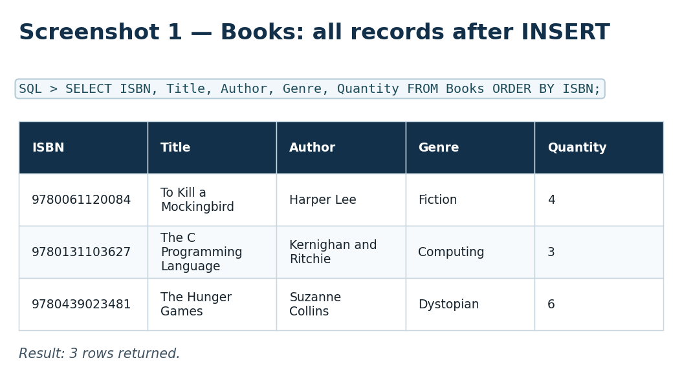
Figure 1. All Books records after insertion.
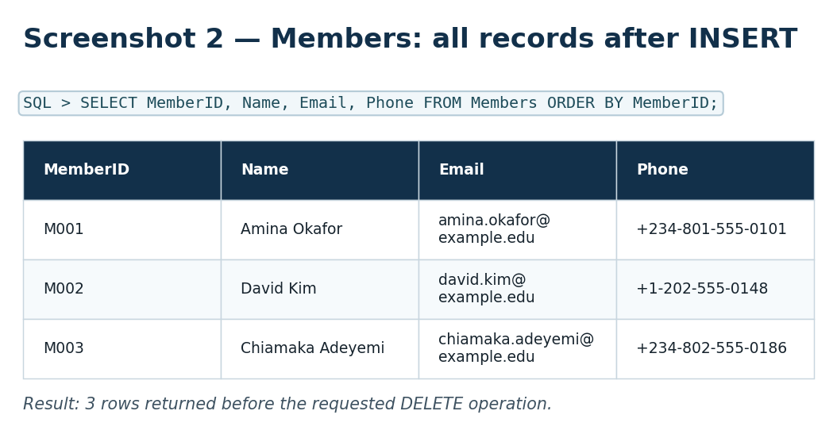
Figure 2. All Members records after insertion and before deletion.
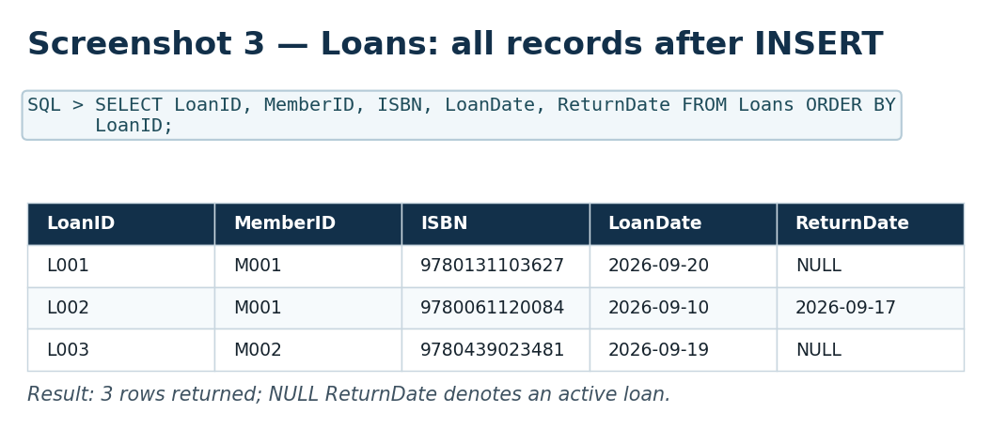
Figure 3. All Loans records after insertion.
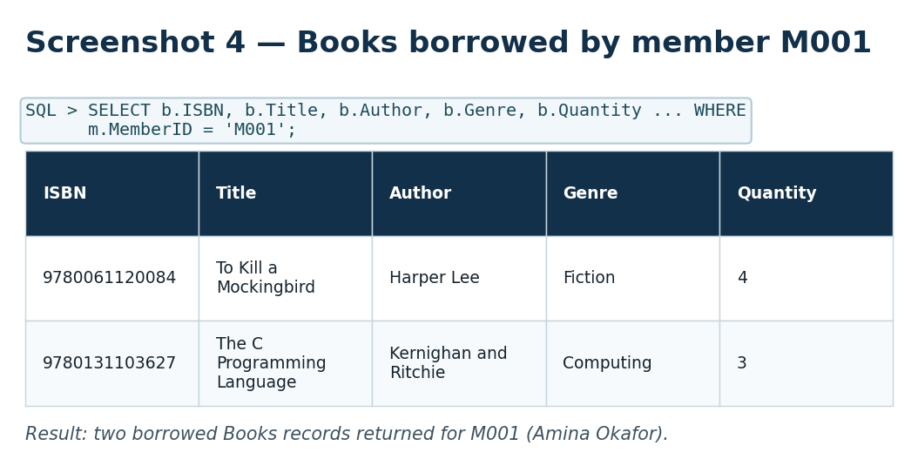
Figure 4. Catalogue information for books borrowed by M001.
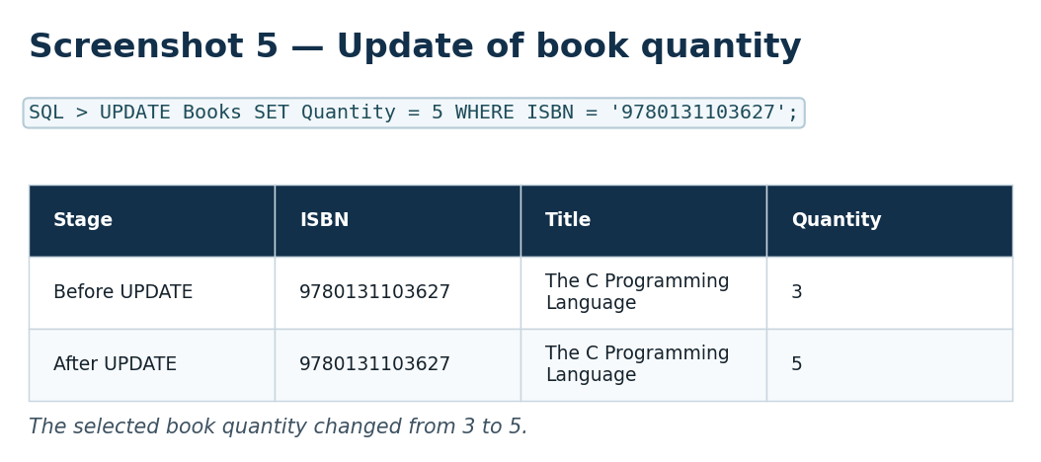
Figure 5. Quantity changed from 3 to 5 for the selected ISBN.
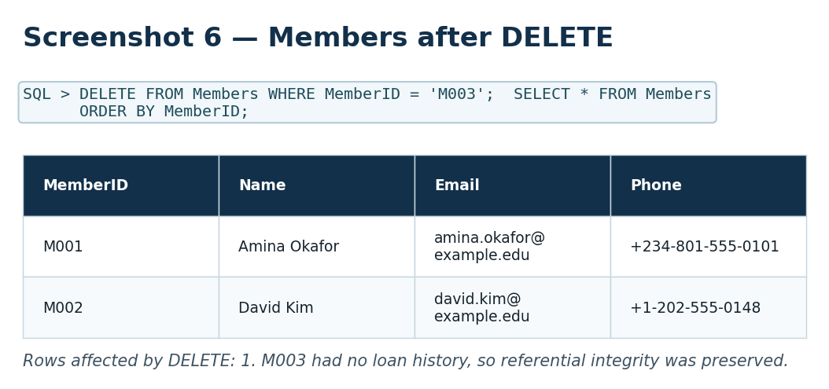
Figure 6. Members relation after deletion of M003.

References
SQLite. (n.d.). Foreign key support.
Vidhya, V., Jeyaram, G., & Ishwarya, K. R. (2016). Database management systems. Alpha Science International.

