Observed uptake, geographic reach, and patient-flow structure of therapeutic ERCP in Brazil's Unified Health System, 2021–2025: a nationwide administrative study
Shuo Feng¹, Chao Shi¹, Tianming Liu¹, Haoran Ding¹, Fenghe Hang¹, Zhenghao Huang¹, Xianzhi Meng¹*
¹ Provincial Key Laboratory of Hepatosplenic Surgery, The First Affiliated Hospital of Harbin Medical University
* Corresponding author: Xianzhi Meng; Email: mengxianzhi@hrbmu.edu.cn

Structured abstract

Background
Formal incorporation of a specialist procedure into a universal health system does not by itself establish sustained delivery, geographic reach, or resilient referral arrangements. We described the nationwide observed uptake, maintenance, modelled road-time reach, ecological equity, patient-flow structure, and supportive in-hospital outcome associations for therapeutic endoscopic retrograde cholangiopancreatography (ERCP) in Brazil's Unified Health System (SUS).

Methods
We linked 2021–2025 SUS hospital claims, hospital registry data, municipal population and vulnerability measures, road-network models, and policy records. Cohort A comprised all deduplicated claims containing the dedicated therapeutic ERCP code. Cohort B restricted the population to adults with administrative diagnoses consistent with common bile duct stones and excluded principal malignant indications. Analyses described first observed coded use, coded maintenance, routed times among realised treated flows, potential adult population reach within 120 and 180 road-minutes, ecological inequality, a privacy-suppressed patient-flow network, structural hub-removal stress tests, and complete-context risk-adjusted in-hospital death associations.

Findings
Cohort A contained 91,175 unique hospital authorisations (AIHs), and Cohort B contained 33,497. Therapeutic ERCP use was observed in 445 hospitals. Of these, 23 were prevalent users at the January 2021 left-censoring boundary. Among 390 hospitals evaluable for their first completed 12 months, 252 met the coded maintenance definition. Among 33,321 routed AIHs, the flow-weighted median route time was 23.2 minutes, the 90th percentile was 213.4 minutes, and 20.7% exceeded 120 minutes. Modelled potential 120-minute adult-population reach increased from 71.9% in 2021 to 82.1% in 2025. Corresponding 180-minute values were 81.2% and 90.4%. The pooled patient-flow projection contained 3,338 municipality nodes and 166,959 shared-destination edges. The supportive outcome analysis included 30,900 AIHs and 378 in-hospital deaths, but the bootstrap analysis was DOWNGRADE and formal intervals were NOT_EVALUATED.

Interpretation
Observed coded use and modelled potential road reach expanded during 2021–2025, while ecological inequality, long routed-travel tails, destination dependence, and structural vulnerability remained visible. These findings are descriptive or associational. They do not identify an effect of policy incorporation, and no formal Aim 4 confidence interval or quasi-causal estimate was available.

Funding
This study was supported by the National Natural Science Foundation of China (grant no. 82270598).

Introduction
Endoscopic retrograde cholangiopancreatography is an established therapeutic option for common bile duct stones, including cases that require duct clearance or biliary decompression. Appropriate patient selection and systems for preventing and managing procedure-related adverse events are central to its use [1–3]. These requirements make ERCP more than a billing-code question. Delivery also depends on where capable services operate, whether they remain active, and how patients move through referral networks.
Brazil's Unified Health System provides a national setting in which formal incorporation and actual delivery can be separated analytically. Universal entitlement is a defining feature of SUS, but availability of a reimbursable procedure does not establish its implementation at hospital level [14–15,23]. The dedicated therapeutic ERCP code was present in the January 2021 SIGTAP table after the relevant national policy process [26–28]. January 2021 nevertheless marks the beginning of a homogeneous observation window, not the beginning of ERCP practice in Brazil. Hospitals already billing the code in that month are therefore left-censored prevalent users.
Existing studies have examined ERCP utilisation, procedural quality, hospital volume, centralisation, and disparities in separate settings [4–11]. Brazilian studies include single-centre assessments and broader work on surgical implementation and access [4,14–16,20]. In searches of PubMed, Europe PMC, OpenAlex, and Crossref conducted on August 23, 2026, we found no published study that integrated nationwide ERCP uptake, road-time reach, ecological equity, patient-flow structure, and structural resilience in one design. This is a search-bounded statement, not a claim of global priority.
We therefore examined a prespecified sequence of questions. The manuscript's core Aims 1–3 described observed uptake and maintenance, geographic reach and ecological equity, and patient-flow structure and structural resilience. Aim 4 was a supportive risk-adjusted analysis of in-hospital death. A planned quasi-causal module could not be estimated under the prespecified eligibility criteria and is not presented as an empirical result.

Methods

Study design and reporting
This nationwide study combined descriptive longitudinal, ecological associational, geospatial, network, structural stress-test, and supportive outcome analyses. The study period was January 2021 through December 2025. Reporting was designed around the STROBE and RECORD recommendations for observational studies using routinely collected health data [21–22]. The statistical analysis plan specified the cohorts, estimands, missing-data rules, and quality-control criteria before the outcome analyses. Dated amendments retained the original estimands and adjustment set.

Data sources and policy context
Hospital claims came from the Hospital Information System of SUS. Procedure detail rows identified claims containing code 0407030255, and hospitalisation records supplied diagnoses, patient characteristics, residence municipality, provider, and in-hospital disposition. The National Registry of Health Establishments supplied time-aligned hospital information. Microdatasus informed reproducible acquisition and preprocessing of DATASUS records [12], while known limitations of administrative surgical data informed the measurement-error analysis [13]. Population denominators and municipality geography came from official Brazilian Institute of Geography and Statistics sources. The municipal Social Vulnerability Index (IVS) supplied an ecological contextual exposure. Supplementary-insurance coverage was retained as contextual information. OpenStreetMap road data were routed with GraphHopper. Policy chronology was verified against the CONITEC recommendation, national ordinances, and monthly SIGTAP archives [26–28].
Record-level source data were kept read-only. Public displays suppressed counts below five and contained no individual-level records. Figures were generated from prespecified aggregate source tables.

Cohorts and counting units
The counting unit was a unique AIH. Procedure-detail records were filtered for the therapeutic ERCP code, then collapsed by competence month, provider CNES identifier, and AIH number before linkage to the hospitalisation record. Cohort A included all unique AIHs with the code. Cohort B restricted Cohort A to adults whose valid diagnostic fields included K80.3, K80.4, or K80.5 and excluded principal C23 or C24 indications. Cohort A supported observed-uptake analyses. Cohort B supported the clinical, equity, travel, and outcome analyses. Administrative diagnosis fields were not chart adjudicated.

Aim 1: observed uptake and maintenance
Observed uptake was defined by the first month in which a hospital recorded at least one unique therapeutic ERCP AIH. We use the term first observed coded use because earlier practice cannot be identified at the January 2021 boundary. Hospitals active in January 2021 were classified as left-censored prevalent users. Eligible hospital-months were derived from contemporaneous CNES information. Months before first observed coded use were not treated as post-uptake inactivity.
Maintenance was based on coded activity in the first completed 12-month window after first observed coded use. A hospital met the maintenance definition when activity was recorded in at least six months of that window. The risk-set denominator included only hospitals with a completed evaluable window by December 2025. This measure reflects billing continuity and does not establish continuously staffed capacity or procedural quality.

Aim 2: ecological equity and road-time measures
Municipality-year treated-use rates were standardised to the adult population. IVS was analysed as a ranked ecological exposure, and inequality was summarized using the slope index of inequality (SII) and relative index of inequality (RII). The 2010 municipal IVS record was held static across 2021–2025. These measures describe contextual gradients and cannot be interpreted as individual socioeconomic effects.
Realised route time was estimated for residence-to-provider municipality pairs observed among treated Cohort B flows, treating travel time as one dimension of spatial accessibility [24]. Routes were weighted by the number of linked AIHs. City-seat or audited municipal anchors approximate locations. They are not patient addresses or measured journeys. The resulting distribution therefore describes routed travel among realised treated flows, not population access or unmet need.
Potential reach was estimated for the adult population within 120 and 180 road-minutes of an observed provider municipality in each year. Routing was completed for all 456 provider-threshold pairs. IBGE city-seat anchors were substituted for three municipalities only after their original anchors returned a Point not found error. Timeout-only municipalities retained their original anchors and longer runtime. Because raw GraphHopper contour approximations were non-nested for 58 providers, cumulative 180-minute reach used the union of raw 120- and 180-minute polygons. Municipalities without a valid anchor remained unknown rather than being classified as uncovered. Potential reach does not measure capacity, quality, need, or realised service use.
The prespecified Aim 2 primary model family used modified-Poisson standardisation. Its model-derived inference was downgraded because some standardised potential-coverage predictions exceeded one. We report the descriptive coverage estimates separately and do not use those probability-invalid predictions as accepted inference.

Aim 3: patient-flow network, service areas, and resilience
Annual directed weighted flows linked residence municipalities to performing hospitals. Public network displays applied the prespecified small-cell threshold. A pooled municipality projection connected residence municipalities that shared performing destinations. Projection edges are shared-destination relations, not patient-to-patient links. Service areas assigned residence municipalities to their modal observed destination and were interpreted as patterns of treated flow, not as measures of need or referral appropriateness. Figure 5 reports non-spatial network summaries and uses no fabricated coordinates.
Structural resilience was evaluated by sequentially removing prespecified high-in-strength hubs from the potential-access matrix and counting adults without an alternative provider within 180 minutes. Sensitivity analyses used 120 minutes. Random node removal provided eight benchmark scenarios at k=1, 5, 10, and 20 removals, with 1,000 replicates per threshold-scenario and seed 20260830. Random quantiles are benchmark envelopes, not confidence intervals. The analysis is a structural stress test and not a real-world rerouting counterfactual.

Aim 4: supportive in-hospital outcome analysis
The primary outcome was in-hospital death in Cohort B. The exposure was trailing 12-month all-indication hospital ERCP volume. The complete-context model adjusted for the prespecified patient, hospital, contextual, provider-state, and calendar covariates. Post-exposure variables such as length of stay and intensive-care use were not included. Administrative comorbidity definitions followed established ICD coding approaches [25]. Separation diagnostics triggered the prespecified bias-reduced logistic-regression fallback. Two prespecified bias-reduced estimators generated standardised risks at the hospital-volume p10 and p90 and their risk difference and risk ratio. Phenotype, adjustment, and diagnostic definitions are reported in the supplementary sections on cohort construction, missing-data handling, and the supportive outcome analysis.
Uncertainty was assessed with a 2,000-replicate hospital-cluster bootstrap. The prespecified validity criterion was not met because too few replicates were valid. The point estimates are therefore supportive associations only. Bootstrap quantiles are not accepted confidence intervals, and the model specification and replicate target were not altered after applying the validity criterion. The failure categories and validity thresholds are reported in the supplementary section ‘Supportive in-hospital outcome analysis’.

Missing data, downgrades, and reproducibility
Identifiers, linkage keys, procedure presence, first observed coded use, and primary outcomes were not imputed. The Aim 4 model used complete contextual information. A variable-level breakdown of the 2,597 records outside that analysis was unavailable, so no missingness pattern was inferred from aggregate totals. Municipalities without valid road anchors remained unknown. A planned staggered-uptake analysis could not be interpreted causally because no hospital-months preceded first observed coded use; its estimates are not reported.

Results

Cohorts and observed uptake
The linked data contained 91,175 Cohort A unique AIHs and 33,497 Cohort B unique AIHs (Figure 1 and Table 1). Therapeutic ERCP use was observed in 445 hospitals. Twenty-three hospitals were active in January 2021 and were classified as left-censored prevalent users rather than newly adopting hospitals (Figure 1).
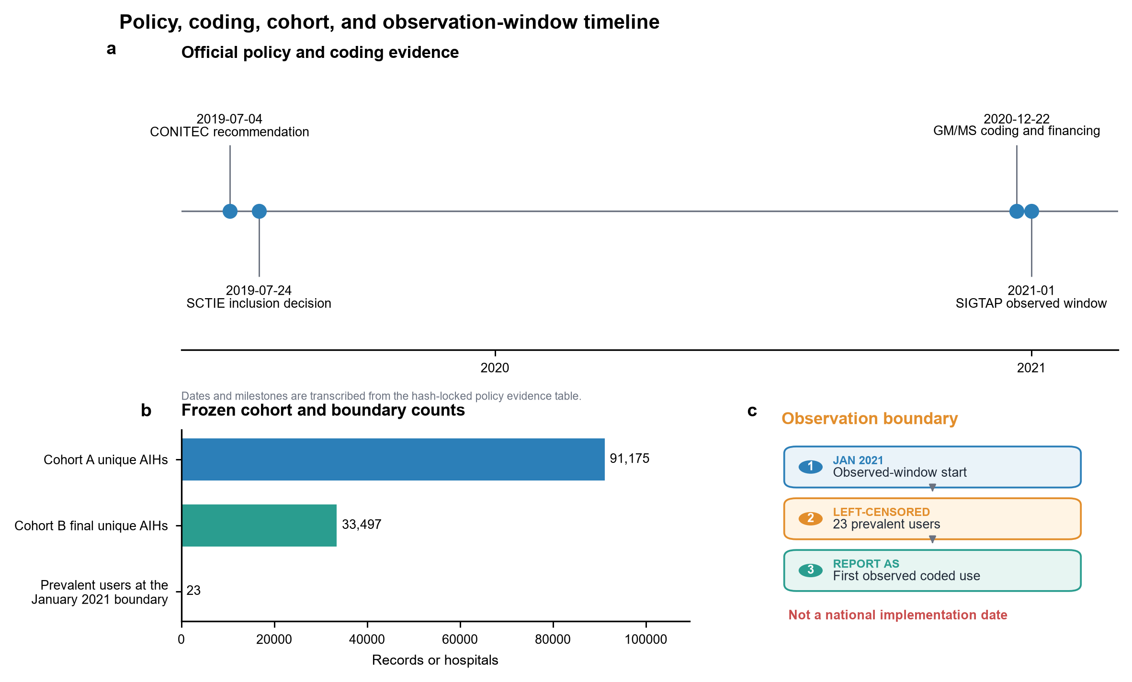
Figure 1. Policy, coding, cohort, and observation-window timeline. (A) Policy and coding milestones. (B) Counts for Cohort A, Cohort B, and hospitals active at the January 2021 observation boundary. (C) The observed-window start, left-censored prevalent users, and first observed coded use. January 2021 is not interpreted as a national implementation date.
Table 1. Study cohorts and analytical population.
Measure | Value | Denominator | Evidence | Key limitation
Cohort A unique AIHs | 91,175 AIHs | — | descriptive | Billing AIHs are deduplicated administrative records, not independently adjudicated clinical cases.
Cohort B final unique AIHs | 33,497 AIHs | 91,175 Cohort A unique AIHs | descriptive | Administrative diagnosis fields do not provide chart-adjudicated phenotype validation.
Hospitals with observed coded therapeutic ERCP use | 445 hospitals | — | descriptive | This is observed uptake, not a true technology-adoption date.
Aim 4 complete primary analysis rows | 30,900 AIHs | 33,497 Cohort B unique AIHs | associational | Complete-context restriction and residual confounding limit generalisability and causal interpretation.
Aim 4 hospitals | 360 hospitals | 30,900 Aim 4 analysis AIHs | associational | Hospital-level associations remain susceptible to residual confounding and referral selection.
AIH, Autorização de Internação Hospitalar; ERCP, endoscopic retrograde cholangiopancreatography.
First observed coded use occurred in 176 hospitals in 2021, including the 23 left-censored January prevalent users, 83 in 2022, 66 in 2023, 63 in 2024, and 57 in 2025 (Figure 2 and Table 2). Among 390 hospitals with an evaluable first completed 12-month window, 252 (64.6%) met the coded maintenance definition (Figure 2 and Table 2). The first-observed-use model had limited events per parameter; its estimates were therefore treated as associational and not as causal evidence.
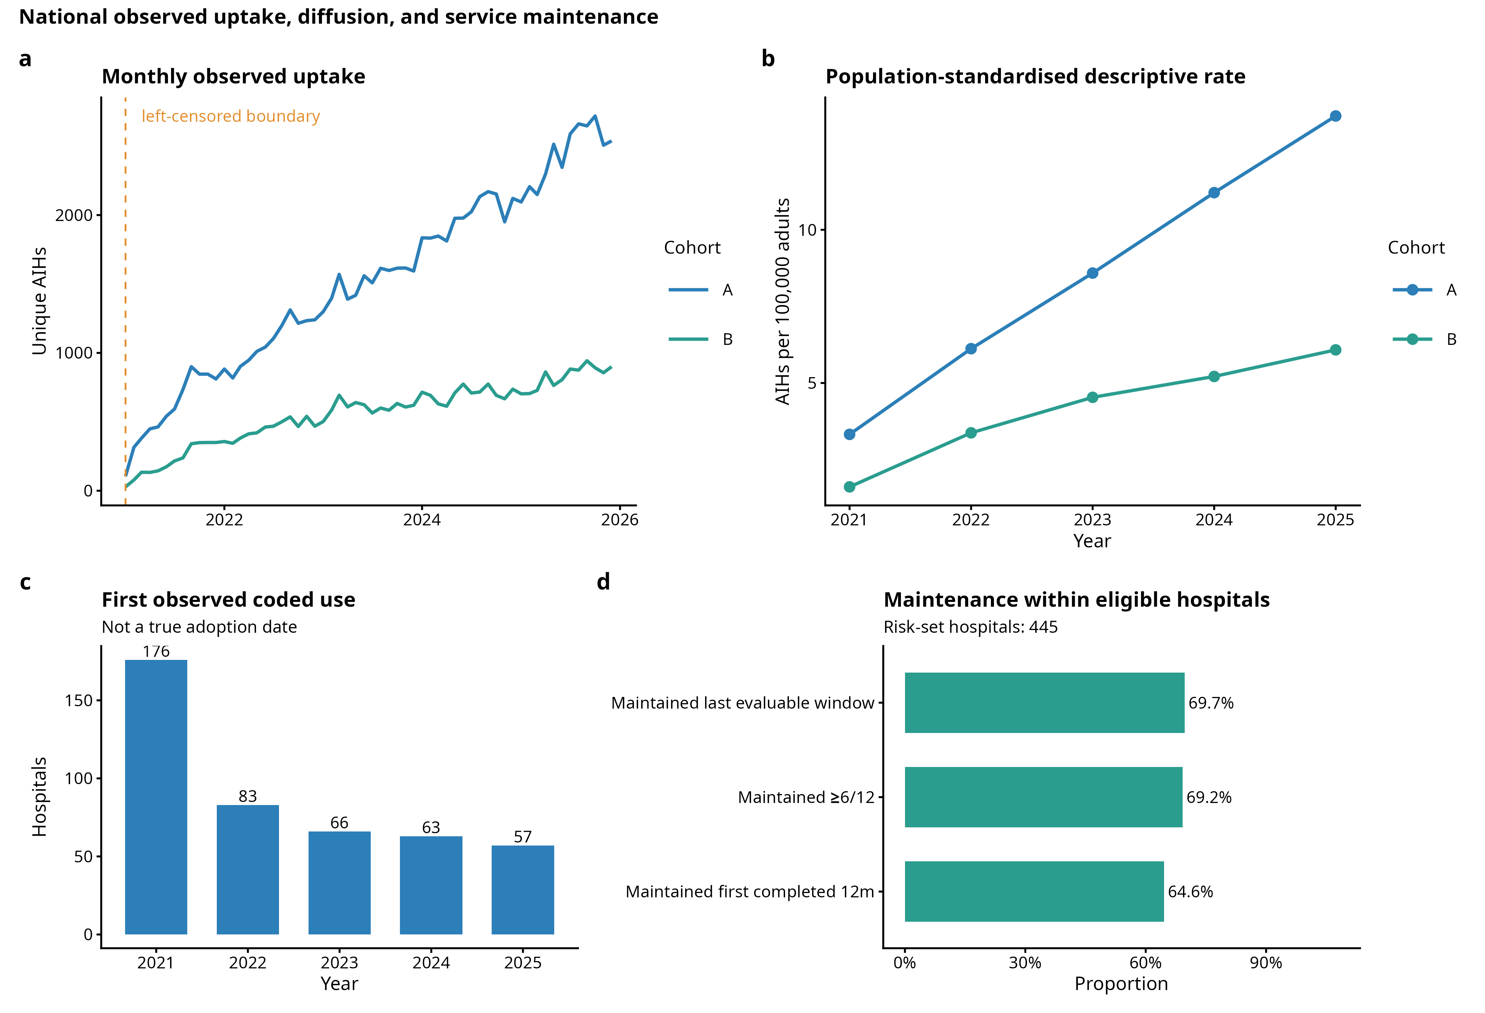
Figure 2. National observed uptake, diffusion, and service maintenance. Monthly and annual therapeutic ERCP use, first observed coded use by year, and billing-defined maintenance among hospitals with an evaluable completed 12-month window. First observed coded use is not a true adoption date, and coded maintenance is not audited service capacity.
Table 2. Observed therapeutic ERCP use and maintenance by hospital.
Measure | Value | Denominator | Evidence | Key limitation
Hospitals with observed coded therapeutic ERCP use | 445 hospitals | — | descriptive | This is observed uptake, not a true technology-adoption date.
Prevalent users at the January 2021 boundary | 23 hospitals | 445 hospitals ever observed | descriptive | The observation boundary cannot distinguish earlier use from first use.
First observed coded use in 2021 | 176 hospitals | 445 hospitals ever observed | descriptive | First observed coded use is not a true adoption date.
First observed coded use in 2022 | 83 hospitals | 445 hospitals ever observed | descriptive | First observed coded use is not a true adoption date.
First observed coded use in 2023 | 66 hospitals | 445 hospitals ever observed | descriptive | First observed coded use is not a true adoption date.
First observed coded use in 2024 | 63 hospitals | 445 hospitals ever observed | descriptive | First observed coded use is not a true adoption date.
First observed coded use in 2025 | 57 hospitals | 445 hospitals ever observed | descriptive | First observed coded use is not a true adoption date.
Maintained service through first completed 12 months | 252 hospitals | 390 first-12-month evaluable hospitals | descriptive | Maintenance is defined from coded billing continuity rather than audited service capacity.
First-observed-use model status | PASS WITH WARNING | — | associational | Events per parameter were below the conventional 10-per-parameter heuristic; results are associational.
AIH, Autorização de Internação Hospitalar; ERCP, endoscopic retrograde cholangiopancreatography.

Ecological equity and realised routed travel
Across 27,825 municipality-years, the IVS RII was 0.55 and the SII was −2.56 treated AIHs per 100,000 adults (Supplementary Table 3). These estimates indicate an ecological gradient in observed treated use. They do not identify an individual deprivation effect.
Routes were available for 33,321 treated-flow AIHs. The flow-weighted median route time was 23.2 minutes and the 90th percentile was 213.4 minutes (Figure 3). Overall, 20.7% of routed treated flows exceeded 120 minutes. The long upper tail coexisted with a short median, indicating that national central summaries conceal a subgroup of lengthy routed journeys among patients who reached treatment.
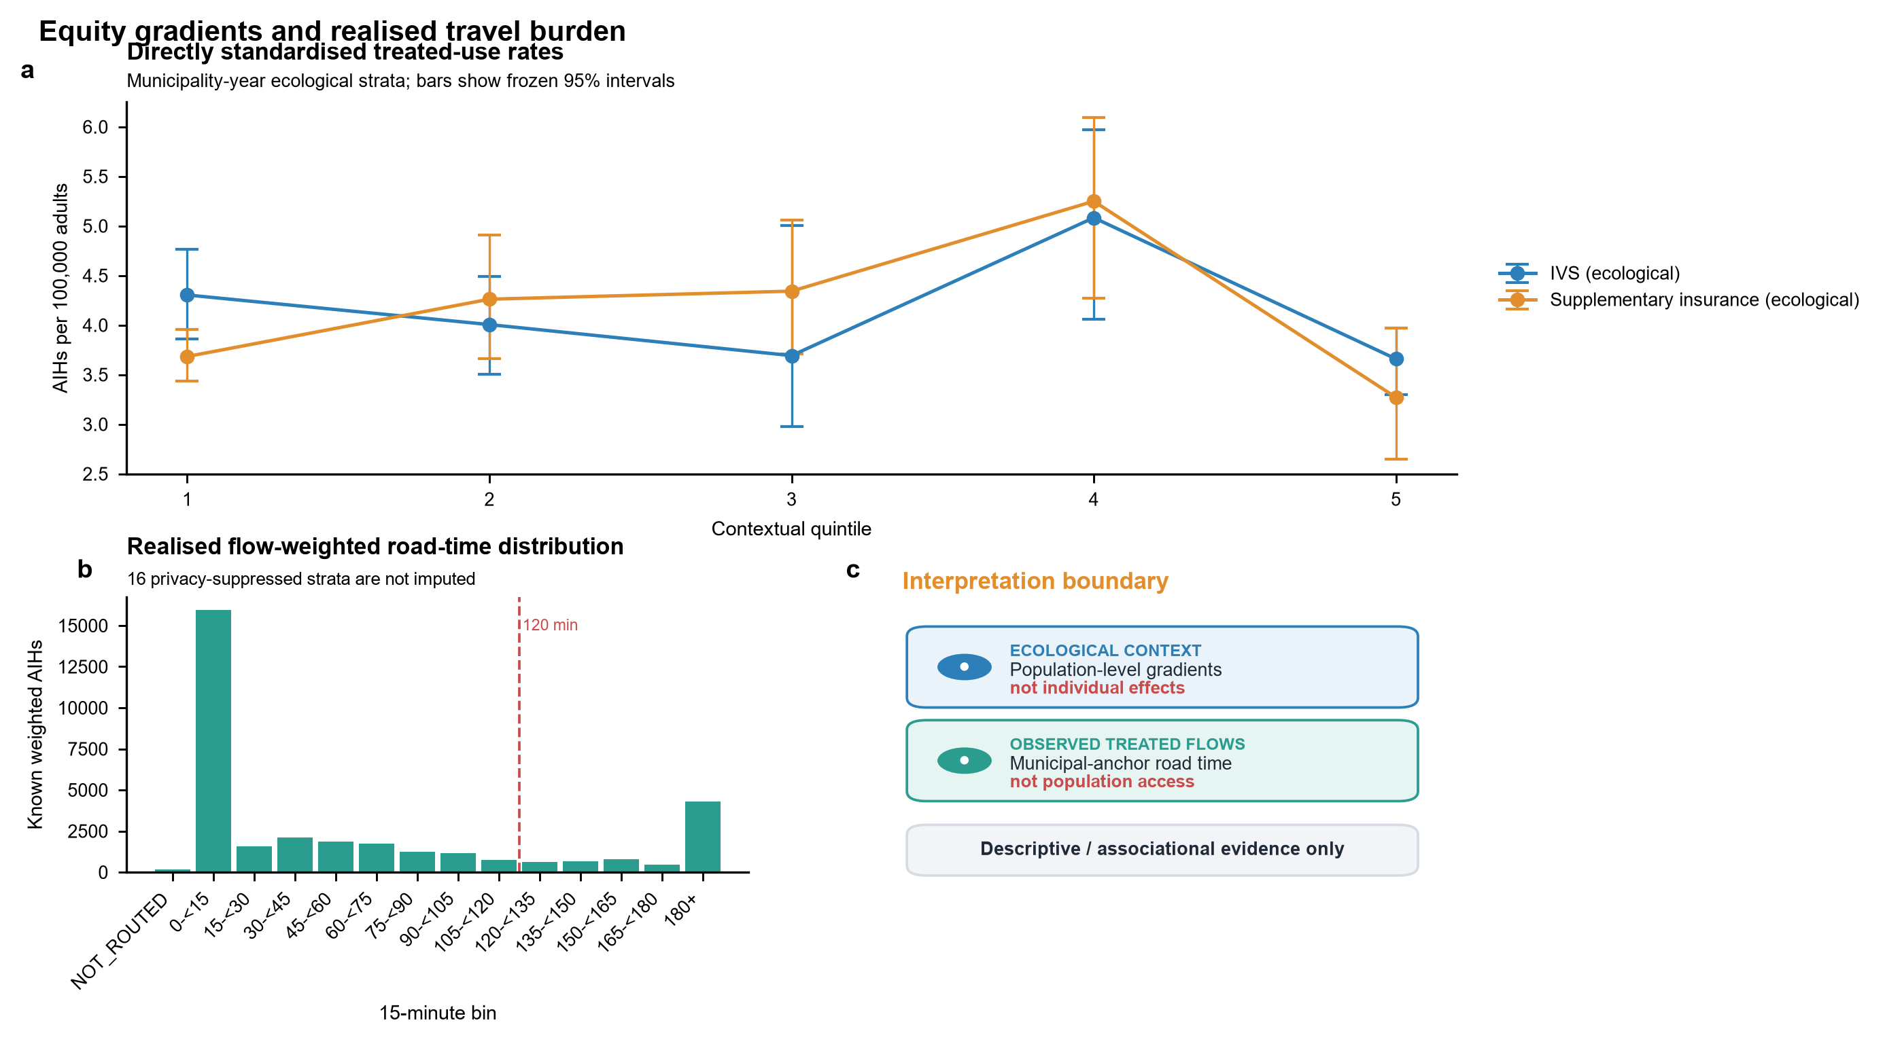
Figure 3. Ecological equity gradients and realised routed travel. (A) Directly standardised treated-use rates across IVS and supplementary-insurance quintiles with 95% intervals. (B) Flow-weighted road-time distribution among observed treated flows; privacy-suppressed strata were not imputed. (C) Interpretation boundary separating ecological context and routed treated travel from individual effects and population access.

Potential road-time reach
The adult population within 120 road-minutes of an observed provider municipality was 71.9% in 2021, 74.2% in 2022, 78.6% in 2023, 80.6% in 2024, and 82.1% in 2025 (Figure 4). Corresponding cumulative 180-minute values were 81.2%, 82.6%, 87.2%, 89.3%, and 90.4% (Figure 4). Supplementary Table 3 reports the endpoint-year values for both thresholds. Adult person-year anchor coverage exceeded 99.99%. One municipality lacked a valid road anchor in 2025 and remained unknown. Regional coverage and the vulnerability-gap components of Figure 4 were NOT_EVALUATED because the available data lacked the required municipality-to-region mapping and municipality-level IVS join.
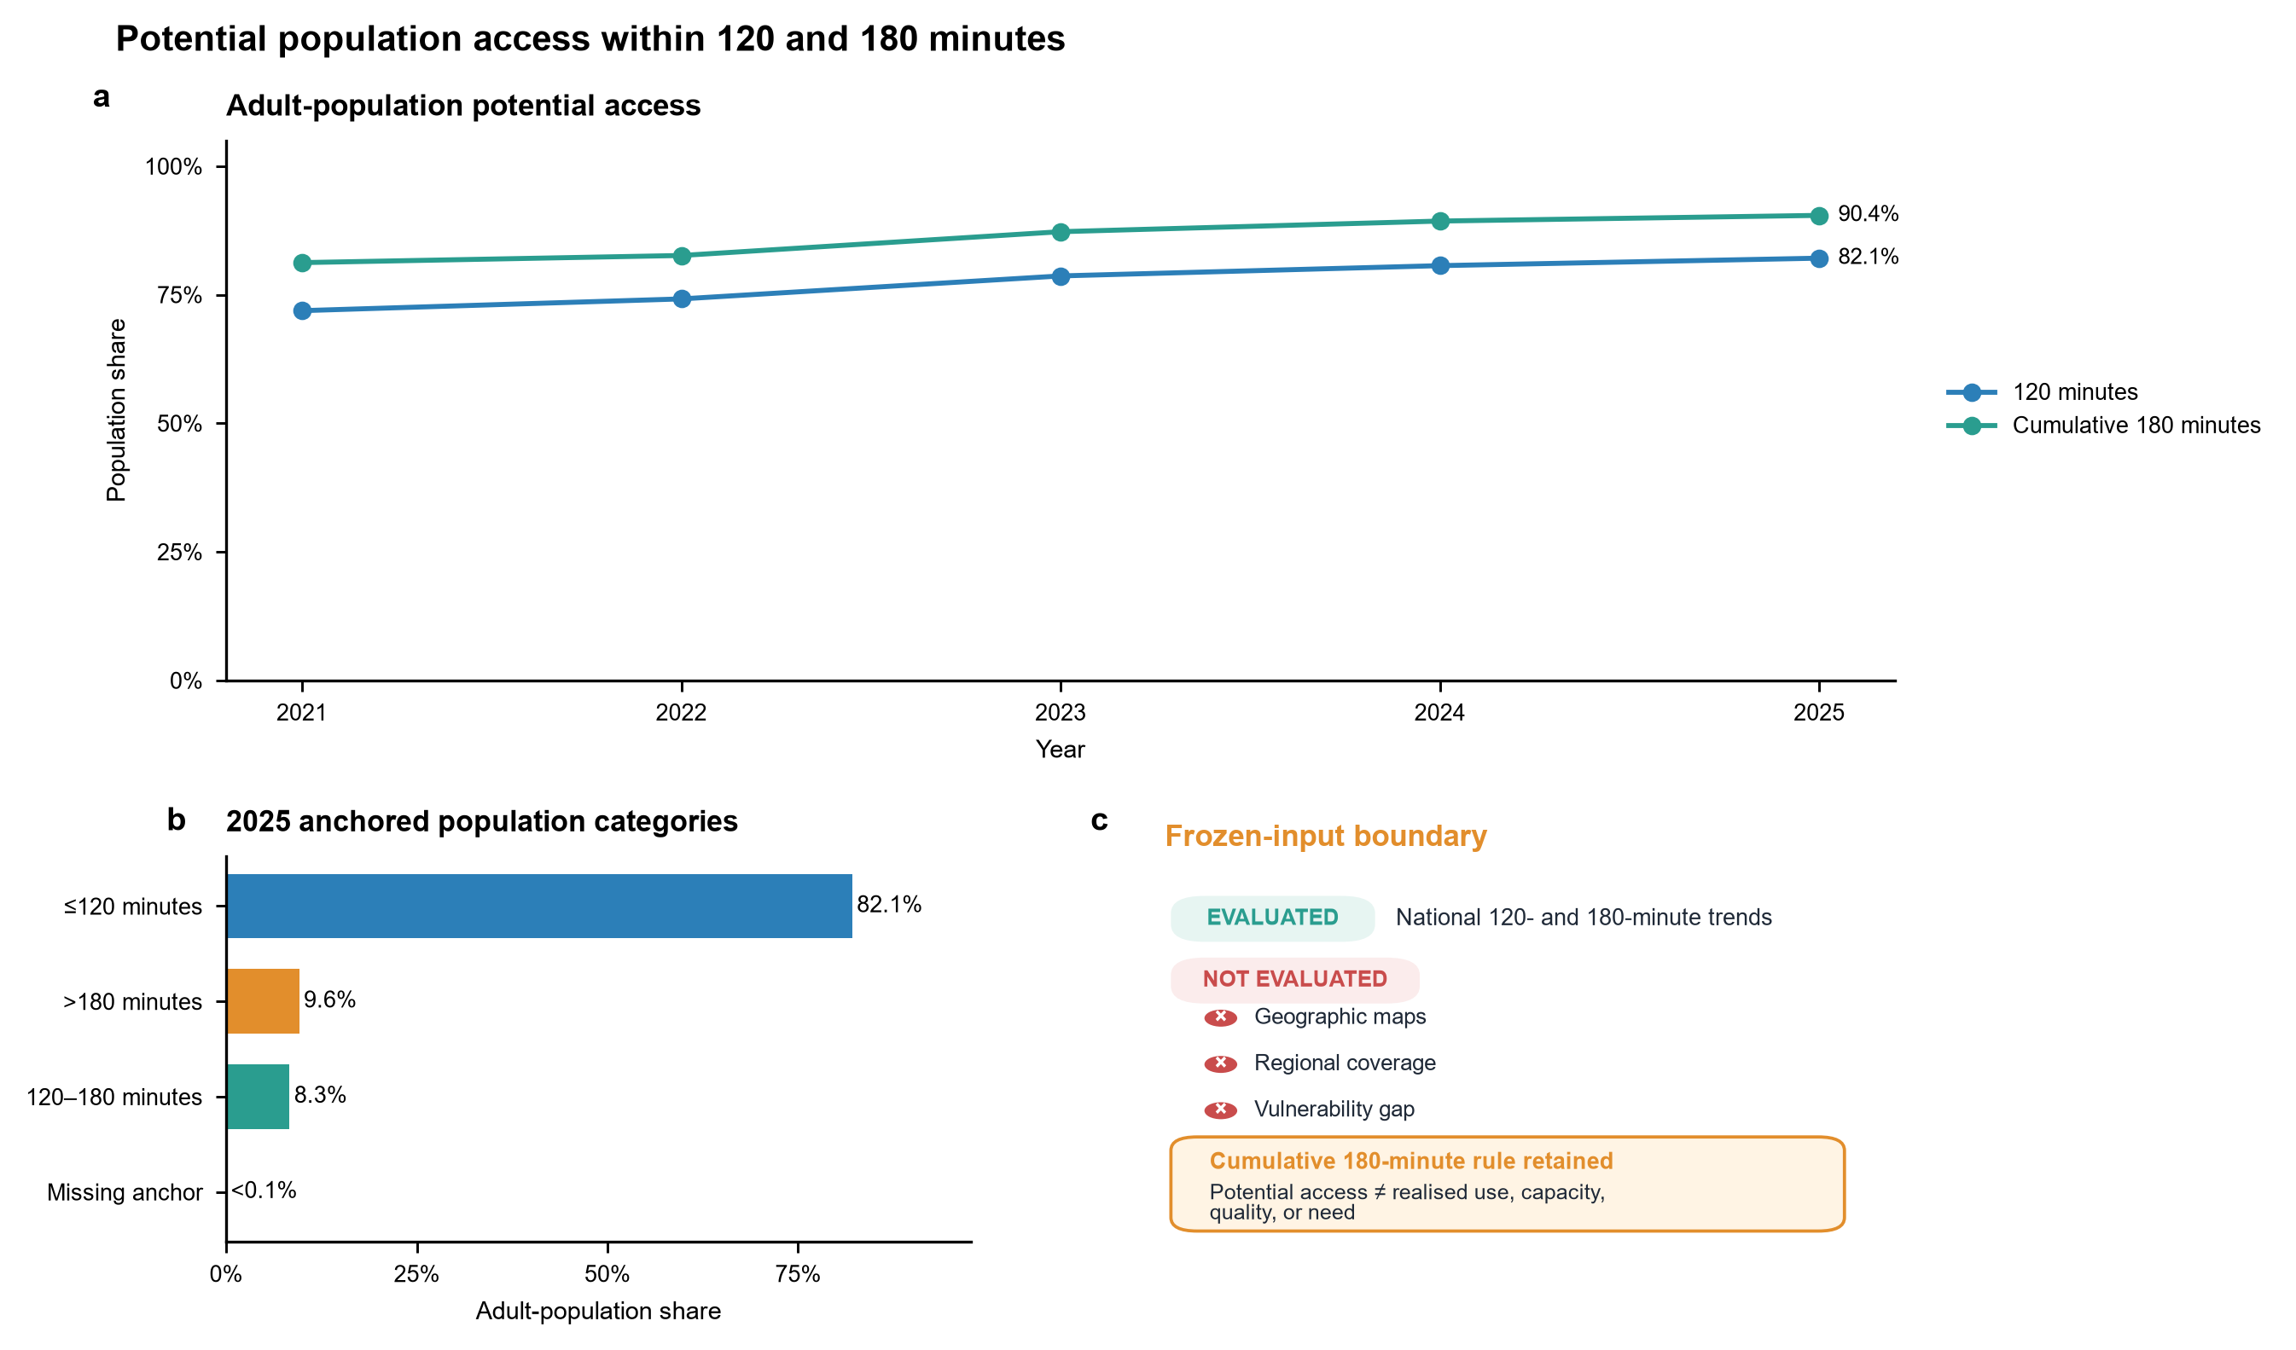
Figure 4. Potential population reach within 120 and 180 road-minutes. (A) National adult-population shares within 120 and cumulative 180 road-minutes of observed provider municipalities. (B) Population categories for 2025 among anchored municipalities. (C) Availability of required analytical inputs. Geographic maps, regional coverage, and the vulnerability gap were not evaluated; potential reach is not realised use, capacity, quality, or need.

Patient-flow structure and structural resilience
The pooled patient-flow projection contained 3,338 municipality nodes and 166,959 shared-destination edges (Figure 5 and Supplementary Table 3). The complete potential-access matrix contained 8,723,036 rows, of which 142,299 were reachable under the prespecified construction. Contextual service-area summaries used 5,565 municipal-total IVS records. These network counts describe concentration in observed performing destinations and do not measure referral quality.
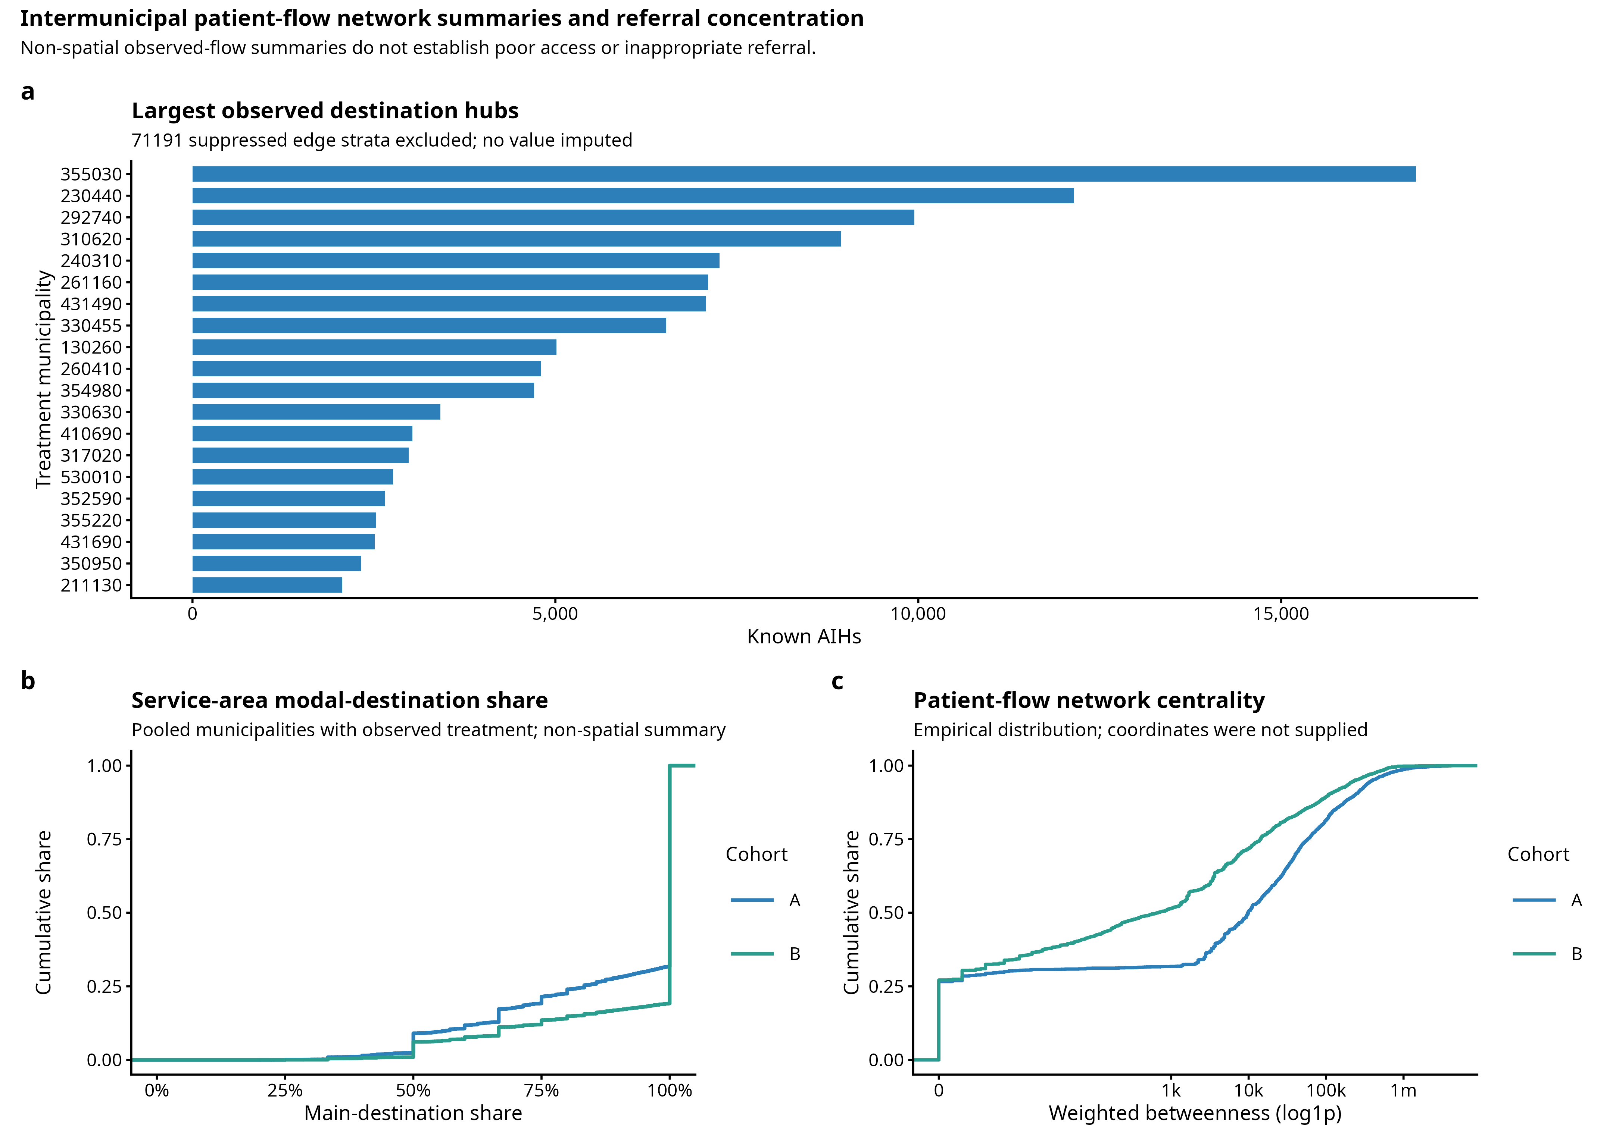
Figure 5. Intermunicipal patient-flow network summaries and destination concentration. Non-spatial summaries of the privacy-suppressed patient-flow network, modal-destination service areas, and centrality distributions. Projection edges are not patient-to-patient links, and cross-municipal flow does not establish poor access or inappropriate referral.
Each random-removal scenario contained 1,000 replicates (Supplementary Figure 1). At the primary 180-minute threshold, targeted removal of five, ten, and twenty hubs newly uncovered 11.3 million, 25.5 million, and 33.5 million adults in the complete-case structural stress test. The corresponding random-removal means were 3.1 million, 6.4 million, and 12.3 million. Exact values are provided in the aggregate source-data files. These contrasts describe structural dependence on selected hubs. They do not predict the effect of closing facilities or the destinations patients would use after a disruption.

Supportive in-hospital outcome associations
The complete-context supportive analysis included 30,900 AIHs, 378 in-hospital deaths, and 360 hospitals (Figure 6 and Supplementary Table 4). Both prespecified bias-reduced estimators produced the same associational point estimates; detailed estimates and diagnostics are reported in the supplementary section ‘Supportive in-hospital outcome analysis’.
Only 618 of 2,000 AS_mean bootstrap replicates and 617 of 2,000 MPL_Jeffreys replicates were valid. Bootstrap inference was therefore DOWNGRADE, and formal intervals were NOT_EVALUATED (Figure 6). These point estimates cannot establish the direction, absence, or equivalence of a hospital-volume association. The quasi-causal family was also downgraded and contributes no empirical estimate to this manuscript (Supplementary Table 4).
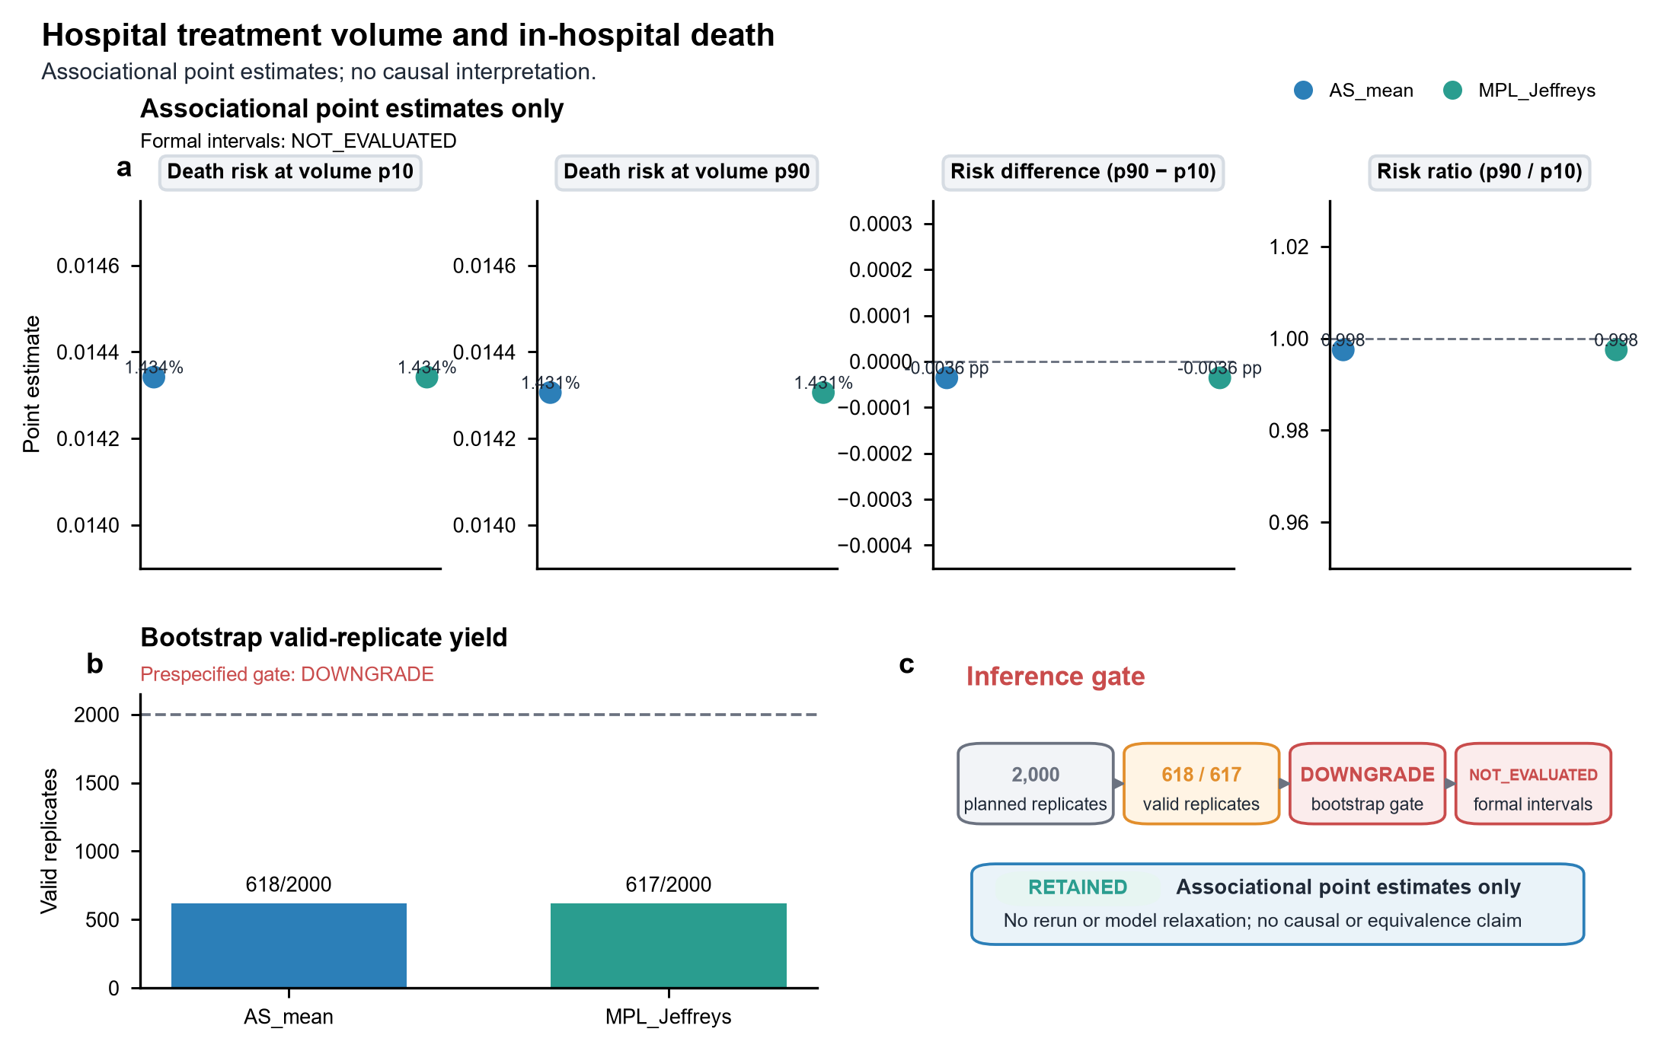
Figure 6. Hospital treatment volume and in-hospital death. (A) Standardised risks and contrasts at hospital-volume p10 and p90 from two prespecified bias-reduced estimators. (B) Valid bootstrap-replicate yield. (C) Prespecified inferential assessment. Point estimates are associational only; bootstrap inference was downgraded and formal intervals were not evaluated.

Discussion
This nationwide study identified increasing observed coded use and expanding modelled potential road reach for therapeutic ERCP in SUS between 2021 and 2025. Expansion did not eliminate ecological inequality, a long upper tail of routed travel among treated flows, or dependence on a limited set of performing destinations. Structural stress tests showed that removal of selected hubs could leave substantially more adults without an alternative provider within the modelled threshold than average random removals. The supportive Aim 4 analysis remained downgraded and did not provide accepted interval inference.
The observed patterns are consistent with service development that depends on hospital capability, specialist teams, equipment, referral relationships, and regional demand. Prior studies have linked ERCP outcomes and adverse events to institutional or operator experience, although results vary across settings [4,7–9]. Our data did not directly measure staffing, equipment uptime, technical success, case complexity beyond available administrative fields, or referral decision-making. These mechanisms should therefore be treated as explanations to test, not mediators established by the present analysis.
Concentration presents a planning tension. Prior literature links procedural volume and experience to ERCP outcomes and has debated centralisation [7,10]. In this study, concentrated destinations coexisted with a long routed-travel tail and structural dependence on selected hubs. These descriptive patterns locate the tension but do not show that centralisation caused either longer travel or hub dependence. A high-centrality provider is structurally important in the observed system, but centrality alone does not show that referrals are inappropriate or that decentralisation would improve outcomes. Likewise, the hub-removal analysis does not model capacity redistribution, behavioural adaptation, or new routes.
For service planning, procedure counts alone are insufficient. A monitoring dashboard could combine observed uptake, coded maintenance, potential road-time reach, treated-flow travel, and destination dependence to screen areas for local review. It is not a validated allocation or referral decision rule and cannot determine whether expansion, referral redesign, or hub protection is appropriate. Implementation would require local validation using workforce, procedure-room and anaesthesia capacity, surgical and radiological backup, operating schedules, quality, transport, referral governance, and stakeholder input. Application beyond Brazil should remain cautious. Universal health systems in other middle-income settings differ in geography, purchasing, referral rules, coding, and specialist capacity.
Several limitations constrain interpretation. Procedure codes and diagnoses were obtained from billing records rather than clinical charts, and the Cohort B administrative diagnostic phenotype was not externally validated. January 2021 left censoring prevents estimation of true adoption dates. IVS was ecological and static, and municipal anchors approximated patient and provider locations. Routed treated flows exclude people who did not obtain ERCP, so they cannot measure unmet need. Potential reach ignored capacity, quality, competing demand, and actual referral feasibility. Privacy suppression removed small displayed flows. Municipal centroids and claims also do not represent patient preferences, remote or Indigenous travel conditions, informal care pathways, or cross-border mobility. The complete-context outcome model remained vulnerable to residual confounding and referral selection, and in-hospital death excluded events after discharge. COVID-19 disrupted elective activity in Brazil during the study period [17–18]. The conference-level Brazilian ERCP report [19] is retained only as contextual support. Finally, Aim 2 model-based inference, Aim 4 bootstrap inference, and the planned quasi-causal family were downgraded. None of these unavailable analyses is a null finding.
In conclusion, therapeutic ERCP showed broader observed coded use and greater modelled road-time reach in SUS during 2021–2025, alongside persistent geographic and ecological inequality and patient-flow network dependence. Joint monitoring of these dimensions may provide a more informative account of service configuration than national volume alone. The data do not attribute the observed changes to policy incorporation.

Data availability
This study used routinely collected SIH/SUS and CNES records obtained from DATASUS, together with public contextual data from IBGE, Ipea/IVS, ANS, OpenStreetMap, CONITEC, national ordinances, and SIGTAP archives. Record-level SUS files are not redistributed. Data-acquisition instructions, source URLs, access dates, and a data dictionary are supplied so that eligible users can reacquire source material under the custodians' current terms. Aggregate data underlying the figures and tables are included with the reproducibility materials. For the 2,597 records outside the Aim 4 complete-context analysis, variable-specific missingness counts were unavailable and were not inferred from aggregate totals.

Code availability
The reproducibility package contains the transformation and analysis scripts, environment specification, tests, aggregate source-data generation, and figure and table rendering code. It contains no credentials, restricted record-level data, unredacted small cells, or writable result-registry files. A permanent public archive will be cited when assigned.

Ethics approval and informed consent
This study used only public, de-identified, or aggregate database records and involved no participant recruitment, contact, or identifiable personal data. Ethics approval and informed consent were therefore not required.

Funding
This study was supported by the National Natural Science Foundation of China (grant no. 82270598). The funder had no role in study design, data analysis, interpretation of results, manuscript preparation, or the decision to submit.

Competing interests
The authors declare no competing interests.

Author contributions
Shuo Feng: Conceptualization, Methodology, Data curation, Software, Formal analysis, Validation, Visualization, Project administration, Writing - original draft, Writing - review and editing. Chao Shi: Methodology, Investigation, Validation, Interpretation of results, Writing - original draft, Writing - review and editing. Tianming Liu: Investigation, Data curation, Validation, Writing - review and editing. Haoran Ding: Investigation, Validation, Writing - review and editing. Fenghe Hang: Investigation, Resources, Validation, Writing - review and editing. Zhenghao Huang: Investigation, Resources, Validation, Writing - review and editing. Xianzhi Meng: Conceptualization, Methodology, Supervision, Project administration, Resources, Funding acquisition, Writing - review and editing. All authors critically reviewed the manuscript, approved the final version, and agree to be accountable for the integrity of the work.

References
1. Manes G, Paspatis G, Aabakken L, Anderloni A, Arvanitakis M, Ah-Soune P, et al. Endoscopic management of common bile duct stones: European Society of Gastrointestinal Endoscopy (ESGE) guideline. Endoscopy. 2019;51(05):472-491. doi:10.1055/a-0862-0346.
2. Dumonceau J, Kapral C, Aabakken L, Papanikolaou I, Tringali A, Vanbiervliet G, et al. ERCP-related adverse events: European Society of Gastrointestinal Endoscopy (ESGE) Guideline. Endoscopy. 2020;52(02):127-149. doi:10.1055/a-1075-4080.
3. Williams E, Beckingham I, El Sayed G, Gurusamy K, Sturgess R, Webster G, et al. Updated guideline on the management of common bile duct stones (CBDS). Gut. 2017;66(5):765-782. doi:10.1136/gutjnl-2016-312317.
4. BORGES A, ALMEIDA P, FURLANI S, CURY M, PLESKOW D. ERCP PERFORMANCE IN A TERTIARY BRAZILIAN CENTER: FOCUS ON NEW RISK FACTORS, COMPLICATIONS AND QUALITY INDICATORS. ABCD, arq. bras. cir. dig.. 2018;31(1):e1348. doi:10.1590/0102-672020180001e1348.
5. Coelho-Prabhu N, Shah N, Van Houten H, Kamath P, Baron T. Endoscopic retrograde cholangiopancreatography: utilisation and outcomes in a 10-year population-based cohort. BMJ Open. 2013;3(5):e002689. doi:10.1136/bmjopen-2013-002689.
6. Huang R, Thosani N, Barakat M, Choudhary A, Mithal A, Singh G, et al. Evolution in the utilization of biliary interventions in the United States: results of a nationwide longitudinal study from 1998 to 2013. Gastrointestinal Endoscopy. 2017;86(2):319-326.e5. doi:10.1016/j.gie.2016.12.021.
7. Lee H, Cho C, Heo J, Jung M, Kim T, Kim K, et al. Impact of Hospital Volume and the Experience of Endoscopist on Adverse Events Related to Endoscopic Retrograde Cholangiopancreatography: A Prospective Observational Study. Gut and Liver. 2020;14(2):257-264. doi:10.5009/gnl18537.
8. Williams E, Taylor S, Fairclough P, Hamlyn A, Logan R, Martin D, et al. Are we meeting the standards set for endoscopy? Results of a large-scale prospective survey of endoscopic retrograde cholangio-pancreatograph practice. Gut. 2007;56(6):821-829. doi:10.1136/gut.2006.097543.
9. Glomsaker T, Hoff G, Kvaløy J, Søreide K, Aabakken L, Søreide J. Patterns and predictive factors of complications after endoscopic retrograde cholangiopancreatography. Br J Surg. 2013;100(3):373-380. doi:10.1002/bjs.8992.
10. Muller A. Endoscopic retrograde cholangiopancreatography: is the centre better? The case against centralisation of ERCP services. Frontline Gastroenterol. 2013;4(3):210-212. doi:10.1136/flgastro-2012-100182.
11. Dahiya D, Perisetti A, Sharma N, Inamdar S, Goyal H, Singh A, et al. Racial disparities in endoscopic retrograde cholangiopancreatography (ERCP) utilization in the United States: are we getting better?. Surg Endosc. 2023;37(1):421-433. doi:10.1007/s00464-022-09535-w.
12. Saldanha R, Bastos R, Barcellos C. Microdatasus: pacote para download e pré-processamento de microdados do Departamento de Informática do SUS (DATASUS). Cad. Saúde Pública. 2019;35(9):e00032419. doi:10.1590/0102-311x00032419.
13. VIANA S, FALEIRO M, MENDES A, TORQUATO A, TAVARES C, FERES B, et al. Limitations of using the DATASUS database as a primary source of data in surgical research: a scoping review. Rev. Col. Bras. Cir.. 2023;50:e20233545. doi:10.1590/0100-6991e-20233545-en.
14. OLIJNYK J, VALANDRO I, RODRIGUES M, CZEPIELEWSKI M, CAVAZZOLA L. Cohort cholecystectomies in the Brazilian public system: is access to laparoscopy universal after three decades?. Rev. Col. Bras. Cir.. 2022;49:e20223180. doi:10.1590/0100-6991e-20223180-en.
15. Olijnyk J, Cavazzola L, de Aguilar-Nascimento J, Nácul M, e Almeida Filho E. Video-Assisted Surgery Implementation in the Public Health System of a Developing Country. World J Surg. 2014;38(8):1912-6. doi:10.1007/s00268-014-2493-3.
16. FELÍCIO S, MATOS E, CERQUEIRA A, FARIAS K, SILVA R, TORRES M. MORTALITY OF URGENCY VERSUS ELECTIVE VIDEOLAPAROSCOPIC CHOLECYSTECTOMY FOR ACUTE CHOLECYSTITIS. ABCD, arq. bras. cir. dig.. 2017;30(1):47-50. doi:10.1590/0102-6720201700010013.
17. Frio G, Russo L, de Albuquerque C, da Mota L, Barros-Areal A, Oliveira A, et al. The disruption of elective procedures due to COVID-19 in Brazil in 2020. Sci Rep. 2022;12(1):10942. doi:10.1038/s41598-022-13746-5.
18. Portela M, de Aguiar Pereira C, Lima S, de Andrade C, Martins M. Patterns of hospital utilization in the Unified Health System in six Brazilian capitals: comparison between the year before and the first six first months of the COVID-19 pandemic. BMC Health Serv Res. 2021;21(1):976. doi:10.1186/s12913-021-07006-x.
19. Correa T. REDUCTION IN THE NUMBER OF ENDOSCOPIC RETROGRADE CHOLANGIOPANCREATOGRAPHIES PERFORMED IN BRAZIL DURING THE COVID-19 PANDEMIC. Endoscopy. 2022;54(S 01):S148-S148. doi:10.1055/s-0042-1744961.
20. dos Santos J, Kemp R, Orquera A, Gaspar A, Júnior J, Queiroz L, et al. The Safety and Cost Analysis of Outpatient Laparoendoscopy in the Treatment of Cholecystocholedocholithiasis: A Retrospective Study. JCM. 2024;13(2):460. doi:10.3390/jcm13020460.
21. von Elm E, Altman D, Egger M, Pocock S, Gøtzsche P, Vandenbroucke J. The Strengthening the Reporting of Observational Studies in Epidemiology (STROBE) Statement: Guidelines for Reporting Observational Studies. PLoS Med. 2007;4(10):e296. doi:10.1371/journal.pmed.0040296.
22. Benchimol E, Smeeth L, Guttmann A, Harron K, Moher D, Petersen I, et al. The REporting of studies Conducted using Observational Routinely-collected health Data (RECORD) Statement. PLoS Med. 2015;12(10):e1001885. doi:10.1371/journal.pmed.1001885.
23. Paim J, Travassos C, Almeida C, Bahia L, Macinko J. The Brazilian health system: history, advances, and challenges. The Lancet. 2011;377(9779):1778-1797. doi:10.1016/s0140-6736(11)60054-8.
24. Guagliardo M. Spatial accessibility of primary care: concepts, methods and challenges. Int J Health Geogr. 2004;3(1):3. doi:10.1186/1476-072x-3-3.
25. Quan H, Sundararajan V, Halfon P, Fong A, Burnand B, Luthi J, et al. Coding Algorithms for Defining Comorbidities in ICD-9-CM and ICD-10 Administrative Data. Medical Care. 2005;43(11):1130-1139. doi:10.1097/01.mlr.0000182534.19832.83.
26. Brasil. Ministério da Saúde. Relatório de Recomendação no. 471: Colangiopancreatografia endoscópica retrógrada pré-cirúrgica no tratamento de coledocolitíase. CONITEC; 2019.
27. Brasil. Ministério da Saúde. Portarias SCTIE no. 37, 38, and 39 of 2019, including Portaria SCTIE no. 39 of July 24, 2019.
28. Brasil. Ministério da Saúde. SIGTAP monthly procedure table, code 0407030255; archived December 2020 and January 2021 editions.

